REPUBLIQUE DU CAMEROUN
Paix-Travail-Patrie

REPUBLIC OF CAMEROON
Peace-Work-Fatherland


SOFTINFRA TECH
Location: Station Truck Olembe

AFRICAN INSTITUTE OF COMPUTER SCIENCE - PAUL BIYA TECHNOLOGY CENTER OF EXCELLENCE
P.O. Box: 13 719 Yaoundé-Cameroun
Tel : (237) 242 72 99 57 / 242 72 99 58
E-mail : contact@iaicameroun.com
Web Site: www.iaicameroun.com

INTERNSHIP REPORT

THEME : Design and Implementation of a Police Criminal Record System for Cameroon

Internship carried out from the 1st of July to 30th of September 2026
In view of obtaining a Higher Technician Diploma (HTD) in computer sciences option Software Engineering

Submitted by:
BASSONG PIERRE DORIAN
Level II student at AICS-Cameroon

SUPERVISORS:

PROFESSIONAL SUPERVISOR
Mr. Essonkouat Sadouo Ulrich Aubin
Professional Supervisor

ACADEMIC SUPERVISOR
Mme AUGENE VANESSA
Academic Supervisor

ACADEMIC YEAR 2025-2026

DEDICATION

DEDICATED TO MY LOVELY FAMILY

ACKNOWLEDGEMENTS
This work would not have been successfully accomplished without the invaluable help, guidance, encouragement, and advice of the following individuals and organizations.
- We extend our profound gratitude to the African Institute of Computer Sciences (AICS), specifically to the Resident Representative, MR. ARMAND CLAUDE ABANDA.
- Our sincere thanks goes to the The Delegate of National Security and his entire staff for providing us with the opportunity to serve as interns at their prestigious institution.
- We are deeply indebted to our professional supervisor Mr. Essonkouat Sadouo Ulrich Aubin for his expert guidance throughout this internship.
- A special note of thanks to our academic supervisor and lecturer at AICS Cameroon, for his invaluable advice, guidance, and constant encouragement.
- We also thank all the teachers of the African Institute of Computer Sciences for their foundational role in our education.
- On a personal note, a special thanks to my dear parents, Mr. Bikai James Pascal and Mrs Sime Clarisse Eugenie for their unconditional love, unwavering financial support, and countless sacrifices. To my brothers and sisters, thank you for your love and support.
- We acknowledge the countless contributors of the open-source programming community, whose resources were instrumental in helping us learn essential skills and solve complex problems.
- Finally, thanks to my Sister, Bassong Debora Leslie , for their camaraderie and collaboration.

SUMMARY
DEDICATION i
ACKNOWLEDGEMENTS ii
SUMMARY iii
LIST OF FIGURES iv
LIST OF TABLES vi
LIST OF ABBREVIATIONS vii
ABSTRACT viii
RESUME ix
GENERAL INTRODUCTION 1
PART ONE : INSERTION PHASE 2
PART TWO: TECHNICAL PHASE 14
DOCUMENT ONE: EXISTING SYSTEM 15

LIST OF FIGURES

Figure 1: Site plan of SoftInfra Tech 16
Figure 2: SoftInfra Tech Organization Chart 20
Figure 3: The “Y” shape of the 2TUP development process 49
Figure 4: Formalism of a UML use case diagram 52
Figure 5: Global use case diagram of the Police Criminal Record System 56
Figure 6: Specific use case diagram for Register New Case / Incident 57
Figure 7: Specific use case diagram for Verify Criminal Record 58
Figure 8: Specific use case diagram for Validate / Authorize Wanted Alert 58
Figure 9: Formalism of a UML communication diagram 65
Figure 10: Communication diagram of the Authenticate operation 68
Figure 11: Formalism of a UML sequence diagram 71
Figure 12: Sequence diagram of the Authenticate operation 73
Figure 14: Formalism of a UML activity diagram 75
Figure 15: Activity diagram of the Authenticate operation 78

LIST OF TABLES

LIST OF ABBREVIATIONS

ABSTRACT

RESUME

GENERAL INTRODUCTION
In an era where information technology underpins institutional efficiency, public security agencies increasingly turn to digital solutions to modernize their operations. In Cameroon, the management of criminal records is a particularly sensitive function of law enforcement, directly supporting judicial proceedings and the maintenance of public order. At the Délégation Générale à la Sûreté Nationale (DGSN), this task has historically relied on manual, paper-based processes carried out across its ten regional delegations — an approach that, while functional, exposes the institution to delays in record retrieval, document loss, difficulties cross-referencing information, and limited traceability.
It is within this context that the present internship was carried out, from 1st July to 30 September 2026, at SoftInfra Tech, an IT company based in Yaoundé, around the design and implementation of a web-based Police Criminal Record System intended for the DGSN. The general objective is to conceive and model a reliable digital tool that improves the efficiency, security, and traceability of criminal record management, allowing authorized personnel — administrative officers, police officers, and judicial authorities — to register, consult, update, and validate criminal records and wanted alerts through a unified interface. More specifically, the project analyzes the existing manual system, defines the target system's functional and technical requirements, and models it using the Unified Modeling Language (UML).
This report is structured in two main parts: the Insertion Phase, which retraces the intern's integration into SoftInfra Tech and presents the host company; and a second part dedicated to the project itself, organized into several files covering the specification book, the analysis and design, the conception, and the realization of the Police Criminal Record System.

PART ONE: INSERTION PHASE

Content:

INTRODUCTION
- WELCOME WITHIN THE COMPANY
- PRESENTATION OF THE COMPANY
- SOFTWARE ENGINEERING PRESENTATION
- SYSTEM AND COMPUTER NETWORK DEPARTMENT
- BRIEF PRESENTATION OF THE PROJECT
CONCLUSION

INTRODUCTION
The insertion phase is an initial period, generally lasting two (02) weeks, during which the student becomes acquainted with the internship environment and adapts to the organization's professional culture. During this stage, the intern is introduced to the workplace, meets their internship supervisor (commonly referred to as the professional mentor), and establishes productive working relationships with colleagues. This phase also enables the company to define and assign an internship project or research theme based on an identified organizational need or problem to be addressed throughout the internship. Accordingly, this insertion phase was carried out at SoftInfra Tech, where the intern became familiar with the company's structure, operations, and work environment. A detailed presentation of the company is provided in the following pages.
I. WELCOME WITHIN THE COMPANY
1. Welcome
July 1st, 2026, marked the beginning of our internship at SoftInfra Tech, located in Station Truck Olembe. We received a warm and professional welcome from Mr. Essonkouat Sadouo Ulrich Aubin and Mr. Ngningtedem Feupi Vaillant, both Computer Engineers at the company.
During this introductory session, they presented the company's activities, mission, and professional environment. They also explained the objectives of the internship, the purpose of the immersion period, and the expectations regarding our conduct, commitment, and performance throughout the internship. In addition, they introduced us to the workspace and the resources made available to facilitate the successful completion of our internship activities.
2. Integration
During this two-week insertion phase, our objective was to adapt to the professional environment of SoftInfra Tech and become familiar with its organizational structure. We interacted with the various departments involved in our project and, in collaboration with our supervisors, evaluated several project ideas before selecting the most feasible and relevant one as the official theme of our internship.
II. PRESENTATION OF THE COMPANY
1. History
SoftInfra Tech is an IT company founded by two Computer Engineers specializing in Software Engineering and Computer Networks and Systems. Their shared vision of delivering high-quality IT solutions inspired the creation of the company. Established in January 2026, the project was driven by these two founders, who remained committed despite the challenges encountered during its early stages. Their perseverance led to the official establishment of SoftInfra Tech as a Limited Liability Company (SARL) in February 2026.
2. Location
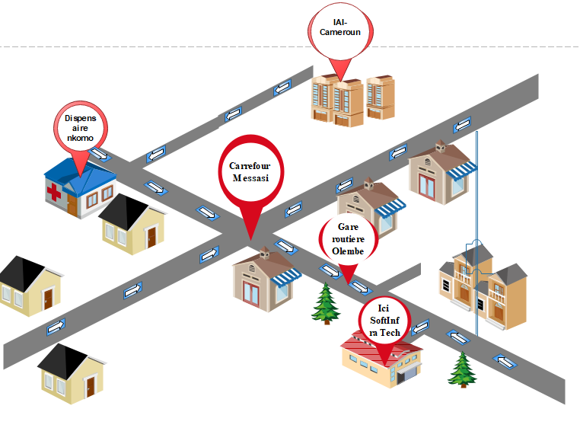
Figure 1: Site plan
Coming from the Messasi, the location of SoftInfra Tech is facilitated by the map above.
3. Missions
SoftInfra Tech is committed to providing innovative IT solutions that address the technological challenges faced by organizations across various sectors of activity. In addition to its consulting and technical services, the company promotes the adoption of Information and Communication Technologies (ICT) by offering professional training programs in various areas of information technology. Upon successful completion of these programs, participants are awarded certificates of completion.
4. Social Object (Purpose)
The company's purpose is:
• Design and realization of web, mobile and desktop applications;
• Administration of computer networks;
• Training in software design and development;
• Training in network administration;
• IT maintenance;
• Infographics;
• Product of services, general commerce.
And, generally, all financial, commercial, industrial, movable and immovable operations, which can be directly or indirectly related to the object above or to all similar or related objects.
5. Organization Chart and Functioning of the Structure
SoftInfra Tech is organized into two (02) main directorates, each comprising several specialized departments. During our internship, we were assigned to the Technical Directorate, specifically to the Software Engineering Department, where we carried out all our internship activities. The company's organizational structure is illustrated in the figure below.
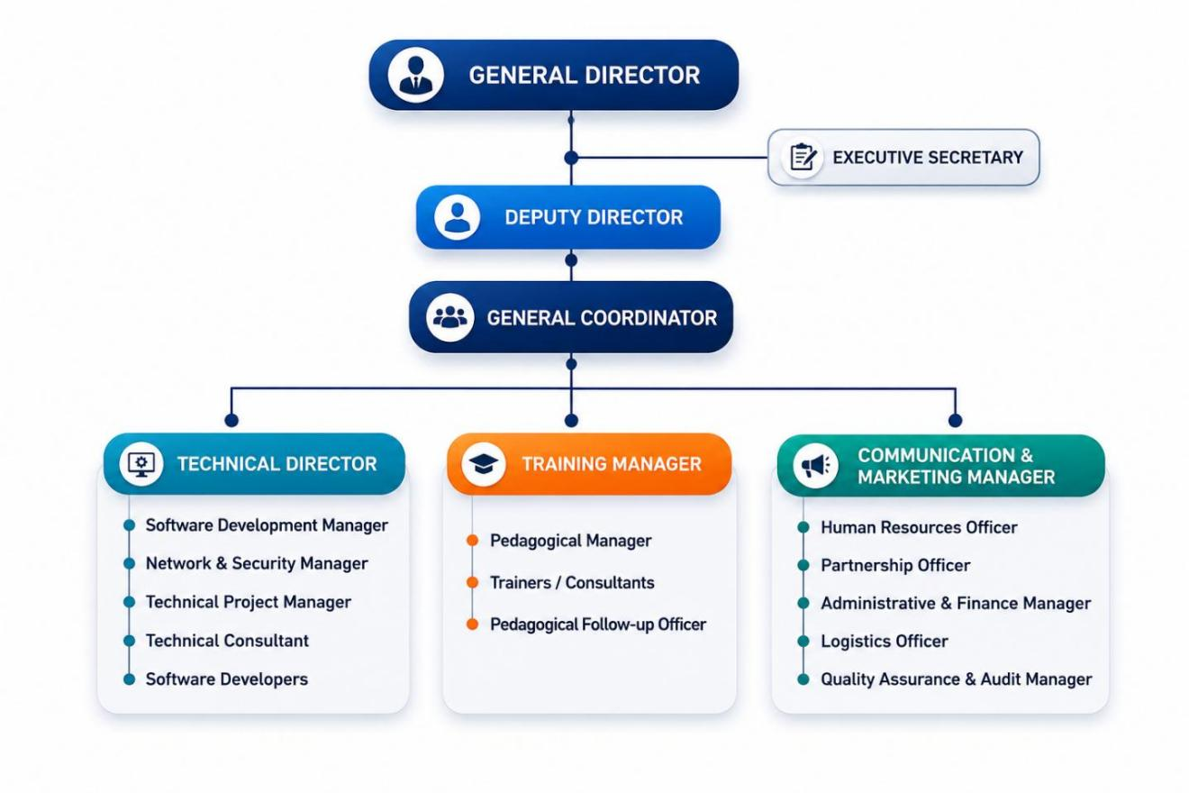
Figure 2: SoftInfra Tech Organization Chart. Source: SoftInfra Tech
6. Hardware and Software Resources
SoftInfra Tech has many equipment for its operation for a reliable, fast and efficient service.
a. Hardware Resources
Table 1: hardware resources of SoftInfra Tech
Quantités | Noms | Rôles
2 | Projecteurs NEC | Equipement utiliser pour présenter les notions d'apprentissage
1 | Equipement solaire | Pour une continuité de service même après coupure d'électricité
1 | Imprimante SAMSUNG | Est un équipement matériel informatique qui se charge de l'impression des documents
1 | Mac Book pro air 2017 Desktop | Terminal de travail
1 | Gameur MSI | Terminal de travail
1 | Ecran IIYAMA | Terminal de travail
3 | Modem (2 fybox, 1 fibre optique Camtel) | Pour la fourniture continue de connexion internet
1 | Serveur Synology | Appareil utilisé pour stocker les fichiers et gérer la base de données de l'entreprise
2 | Switch | Il permet de relier en réseau différents équipements informatiques entre eux, et contribue aussi à la sécurité du réseau d'entreprise
1 | Routeur | Est un équipement matériel informatique qui se charge de diriger et d'orienter le transit des données à travers un réseau
1 | Camera canon eds700d | Capturer
1 | Caméscope IR night vision | Surveillance
2 | Laptop Samsung | Terminal de travail
3 | Laptop HP | Terminal de travail
1 | Laptop Aser | Terminal de travail
1 | Laptop Toshiba | Terminal de travail
b. Software Resources
SoftInfra Tech has several tools that enable it to carry out its various daily tasks. Regarding software resources, the company also relies on the SCRUM methodology for project management.
Table 2: software resources of SoftInfra Tech
Name | Type | Function
Windows 11 License | License | Upgrade a Windows 10 Professional device to Windows 11 Professional
Google Cloud Storage | Storage | Use remote servers to store data such as files, business data, videos, or images
Ubuntu (versions 21, 22, 23) | Operating System | Distribute and modify the code that makes up this operating system
Odoo | Application | Create or duplicate articles and their hierarchy to share company knowledge and make it customizable internally
III. SOFTWARE ENGINEERING DEPARTMENT PRESENTATION
Under the authority of a Technical Director, the Software Engineering department analyzes information systems, develops applications, and conducts software testing. More specifically, the Software Engineering department's role includes:
- Designing and developing web, Android, and desktop applications;
- Designing data warehouses;
- Creating test scripts for software;
- Providing training on software design and development;
- Designing and developing technical specifications.
IV. PRESENTATION OF THE SYSTEMS AND COMPUTER NETWORKS DEPARTMENT
Under the authority of a Technical Director, the Systems and Networks department plays a key role in:
- Designing and implementing optimized network architectures (LAN, MAN, WAN);
- Setting up network services;
- Designing administration tools;
- Optimizing bandwidth;
- Deploying applications;
- Managing the company's network infrastructure.
V. BRIEF PRESENTATION OF THE PROJECT
The Police Criminal Record System for Cameroon is a computerized information system designed to replace the manual, paper-based processes currently used by Cameroon's national police (DGSN) to manage criminal records, suspect registrations, and wanted alerts. Following our integration into SoftInfra Tech's Software Engineering Department, this project was selected, among several ideas evaluated with our supervisors, as the official theme of our internship, on account of its relevance and technical feasibility within the two-week planning window.
The project aims to improve the accuracy, security, and accessibility of criminal record management while giving oversight bodies real-time visibility into system-wide activity. The proposed system incorporates features such as user authentication with role-based access control, suspect and case registration, criminal record verification against a national database, and a wanted alert workflow spanning request, judicial authorization, issuance, and resolution.
By digitizing criminal record management, the Police Criminal Record System is expected to contribute to improved investigative efficiency, stronger inter-agency coordination, and better-informed decision-making for the institution it is designed to serve.

CONCLUSION
The insertion phase of my internship at SoftInfra Tech was conducted in a friendly environment and allowed me to understand the importance of collaborative work and to confront the realities of the professional environment. It allowed me to understand the company's structure and mission, to become familiar with the Software Engineering Department, and to identify, alongside my supervisors, the project theme that would guide the remainder of this internship.
Throughout this phase, I received the necessary guidance and support from my supervisors and colleagues, which greatly facilitated my integration into the professional environment of SoftInfra Tech.
Overall, the insertion phase laid a solid foundation for the successful execution of my internship, and the chapters that follow present the technical work carried out on the Police Criminal Record System.

PART TWO TECHNICAL PHASE

FILE 1: THE EXISTING SYSYEM
FILE 2: THE SPECIFICATION BOOK
FILE 3: THE ANALYSES PHASE
FILE 4: REALIZATION PHASE
FILE 5: TEST OF FUNCTIONALITIES
FILE 6: USER GUIDE

FILE 1: EXISTING SYSTEM

CONTENT:

INTRIDUCTION
- PRESENTATION OF THEME
- STUDY OF THE EXISTING SYSTEM
- LIMITATION OF THE EXISTING SYSTEM
- PROBLEMATIC
- PROPOSED SOLUTION
CONCLUSION

INTRODUCTION
The management of criminal record is a critical function of any national police force. In Cameroon the directorate of General National Security (DGSN) is responsible for maintaining law and order, and for tracking criminal activities across the national territory. However, the current system managing suspect and case information still relies heavily on manual processes. This present the theme of our project, studies the existing system, identifies it limitation, states the problematic, and proposes and proposes a digital solution to modernize criminal record management at (DGNS)

- PRESENTATION OF THE THEME
Our project is titled : «Design and Implementation of a police criminal record system for Cameroon». The main objectives is to develop a centralized and secure web based platform that will allow the police officers, investigators,Gendamerie, Border police DGSN commander to register suspect, manage case files, issues national alert and generate report in real time. The system aim to replace paper files with a digital database to improve speed, accuracy and inter-agency collaboration.
- STUDY OF THE EXISTING SYSTEM
Currently at the DGSN criminal record are manage manually:
- Registration: Suspect information is recorded on a paper forms and stored in physical files at each police station.
- Case Files: Investigator maintain paper dossiers. Updates requires physical transfert of files between deparments.
- Search and verification: To check a suspects record, officers must call other stations or consult local registrations there is no central database.
- Alerts: Wanted notice are communicated via phones ,fax, or WhatsApp groups. No automated national alerts system existing
- Reporting: Statistics are compiled manually using Excel which is time consuming and prone to errors.

- Limitation of the Existing System
The current manual system present several major limitations:
- Data Duplication and Losses: The same suspect can be register multiple times papers files can be lost, damaged or misplaced.
- Slow Access to Information: verifying criminal record takes hours or days, slowing investigations.
- Lack of Interconnection: Police, Gendemerie and border police do not share common database
- No Real-time Alerts: suspect can cross border before WANTED notices reach the border post.
- Poor Security and trace-ability: No audit trail. Unauthorize access to paper is possible
- Inefficient Reporting: Generating national statistics is slow and often inaccurate.

FILE TWO: SPECIFICATION BOOK

CONTENT:
INTRODUCTION
- CONTEXT AND JUSTIFICATION
- OBJECTIVES OF THE PROJECT
- EXPRESSION OF NEED
- PROJECT PLANNING
- ESTIMATED COST OF THE PROJECT
- LIST OF PARTICIPANTS
- PROJECT CONSTRAINT
- DELIVERABLES
CONCLUSION
CONCLUSION

INTRODUCTION
This specification book (cahier des charges) formalizes the scope of the project introduced in the previous chapter. It sets out the justification for the project, its objectives, the needs it must satisfy, the planning followed to carry it out, the resources involved, and the expected deliverable. It serves as the reference against which the analysis, design, and implementation phases that follow are built and evaluated.

I. CONTEXT AND JUSTIFICATION
As presented in the study of the existing system, the DGSN currently manages criminal records manually: suspect information is recorded on paper forms, case dossiers are maintained physically, and verification requires officers to call other stations or consult local registers, since no central database exists. Wanted notices are relayed informally by phone, fax, or WhatsApp, and statistics are compiled by hand in Excel.
This manual process results in duplicated suspect records, slow access to information, a lack of interconnection between the Police, Gendarmerie, and Border Police, the absence of real-time national alerts, weak traceability, and unreliable reporting. These limitations directly affect the speed and reliability of criminal investigations and justify the need for a centralized, digital, and secure alternative. This project was therefore carried out individually, over the course of the internship, to design and implement such a system for the DGSN.

II. OBJECTIVES OF THE PROJECT
General objective: to design and implement a centralized, secure, web-based Police Criminal Record System that replaces the current manual process at the DGSN.
Specific objectives:
• Provide a secure authentication mechanism with role-based access control.
• Allow authorized officers to register suspects digitally, reducing duplication.
• Allow investigators to create and track case files linked to a suspect.
• Allow authorized commanders to issue national alerts visible in real time to all stations.
• Provide a fast search function to retrieve a suspect's criminal history.
• Generate statistical reports automatically instead of manually through Excel.
• Maintain an audit log of sensitive actions to ensure accountability and traceability.

III. EXPRESSION OF NEEDS
Based on the limitations identified in the existing system, the DGSN needs a single web-based platform built around the following core functions:
Need | Description
User Authentication | Secure login restricted to authorized personnel only.
Suspect Registration | Digital registration of suspects, replacing paper forms.
Case Tracking | Creation and follow-up of case files linked to suspects.
National Alerts | Real-time broadcast of wanted notices to all stations nationwide.
Search & Reporting | Fast record lookup and automatic generation of statistics.
Role-Based Access | Each user sees and does only what their role permits.
Audit Logs | A traceable history of every sensitive action performed in the system.

IV. PROJECT PLANNING
The project was carried out across the full internship period, from 15 July to 30 September 2026 (approximately 11 weeks), following the same phases presented in this report.
Phase | Activity | Duration
1 | Insertion phase (welcoming, discovery of SoftInfra Tech, environment) | 2 weeks
2 | Study of the existing system (theme, limitations) | 1 week
3 | Specification (this file — needs, planning, constraints) | 1 week
4 | Analysis phase (use cases, data dictionary) | 1.5 weeks
5 | Conception phase (architecture, database design) | 1.5 weeks
6 | Realisation phase (development of the system) | 3 weeks
7 | Testing of functionalities and finalization of documentation | 1 week

V. ESTIMATED COST OF THE PROJECT
The project reused the DGSN's existing infrastructure, so it did not require any additional capital expenditure in practice. For planning and budgeting purposes, however, the tables below give an indicative market-value estimate of the software, hardware, and human resources involved, as if they had to be acquired from scratch.

A. Software Resources
RESOURCES | DESIGNATION | USAGE | QUANTITY | UNIT COST (FCFA)
Software | Windows 10/11 | Workstation operating system | 1 | 60,000
Software | MySQL Community Edition | Database management (DBMS) | 1 | 0 (open-source)
Software | Visual Studio Code | Development environment | 1 | 0 (open-source)
Software | Antivirus Suite | System and data protection | 1 | 15,000
Software | Microsoft Office Suite | Documentation and reporting | 1 | 45,000
Software | Google Chrome / Microsoft Edge | Web browsing and testing | 1 | 0 (free)
TOTAL |  |  | 6 | 120,000

B. Hardware Resources
RESOURCES | DESIGNATION | USAGE | QUANTITY | UNIT COST (FCFA)
Hardware | Laptop Computer | Portable development machine | 1 | 300,000
Hardware | Server | Application and database hosting | 1 | 0 (existing DGSN server)
Hardware | Network Switch/Router | LAN connectivity | 1 | 0 (existing DGSN network)
Hardware | UPS (Uninterruptible Power Supply) | Backup power during outages | 1 | 40,000
Hardware | Multifunction Printer/Scanner | Document handling | 1 | 100,000
Hardware | USB HP 2.2 Flash Drive V22W - 8GB | Data transfer and backup storage | 1 | 5,200
TOTAL |  |  | 6 | 445,200

C. Human Resources
RESOURCES | DESIGNATION | USAGE | QUANTITY | UNIT COST (FCFA)
Human Resources | Bassong Pierre Dorian (Intern) | Analysis, design, development, testing | 1 | 0 (internship)
Human Resources | Mr. Libog Roger (Professional Supervisor) | On-site technical supervision | 1 | 0 (DGSN staff duty)
Human Resources | Mme Augene Vanessa (Academic Supervisor) | Academic supervision and follow-up | 1 | 0 (AICS staff duty)
TOTAL |  |  | 3 | 0

D. Global Estimation
CATEGORY | ESTIMATED TOTAL COST (FCFA)
Software Resources | 120,000
Hardware Resources | 445,200
Human Resources | 0
GRAND TOTAL | 565,200

VI. LIST OF PARTICIPANTS
Name | Role
Bassong Pierre Dorian | Intern — Analysis, design, development, and testing of the system
Mr. Libog Roger | Professional Supervisor — Guidance on-site at the DGSN throughout the internship
Mme Augene Vanessa | Academic Supervisor — Academic guidance and follow-up on behalf of AICS
Bassong Debora Leslie | Advisor
Bikai James Pascal | Sponsor — Provided financial and material support for the project

VII. PROJECT CONSTRAINTS
• Time constraint: the entire project had to be completed within the internship period (15 July – 30 September 2026), leaving limited time for each phase.
• Access constraint: as an intern, direct modification of DGSN's live production systems was not permitted; development and testing were carried out in a separate environment.
• Infrastructure constraint: the system had to work with the hardware and network already available at DITT, without requesting additional equipment.
• Confidentiality constraint: real suspect and case data could not be used for testing, for security and privacy reasons; sample/test data was used instead.
• Connectivity constraint: the solution needed to remain usable across DGSN's 10 regional delegations, which do not all have the same quality of network connectivity.

VIII. DELIVERABLES
• A functional web-based Police Criminal Record System covering authentication, suspect registration, case tracking, national alerts, search, reporting, and audit logging.
• The technical documentation of the system (specification, analysis, conception, and testing records).
• A user guide explaining how each role uses the system.
• This internship report.

CONCLUSION
This specification book fixes the scope, objectives, and boundaries of the Police Criminal Record System project. It confirms that the project responds directly to the limitations identified in the study of the existing system, and it sets the baseline — in terms of needs, planning, and constraints — against which the analysis and design choices presented in the next chapters are made.

FILE 3 ANALYSES AND DESIGN PHASE

CONTENT:
INTRODUCTION
- METHODOLOGY
- COMPARATIVE STUDY BETWEEN MERIS AND UML
- PRESENTATION OF THE 2TUP
- CHARACTERISTICS OF THE 2TUP
- JUSTIFICATION OF HE CHOICE OF THE ANALYSIS
- MODELING
- USE CASE DIAGRAM
- COMMUNICATION DIAGRAM
- SEQUENCE DIAGRAM
- ACTIVITY DIAGRAM
CONCLUSION

INTRODUCTION
Following the specification book, which defined the scope, objectives, and requirements of the Police Criminal Record System, this file addresses the analysis and design phase of the project. Its purpose is to translate the expressed needs into a structured technical model that will guide the implementation of the system.
This file presents the methodology adopted for the analysis, identifies the actors interacting with the system, and models their interactions through use case and sequence diagrams. It further details the static structure of the system through a class diagram, defines the database design, and presents the overall system architecture along with the technology stack selected for implementation. Together, these elements constitute the technical blueprint upon which the Police Criminal Record System will be built.

I. METHODOLOGY
The analysis document that adheres to a specific method for the project explains the rationale behind this choice. All of the elements presented in this document contribute to a clearer understanding of the information system being modeled, offering a structured view of the issue and the proposed solution, supported by diagrams.
Choosing an appropriate methodology is a critical step in the analysis and design phase, as it determines how the system's requirements, structure, and behavior will be captured and represented. Two methodologies were considered for this project: MERISE and UML, presented and compared below.

a. Comparative Study Between MERISE and UML
Before selecting an analysis approach for the Police Criminal Record System, two major methodologies were considered: MERISE and UML.
MERISE is a systems analysis and design method developed in France in the 1970s, structured around a strict separation of data and processing, modeled respectively through the Conceptual Data Model (CDM) and the Conceptual Processing Model (CPM). It follows a sequential, top-down life cycle and is well suited to information systems with a strong data-processing orientation, but it offers limited support for object-oriented design and for modeling dynamic, interactive behavior.
UML (Unified Modeling Language), on the other hand, is an object-oriented modeling language that unifies the representation of a system's structure and behavior through a coherent set of diagrams (use case, class, sequence, activity, among others). It supports iterative and incremental development, facilitates the modeling of complex interactions between actors and the system, and is the de facto standard in modern software engineering, particularly for web-based and object-oriented systems.

The table below summarizes the main differences between the two approaches:
Criteria | MERISE | UML
Origin | France, 1970s | Object Management Group (OMG)
Paradigm | Structured / data-oriented | Object-oriented
Data and processing | Modeled separately | Modeled together (classes)
Diagrams | CDM, CPM, MCT, etc. | Use Case, Class, Sequence, Activity, etc.
Development approach | Sequential | Iterative and incremental
Suitability for web systems | Limited | Well suited

Given the object-oriented nature of the Police Criminal Record System and the need to model interactions between multiple actors (administrators, officers, judicial authorities) and system behavior in detail, UML was retained as the modeling language for this project.

b. Presentation of the 2TUP
Having retained UML as the modeling language, a specific development process was needed to organize how the models would be produced and articulated throughout the project. The 2TUP (Two Track Unified Process) was selected for this purpose.
The 2TUP is a variant of the Unified Process (UP) proposed by Valtech, designed to address the frequent and continuous changes affecting information systems, whether they originate from evolving functional requirements or from changes in technical environments (networks, hardware, operating systems, standards). To manage these two types of constraints independently before merging them, the 2TUP is structured according to a "Y" shape, built around three branches:

• The functional branch, which captures, analyzes, and models the business requirements of the system independently of any technical consideration. This branch produces the use case, sequence, and activity diagrams;
• The technical branch, which captures and models the technical constraints and choices of the target environment (architecture, development tools, technology stack), independently of the business logic;
• The realization branch, which merges the results of the functional and technical branches to produce the actual system design (class diagram, database design, and overall architecture), leading to the coding, testing, and delivery of the system.
This dual-track structure allows functional and technical work to progress in parallel, reducing the impact of changes in either dimension on the overall project and resulting in a system design that is both aligned with user needs and adapted to the technical environment.

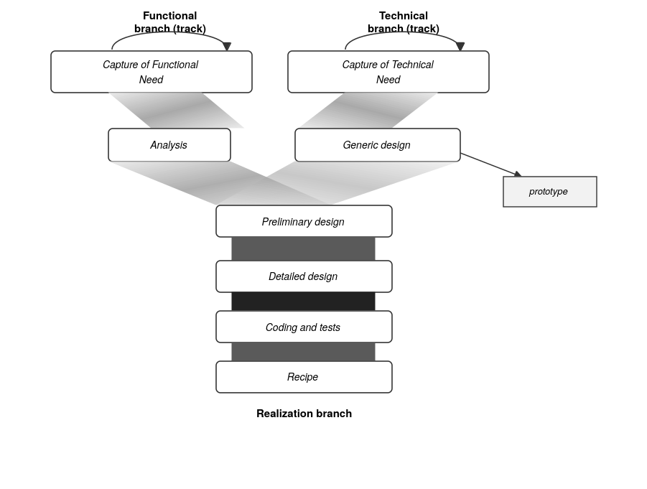
Figure 3: The "Y" shape of the 2TUP development process

c. Characteristics of the 2TUP
As a variant of the Unified Process, the 2TUP inherits and reinforces several key characteristics that shaped how the Police Criminal Record System was analyzed and designed:
• Use-case driven: the development process is guided by the use cases, which express the functional needs of the actors and serve as the thread running through the entire analysis, from requirements capture to testing;
• Architecture-centrist: technical constraints are treated as first-class citizens from the earliest stages, ensuring that the system's architecture is defined in parallel with, and not merely after, the functional requirements;

• Iterative and incremental: the system is built through successive iterations, each producing a more refined and complete version of the models and, eventually, of the system itself, allowing requirements to be adjusted as understanding deepens;
• Risk-driven: by separating the functional and technical branches, the 2TUP allows risks specific to each dimension (e.g., misunderstood business rules on one side, unsuitable technology choices on the other) to be identified and addressed early and independently;
• Component-based: the resulting system is structured into reusable, loosely coupled components, facilitating maintenance and future evolution of the system;
• Trace-ability: each artifact produced (use cases, diagrams, code) can be traced back to the requirement that motivated it, ensuring that the final system remains aligned with the initial needs expressed in the specification book.
These characteristics make the 2TUP particularly well suited to a project such as the Police Criminal Record System, where both the functional requirements (roles, workflows, data confidentiality) and the technical environment (limited infrastructure, network constraints across DGSN's regional and local services) needed to be addressed with equal rigor.

d. Justification of the Choice of the Analysis
The choice of UML combined with the 2TUP process for the analysis and design of the Police Criminal Record System is justified by several factors specific to the context of this project.
First, the system involves multiple actors with distinct roles and responsibilities (administrators, police officers, judicial authorities, and other DGSN personnel), whose interactions with the system are best captured through use case and sequence diagrams rather than the more data-centric models offered by MERISE.
Second, the project had to reconcile functional requirements, expressed through interviews and the specification book, with technical constraints inherent to the DGSN's environment, notably limited infrastructure and uneven connectivity across regional and local services. The 2TUP's separation of the functional and technical branches allowed these two dimensions to be

addressed independently before being merged into a coherent design, reducing the risk of a solution that is functionally sound but technically unrealistic, or vice versa.
Third, given the internship's limited time frame, an iterative and incremental approach allowed the models to be progressively refined as understanding of the DGSN's processes deepened, rather than requiring a complete and definitive specification from the outset.
For these reasons, the combination of UML and the 2TUP was retained as the most appropriate approach for the analysis and design of the system, providing both the expressive power needed to model complex actor interactions and the flexibility needed to accommodate the project's technical and organizational constraints.

II. MODELING

a. USE CASE DIAGRAM
i. Definition
A use case diagram is a UML behavioral diagram that represents the functional requirements of a system from the perspective of its users. It describes the interactions between the actors and the system by showing which functionalities (use cases) each actor can access, without detailing how these functionalities are internally implemented.
ii. Formalism
The formalism of a use case diagram relies on a small set of standard notations, illustrated below:
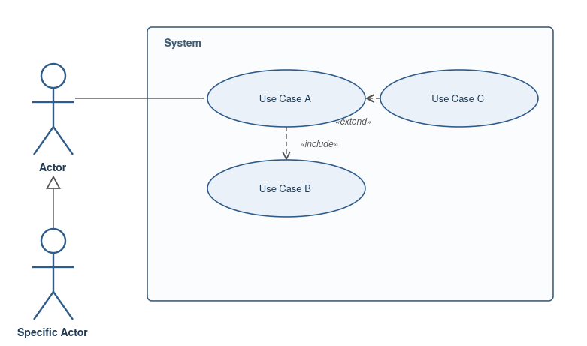
Figure 4: Formalism of a UML use case diagram

iii. Components of Use Case Diagram
The table below summarizes each element of the use case diagram notation, its graphical representation, and its meaning:
Element | Notation | Description
Actors | 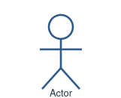 | Represents an entity (a person, an external system, or a device) that directly interacts with the system. The actor is what performs the different possible actions of the system.
Use Case | 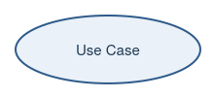 | A use case represents a functionality of the system. It is an action that can be performed by an actor.
Association | 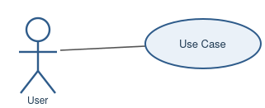 | Indicates that an actor takes part in a use case.
Include | 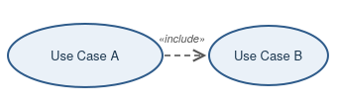 | An inclusion denotes that an included action must be performed before the including action can be performed.
Extend | 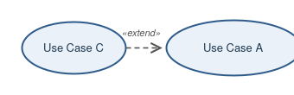 | An extension denotes that an extending action may be performed while an extended action is being performed.
Generalization | 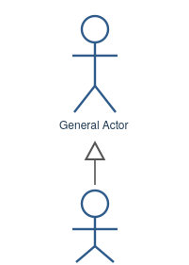 | Shows that an actor or a use case is a kind of another, more abstract or concrete actor/use case, which can be defined and later specialized using a generalization relationship.
System | 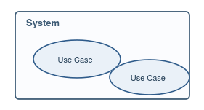 | A container of use cases which interact with external actors.

iv. Actors of Our System
The actors identified for the Police Criminal Record System are classified into primary actors, who directly initiate the main use cases of the system, and secondary actors, who support the system's operation without initiating its core functionalities.
Primary Actors
Actor | Role
Administrative Officer | Manages user accounts and access permissions within the system, and consults audit logs to ensure the proper functioning and security of the platform.
Police Officer | The main operational user of the system. Registers new cases and persons of interest, requests and searches wanted alerts, verifies persons against active alerts, and requests or verifies criminal records.
Judicial Authority | Reviews case and suspect information submitted by police officers and validates or authorizes wanted alerts before they are issued and distributed.
General Inspectorate | Acts in an oversight capacity, generating reports, monitoring system activity, and reviewing requests and audit logs to ensure compliance with internal DGSN procedures.

Secondary Actors
Actor | Role
External Criminal Records Database | This external system is solicited to verify criminal records against an authoritative external source, ensuring that the information held by the system remains accurate and up to date.

v. General Use Case Diagram
The diagram below presents the complete use case model of the Police Criminal Record System. Use cases are grouped by functional area Administration, Police Operations, Wanted Person & Alert Management, Monitoring & Reporting, and Judicial Validation and involve five actors:
• Administrative Officer: manages user accounts and access permissions, and consults audit logs to ensure the proper functioning and security of the system;
• Police Officer: handles the operational core of the system registering cases and persons of interest, requesting and searching wanted alerts, and consulting or requesting criminal records;
• Judicial Authority: reviews case and suspect information and validates or authorizes wanted alerts before they are issued;
• General Inspectorate: acting in an oversight capacity, generates reports, monitors system activity, and reviews requests and audit logs;
• External Criminal Records Database: modeled as an external system, is solicited to verify criminal records during the verification process.
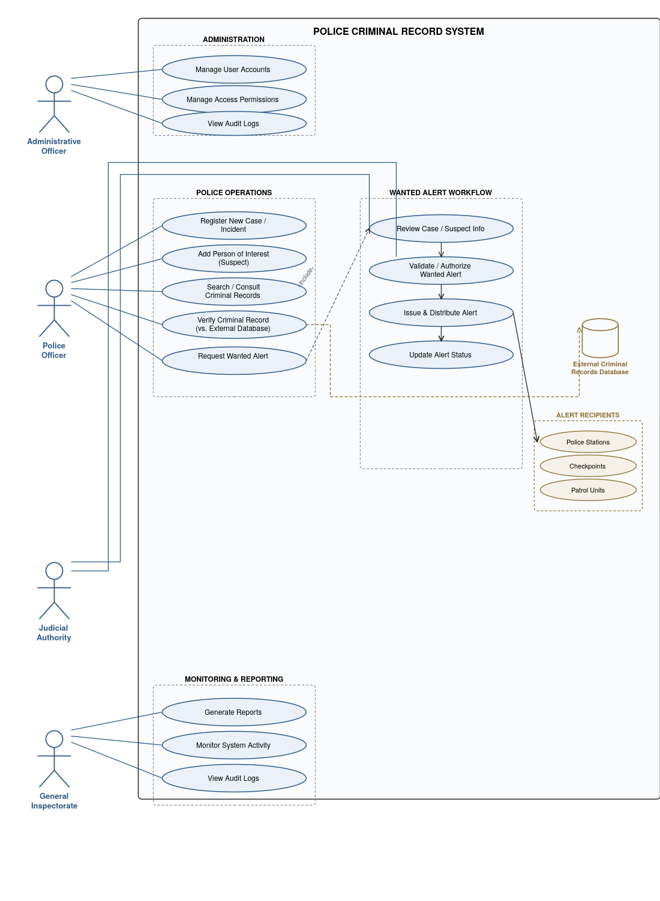
Figure 5: Global use case diagram of the Police Criminal Record System
vi. Specific Use Case Diagrams
For readability, the «include» and «extend» relationships attached to the three most complex use cases are detailed separately below, each in its own focused diagram.
Specific Use Case Diagram: Register New Case / Incident
Registering a new case or incident may optionally extend into the registration of a wanted person directly from that case, and always includes a review of the case and suspect information by the Judicial Authority.
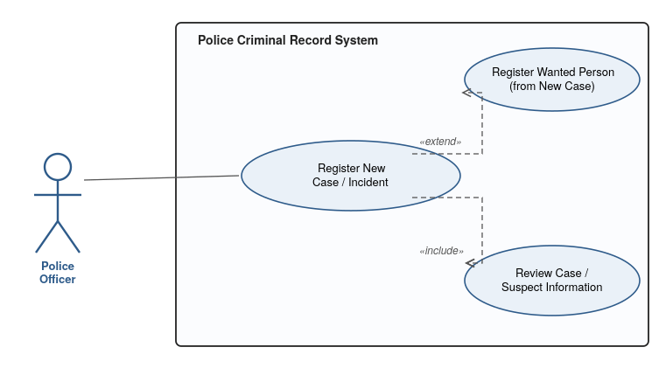
Figure 6: Specific use case diagram for Register New Case / Incident

Specific Use Case Diagram: Verify Criminal Record
Verifying a criminal record always includes a cross-check against the External Criminal Records Database, ensuring that the information held by the system remains accurate and up to date.
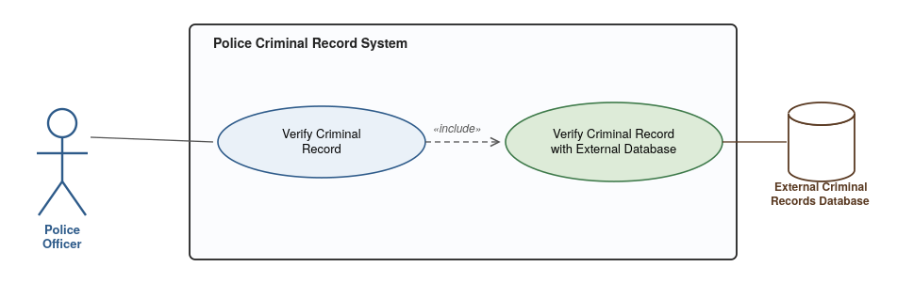
Figure 7: Specific use case diagram for Verify Criminal Record

Specific Use Case Diagram: Validate / Authorize Wanted Alert
Validating or authorizing a wanted alert always includes updating the alert's status and reviewing the underlying case and suspect information submitted by the Police Officer.
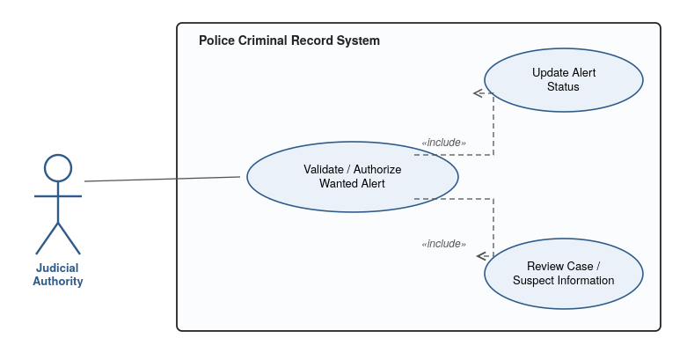
Figure 8: Specific use case diagram for Validate / Authorize Wanted Alert

vii. Textual Description of Use Cases
This section details the internal logic of the system's key use cases through structured textual descriptions, specifying for each one its actors, preconditions, triggering event, nominal and alternative scenarios, and outcomes.
USE CASE: AUTHENTICATE
Summary | Permit an authorized user to access the system.
Actors | Administrative Officer, Police Officer, Judicial Authority, General Inspectorate.
Pre-condition(s) | 1. The actor already has an account;  2. The system is accessible;  3. The account is active.
Trigger | The user clicks on the “Login” button.
Nominal scenario | 1. The user clicks on the login button;  2. The system displays the login page;  3. The user fills in their credentials (username and password) and submits;  4. The system checks the conformity of the submitted data;  5. The system sends a verification query to the database;  6. The system processes the result returned by the database;  7. The user is redirected to their role-specific dashboard.
Alternative scenario | 8. If in step 4 the format is incorrect, an error message is returned to the user, who returns to step 3;  9. If in step 6 no matching account is found, the system displays an error message and the user returns to step 3.
Post-condition of success | The user is authenticated and granted access to the system according to their role.
Post-condition of failure | An error message is displayed and the user does not gain access to the system.
USE CASE: REGISTER NEW CASE / INCIDENT
Summary | Permit a Police Officer to register a new criminal case or incident in the system.
Actors | Police Officer.
Pre-condition(s) | 1. The Police Officer is authenticated;  2. The Police Officer has the necessary permissions to register a case.
Trigger | The Police Officer clicks on the “Register New Case” button.
Nominal scenario | 1. The Police Officer clicks on the “Register New Case” button;  2. The system displays the case registration form;  3. The Police Officer fills in the case details (nature, date, location, description) and submits;  4. The system checks the conformity of the submitted data;  5. The system saves the new case record;  6. The system displays a confirmation message and assigns a unique case reference number.
Alternative scenario | 7. If in step 4 the submitted data is incomplete or invalid, an error message is returned to the Police Officer, who returns to step 3;  8. The Police Officer may optionally extend this scenario by registering a wanted person directly from the newly created case.
Post-condition of success | The new case is saved in the system with a unique reference number, and is available for further actions such as adding persons of interest or requesting a wanted alert.
Post-condition of failure | No case record is created, and an error message is displayed to the Police Officer.

USE CASE: VERIFY CRIMINAL RECORD
Summary | Permit a Police Officer to verify a criminal record, cross-checked against the External Criminal Records Database.
Actors | Police Officer, External Criminal Records Database.
Pre-condition(s) | 1. The Police Officer is authenticated;  2. The criminal record to be verified exists in the system.
Trigger | The Police Officer clicks on the “Verify Record” button for a given criminal record.
Nominal scenario | 1. The Police Officer selects a criminal record and clicks on the “Verify Record” button;  2. The system retrieves the record's identifying details;  3. The system sends a verification query to the External Criminal Records Database;  4. The External Criminal Records Database processes the query and returns a response;  5. The system compares the returned data with the local record;  6. The system displays the verification result to the Police Officer.
Alternative scenario | 7. If the External Criminal Records Database is unreachable, the system displays an error message and invites the Police Officer to retry later;  8. If the returned data conflicts with the local record, the system flags the record for review instead of confirming it as verified.
Post-condition of success | The criminal record is marked as verified, with a time-stamp and reference to the external cross-check.
Post-condition of failure | The record remains unverified, and an error or discrepancy message is displayed to the Police Officer.

b. COMMUNICATION DIAGRAM
i. Definition
A communication diagram is a UML interaction diagram that models the exchanges between the participants (objects and actors) involved in realizing a given operation of the system. Unlike the sequence diagram, which emphasizes the chronological ordering of messages along a timeline, the communication diagram emphasizes the structural links between participants, while still capturing the chronological order of the exchanged messages through sequence numbering. It therefore shows both the static organization of the participants and the dynamic succession of the actions performed by an actor to realize an operation.

ii. Formalism
The formalism of a communication diagram relies on a small set of standard notations, illustrated below:
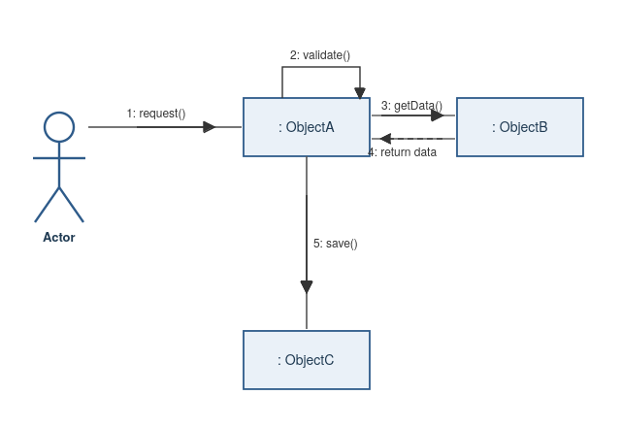
Figure 9: Formalism of a UML communication diagram
iii. Components of Communication Diagram
The table below summarizes each element of the communication diagram notation, its graphical representation, and its meaning:
Element | Notation | Description
Actor |  | Represents a role played by a person, an external system, or a device that initiates or participates in the interaction, in the same way as in a use case diagram.
Object / Participant | 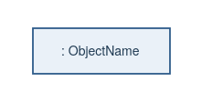 | Represents an instance of a class involved in the interaction. It is depicted as a rectangle labeled with the object's name preceded by a colon (e.g., ": ObjectName").
Link | 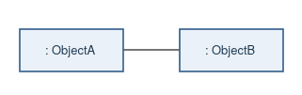 | A plain line connecting two participants (objects or actors), indicating that they can exchange messages during the interaction.
Message | 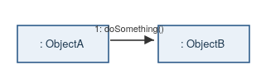 | A labeled arrow placed along a link, representing a call from one participant to another. It is prefixed with a sequence number indicating its chronological order (e.g., "1: doSomething()").
Return Message | 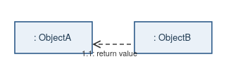 | A dashed arrow representing the value or result sent back by the called participant once a message has been processed.
Self-Message | 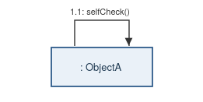 | A message that a participant sends to itself, typically representing an internal operation, shown as a looping arrow attached to the same object.

iv. Communication Diagram of the Authenticate Operation
Following the recommended approach for drawing a communication diagram, the participants (the User actor, the Login-form, the Authentication Controller, and the User Account) are first laid out and connected through links reflecting their structural relationships. The messages exchanged between them are then numbered in their chronological order and placed directly on the corresponding links, with return messages shown as dashed arrows immediately following the call they respond to.
The diagram below illustrates how the Authenticate operation, described textually in Section vii, is realized through the collaboration of three participants: the User, the System, and the DBMS. To keep the diagram readable, the System's internal processing steps are grouped into a single self-message annotation rather than being drawn as separate loops.
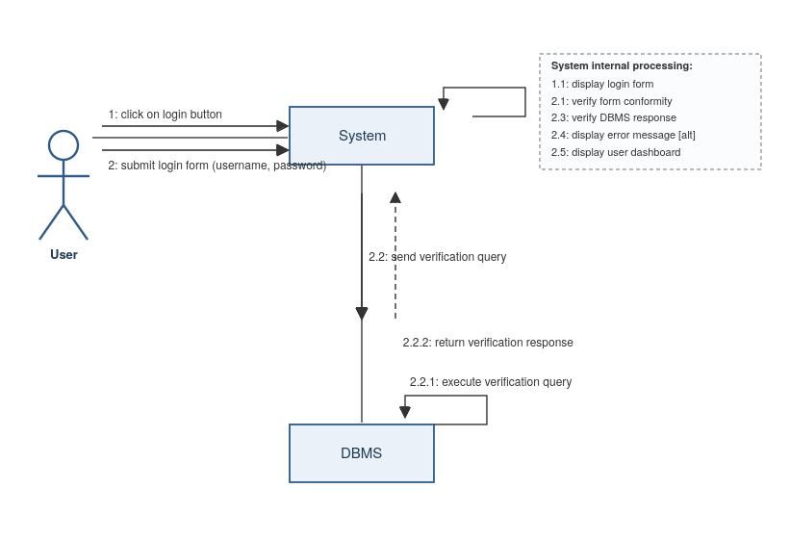
Figure 10: Communication diagram of the Authenticate operation
The User first clicks on the login button (message 1) and then submits the login form with their credentials (message 2). The System internally displays the login form, verifies the conformity of the submitted data, and sends a verification query to the DBMS (message 2.2). The DBMS executes the query (message 2.2.1) and returns the verification response (message 2.2.2). The System then verifies this response and, depending on the outcome, either displays an error message or the user's role-specific dashboard.

c. SEQUENCE DIAGRAM
i. Definition
A sequence diagram is a UML interaction diagram that represents the exchanges between participants (objects and actors) involved in realizing a given operation of the system, emphasizing the chronological ordering of messages along a timeline. Unlike the communication diagram, which highlights the structural links between participants, the sequence diagram makes the temporal sequence of interactions explicit by arranging participants along the top of the diagram and representing the passage of time as a vertical axis, with messages drawn as horizontal arrows positioned according to when they occur.
ii. Formalism
The formalism of a sequence diagram relies on a small set of standard notations, illustrated below:
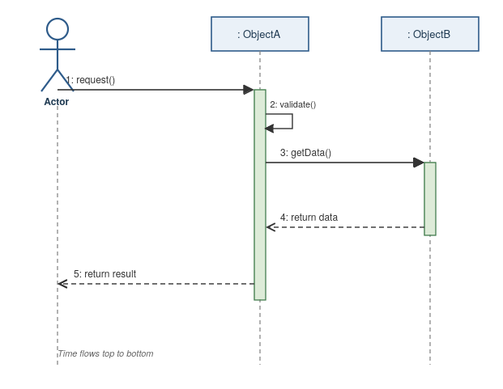
Figure 11: Formalism of a UML sequence diagram
iii. Components of Sequence Diagram
The table below summarizes each element of the sequence diagram notation, its graphical representation, and its meaning:
Element | Notation | Description
Actor |  | Represents a role played by a person, an external system, or a device that initiates or participates in the interaction, positioned at the top of the diagram like any other participant.
Lifeline | 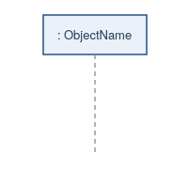 | A dashed vertical line extending downward from a participant, representing its existence and availability over the course of the interaction. Time flows from top to bottom along the lifeline.
Activation Bar | 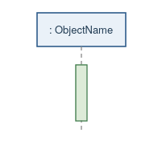 | A thin rectangle placed on a lifeline, indicating the period during which a participant is actively processing a message (executing an operation).
Synchronous Message | 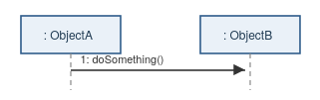 | A solid arrow with a filled arrowhead, representing a call from one participant to another. It is prefixed with a sequence number indicating its chronological order (e.g., "1: doSomething()").
Return Message | 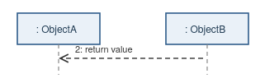 | A dashed arrow with an open arrowhead, representing the value or result sent back once a message has been processed, drawn from the end of the corresponding activation bar.
Self-Message | 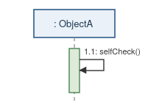 | A message that a participant sends to itself, typically representing an internal operation, shown as a small looping arrow attached to its own lifeline and activation bar.

iv. Sequence Diagram of the Authenticate Operation
The sequence diagram below models the same Authenticate operation previously described through its communication diagram, this time emphasizing the chronological ordering of messages along the User, Login-form, Authentication Controller, and DBMS lifelines:
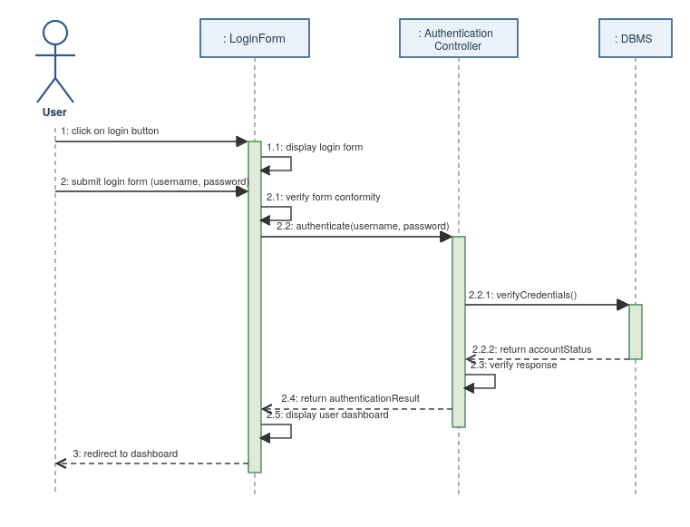
Figure 12: Sequence diagram of the Authenticate operation
After the User clicks on the login button and submits the form, the Login-form verifies the conformity of the submitted data before forwarding the credentials to the Authentication Controller (message 2.2). The controller queries the DBMS to verify the credentials (message 2.2.1) and, once it receives the account status in return (message 2.2.2), verifies the response before returning the authentication result to the Login-form (message 2.4). The Login-form then displays the user's dashboard and redirects the User accordingly.
v. Sequence Diagram of the Validate / Authorize Wanted Alert Operation
The sequence diagram below models the message-level realization of the Validate / Authorize Wanted Alert operation, in which a Judicial Authority reviews a pending alert and decides whether to authorize or reject it:
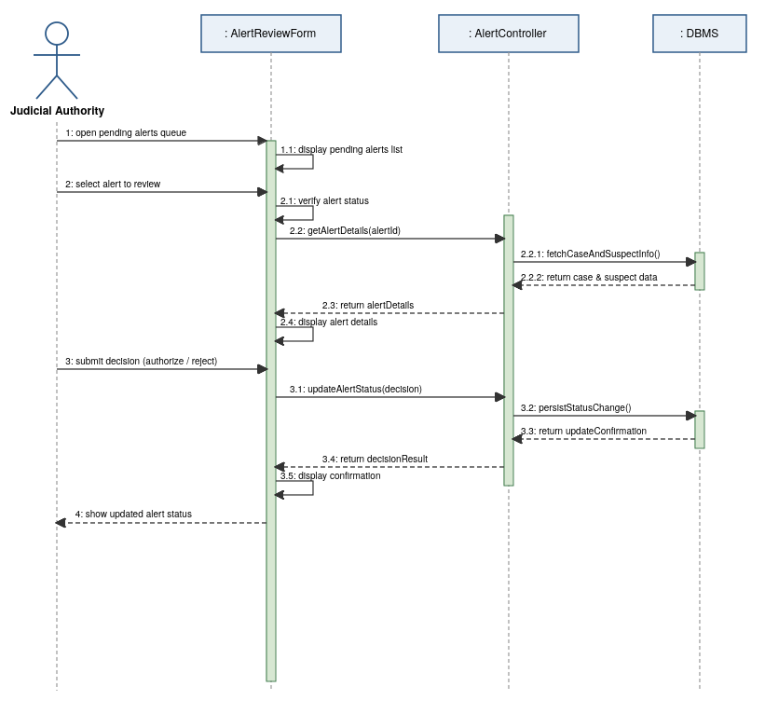
Figure 13: Sequence diagram of the Validate / Authorize Wanted Alert operation
After opening the pending alerts queue and selecting an alert to review, the Judicial Authority is shown the case and suspect information retrieved from the DBMS through the AlertController. Once a decision is submitted, the AlertReviewForm forwards it to the AlertController, which persists the new status in the DBMS and returns a confirmation that is displayed back to the Judicial Authority.

d. ACTIVITY DIAGRAM
i. Definition
An activity diagram is a UML behavioral diagram that models the flow of control or data through a process, describing the sequence of actions performed to achieve a particular goal. Unlike interaction diagrams (communication and sequence diagrams), which focus on the exchanges between individual participants, the activity diagram emphasizes the overall logic of a process, including decision points, parallel flows, and the conditions under which the process branches, loops, or terminates.

ii. Formalism
The formalism of an activity diagram relies on a small set of standard notations, illustrated below:
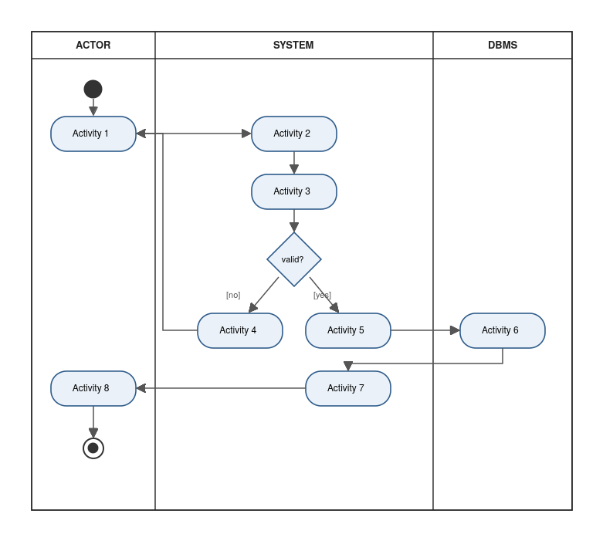
Figure 14: Formalism of a UML activity diagram

iii. Components of Activity Diagram
The table below summarizes each element of the activity diagram notation, its graphical representation, and its meaning:
Element | Notation | Description
Initial Node |  | A filled circle marking the starting point of the activity flow. Every activity diagram begins with exactly one initial node.
Final Node |  | A filled circle surrounded by a ring, marking the end of the activity flow. A diagram may have one or more final nodes, reached whenever a flow of execution completes.
Activity / Action | 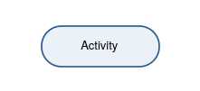 | A rounded rectangle representing a single step or task performed within the process.
Decision / Merge Node |  | A diamond shape. As a decision node, it splits the flow into alternative branches based on guard conditions (e.g., [yes] / [no]). As a merge node, it recombines alternative branches back into a single flow.
Fork / Join | 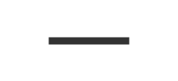 | A solid black bar. As a fork, it splits a single flow into multiple concurrent flows. As a join, it synchronizes multiple concurrent flows back into a single flow before continuing.
Swimlane | 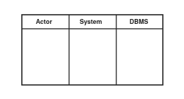 | A vertical (or horizontal) partition that groups activities according to the participant responsible for performing them, clarifying which actor or component carries out each step.

iv. Activity Diagram of the Authenticate Operation
Unlike the communication and sequence diagrams, which focus on the message-level realization of the Authenticate operation, the activity diagram below models its overall logic as a process, organized into three swim-lanes (User, System, DBMS) and including both the nominal scenario and the two alternative (error) scenarios described textually in Section vii:
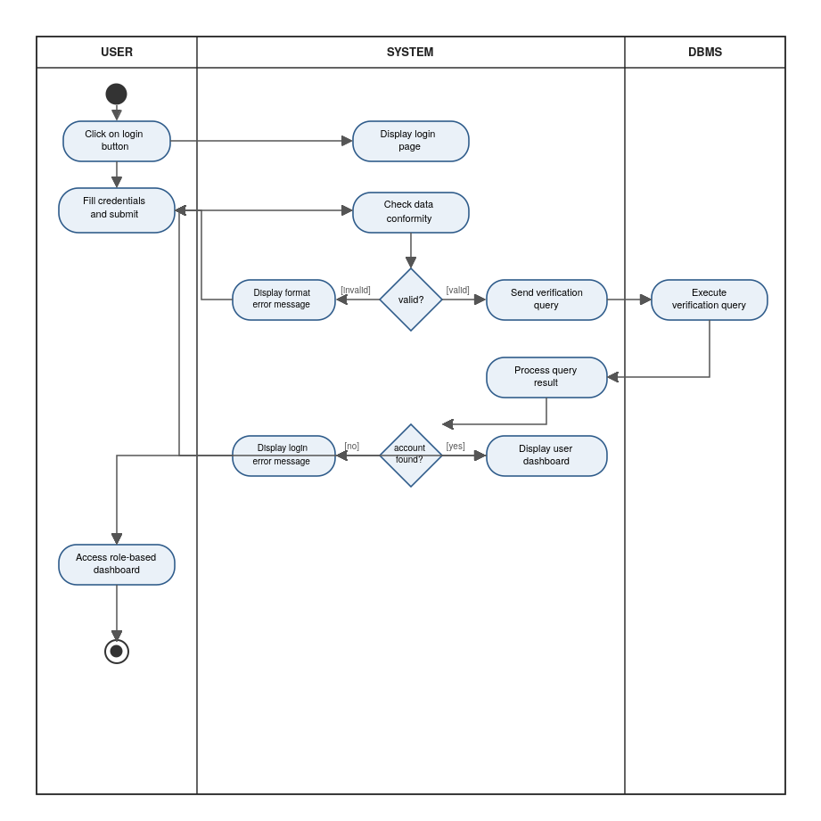
Figure 15: Activity diagram of the Authenticate operation

After the User submits their credentials, the System checks the conformity of the submitted data. If the format is invalid, an error message is displayed and the User is prompted to resubmit the form. Otherwise, the System queries the DBMS to verify the credentials. If no matching account is found, a login error message is displayed and the User again returns to the credentials form; otherwise, the System displays the User's dashboard and grants access accordingly.
v. Activity Diagram of the Validate / Authorize Wanted Alert Operation
The activity diagram below models the overall process logic of the Validate / Authorize Wanted Alert operation, organized into three swim-lanes (Judicial Authority, System, DBMS), including both the nominal authorization path and the rejection path:
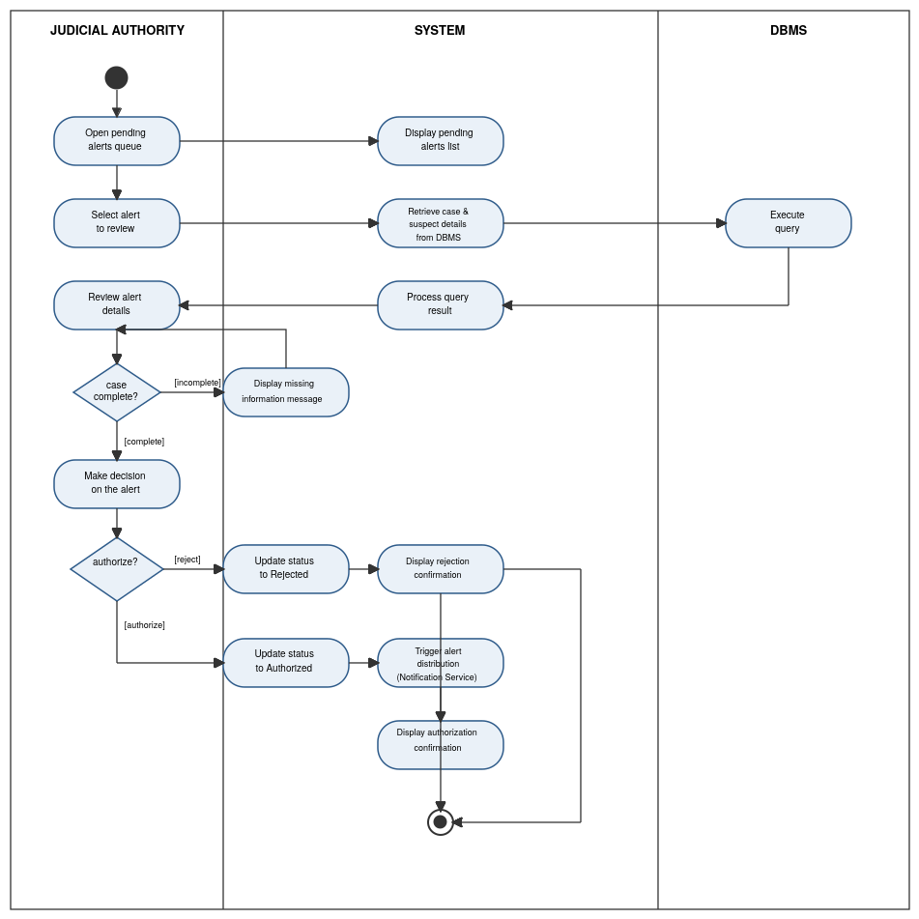
Figure 16: Activity diagram of the Validate / Authorize Wanted Alert operation
After reviewing the case and suspect information retrieved from the DBMS, the Judicial Authority makes a decision on the alert. If the underlying case information is incomplete, the System prompts for the missing information before the review can proceed. Once a decision is made, the System updates the alert's status accordingly: an authorized alert triggers distribution through the Notification Service, matching the transition rules defined in the state diagram, while a rejected alert simply concludes the review.

FILE FOUR. CONCEPTUAL PHASE

CONTENT:

INTRODUCTION
- CAPTURE OF TECHNICAL NEED
- CLASS DIAGRAM
- STATE DIAGRAM
- PACKAGE DIAGRAM
- DATABASE DESIGN
- SYSTEM ARCHITECTURE
CONCLUSION

INTRODUCTION
Following the analysis phase, which modeled the system's functional requirements and dynamic behavior through use case, communication, sequence, and activity diagrams, this file addresses the conception phase of the project. Its purpose is to define the static structure of the system that will support the interactions previously modeled.
This file presents the class diagram, which formalizes the system's classes, attributes, and relationships; the database design, which translates this class diagram into a relational schema; and the overall system architecture, which describes how the different components of the system are organized and how they communicate with one another.

I. Capture of Technical Needs
Just as the functional branch of the 2TUP process captured the actors' expectations of the system, the technical branch requires that the technical environment and constraints be identified before any architectural or design decision is made. This section presents the hardware, software, network, and security requirements that the Police Criminal Record System must satisfy, based on the environment observed at the DGSN during the insertion phase and the constraints already identified in the specification book.

1. Physical Architecture
The physical architecture describes how the hardware components of the system are deployed and connected across the DGSN's sites. It follows a client-server model: client workstations at the various directorates, regional delegations, and local police units connect over the DGSN network to a central application server and database server.
• Server infrastructure: a server (physical or virtualized) capable of hosting the web application, the database management system, and handling concurrent connections from multiple DGSN regional and local units.
• Client workstations: standard desktop or laptop computers, already available at the DGSN's directorates and regional delegations, equipped with a modern web browser and a stable network connection.
• Network equipment: routers and switches capable of supporting the connectivity required between the central server and the various regional and local police services.
• Network and connectivity constraints: as identified in the specification book, the solution must remain usable across DGSN sites with uneven connectivity, tolerating latency and minimizing bandwidth-intensive operations wherever possible.
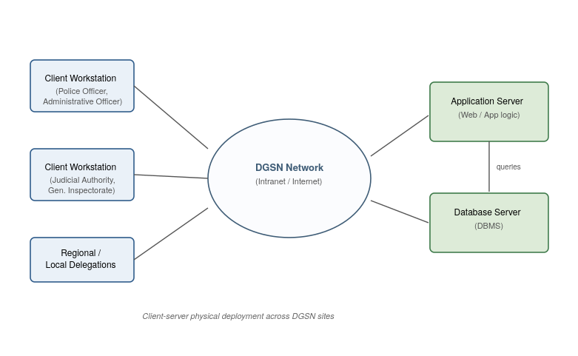
Figure 17: Physical architecture of the Police Criminal Record System

2. Logical Architecture
The logical architecture describes how the system's software is organized independently of its physical deployment. The system follows a layered (three-tier) architecture, separating the presentation, business logic, and data concerns to improve maintainability, security, and scalability.
• Presentation Layer: provides the user interfaces through which each actor (Administrative Officer, Police Officer, Judicial Authority, General Inspectorate) interacts with the system, built with standard web technologies accessible through any modern browser.
• Business Logic Layer: implements authentication, validation rules, the wanted alert workflow, and role-based access control, ensuring that each actor can only access the functionalities and data relevant to their role.
• Data Layer: a relational Database Management System responsible for storing and enforcing the integrity of criminal records, wanted alerts, user accounts, and audit logs, and for supporting concurrent access from multiple users across the network.
• Security and traceability: given the confidential nature of criminal records, all exchanges between layers must be secured, and all actions performed on the system must be logged to preserve traceability and support the audit requirements expressed in the specification book.
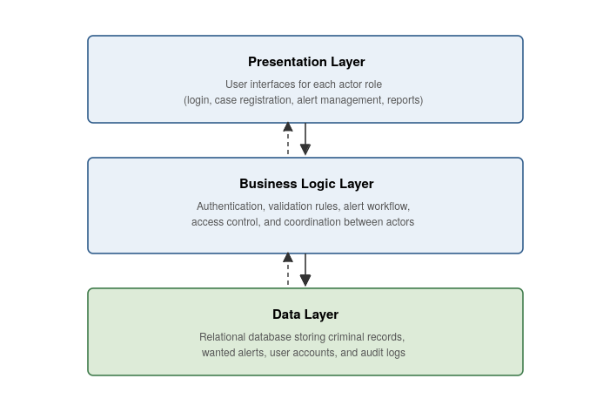
Figure 18: Logical (layered) architecture of the Police Criminal Record System

II. Class Diagram
i. Definition
A class diagram is a UML structural diagram that models the static structure of a system by representing its classes, their attributes and operations, and the relationships that connect them. Unlike the behavioral diagrams presented in the analysis phase (use case, communication, sequence, and activity diagrams), which describe how the system behaves over time, the class diagram describes what the system is made of, providing the conceptual foundation from which the database design is subsequently derived.

ii. Formalism
The formalism of a class diagram relies on a small set of standard notations, illustrated below:
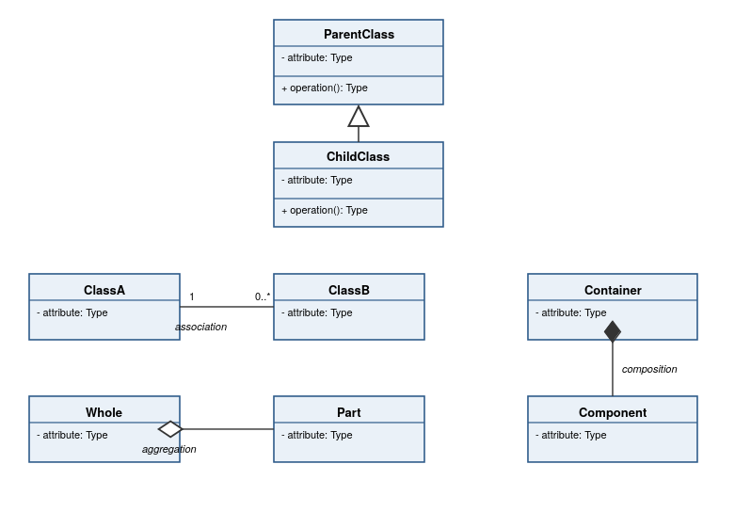
Figure 19: Formalism of a UML class diagram

iii. Components of Class Diagram
The table below summarizes each element of the class diagram notation, its graphical representation, and its meaning:
Element | Notation | Description
Class | 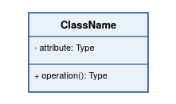 | Represents a group of objects sharing common attributes and operations. It is depicted as a rectangle divided into three compartments: the class name, its attributes, and its operations.
Attribute | 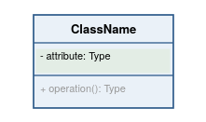 | A characteristic or property of a class, listed in the second compartment. It is typically written as “visibility name: Type”, where visibility is denoted by - (private), + (public), or # (protected).
Operation | 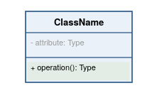 | A behavior or function that instances of the class can perform, listed in the third compartment, typically written as “visibility operation(): ReturnType”.
Association | 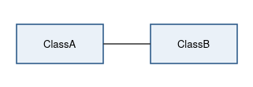 | A plain line connecting two classes, indicating a structural relationship between their instances.
Multiplicity | 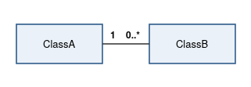 | Numbers or ranges (e.g., 1, 0..*, 1..*) placed near each end of an association, indicating how many instances of one class relate to a single instance of the other.
Aggregation | 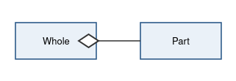 | A line ending with a hollow diamond on the side of the whole, representing a “has-a” relationship in which the part can exist independently of the whole.
Composition | 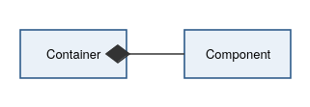 | A line ending with a filled diamond on the side of the container, representing a strong “part-of” relationship in which the part cannot exist independently of the whole.
Generalization | 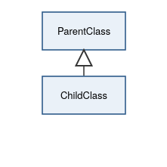 | A line ending with a hollow triangle pointing to the parent class, representing an “is-a” (inheritance) relationship between a more specific class and a more general one.

iv. Class Diagram of the Police Criminal Record System
The diagram below models the static structure of the system, built directly from the actors and use cases established in the analysis phase. The four actor roles (Administrative Officer, Police Officer, Judicial Authority, General Inspectorate) are modeled as sub-classes of an abstract User class, reflecting the fact that they all share core authentication behavior while each performs a distinct set of operations. The domain classes (CriminalCase, PersonOfInterest, CriminalRecord, WantedAlert, AuditLog) capture the information the system must persist:
• Criminal Case: a case or incident registered by a Police Officer, which may involve one or more persons of interest and may originate a wanted alert.
• Person Of Interest: an individual associated with a case, who may have an associated criminal record and may become the subject of a wanted alert.
• Criminal-Record: the verified criminal history of a person of interest, linked by composition since a record cannot exist independently of the person it describes.
• Wanted Alert: an alert issued for a person of interest, authorized by a Judicial Authority before distribution.
• Audit-log: a record of actions performed by any user, supporting the trace-ability requirement expressed in the specification book.
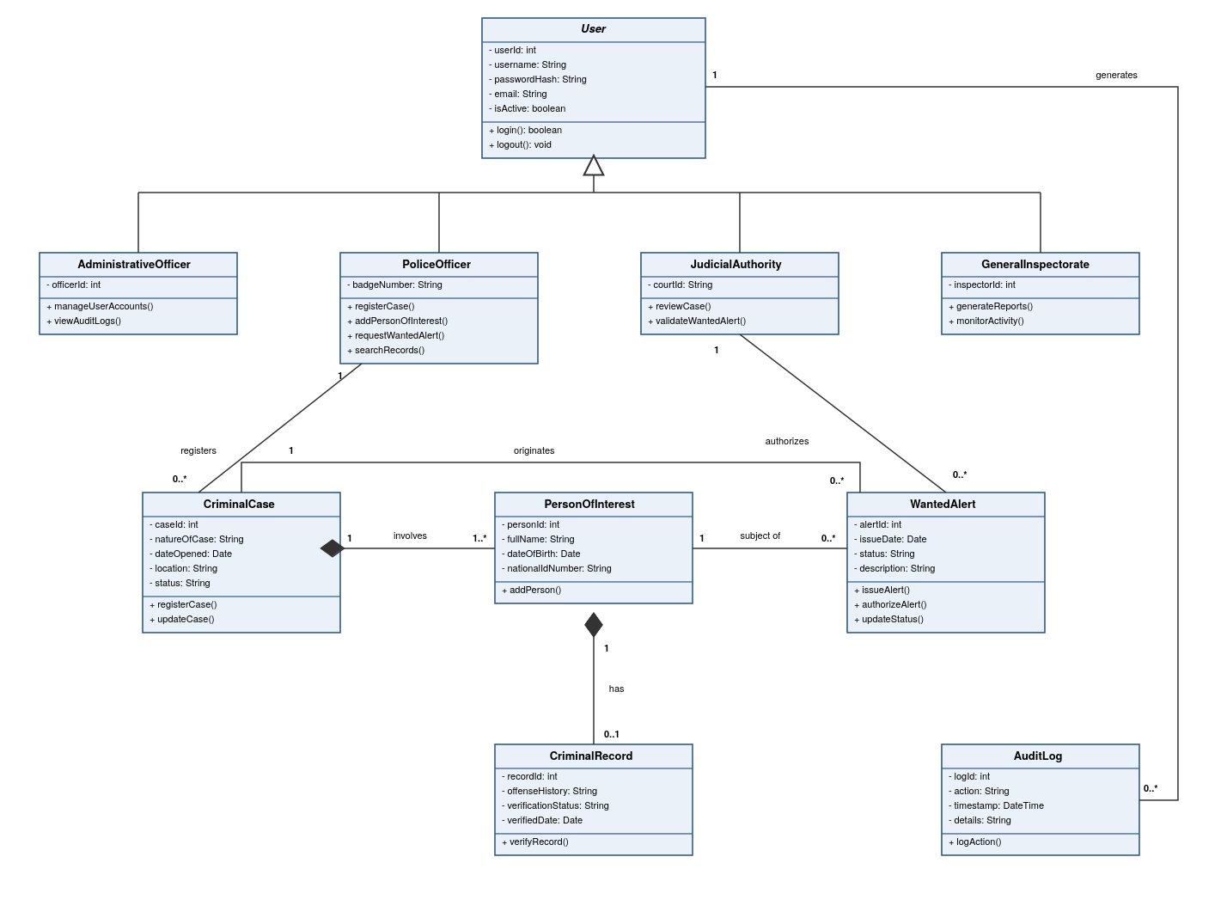
Figure 20: Class diagram of the Police Criminal Record System

III. State Diagram
i. Definition
A state diagram (or state machine diagram) is a UML behavioral diagram that models the different states an object can occupy throughout its life-cycle, together with the events and transitions that cause it to move from one state to another. Unlike the activity diagram, which focuses on the flow of actions within a process, the state diagram focuses on a single object and describes how its internal condition evolves in response to events, providing a precise view of the object's possible states and the rules governing state changes.
ii. Formalism
The formalism of a state diagram relies on a small set of standard notations, illustrated below:
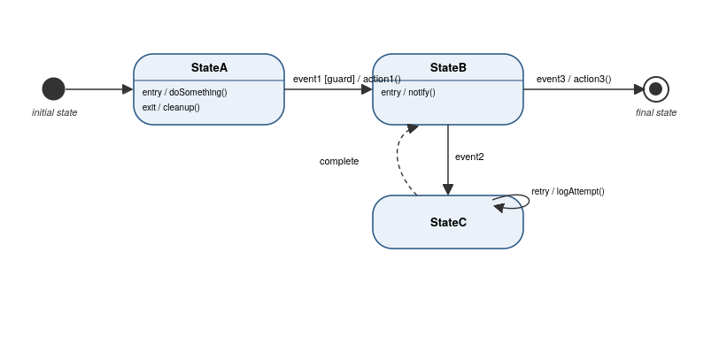
Figure 21: Formalism of a UML state diagram
iii. Components of State Diagram
The table below summarizes each element of the state diagram notation, its graphical representation, and its meaning:
Element | Notation | Description
Initial State |  | A filled circle marking the starting point of the object's life-cycle. Every state diagram begins with exactly one initial pseudo-state.
Final State |  | A filled circle surrounded by a ring, marking the end of the object's life-cycle, reached once no further transitions are possible.
State | 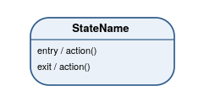 | A rounded rectangle representing a condition or situation in the life of an object, optionally showing entry and exit actions executed automatically upon entering or leaving the state.
Transition | 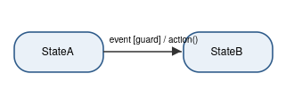 | An arrow connecting two states, labeled with the triggering event, an optional guard condition in square brackets, and an optional action, following the format “event [guard] / action()”.
Self-Transition | 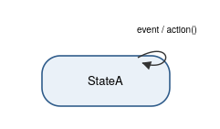 | A transition that leaves and re-enters the same state, typically representing an event that is handled without changing the object's overall condition.

iv. State Diagram of the Wanted Alert
Among the classes identified in the conception phase, the Wanted-alert class is the one whose status attribute evolves most visibly throughout the system's work-flow, making it a natural candidate for a state diagram. The diagram below models the complete life-cycle of a wanted alert, from its creation by a Police Officer to its final resolution:
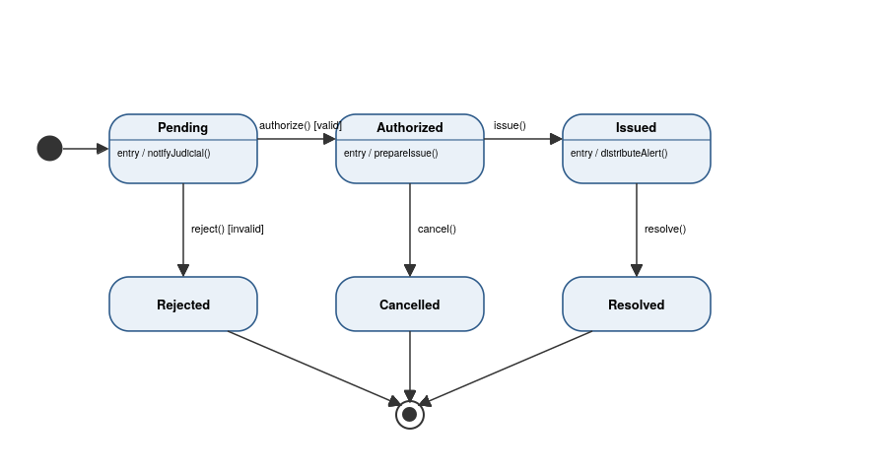
Figure 22: State diagram of the Wanted Alert
Once created, a wanted alert enters the Pending state and the Judicial Authority is notified for review. If the request is found valid, the alert moves to the Authorized state; otherwise, it is Rejected and the process ends. Once authorized, the alert is issued and distributed to police stations, checkpoints, and patrol units, entering the Issued state. From there, it may be Resolved once the wanted person is apprehended or the case is closed, or Canceled if it is no longer relevant. Both outcomes terminate the alert's lifecycle.

IV. Package Diagram
i. Definition
A package diagram is a UML structural diagram that groups related classes and other model elements into packages, providing a higher-level view of how the system is organized. Rather than showing individual attributes and operations as the class diagram does, the package diagram emphasizes the logical partitioning of the system into cohesive modules and the dependencies between them, making it a useful tool for planning the system's overall architecture before implementation begins.
ii. Formalism
The formalism of a package diagram relies on a small set of standard notations, illustrated below:
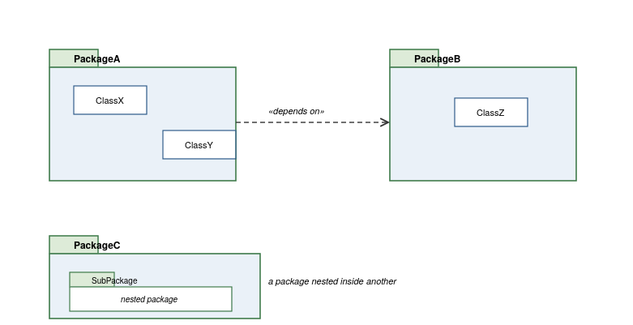
Figure 23: Formalism of a UML package diagram
iii. Components of Package Diagram
The table below summarizes each element of the package diagram notation, its graphical representation, and its meaning:
Element | Notation | Description
Package | 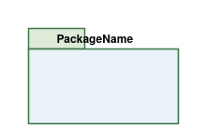 | A folder-shaped container, drawn as a rectangle with a small tab, used to group related model elements (classes, interfaces, or other packages) under a common name.
Contained Element | 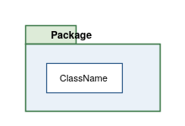 | A class or other model element shown nested inside a package, indicating that it belongs to that package.
Nested Package | 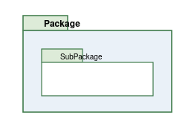 | A package drawn inside another package, representing a further subdivision of a module into smaller, more focused sub-modules.
Dependency | 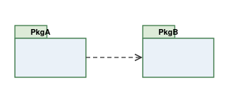 | A dashed arrow with an open arrowhead, indicating that one package relies on elements defined in another package, typically labeled with the stereotype «depends on» or «uses».

iv. Package Diagram of the Police Criminal Record System
The diagram below organizes the classes identified in the class diagram into four cohesive packages, clarifying the system's modular structure and the dependencies between its modules:
• User Management: groups the abstract User class and its four role-based sub-classes, providing authentication and account-related behavior to the rest of the system.
• Case Management: groups Criminal Case, Person Of Interest, and Criminal-record, and depends on User Management since cases are registered by a Police Officer.
• Alert Management: contains Wanted Alert, and depends on both Case Management, since alerts originate from a case, and User Management, since alerts are authorized by a Judicial Authority.
• Audit: contains Audit-log, and depends on User Management since every logged action is tied to the user who performed it.
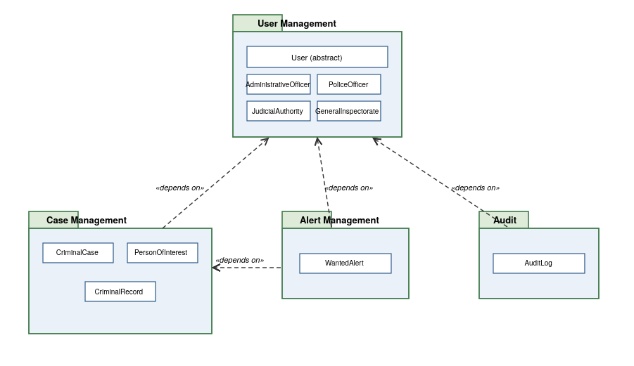
Figure 24: Package diagram of the Police Criminal Record System

CONCLUSION
This conception phase translated the requirements and behavior modeled during the analysis phase into a concrete design. The capture of technical needs established the physical and logical architectures the system must respect; the class diagram formalized its static structure; the state diagram detailed the lifecycle of the WantedAlert, the class whose behavior is most central to the system's alerting mission; and the package diagram organized this structure into cohesive, loosely-coupled modules. Together, these artifacts provide the design foundation from which the system's realization can proceed.

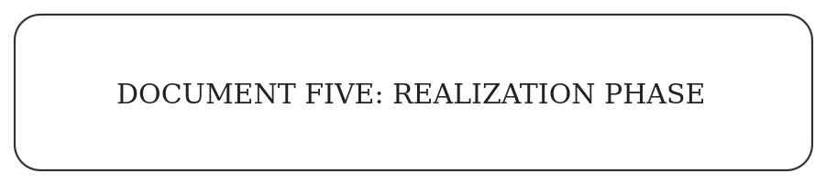

Content:
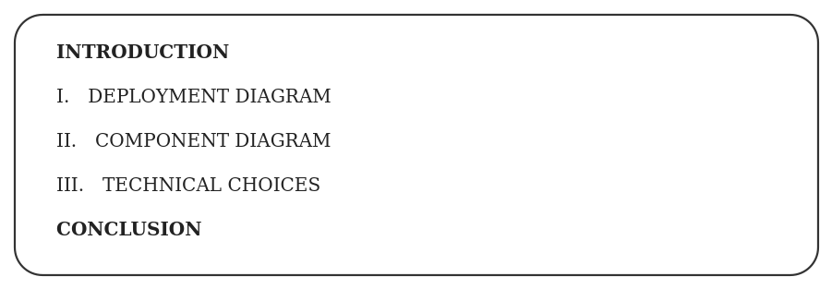

INTRODUCTION
Following the conception phase, which defined the system's static structure, state behavior, and modular organization, this file addresses the realization phase of the project. Its purpose is to describe how the designed system is deployed onto physical infrastructure and organized into software components, and to justify the technical choices retained for its implementation.

I. Deployment Diagram
a. Definition
A deployment diagram is a UML structural diagram that shows the physical architecture of a system at runtime: the hardware nodes on which the system executes, the software artifacts deployed on each node, and the communication paths connecting them. Unlike the class or package diagrams, which describe the system's logical organization, the deployment diagram describes where that logic actually runs once the system is installed and operating.
b. Formalism
The formalism of a deployment diagram relies on a small set of standard notations, illustrated below:
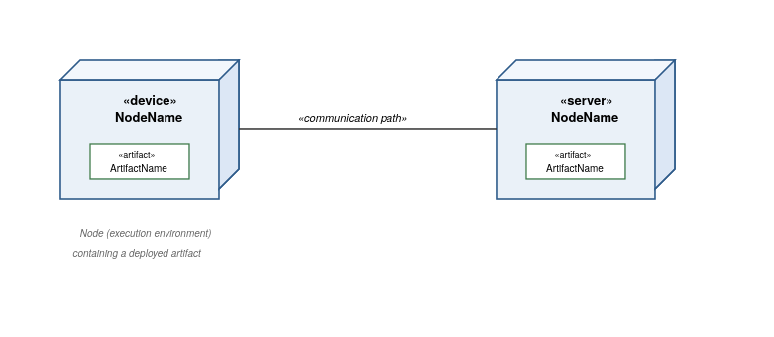
Figure 25: Formalism of a UML deployment diagram
c. Components of Deployment Diagram
The table below summarizes each element of the deployment diagram notation, its graphical representation, and its meaning:
Element | Notation | Description
Node | 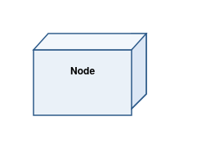 | A three-dimensional box representing a physical or virtual execution environment — a device, a server, or a cloud platform — on which software can run.
Artifact | 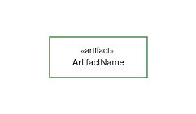 | A concrete piece of deployed software (an application package, a database, a service) shown nested inside the node that hosts it.
Communication Path | 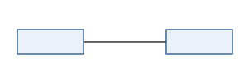 | A line connecting two nodes, representing the physical or network connection through which they exchange data.
d. Deployment Diagram of the System
The diagram below shows how the Police Criminal Record System is physically deployed. The mobile application runs on each officer's smartphone, communicating over HTTPS with a Node.js server hosting the Express API and the authentication and business logic layers. The Node.js server communicates over SQL/TCP with a dedicated PostgreSQL server, which stores and enforces the integrity of the system's data. When a wanted alert is issued, the Node.js server notifies the Push and SMS gateways, which distribute the alert onward:
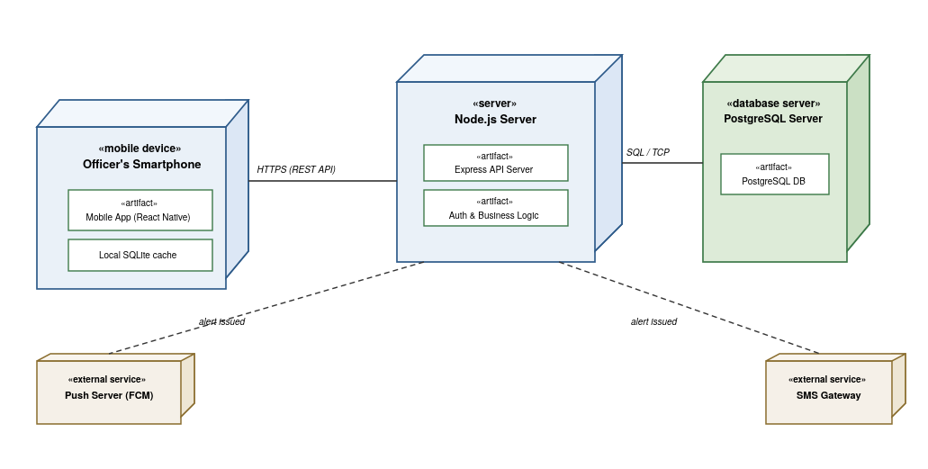
Figure 26: Deployment diagram of the Police Criminal Record System

II. Component Diagram
a. Definition
A component diagram is a UML structural diagram that shows how a system is organized into interchangeable software components, and how those components depend on one another through well-defined interfaces. Where the deployment diagram describes physical placement, the component diagram stays at the software level: it identifies the provided interfaces a component exposes and the required interfaces it depends on, making the boundaries between modules of the implementation explicit.
b. Formalism
The formalism of a component diagram relies on a small set of standard notations, illustrated below:
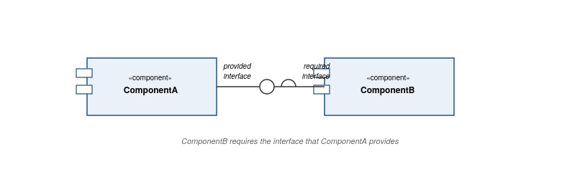
Figure 27: Formalism of a UML component diagram
c. Components of the Component Diagram
The table below summarizes each element of the component diagram notation, its graphical representation, and its meaning:
Element | Notation | Description
Component | 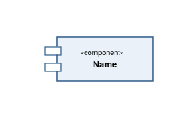 | A modular, replaceable part of the system, marked with the «component» stereotype and the small connector icon, encapsulating a specific piece of functionality behind its interfaces.
Provided Interface | 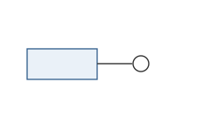 | A “lollipop” symbol showing a service that a component makes available for other components to use.
Required Interface | 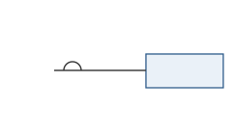 | A “socket” symbol showing a service that a component needs from another component in order to function.
d. Component Diagram of the System
The diagram below identifies the software components that make up the Police Criminal Record System and the interfaces through which they interact. The Mobile App (React Native) depends on the REST API Interface exposed by the Express API Server, which centralizes authentication, route handling, and the validation of the business rules formalized in the conception phase. The Express API Server in turn depends on the Database Interface exposed by the PostgreSQL Database to persist and retrieve data. When a wanted alert's status changes to issued, the Express API Server relies on the Notification Service to trigger its distribution:
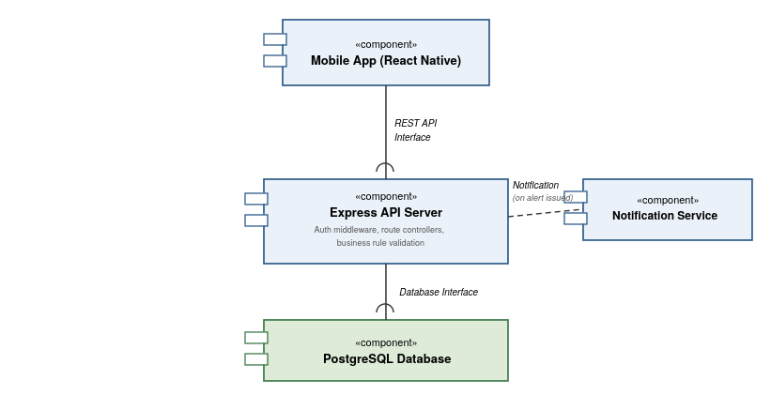
Figure 28: Component diagram of the Police Criminal Record System

III. Technical Choices
The sections below present the core technologies retained for the development of the Police Criminal Record System — React Native, Node.js, and PostgreSQL — together with supporting tools, explaining the role each one plays and the reason it was chosen.
React Native
React Native is the mobile application framework used to build the client app. It allows a single JavaScript/TypeScript codebase to target both Android and iOS, matching the requirement that the system be usable on both platforms, while giving direct access to native device features needed for offline storage and push notifications.


Node.js
Node.js is the JavaScript runtime powering the backend server. It lets the same language (JavaScript/TypeScript) be used across both the mobile app and the server, and its non-blocking I/O model is well suited to handling many concurrent requests from officers across different stations.


Express.js
Express.js is the web framework used to build the REST API on top of Node.js. It provides a lightweight, well-documented structure for defining routes, middleware, and authentication logic, keeping the API organized around the use cases identified in the analysis phase.


PostgreSQL
PostgreSQL is the Relational Database Management System retained for this project. It is a mature, standards-compliant DBMS capable of enforcing the schema, constraints, and relationships defined during the conception phase, with strong support for the structured, relational data the system manages.


VSCodium
VSCodium is the Integrated Development Environment used throughout development. It is an open-source build of Visual Studio Code, used for writing, debugging, and navigating both the mobile app and server source code from a single editor.
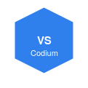

Git
Git is the version control system used to track changes to the codebase. It allows reverting to previous versions and supports collaborative development without risk of losing work.


CONCLUSION
This realization phase completed the transition from design to implementation. The deployment diagram situated the system's components on concrete physical infrastructure, from the officer's smartphone to the Node.js server and the external notification services it depends on; the component diagram made explicit the software boundaries and interfaces within that infrastructure, centered on the React Native mobile app, the Express API server, and the PostgreSQL database; and the technical choices justified the specific tools and technologies retained for development. Together with the preceding conception phase, these artifacts complete the technical blueprint from which the Police Criminal Record System has been built.

