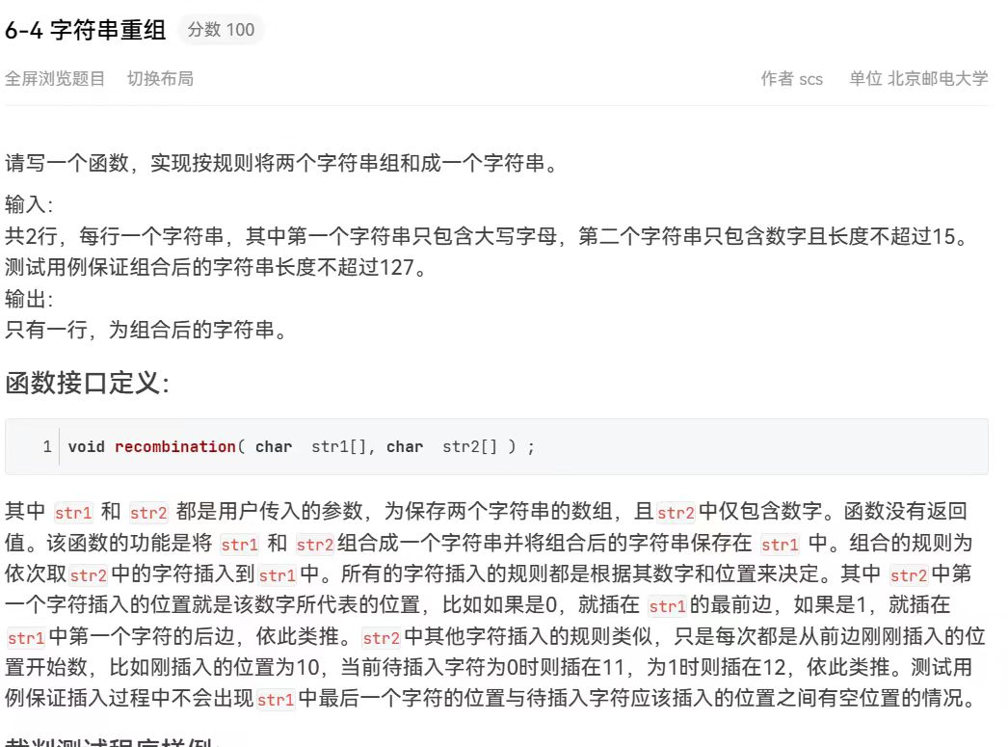void recombination( char str1[] , char str2[] ) ;

int main()
{
char str1[LENA] , str2[LENB] ;

scanf( "%s%s" , str1 , str2 ) ;
recombination( str1 , str2 ) ;
printf( "%s\n" , str1 ) ;

return 0;
}
#include<string.h>
void recombination( char str1[] , char str2[] ){//str2不再是个数组了，是指针，丢失数组长度信息，退化，不能用sizeof(str2)，int*为8
// warning: ‘sizeof’ on array function parameter ‘str2’ will return size of ‘char*’ [-Wsizeof-array-argument]
//sizeof吞数组
//也不可以用LENB，因为a.cpp: In function ‘int main()’:
//a.cpp:12:10: warning: ignoring return value of ‘int scanf(const char*, ...)’, declared with attribute warn_unused_result [-Wunused-result]
//scanf( "%s%s" , str1 , str2 ) ;
// ~~~~~^~~~~~~~~~~~~~~~~~~~~~~~
//因为str2【】后面可能出现很大很离谱的数，造成数组越界问题
//strlen不含\0

总的思想是走移插，移动是移动数组省下位置，走是数的意思，数是逐渐增加的过程，是b完成的操作
nt b=-1;

for(int i=0;i<strlen(str2);i++){
char str3[LENA];
b+=str2[i]-'0';

for(int t=0;t<128;t++){
str3[t]=str1[t];
}

for(int a=b+1+i;a<127;a++){
str1[a+1]=str3[a];
}
str1[b+1+i]=str2[i];//加的b，是加了多少走的数

}

}


#include<stdio.h>
#include<stdlib.h>
#include<stdbool.h>

bool check(int energy[], int n, int m, int energyPerWarrior) {
int totalWarriors = 0;
for (int i = 0; i < n; i++) {
totalWarriors = energy[i] / energyPerWarrior+totalWarriors;
}
if(totalWarriors >= m) return true;
else
return false;
}

//right一开始为sum / m，没有能量浪费，最小为0
//左闭右闭区间
int binarySearch(int energy[], int n, int m, int left, int right) {
int mid;
while (left <= right) {

mid = left + (right - left) / 2; // 防止溢出
if (check(energy, n, m, mid))//mid可以，左边都可以
left = mid + 1;
else
right= mid - 1;
}
return right;
}
/*左闭右开区间
int binarySearch(int energy[], int n, int m, int left, int right) {
int mid;
while (left < right) {

mid = left + (right - left) / 2; // 防止溢出
if (check(energy, n, m, mid))//mid可以，左边都可以
left = mid+1;
else
right= mid ;
}
return mid;
}

*/

int main() {
int n, m;
long long sum = 0;//超时危险
scanf("%d%d", &n, &m);
int* energy = (int*)malloc(sizeof(int) * n);

for (int i = 0; i < n; i++) {
scanf("%d", &energy[i]);
sum += energy[i];
}

int maxEnergy = sum / m;
printf("%d", binarySearch(energy, n, m, 1, maxEnergy));
free(energy);
return 0;
}

