

**TASK**

**Exploratory Data Analysis on the PUBG Gun Data Set**

￼

**Introduction**

PlayerUnknown's Battlegrounds (PUBG) is an online multiplayer battle royale game developed and published by PUBG Corporation, a subsidiary of South Korean video game company Bluehole. The game is based on previous mods that were created by Brendan "PlayerUnknown" Greene for other games, inspired by the 2000 Japanese film Battle Royale, and expanded into a standalone game under Greene's creative direction. In the game, up to one hundred players parachute onto an island and scavenge for weapons and equipment to kill others while avoiding getting killed themselves. The available safe area of the game's map decreases in size over time, directing surviving players into tighter areas to force encounters. The last player or team standing wins the round. This data set contains all the wepons a player can use to win.

**DATA CLEANING**

The data was converted from a google sheet and then exsported to csv to be up loaded into python,

MISSING DATA

The missing data is due to 2 different circumstances

1. Drag - Here the data is missing and it has not been included in the spreadsheet - this will be replaced with 0

2. The game also contains weapons that are not classified as a fire arm I.E it does not work with a projectile, these will have to be removed. The following have missing values namely mag, ext. mag and scoping. This is expected because they do not work with Bullets and thus are not relevant data to use. These will be resolved below

There was mising data namly in the

DATA STORIES AND VISUALIZATIONS

Different weapons

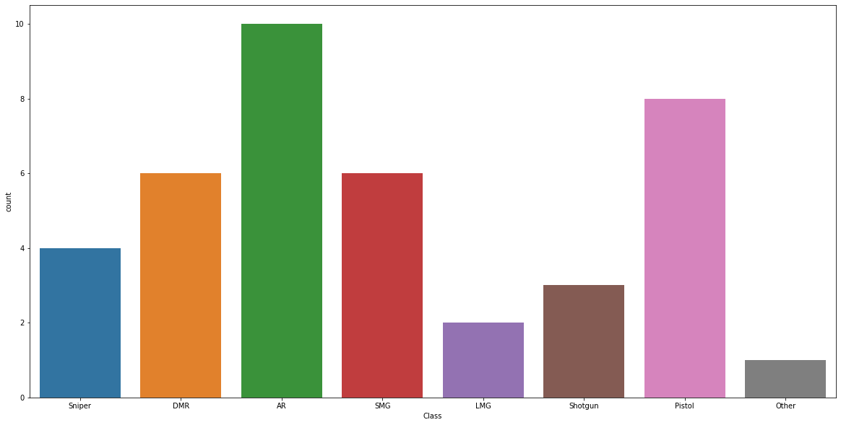

Here we can see that there is a lot more Assault rifles and pistols, which mean that a player is much more Lickly to find a weapon in this class

Similarly, we can determine that players will not be using weapons in their other class which is the crossbow and LMG because the verity in these classes is a lot lower.

it can be determent that players can expect to encounter players wielding Assault rifles and Pistols in the early start of the game when players still are looking for supplies

Diffirnt types of Ammo that is found in the game

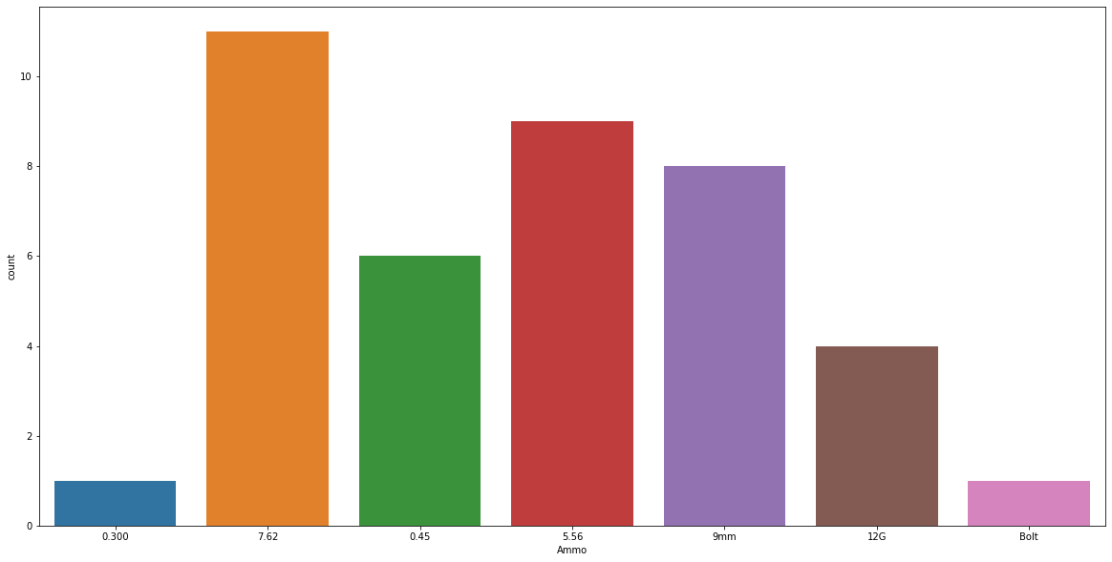

Here we can see that players should look for a gun that uses 7.62-millimeter Ammo, because a lot more guns use this Ammo is

relevant to assume that a player has a lot better chance to come across this Ammo and it can be concluded that a player should look for weapons that uses these Ammo types

Players should stay away from the 0.300 magnum and the crossbow because these guns use the Ammo that is very particular it

can be assumed that these will be a lot harder to find and thus will not be very affective in combat

The damage stats

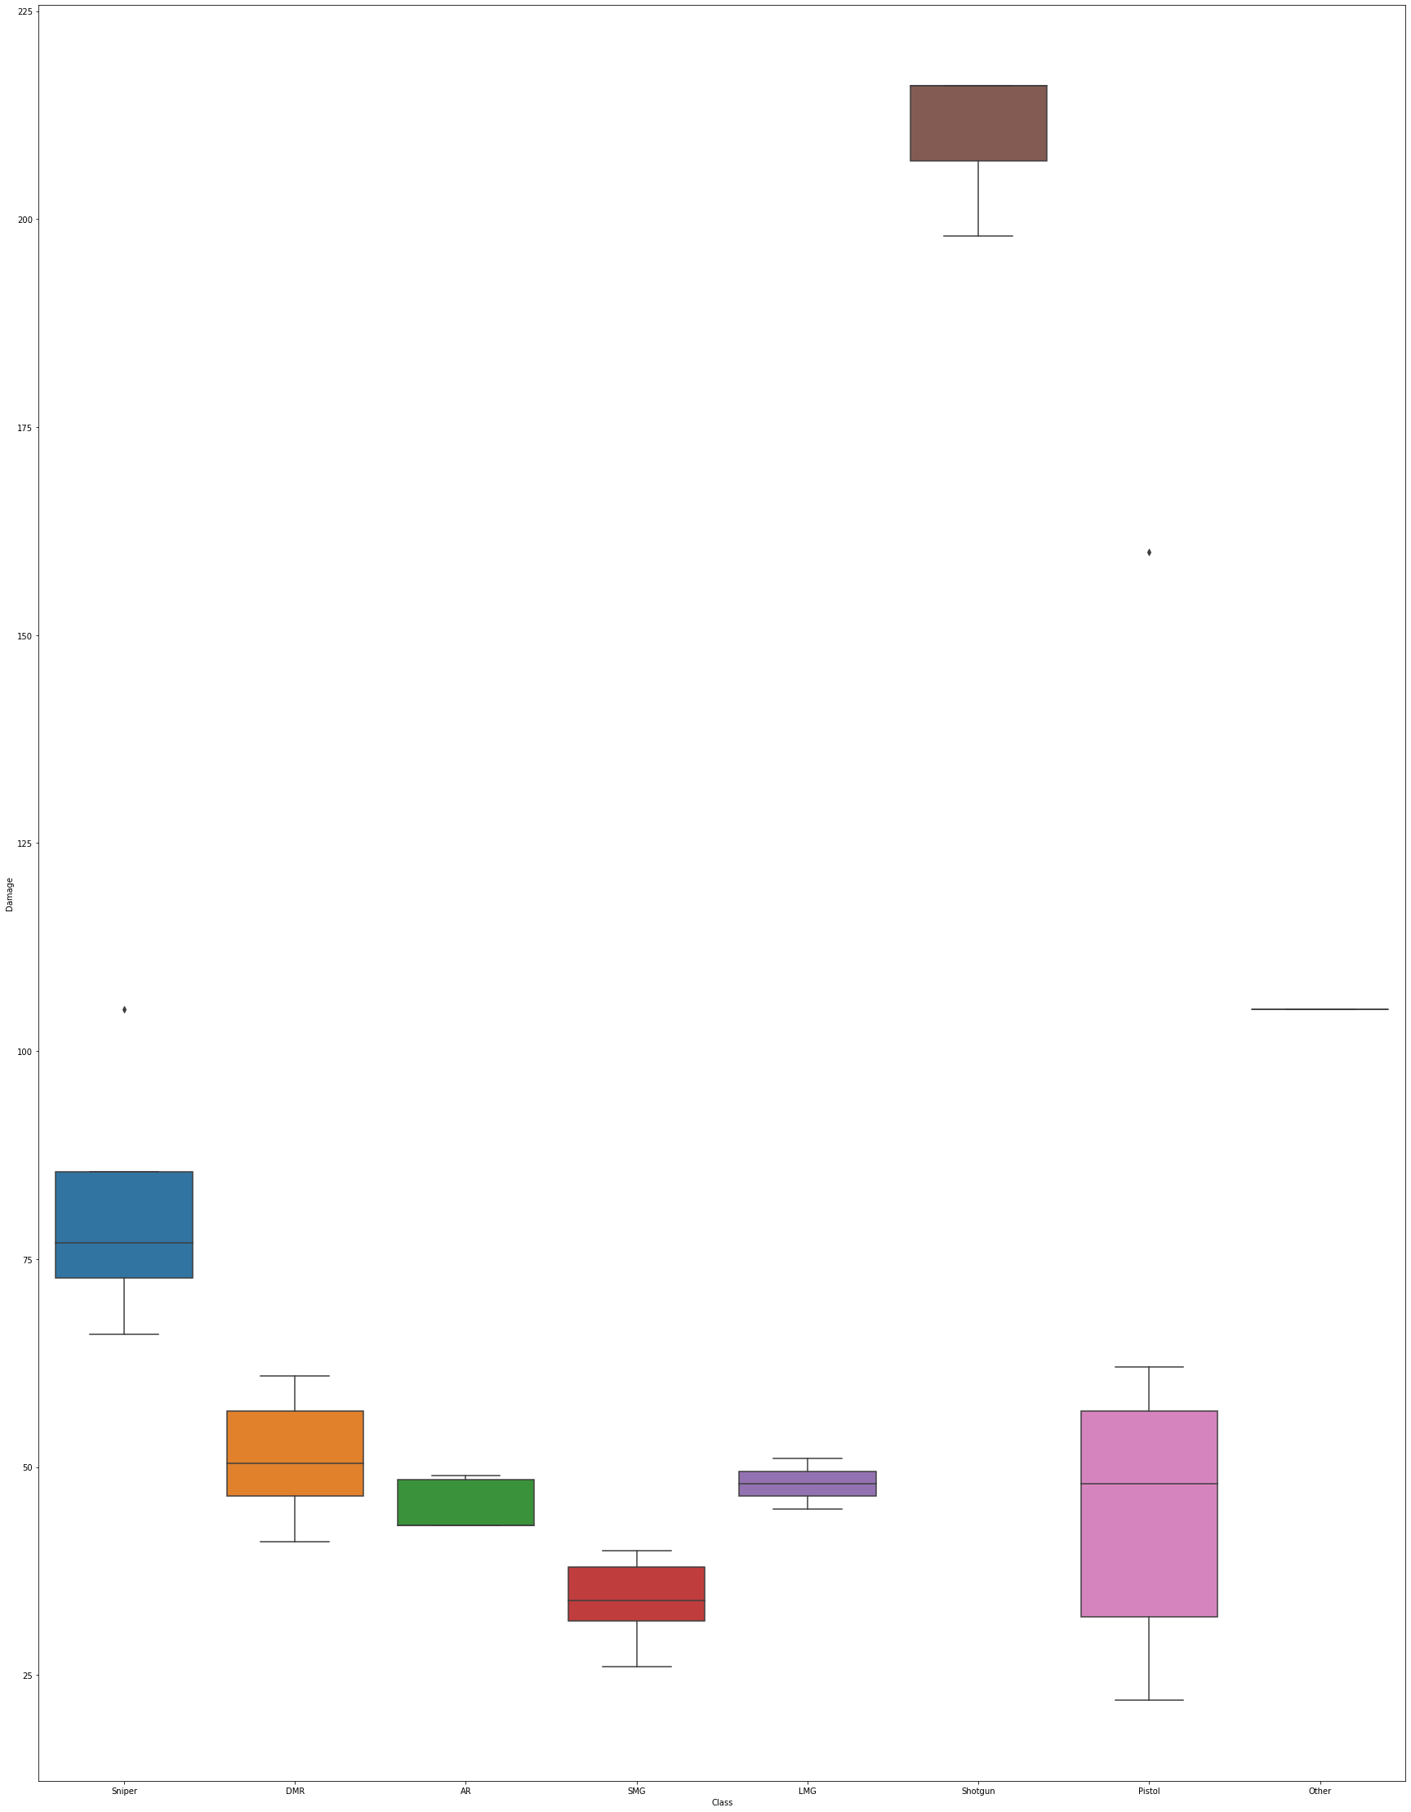

**1 . We can see that shot guns have by far the most damage,**

**followed by the crossbow and the sniper rifle class.**

**2. when looking at the data we can see that Pistols and Snipers both have outliers, but the rest of the classes are balanced and in balance.**

**3. almsot all of the classes are skewed expect LMG, which means that LMGS behave the same,**

**damage while it does not matter which LMG you pick up, however there is a big difference in the pistol and this means that**

**it matters a lot which pistol you get and decide to pick up**

**Summarized**

**looking at damage, shot guns are by far the best, followed by sniper rifles, i would not recommend looking at the crossbow because it has a very restricted to a rare ammo type and would be hard to find ammo for it to be considered effective**

**Compare sustained DPS**

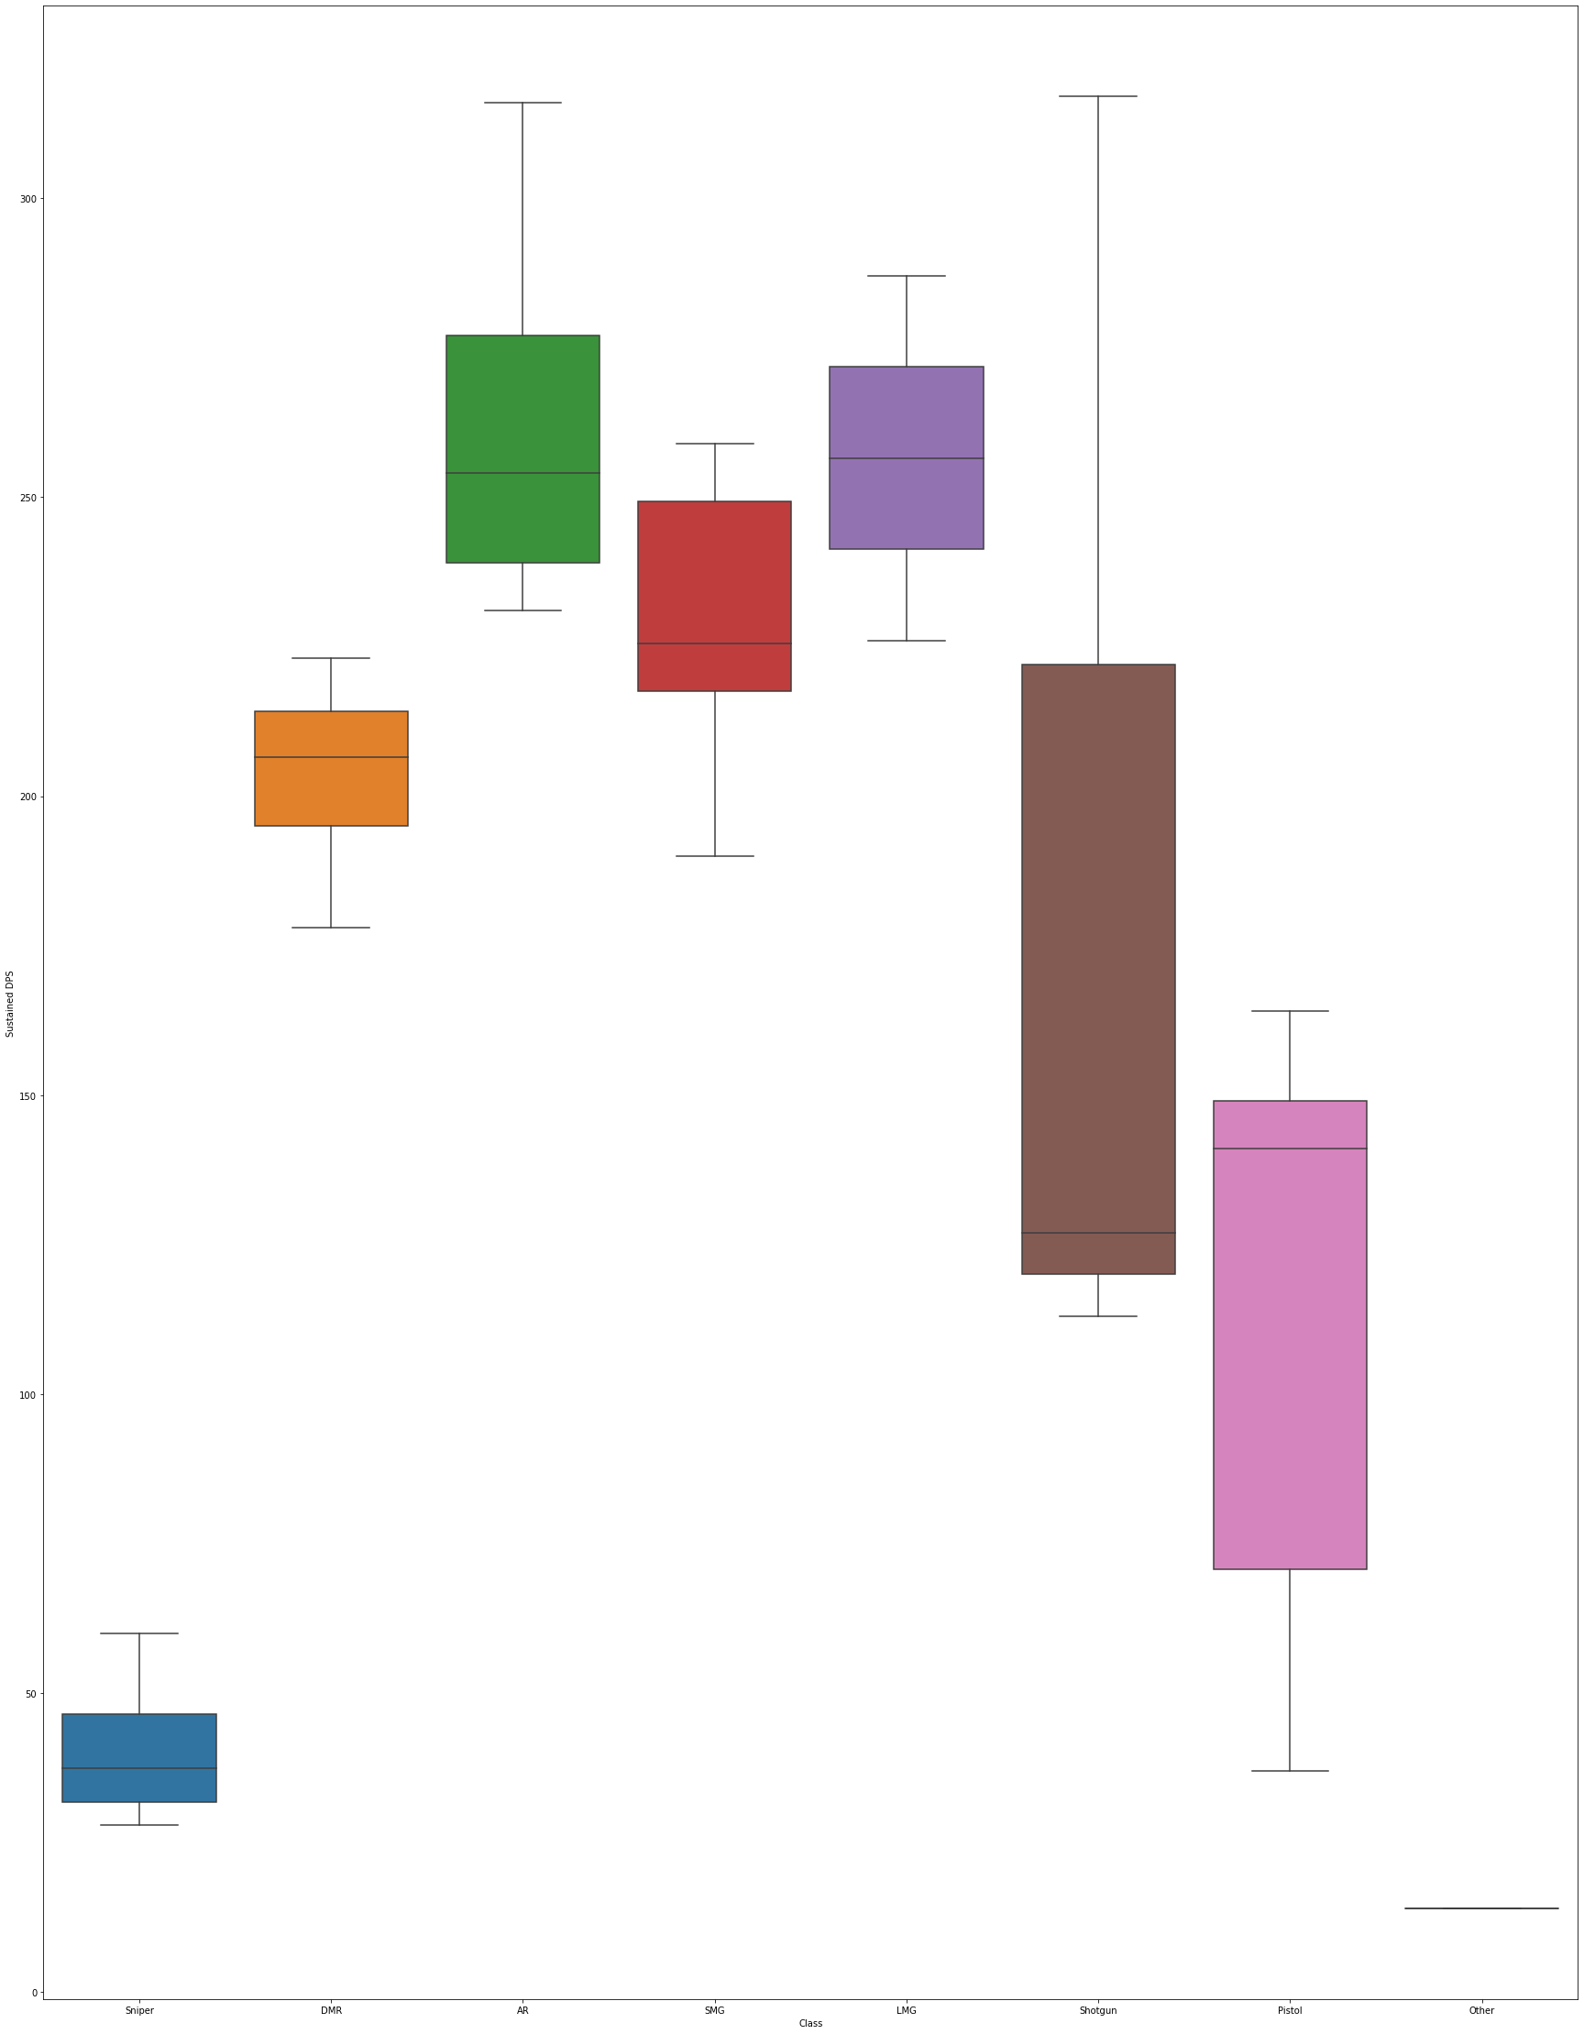

**This is the weapons capability to do damage over time,**

**looking at the data we can see that shot guns vary widely, which means that it depends a lot on the model you have, reasons for this could be fire speed and ammo count.**

**snipers have the least amount of sustained dps, this means that if you would like to use a sniper you should make every shot**

**count because it deals the least amount of damage over time.**

**The best weapon class to use according to the data would be the Assault rifle or the lmg, because it provides the most damage per second then the rest of the classes, this could be due to the fact that the magazine size fire rate and damage is higher than the over classes, we can deduce that these classes are far better to use when there is a lot of targets**

**and the sniper rifle is better when focusing on a single target.**

**The bullet speed of the classes**

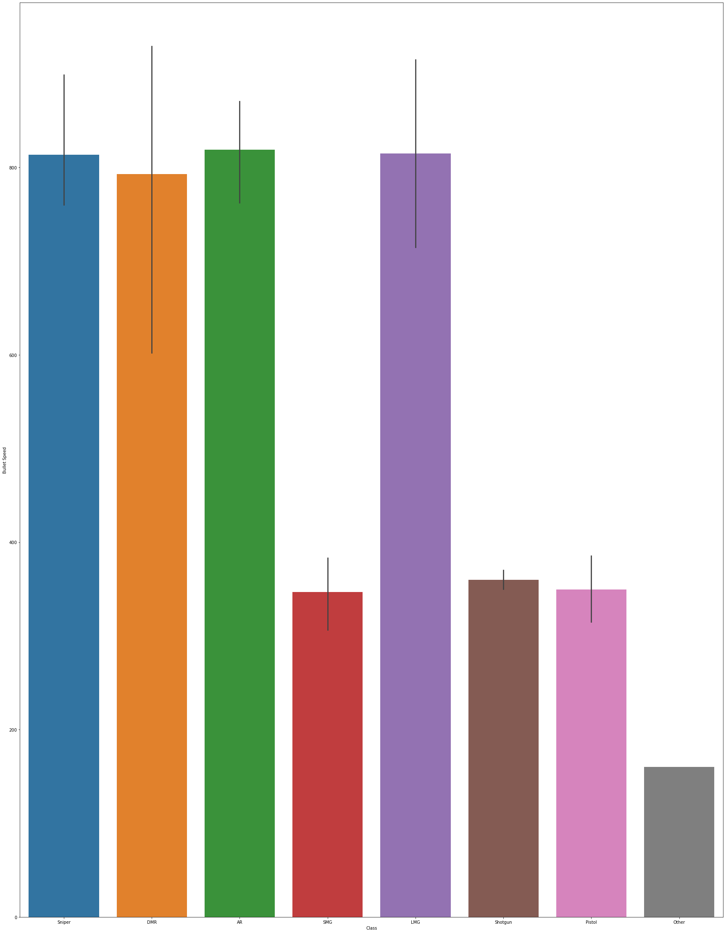

**Here we can see that the Assault rifle class has the fasted bullets followed by the LMG and sniper.**

**This means that these 3 classes have the least amount of travel time from gun to target, so these classes are the best to use when fighting over a distance because these classes will reach their targets fist and thus will give the player a small advantage that can turn the tide of battle.**

**Range of the wepon Classes**

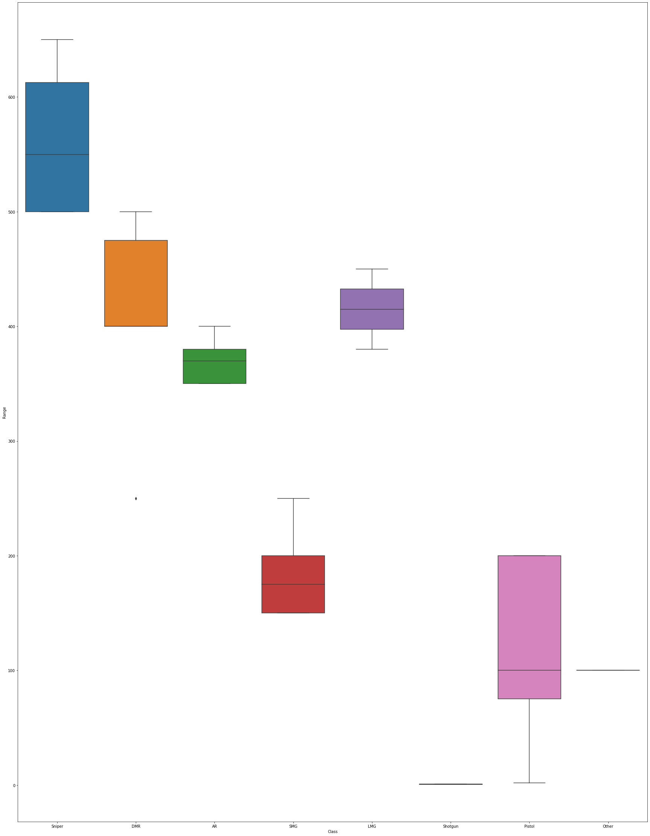

**When comparing range, we see that sniper rifles have the most range by far, followed by the marks men rifle and the Assault rifle class. From the data we can conclude that for engagements over a long distance you should use a sniper rifle, for mid to far an Assal rife would be the best choice, and then for close range you should look at a shot gun**

**From the data we can determent that the best classes to use is the Assault rifle and the sniper rifle and shot gun**

**The shotgun is for close range, sniper for long range and the assault rifle is for the mid to close**

**the Assault rifle is over all the best but the sniper is better for focusing a target over range and the shot gun for close encounters. Now these two classes will be analyzed to see which one in the class will be the best to use.**

**Damage of the Sniper rifle sub class**

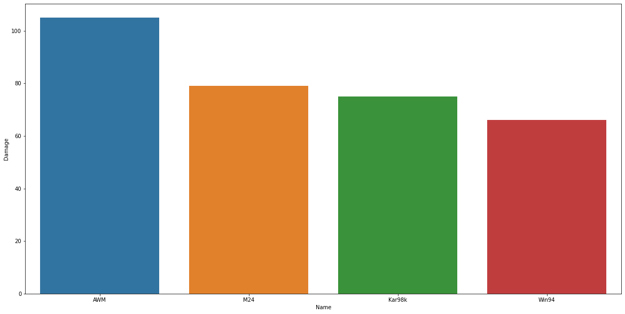

**Here we can see that the AWM is the most powerful sniper rifle followed by the M24, so i would suggest using one of these if they are found by the player, i would recommend staying away from the Win94 because it the worst in it class**

**Ammo type of the Sniper rifle sub class**

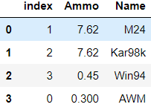

Here we can see that the AWM uses the 0.300 ammo which is very hard to get, so i would suggest that when given the choice the player should go with the M24 when considering damage and ammo availability

**Damage** Assault rifle class

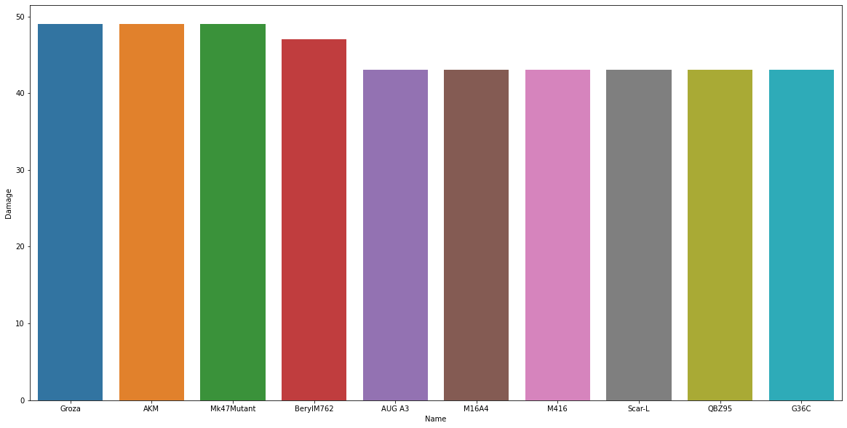

Here we can see that the Groza, AKM and Mk47 Mutant is the best weapons to use when it comes to damages in the assault rifle class.

Ammo type of the assalt rifle sub class

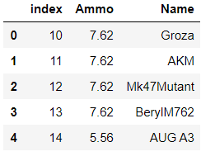

Here we can see that the guns that do the most damage has the ammo that is the most widely available, which mean that Groza, AKM and Mk47 Mutant are the top picks in the Assault rifle class

Damage of the Shot gun sub class

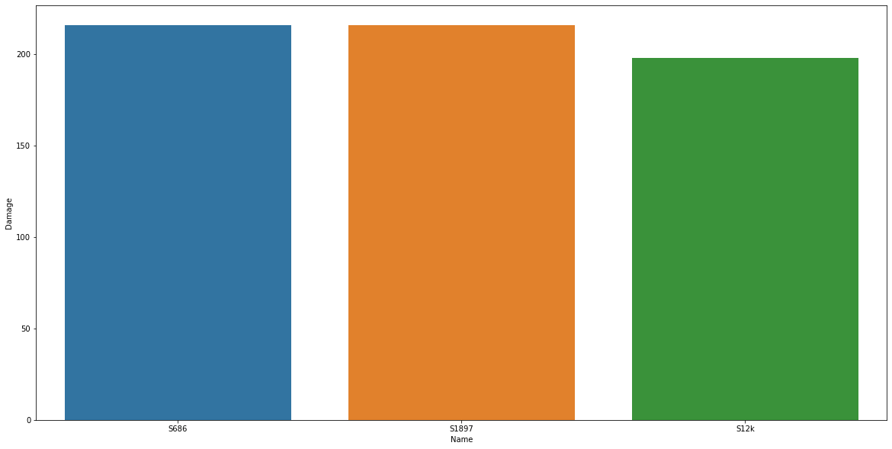

Here we can see that the damage for the shot guns is uniform so it does not really matter which one the player pick when looking at damage.

Shot guns grouped by range

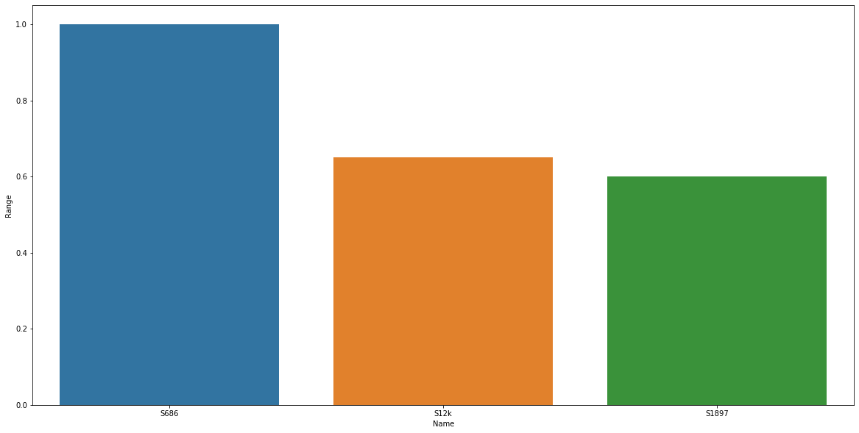

Here we can see that the S686 has the best range of all the shot guns

In summery

players have different play styles, but it can manly be categorized into 3 classes

1. long range

2. mind range

3. close range

So, the best class to use

if you prefer to play long range is the Sniper rifle class is the best and the one that would work the best in the class is the M24

if you prefer mid-range the class that world work best is the Assault rifle and here the player, can choose between the Groza, AKM or Mk47

if the player prefers close range the best class to use is a shot gun and here the S686 is the best one in the class because it has the best ranges and that makes a huge difference.

but for the overall the Assault rifle will be the best because engagements do take place over long and short ranges so it will be a lot more versatile

**THIS REPORT WAS WRITTEN BY : Bastiaan Erlank**

