# Explanation Graphical Design:

The graphical design and all associated files can be found on our public GitHub Repository under the MIT license. The repository can be found by using the following link:

<https://github.com/BastiaanvdB/Dataset-groep-1---Paddle-Person>

A small app is designed to showcase the application of our computer vision solution for Ludus Alliance. This document will explain the functionality of the app and in the folder, a pdf and Figma file can be found with our graphical design. Import to mention is that this a proof of concept and everything can be modified. We chose a simple color palette and this can also be changed to the wishes of the clients.

## Step 1: Start a session

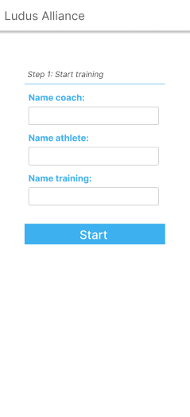

When the app is opened, a simple form is shown to the user. In our design we used some simple input fields for the names of the coach, the athlete and the training but this can be modified to every need of the client. After the fields are filled in, the user can start the session/training/competition.

## Step 2: Check position

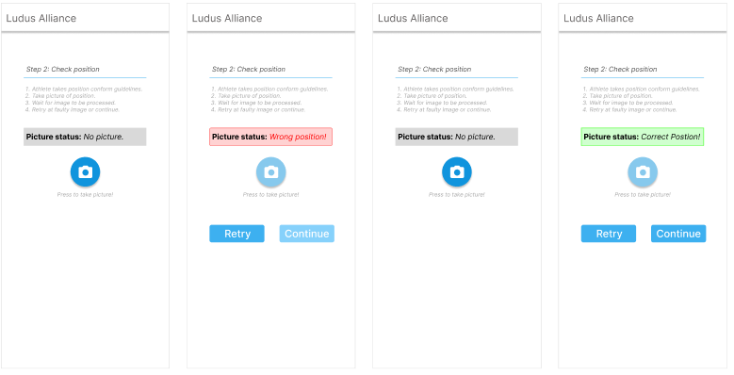

Before a training or competition can be started, the player has to be in correct position. To check this without physical referee, a initial picture is taken with the camera and send to the API. A python script checks, using computer vision, if the player is standing in a correct position. If not, an error is returned and displayed in the app. The user is informed that the position of the athlete is incorrect and he/she can retry by making a new picture when the athlete has adjusted his position. If the position is correct, the API returns that the position is good and the user is informed.

## Step 3: Streaming

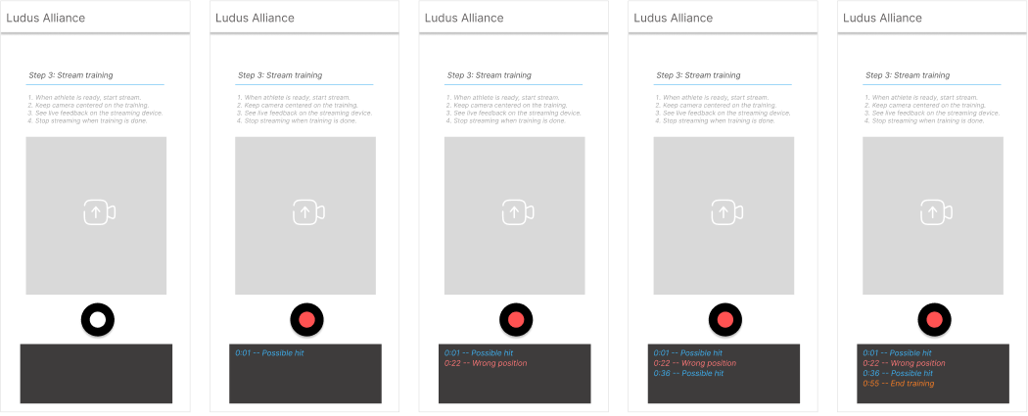

After the correct position, the coach/holder of phone can start the training. When pushed on the rec. button, a stream is starting. While streaming, the user is given immediate feedback about important events during the stream like when the player hits the paddle, or when the position is incorrect. This can be modified to the needs of the client. We are also looking into giving visual feedback on screen but there are some roadblocks that have to be taken into consideration. Currently, our goal is to process each frame in under 35ms to process 30 frames in under 1000ms/1 second. The lower this is, the less latency there will be and this is needed for fast visual feedback. This will be our primary goal for the next period of school.

## Step 4: End training

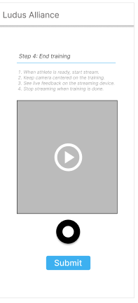

When the training is over, the rec. button can be pushed again and the streaming is stopped. The server saves a video of the training where all calculated data like distances, heights and more can be seen with the data. The data is also saved in a database. The video can be seen when the streaming is ended and the processing is done. If everything is right, the training/competition can be finished and submitted.