PowerTune User Manual for Raspberry PI (not finished yet)

Table of contents :

Installation
Setup for Serial Based ECU’s APEXI_PowerFC , Adaptronic_Select , ELM327_OBDII
Setup the Pi for CAN BUS ECU’s
Setup the ECU for CAN BUS output Adaptronic Modular
Wiring up the CAN BUS
Setup PowerTune for your ECU

Installation

Download the official PowerTune image from our Facebook Site here
unzip the file and you should get a file with the ending “.img” .

Installing the image to the SD card :

There are various programs that you can use to write a raspberry pi image to a SD card .
In this example i use Etcher as its available for Windows Mac and Linux systems
https://etcher.io/

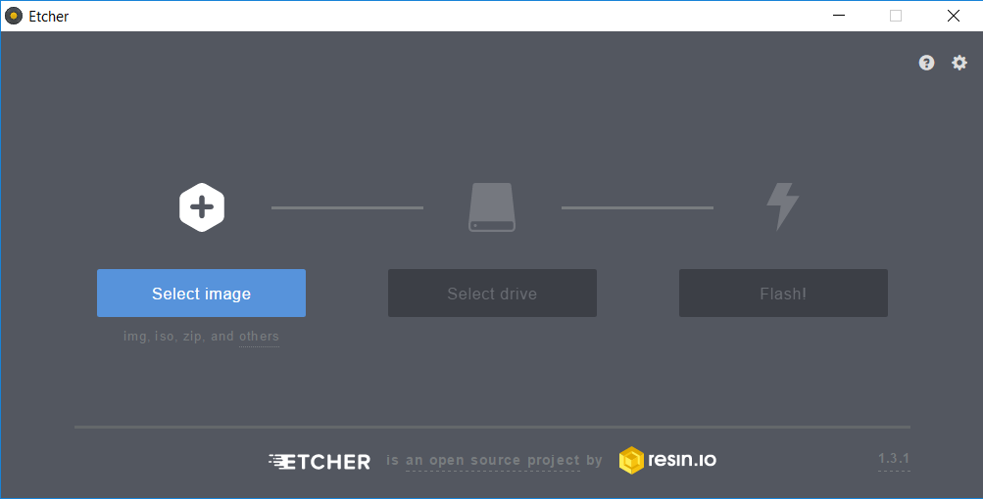
Just select the PowerTune image , selct the drive ( drive letter of the SD card) then click flash.
This process takes 5-10 minutes . Once the file is written your SD card is split into two sections , a fat and a Linux partition . On Windows it will tell you it can’t read the second partition , this is OK .
Now insert the SD card into your Raspberry Pi and connect the Power Cable . Your Raspberry pi should be booting now directly into PowerTune .

After Startup , quit PowerTune.
At the login promt login as : pi password : raspberry

now open raspi-config by typing :

sudo raspi-config

Goo to Advanced Options

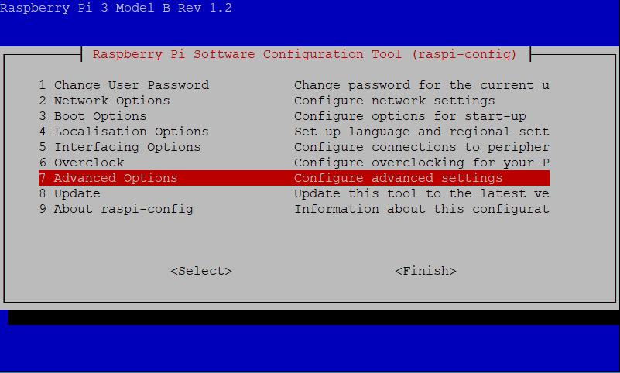

Now select “Expand Filesystem”

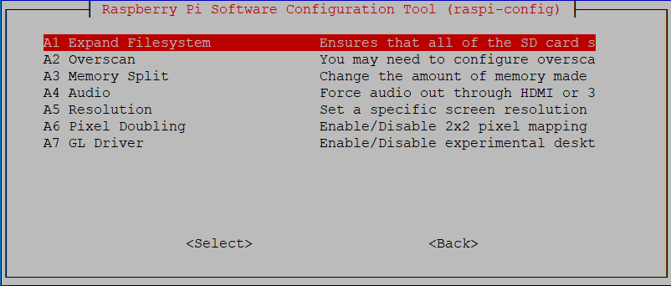

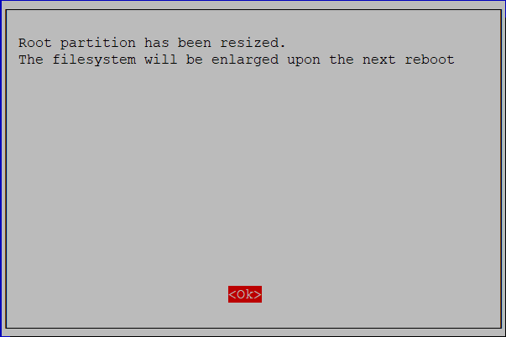

Now Finish and reboot

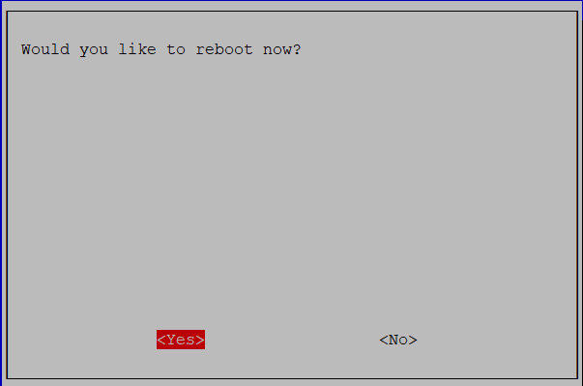

Setup the Pi for CAN BUS ECU’s

CAN BUS based ECU’s are supported by means of SocketCAN ,therefore CAN BUS ECU’s are only supported on LINUX versions of PowerTune .

Using the official Raspberry Pi image

There are many different options for CAN BUS communication available for Raspberry PI. Please ensure that the CAN Module / HAT you buy is SocketCAN compatible . Here is a example on how to setup the PiCAN2 module.

Start up your fresh installed PowerTune image ( link available on our Facebook page )
After Startup , quit PowerTune.
At the login promt login as : pi password : raspberry

Now you need to edit the config.txt file to make Linux recognise the CAN Module

sudo nano boot/config.txt
now add these lines at the bottom of the file :

dtparam=spi=on
dtoverlay=mcp2515-can0,oscillator=16000000,interrupt=25
dtoverlay=spi-bcm2835-overlay

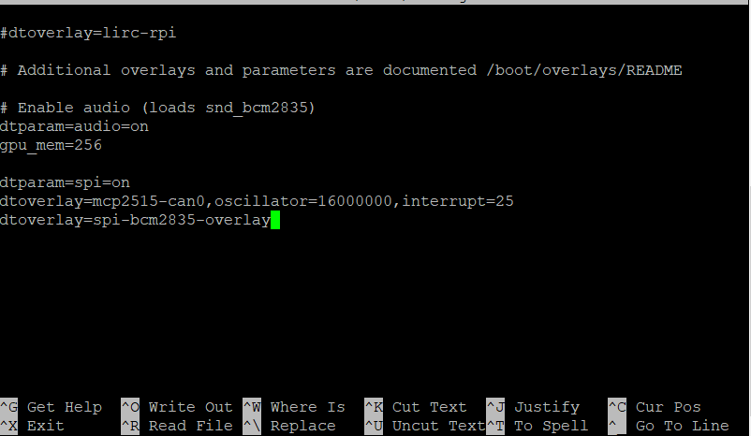
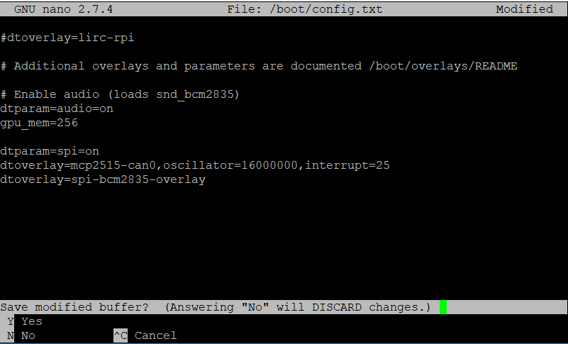
now press “Ctrl +x” and then “y” to confirm and finally “enter to save changes to your file .

Your CAN Module should now be available as “CAN0” . Now reboot your raspberry pi for the changes to take effect .
To reboot Type :

sudo reboot

Setup the ECU for CAN BUS (Adaptronic Modular)

In Eugene make shure the settings are as below .
( The bitrate depends on how much your CAN Module can handle, the PiCAN2 can handle 1 Mbps)
Bitrate : 1Mbps
Terminate : yes
Enable Adaptronic OutputMode : yes

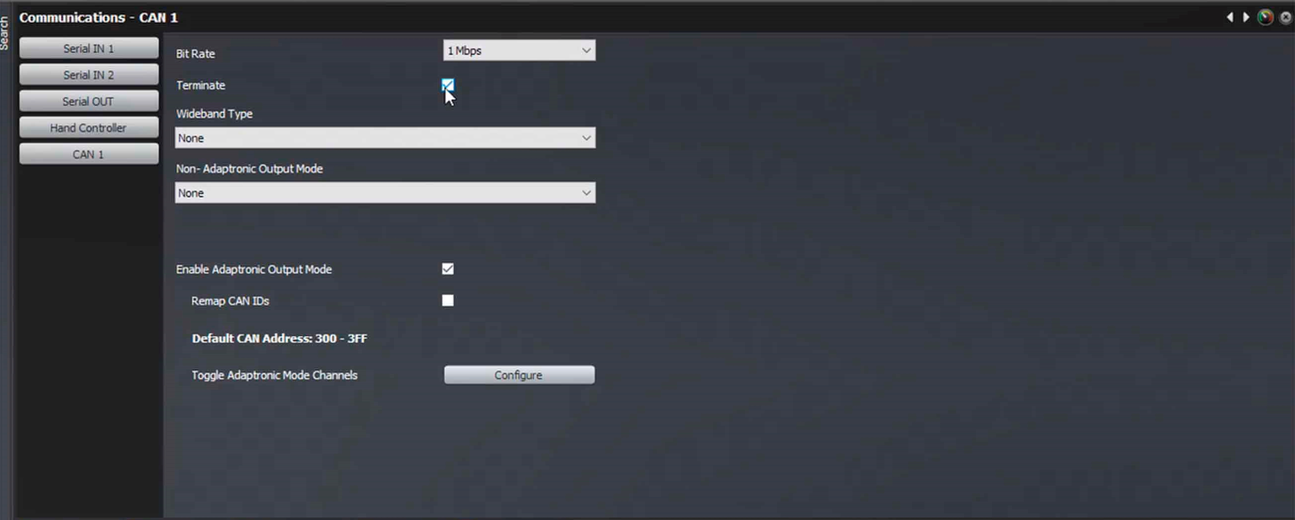

Wiring up the CAN BUS

To find the where the CAN High and CAN Low connectors are located on your ECU please refer to Adaptronics Website :

http://www.adaptronic.com.au/downloadpage/quick-download-for-installation-and-startup-guides-for-modular/

On your raspberry Pi please consult the Manufacturer of your CAN Module

Setup PowerTune for your ECU

After PowerTune has started up swipe till you get to the setup screen .
On ECU Selection select the ECU you want to use .
If you select a ECU thats connected via Serial choose the appropriate Serial Port .
Now Click connect and check if your ECU data is received . If everything works correct push the Autoconnect buton to the right side (This will remember your settings and will automatically connect with these settings at every startup)
