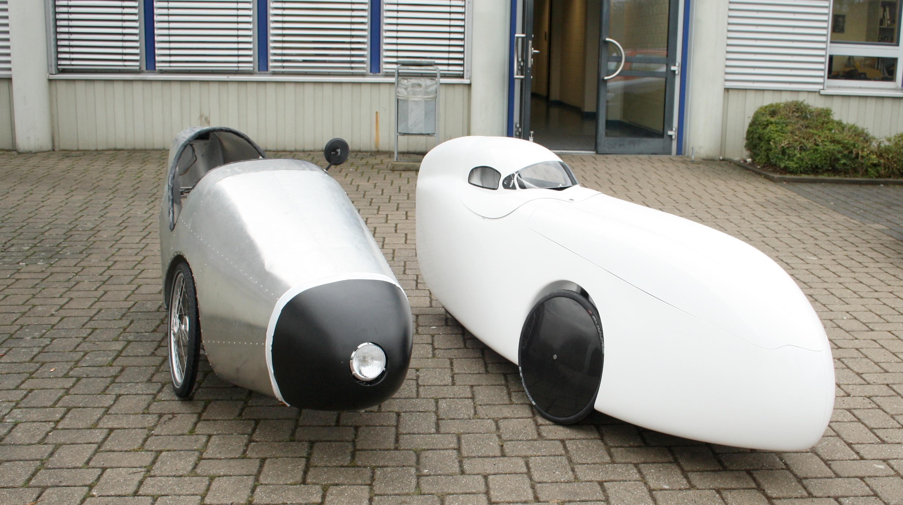 | Real World Optimization of Energy Efficient Vehicle Control

Title | Real World Optimization of Energy Efficient Vehicle Control
Context | BRSU: Internal project on efficient transportation
Module | R&D
Semester | 2-4
First Advisor | Prof. Dr. Alexander Asteroth  Tel. 02241-865 290, E-Mail: alexander.asteroth@h-brs.de
Second Advisor | To be decided
Language | English
Prerequisites | Basic knowledge of autonomous mobile robotics and machine learning techniques, interest or background in EE/hardware, interest in efficient transportation, good C/C++ programming skills, good grades in 1. semester
Project objectives | Energy efficient vehicle controller have the purpose to reduce the energy consumption of vehicles. Using such optimal controllers could help to save money and reduce CO2 emissions. But optimal control strategies are hard to come up with, even for known tracks and when computed offline. Previous approaches to energy efficient vehicle control include optimal control theory and graph search algorithms. Unfortunately solutions using optimal control theory can only be found under certain conditions and graph search algorithms need very much space for coming up with good approximations to the optimal solution.  A recent approach proposes the use of artificial neural networks and evolutionary strategies to come up with an optimal control strategy. One advantage of this approach is that the resulting strategies do not need much space. So far this approach has been applied only in simulation. But literature showed that transferring evolved solutions from simulation into reality usually yields suboptimal results (called “Reality Gap”). There have been approaches to address the Reality Gap problem in other domains, including the addition of noise, the use of more accurate models for simulation and the so-called transferability approach.  The target of this R&D is the real-world validation of an energy efficient vehicle controller designed by using evolutionary strategies and the application of methods to overcome the expected Reality Gap.
List of deliverables | Minimum  - Real world validation  - Model  - Controller behavior  - Comparison with  - Humans  - Naive approach (Cruise Control)  - Real valued versus Discrete motor commands  Expected  - Data driven vehicle model  - Reality Gap  and/or  - Parameter identification of more elaborate models  Maximum  - Multi-objective  - Optimization  - Performance  - Modeling
Management plan | - Biweekly project meetings  - Meetings with Prof. Asteroth from time to time  - Presentations after  - 3 month s  - 6 month s  - before colloquium
Milestones | - Proficient Knowledge about Evolutionary Strategies, Reality Gap, Energy Efficient Vehicle Controller and Non-linear System Identification  - Being familiar with hardware  - Improved Vehicle Model  - Working implementation of algorithms  - Real world evaluation results  - R&D report
Learning target | Proficient knowledge of ES and their application in autonomous mobile robotics.
Starting literature | [1] Gaier, Adam, and Alexander Asteroth. "Evolving look ahead controllers for energy optimal driving and path planning." Innovations in Intelligent Systems and Applications (INISTA) Proceedings, 2014 IEEE International Symposium on. IEEE, 2014.  [2] H.-G. Beyer, H.-P. Schwefel: Evolution Strategies – A com-  prehensive introduction, Natural Computing 1, pp. 3-52, Klu-  wer Academic Publishers, 2002  [3] Fröberg, Anders, Erik Hellström, and Lars Nielsen. Explicit fuel optimal speed profiles for heavy trucks on a set of topographic road profiles. No. 2006-01-1071. SAE Technical Paper, 2006.  [4] Stanley, Kenneth O., and Risto Miikkulainen. "Evolving neural networks through augmenting topologies." Evolutionary computation 10.2 (2002): 99-127.  [5] Koos, Sylvain, Jean-Baptiste Mouret, and Stéphane Doncieux. "The transferability approach: Crossing the reality gap in evolutionary robotics." Evolutionary Computation, IEEE Transactions on 17.1 (2013): 122-145.  [6] Nelles, Oliver. Nonlinear system identification: from classical approaches to neural networks and fuzzy models. Springer Science & Business Media, 2001.

