**Recall: A-Star**

* Describe how the A-Star algorithm works using a list of steps.
* What makes A-Star different from Dijkstra’s algorithm?

**Apply: Dijkstra’s Algorithm**

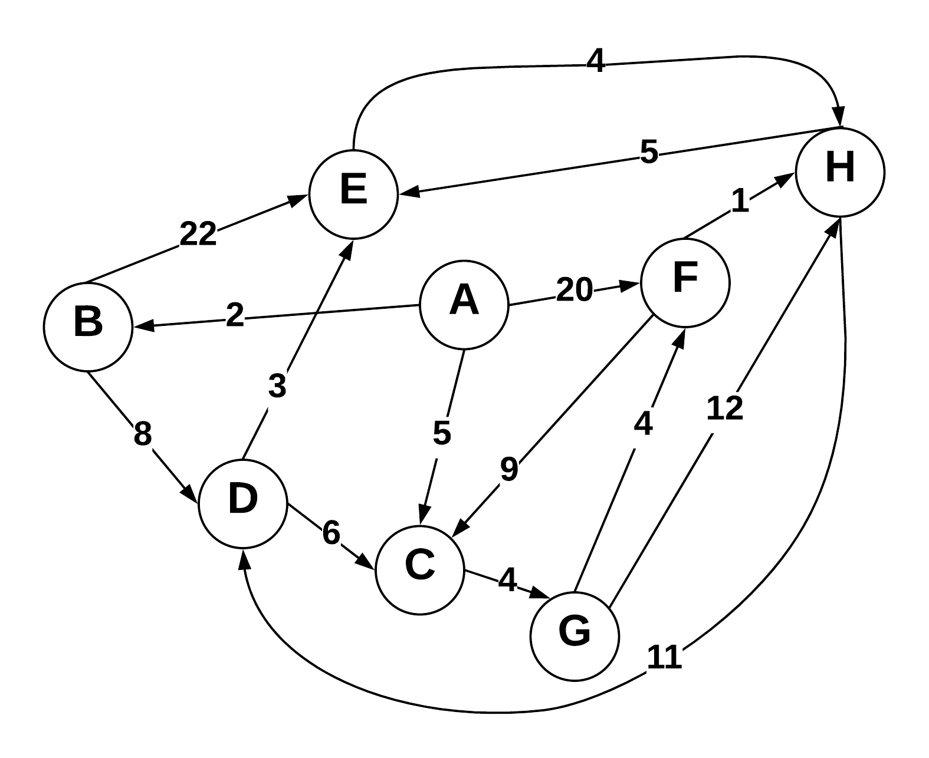

Use Dijkstra’s algorithm to compute the shortest paths from vertex A to every other vertex. Show your work in the space provided below. As the algorithm proceeds, cross out old values and write in new ones, from left to right in each cell. If during your algorithm two unvisited vertices have the same distance, use alphabetical order to determine which one is selected first. Also list the vertices in the order which Dijkstra's algorithm marks them as discovered.

Vertices in Order of Discovery:

|  |  |  |  |  |  |  |  |  |
| --- | --- | --- | --- | --- | --- | --- | --- | --- |
|  |  |  |  |  |  |  |  |  |

|  |  |  |  |
| --- | --- | --- | --- |
| Vertex | Known | Cost | Previous |
| A |  |  |  |
| B |  |  |  |
| C |  |  |  |
| D |  |  |  |
| E |  |  |  |
| F |  |  |  |
| G |  |  |  |
| H |  |  |  |