Working on the cluster

Bryam X. Astudillo  
www.bryamastudillo.com

Contents

To use Linux commands 2

Clone an environment 2

Others 2

Other stuff 3

Setting up Dingbin cluster 5

Scratch folder 6

## To use Linux commands

conda install m2-base

## Clone an environment

conda create --name myclone --clone myenv

## Others

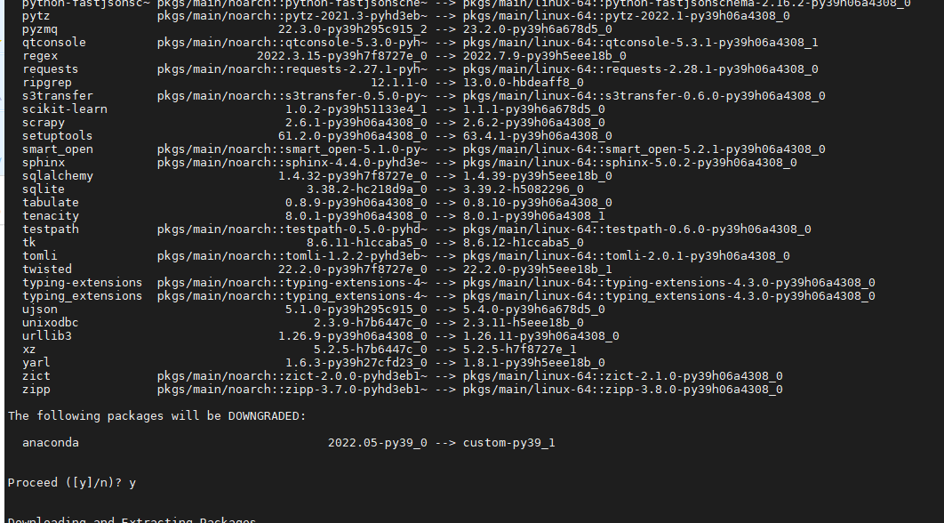

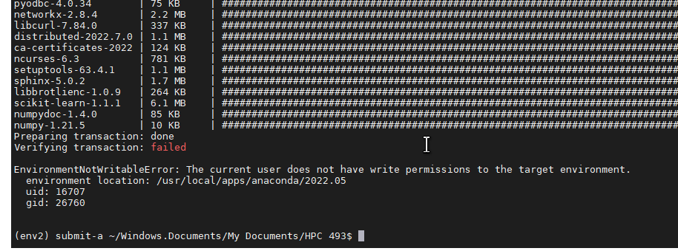

# Other stuff

# print('This message will be displayed on the screen.')

# original_stdout = sys.stdout # Save a reference to the original standard output

# with open('filename.txt', 'w') as f:

# sys.stdout = f # Change the standard output to the file we created.

# print('This message will be written to a file.')

# sys.stdout = original_stdout # Reset the standard outp

# module load anaconda

# source env1/bin/activate

# create and submit multiple jobs

#----------------

#srun -A cce -p share -n 1 python3 myCode.py $modulo_list &

# just in case sbatch is needed instead

# sed 's/modulo/$moduleo_list/' template.sh > test_$modulo_list\.sh

#sbatch test_$modulo_list\.sh

#--------

# from mpi4py import MPI

# comm = MPI.COMM_WORLD

# rank = comm.Get_rank()

# print(rank)

# mpiexec -4 python3 a.py

# pip install mpi4py

# module load openmpi

# squeue

#srun -A cce -p share -n 6 --pty bash

nano ~/.bashrc

#!/bin/bash

#SBATCH -J helloWorld # name of job

#SBATCH -A astudilb # name of my sponsored account, e.g. class or research group, NOT ONID!

#SBATCH -p share # name of partition or queue

#SBATCH -o helloWorld.out # name of output file for this submission script

#SBATCH -e helloWorld.err # name of error file for this submission script

# load any software environment module required for app (e.g. matlab, gcc, cuda)

module load software/version

# run my job (e.g. matlab, python)

mySoftwareExecutable

# Setting up Dingbin cluster

* go to <https://login.sherlock.stanford.edu/pun/sys/shell/ssh>
* ssh login.sherlock.stanford.edu
* insert Stanford password
* Accept duo request
* You are in the login node
* Ask for a development node

sdev

* module load python/3.9

python --version

not work. import openseespy.opensees as ops; import numpy as np

Create an environment

python3 -m venv myenv

source myenv/bin/activate

* Download MobaXterm to ease SHH connection.
* Go to sessions>> ssh >>
* Complete
* Sessions>>sftp
* Complete

Create the submit.sh

Create template.sh

Create RunFromCluster.py

sdev

cd folder

bash submit.sh

squeue -u bastudil

# Scratch folder

sshfs -o allow_other bastudil@login.sherlock.stanford.edu:/scratch/users/bastudil/ ~/sherlock_scratch

lfs quota -h /scratch/users/<username>

….

Stanford Sherlock provides a "scratch" file system that is optimized for high-performance I/O operations and is intended for temporary or intermediate files that do not need to be stored long-term. You can run your code in the scratch folder by copying your code and any necessary input files to the scratch file system and running your code from there.

Here are the steps to run your code in the scratch folder:

1. Log in to Sherlock and navigate to your home directory by typing **cd ~** in the terminal.
2. Create a new directory in the scratch file system by typing **mkdir /scratch/users/<username>/myproject** in the terminal, where **<username>** is your Sherlock username and **myproject** is the name of your project.
3. Copy your code and any necessary input files to the scratch folder by typing **cp -r /path/to/code /scratch/users/<username>/myproject** in the terminal. Replace **/path/to/code** with the path to your code and any input files.
4. Navigate to the scratch folder by typing **cd /scratch/users/<username>/myproject** in the terminal.
5. Run your code from the scratch folder by typing **./mycode** in the terminal, where **mycode** is the name of your code file.

sshfs -o allow_other bastudil@login.sherlock.stanford.edu:./ ~/sherlock_home

sshfs -o allow_other bastudil@login.sherlock.stanford.edu:/scratch/users/bastudil/ ~/sherlock_scratch

ssh bastudil@login.sherlock.stanford.edu