

**Tribhuvan University Faculty of Humanities and Social Science**

**ONLINE EXAMINATION MANAGEMENT SYSTEM**

**A PROJECT REPORT**

**Submitted to**

**Department of Computer Application**

**Birendra Multiple Campus**

***In partial fulfilment of the requirements for the Bachelors in Computer Application***

Submitted by

Name: Manish Pokharel

Under the Supervision of

**Soba Raj Poudel**



**Tribhuvan University**

**Faculty of Humanities and Social Science**

**Birendra Multiple Campus**

**Supervisor’s Recommendation**

I hereby recommend that this project prepared under my supervision by MANISH POKHAREL entitled **“ONLINE BILLING SYSTEM”** in partial fulfilment of the requirements for the degree of Bachelor of Computer Application is recommended for the final evaluation.

………………….

**SIGNATURE**

Soba Raj Poudel

**SUPERVISOR**

BCA

Bharatpur-10 Chitwan



**Tribhuvan University**

**Faculty of Humanities and Social Science**

**Birendra Multiple Campus**

**Letter Of Approval**

This is to certify that this project prepared by Manish Pokharel entitled “ONLINE BILLING SYSTEM” in partial fulfilment of the requirements for the degree of Bachelor in Computer Application has been evaluated. In our opinion it is satisfactory in the scope and quality as a project for the required degree.

|  |  |
| --- | --- |
| **………………………………**  Soba Raj Poudel  Supervisor  Department of computer Application  Birendra Multiple Campus  Bharatpur-10, Chitwan | **…………………………………..**  Soba Raj Poudel  Program Co-Ordinator  Department of computer Application  Birendra Multiple Campus  Bharatpur-10, Chitwan |
| **Internal Examiner** | **External Examiner** |

**Abstract**

**Online Billing system is very useful for the customer. They can purchase in their home are somewhere else from their location. They can see all the products and different types of products. They can order the product they wanted, it will be delivered within a week or days. the payment for the product will be done by online payment or else cast on delivery. So, the customer can pay for their convenience. After a few days, they will come and pick the product. We can buy another product.** The main motto of this project is to provide best quality clothes at reasonable price.

Acknowledgment

We are using this opportunity to express our gratitude to the Department of Computer

Science and Information Technology, Birendra Multiple Campus for providing us the

opportunity to explore our potentiality in the field of our interest through technology

via this project.

We would like to thank our Supervisor Soba Raj Poudel for his kind support,

Coordination and valuable supervision for this project. His useful suggestion for

this project and co-operative behavior are sincerely acknowledged.

We are also thankful to our HOD **Soba Raj Poudel**, Co-Ordinator

**Soba Raj Poudel,** faculty teachers and friends who persuaded, helped us for accomplishing this

project.

We would also like to acknowledge and extend our gratitude to everyone for his/her

support and encouragement for this project.

.

Table of Contents

Chapter 1: Introduction 1

1.1 Introduction 1

1.2 Problem Statement 1

1.3 Objectives 1

1.4 Scope and Limitation 2

1.5 Report Organization 2

Chapter2:BackgroundStudyandLiterature Review 4

2.1 BackgroundStudy 4

2.2 Literature Review 4

Chapter3:SystemAnalysisand Design 6

3.1 System Analysis 6

3.1.1 RequirementAnalysis 6

3.1.2 FeasibilityAnalysis 7

A. Technical Feasibility 7

• This project is developed using HTML, CSS, Php, MySQL etc. which are already available in the market so there are no technical hurdle to build this system. 7

• This system requires web server to serve the user of the software. 7

Software Requirements 7

3.1.3 DataModelling(ER-Diagram) 9

3.1.4 ProcessModelling(DFD) 9

3.2 System Design 10

3.2.1 ArchitecturalDesign 10

3.2.2 DatabaseSchemaDesign 11

3.2.3 InterfaceDesign 11

Chapter 4: Implementation and Testing 13

4.1 Implementation 13

4.1.1 Tools Used 13

4.1.2 ImplementationDetailsofModules 13

4.2 Testing 13

4.2.1 TestCases forUnit Testing 14

4.2.2 TestCases forSystem Testing 14

Chapter 5: Conclusion and Future Recommendations 15

5.1 Lesson Learnt/ Outcome 15

5.2 Conclusion 15

5.3 Future Recommendation 15

Appendices (Source Code/UI Interface 16

Chapter 6: References 22

List of Abbreviations

CSS: Cascading Style Sheet

HTML: Hypertext Markup Language

MYSQL: MY Structure Query Language

PHP: Hypertext Pre-processor

JavaScript

Xampp server

List of Figures

Figure 1: Use Case Diagram…………………………………………………6

Figure 2: ER Diagram……………………….……………………………….9

Figure 3: Level 0 DFD……………………………………………………….9

Figure 4: Level 1 DFD……………………………………………………...10

Figure 5: Two tier Architechtural Design…………………………………..10

Figure 6: Interface Design…………………………………………………..12

Figure 9: Dashboard (Admin) ………………………………………………16

Figure 11: User login page…………………………………………………16

List of Table

Table 1: Gantt Chart………………………………………………………..8

Table 2: System Testing…………………………………………………..14

# Introduction

## Introduction

The project " Billing System “is an application to automate the process of ordering and billing of a "Departmental Store ".This web based application is designed considering the chain of departmental store which is located in various cities. This application also administrates its users and customers.

The computer has brought revolution in every sphere of human life. Whether it is business, education field, governance, medical science etc. The computer has reduced the human work load, businesses are going global and everything is available at the click of mouse. The concept of e-shopping has been introduced and we can buy the products online and make payments through credit or debit cards.

Presently I am proposing the system “General Store Billing System”. The general stores issue their client handwritten bills and they enter details in manual registers. And maintain MS Excel file for product rate. So the proposed system will computerised their manual bill generation system

As stated above the general stores presently uses manual bills and hand written record to maintains their product list, customer list, and keep the invoice, there is lot of duplicate work, and chance of mistake. When the product prices are changed they need to update each and every hand written record.

There is no security; anybody can access any report and sensitive data, also there are no reports to find out the sales volume, stock list, and summary report. This Billing system is used to overcome the entire problem which the client is facing currently, and making complete atomization of manual billing system.

## Problem Statement

The problem of Onling billingis listed below:

1. Inability of modification of data
2. Not user friendly

## Objectives

The main objectives of these project are:

* To aid Customer, Products, Billing Generation
* To aid report Generation
* To develop a system that will be user friendly in all possible ways.
* To develop a system that provides easier work than existing system for the user.

## Scope and Limitation

### Scopes

1. This project will help the store keeper in fast billing.
2. This project enables to maintain a great database of all customers visited and purchase product from Departmental store.
3. Project will enable to see report regarding product and category.
4. Easy to maintain in future prospect.

### Limitations

* The app must be able to show the results from many online shopping sites with their prices side by side. This is the most challenging part in our product.
* It must be able to show the exact searched item with price and ratings. If the app is not able to do so then users will stop using the app.

## Report Organization

1. Daily Sales Report  
2. Monthly Customer Report  
3. Daily Product Report  
4. Due Date Report (Report of a particular Day)  
5. Billing Report

# Background Study and Literature Review

## Background Study

 Background of the Study Online Billing is one of the most in-demand systems all over the world. It’s because of the grossing industry of hotels and resorts. There are many advantages in this system like security for the owner, easy to use, and gives convenience to the customers. Security helps the owner and its crew to assure that the customers will not waste their time in reserving some facilities and owners can make plans.

.

## Literature Review

Billing system is very complex starting from network elements that generate usage to the billing system to usage collection, mediation, rating, and invoicing. The system user navigates through the company site and views company services, and he decides to order one of the available services. If he has no account, then he signs up for a new account, else he signs in. Then the user asks to conduct an order with the selected service. The service may be prepaid where he has to pay to have credits to use the service, or it may be postpaid, where he has to pay if the service has installation or set fees, and later on he will pay for his usage of each billing cycle.

The billing system should provide service to the user, collect user usage records, and generate invoices of each expired credit or due credit, each billing cycle depends on the billing type, collect payments and adjust customers’ balances.

Service is the entity offered by the company and targeted to the customers. Each service is defined by an engineering employee as a service catalog which includes service type, name, billing policy, and its default rating profile. After service ordering by the customer, it takes a unique attached with the account of the customer, provided by the provisioning system to the customer at a certain date.

# System Analysis and Design

## System Analysis

Before we begin a new system it is important to study the system that will be  
improved or replaced (if there is one). We need to analyze how this system  
uses hardware, software, network and the people resources to convert data  
resources, such as transaction data, into information products, such as  
reports and displays. Thus we should document how the information system  
activities of input, processing, output, storage and control are accomplished.

Waterfall model is used for this project. This project has fixed specification, ample time, enough resources and well understood technology. So, we used waterfall methodology to build this system.

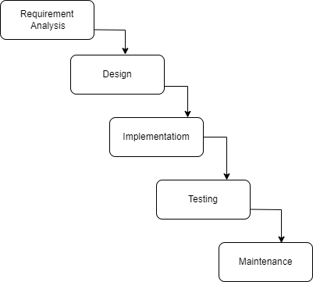

Figure ‑ Waterfall Model

### Requirement Analysis

Requirement analysis is done while developing a system and before implementing. It is categories into following two parts

1.Functional Requirements

2.Non-functional Requirements

#### Functional Requirements.

**1. User Registration:**

Registration is open to all visitors to Shop Via. Users can register to Shop Via by filling the necessary information in the Sign Up tab. User then selects appropriate Login credentials (Username and Password) to access his profile.

**2. Searching for the product:**

The users should be able to input the desired product and be able to search for the product.

**3. Getting the desired result:**

The user should be able to view the desired result and it must be easy to get the comparison prices.

**4. Logout :**

The user should be able to logout of the system easily

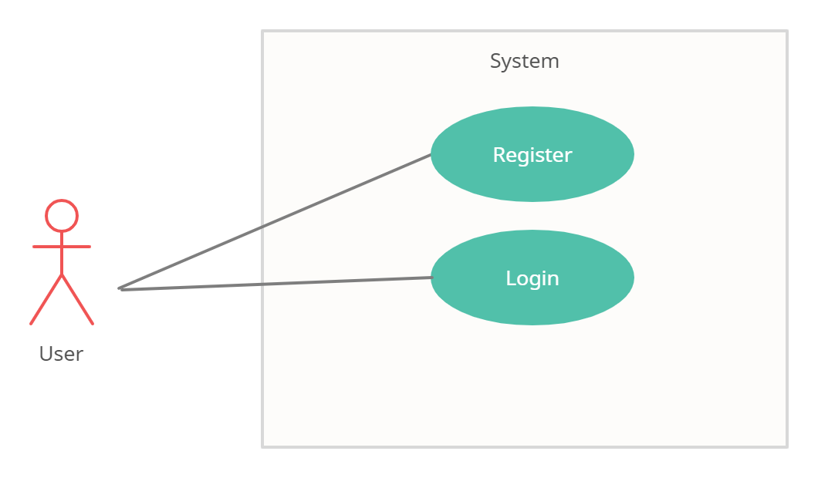

Figure ‑ Use case diagram

#### Non-Functional Requirements

Non-functional requirements define system attributes such as portability, reliability, scalability and usability. It specifies how the system work.

1. **Usability**

Nowadays almost all people have knowledge about the internet and e-commerce sites. So, our project is worth to almost all age groups.

1. **Reliability**

Our App is reliable in getting the data from the different sites.

1. **Safety**

The user information such as name, email, and password are protected and won’t be misused or shared with any third party

.

### Feasibility Analysis

Feasibility report for the computerization of the various activities of  
the company.

**1.Technical Feasibility**

Technical feasibility centers on the existing computer system ( hardware,  
software etc ) and to what extent it can support the proposed system  
addition. For example, if the current system is operating at 70% capacity ( an  
arbitrary value ), then another application could overload the system or  
require additional hardware. If the budget is serious constrain then the  
project is judged not feasible.  
The technologies and the environment which are used in this project are

**2.Operational Feasibility**

The System is operational feasible since the user are familiar with the technologies and hence there is no need to gear up the personnel to use the system. Also, the system is very user friendly and easy to use.

* Front end:

HTML

CSS

JavaScript

* Back end:

My SQL

PHP

**3. Economic Feasibility**

The procedure is to determine the benefits and savings that are expected  
from a candidate system and compare it with the costs. If a benefit outweighs  
costs, then the decision is made to design and implement the system.  
Otherwise further alterations are made in the proposed system.

1. Manpower cost  
2. Hardware and software cost

**4. Schedule Feasibility**

Schedule Feasibility is the probability of a project to be completed within its scheduled limits, by a planned due date.

Gantt Chart is a time framework required to conduct the projected activity. It gives clear concept of conducting activities timely.

Table 3‑1 Gantt chart

|  |  |  |  |  |  |  |  |  |  |  |  |  |
| --- | --- | --- | --- | --- | --- | --- | --- | --- | --- | --- | --- | --- |
| week  Phases | 1 | 2 | 3 | 4 | 5 | 6 | 7 | 8 | 9 | 10 | 11 | 12 |
| Study and Analysis |  |  |  |  |  |  |  |  |  |  |  |  |
| Design |  |  |  |  |  |  |  |  |  |  |  |  |
| coding |  |  |  |  |  |  |  |  |  |  |  |  |
| implementation |  |  |  |  |  |  |  |  |  |  |  |  |
| Testing |  |  |  |  |  |  |  |  |  |  |  |  |
| Documentation |  |  |  |  |  |  |  |  |  |  |  |  |
| Review |  |  |  |  |  |  |  |  |  |  |  |  |

### Data Modelling (ER Diagram)

This article will discuss the step by step process on how to prepare the entity relationship diagram or ERD of the project entitled Billing System.

The core feature of the [Billing](https://www.blogarama.com/search-posts/?search=billing) system is to record, store and save the information of customers, the transactions conducted that includes the billing information with attachment and charges information. Billing information can easily be search and printed which will make the transaction faster between the customer and the management.

In the Billing Management System we have the following entities

* User
* User Log
* Customer
* Billing
* Billing Information
* Attached File
* Charges
* Currency History

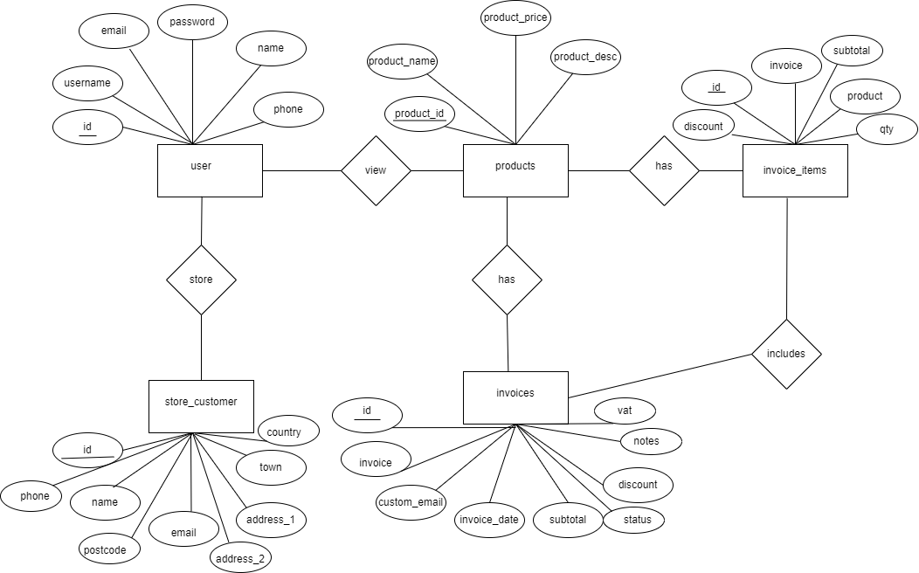

Figure 3‑3 ER Diagram

### Process Modelling (DFD)

A data flow diagram is graphical representation that depicts information flow and the transforms that are applied as data move from input to output. The basic form of data flow diagram is also known as data flow graph or bubble chart.

Product

Management

Sales

Management

Inventory

Management

Client management

Payment

Management

Discount

Management

Figure ‑ level DFD

This system has users and admin. Users can attend exam and view result. Admin can get information and insert/update data in database.

## System Design

### Architectural Design

**Online** **billing system** is a software stack of subsystems and components that creates bills and invoices for different consumers.

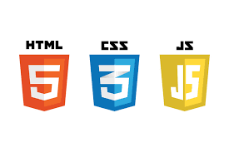



Figure ‑5Architectural Design

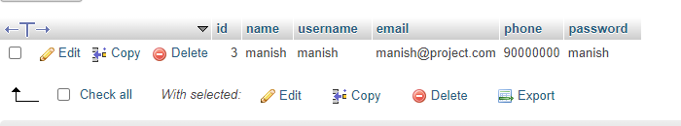

Figure 3‑6 Database users table

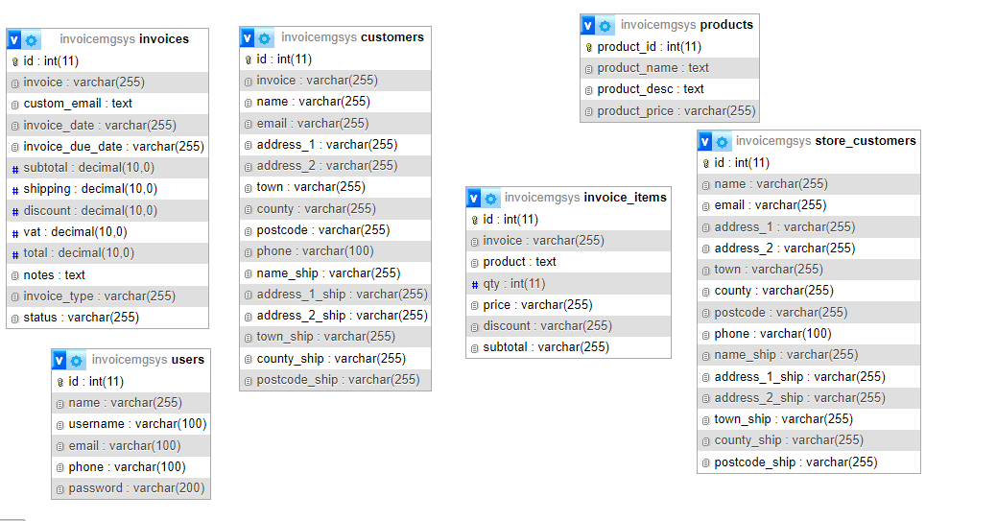

**Figure 3-7 Database Schema**

### Interface Design

User interface design creates an effective communication medium between a human and a computer. Following asset of interface design principles, design identifies objects and action and then creates a screen layout that forms the basis for a user interface prototype. Interface design of General Store Billing System is based on the following three principles

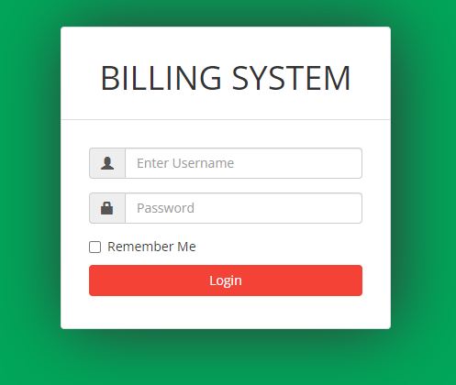

Figure 3‑7 login panel

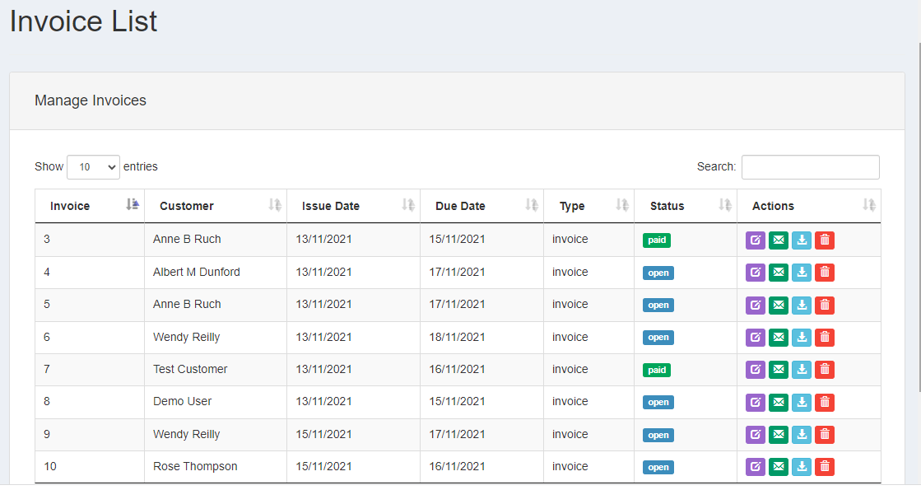

Figure 3‑8 Invoice list Panel

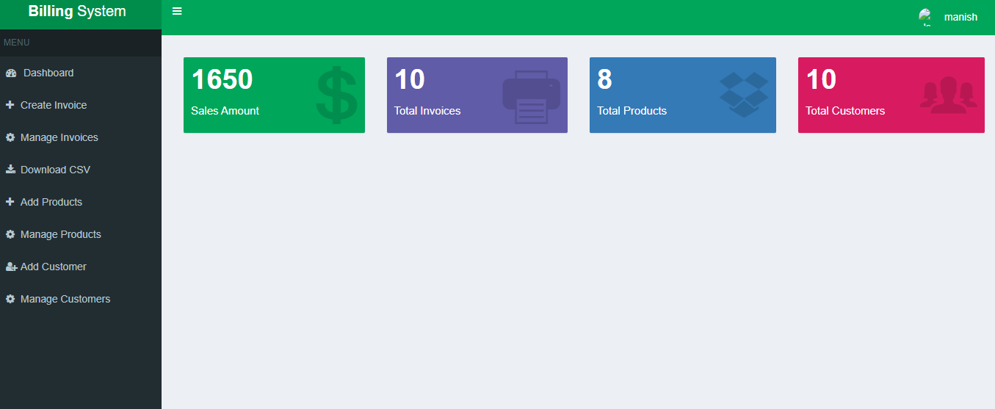

Figure 3‑9 Dashboard panel

# Implementation and Testing

## Implementation

Implementation is the logical conclusion, after evaluating, deciding, visioning, planning, applying, coding, testing and support. The project implementation phase involves the putting the project plan into action. This is the phase where the system is actually being built and converting the system design specification into working software.

### Tools Used

The various system tools that have been used in developing both the front-end and back-end of the project are being discussed in this chapter.

**Front end**

HTML, CSS, JavaScript are used for developing the front end.

**1.HTML (Hyper Text Markup Language)**

HTML is the standard markup language for documents designed to be displayed in a web browser.

**2.CSS (Cascading Style Sheets)**

CSS is a style sheet language used for describing the look for formatting of a document written in a markup language. It helps for better look of the website.

**3.JavaScript**

JavaScript is an object-oriented programming language commonly used to create interactive effects within web browsers. It is used to enhance HTML pages and is commonly found embedded in HTML code.

**Back end**

The back-end is implemented using PHP, MySQL.

**1.PHP**

PHP is a server-side scripting language designed for web development but also used as a general-purpose programming language. PHP code is interpreted by a web server with a PHP processor module, which generates the resultant web page.

**2.MySQl**

MySQL is easy to use, yet extremely powerful and secure. And because of its small size and speed, it is the ideal database solution for websites.

### Implementation Details of Modules

After the design was made and the problems arising from the design process were clarified and dealt with.

**INVENTORY MODULE**

This module is used where we can update our stock available and sold items. In the present module user (System Admin) can keep track record of sales if some item is sold it will be deducted from the database, we can also add new items stock to the database. At the end of the day we can view the particular item stock so as if the store is running out of any item we can update its stock.

**REPORTS** **MODULE**

 This module used to generate sales bill for every purchase made by the customer through invoice number which will be different for every customer. All the bills generated by this system are also updated in database. The General Store owner can generate day- to –day wise Invoice for keeping grand sales record for his use. Stock detail reports are also generated by present module.

.

## Testing

Testing is done to check the behavior of complete and fully integrated software products based on the software requirements specification of document. There are many types of tests to be carried out on a web application for performance, fuctionability, data loading time, response time, server time handling, users’ actions and many others. The testing phase of the software development life cycle is where it is focus on investigation and discovery. There are several types of testing during the test phase, including unit testing, system testing, quality assurance testing (QA), system integration testing (SIT), and user acceptance testing (UAT). Some of them are given below

### Test Cases for Unit Testing

Unit testing is defined as a type of software testing where individual concepts of software are tested and product is carried out during the development of application. Each module is considered independently, so it focuses on each unit of software as implemented in the source code. It is also a white box testing.

### Test Cases for System Testing

System testing is executing program to check logical changes made in with intentions of finding errors. A system is tested for online response, volume of transactions, recovery from failure etc. System testing is done to ensure that the system satisfies all the user requirements.

|  |  |  |  |
| --- | --- | --- | --- |
| **S.No** | **Test case** | **Condition** | **Expected Output** |
| 1 | Get Systems | Input Domain name | Print list of all system in current domains & response time |
| 2 | Get User | Input Domain name | System id, user id, port no, domain name |
| 3 | Get Processes details | Select process | Output the details of processes |
| 4 | Get modules details | Select process & select thread opt | Details of modules |
| 5 | Get thread details | Select process & select thread opt | Details of threads |
| 6 | Stop the processes | System id, user id, password | Process close |
| 7 | Stop the system | System id | System close |

Table 4‑1

**4.2.3Testing Analysis:**

|  |  |  |  |  |  |
| --- | --- | --- | --- | --- | --- |
| **S.No** | **Testing object** | **Expected value** | **Simulated value** | **Explanation** | **Remarks** |
| 1 | User name & Password | AEIND  GUEST | AEIND  GUEST | Equal of expected and simulated values | Pass |
| 2 | User name & Password | AEIND  GUEST | AEIND  GUEST | Unequal of expected and simulated value | Fail |
| 3 | Change password | GUESS | GUEST  (Old password) | Equal of these two passwords | Pass |
| 4 | Start time and end time | 11:03:05 | 11:03:05 | Equal of these times | Pass |
| 5 | Start date and end date | 02/01/2006 | 02/01/2006 | Equal of these dates | Pass |

**Table 4-1**

# Conclusion and Future Recommendations

## Lesson Learnt / Outcome

The following are the outcomes to be expected when the project is completed:

• **Automation of ordering and billing process**: The project aims to automate the

process of ordering and billing for a departmental store to make it faster and more

efficient.

• **User-friendly interface**: The project aims to provide an intuitive interface that is

easy to use, reducing the need for extensive training and improving productivity.

• **Report generation**: The project aims to make it easier to generate reports by

providing a system that can generate reports quickly and easily.

.

## Conclusion

This was our project of system design lab about “BILLING SYSTEM”. Development of this system takes a lot of efforts from us. We think this system gave a lot of satisfaction to all of us.

Though every task is never said to be perfect in a development field even more improvement may be possible in this system. We learned so many things and gained a lot of knowledge about development field. We hope this will prove fruitful to us.

## Future Recommendations

This system is simple for now but in coming future system will be updating so that it can be used professionally in near future. There is a future scope of this project that many more features would be added such as different kind of online paying methods and will be updating the reviews system on the products by the users. And some other updates will be added to this project on coming future thus making it more interactive more users friendly and project which fulfills each users need in the best way possible.

# References

[1] M. Takavingofa, Manzlee Retail Management System, Lazim: Great Zimbabwe

University, 2006.

[2] O. Obikoya, &quot;Design and Implementaion of Supermarket management system,&quot;

Academia, 3 May 2016. [Online]. Available: https://www.academia.edu. [Accessed 18

March 2023].

[3] S. Hassan, POS system (Shoe Retail System) Documentation, Chicago: System Works

Press, 2015.