1. Input 2 number and display their sum.

Code:

using System;

using System.Collections.Generic;

using System.Linq;

using System.Text;

namespace ConsoleApp1

{

class Program

{

static void Main(string[] args)

{

Console.WriteLine("Enter first number");

int a =Convert.ToInt32(Console.ReadLine());

Console.WriteLine("Enter second number");

int b = Convert.ToInt32(Console.ReadLine());

int c = a + b;

Console.WriteLine("The sum is " + c);

Console.ReadKey();

}

}

}

Output:

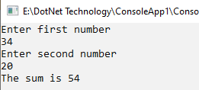

2. Area of rectangle.

Code:

using System;

using System.Collections.Generic;

using System.Linq;

using System.Text;

namespace ConsoleApp1

{

class Program

{

static void Main(string[] args)

{

Console.WriteLine("Enter length of rectangle");

int l =Convert.ToInt32(Console.ReadLine());

Console.WriteLine("Enter breadth of rectangle");

int b = Convert.ToInt32(Console.ReadLine());

int a = l \* b;

Console.WriteLine("The area of rectangle is " + a);

Console.ReadKey();

}

}

}

Output:

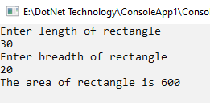

3. even or odd.

Code:

using System;

using System.Collections.Generic;

using System.Linq;

using System.Text;

namespace ConsoleApp1

{

class Program

{

static void Main(string[] args)

{

Console.WriteLine("Enter a number");

int n =Convert.ToInt32(Console.ReadLine());

if(n%2==0)

{

Console.WriteLine(n + " is an even number");

}

else

{

Console.WriteLine(n + " is odd number");

}

Console.ReadKey();

}

}

}

Output:

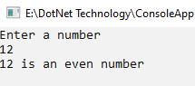

4. positive or negative.

Code:

using System;

using System.Collections.Generic;

using System.Linq;

using System.Text;

namespace ConsoleApp1

{

class Program

{

static void Main(string[] args)

{

Console.WriteLine("Enter a number");

int n =Convert.ToInt32(Console.ReadLine());

if(n>=0)

{

Console.WriteLine(n + " is positive number");

}

else

{

Console.WriteLine(n + " is negative number");

}

Console.ReadKey();

}

}

}

Output:

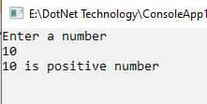

5. greatest among 3 numbers.

Code:

using System;

using System.Collections.Generic;

using System.Linq;

using System.Text;

namespace ConsoleApp1

{

class Program

{

static void Main(string[] args)

{

Console.WriteLine("Enter any 3 number");

int a = Convert.ToInt32(Console.ReadLine());

int b = Convert.ToInt32(Console.ReadLine());

int c = Convert.ToInt32(Console.ReadLine());

if(a>=b && a>=c)

{

Console.WriteLine(a + " is greatest number");

}

else if(b>=a && b>=c)

{

Console.WriteLine(b + " is greatest number");

}

else

{

Console.WriteLine(c + " is greatest number");

}

Console.ReadKey();

}

}

}

Output:

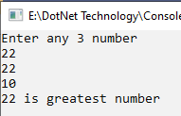

6. Wap to input 10 numbers and display their sum using for loop.

Code:

using System;

using System.Collections.Generic;

using System.Linq;

using System.Text;

namespace ConsoleApp1

{

class Program

{

static void Main(string[] args)

{

Console.WriteLine("Enter any 10 number");

int sum = 0;

for(int i=0;i<10;i++)

{

sum+= Convert.ToInt32(Console.ReadLine());

}

Console.WriteLine("The sum is " + sum);

Console.ReadKey();

}

}

}

Output:

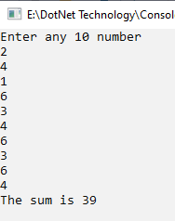

7. display factorial.

Code:

using System;

using System.Collections.Generic;

using System.Linq;

using System.Text;

namespace ConsoleApp1

{

class Program

{

static void Main(string[] args)

{

Console.WriteLine("Enter a number");

int n = Convert.ToInt32(Console.ReadLine());

int fact = 1;

for(int i=2;i<=n;i++)

{

fact \*= i;

}

Console.WriteLine("The factorial of "+n+" is " + fact);

Console.ReadKey();

}

}

}

Output:

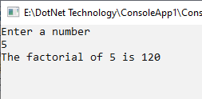

8. display series 1,2,3,4,…..,100.

Code:

using System;

using System.Collections.Generic;

using System.Linq;

using System.Text;

namespace ConsoleApp1

{

class Program

{

static void Main(string[] args)

{

for(int i=1;i<=100;i++)

{

Console.Write(i+" ");

}

Console.ReadKey();

}

}

}

Output:

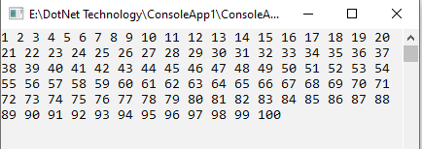

9. display series 1,3,5,7,……101.

Code:

using System;

using System.Collections.Generic;

using System.Linq;

using System.Text;

namespace ConsoleApp1

{

class Program

{

static void Main(string[] args)

{

for(int i=1;i<=101;i+=2)

{

Console.Write(i+" ");

}

Console.ReadKey();

}

}

}

Output:

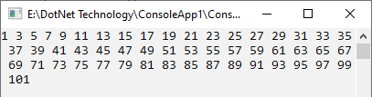

10. display series 1,4,9,16,…….,100.

Code:

using System;

using System.Collections.Generic;

using System.Linq;

using System.Text;

namespace ConsoleApp1

{

class Program

{

static void Main(string[] args)

{

for(int i=1;i<=10;i++)

{

Console.Write(i\*i +" ");

}

Console.ReadKey();

}

}

}

Output:

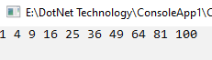

11. Wap to input a no. and display is it prime or not.

Code:

using System;

using System.Collections.Generic;

using System.Linq;

using System.Text;

namespace ConsoleApp1

{

class Program

{

static void Main(string[] args)

{

Console.WriteLine("Enter any number");

int n = Convert.ToInt32(Console.ReadLine());

int count=0;

for(int i=2;i<n;i++)

{

if (n % i == 0)

{

count++;

break;

}

}

if(count==1)

{

Console.WriteLine(n + " is a composite number");

}

else

{

Console.WriteLine(n + " is a prime number");

}

Console.ReadKey();

}

}

}

Output:

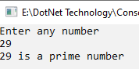

12. Wap to input a no. and display no. of digits in it.

Code:

using System;

using System.Collections.Generic;

using System.Linq;

using System.Text;

namespace ConsoleApp1

{

class Program

{

static void Main(string[] args)

{

Console.WriteLine("Enter any number");

int n = Convert.ToInt32(Console.ReadLine());

int m = n;

int count=0;

while(n!=0)

{

n = n/10;

count++;

}

Console.WriteLine(m + " has "+count+" digits");

Console.ReadKey();

}

}

}

Output:

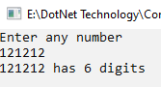

13. Wap to input a no. and display sum of digits.

Code:

using System;

using System.Collections.Generic;

using System.Linq;

using System.Text;

namespace ConsoleApp1

{

class Program

{

static void Main(string[] args)

{

Console.WriteLine("Enter any number");

int n = Convert.ToInt32(Console.ReadLine());

int m = n;

int rem,sum=0;

while(n!=0)

{

rem= n%10;

sum = sum + rem;

n = n / 10;

}

Console.WriteLine("The sum of digits of "+m+" is "+sum);

Console.ReadKey();

}

}

}

Output:

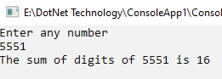

14. Wap to input a no. and display its reverse.

Code:

using System;

using System.Collections.Generic;

using System.Linq;

using System.Text;

namespace ConsoleApp1

{

class Program

{

static void Main(string[] args)

{

Console.WriteLine("Enter any number");

int n = Convert.ToInt32(Console.ReadLine());

int m = n;

int rem,rev=0;

while(n!=0)

{

rem= n%10;

rev = rev \* 10 + rem;

n = n / 10;

}

Console.WriteLine("The reverse of "+m+" is "+rev);

Console.ReadKey();

}

}

}

Output:

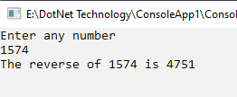

15. Wap to input a no. and display is it palindrome or not.

Code:

using System;

using System.Collections.Generic;

using System.Linq;

using System.Text;

namespace ConsoleApp1

{

class Program

{

static void Main(string[] args)

{

Console.WriteLine("Enter any number");

int n = Convert.ToInt32(Console.ReadLine());

int m = n;

int rem,rev=0;

while(n!=0)

{

rem= n%10;

rev = rev \* 10 + rem;

n = n / 10;

}

if(rev==m)

{

Console.WriteLine(m+" is a Palindrome number");

}

else

{

Console.WriteLine(m + " is not a palindrome number");

}

Console.ReadKey();

}

}

}

Output:

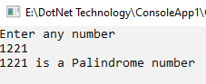

16. Wap to input a no. and display is it Armstrong or not.

Code:

using System;

using System.Collections.Generic;

using System.Linq;

using System.Text;

namespace ConsoleApp1

{

class Program

{

static void Main(string[] args)

{

Console.WriteLine("Enter any number");

int n = Convert.ToInt32(Console.ReadLine());

int temp1 = n;

int temp2 = n;

int rem,count=0;

double sum = 0;

while (n!=0)

{

n = n / 10;

count++;

}

while(temp1!=0)

{

rem = temp1 % 10;

sum = sum + Math.Pow(rem, count);

temp1 = temp1 / 10;

}

if(temp2==sum)

{

Console.WriteLine(temp2 +" is armstrong number");

}

else

{

Console.WriteLine(temp2 + " is not armstrong number");

}

Console.ReadKey();

}

}

}

Output:

