**Career Advancements of the Faculties of Higher Education**

##### A

##### MINOR PROJECT-II REPORT

Submitted in partial fulfillment of the requirements for the degree of

BACHELOR OF TECHNOLOGY

in

COMPUTER SCIENCE & ENGINEERING

By

GROUP NO.03

|  |  |
| --- | --- |
| **Anuj Raghuwanshi** | **0187CS221050** |
| **Basuki Nath pandey** | **0187CS221070** |

Under the guidance of **Mr. Ankit Gupta** (Associate Professor)

Department of Computer Science & Engineering

Sagar Institute of Science &Technology (SISTec), Bhopal (M.P)

**Approved by AICTE, New Delhi & Govt. of M.P.**

**Affiliated to Rajiv Gandhi Proudyogiki Vishwavidyalaya, Bhopal (M.P.)**

May - 2025

**Sagar Institute of Science & Technology (SISTec), Bhopal (M.P) Department of Computer Science & Engineering**



***CERTIFICATE***

We hereby certify that the work which is being presented in the B.Tech. Minor Project-I Report entitled **“Career Advancements of the Faculties of Higher Education”** in partial fulfillment of the requirements for the award of the degree of ***Bachelor of Technology,*** submitted to the Department of **Computer Science & Engineering**, Sagar Institute of Science & Technology (SISTec)**,**Bhopal (M.P.) is an authentic record of our own work carried out during the period from Feb-2025 to May-2025 under the supervision of **Mr. Ankit Gupta.**

The content presented in this project has not been submitted by me for the award of any other degree elsewhere.

**Anuj Raghuwanshi Basuki Nath pandey**

**0187CS221050 0187CS221070**

This is to certify that the above statement made by the candidate is correct to the best of my knowledge.

***Date:***

|  |  |  |
| --- | --- | --- |
| **Mr. Ankit Gupta** | **Mr. Nargish Gupta** | **Dr. Manish Billore** |
| **Project Guide** | **HOD, CSE** | **Principal** |

ACKNOWLEDGEMENT

We would like to express our sincere thanks to **Dr. Manish Billore**, **Principal, SISTec and Dr. Swati Saxena, Vice Principal SISTec** Gandhi Nagar, Bhopal for giving us an opportunity to undertake this project.

We also take this opportunity to express a deep sense of gratitude to **Mr. Nargish Gupta, HOD, Department of Computer Science & Engineering** for his kindhearted support

We extend our sincere and heartfelt thanks to our guide, **Mr. Ankit Gupta,** for providing us with the right guidance and advice at crucial junctures and for showing us the right way.

I am thankful to the **Project Coordinator, Prof. Mayank kurchaniya,** who devoted his precious time in giving us the information about various aspects and gave support and guidance at every point of time.

I would like to thank all those people who helped me directly or indirectly to complete my project whenever I found myself in any issue.

|  |  |
| --- | --- |
| **Table of Content** |  |
| **TITLE** | **PAGE NO.** |
| Abstract | i |
| List of Abbreviation | ii |
| List of Figures | iii |
| List of Tables | iv |
| Chapter 1 Introduction | 1 |
| 1.1 About Project | 2 |
| 1.2 Project Objectives | 3 |
| Chapter 2 Software & Hardware Requirements | 4 |
| 2.1 Software Requirements | 5 |
| 2.2 Hardware Requirements | 6 |
| Chapter 3 Problem Description | 7 |
| 3.1 Introduction | 8 |
| 3.2 Problem Statement | 8 |
| 3.3 Objectives of the Project | 9 |
| 3.4 Scope of the Project | 9 |
| 3.5 Challenges & Constraints | 10 |
| 3.6 Expected Outcomes | 10 |
| Chapter 4 Literature Survey | 11 |
| 4.1 Introduction to the Domain | 12 |
| 4.2 Current Technological Interventions | 12 |
| 4.3 Tools and Systems Already Available | 13 |
| 4.4 Environmental Impact and Policy Considerations | 13 |
| 4.5 Challenges and Future Directions | 14 |
| 4.6 Conclusion | 14 |
| Chapter 5 Software Requirements Specification | 15 |
| 5.1 Functional Requirements | 16 |
| 5.2 Non-Functional Requirements | 17 |
| 5.2.1 Performance | 17 |
| 5.2.2 Reliability | 17 |
| 5.2.3 Usability | 18 |

|  |  |  |
| --- | --- | --- |
| Chapter 6 | Software and Hardware Design | 19 |
|  | 6.1 Use Case Diagram | 20 |
|  | 6.2 Architecture | 21 |
| Chapter 7 | Coding | 22 |
|  | 7.1 Code Implementation | 23 |
| Chapter 8 | Result & Output Screens | 45 |
|  | 8.1 Results | 46 |
|  | 8.2 Output Screens | 47 |
| Chapter 9 | Conclusions & Future Work | 50 |
|  | 9.1 Conclusion | 51 |
|  | 9.2 Future Work | 51 |

References 53

Project summary 54

Appendix-1: Glossary of Terms 59

SISTec/BTech/CS/2024/5/MinorProject_I/3

ABSTRACT

The “**Career Advancements of the Faculties of Higher Education”** aims to develop a secure and user-friendly web-based system to automate the faculty self-appraisal process in higher education institutions. Traditional appraisal methods are often inefficient, paper-based, and lack transparency. This system allows faculty members to log and update their academic contributions—such as research publications, seminars, events, and projects—in real time. It features secure authentication, dynamic forms, a centralized database, and an admin panel for reviewing and downloading submissions. The platform enhances transparency, saves time, reduces paperwork, and supports data-driven decision-making by administrators, ultimately fostering a culture of continuous improvement and aligning with the Paperless India initiative..

SISTec/BTech/CS/2024/5/MinorProject_I/3

LIST OF ABBREVIATIONS

|  |  |
| --- | --- |
| **ACRONYM** | **FULL FORM** |
| API | Application Programming Interface |
| HTML | HyperText Markup Language |
| CSS | Cascading Style Sheet |
| JS | JavaScript |
| MVC | Model View Controller |
|  |  |
|  |  |
|  |  |
|  |  |
|  |  |
|  |  |

SISTec/BTech/CS/2024/5/MinorProject_I/3

LIST OF FIGURES

|  |  |  |
| --- | --- | --- |
| **FIG. NO.** | **TITLE** | **PAGE NO.** |
| 5.1 | Use Case Diagram | 23 |
| 8.2.1 | Login and Signup page | 48 |
| 8.2.2 | Signup Details and home page of app | 48 |
| 8.2.3 | Profile Details and Lab details | 49 |
| 8.2.4 | Whether Report and Soil Report Details | 49 |
| 8.2.5 | Lab Booking Details and Soil Test Tracker | 50 |
|  |  |  |
|  |  |  |
|  |  |  |
|  |  |  |
|  |  |  |
|  |  |  |
|  |  |  |
|  |  |  |
|  |  |  |



SISTec/BTech/CS/2024/5/MajorProject_I/3

**CHAPTER-1 INTRODUCTION**

###### ABOUT PROJECT

The **“Career Advancements of the Faculties of Higher Education”** is a web-based solution developed to modernize and simplify the traditional faculty self-appraisal process used in universities and higher education institutions. The project aims to eliminate the inefficiencies of paper-based systems by providing a digital platform that enables real-time tracking, submission, and evaluation of faculty academic and professional activities.

Faculty members can log in securely and submit their achievements, such as research publications, seminars attended, projects handled, lectures delivered, and other academic contributions through a structured self-appraisal form. The system ensures that all the data is stored safely in a centralized database, easily retrievable for evaluation purposes.

In addition to the faculty interface, the system includes a dedicated **Admin Panel** where authorized university officials can view all submissions, sort them by name, employee code, or date, and download them in PDF format for reporting and record-keeping. The platform also supports automated tracking of research publications by integrating with services like Google Scholar.

By implementing this system, the project not only ensures transparency and efficiency in faculty evaluations but also aligns with the broader objectives of digital transformation in education and sustainable paperless administration. It empowers both faculty and administrators to focus on professional growth, strategic planning, and quality enhancement in academic environments.

###### PROJECT OBJECTIVES

The primary objective of the **“ Career Advancements of the Faculties of Higher Education”** is to develop a secure, efficient, and user-friendly web-based platform that simplifies and digitizes the faculty self-appraisal process. The system aims to achieve the following key goals:

1. **Digitize Faculty Self-Appraisal**  
   Replace traditional paper-based appraisal forms with a digital, real-time submission system for academic activities and achievements.
2. **Enhance Transparency and Accuracy**  
   Provide a transparent system that ensures accurate recording and tracking of faculty contributions like publications, seminars, projects, and lectures.
3. **Automate Data Management**  
   Maintain a centralized and secure database that stores faculty records systematically, reducing manual errors and administrative burden.
4. **Simplify Administrative Evaluation**  
   Enable administrators to access, sort, filter, and download appraisal data efficiently through an interactive admin panel.
5. **Integrate Real-Time Updates**  
   Allow faculty members to update their activities anytime, ensuring that appraisal data is always up-to-date and reflective of current contributions.
6. **Support Paperless Initiatives**  
   Contribute to the “Paperless India” mission by reducing dependency on printed documents and physical filing systems.
7. **Improve Decision-Making**  
   Provide structured and consolidated reports to help university authorities make informed decisions regarding faculty promotions, rewards, and development.
8. **Ensure Data Security**  
   Implement secure login systems and access controls to protect sensitive user data and ensure only authorized access.



**CHAPTER-2 SOFTWARE AND HARDWARE REQUIREMENTS**

###### SOFTWARE REQUIREMENTS

The software components used in the application are essential for managing academic data, verifying publication authenticity, and providing an interactive and user-friendly platform for faculty members and administrators.

The specific requirements are as follows:

* + 1. **Development Tools**
       - **Frontend Development:**
         * HTML5, CSS, JavaScript
         * IDE: VS Code
       - **Backend Development:**
         * Firebase
         * JavaScript
    2. **APIs:**
       - Crossref REST API: For validating Publications.
       - Cloudinary API: For storing media files.
       - Firebase API: For user registration, storing and retrieving data.
    3. **User Requirements**
       - Modern Web Browser that supports HTML5, ES6 JavaScript and Firebase SDKs.
       - Operating System: Any
    4. **Firebase**

Firebase is used to store data like publications, projects, user profiles, seminar-logs and activity logs. Its scalability and fast querying enable efficient data management and real-time updates for users.

###### HARDWARE REQUIREMENTS

The hardware components ensure smooth functioning, development, and usage of the application. The specific requirements are as follows:

* + 1. **Developer Machines**
       - Processor : Quad-core or higher
       - RAM : Minimum 4GB
       - Storage : 128 GB
       - Operating System : Windows 10/11, macOS
    2. **Test Devices**
       - PC/Mobile Phones
       - Web Browsers
    3. **User Requirements**
       - Device: Smartphone or Tablet or PC
       - Processor: Dual-core or higher
       - RAM: 2GB OR higher

-



**CHAPTER-3 PROBLEM DESCRIPTION**

###### INTRODUCTION

Within many higher education institutions, the faculty self-appraisal process is still conducted using manual and paper-based systems. These traditional methods are often inefficient, time-consuming, and prone to human error, leading to delays, lack of transparency, and poor documentation of faculty contributions. Due to the absence of a centralized and automated system, tracking academic achievements such as research publications, seminars, workshops, and project involvements becomes a cumbersome task, hindering fair and timely career advancements.

Moreover, faculty members find it difficult to maintain organized records of their academic and professional growth, while administrators face challenges in evaluating faculty performance accurately and promptly. These limitations also restrict the institution’s ability to make data-driven decisions regarding promotions, recognitions, and resource allocations.

There is a strong need for a robust, secure, and real-time web-based system that can automate and digitize the entire faculty self-appraisal process. Such a system must enable faculty to easily log their achievements and administrators to access, sort, and evaluate data efficiently. This project addresses these challenges by developing a scalable and user-friendly platform aimed at enhancing the quality, transparency, and efficiency of faculty career advancement mechanisms in higher education institutions.

###### PROBLEM STATEMENT

The traditional faculty self-appraisal process in higher education is often manual, time-consuming, and lacks transparency. This project aims to develop a secure, user-friendly web-based system that digitizes and automates faculty self-assessment. It will allow faculty members to log academic activities such as research, seminars, lectures, and projects in real-time. The system will feature secure login, dynamic forms, and an admin panel for evaluation and PDF downloads. By streamlining data collection and providing real-time tracking and accessibility, the platform supports informed administrative decisions, promotes paperless practices, and fosters continuous professional development

###### OBJECTIVES OF THE PROJECT

The primary objectives of this project are as follows:

**To Digitize Faculty Self-Appraisal Processes**

Eliminate manual and paper-based self-appraisal systems by introducing a secure and efficient web-based platform

**To Enable Real-Time Activity Logging**

Allow faculty members to input and update their academic and professional activities — such as publications, seminars, workshops, and lectures — in real-time

**To Provide a Secure Authentication System**

Ensure secure registration and login for both faculty members and administrators to protect confidential academic data

**To Offer a User-Friendly Interface**

Develop a simple and intuitive user interface for easy navigation and data entry, minimizing training requirements.

**To Facilitate Efficient Data Management and Retrieval**

Store appraisal data securely in a centralized database and enable fast, structured access for administrative review

**To Support Informed Decision-Making**

Help administrators evaluate faculty performance based on organized, accurate, and up-to-date data for promotions and resource allocation.

**To Promote Transparency and Accountability**

Foster a transparent system that gives both faculty and administrators a clear view of academic contributions and progress.

**To Align with Sustainable and Paperless Initiatives**

Contribute to the "Paperless India" initiative by reducing the need for physical documentation and supporting digital transformation in academia.

###### 3.4 Scope of the Project

###### The project aims to develop a secure, web-based platform to automate the self-appraisal process for faculty members in higher education institutions. It will allow faculty to log and update their academic activities such as publications, seminars, events, and lectures in real-time. Administrators will be able to access, sort, and download appraisal data through a dedicated admin panel. The system will support secure login, user-friendly forms, and a centralized database, reducing paperwork and enhancing transparency. This platform is scalable and aligns with the goals of digital governance, continuous professional development, and the Paperless India initiative.

###### 3.5 CHALLENGES AND CONSTRAINTS

Despite the significant advantages of developing an automated faculty appraisal system, the project may face the following challenges and constraints

**Data Accuracy and Completeness**

Ensuring that faculty members enter complete and accurate data for all their activities is crucial. Incomplete or incorrect entries may affect performance evaluations.

**User Adoption Resistance**

Faculty members and administrators accustomed to traditional methods may initially resist shifting to a digital system, requiring orientation and training.

**Integration with Existing Systems**

Integrating the platform with other existing university systems (such as ERP, publication databases like Google Scholar, etc.) could be technically challenging.

**Security and Privacy Concerns**

Handling sensitive academic and personal data requires strong encryption and secure access control to prevent data breaches.

**Scalability for Large Institutions**

The system must be able to handle a large number of users and data entries without performance issues, especially in universities with a large faculty base.

**Limited Technical Infrastructure**

Some institutions may lack the technical infrastructure (e.g., high-speed internet, updated browsers) necessary for optimal use of the platform.

**Platform Compatibility**

Ensuring compatibility across multiple browsers and devices can be challenging but is necessary for universal accessibility.

**Maintenance and Updates**

Regular updates, bug fixes, and technical support will be required to keep the platform functional and up to date with changing academic processes.

**3.6 Expected Outcomes**

The project is expected to deliver a robust and user-friendly web-based system that simplifies and digitizes the faculty self-appraisal process in higher education. Faculty members will be able to easily log their academic contributions such as research papers, seminars, and events, while administrators will gain access to organized and downloadable appraisal reports for informed decision-making. The system will enhance transparency, reduce manual effort, and ensure secure handling of sensitive data. Overall, it will promote efficiency, data-driven evaluation, and support the vision of a paperless and modern academic ecosystem.



**CHAPTER-4 LITERATURE SURVEY**

###### INTRODUCTION TO THE DOMAIN

The domain of this project lies within Higher Education Management Systems, specifically focusing on Academic Human Resource Development. In modern academic institutions, maintaining the quality of education and encouraging faculty growth are essential for institutional success. Faculty appraisal is a key element of this process, as it helps evaluate teaching effectiveness, research contributions, participation in academic events, and overall engagement in institutional development.

Traditionally, faculty self-appraisal has been a manual, paper-based process that is often time-consuming, inconsistent, and prone to errors. With the advancement of digital technologies and the growing emphasis on paperless workflows, data-driven evaluation, and performance transparency, there is an urgent need to automate and modernize these processes.

This domain combines web development, database management, user authentication, and real-time data tracking to create efficient systems that streamline academic performance evaluations. By developing a secure and scalable web-based platform, this project contributes to digital transformation in higher education institutions, aligning with broader goals such as Digital India and academic excellence.

###### 

###### 4.2 Current Technological Interventions

Programs In the domain of faculty management and appraisal systems in higher education, several technological interventions have emerged to streamline and digitize the appraisal process. These interventions aim to enhance transparency, accuracy, and efficiency in tracking faculty activities and contributions.

**1. Enterprise Resource Planning (ERP) Systems**

Many universities and colleges have adopted ERP systems such as TCS iON, PeopleSoft, or SAP-based platforms. These systems help manage various academic and administrative functions, including limited support for faculty appraisals. However, most ERP solutions are complex, costly, and not specifically tailored for comprehensive academic performance evaluation.

**2. Google Scholar & Academic Databases**

Platforms like Google Scholar, Scopus, and Web of Science automatically track research publications, citations, and author metrics. These tools are widely used by institutions for assessing research output but do not integrate well with broader appraisal system

**4. Digital Forms and Cloud Storage**

Some institutions use tools like Google Forms, Microsoft Forms, and Excel Sheets stored in Google Drive or OneDrive for collecting self-appraisal data. While easy to implement, these solutions lack security, standardization, real-time analysis, and integrated admin dashboards.

**5. Custom Web-Based Portals**

A few universities have developed in-house web portals for faculty data management. These systems vary in functionality and often lack automation, real-time data integration, or scalability.

###### 4.1 Tools and Systems Already Available

Currently, faculty self-appraisal in many institutions is conducted through manual or semi-digital processes, such as paper-based forms or basic Excel sheets. Some universities use Learning Management Systems (LMS) or HR portals with limited features for faculty evaluation. While platforms like Google Scholar help track publications, and ERP systems manage basic employee data, they lack integration and real-time tracking of academic activities like seminars, projects, and lectures. These existing tools often fail to provide a comprehensive, user-friendly, and automated solution tailored specifically for holistic faculty appraisal and career advancement tracking

###### 4.2 ENVIRONMENTAL IMPACT AND POLICY CONSIDERATIONS

The proposed web-based system significantly reduces the need for paper-based documentation, contributing to eco-friendly and sustainable administrative practices. By digitizing the faculty appraisal process, it aligns with the **"Digital India"** and **"Paperless Office"** initiatives, minimizing environmental waste and carbon footprint. Furthermore, the system ensures compliance with institutional data privacy and security policies by incorporating secure login and data protection measures. Adhering to these policies not only protects user information but also promotes responsible and ethical data management in higher education.

###### CHALLENGES AND FUTURE DIRECTIONS

The development and deployment of the “**Career Advancements of the Faculties of Higher Education”** come with several challenges and opportunities for future growth. One of the primary challenges is ensuring the accuracy and authenticity of the data submitted by faculty members, especially regarding research publications, seminar participation, and project involvement. Manual data entry may lead to errors or inconsistencies, necessitating robust verification mechanisms. Another significant challenge lies in integrating the system with external platforms such as Google Scholar, Scopus, or institutional databases, which often require technical know-how and API-level access permissions. Additionally, user adoption can be a concern, particularly among faculty members who may not be familiar with digital platforms. Hence, designing a user-friendly interface and offering proper training and support becomes critical.

Security is also a major concern, as the system handles confidential academic and personal data. Implementing strong authentication protocols, encrypted storage, and access controls is essential to ensure data privacy. Furthermore, as the system scales to accommodate more users and institutions, maintaining performance and ensuring low latency becomes technically demanding. Administrative workload, despite automation, still exists in the form of data reviews and approvals, requiring efficient backend tools and possibly AI assistance in the future.

Looking forward, several future directions can enhance the effectiveness of the platform. Incorporating AI and machine learning can provide insightful analytics, such as performance trends or promotion-readiness suggestions. The development of a mobile application can significantly increase accessibility and ease of use. Automated tracking of publications by integrating with academic databases would further streamline data entry. Features like gamification can help increase user engagement, while multilingual support and accessibility options will ensure inclusivity for diverse faculty groups. Additionally, scaling the system to serve multiple institutions with customized modules could position it as a comprehensive and standard solution across higher education systems. These enhancements aim to make the appraisal process more dynamic, transparent, and aligned with modern academic and administrative needs.

**4.4 CONCLUSION**

The project **" Career Advancements of the Faculties of Higher Education"** addresses the pressing need to modernize and streamline the faculty self-appraisal process in academic institutions. Traditional methods of evaluation, often paper-based and inefficient, create bottlenecks in tracking faculty contributions and hinder transparency. This project proposes a web-based solution that integrates secure login systems, dynamic data entry forms, automated activity tracking, and a centralized admin panel—allowing for seamless monitoring, evaluation, and documentation of faculty achievements.

It not only fosters a culture of continuous improvement and professional development but also contributes to the national vision of a **paperless and digital India**. The platform, with its scalable and secure architecture, lays the foundation for future enhancements.

In conclusion, this project presents a comprehensive and sustainable solution to an existing academic challenge, reinforcing transparency, efficiency, and accountability in faculty appraisal processes. It serves as a significant step toward transforming the higher education landscape through smart and innovative digital interventions.



**CHAPTER-5** **SOFTWARE REQUIREMENTS SPECIFICATION**

###### FUNCTIONAL REQUIREMENTS

The functional requirements of the application outline the core functionalities the system must perform. These requirements define the operations the app is expected to perform, ensuring it provides a seamless, efficient, and user-centric experience that fulfills its intended purpose of managing academic activities such as publications, projects, and seminars.

**1. User Authentication & Management**

* Users must be able to sign up and log in using email/password
* Only authenticated users can access or manage publications, projects, and seminars.
* Users can log out securely.

**2. Publication Management**

* Users can add a publication with the following fields:
* Title, Type, Journal Name, Date, DOI, Co-authors, Indexed In, Role, Abstract, File Upload (PDF), etc.
* System should verify DOI by fetching data from the Crossref API.
* The system should prevent duplicate submissions by checking for existing DOI entries.

**3. Project and Seminar Tracking**

* Users can log projects and seminars with title, description, collaborators, date, etc.
* Seminar entries should support an "Ongoing" checkbox that disables and fills in the end date.

**4. Activity Feed**

* System automatically logs activities: "Publication Added", "Project Logged", "Seminar Recorded"

**5. File Upload Support**

* Users can upload PDFs and images related to publications.
* Files are uploaded to Cloudinary and their URLs are saved to Firestore.

**6. Filtration**

* Admin can filter records based on names, departments, etc.

###### NON-FUNCTIONAL REQUIREMENTS

The ***“Career Advancements of the Faculties of Higher Education”*** is designed to meet several key non-functional requirements. Performance is a priority, ensuring fast response times for data retrieval and form submissions, even under high user load. Scalability is essential, enabling the system to accommodate increasing users and data without performance degradation. Reliability is crucial, with minimal downtime to ensure continuous access and functionality. Security is implemented through strong encryption and access controls to protect sensitive faculty data, ensuring privacy. Additionally, the system prioritizes usability with an intuitive interface that requires minimal training

**5.2.1 PERFORMANCE**

The performance of the ***“Career Advancements of the Faculties of Higher Education”*** is a critical non-functional aspect that directly impacts user satisfaction and system efficiency. The system is designed to ensure fast response times during form submissions, data retrieval, and admin-side operations, even under high user load. It should be optimized to handle concurrent requests without causing delays or timeouts. Real-time updates of faculty activities such as research publications, event participation, and seminars must be reflected instantly in the system. Efficient database queries, optimized backend services, and lightweight frontend components ensure smooth and uninterrupted interactions. This high-performance capability supports quick decision-making and seamless usage for both faculty members and university administrators, even during peak usage times such as appraisal periods.

**5.2.2 RELIABILITY**

Reliability ensures the system operates consistently with minimal downtime **“*Career Advancements of the Faculties of Higher Education*”** will feature robust error handling, automatic recovery mechanisms, and continuous monitoring to prevent disruptions and data loss, ensuring stable performance over time.

**5.2.3 MAINTAINABILITY**

User Maintainability ensures the system can be easily updated, modified, and fixed. It will feature clear documentation and modular architecture to simplify troubleshooting, updates, and enhancements over time.

* + 1. **USABILITY**

The Usability focuses on creating an intuitive and user-friendly interface, allowing faculty and administrators to navigate the system with ease. The system should require minimal training, ensuring a smooth experience for all users.

* + 1. **SECURITY**

User Security ensures the protection of sensitive faculty data through encryption, secure user authentication, and strict access controls. The system will safeguard user privacy and prevent unauthorized access, maintaining data integrity.



**CHAPTER-6 SOFTWARE AND HARDWARE DESIGN**

###### USE CASE DIAGRAM

The use case diagram for the **Career Advancement of faculties of Higher Education** demonstrates the interaction between various actors and the system, highlighting the key functionalities and how they connect to external entities. Below is an outline of the use case diagram:

**Key Elements:**

* + - **Actors:** Represent users or other systems interacting with the app.
    - **Use Cases:** Denote the actions or services the system performs for the user.

**Description:**

The primary actor in this system is the **Faculty Member**, who interacts with the web-based platform to manage their self-appraisal data. Faculty can register, log in securely, and fill out a detailed appraisal form that includes personal details, academic qualifications, research publications, seminars, lectures, projects, and event participations.

The **University Administrator** accesses the Admin Panel to monitor, sort, and evaluate submitted appraisals. Admins can view entries by faculty name, employee code, or submission date and download appraisal reports in PDF format.

Below is the Use-Case diagram:-

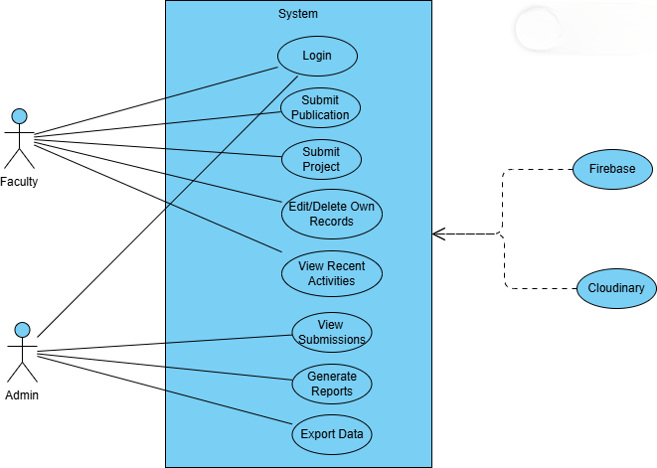

**Figure 5.1: Use Case Diagram**

###### ARCHITECTURE

The architecture of your Faculty Achievement Management System can be designed using a three-tier architecture for scalability, maintainability, and clarity. Here's a breakdown of the project architecture:

1. **Client Tier (Frontend)**

* Technology: HTML, CSS, JavaScript
* Libraries/Tools: Firebase SDK, Cloudinary API

**Functionality:**

* User Interface for login, forms (publication, project, seminar).
* Input validation and event handling.
* Handles file uploads using Cloudinary.
* Calls Firebase functions for authentication and data storage

1. **Application Tier (Logic/Service Layer)**

* Technology: JavaScript (modules/functions)

**Functionality:**

* Authentication: Firebase Authentication
* Storing & retrieving publications, projects, seminars.
* Verifying DOI metadata via CrossRef API.
* Managing role-based access (e.g., Admin vs Faculty).
* Activity logging and filtering.

1. **Data Tier (Backend/Storage)**

* Databases: Firebase Firestore

**Storage:**

* Firebase Firestore for structured data (publications, user info, logs).
* Cloudinary for file storage (PDFs, images).

.**Data Flow:**

* 1. User interact with the application.
  2. Uses Firebase Auth to confirm the user's identity.
  3. Receives form inputs from the user and Uploads files to Cloudinary using upload_preset
  4. Saves data into Firestore Collections.
  5. Displays the UI elements (list of publications, activity logs, etc.)



**CHAPTER-7 CODING**

###### 8.1 CODE IMPLEMENTATION:

The project uses HTML, CSS, and JavaScript for the frontend interface. User authentication is handled through Firebase Authentication. Upon login, users can submit publications, projects, and seminar logs via structured forms.

Data is validated and sent to Firebase Firestore, where it's stored under collections like Publications, Projects, and Seminars, each tagged by userId. PDF and image files are uploaded to Cloudinary, and the returned URLs are saved in Firestore.

DOI metadata is fetched using the CrossRef API to autofill publication details. Recent activities are recorded in an Activsvvities collection and displayed on the dashboard. The dashboard also loads user-specific entries and shows statistics and recent actions dynamically.

### Home.html

<!DOCTYPE html>

<html lang="en">

<head>

<meta charset="UTF-8">

<meta name="viewport" content="width=device-width, initial-scale=1.0">

<title>ScholaTrek - Faculty Self-Appraisal System</title>

<link rel="stylesheet" href="CSS/home.css">

</head>

<body>

<header>

<div class="container">

<nav>

<button class="hamburger" onclick="openNav()">&#9776;</button>

<div class="logo">

<h1>Schola<span>Trek</span></h1>

</div>

<ul class="nav-links">

<button class="close-btn" onclick="closeNav()">&#10006;</button>

<li><a href="#home">Home</a></li>

<li><a href="#features">Features</a></li>

<li><a href="#how-it-works">How It Works</a></li>

<li><a href="#about">About</a></li>

<li><a href="#Contact">Contact</a></li>

</ul>

<div class="auth-buttons">

<!-- <button class="btn btn-outline">Login</button> -->

<a href="auth.html"><button class="btn btn-primary">Login</button></a>

</div>

</nav>

</div>

</header>

<section class="hero" id="home">

<div class="container">

<h2>Revolutionizing Faculty Self-Appraisal</h2>

<p>ScholaTrek is a comprehensive web-based platform designed to streamline and modernize the faculty self-appraisal process in higher education institutions.</p>

<div class="auth-buttons">

<a href="auth.html"><button class="btn btn-primary">Get Started</button></a>

</div>

</div>

</section>

<section class="features" id="features">

<div class="container">

<div class="section-title">

<h2>Key Features</h2>

<p>Discover how ScholaTrek transforms the traditional faculty evaluation process into a seamless digital experience.</p>

</div>

<div class="feature-grid">

<div class="feature-card">

<div class="feature-icon">📊</div>

<h3>Real-Time Updates</h3>

<p>Update academic achievements, research publications, and professional activities in real-time, eliminating delays associated with traditional methods.</p>

</div>

<div class="feature-card">

<div class="feature-icon">📱</div>

<h3>User-Friendly Interface</h3>

<p>Intuitive design requires minimal training for faculty members and administrators to navigate efficiently.</p>

</div>

<div class="feature-card">

<div class="feature-icon">📝</div>

<h3>Comprehensive Forms</h3>

<p>Capture detailed information about research publications, event participation, seminars, projects, and lectures.</p>

</div>

<div class="feature-card">

<div class="feature-icon">👨‍💼</div>

<h3>Admin Panel</h3>

<p>Administrators can view, sort, and download appraisal data in PDF format for informed decision-making.</p>

</div>

<div class="feature-card">

<div class="feature-icon">🔒</div>

<h3>Secure Access</h3>

<p>Robust authentication ensures that faculty data remains confidential and accessible only to authorized personnel.</p>

</div>

<div class="feature-card">

<div class="feature-icon">🌱</div>

<h3>Paperless Solution</h3>

<p>Supports sustainable practices by eliminating the need for paper-based documentation.</p>

</div>

</div>

</div>

</section>

<section class="how-it-works" id="how-it-works">

<div class="container">

<div class="section-title">

<h2>How It Works</h2>

<p>ScholaTrek simplifies the faculty self-appraisal process through a few easy steps.</p>

</div>

<div class="steps">

<div class="step">

<div class="step-number">1</div>

<h3>Register</h3>

<p>Faculty members securely register with their institutional credentials.</p>

</div>

<div class="step">

<div class="step-number">2</div>

<h3>Input Data</h3>

<p>Enter details about academic achievements, research publications, and professional activities.</p>

</div>

<div class="step">

<div class="step-number">3</div>

<h3>Regular Updates</h3>

<p>Update information in real-time as new achievements and activities occur.</p>

</div>

<div class="step">

<div class="step-number">4</div>

<h3>Review & Submit</h3>

<p>Review compiled data and submit for administrative evaluation.</p>

</div>

</div>

</div>

</section>

<section class="testimonials" id="about">

<div class="container">

<div class="section-title">

<h2>What Educators Say</h2>

<p>Hear from faculty members and administrators who have transformed their appraisal process with ScholaTrek.</p>

</div>

<div class="testimonial-grid">

<div class="testimonial-card">

<p class="testimonial-text">"ScholaTrek has revolutionized how I track my academic achievements. The real-time updates and user-friendly interface have made self-appraisal a breeze."</p>

<div class="testimonial-author">

<div>

<h4>Dr. Sarah Johnson</h4>

<p>Professor of Computer Science</p>

</div>

</div>

</div>

<div class="testimonial-card">

<p class="testimonial-text">"As an administrator, ScholaTrek has provided unprecedented transparency and efficiency in our faculty evaluation process. The sorting and export features save hours of work."</p>

<div class="testimonial-author">

<div>

<h4>Dr. Michael Chang</h4>

<p>Dean of Engineering</p>

</div>

</div>

</div>

<div class="testimonial-card">

<p class="testimonial-text">"The comprehensive tracking of research publications and academic engagements has helped me identify areas for professional growth. ScholaTrek is an invaluable tool."</p>

<div class="testimonial-author">

<div>

<h4>Dr. Emily Rodriguez</h4>

<p>Associate Professor of Biology</p>

</div>

</div>

</div>

</div>

</div>

</section>

<section class="cta" id="Contact">

<div class="container">

<h2>Ready to Transform Your Faculty Appraisal Process?</h2>

<p>Join academic institutions across the country that have embraced ScholaTrek for streamlined, transparent, and efficient faculty self-appraisal.</p>

<a href="auth.html"><button class="btn btn-primary">Explore Dashboard</button></a>

</div>

</section>

<footer>

<div class="container">

<div class="footer-content">

<div class="footer-column">

<h3>Schola<span>Trek</span></h3>

<p>Revolutionizing faculty self-appraisal in higher education through innovative technology.</p>

</div>

<div class="footer-column">

<h3>Quick Links</h3>

<ul>

<li><a href="#home">Home</a></li>

<li><a href="#features">Features</a></li>

<li><a href="#how-it-works">How It Works</a></li>

<li><a href="#about">About Us</a></li>

<li><a href="#Contact">Contact</a></li>

</ul>

</div>

<div class="footer-column">

<h3>Resources</h3>

<ul>

<li><a href="#">User Guide</a></li>

<li><a href="#">FAQ</a></li>

<li><a href="#">Blog</a></li>

<li><a href="#">Support</a></li>

</ul>

</div>

<div class="footer-column">

<h3>Contact Us</h3>

<ul>

<li>Email: info@scholatrek.com</li>

<li>Phone: (123) 456-7890</li>

</ul>

</div>

</div>

<div class="copyright">

<p>&copy; 2025 ScholaTrek. All rights reserved.</p>

</div>

</div>

</footer>

<script>

function openNav() {

document.querySelector(".nav-links").classList.add("show");

document.querySelector(".close-btn").style.display = "block";

}

function closeNav() {

document.querySelector(".nav-links").classList.remove("show");

document.querySelector(".close-btn").style.display = "none";

}

</script>

</body>

</html>

**Auth.html**

<!DOCTYPE html>

<html lang="en">

<head>

<meta charset="UTF-8">

<meta name="viewport" content="width=device-width, initial-scale=1.0">

<title>ScholaTrek - Faculty Self-Appraisal System</title>

<link rel="stylesheet" href="CSS/auth.css">

<script src="https://kit.fontawesome.com/075e655501.js" crossorigin="anonymous"></script></head>

<script type="module" src="JS/firebaseConfig.js"></script>

<script type="module" src="JS/auth.js" defer></script>

</head>

<body>

<div class="container">

<div class="info-side">

<div class="logo-container">

<a href="Home.html"><div class="logo-text">Schola<span>Trek</span></div></a>

</div>

<div class="tagline">Tracking academic contributions and growth.</div>

<div class="feature-item">

<div class="feature-icon">📊</div>

<div class="feature-text">Real-Time Performance Insights</div>

</div>

<div class="feature-item">

<div class="feature-icon">⏱</div>

<div class="feature-text">Monitor time spent on specific topics</div>

</div>

<div class="feature-item last-feature ">

<div class="feature-icon">🔍</div>

<div class="feature-text">Ensures transparency, efficiency, and data-driven performance evaluation.</div>

</div>

<div class="copyright">© 2025 ScholaTrek. All rights reserved.</div>

</div>

<div class="form-side">

<div class="form-container">

<div class="tab-container">

<div class="tabs">

<div class="tab active" id="login-tab">Login</div>

<div class="tab" id="signup-tab">Sign Up</div>

</div>

</div>

<form class="form active" id="login-form">

<div class="welcome-text">Welcome Back</div>

<div class="form-group">

<label for="login-email">Email Address</label>

<input type="email" id="login-email" placeholder="Enter your email" required autocomplete="off">

</div>

<div class="form-group">

<label for="login-password">Password</label>

<input type="password" id="login-password" placeholder="Enter your password" required autocomplete="off">

<span id="toggle-password">

<i class="fa-solid fa-eye-slash"></i>

</span>

</div>

<div class="form-footer">

<div class="remember-me">

<input type="checkbox" id="remember">

<label for="remember">Remember me</label>

</div>

<a href="#" class="forgot-password">Forgot Password?</a>

</div>

<button type="submit" class="submit-btn">Login</button>

<div class="divider">

<!-- <span class="divider-text">OR</span> -->

</div>

<!-- <div class="social-login">

<div class="social-btn"><i class="fa-brands fa-google fa-lg"></i></div>

<div class="social-btn"><i class="fa-brands fa-linkedin fa-lg"></i></div>

<div class="social-btn"><i class="fa-brands fa-github fa-lg"></i></div>

</div> -->

<div class="terms">

By logging in, you agree to our <a href="#">Terms of Service</a> and <a href="#">Privacy Policy</a>

</div>

</form>

<form id="signup-form" class="form">

<div class="welcome-text">Create Account</div>

<div class="user-type-container">

<div class="user-type active" id="faculty-type">

<h4>Faculty</h4>

<p>For teaching staff</p>

</div>

<div class="user-type" id="admin-type">

<h4>Admin</h4>

<p>For admins</p>

</div>

</div>

<!-- Type -->

<input type="hidden" id="user-type" name="user-type" value="faculty">

<div class="form-group">

<label for="full-name">Full Name</label>

<input type="text" id="full-name" placeholder="Enter your full name" required autocomplete="off">

</div>

<div class="form-group">

<label for="signup-email">Email Address</label>

<input type="email" id="signup-email" placeholder="Enter your email address" required autocomplete="off">

</div>

<div class="form-group">

<label for="employee-code">Employee Code</label>

<input type="text" id="employee-code" placeholder="Enter your employee code" required autocomplete="off">

</div>

<div class="form-group">

<label for="employee-code">College Code</label>

<input type="text" id="college-code" placeholder="Enter your employee code" required autocomplete="off">

</div>

<div class="form-group">

<label for="department">Department</label>

<select id="department" required autocomplete="off">

<option value="">Select Department</option>

<option value="cs">Computer Science</option>

<option value="ee">Electrical Engineering</option>

<option value="me">Mechanical Engineering</option>

<option value="ce">Civil Engineering</option>

<option value="hs">Humanities & Social Sciences</option>

<option value="ms">Management Studies</option>

</select>

</div>

<div class="form-group">

<label for="signup-password">Password</label>

<input type="password" id="signup-password" placeholder="Create a password" required autocomplete="off">

</div>

<div class="form-group">

<label for="confirm-password">Confirm Password</label>

<input type="password" id="confirm-password" placeholder="Confirm your password" required autocomplete="off">

</div>

<button type="submit" class="submit-btn" id="signup-btn">Create Account</button>

<div class="terms">

By creating an account, you agree to our <a href="#">Terms of Service</a> and <a href="#">Privacy Policy</a>

</div>

</form>

</div>

</div>

</div>

</body>

</html>

### FacultyDashboard.html

### <!DOCTYPE html>

### <html lang="en">

### <head>

### <meta charset="UTF-8" />

### <meta name="viewport" content="width=device-width, initial-scale=1.0" />

### <title>ScholaTrek - Faculty Dashboard</title>

### <link rel="stylesheet" href="CSS/dashboard.css" />

### <script type="module" src="JS/firebaseConfig.js" defer></script>

### <script type="module" src="JS/Fetch_Profile.js"></script>

### <script type="module" src="JS/AddPubliation.js"></script>

### <!-- Fetch Publications -->

### <script type="module" src="JS/FetchPublications.js"></script>

### <!-- sweet-alert -->

### <link href="https://cdn.jsdelivr.net/npm/@sweetalert2/theme-dark@4/dark.css" rel="stylesheet">

### <script src="https://cdn.jsdelivr.net/npm/sweetalert2@11/dist/sweetalert2.min.js"></script>

### <!-- font awesome -->

### <script

### src="https://kit.fontawesome.com/075e655501.js"

### crossorigin="anonymous"

### ></script>

### </head>

### <body>

### <div class="dashboard-container">

### <div class="sidebar">

### <div class="sidebar-logo">

### <h2>

### <span class="schola">Schola</span><span class="trek">Trek</span>

### </h2>

### </div>

### 

### <div class="menu-section">Main</div>

### <ul class="sidebar-menu">

### <li><a href="#" class="active">📊 <span>Dashboard</span></a></li>

### <li><a href="#">📝 <span>Appraisal</span></a></li>

### <li><a href="#">📚 <span>Publications</span></a></li>

### <li><a href="#">🎯 <span>Projects</span></a></li>

### </ul>

### <div class="menu-section">Activities</div>

### <ul class="sidebar-menu">

### <li><a href="#">🏫 <span>Seminars</span></a></li>

### <!-- <li><a href="#">📅 <span>Events</span></a></li> -->

### </ul>

### <div class="menu-section">Account</div>

### <ul class="sidebar-menu">

### <li>

### <a href="#"><i class="fa-solid fa-gear"></i> <span>Settings</span></a>

### </li>

### </ul>

### </div>

### <!-- Main Content -->

### <div class="main-content" id="mainContent">

### <!-- Top Bar -->

### <div class="top-bar">

### <div class="page-title">

### <h1>Faculty Dashboard</h1>

### </div>

### <div class="user-actions">

### <div class="user-profile" onclick="toggleProfileCard()">

### <div class="profile-initial" id="user-initial"></div>

### <div class="user-info">

### <div class="user-name" id="user-name"></div>

### </div>

### </div>

### <!-- Profile Card -->

### <div id="profile-card" class="profile-card">

### <div class="card-header"></div>

### <div class="card-content">

### <div class="initial-circle" id="profile-initial"></div>

### <h2 class="user-name" id="profile-name">Loading...</h2>

### <h4 id="user-role">Loading...</h4>

### <div class="info-item">

### <label for="user-email">Email :-</label> <span id="user-email">Loading...</span>

### </div>

### <div class="info-item">

### <label for="user-employee-code">Employee-Code :-</label> <span id="user-employee-code">Loading...</span>

### </div>

### <div class="info-item">

### <label for="user-department">Department :-</label> <span id="user-department">Loading...</span>

### </div>

### <button class="logout-btn" id="logout-button"><i class="fa-solid fa-right-from-bracket"></i> <span>Log out</span></button>

### </div>

### </div>

### </div>

### </div>

### <!-- Quick Actions -->

### <div class="dashboard-section">

### <div class="quick-actions">

### <a href="Appraisal_form.html" class="action-button">

### <div class="action-icon">📝</div>

### <div class="action-label">New Appraisal</div>

### </a>

### <a href="#publication" class="action-button">

### <div class="action-icon">📚</div>

### <div class="action-label">Add Publication</div>

### </a>

### <a href="seminarLog.html" class="action-button">

### <div class="action-icon">🏫</div>

### <div class="action-label">Log Seminar</div>

### </a>

### <a href="AddProject.html" class="action-button">

### <div class="action-icon">🎯</div>

### <div class="action-label">Add Project</div>

### </a>

### </div>

### </div>

### <!-- Dashboard Stats -->

### <div class="dashboard-section">

### <div class="dashboard-cards">

### <div class="card stat-card">

### <div class="stat-icon">📚</div>

### <div class="stat-info">

### <h3 id="publication-count">0</h3>

### <p>Research Publications</p>

### </div>

### </div>

### <div class="card stat-card">

### <div class="stat-icon">🎯</div>

### <div class="stat-info">

### <h3 id="project-count">0</h3>

### <p>Active Projects</p>

### </div>

### </div>

### <div class="card stat-card">

### <div class="stat-icon">🏫</div>

### <div class="stat-info">

### <h3>0</h3>

### <p>Seminars Conducted</p>

### </div>

### </div>

### </div>

### </div>

### <!-- Activity Charts -->

### <!-- <div class="dashboard-section">

### <div class="chart-container">

### <div class="chart-header">

### <div class="chart-title">

### <h3>Academic Performance Overview</h3>

### </div>

### <div class="chart-filters">

### <select>

### <option>Last 6 Months</option>

### <option>Last Year</option>

### <option>All Time</option>

### </select>

### </div>

### </div>

### <!-- Two Column Layout -->

### <div class="two-columns">

### <!-- Recent Publications -->

### <div class="card">

### <div class="section-title">

### <h2>Recent Publications</h2>

### <a href="#">View All</a>

### </div>

### <ul class="item-list" id="Publication-list">

### </ul>

### <p id="no-publications-msg" style="display: none; color: gray; text-align: center;">

### No Publications Found

### </p>

### </div>

### <!-- Upcoming Events -->

### <!-- <div class="card">

### <div class="section-title">

### <h2>Upcoming Events</h2>

### <a href="#">View All</a>

### </div>

### <ul class="item-list event-list">

### <li class="list-item">

### <div class="event-date">

### <span class="month">Apr</span>

### <span class="day">12</span>

### </div>

### <div class="event-details">

### <h4>Educational Technology Conference</h4>

### <p>Virtual Event</p>

### </div>

### </li>

### </ul>

### </div> -->

### </div>

### <!-- Recent Activities -->

### <div class="dashboard-section">

### <div class="section-title">

### <h2>Recent Activities</h2>

### </div>

### <div class="activities-list" id="recent-activity-list">

### <div class="activity-item">

### <div class="activity-icon">

### <i>📚</i>

### </div>

### <div class="activity-details" id="recent-activity-list">

### <h4>Publication Added</h4>

### <p>

### You added a new publication "Innovative Approaches to Faculty

### Self-Appraisal in Higher Education"

### </p>

### </div>

### <div class="activity-time">2 days ago</div>

### </div>

### </div>

### </div>

### <!-- Quick Entry Form -->

### <div class="form-section" id="publication">

### <h3 class="form-title">Quick Entry - Add Publication</h3>

### <form>

### <div class="form-row">

### <div class="form-group">

### <label class="form-label" >Publication Title</label>

### <input

### type="text"

### class="form-input"

### placeholder="Enter publication title" id="Publication_title" required

### />

### </div>

### <div class="form-group">

### <label class="form-label">Publication Type</label>

### <select class="form-input" id="Publication_type" required>

### <option disabled selected>Select</option>

### <option>Journal Article</option>

### <option>Conference Paper</option>

### <option>Book Chapter</option>

### <option>Book</option>

### <option>Other</option>

### </select>

### </div>

### </div>

### <div class="form-row">

### <div class="form-group">

### <label class="form-label">Journal/Conference Name</label>

### <input

### type="text"

### class="form-input"

### placeholder="Enter journal or conference name" id="Publication_journal" required

### />

### </div>

### <div class="form-group">

### <label class="form-label">Publication Date</label>

### <input type="date" class="form-input" id="Publication_date" required/>

### </div>

### </div>

### <div class="form-row">

### <div class="form-group">

### <label class="form-label">DOI</label>

### <input

### type="text"

### class="form-input"

### placeholder="Enter DOI" id="Publication_DOI" required

### />

### </div>

### <div class="form-group">

### <label class="form-label">Co-authors</label>

### <input

### type="text"

### class="form-input"

### placeholder="Enter co-authors (comma separated)" id="Publication_CoAuthors"

### />

### </div>

### </div>

### <div class="form-row">

### <div class="form-group">

### <label class="form-label">Indexed In</label>

### <select class="form-input" id="Publication_Indexed" required>

### <option disabled selected>Select</option>

### <option>Scopus</option>

### <option>Web of Science</option>

### <option>Google Scholar</option>

### <option>UGC Care</option>

### <option>None</option>

### </select>

### </div>

### <div class="form-group">

### <label class="form-label">Author Role</label>

### <select class="form-input" id="Author_Role" required>

### <option disabled selected>Select</option>

### <option>First Author</option>

### <option>Corresponding Author</option>

### <option>Co-author</option>

### </select>

### </div>

### </div>

### <div class="form-row">

### <div class="form-group">

### <label class="form-label">Upload Publication PDF</label>

### <input type="file" class="form-input" accept=".pdf" id="Publication_pdf" required/>

### </div>

### <div class="form-group">

### <label class="form-label"

### >Upload Indexing Proof</label

### >

### <input type="file" class="form-input" accept=".pdf,.jpg,.png" id="Publication_Indexing" required/>

### </div>

### </div>

### <div class="form-row">

### <div class="form-group" style="width: 100%">

### <label class="form-label">Abstract</label>

### <textarea

### class="form-input"

### rows="4"

### placeholder="Enter abstract here..." id="Publication_text" required

### ></textarea>

### </div>

### </div>

### <div class="form-row form-buttons">

### <div class="verify-group">

### <button type="button" id="Verify-Button" class="btn-cancel">Verify</button>

### <div id="result"></div>

### </div>

### <div class="action-buttons">

### <button type="button" class="btn-cancel" id="cancel-button">Cancel</button>

### <button type="submit" class="form-submit" id="submit-button" disabled>

### Submit Publication

### </button>

### </div>

### </div>

### </form>

### </div>

### </div>

### </div>

### </body>

### <script>

### function toggleProfileCard() {

### const card = document.getElementById("profile-card");

### card.style.display = card.style.display === "block" ? "none" : "block";

### }

### // Hide profile card when clicking outside

### document.addEventListener("click", function (event) {

### const profile = document.querySelector(".user-profile");

### const card = document.getElementById("profile-card");

### if (!profile.contains(event.target) && !card.contains(event.target)) {

### card.style.display = "none";

### }

### });

### </script>

### </html>

### AdminDashboard.html

<!DOCTYPE html>

<html lang="en">

<head>

<meta charset="UTF-8">

<meta name="viewport" content="width=device-width, initial-scale=1.0">

<title>Faculty Self-Appraisal Admin Panel</title>

<link rel="stylesheet" href="CSS/Admin.css">

<script src="https://kit.fontawesome.com/075e655501.js" crossorigin="anonymous"></script>

</head>

<body>

<div class="container">

<button class="hamburger" id="hamburger">&#9776;</button> <!-- Unicode for ☰ -->

<!-- Sidebar Navigation -->

<div class="sidebar">

<div class="logo">

<h2>Schola<span>Trek</span></h2>

</div>

<div class="nav-menu">

<div class="menu-item active">

📊

<span>Dashboard</span>

</div>

<div class="menu-item">

📝

<span>Submissions</span>

</div>

<div class="menu-item">

👨‍🏫

<span>Faculty Directory</span>

</div>

<div class="menu-item">

📈

<span>Reports</span>

</div>

<div class="menu-item">

⚙

<span>Settings</span>

</div>

<div class="menu-item">

🔍

<span>Advanced Search</span>

</div>

<div class="menu-item">

📤

<span>Export Data</span>

</div>

<div class="menu-item">

❓

<span>Help</span>

</div>

</div>

</div>

<!-- Main Content Area -->

<div class="main-content">

<div class="header">

<h1>Admin Dashboard</h1>

<div class="user-profile">

<div class="profile-img">A</div>

<span>Admin User</span>

</div>

</div>

<!-- Dashboard Stats -->

<div class="stats-container">

<div class="stat-card">

<div class="stat-icon">📝</div>

<div class="stat-title">Total Submissions</div>

<div class="stat-value">247</div>

</div>

<div class="stat-card">

<div class="stat-icon">⏳</div>

<div class="stat-title">Pending Review</div>

<div class="stat-value">42</div>

</div>

<div class="stat-card">

<div class="stat-icon">✅</div>

<div class="stat-title">Reviewed</div>

<div class="stat-value">205</div>

</div>

<div class="stat-card">

<div class="stat-icon">📊</div>

<div class="stat-title">Publications</div>

<div class="stat-value">183</div>

</div>

</div>

<!-- Search & Filter -->

<div class="search-container">

<input type="text" class="search-box" placeholder="Search by name, employee code, or department...">

</div>

<div class="filter-options">

<select class="filter-select">

<option>Sort by: Name</option>

<option>Sort by: Employee Code</option>

<option>Sort by: Date of Submission</option>

<option>Sort by: Department</option>

</select>

<select class="filter-select">

<option>Status: All</option>

<option>Status: Pending</option>

<option>Status: Reviewed</option>

</select>

<select class="filter-select">

<option>Department: All</option>

<option>Department: Computer Science</option>

<option>Department: Engineering</option>

<option>Department: Management</option>

<option>Department: Humanities</option>

</select>

</div>

<div class="action-buttons">

<button class="btn btn-primary">

📥 Download All

</button>

<button class="btn btn-secondary">

📊 Generate Report

</button>

</div>

<!-- Submissions Table -->

<table class="data-table">

<thead>

<tr>

<th>Faculty Name</th>

<th>EmployeeCode</th>

<th>Department</th>

<th>SubmissionDate</th>

<th>Publications</th>

<th>Status</th>

<th>Actions</th>

</tr>

</thead>

<tbody>

<tr>

<td>Dr. Rajesh Kumar</td>

<td>FAC001</td>

<td>Computer Science</td>

<td>24 Mar 2025</td>

<td>12</td>

<td><span class="status status-reviewed">Reviewed</span></td>

<td class="action-cell">

<button class="action-btn view-btn" onclick="openModal()">View</button>

<button class="action-btn download-btn">PDF</button>

</td>

</tr>

<tr>

<td>Prof. Ananya Singh</td>

<td>FAC018</td>

<td>Management</td>

<td>01 Apr 2025</td>

<td>5</td>

<td><span class="status status-pending">Pending</span></td>

<td class="action-cell">

<button class="action-btn view-btn" onclick="openModal()">View</button>

<button class="action-btn download-btn">PDF</button>

</td>

</tr>

<tr>

<td>Dr. Mehta Patel</td>

<td>FAC042</td>

<td>Engineering</td>

<td>28 Mar 2025</td>

<td>8</td>

<td><span class="status status-reviewed">Reviewed</span></td>

<td class="action-cell">

<button class="action-btn view-btn" onclick="openModal()">View</button>

<button class="action-btn download-btn">PDF</button>

</td>

</tr>

<tr>

<td>Prof. David Wilson</td>

<td>FAC056</td>

<td>Humanities</td>

<td>02 Apr 2025</td>

<td>4</td>

<td><span class="status status-pending">Pending</span></td>

<td class="action-cell">

<button class="action-btn view-btn" onclick="openModal()">View</button>

<button class="action-btn download-btn">PDF</button>

</td>

</tr>

<tr>

<td>Dr. Sunita Desai</td>

<td>FAC073</td>

<td>Computer Science</td>

<td>31 Mar 2025</td>

<td>15</td>

<td><span class="status status-reviewed">Reviewed</span></td>

<td class="action-cell">

<button class="action-btn view-btn" onclick="openModal()">View</button>

<button class="action-btn download-btn">PDF</button>

</td>

</tr>

</tbody>

</table>

<!-- Pagination -->

<div class="pagination">

<div class="page-item">Prev</div>

<div class="page-item active">1</div>

<div class="page-item">2</div>

<div class="page-item">3</div>

<div class="page-item">Next</div>

</div>

</div>

</div>

<!-- Modal for Faculty Details -->

<div class="modal" id="facultyModal">

<div class="modal-content">

<span class="close-modal" onclick="closeModal()">&times;</span>

<div class="modal-header">

<h2>Faculty Self-Appraisal Details</h2>

</div>

<div class="faculty-info">

<div class="info-group">

<div class="info-label">Name</div>

<div class="info-value">Dr. Rajesh Kumar</div>

</div>

<div class="info-group">

<div class="info-label">Employee Code</div>

<div class="info-value">FAC001</div>

</div>

<div class="info-group">

<div class="info-label">Department</div>

<div class="info-value">Computer Science</div>

</div>

<div class="info-group">

<div class="info-label">Designation</div>

<div class="info-value">Associate Professor</div>

</div>

<div class="info-group">

<div class="info-label">Email</div>

<div class="info-value">rajesh.kumar@university.edu</div>

</div>

<div class="info-group">

<div class="info-label">Submission Date</div>

<div class="info-value">24 Mar 2025</div>

</div>

<div class="info-group">

<div class="info-label">Teaching Experience</div>

<div class="info-value">12 years</div>

</div>

<div class="info-group">

<div class="info-label">Status</div>

<div class="info-value"><span class="status status-reviewed">Reviewed</span></div>

</div>

</div>

<div class="activity-section">

<div class="section-title">Research Publications</div>

<ul>

<li>Kumar, R., & Smith, J. (2024). "Advanced Machine Learning Algorithms for Medical Diagnosis." Journal of AI in Healthcare, 15(2), 112-128.</li>

<li>Kumar, R., Patel, S., & Johnson, D. (2024). "Neural Networks in Image Processing: A Comprehensive Review." IEEE Transactions on Image Processing, 29(4), 1845-1860.</li>

<li>Wilson, P., & Kumar, R. (2023). "Cloud Computing Architectures for Big Data Analytics." International Journal of Cloud Computing, 8(3), 224-241.</li>

</ul>

</div>

<div class="activity-section">

<div class="section-title">Seminars & Conferences</div>

<ul>

<li>International Conference on Computer Science and Information Technology (ICCSIT), Speaker, "Future of AI in Education," March 2025</li>

<li>Workshop on Data Privacy, Organizer, University Campus, February 2025</li>

<li>Annual Faculty Development Program, Participant, "Research Methodologies," January 2025</li>

</ul>

</div>

<div class="activity-section">

<div class="section-title">Projects</div>

<ul>

<li>Principal Investigator, "Smart Campus Initiative," University Grant, 2024-present</li>

<li>Co-Investigator, "AI-Based Learning Management System," Government Research Grant, 2023-2025</li>

</ul>

</div>

<div class="activity-section">

<div class="section-title">Teaching & Lectures</div>

<ul>

<li>CSE401: Advanced Database Systems, Fall 2024, Student Rating: 4.8/5</li>

<li>CSE302: Machine Learning Fundamentals, Spring 2025, Student Rating: 4.7/5</li>

<li>Guest Lecturer, "Blockchain Technology," Management Department, February 2025</li>

</ul>

</div>

<div class="action-buttons">

<button class="btn btn-primary">

<i>📥</i> Download PDF

</button>

<button class="btn btn-secondary">

<i>✏</i> Add Note

</button>

</div>

</div>

</div>

<script>

// Modal functionality

const modal = document.getElementById("facultyModal");

function openModal() {

modal.style.display = "flex";

}

function closeModal() {

modal.style.display = "none";

// Close modal when clicking outside

window.onclick = function(event) {

if (event.target == modal) {

closeModal();

}

}

const hamburger = document.getElementById('hamburger');

const sidebar = document.querySelector('.sidebar');

hamburger.addEventListener('click', () => {

sidebar.classList.toggle('open');

document.body.classList.toggle("no-scroll", sidebar.classList.contains("open"));

});

let lastWindowWidth = window.innerWidth;

window.addEventListener("resize", () => {

const currentWidth = window.innerWidth;

// If resizing from >1000px to <=1000px

if (lastWindowWidth > 1000 && currentWidth <= 1000) {

sidebar.classList.remove("open");

document.body.classList.remove("no-scroll"); // Unfreeze

}

lastWindowWidth = currentWidth;

});

</script>

</body>

</html>



**CHAPTER-8 RESULT AND OUTPUT SCREENS**

###### RESULTS

The implementation of the "Automated System for Career Advancements of the Faculties of Higher Education" demonstrates a functional and efficient digital platform for managing faculty self-appraisals. The frontend, developed using HTML, CSS, and JavaScript, provides a clean and responsive interface for seamless user interaction. Firebase Authentication enables secure and role-based login functionality for faculty members and administrators.

###### OUTPUTSCREENS

Below are the output screens captured during the testing phase:

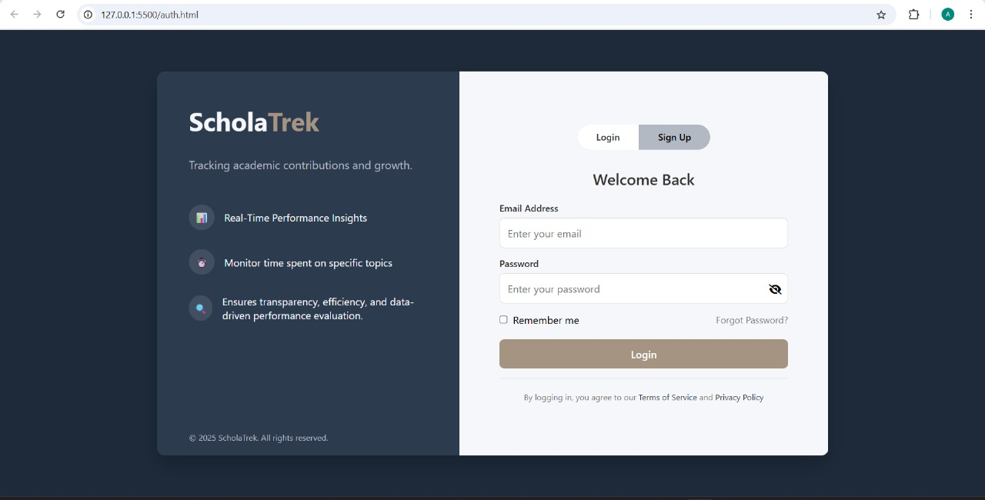

**Figure 8.2.1: Login Page**

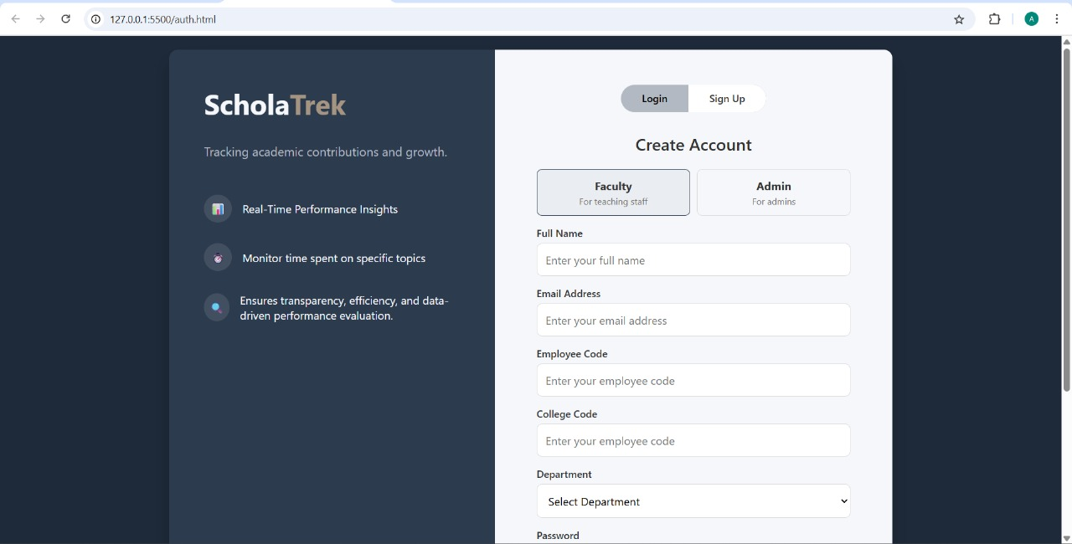

**Figure 8.2.2: Sign Up Page**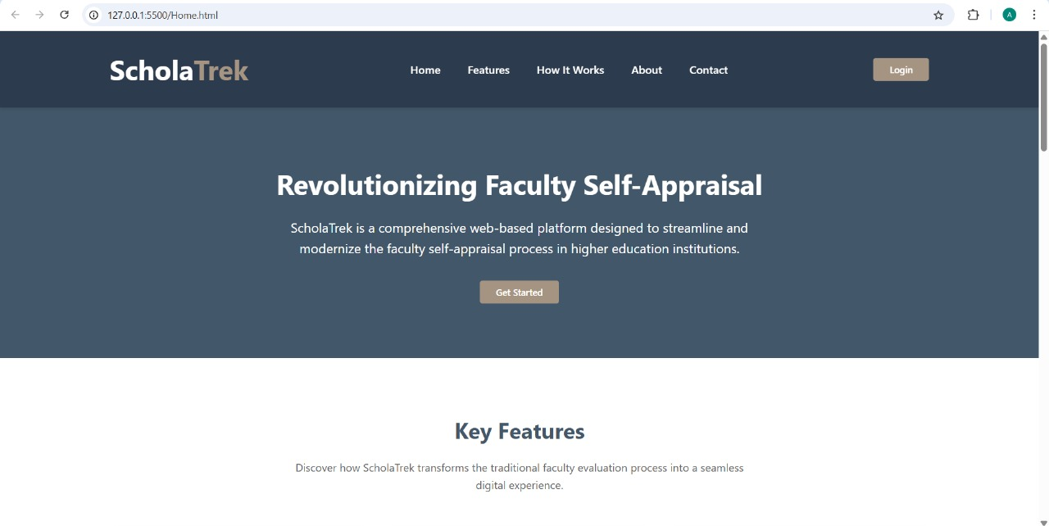

**Figure 8.2.3: Home Page**

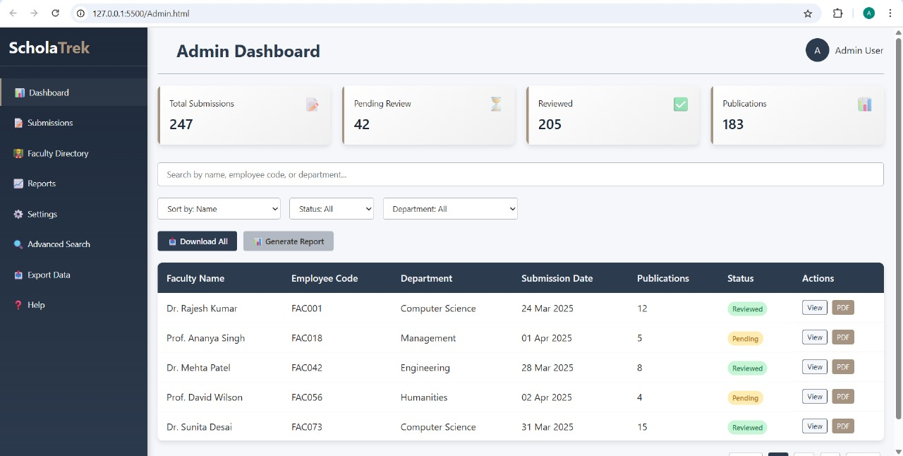

**Figure 8.2.4: Admin Dashboard**

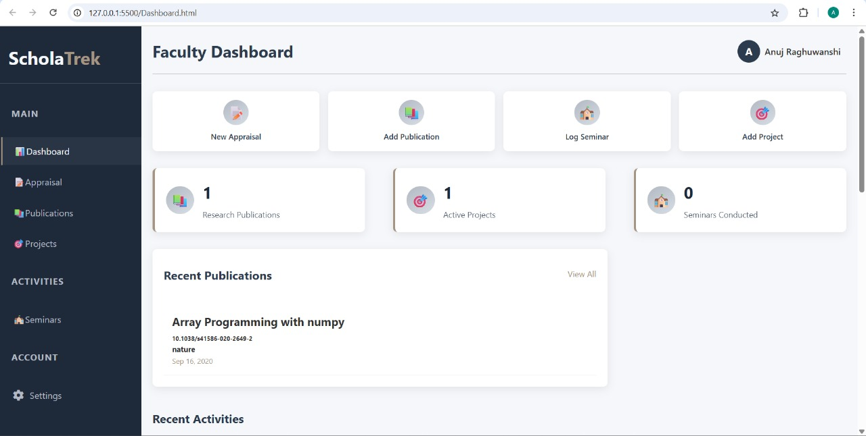

**Figure 8.2.5 : Faculty Dashboard**





Sistec/Btech/CS/2024/5/MinorProject_I/3

**CHAPTER-9 CONCLUSIONS AND FUTURE WORK**

###### CONCLUSION

The developed web-based application streamlines the process of recording, verifying, and displaying faculty achievements such as publications, projects, and seminars. By integrating Firebase for authentication and database management, along with Cloudinary for secure file storage, the system ensures scalability, reliability, and ease of use. The DOI verification feature further enhances credibility by validating publication data against trusted external sources like CrossRef.

With role-based access control and real-time updates, the system empowers both faculty members and administrators to efficiently manage and track academic contributions. Overall, this solution addresses key challenges in academic data management and provides a robust platform for maintaining transparency and academic integrity in higher education institutions.

###### FUTURE WORK

To enhance the system’s capabilities, the following future developments are proposed:

* + 1. **Advanced Search & Filters:** Implementing keyword-based search, date range filters, and category sorting for better publication and project management.
    2. **Analytics Dashboard:** Integrating data visualization to show trends in research output, collaboration networks, and indexing status.
    3. **Email Notifications:** Alerting users about successful submissions, pending actions, and collaboration requests.
    4. **Integration with ORCID/Google Scholar:** Allowing users to import/export their academic data easily.

# REFERENCES

###### JOURNALS / RESEARCH PAPERS

1. Sharma, R., & Singh, P. (2017). "Impact of Soil Health Card Scheme on Fertilizer Usage and Productivity." *International Journal of Agricultural Sciences*, 9(3), 23-29.
2. Gupta, V., & Mehta, S. (2019). "Evaluation of Soil Health Card Program in Enhancing Agricultural Productivity." *Journal of Soil and Water Conservation*, 18(2), 12-18.
3. Reddy, A. (2020). "Role of Soil Health Cards in Sustainable Agriculture." *Indian Journal of Agronomy*, 25(1), 5-10.

###### BOOKS

1. Brady, N. C., & Weil, R. R. *The Nature and Properties of Soils*, Pearson Education, 15th Edition, 2016.
2. Lal, R., & Stewart, B. A. *Soil Management for Sustainability*, CRC Press, 1st Edition, 2019.
3. Tisdale, S. L., & Nelson, W. L. *Soil Fertility and Fertilizers*, Macmillan, 8th Edition, 2013.

###### WEBSITES

<https://www.soilhealth.dac.gov.in/home> https://[www.india.gov.in/spotlight/soil-health-card-scheme](http://www.india.gov.in/spotlight/soil-health-card-scheme) https://vikaspedia.in/agriculture/agri-schemes/soil-health-management <https://www.fao.org/soils-portal/en/>

# PROJECT SUMMARY

#### About Project

|  |  |
| --- | --- |
| **Title of the project** | **Career Advancement of Faculties of Higher Education** |
| **Semester** | 6th |
| **Members** | 02 |
| **Team Leader** | Anuj RaghuwanshI |
| **Describe role of every member in the project** | Anuj Raghuwanshi  Basuki Nath pandey |
| **What is the motivation for selecting this project?** | The motivation behind this project is to replace the inefficient and paper-based faculty appraisal system with a secure, digital platform that ensures transparency, real-time updates, and data-driven decision-making, supporting both career growth and administrative ease in higher education. |
| **Project Type**  **(Desktop Application, Web Application, Mobile App, Web)** | Web- Based Application |

#### Tools &Technologies

|  |  |
| --- | --- |
| **Programming language**  **used** | HTML, CSS, JS |
| **APIs used**  **(with version)** | CrossRef REST API, Cloudinary API, Firebase API |
| **Front End Technologies (with version, wherever Applicable)** | HTML5, CSS, JavaScript |

|  |  |
| --- | --- |
| **Back End Technologies (with version, wherever applicable)** | Firebase, JavaScript |
| **Data base used** | Firebase, Cloudinary |

#### Software Design & Coding

|  |  |
| --- | --- |
| **Is prototype of the software**  **developed?** | Yes |
| **SDLC model followed (Waterfall, Agile, Spiral etc.)** | Incremental |
| **Why above SDLC model is followed?** | The **Incremental** SDLC model is best for this project because in this approach, a preliminary version of the software is built, tested, and refined based on user feedback, with features being added incrementally until the final product is achieved. |
| **Software Design approach followed**  **(Functional object-oriented)** | Object Oriented Approach |
| **Name the diagrams developed (according to the Design approach followed)** | Use Case Diagram |
| **In case Object Oriented approach is followed, which of the OOPS principles are covered in design?** | Abstraction Polymorphism Encapsulation Inheritance |
| **No. of Tiers**  **(example3-tier)** | 3 |
| **Total no. of front end pages** | 1 |
| **Total no. of tables in database** | 5 |
| **Database is in which Normal**  **Form?** | - |

|  |  |
| --- | --- |
| **Are the entries in database**  **encrypted?** | Yes |
| **Front end validations applied**  **(Yes/No)** | Yes |
| **Session management done**  **(in case of web applications)** | Yes |
| **Is application browser compatible**  **(in case of web applications)** | Yes |
| **Exception handling done**  **(Yes/No)** | Yes |
| **Commenting done in code**  **(Yes/No)** | Yes |
| **Naming convention followed**  **(Yes/No)** | Yes |
| **What difficulties faced during Deployment of project?** | Integration Challenges,  Constantly evolving project requirements, Version Control Issues,  Dependency Management Complexity |
| **Total no. of Use-cases** | 1 |
| **Give titles of Use-cases** | User Management Project Management Document Management |

#### Project Requirements

|  |  |
| --- | --- |
| **MVC architecture followed**  **(Yes/No)** | Yes |
| **Design Pattern used**  **(Yes/No)** | Yes |
| **If yes, write the name of**  **Design Pattern used** | MVC |
| **Interface type**  **(CLI/GUI)** | GUI |
| **No. of Actors** | 2 |

|  |  |
| --- | --- |
| **Name of Actors** | Faculty, Admins |
| **Total no. of Functional**  **Requirements** | 6 |
| **List few important non- Functional Requirements** | Performance, Reliability, Usability, Security |

#### Testing

|  |  |
| --- | --- |
| **Which testing is performed?**  **(Manual or Automation)** | Manual |
| **Is Beta testing done for this project?** | No |

#### Write project narrative covering above mentioned points

The **Career Advancements of the Faculties of Higher Education** was conceptualized and developed to address the limitations of traditional faculty appraisal processes in academic institutions. These manual, paper-based systems were often inefficient, lacked transparency, and required significant administrative effort. This project presents a modern, web-based alternative that streamlines self-appraisal through automation, centralized data management, and real-time analytics.

The platform was built using **HTML, CSS, and JavaScript** to design a user-friendly, responsive front-end interface that allows faculty members to log in securely and perform various appraisal-related activities. **Firebase Authentication** is used to manage user login and maintain access control, ensuring that only authorized faculty and administrators can interact with the system.

|  |  |  |
| --- | --- | --- |
| ANUJ RAGHUWANSHI  BASUKI NATH PANDEY | 0187CS221050  0187CS221070 | Guide Signature  (Mr. Ankit Gupta) |

# APPENDIX-1 GLOSSARY OF TERMS

# F

**Firebase** is a cloud-based platform designed for the development of web and mobile applications, helping to simplify the development process. It provides a set of tools aimed at four main objectives: development, growth, monetization, and data analysis.

**C**

**Cloudinary i**s an image and video management service that automates

the entire lifecycle of media assets , from upload and storage to manipulation, optimization, and delivery.

**J**

**JavaScript** is a versatile programming language primarily used for adding dynamic and interactive elements to websites. It's a scripting language, meaning it's executed directly by a web browser, allowing for features like animations, event handling, and dynamic content updates without needing to reload the entire page.