**Gruha Pathi Switch - Version 1.0.0.0**

**Input Voltage**: 230v – 280v

**Output Voltage**: 5v

There are six major components in the system that work together to provide power, communication, switching and integration of the components.

Major Components are:

* **Power Module**: Transforms 230v AC into 5v DC.
* **Transmitter Module**: Transmit data to the main hub.
* **Receiver Module**: Receiver data from the main hub.
* **Controller Module**: Control all the components in the system except the power module.
* **Relay Module**: Switch ON/OFF device power according to information from the controller.
* **Voltage Usage Meter**: Not Designed.

**Schematic Circuit Design of the Switch**

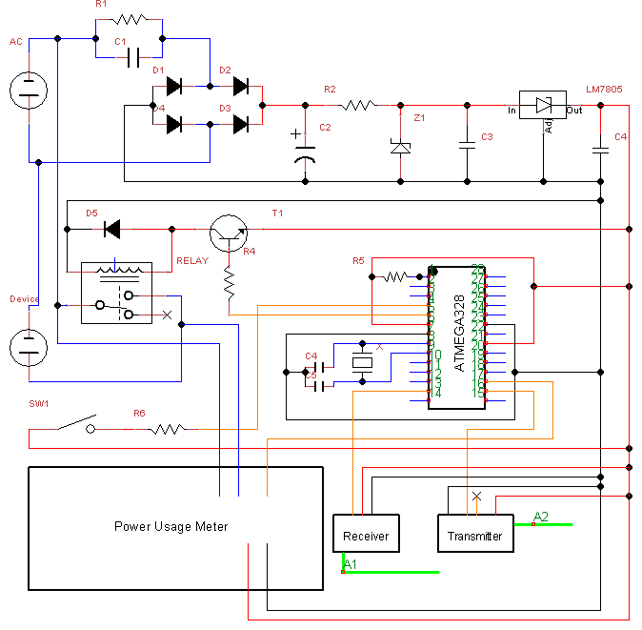

**Future Modifications**

* Introduce Motion detection instead of switch.
* Introduce WI-FI Module instead of RF Modules [**Decide:** 26/11/2016].