

**PLYMOUTH ID :** 10541973

**NAME :** Ratnayake K Basura N B

MAGE DINA POTHA 1.0   
(MY DAY BOOK 1.0)

Project Report

**THE**

**FORE RUNNERS**

Believe and everything is possible

**Degree:** BSc (Honours) Software Engineering

**Stage:** 2

**Module:** SOFT225SL

**Batch:** 14.2

Table of Contents

Acknowledgement i

Declaration ii

Executive Summary iiI

Analysis and Design 1

Problem Identification 1

The Proposed Solution 2

UML Diagrams 3

Use Case 3

Class Diagram 4

Activity Diagrams 5

Normalized Database 5

Functionality of the System 6

System Description 7

Evaluation 14

Functionality 14

Quality 15

Personal Reflection 16

References 17

# Acknowledgement

I would like to thank Mrs. Manoja Weerasekara for giving us the freedom to choose a scenario of our liking and to build the project based on that selected scenario and also for her heartfelt support and guidance throughout the completion of my project.

I dedicate the end result of my project to all those who write down their daily activities on a day book, I hope their task will be made simple by my creation.

**Basura Ratnayake**

30th December, 2015

# Declaration

This is to certify that the work contained herein are the sole and original creations of Ratnayake K Basura N B and that no other external or referential creation/ source by a third-party, other than those cited, were taken-up/ included in the making of this Project. All ownership of this project resides with Ratnayake K Basura N B and all the copyrights of the libraries implemented in the project belong to their respective owners.

# Executive Summary

This project is built based on the scenario that most people have developed a habit of writing down their daily activities on a day book or most commonly referred to as a diary. This habit or task is proven very much effective and helpful for people to remind themselves how they spent their days and also is useful when writing biographies of themselves

The main downfall of this day book writing is that it takes a considerable amount of time to write and since a day book can contain sensitive information regarding a person or people, it may prove to be very dangerous and unsecure.

Considering all the facts I built an electronic day book that people can use to record their daily entries in audio, video or text format and is protected by an encryption.

# Analysis and Design

## Problem Identification

Majority of people use day books or diaries to keep track of their day today activities and some people record sensitive private information about them and about other people in these day books.

The Main problems these people face are,

* **Security**

Anyone can read the entries recorded in these day books.

* **Capacity**

If a person starts recording his or her life at the age 18, when that person reach age 40. He or she would have a total of 22 day books or more.

* **Age**

When people grow old they lose most of their physical strength rendering them unable to continue their daily habit of writing day book entries and in the other hand, teenagers don’t prefer writing, they prefer more interactive approaches to day book writing.

* **Ability**

Some people among us are differently abled so they must also be given the ability to use day books to record their daily activities.

Considering the above identified problems and situations, I formulated an idea that would satisfy both the above mentioned problems and the project criteria that I am to accomplish.

## The Proposed Solution

I believe all problems can be remedied through technology, the answer to this problem is all computer science. By building a computer application that can function as an ordinary day book or diary but without the above realized weaknesses, we can finally obtain a Day Book that any and all can use without any limitations.

**Expected benefits from the new system**

* **Encrypted Day Book that require a password**.

Security issues faced with manual day book systems eliminated.

* **Not only supports text entries but also audio and video entries.**

Any and all people of any age and ability can use the system without any restrictions thus eliminating the Ability and Age issues faced with manual day book systems.

* **Need very little physical space**.

All day book entries are stored in a local database inside a personal computer or other device. Capacity issues faced eliminated.

* **Quick retrieval of recorded entries.**

No time wasting trying to find a record by flipping page after page and book after book.

* **Graphical User Interface**

A very simple and easy interactive user interface built to provide convenience and efficiency.

* **Portability**

The entire day book along with all the recorded entries can be installed on to a thumb drive, making it travel enabled.

* **Platform Independence**

The system can be installed or used in any platform that is currently present.

## UML Diagrams

### Use Case

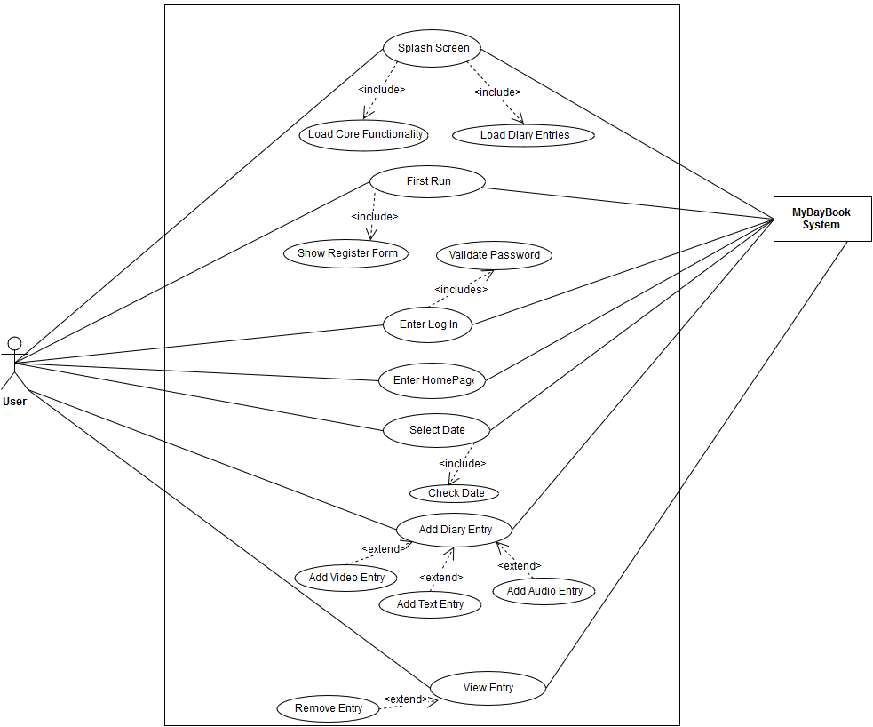**My Day Book System**

### Class Diagram

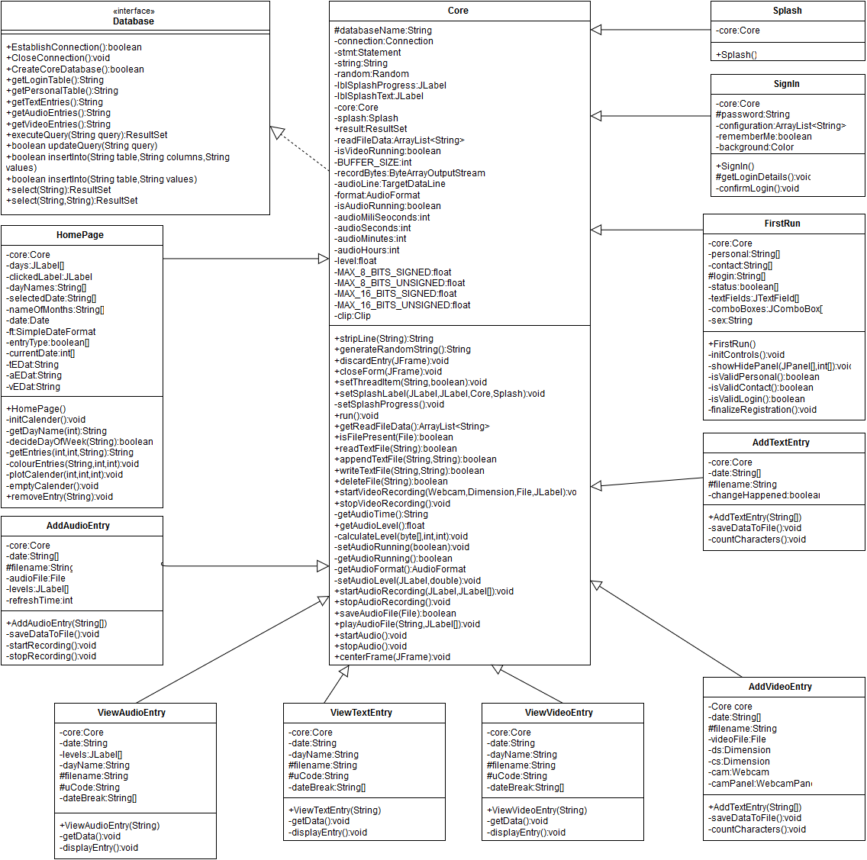

### Activity Diagrams

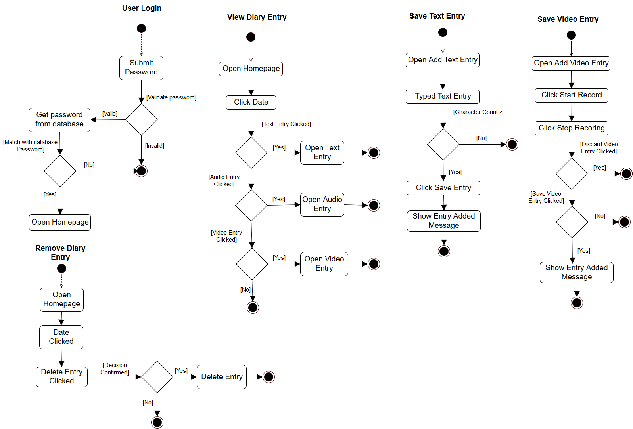

### Normalized Database

The tables loginD and personalD are connected together by the foreign key uniqCode which is the primary key of loginD. There is no connection between the tables textEntries, audioEntries, videoEntries, they exist to save the reference to the saved entry files.

**Table:** loginD

|  |  |  |  |  |
| --- | --- | --- | --- | --- |
| uniqCode | password | secQuestion | answer | lastLogged |

**Table:** personalD

This table contain only one record. The mobile and phone columns contain atomic values.

|  |  |  |  |  |  |  |  |  |
| --- | --- | --- | --- | --- | --- | --- | --- | --- |
| uniqCode | fname | lname | dob | country | sex | email | mobile | phone |

**Table:** textEntries

|  |  |  |
| --- | --- | --- |
| uID | logged | filename |

**Table:** audioEntries

|  |  |  |
| --- | --- | --- |
| uID | logged | filename |

**Table:** videoEntries

|  |  |  |
| --- | --- | --- |
| uID | logged | filename |

## Functionality of the System

* **One Time Only Registration**

The system prompts the user to complete the registration process before the system is run for the first time.

* **Access to the System**

The entire system and all its functionality is blocked by a password protected login screen which makes sure no access is granted to the user if a valid password is not entered.

* **Stored Entries Categorized**

All entries are categorized and stored on files and are also referenced in the database tables.

* **Calendar Control**

In the homepage, the calendar control acts as an control interface that helps the user to add, retrieve, search and remove entries.

* **Audio and Video Recording**

Audio and video recording both available for the user to add and view entries of audio and video format.

The system is fully implemented by using the Object Oriented Programming (OOP) paradigm, which proved to be a decisive advantage when building the project.

# System Description

The scenario for the project is an electronic day book for individuals to record their day today activities, unlike an actual physical day book people have the ability to record a video, audio or a text entry about their day and also the entries they store are protected by a user defined password.

The Graphical User Interface of the system is implemented by using Java Swing and the back-end data storage of the system is performed by SQLite database and file handling, the reason for using the SQLite JDBC driver is because the system is in need of a portable data storage platform. The coding and implementation phase of the system is done using the NetBeans IDE.

The main functionalities of the system, and the screenshots are as follows-

**Splash Screen and Core Functionality Loading:**

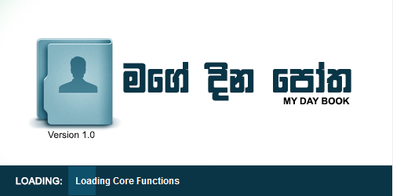

All the core database tables and system configuration files are read and verified in this process. If the user is running the system for the first time the core database tables and the necessary systems files will be created and the user will be redirected to the Registration Screen.

If this is not the users first time the user will be redirected to the Log-In Screen. The system checks the user’s arrival from the settings.config file inside the usr folder.

SQLite JDBC Connection is established and the system file settings.config is accessed in the screen.

A thread is implemented inside the core class to show the progress of the loading screen and to avoid any collisions with the actual analysis of the system files.

**User Registration Screens:**

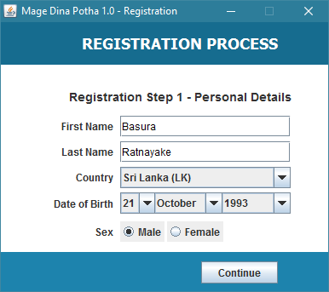

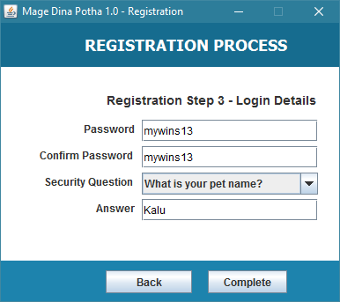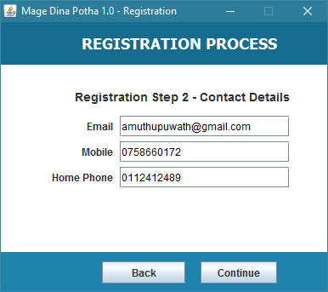

The user is required to provide the mentioned information and register with the system. The registration is a one-time process that a new user must follow in order to use the system in the future.

The user’s inputs are validated from the respective screens to ensure their integrity and then are added to the database storedEntries.db using the SQLite JDBC library. The value in settings.config file is changed from 1 to 0 to indicate the user has registered.

The user is then redirected to the Log-In Screen.

**User Log-In Screen:**

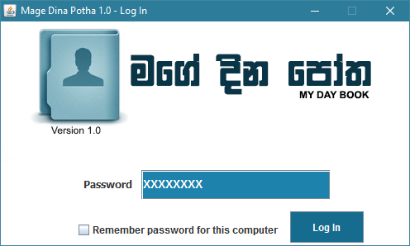

When the constructor of the SignIn class is called the credentials of the registered user are obtained from the database and are then temporally stored in protected variables to be matched against the users input from the password field.

If the user entered password doesn’t match with already registered password of the system, then the user is shown a warning message indicating that the wrong password has been entered.

If the user has entered the correct password and the “Remember password for this computer” checkbox is checked, the next user launches the software the user will be redirected directly to the homepage.

**Home Screen (Control Panel):**

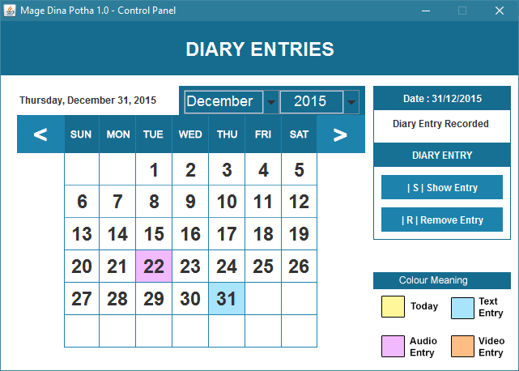

This is the homepage of the system. The calendar control that I have designed for this project automatically adjust itself to the current date and marks the current day with the colour yellow. If diary entries are recorded in the selected month and year then they are marked with different specified colours, so the user can spot the recorded entries much easier.

When the user clicks on a recorded entry date (coloured date), a panel to the right appears with two buttons to Show or Remove an entry.

If the user clicks on an unmarked date, the right panel changes its appearance allowing the user to add an entry to that date. The entry may be a Video, Audio or a Text entry.

**Add Entry - Record Text Entry:**

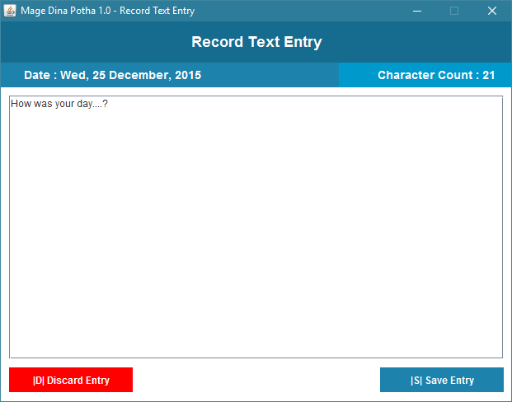

From this screen the user can record his or her day in text format (in a text file). The entry will be added to the date selected by the user. For the convenience of the user a character count is displayed at the top-right corner of the window.

The user can save the recorded entry to his or her day book or discard the recorded entry but once an entry is saved in the day book that entry cannot be modified.

The entry will be first saved in a text file with a random generated name of eight characters and then that filename is added as a reference in the database.

A sample random generated filename will look like xlirbg2o.mdpe

.mdpe = Mage Dina Potha Entry (File Type)

All text based entries are saved in folder usr/entries/text/

**Add Entry - Record Audio Entry:**

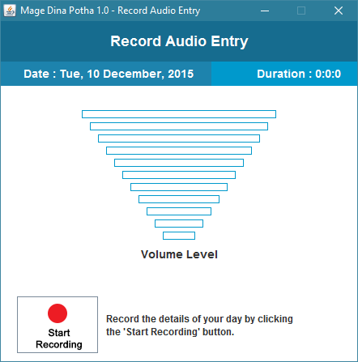

This is the Record Audio Entry screen from this screen the user can record his or her day in audio format. For the convenience of the user the volume level of the microphone is displayed, the volume range is 0.0 – 1.0.

The audio entry is saved in the audio format .wav, after recording the user can decide whether to save the entry or discard it.

All audio only based entries are saved in folder usr/entries/audio/

**Add Entry - Record Video Entry:**

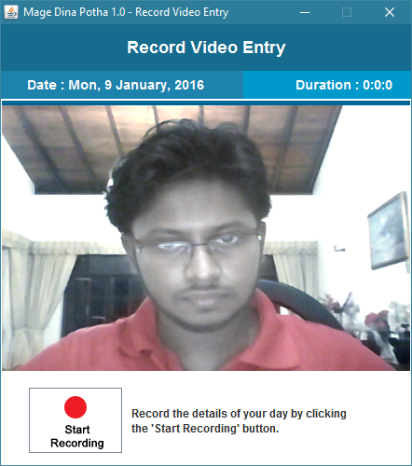

From this screen the user can record his or her day in video format, the video format is both audio and video. When recording the system takes pictures from the webcam every millisecond and when the recording is stopped the taken images are then combined together to form a video clip in the format .ts, which is a streamline version the of popular MPEG format.

The user has the ability to save the recorded video entry or discard it.

All video based entries are saved in folder usr/entries/video/

# Evaluation

## Functionality

The entire system is simple and easy to use from the start to the end, it is made more attractive and user friendly by the GUI design of the system. The First Screen a user sees when they launch the application is the Splash Screen

**The Splash Screen** – Loads the necessary diary entries and the core functionality of the system.

**First Run** – If a user runs the system for the first time he or she is redirected to the registration form, completing the registration process is a mandatory.

**Log-In** – The user must enter his or her password to log into the system, if not the user will not be given access to the system.

**Home Page** – The homepage displays a large calendar of the current month and date; the calendar can be adjusted to see past or future dates. When clicked on an empty white date the user can add a video, audio or a text entry. When clicked with a coloured date the user can view or remove the diary entry from the system.

**Add Text Entry** – When add text entry button in the home page is clicked the user is redirected to the Add Text Entry page, where the user can add text entry to the database.

**Add Audio Entry** – When add audio entry button in the home page is clicked the user is redirected to the Add Audio Entry page, where the user can add audio entry to the database. The user can also see the volume level of the microphone and the duration is also shown.

**Add Video Entry** – When add video entry button in the homepage is clicked the user is redirected to the Add Video Entry page, where the user can add video entry to the database.

**View Diary Entry** – When the show entry in the homepage is clicked the user is redirected to the view entry page. The screen changes according to the selected entry type, if text entry selected then the interface changes to suit the text entry page.

## Quality

I have successfully completed and implemented all the mentioned functionalities of the system, in other words this is a complete and a fully functional system.

The methods that handle the database are written in the Database interface, all the methods in the database interface are implemented in the core class. The core class contains the implemented methods of the database interface and the common and fundamental methods used my other classes in the system. Core acts as the parent class for all the other classes in the system.

If a certain method needs to be optimized or debugged, it can be easily done by changing the method in the core class because every important function is declared in the core class and used inside other classes. I used the divide and conquer principle to the coding to make the process simple and easy to understand and implement.

OOP Concepts Inheritance, Polymorphism, Encapsulation, Abstraction are used.

File Handling, Exception Handling and Database connection are also implemented in the system.

I used the following libraries to implement the functionalities of my system

* SQLite JDBC Connector (sqlite-jdbc-3.8.11.2.jar) – SQLite is used as the database management agent, the reason to use SQLite is mainly because of its portability.
* Sarxos Webcam Capture API (webcam-capture-0.3.10.jar) – This library is used to access and view the webcam.
* Video Processing API (xuggle-xuggler-5.4.jar) – This library is used for video processing which is used to record videos from the webcam.

The functionality in the core class and database interface can be reused by any class or interface, that is the beauty of the coding style I used in implementing this project.

## Personal Reflection

By doing this project I learned to divide big problems into smaller parts so that I can easily understand and implement each smaller part so that it would later become the whole solution for the problem.

Netbeans didn’t have a good and a stable calender control that was larger in size or suitable for my project so I had to create a calendar of my own. Building the calender control gave me a ton of experience in how to work with dates, which helped me a lot in the later stage of the project.

Audio recording was a bit easier because I used the Java Sound API, they provided a good instruction manual but capturing the microphone volume level while recording was a bit trickier, I had to implement multi-threading to accomplsih the task. Which bythe way so frustrating and at the same time interesting.

Webcam video recording, that’s the name everyone uses but its actually capturing images at miliseconds from your webcam and compiling them together to form a video and you have to implement audio recording in the background as a thread to record audio. It took me a long while to realize this small concept, but finally found a nice API to do the task.

I managed to implement the full functionality of the system as stated above. The experience I gained really changed my coding style and my way of approaching a problem to find a solution.

I gained knowledge about working with sound and video processing in java and also managed to handle file and exception processing.

# References

1. Java.lang.Thread.setDaemon() Method Example: <<http://www.tutorialspoint.com/java/lang/thread_setdaemon.htm>>. [14 December 2015].
2. sarxos/webcam-capture: < <https://github.com/sarxos/webcam-capture>>. [20 December 2015].
3. java - use xuggler to play video on jpanel - Stack Overflow: <<http://stackoverflow.com/questions/32297594/use-xuggler-to-play-video-on-jpanel>>. [21 December 2015].
4. audio - Microphone level in Java - Stack Overflow: <<http://stackoverflow.com/questions/3899585/microphone-level-in-java>>. [16 December 2015].
5. Java Sound, Capturing Microphone Data into an Audio File - Developer.com: < <http://www.developer.com/java/other/article.php/2105421/Java-Sound-Capturing-Microphone-Data-into-an-Audio-File.htm>>. [18 December 2015].
6. Java Programming -- 3 -- Using external libraries - YouTube: <<https://www.youtube.com/watch?v=PoyGznP8Ehk>>. [6 December 2015].
7. Xuggler on NetBeans - NetBeans Wiki: < <http://wiki.netbeans.org/Xuggler_on_NetBeans>>. [19 December 2015].
8. Capturing Audio (The Java™ Tutorials > Sound) < <https://docs.oracle.com/javase/tutorial/sound/capturing.html>>. [19 December 2015].