SQL DEVELOPER

TASK-1

Student Management System Project for SQL Developers

* Create a database named StudentManagement
* Create a table named Students with the following fields:

○ StudentID: Primary Key, INT, an auto-incrementing integer.

○ Name:Stores the student's name (up to 50 characters).

○ Gender: A Single character (VARCHAR, 1- 'M' for Male, 'F' for Female).

○ Age: INT

○ Grade: Academic grade (VARCHAR, 10- e.g., 'A', 'B', 'C', etc.).

○ MathScore, ScienceScore, EnglishScore: Integers representing scores in respective subjects

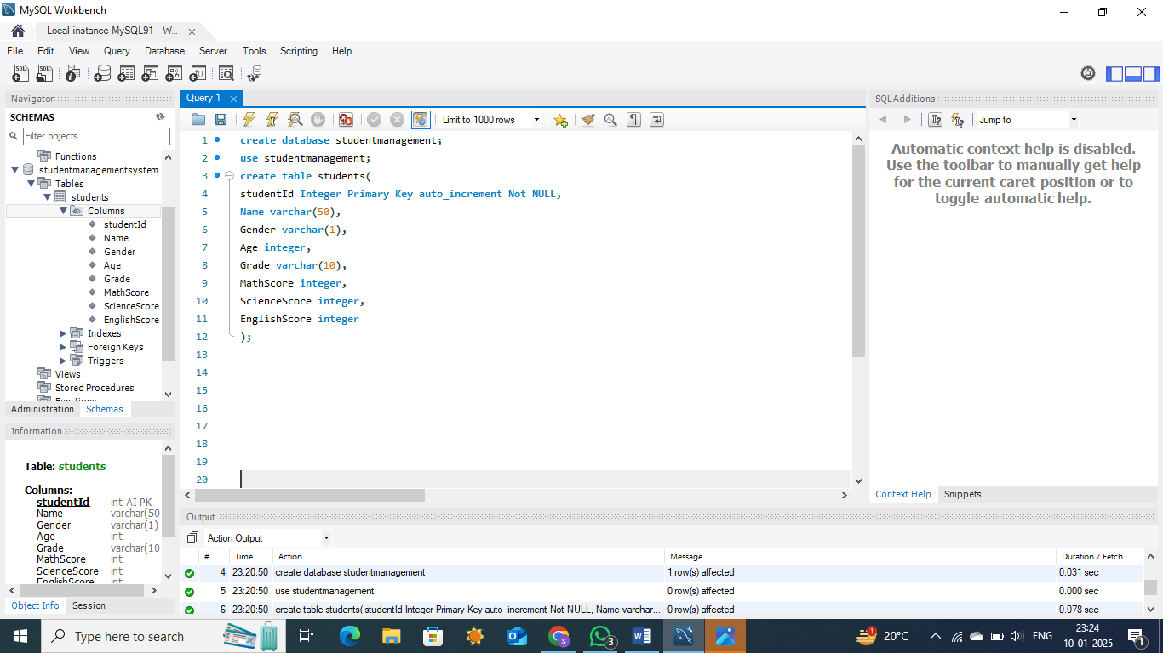

* Insert Data

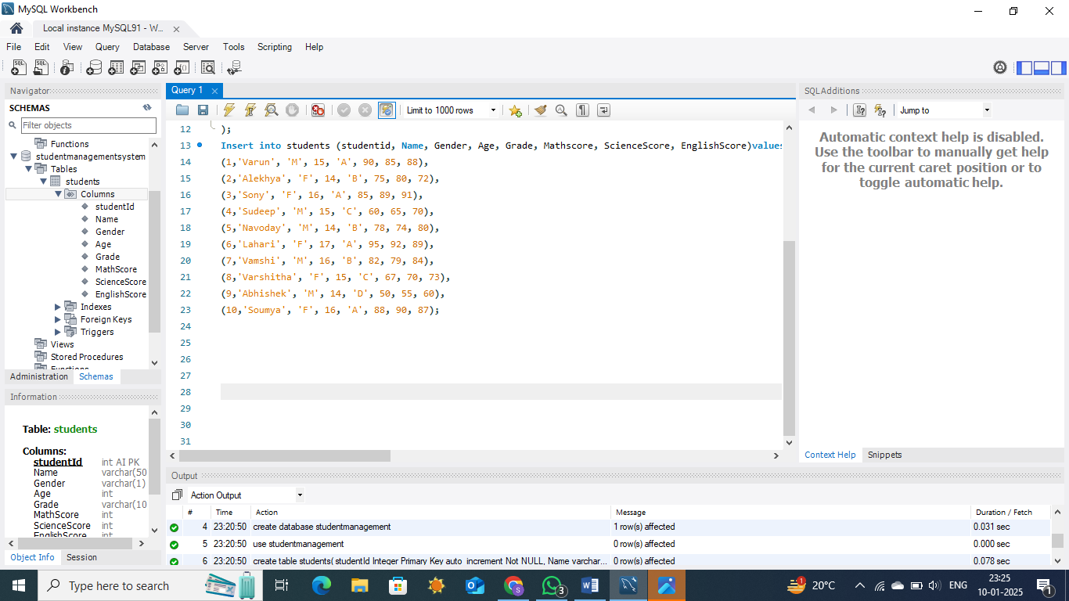

Tasks to be performed:

1. Display all students and their details to get an overview of the data.

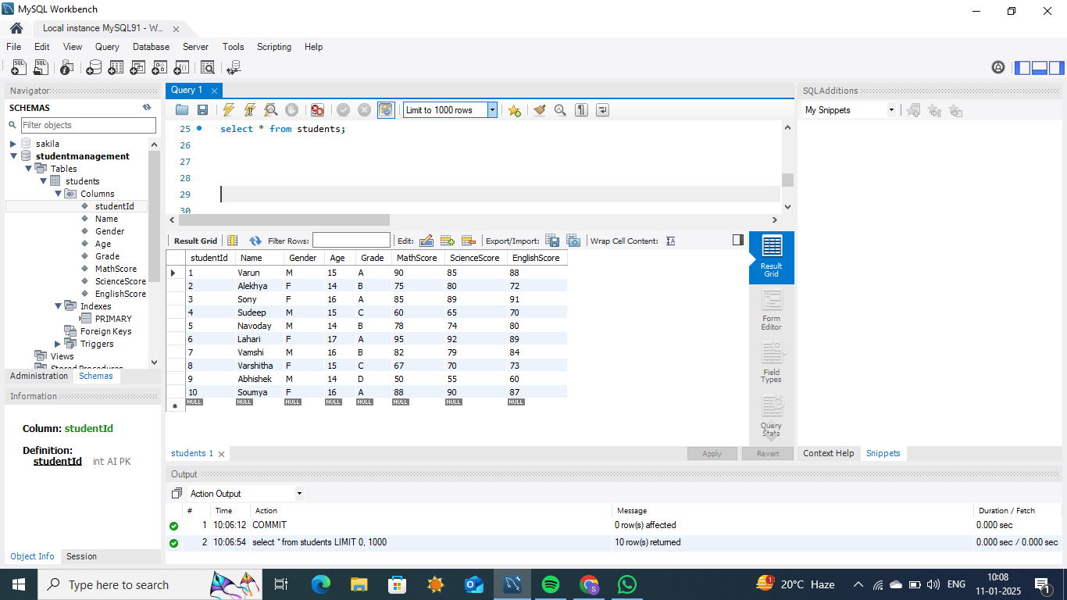

2. Calculate the average scores for each subject to understand subject-wise performance.

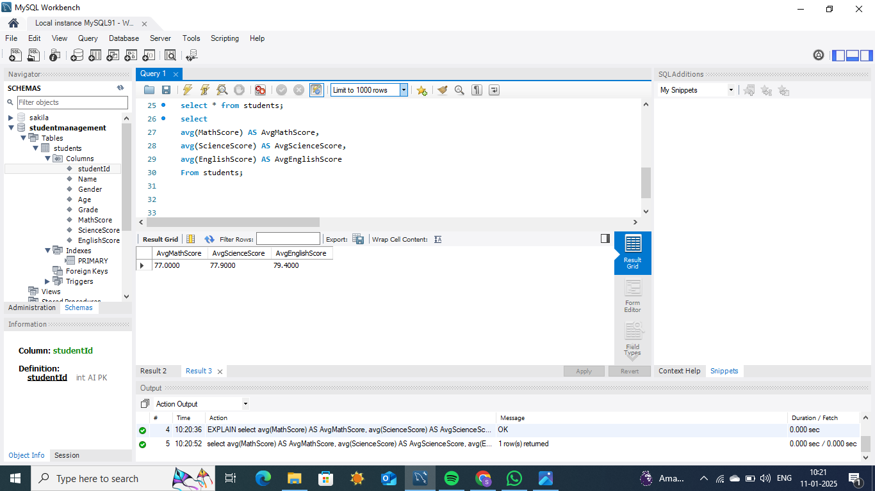

3. Find the student(s) with the highest total score across all subjects to identify the top performer.

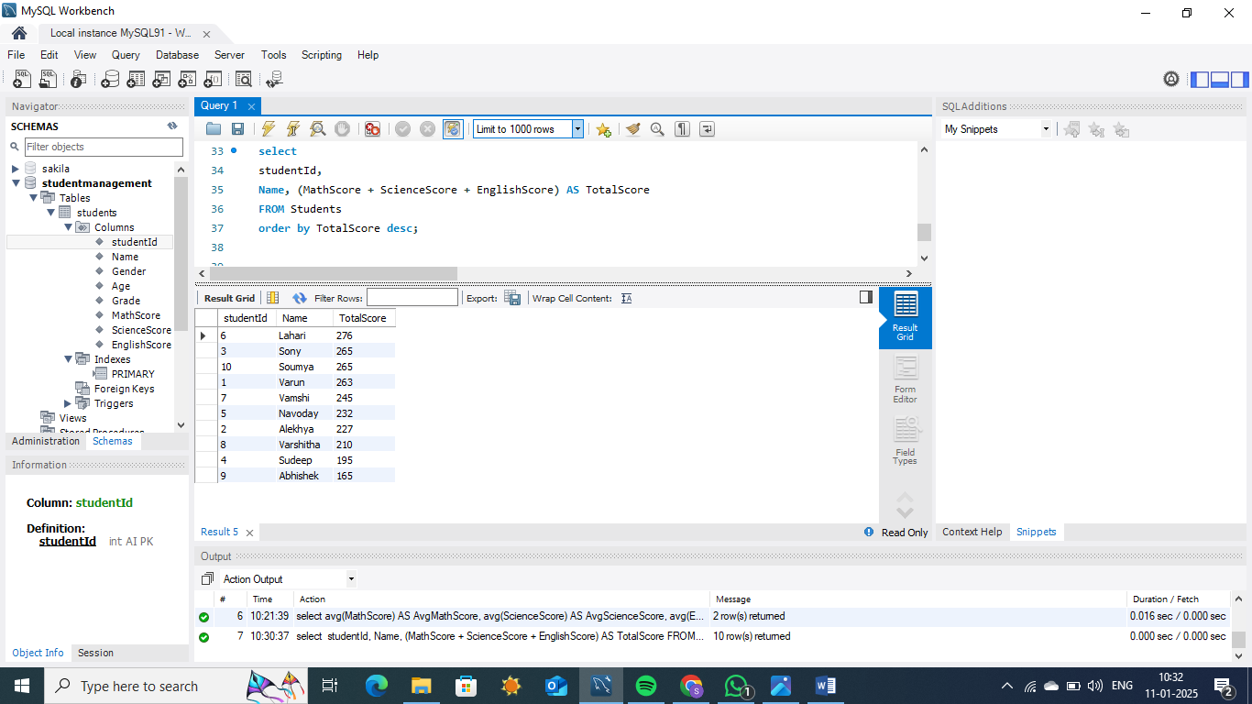

4. Find the average score for male and female students to compare performance by gender.

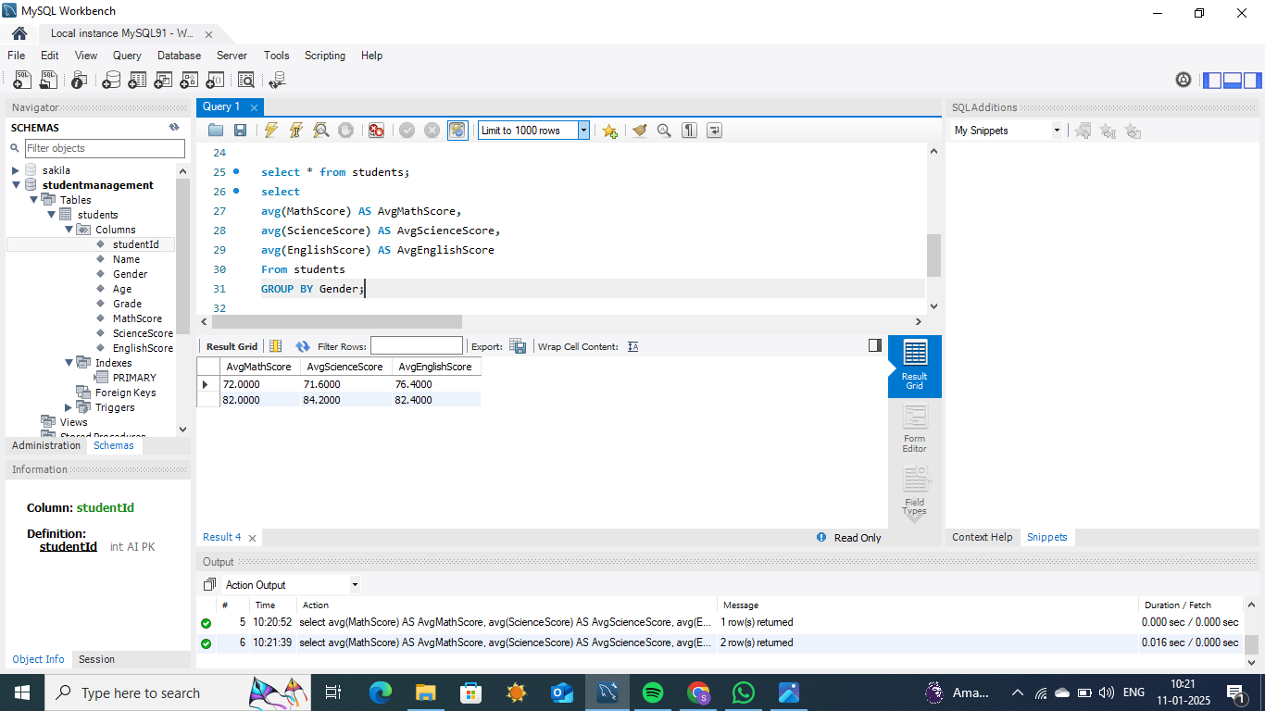

5. Count the number of students in each grade to observe grade distributions.

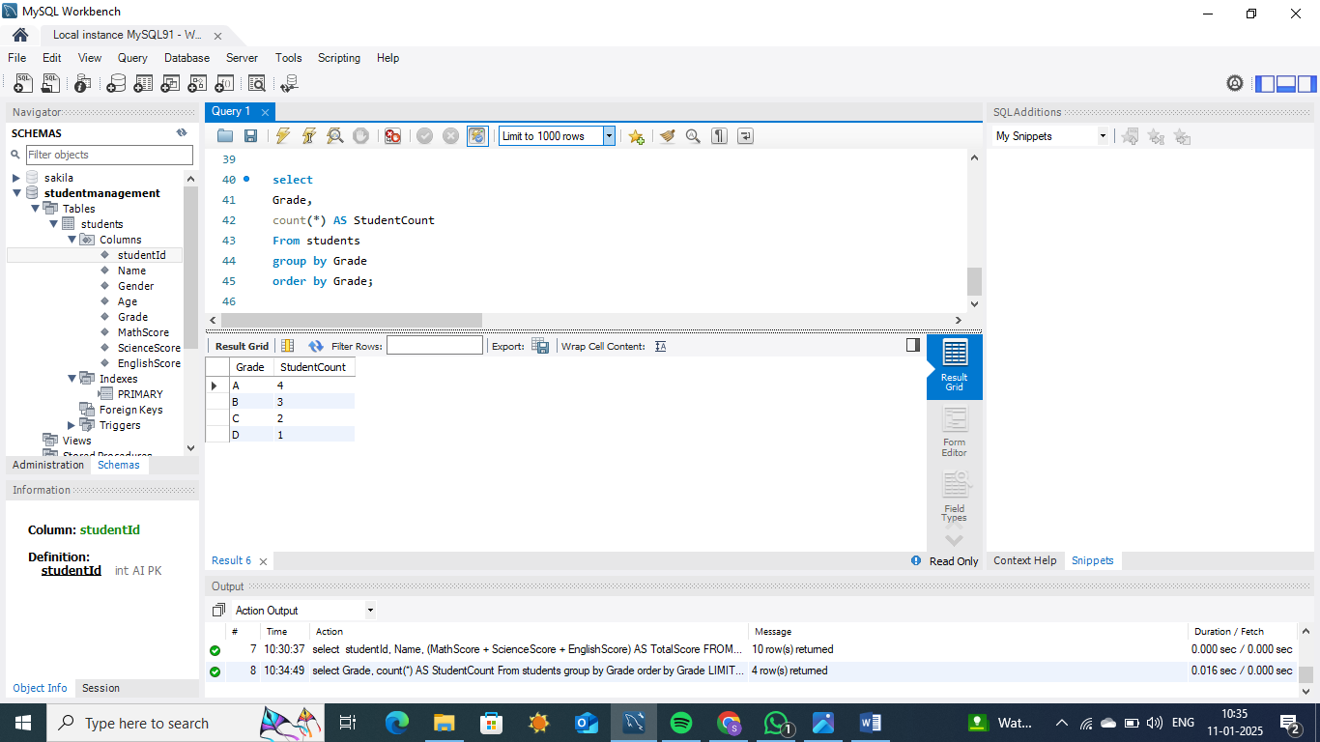

6. Identify students whose Math score is above 80 to highlight high achievers in Math.

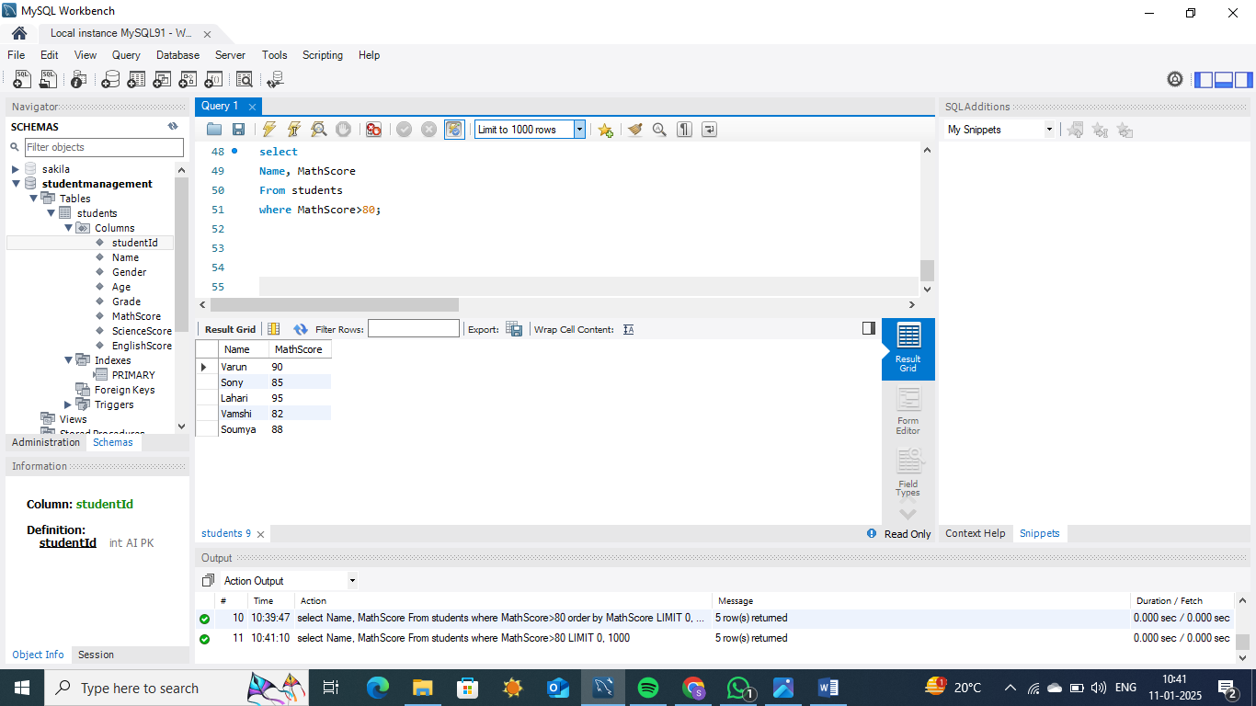

7. Update the grade of a student with a specific Student ID to reflect changes or corrections.

