**SQL DEVELOPER**

TASK-2

Advanced Queries with Joins and Filtering

**Tables to Create**

**1. Students:**

○ Already created in Task 1.

**○** Contains student details such as student_id and name

**2. Courses:**

**○ Fields:**

course_id: Primary Key.

course_name: Name of the course.

course_description: Optional field for details.

**3. Enrolments:**

**○ Fields:**

enrolment_id: Primary Key.

student_id: Foreign Key referencing the Students table.

course_id: Foreign Key referencing the Courses table.

enrolment_date: Date of enrolment.

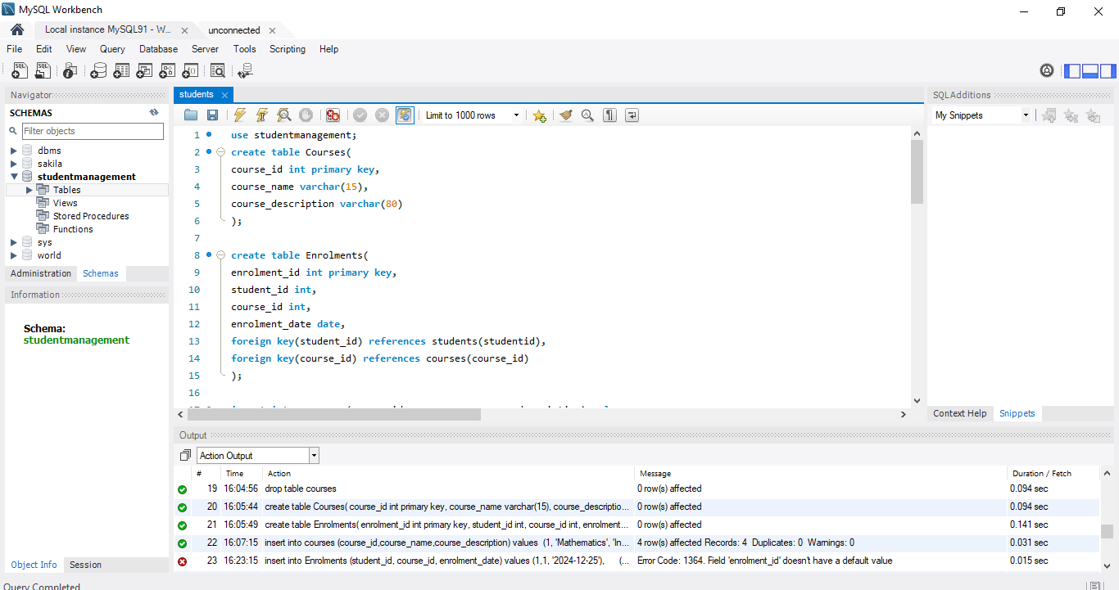

* Insert Data

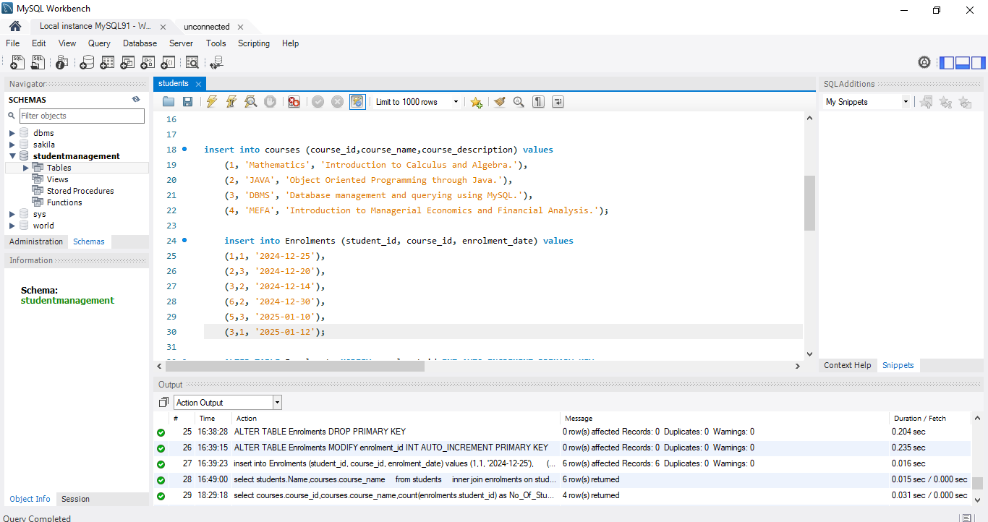

Tasks to be performed:

1.List all students and the courses they are enrolled in.

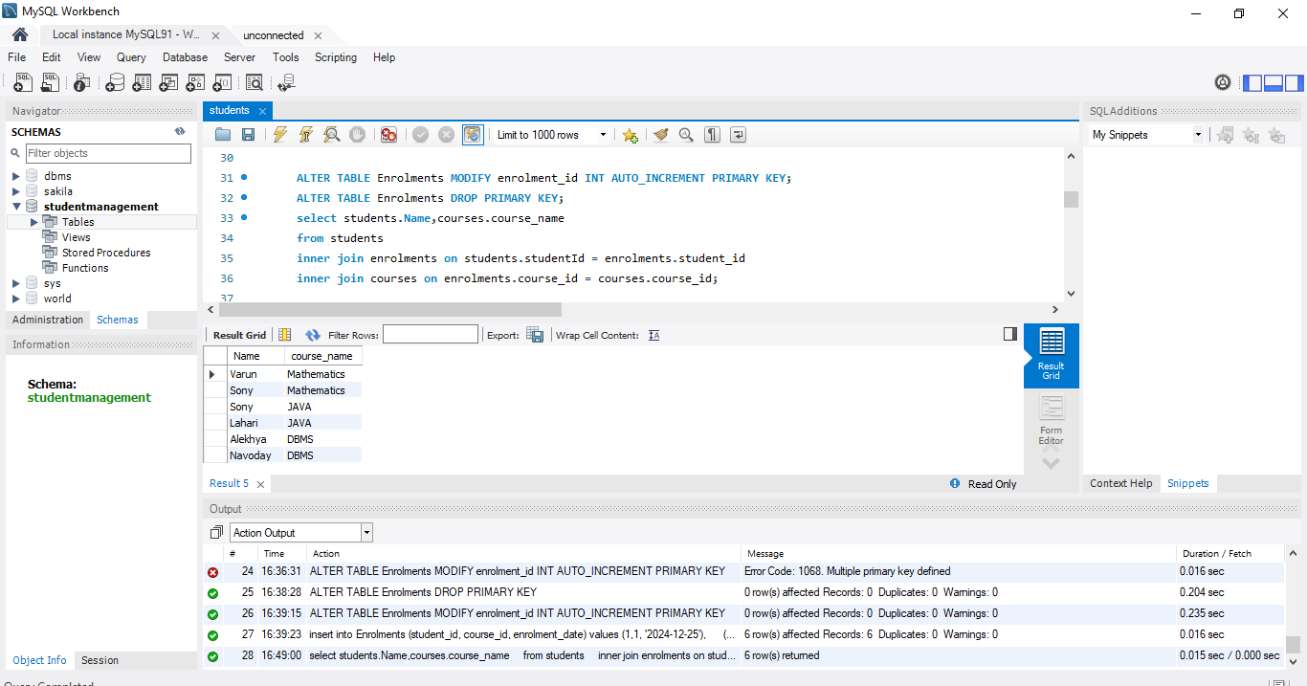

2. Find the number of students enrolled in each course.

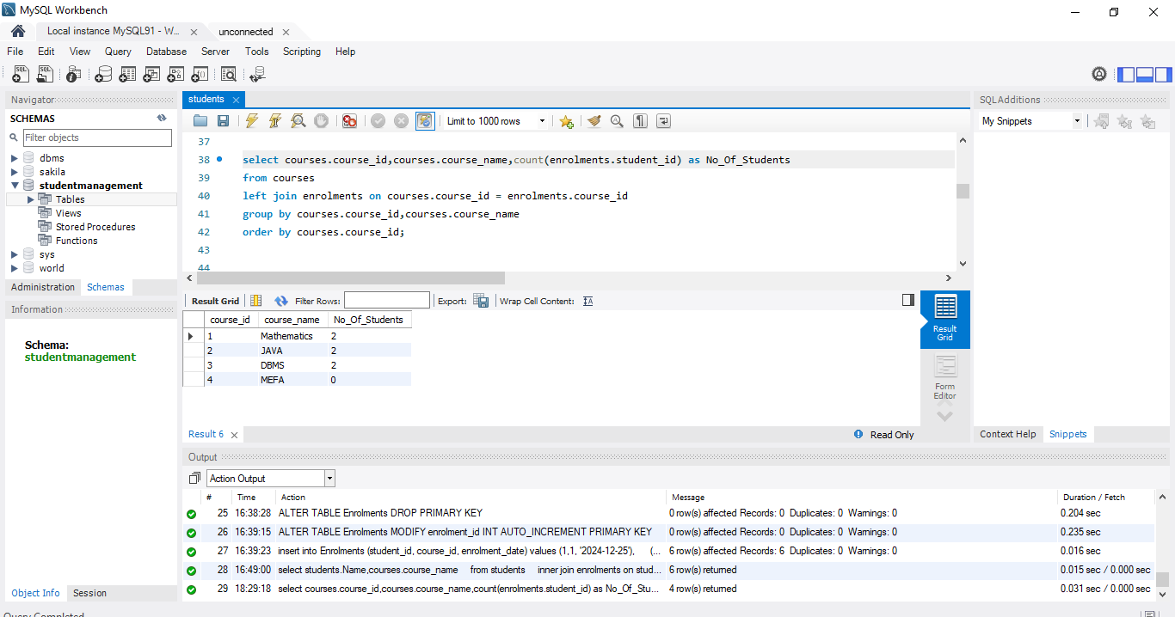

3. List students who have enrolled in more than one course.

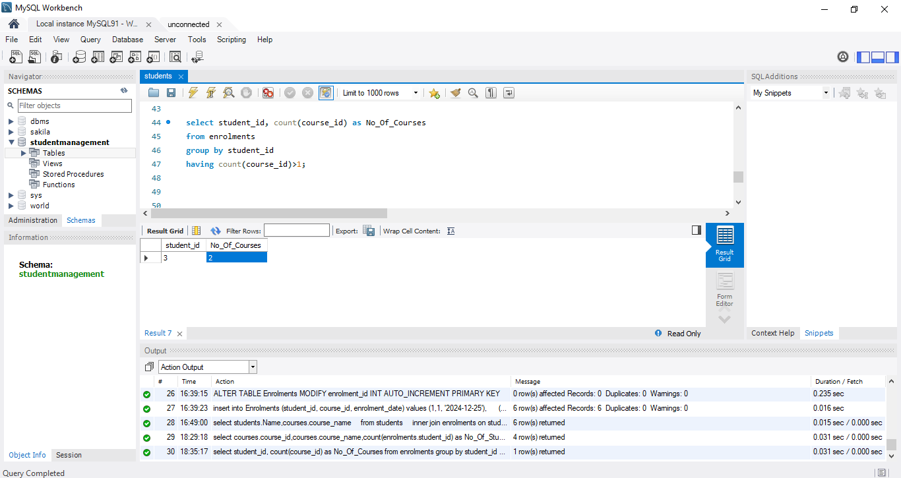

4: Find courses with no enrolled students.

