**SQL DEVELOPER**

TASK-3

**Step 1: Database Setup**

**1. Table: Students**

**○ Fields:**

student_id: Primary Key.

name: Name of the student.

math_score: Math test score.

science_score: Science test score.

english_score: English test score.

total_score: The sum of all scores for each student (optional if

calculated dynamically).

**2. Insert sample data with scores for Math, Science, and English for multiple**

**students.**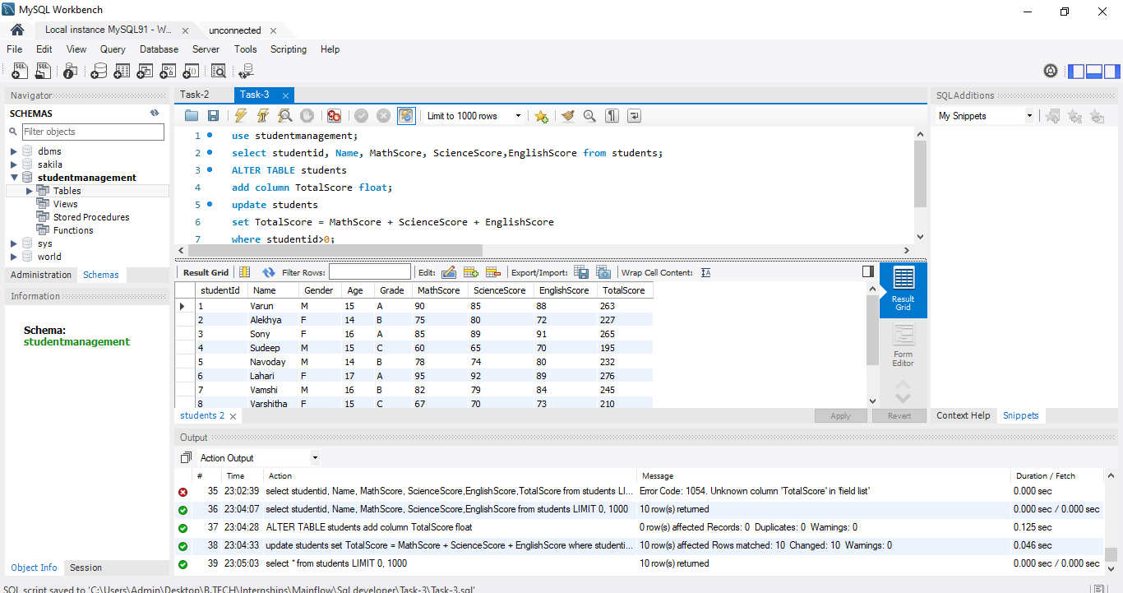

**Step 2: Tasks to Perform**

**Task 1: Identify Top Students by Total Scores**

**●** Use a subquery to calculate the total score (math_score + science_score +

english_score) for each student.

**●** Use an ORDER BY clause to rank students by their total scores in descending order.

● Limit the results to show only the top students (e.g., top 5).

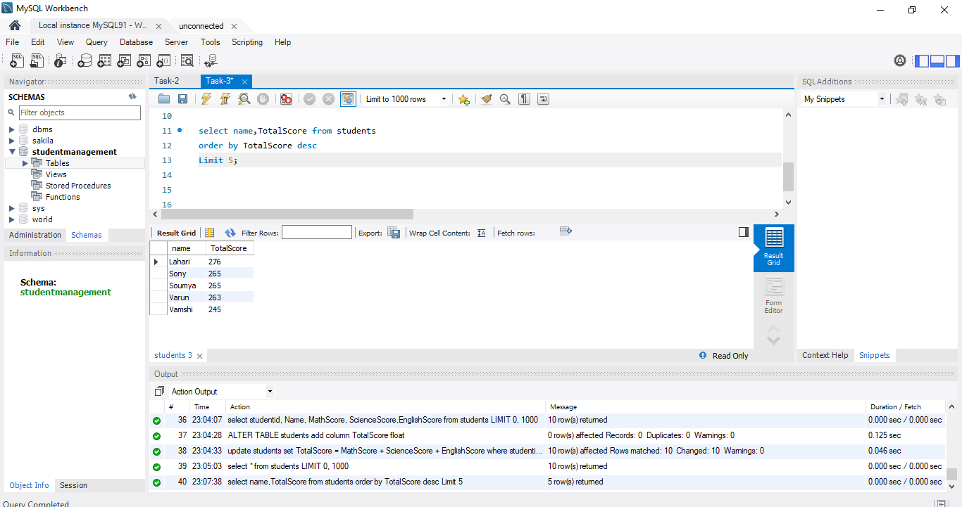

**Task 2: Calculate Averages Based on Specific Conditions**

**● Use subqueries to filter and group data for average calculations:**

○ Example 1: Calculate the average score of students who scored above 70 in

Math.

○ Example 2: Calculate the average total score of students grouped by a specific

condition, such as a score range (e.g., students scoring 200–250 in total).

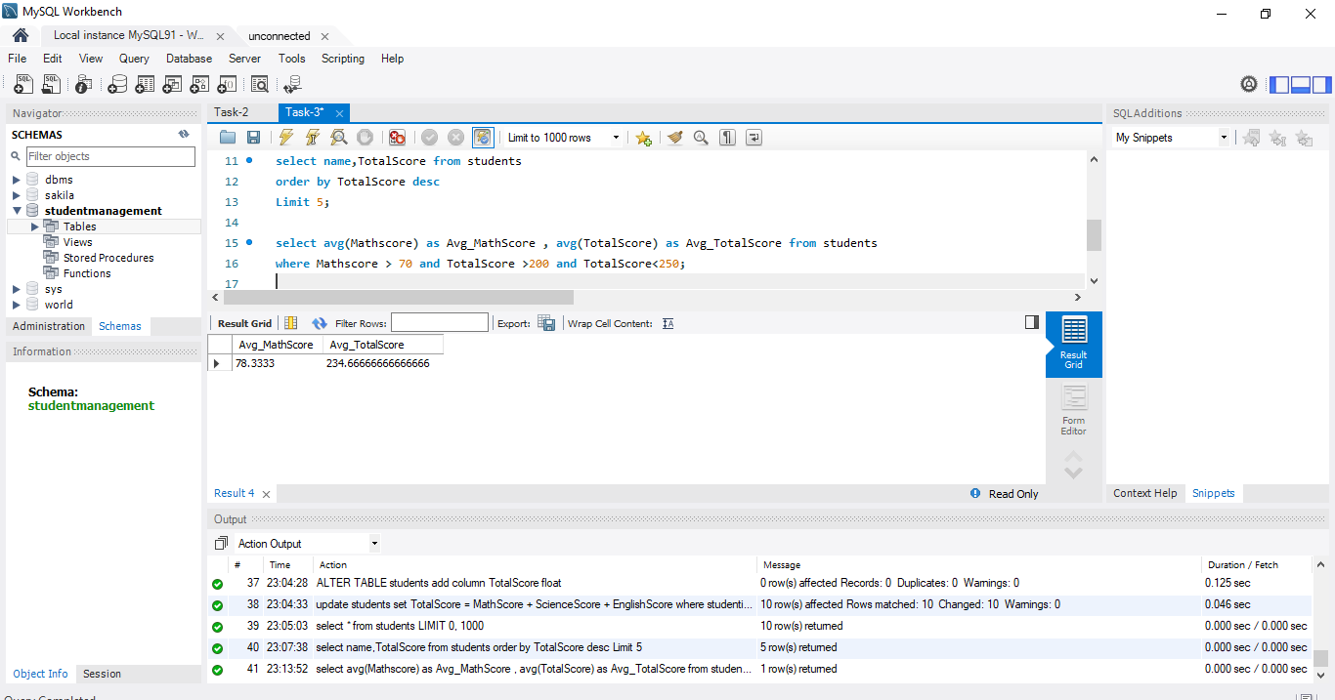

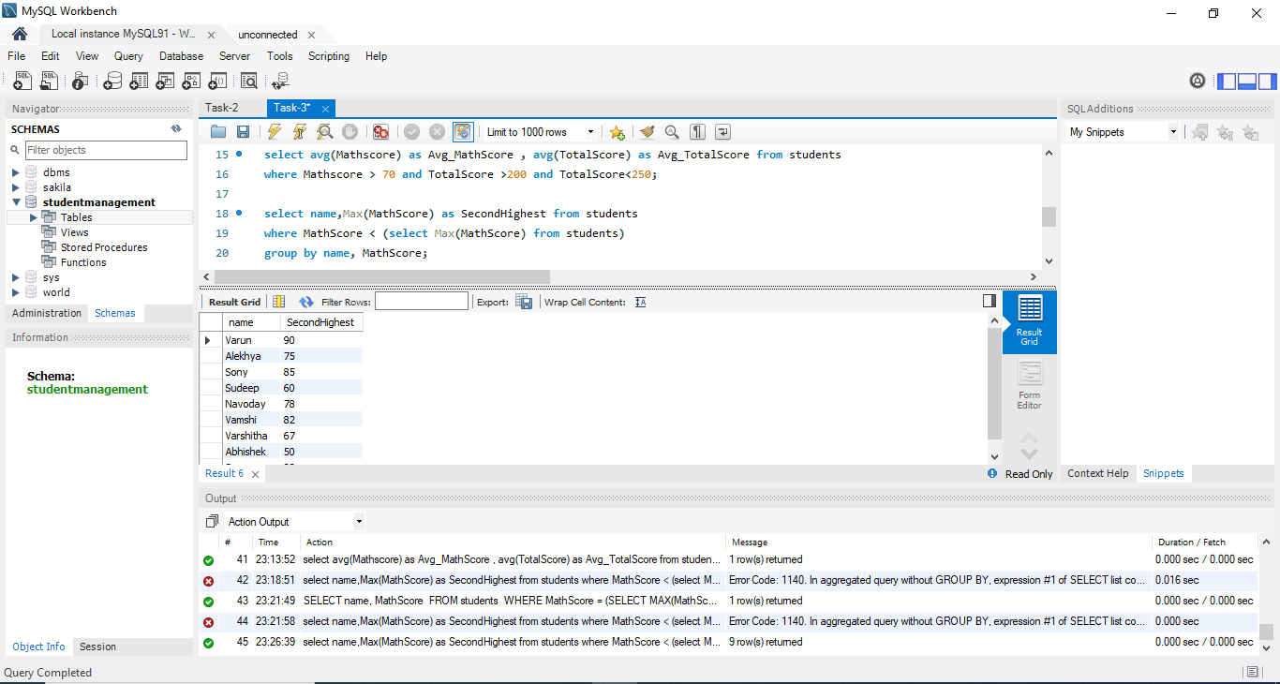**Task 3: Find Second-Highest Math Scores**

● Use a subquery to determine the highest Math score and exclude it in a second query to

find the next highest value.

**● Example:**

**○** Use MAX(math_score) in a subquery to find the highest score.

**○** Use WHERE math_score < (SELECT MAX(math_score) FROM

Students) to exclude the top score and then use MAX again to find the second

highest score.

