**SQL DEVELOPER**

TASK-4

**1. Dataset Setup**

● **Create and Populate Table**: Define a table Students with fields like: ○ StudentID (Primary Key)

○ Name

○ MathScore

○ TotalScore

● Populate with sample data for the analysis.

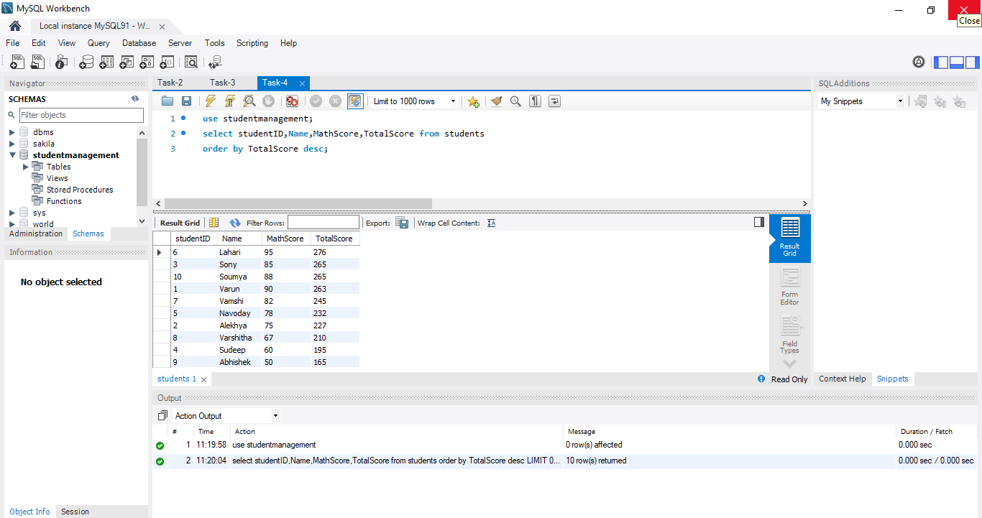

**2. Tasks to Perform**

**Task 1: Rank Students Based on Total Scores**

● **Query Objective**: Use the RANK() function to assign ranks to students based on their TotalScore.

● **Query Explanation**: ○ Use RANK() OVER (ORDER BY TotalScore DESC) to rank students in descending order of their total scores.

○ If two students have the same score, they receive the same rank, and the next rank is skipped.

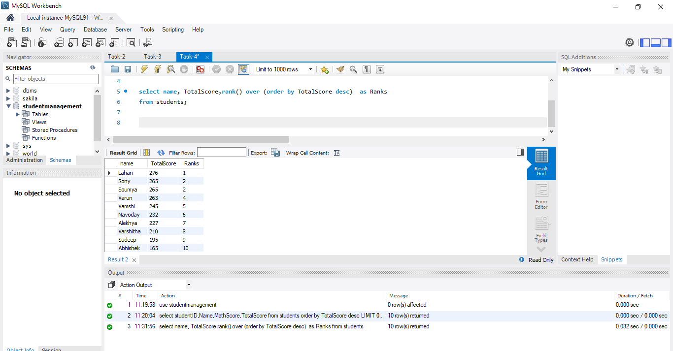

**Task 2: Calculate Running Totals for Math Scores**

● **Query Objective**: Use the SUM() function with OVER() to calculate running totals of MathScore ordered by StudentID.

● **Query Explanation**: ○ Use SUM(MathScore) OVER (ORDER BY StudentID) to compute a cumulative total.

○ This provides the total Math score up to each student in the order specified.

