**SQL DEVELOPER**

TASK-5

CASE Statements for Conditional Transformation

**1. Assign Grades Based on Total Scores**

● **Goal**: Assign grades to students based on their total scores.

● **Logic**: ○ CASE statements can categorize students' total scores into grade brackets, e.g.:

>= 90: A

>= 80: B

>= 70: C

< 70: D (Fail)

● **Expected Output**:

○ Displays StudentID, TotalScore, and the assigned grade.

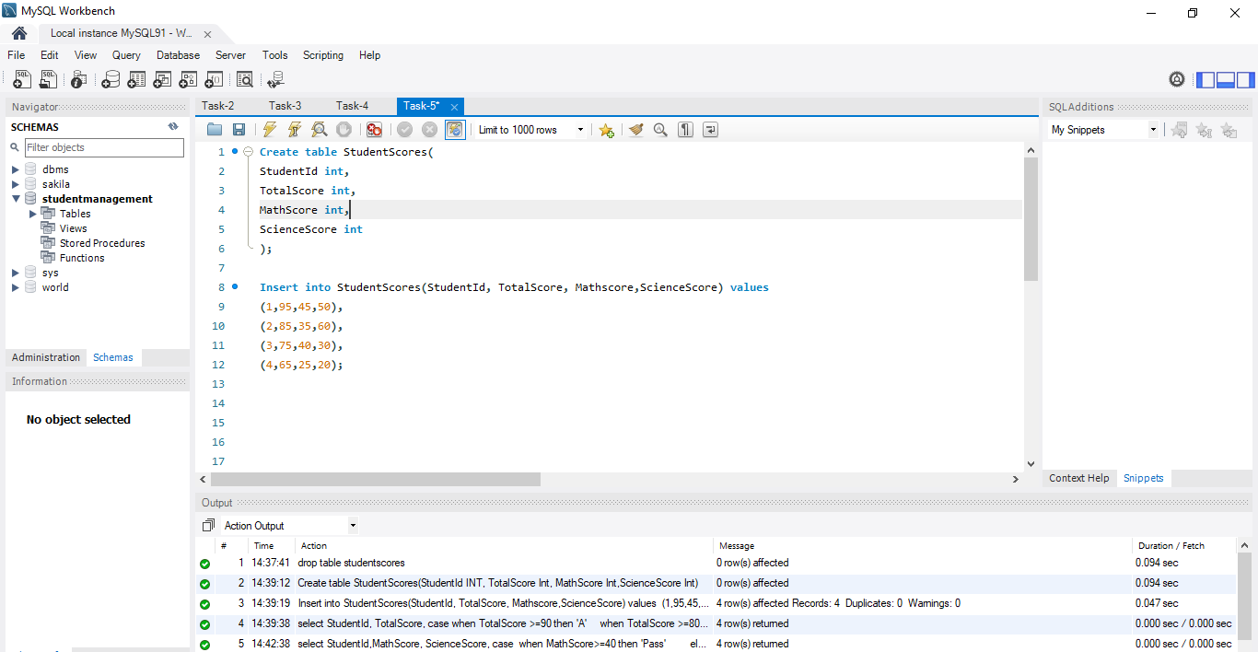

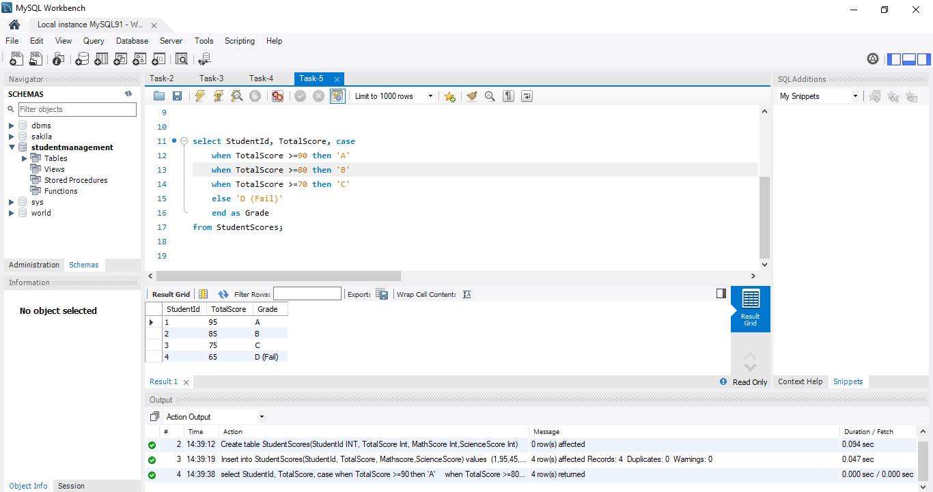

**2. Identify Pass/Fail Status in Specific Subjects**

● **Goal**: Check if a student passed or failed in each subject based on a passing threshold.

● **Logic**: ○ Use a CASE statement to evaluate individual subject scores: Example: Pass if score ≥ 40, Fail otherwise.

● **Expected Output**: ○ Displays StudentID, individual subject scores, and their Pass/Fail status.

