**SQL DEVELOPER**

TASK-8

📌 Section 1: Triggers & Procedures

🎯 Objective

🔹 Automate actions using triggers and create procedures for reusable database operations.

🛠 Tasks to Perform

✅ 1. Triggers

● Automatically log updates in a separate table when student records change.

● Use AFTER UPDATE trigger to capture changes.

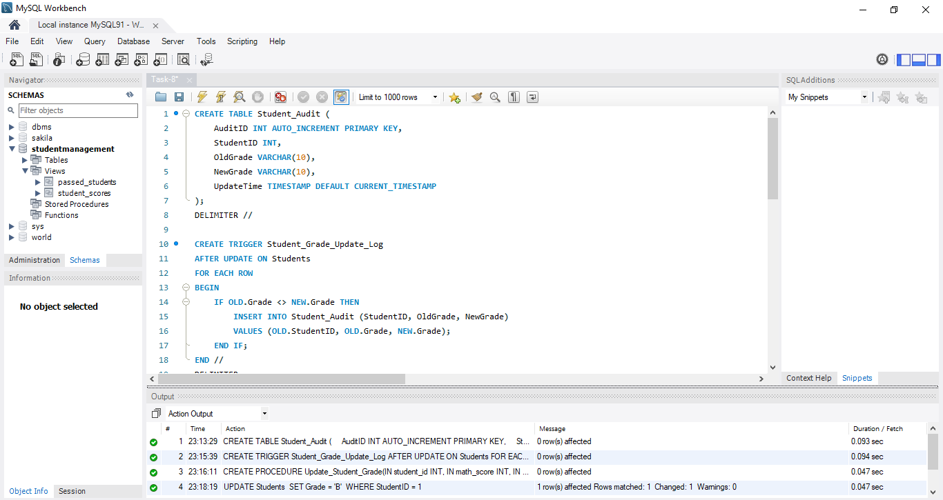

✅ 2. Procedures

● Create a stored procedure to update student grades based on their performance.

● Ensure flexibility to handle different grading criteria.

📌 Deliverable: Automated logging and reusable grade update logic.

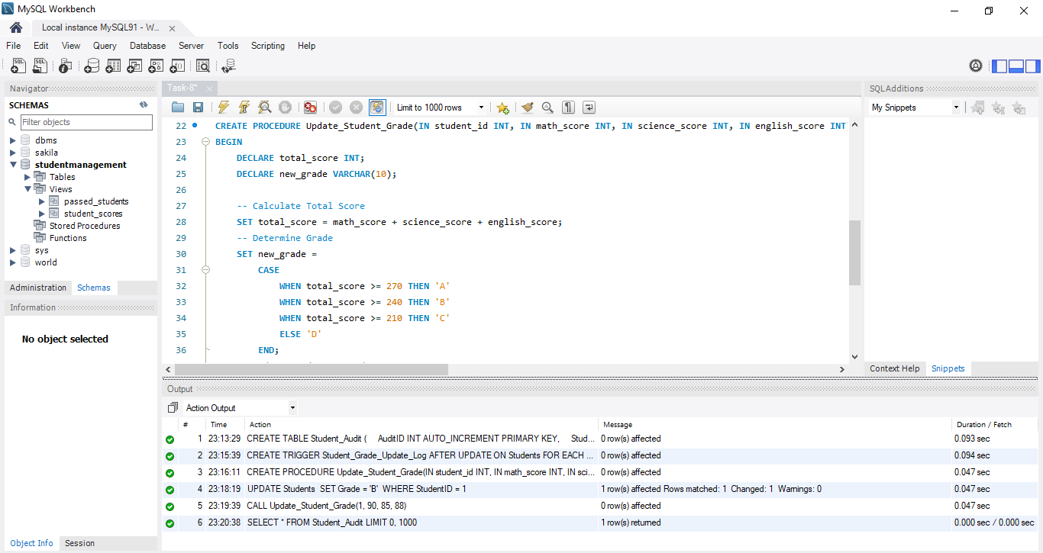

📌 Section 2: Explanation of Queries

🛠 How Triggers Work

✔️Triggers execute automatically after specific actions (e.g., insert, update, delete).

✔️Used to log changes in a separate audit table.

🛠 How Procedures Work

✔️Stored procedures encapsulate reusable SQL operations.

✔️Helps in bulk updates like modifying student grades based on conditions.

