Step 0.5:-

# systemctl stop firewalld

# systemctl disable firewalld

vi /etc/sysconfig/selinux

Current mode: disabled

restart

sestatus

STEP 1 (Basic package install)

# yum install gcc make vim rsync zip unzip bzip2 telnet lsof elinks wget net-tools ca-certificates tmux yum-utils net-snmp-utils epel-release perl-version perl-Sys-Syslog cpan kernel kernel-source kernel-devel

STEP 2 (EXTRA REPO add)

# yum install https://dl.fedoraproject.org/pub/epel/epel-release-latest-7.noarch.rpm

# yum install http://rpms.remirepo.net/enterprise/remi-release-7.rpm

# yum-config-manager --enable remi-php74

STEP 3 ( Install apache+php+phpmyadmin package)

yum install httpd

yum install php-common

yum install php php-mcrypt php-cli php-curl php-zip php-fileinfo php-mysql php-pdo php-gd php-mbstring php-imap php-ldap php-domxml php-xmlrpc php-pecl-apcu php-opcache php-pear-CAS php-mbstring php-imap php-gd php-pdo php-apcu php-xmlrpc php-zend-abi

yum --enablerepo=remi,remi-test install phpMyAdmin

vim /etc/httpd/conf.d/phpMyAdmin.conf

Alias /phpMyAdmin /usr/share/phpMyAdmin

Alias /phpmyadmin /usr/share/phpMyAdmin

<Directory /usr/share/phpMyAdmin/>

AddDefaultCharset UTF-8

# Require local --------------changes

Require all granted --------------- changes

</Directory>

<Directory /usr/share/phpMyAdmin/setup/>

Require all granted -----------------changes

</Directory>

# These directories do not require access over HTTP - taken from the original

# phpMyAdmin upstream tarball

#

<Directory /usr/share/phpMyAdmin/libraries/>

Require all denied

</Directory>

<Directory /usr/share/phpMyAdmin/templates/>

Require all denied

</Directory>

<Directory /usr/share/phpMyAdmin/setup/lib/>

Require all denied

</Directory>

<Directory /usr/share/phpMyAdmin/setup/frames/>

Require all denied

</Directory>

systemctl restart httpd

systemctl enable httpd

STEP 4 (Install mysql & configuration)

rpm -ivh https://repo.mysql.com/mysql80-community-release-el7-1.noarch.rpm

rpm --import https://repo.mysql.com/RPM-GPG-KEY-mysql-2022

yum -y install mysql-community-server --disablerepo=mysql80-community --enablerepo=mysql57-community

/etc/yum.repos.d/mysql-community.repo------------------disable 8.0 and rnable 5.7

systemctl start mysqld

systemctl enable mysqld

$ vim /etc/my.cnf

character_set_server=utf8

max_allowed_packet = 512M

query_cache_size = 256M

innodb_log_file_size = 1024M

$ cd /var/lib/mysql

$ rm -rf ib_logfile1 ib_logfile0

$ systemctl restart mysqld

cat /var/log/mysqld.log | grep -i 'temporary password'

mysql_secure_installation

mysql -u root -p

uninstall plugin validate_password;

STEP 5 (OTRS 6.0.17 Install and configure)

NEW download link : https://wurmberg.otrs.com/external/download-center

wget https://ftp.otrs.org/pub/otrs/otrs-6.0.17.tar.bz2

tar -jxvf otrs-6.0.17.tar.bz2

mv otrs-6.0.17 otrs

cd /opt/otrs/bin/

./otrs.CheckModules.pl

yum install cpan perl-version perl-Sys-Syslog

yum install perl"(Apache::DBI)" perl"(Archive::Tar)" perl"(Archive::Zip)" perl"(Crypt::Eksblowfish::Bcrypt)" perl"(Crypt::SSLeay)" perl"(Date::Format)" perl"(DateTime)" perl"(DBI)" perl"(DBD::mysql)" perl"(DBD::ODBC)" perl"(DBD::Oracle)" perl"(DBD::Pg)" perl"(Mail::IMAPClient)" perl"(Encode::HanExtra)" perl"(IO::Socket::SSL)" perl"(JSON::XS)" perl"(LWP::UserAgent)" perl"(IO::Socket::SSL)" perl"(Authen::SASL)" perl"(Authen::NTLM)" perl"(ModPerl::Util)" perl"(Net::DNS)" perl"(Net::LDAP)" perl"(Template)" perl"(Template::Stash::XS)" perl"(Text::CSV_XS)" perl"(XML::LibXML)" perl"(XML::LibXSLT)" perl"(XML::Parser)" perl"(YAML::XS)"

./otrs.CheckModules.pl

install remaning via cpan

cpan

install IO::Socket::SSL

useradd -d /opt/otrs -c 'OTRS user' otrs

usermod -G apache otrs

cp /opt/otrs/Kernel/Config.pm.dist /opt/otrs/Kernel/Config.pm

perl -cw /opt/otrs/bin/cgi-bin/index.pl

cp /opt/otrs/scripts/apache2-httpd.include.conf /etc/httpd/conf.d/otrs.conf

/opt/otrs/bin/otrs.SetPermissions.pl --web-group=apache --otrs-user=otrs

systemctl restart httpd

systemctl enable httpd

Step 6:- Create DB and user

mysql -u root -p

CREATE DATABASE otrs;

GRANT ALL PRIVILEGES ON otrs.* TO 'otrs'@'localhost' IDENTIFIED BY 'password';

FLUSH PRIVILEGES;

\q

OR with fronend

<http://your_ip/phpmyadmin>

Go to databases and create

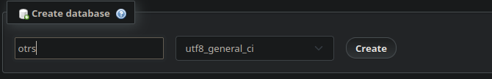

Go to UserAccounts and create user

click to add user accounts

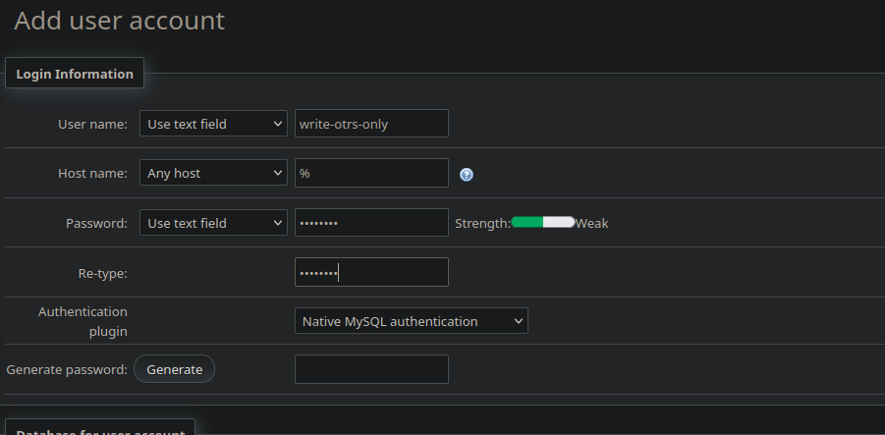

clixk on go

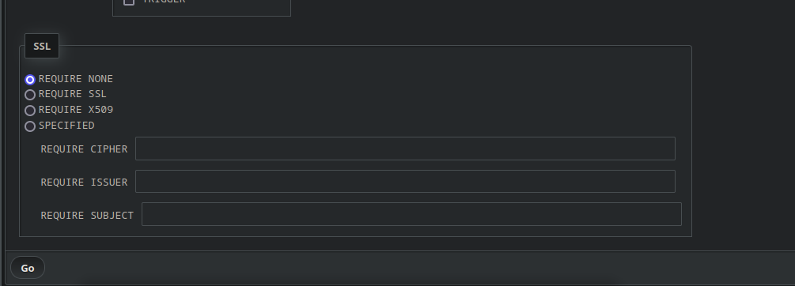

Select your user click go

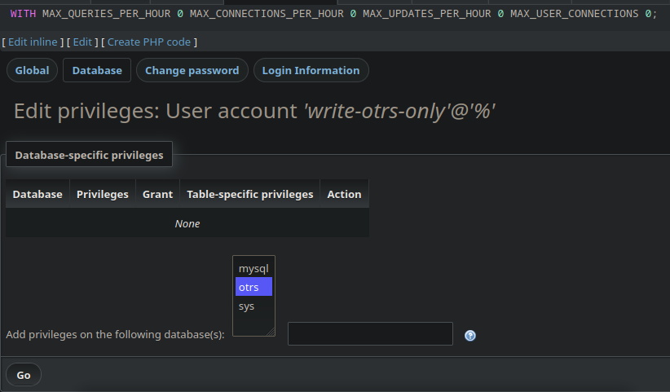

Select Check all then go

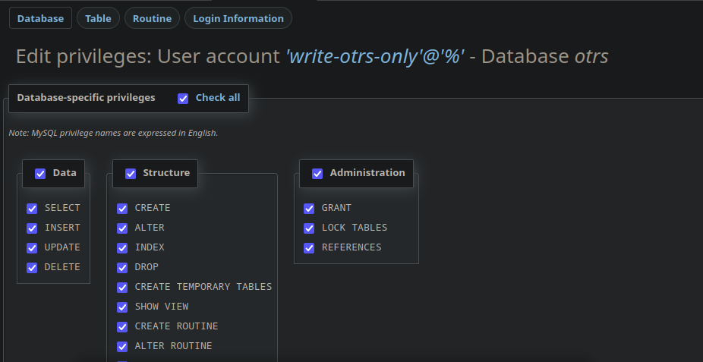

Run below

http://172.16.0.107/otrs/installer.pl

choose existing and do next next next

If any problem please contact on below

Contact:- Dont fucking contact me