https://github.com/Bat-mader/TTT-SLM_project

1) Created a new repository on Github
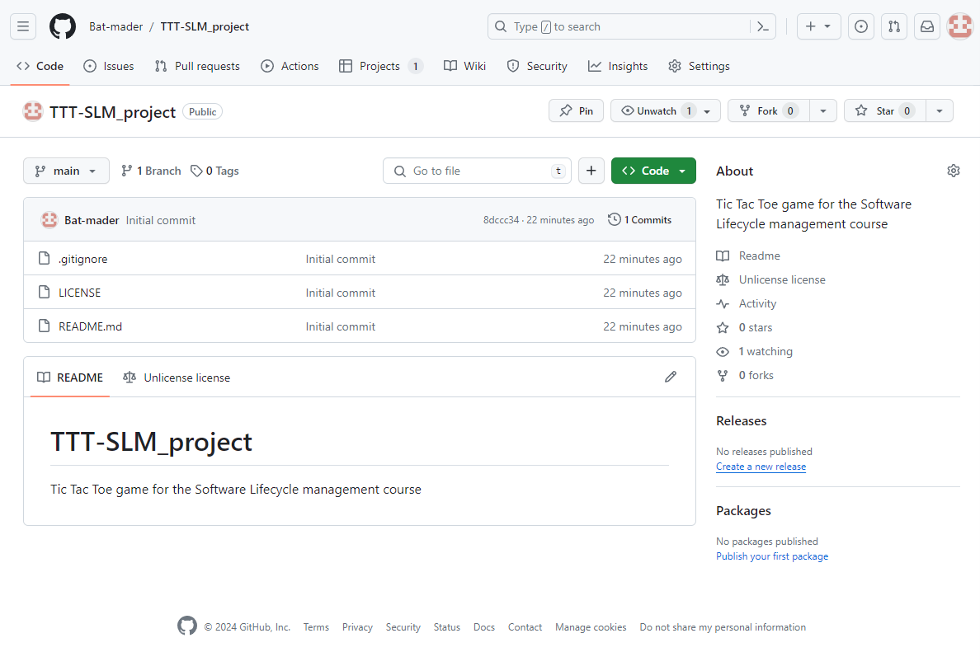
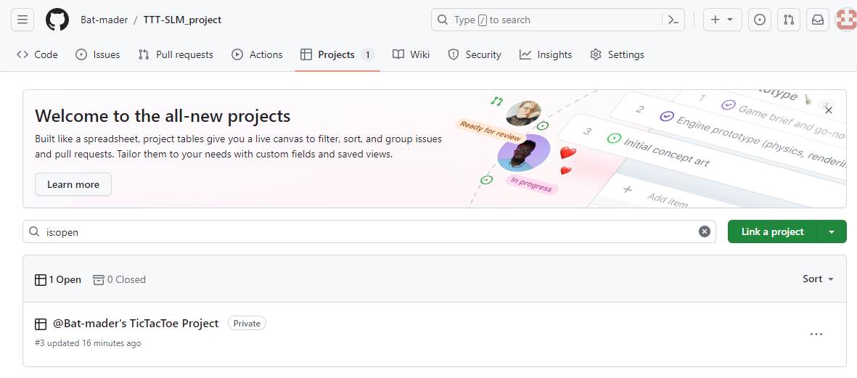
2) Created a new Project linked to the Repository

3) Filled up the Kanban Board with User Stories from the Project Description and commented with a fitting category (e. g. See the current state of the game → User interface)
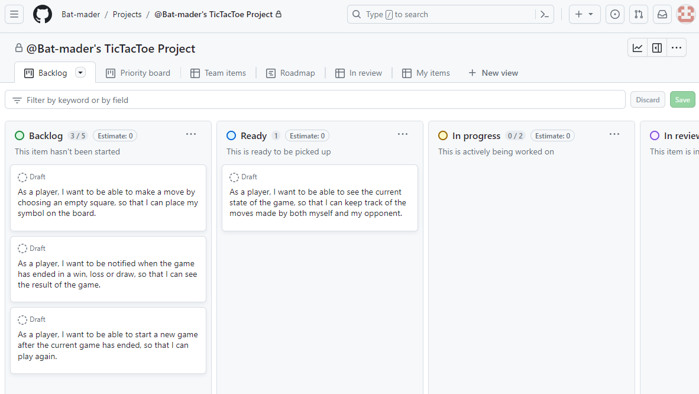
4) Create a new Java project in Intellij and push the blank project to the newly created github repository
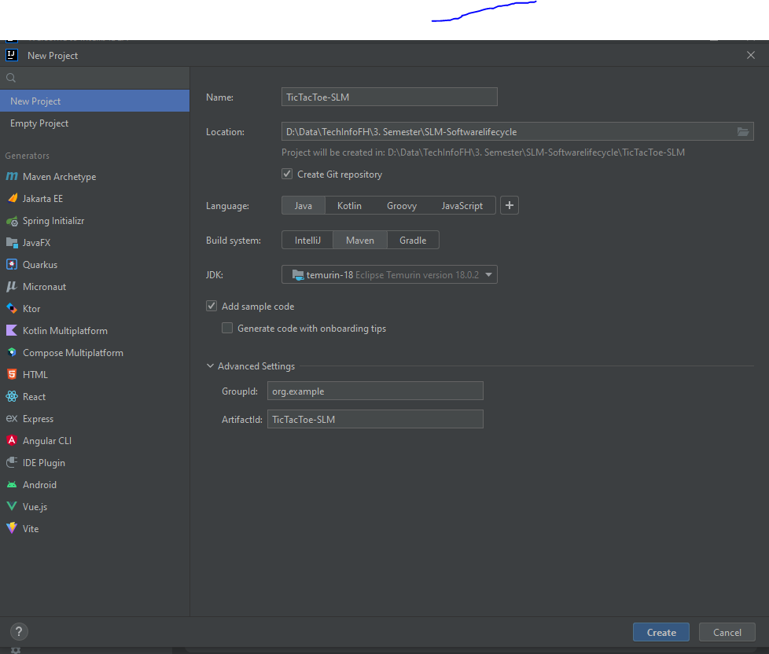

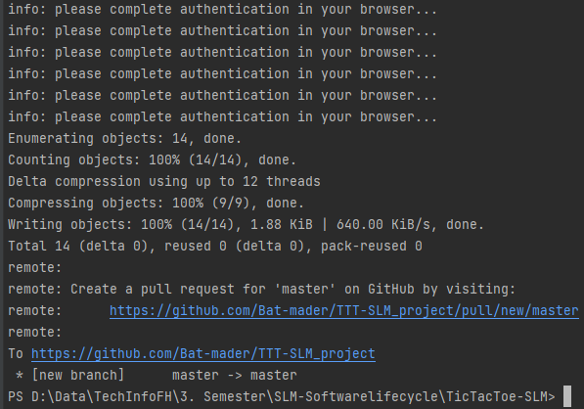

5) Protect the master branch by enabling “pull request required”
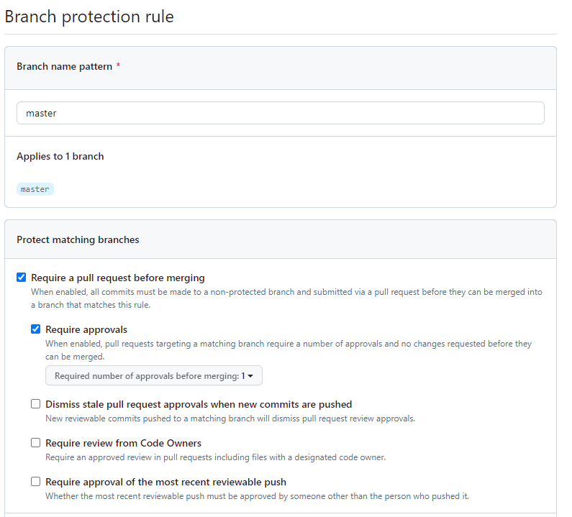
6) Start working
7) Create Pull Request and link issue
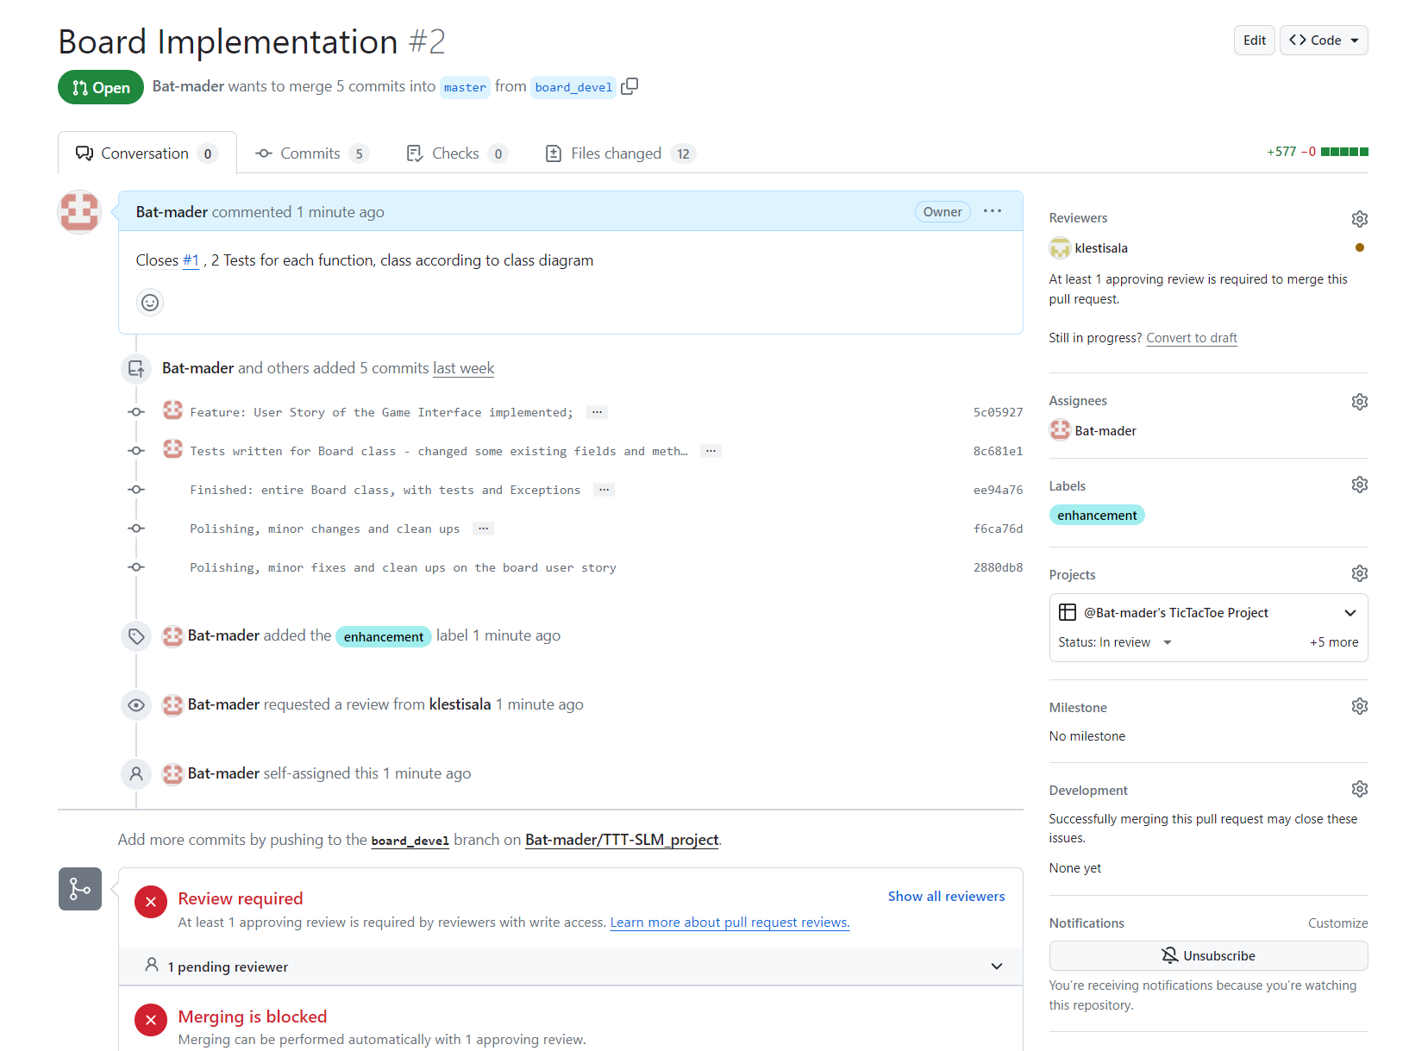
8) Review Pull Request, approve it and then merge the feature branch with the main branch

