View games <http://yorkdojoconnect4.azurewebsites.net/>

Documentation <http://yorkdojoconnect4.azurewebsites.net/Swagger>

Example <https://github.com/YorkCodeDojo/Connect4/tree/master/Connect4.ExampleBot> (C#)

<https://github.com/YorkCodeDojo/Connect4/tree/master/Connect4.CPP> (C++)

APIs <http://yorkdojoconnect4.azurewebsites.net/>api/*something*

## /api/Register [POST]

Register your team and returns your unique player ID.

api/Register?teamName=Winners&password=Secret

## /api/GameState [GET]

Returns the current state of the game

api/GameState?playerID=1234567

## /api/MakeMove [POST]

Places your piece into a column

api/MakeMove?playerID=1234567&ColumnNumber=2&Password=secret

## /api/NewGame [POST]

Clears the board

api/NewGame?playerID=1234567

## Object Structure

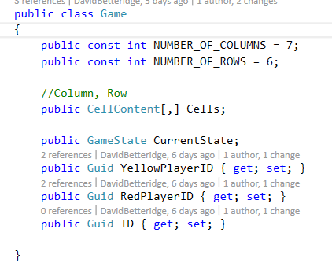 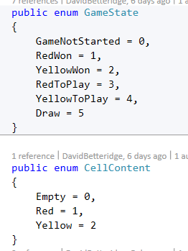

## Sample JSON

{"CurrentState":4,"Cells":[[0,0,0,0,0,0],[0,0,0,0,0,0],[0,0,0,0,0,0],[0,0,0,0,0,0],[0,0,0,0,0,0],[0,0,0,0,0,0],[0,0,0,0,0,0]],"YellowPlayerID":"3f62fd50-ae51-4656-ba8c-830edd7d4bb2","RedPlayerID":"a05bf67c-2bbb-4243-bf18-fe60c52cf4f9","ID":"c3347c13-d55f-4b7c-ad4e-e9cc36f7419c"}

The first column is shown in yellow. The value is red is the bottom row of the second column.