

Project supervisor /

Dr. Heba Elnemr

Project Instructor/

Aya Taha

Project Name/

Pharmacy

Team Members:

Mohamed Ahmed 68456

Mohamed Hamouda 68613

Mohamed Sheriff 68656

Mostafa Mahmoud 68567

Rodaina Waleed 68461

Lina Medhat 68431

Our project is talking about a Pharmacy. We chose this field because we have a known resource to gather all required information to do the project. Our Purpose is to help the patients by providing them the medicine they need.

The staff consist of:

1. Manager.
2. Pharmacist.
3. Delivery.
4. Security.
5. Cleaners.

The tables we created are 7 tables:

1. First table is Branches. It contains the information about our branches like: who is the manger, where is the branch... etc.
2. Second table is Inventory. It contains the information about the medicine we have in our inventory like: what is the active substance in it, the quantity of it, the price, who is its supplier… etc.
3. Third table is Employee. It includes type of job and the information about the people who work in our pharmacy like Pharmacist, security, cleaners, …etc.
4. Fourth table is Suppliers. It includes their contact info and what are they supplying.
5. The Fifth is Customer. It includes an information about customer that have been bought from us before.
6. The sixth table is tb_Events which contain the information on any changes on the data int the tables
7. The seventh table and last table is tb_deleted which contain the deleted records.

The ERD Diagram:

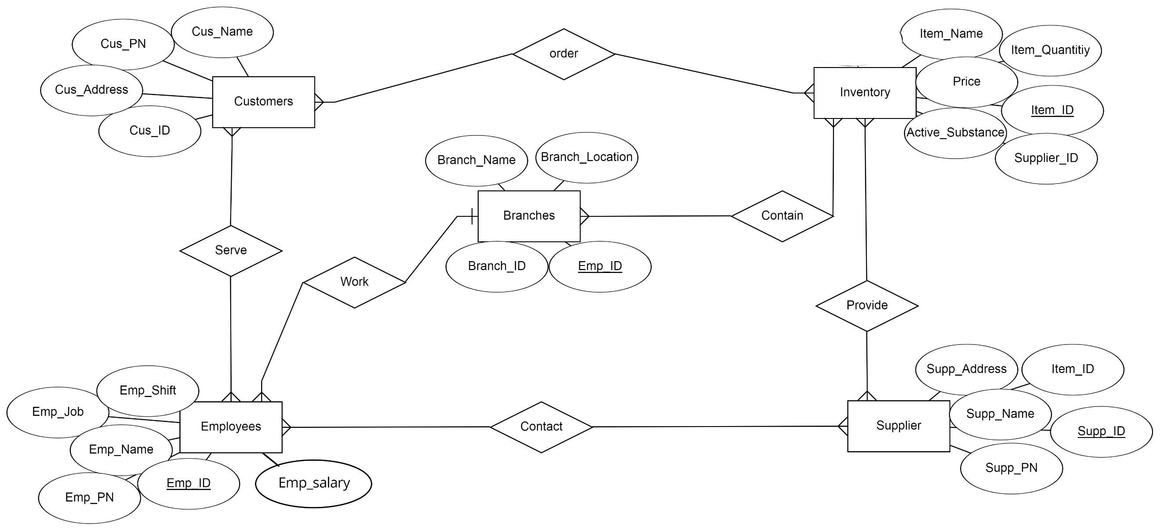

The Branches Table:

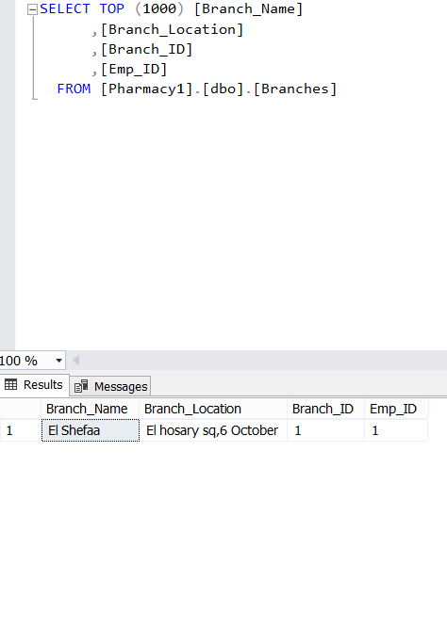

The Customer Table:

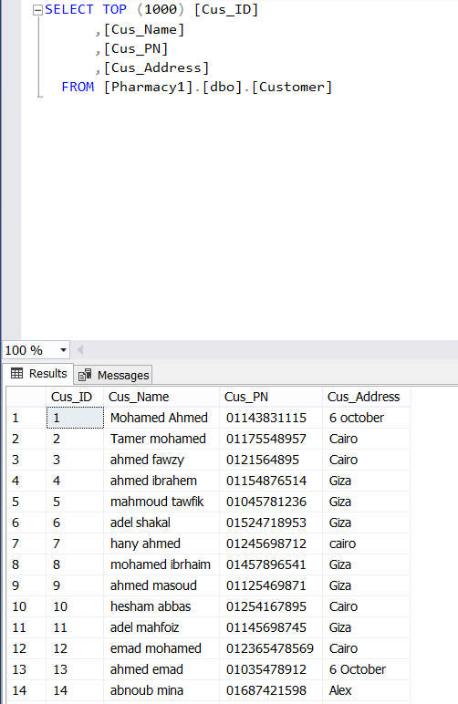

The Employee Table:

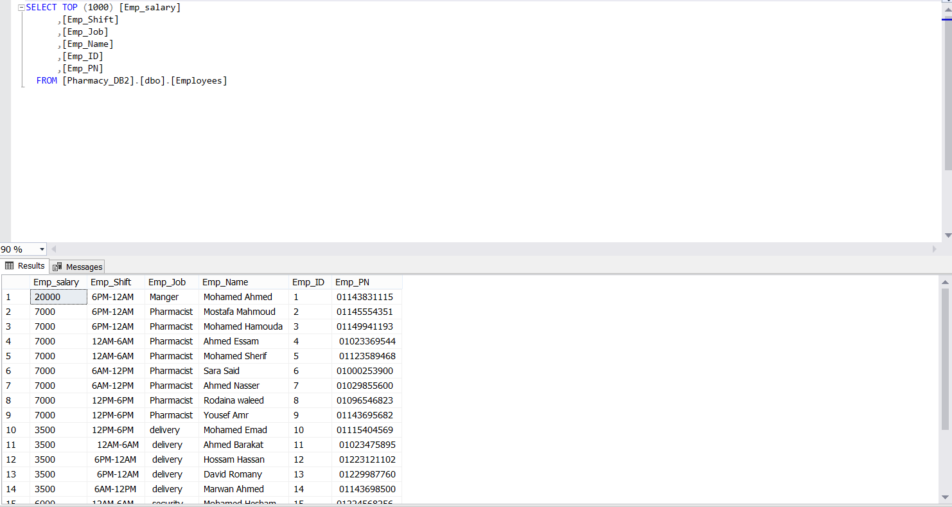

The Inventory Table:

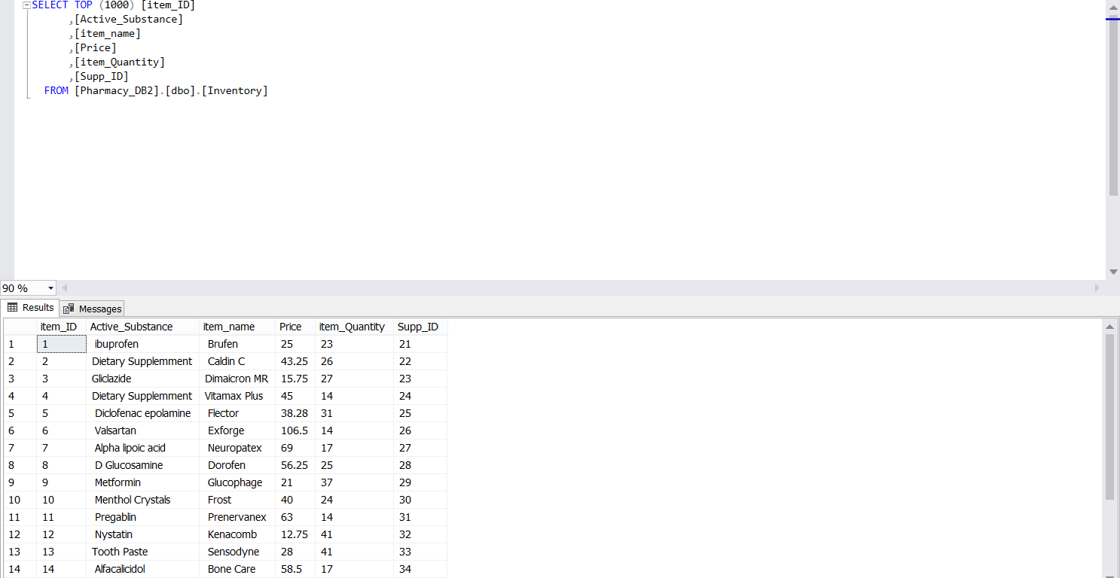

The Suppliers Table:

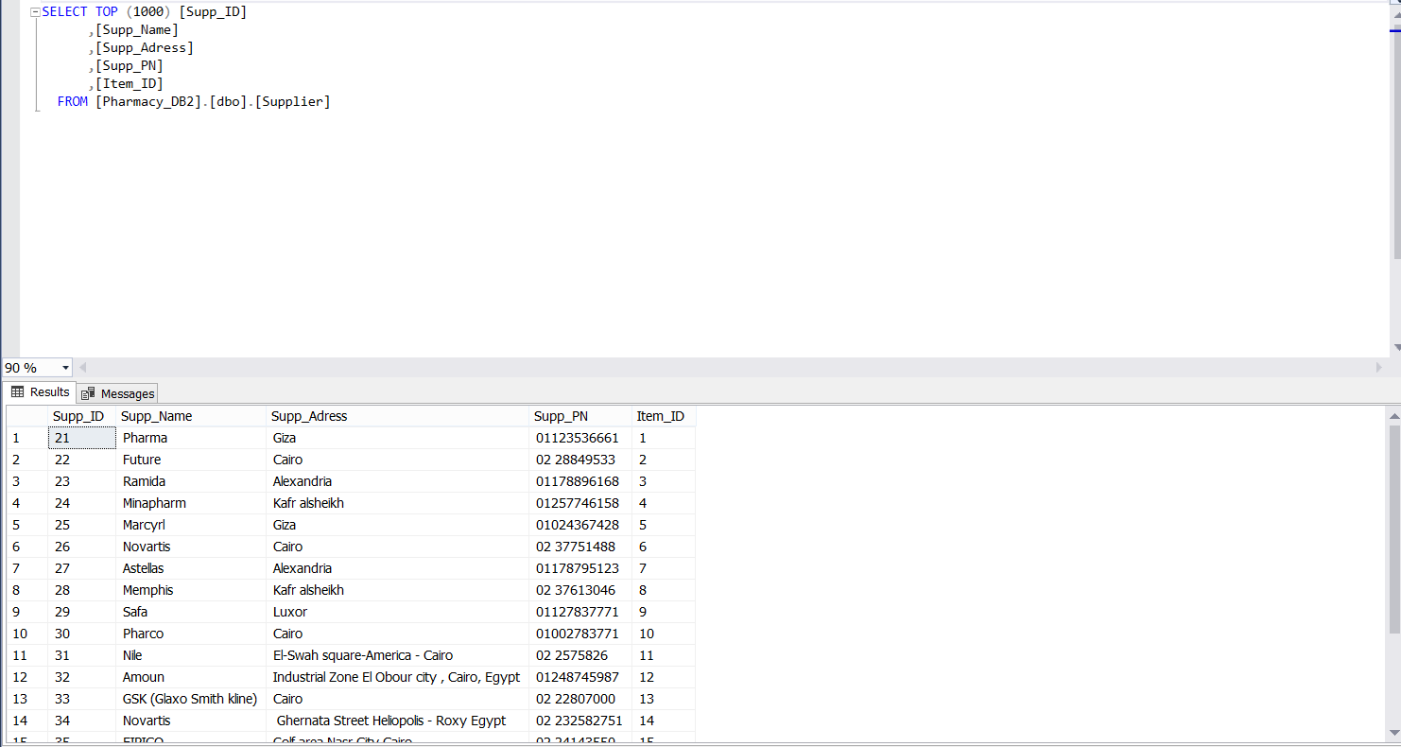

The tb_Events table:

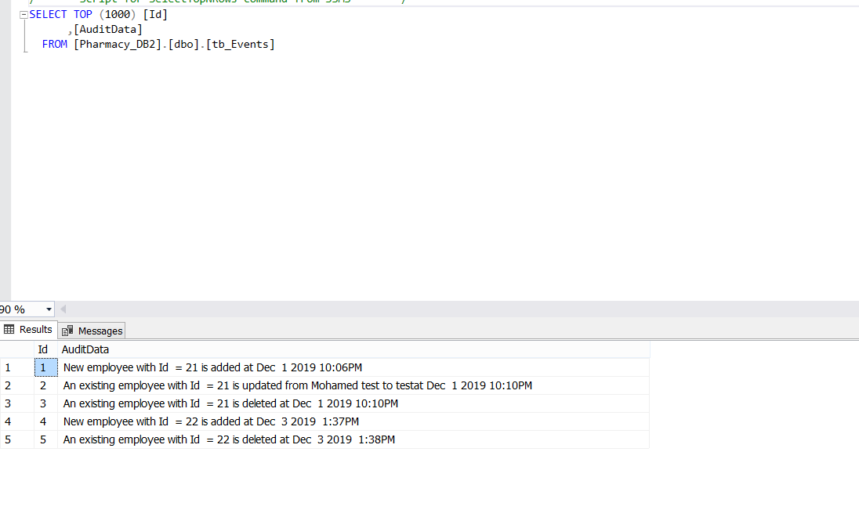

The tb_Deleted table:

