#Code1
void main(){
String str='Coding is';
String str1='Fun';
bool val =(str==str1);
print(val);
String str2='Nandan';
String str3='Nandan';
bool val2 =(str2==str3);
print(val2);
}
Output -
false
true

#Code2
void main(){
List marks=[10,20,30,40];
print(marks[3]);
}
Output-
40
#Code3
void main(){
List<int> numbers=[1,2,3,4,5];
print("Numbers:$numbers");
print("First element:${numbers[0]}");
print("Second elements:${numbers[1]}");
numbers.add(6);
print("After adding 6:$numbers");
numbers.remove(6);
print("After removing 3:$numbers");
int length=numbers.length;
print("Length of the list:$length");
}
Output-
Numbers:[1, 2, 3, 4, 5]
First element:1
Second elements:2
After adding 6:[1, 2, 3, 4, 5, 6]
After removing 3:[1, 2, 3, 4, 5]
Length of the list:5
#Code4
void main(){
final list=[10,15,30];
Map marks={
"Rivaan":10,
"Naman":15,
"OtherKid":30,
};
print(marks['Rivaan']);
}
Output-10
#Code5
void main(){
Map<String,String> capitals={
'USA':'Washington,D.C.',
'France':'Paris',
'Japan':'Tokyo',
};
print("Country-Capital Map:$capitals");
print("'Capital of USA:${capitals['USA']}");
capitals['Germany']='Berlin';
print("After adding Germany:$capitals");
print("Country-Capital Pairs:");
for(var country in capitals.keys){
var capital=capitals[country];
print("The capital of $country is $capital");
}
capitals.remove("France");
print("After removing France:$capitals");
bool hasJapan=capitals.containsKey('Japan');
print("Does the map have Japan as a key? $hasJapan");
}
Output-
Country-Capital Map:{USA: Washington,D.C., France: Paris, Japan: Tokyo}
'Capital of USA:Washington,D.C.
After adding Germany:{USA: Washington,D.C., France: Paris, Japan: Tokyo, Germany: Berlin}
Country-Capital Pairs:
The capital of USA is Washington,D.C.
The capital of France is Paris
The capital of Japan is Tokyo
The capital of Germany is Berlin
After removing France:{USA: Washington,D.C., Japan: Tokyo, Germany: Berlin}
Does the map have Japan as a key? True

#Code6
void main(){
int num1=10;
int num2=5;
int val=4;
switch(val)
{
case 1:int sum=num1+num2;
print("Sum of two numbers is equal to $sum");
break;
case 2: int sub=num1-num2;
print("Difference of two numbers is equal to $sub");
break;
case 3: int prod=num1*num2;
print("Product of two numbers is equal to $prod");
break;
case 4: double div=num1/num2;
print("Division of two numbers is equal to $div");
break;
default:
print("Invalid option");
break;

}
}
#Code7
void main(){
for(int i=1;i<=5;i++){
if(i==3){
continue;
}
print("iteration $i");
}
}
Output-
iteration 1
iteration 2
iteration 4
iteration 5
#Code7
void main(){
int i;
print("Rollno.s");
for(i=1;i<111;i++)
{
if(i==50)
break;
print("$i");
}
}

#Code8
void calculateInterest(double principal,double rate,double time){
double interest=principal * rate* time/100;
print("Simple interest is $interest");

}
void main(){
double principal=5000;
double time=3;
double rate=3;
calculateInterest(principal,rate,time);
}
Output-
Simple interest is 450
#Code 9
class Rectangle {
double? length;
double? breadth;
double area() {
return length! * breadth!;
}
}

void main() {
Rectangle rectangle = Rectangle();
rectangle.length = 10;
rectangle.breadth = 5;
print("Area of rectangle is ${rectangle.area()}.");
}
Output-
Area of rectangle is 50.0

#Code 10
import 'dart:math';
void Generate_Random(int min, int max){
Random random = Random();
int randomNumber = min + random.nextInt((max + 1) - min); // Generates a number between 10 and 20 (inclusive)
print("random number generate is $randomNumber");// Generates a number between 0 and 99
}
void main(){
Generate_Random(1000,10000);
}

Output-8639

Code-11
void main() {
List<int> numbers = [1, 2, 3, 4, 5, 6];
int sumEvenNumbers(List<int> numbers) {
return numbers
.where((n) => n.isEven)
.fold(0, (sum, n) => sum + n);
}

int result = sumEvenNumbers(numbers);
print('Sum of even numbers: $result'); // Output: Sum of even numbers: 12
}
Output-
Sum of even numbers:12
#Code 12
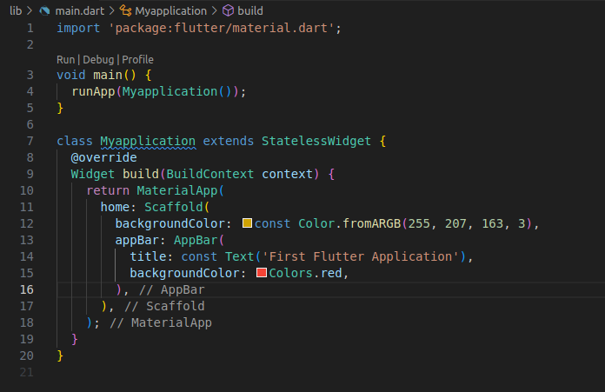
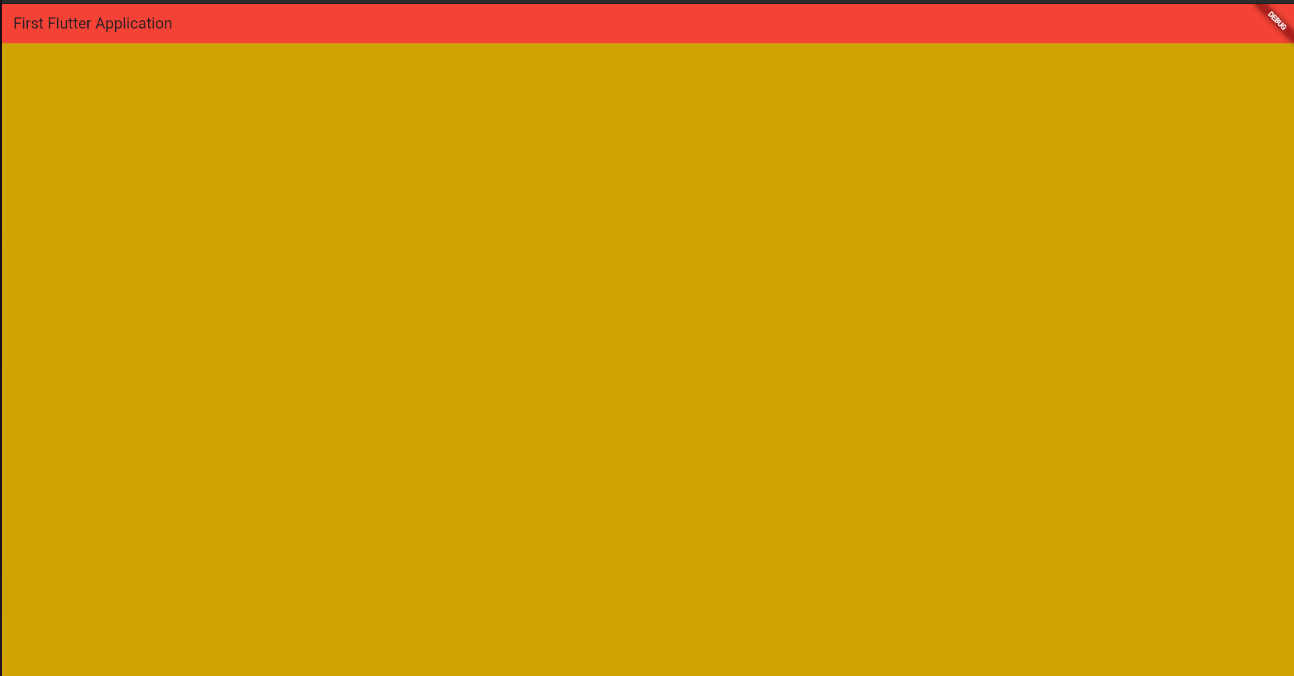

#Code-13
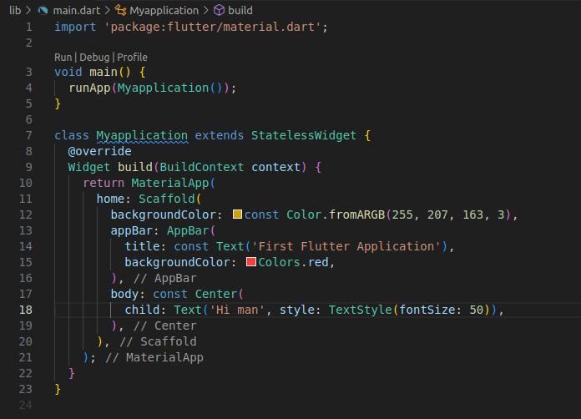
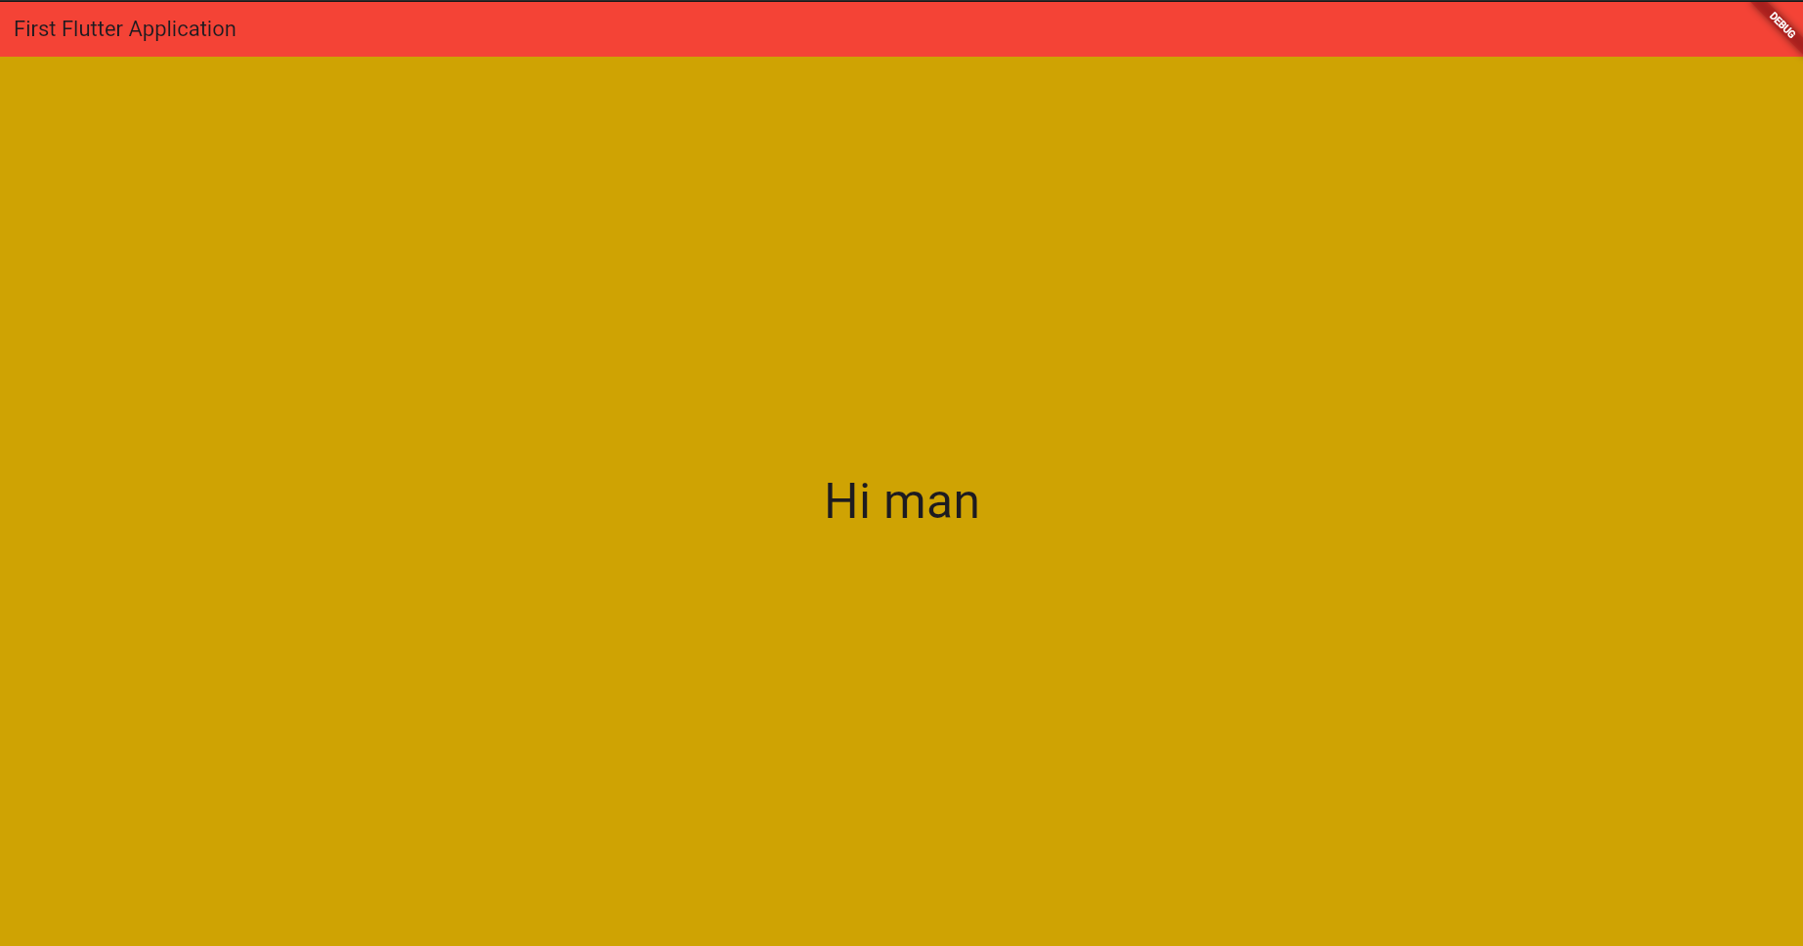

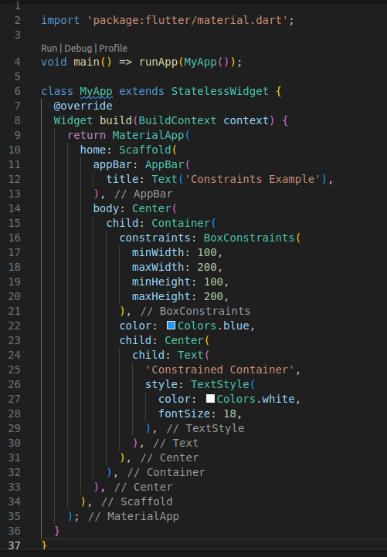
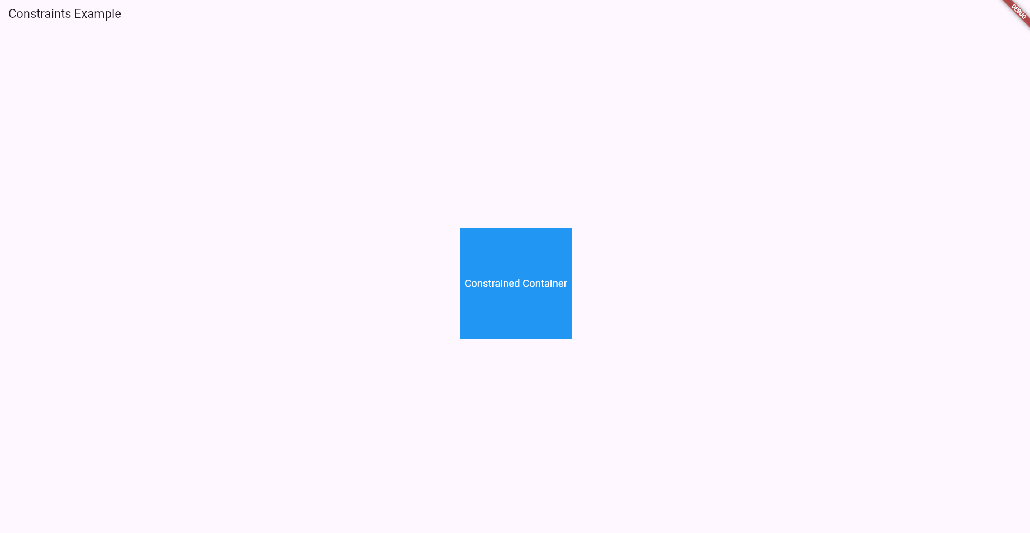
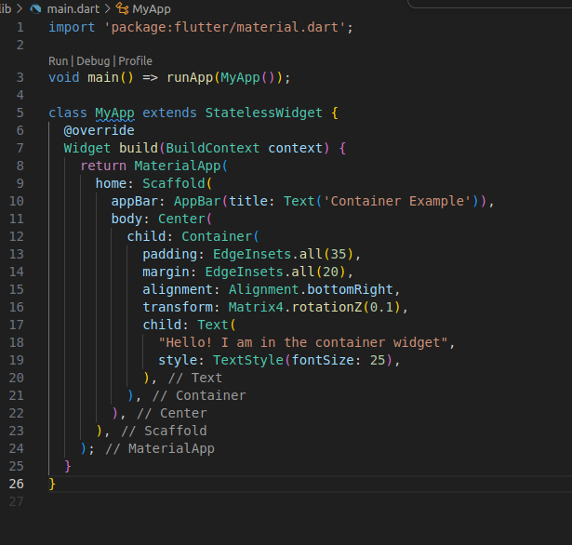
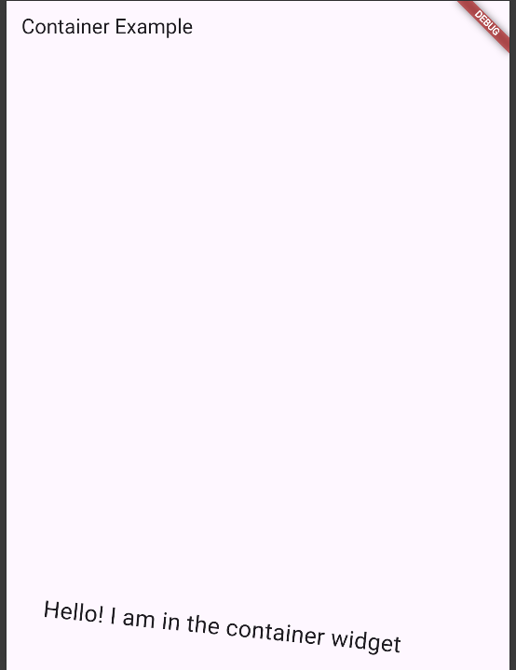

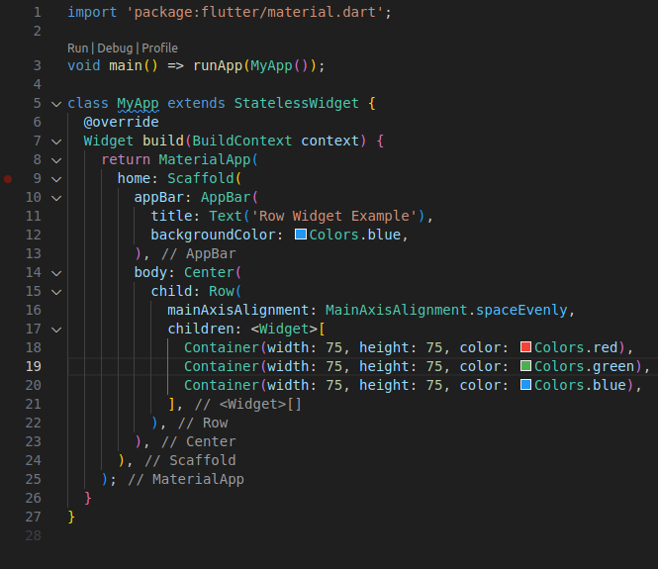
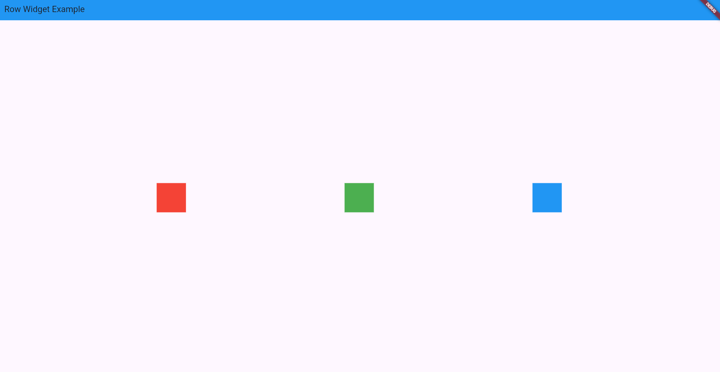
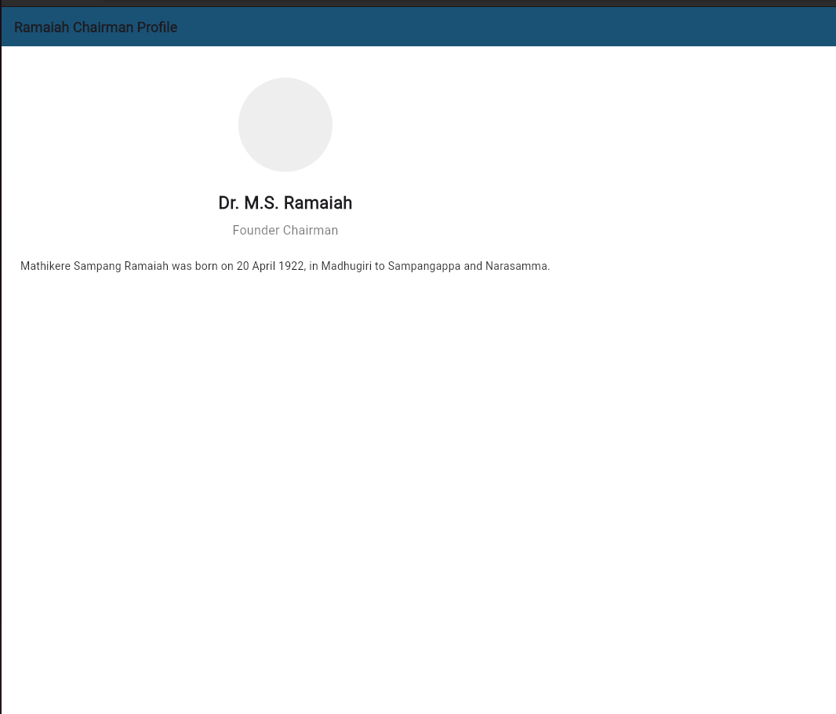
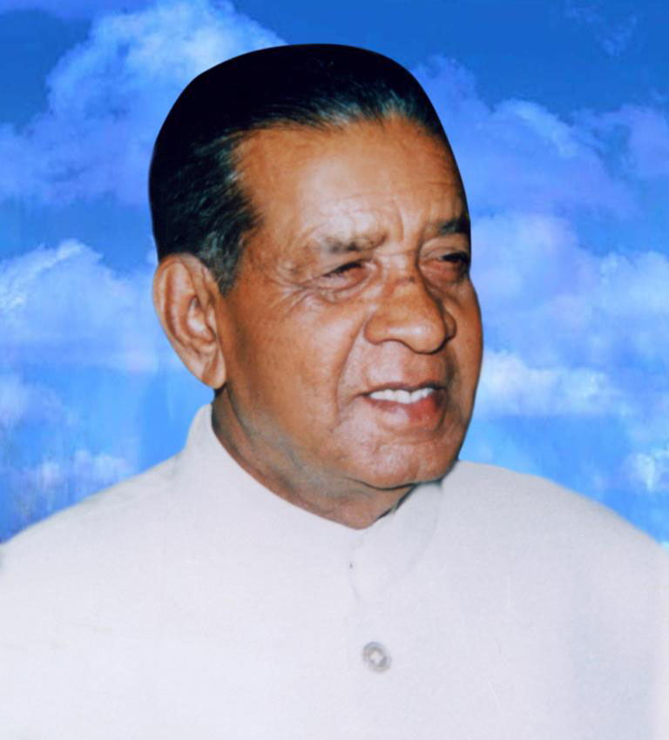
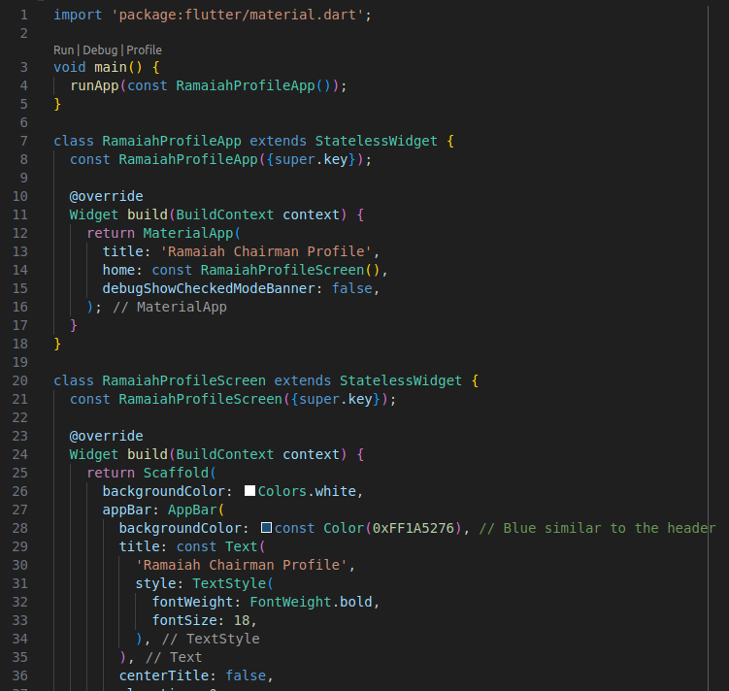
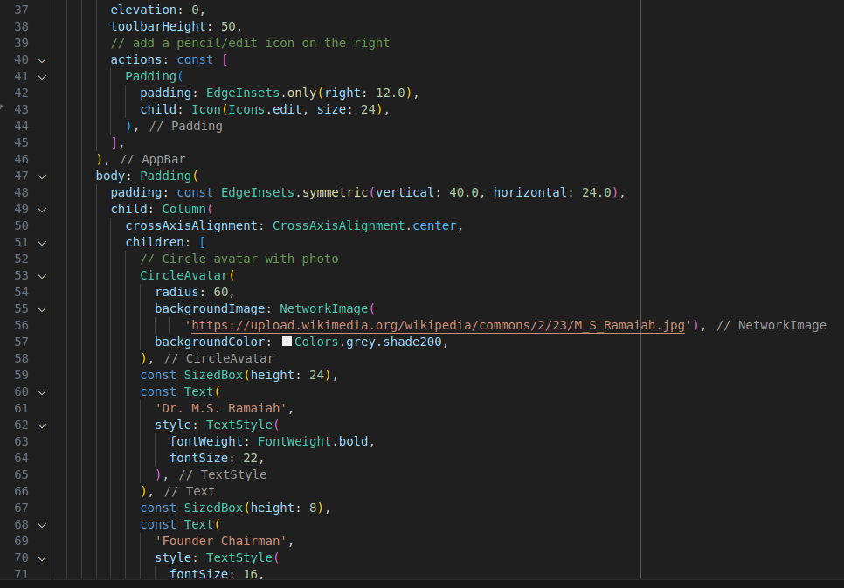
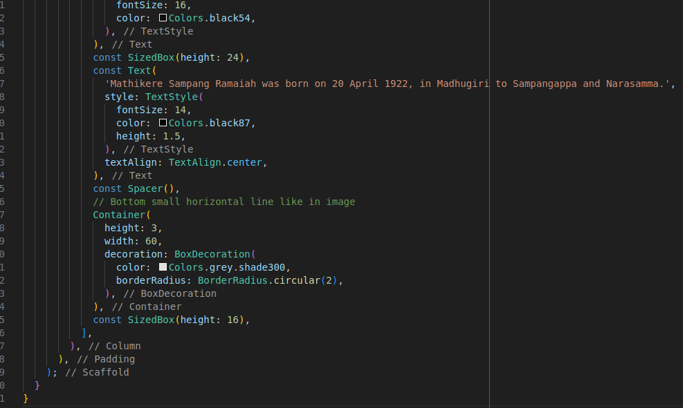
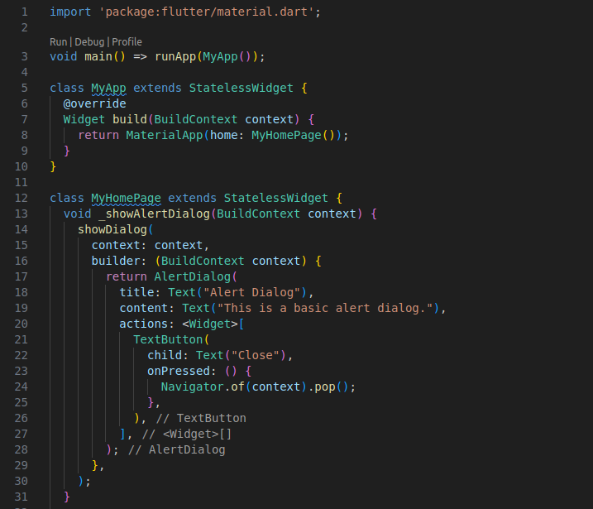
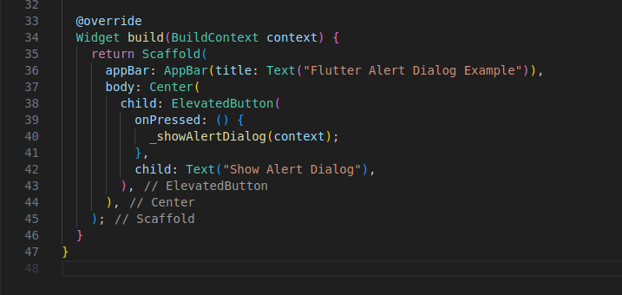
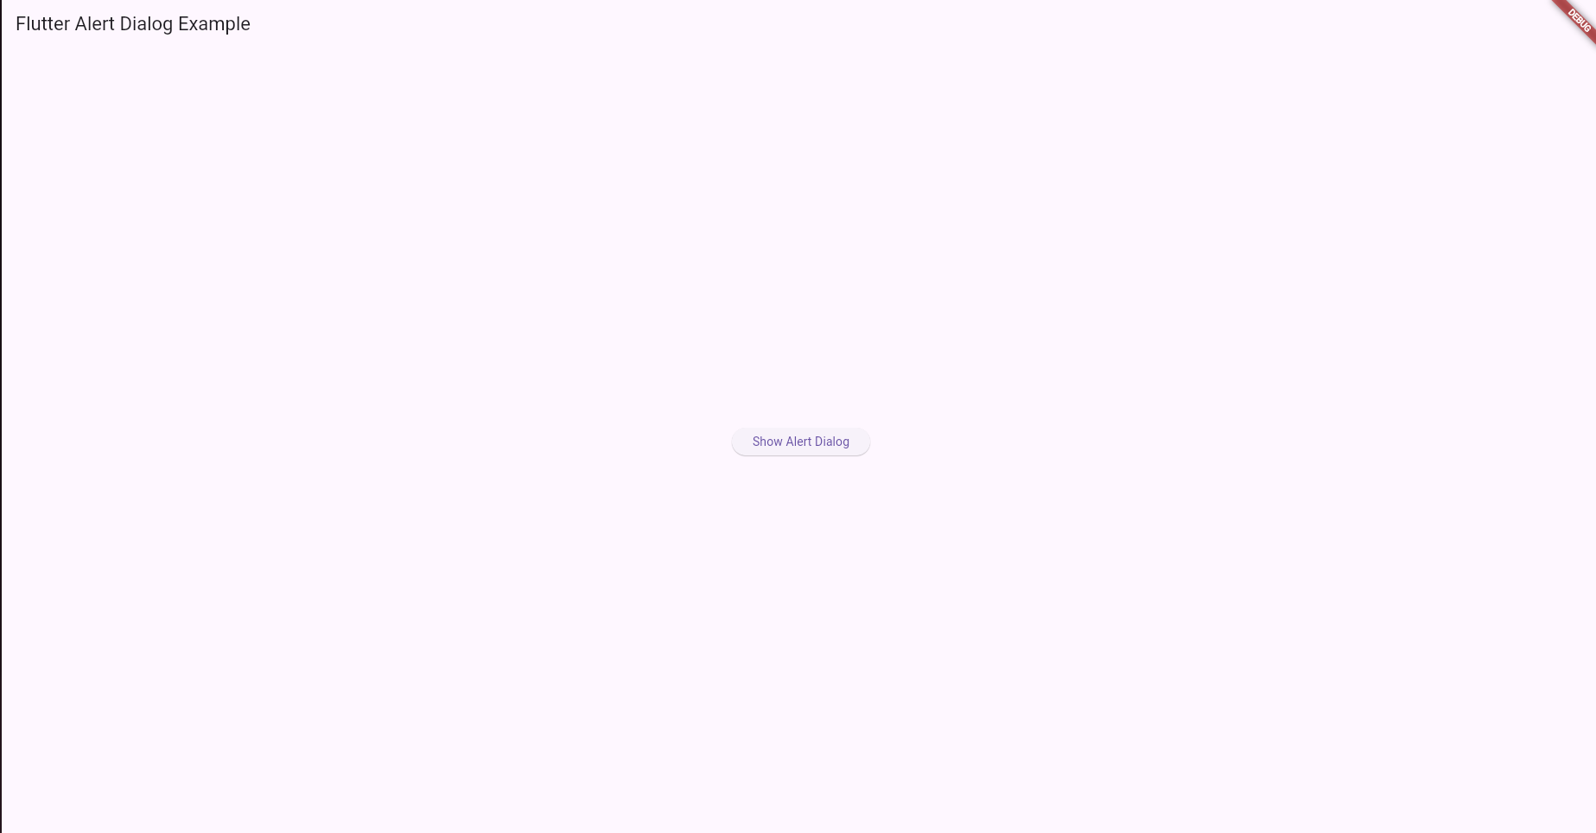
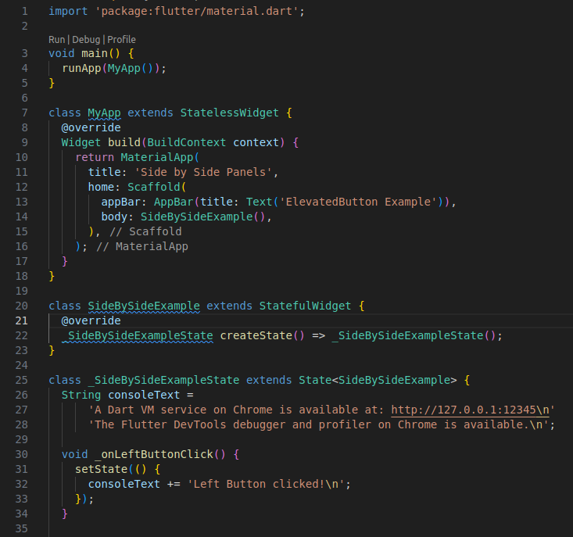
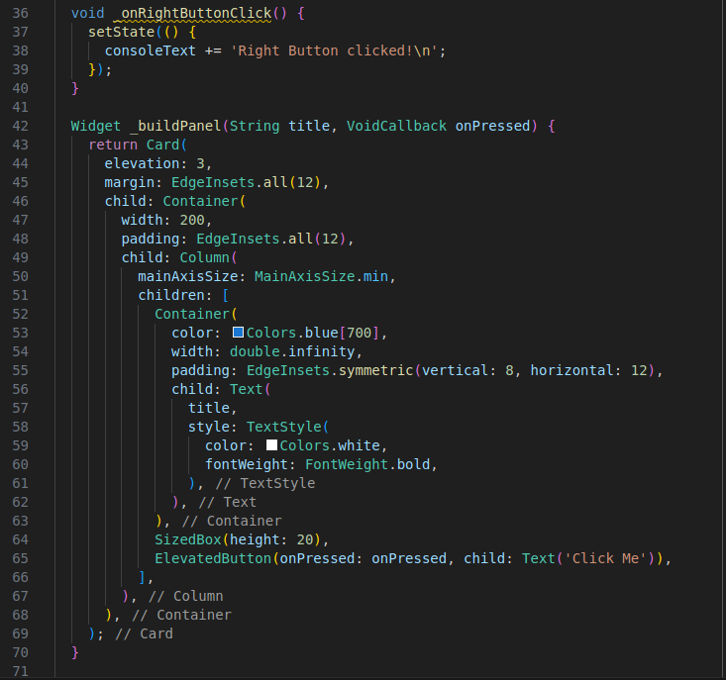
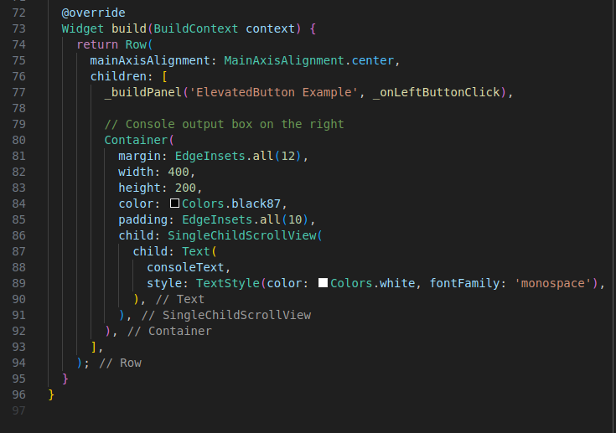
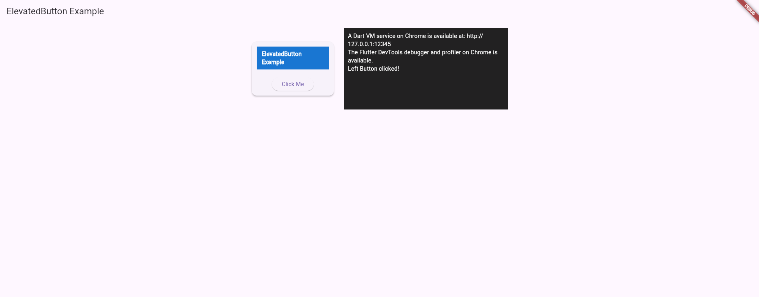
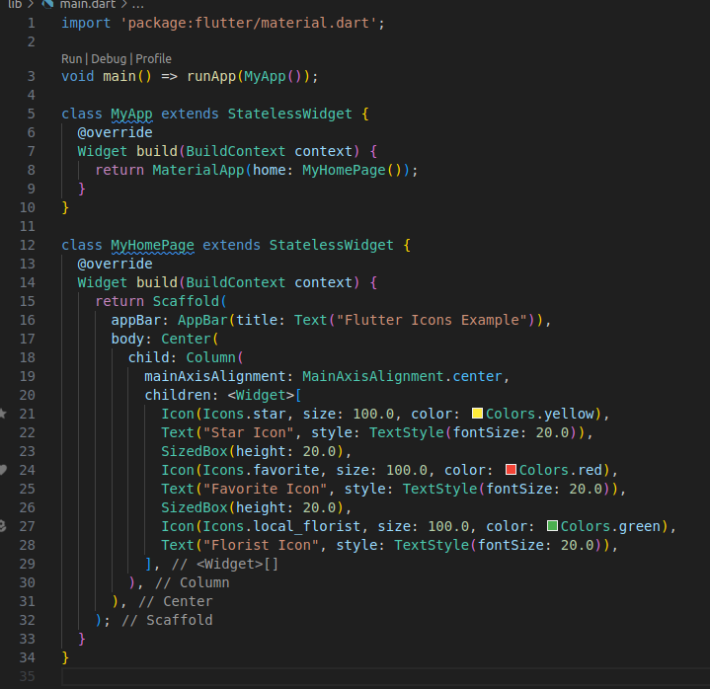
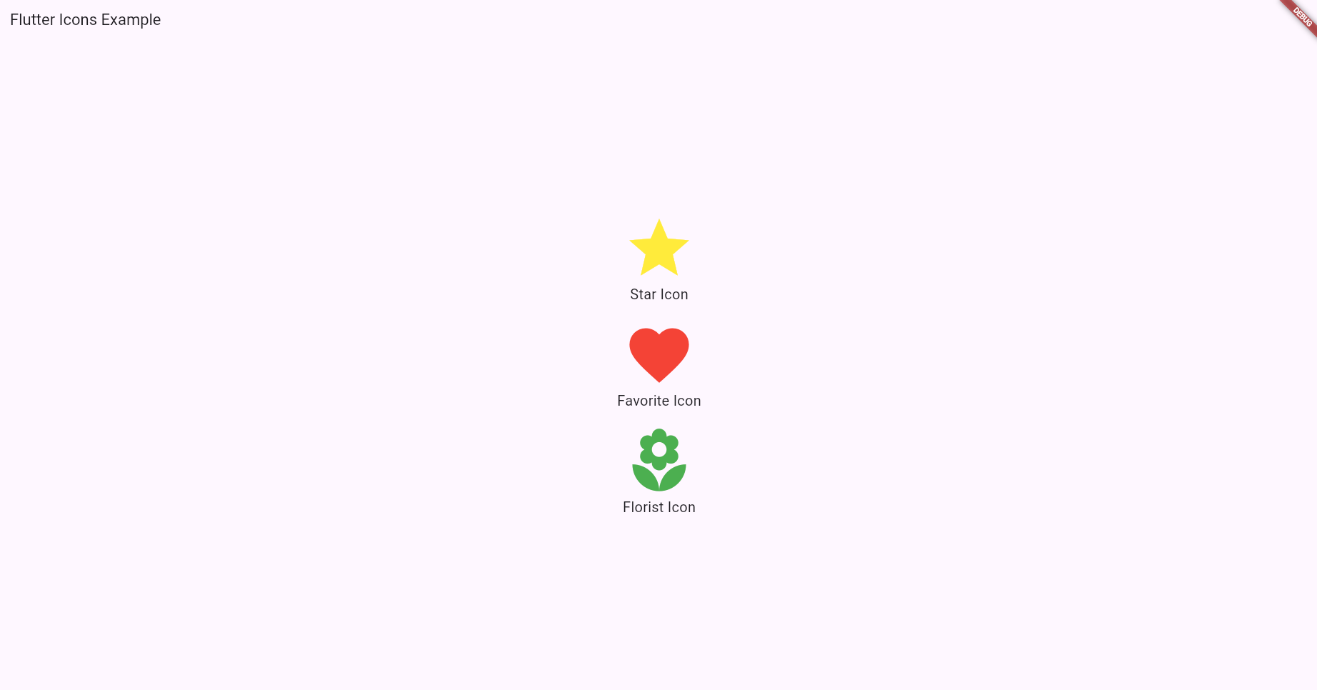
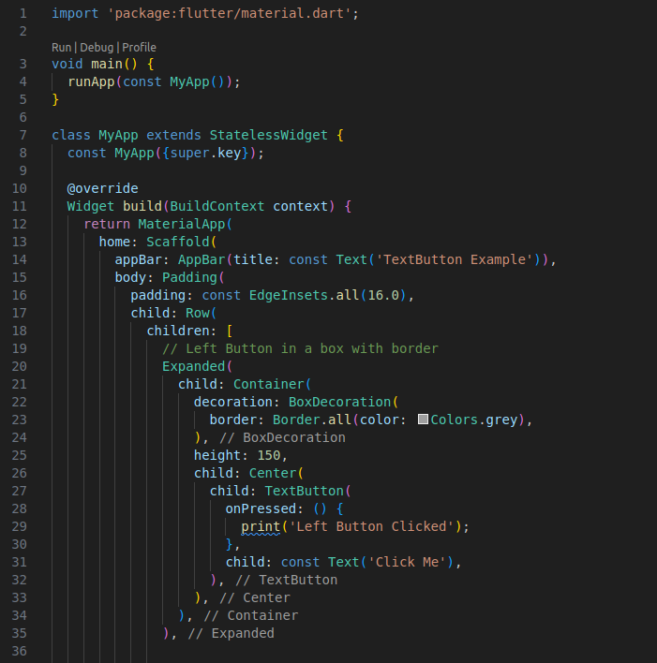
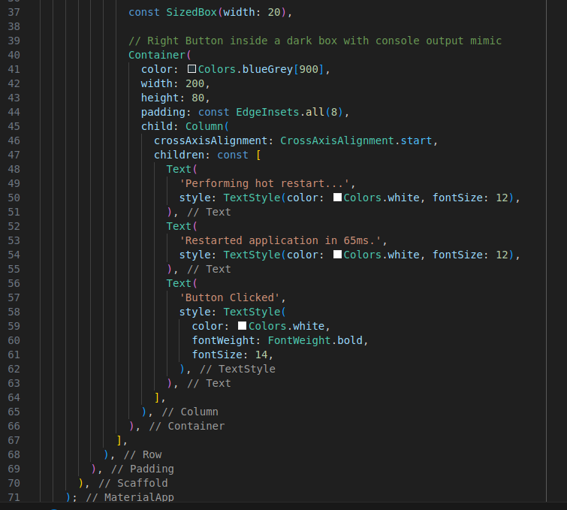
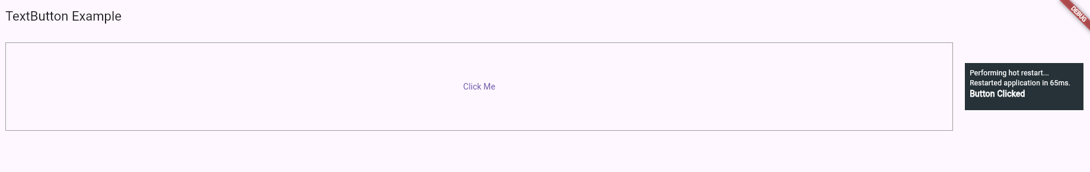
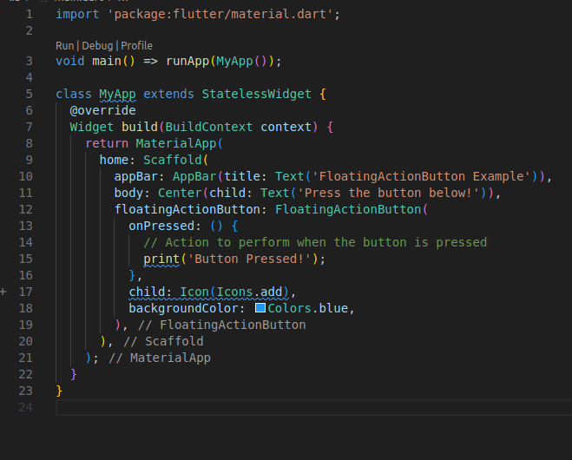
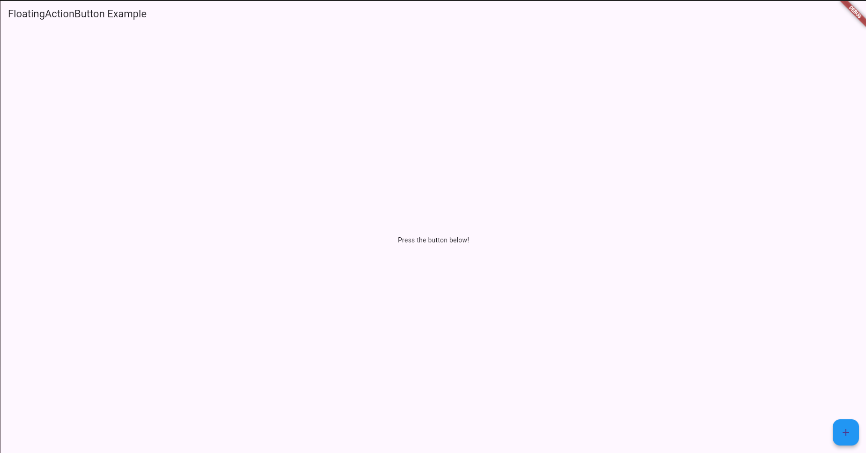
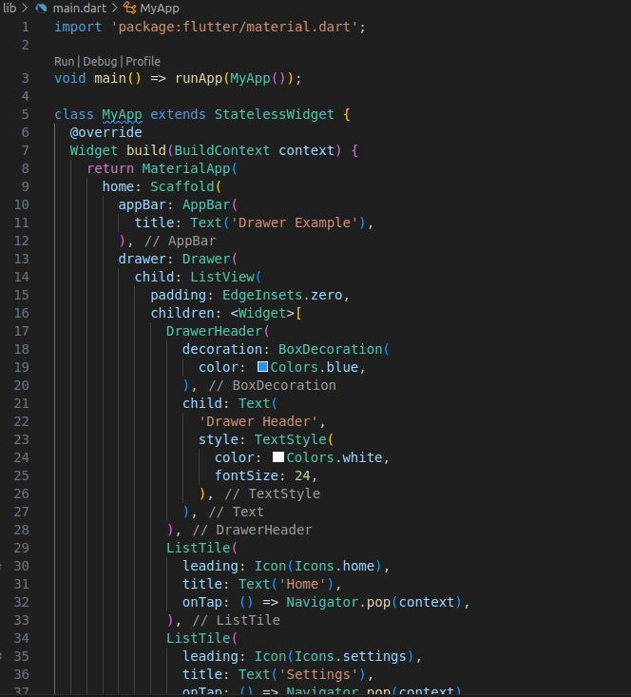
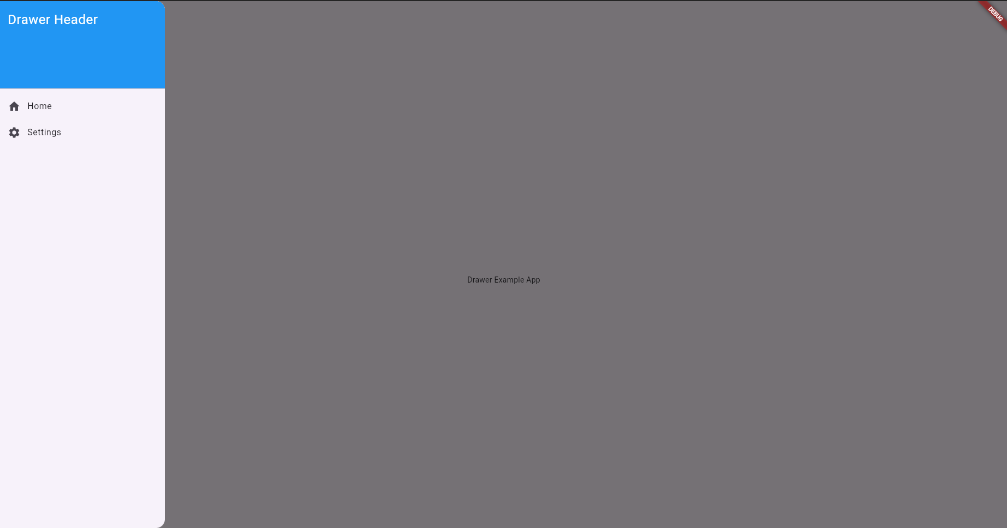
#Code -14
