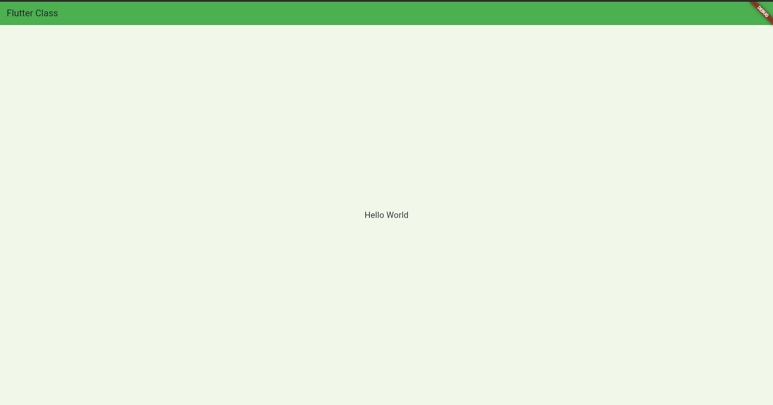

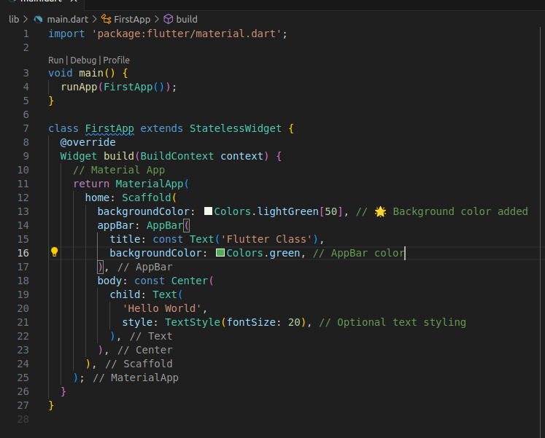

Assignment -5

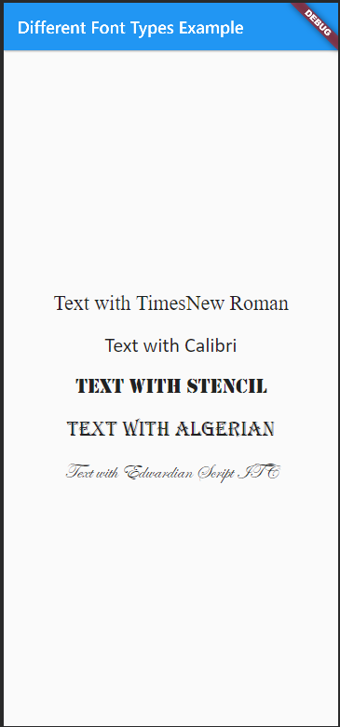

import 'package:flutter/material.dart';

void main() {
runApp(FontEx
ampleApp());
}

class FontExampleApp extends StatelessWidget {
@override
Widget build(BuildContext context) {
return MaterialApp(
title: 'Different Font Types Example',
home: Scaffold(
appBar: AppBar(
title: Text('Different Font Types Example'),
),
body: Padding(
padding: const EdgeInsets.all(16.0),
child: Column(
crossAxisAlignment: CrossAxisAlignment.center,
children: [
SizedBox(height: 30),
Text(
'Text with TimesNew Roman',
style: TextStyle(
fontFamily: 'Times New Roman',
fontSize: 18,
),
),
SizedBox(height: 20),
Text(
'Text with Calibri',
style: TextStyle(
fontFamily: 'Calibri',
fontSize: 18,
),
),
SizedBox(height: 20),
Text(
'TEXT WITH STENCIL',
style: TextStyle(
fontFamily: 'Stencil',
fontWeight: FontWeight.bold,
fontSize: 18,
),
),
SizedBox(height: 20),
Text(
'TEXT WITH ALGERIAN',
style: TextStyle(
fontFamily: 'Algerian',
fontSize: 18,
decoration: TextDecoration.lineThrough,
),
),
SizedBox(height: 20),
Text(
'Text with Edwardian Script ITC',
style: TextStyle(
fontFamily: 'Edwardian Script ITC',
fontStyle: FontStyle.italic,
fontSize: 18,
),
),
],
),
),
),
);
}
}

Assignment -2

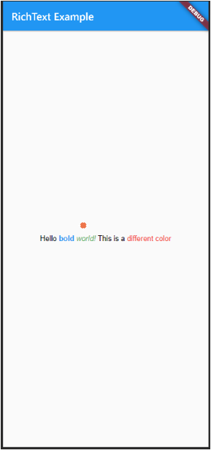
import 'package:flutter/material.dart';

void main() {
runApp(const MyApp());
}

class MyApp extends StatelessWidget {
const MyApp({super.key});

@override
Widget build(BuildContext context) {
return MaterialApp(
title: 'RichText Example',
home: Scaffold(
appBar: AppBar(
title: const Text('RichText Example'),
),
body: const Center(
child: RichText(
text: TextSpan(
style: TextStyle(fontSize: 18, color: Colors.black),
children: <TextSpan>[
TextSpan(text: 'Hello '),
TextSpan(
text: 'bold ',
style: TextStyle(fontWeight: FontWeight.bold, color: Colors.blue),
),
TextSpan(
text: 'world! ',
style: TextStyle(fontStyle: FontStyle.italic, color: Colors.green),
),
TextSpan(
text: 'This is a ',
style: TextStyle(color: Colors.black),
),
TextSpan(
text: 'different color',
style: TextStyle(color: Colors.pink),
),
],
),
),
),
),
);
}
}

Assignment -4

import 'package:flutter/material.dart';

void main() {
runApp(MaterialApp(
home: TextPositionDemo(),
));
}

class TextPositionDemo extends StatelessWidget {
@override
Widget build(BuildContext context) {
return Scaffold(
appBar: AppBar(
title: Text("Text Positions in Flutter"),
),
body: Container(
color: Colors.blue[700],
child: Stack(
children: [
// Top Left Corner
Positioned(
top: 10,
left: 10,
child: Text(
'Top Left Corner',
style: TextStyle(color: Colors.black, fontSize: 16),
),
),
// Specific Position (100, 200)
Positioned(
top: 200,
left: 100,
child: Text(
'Specific Position (100
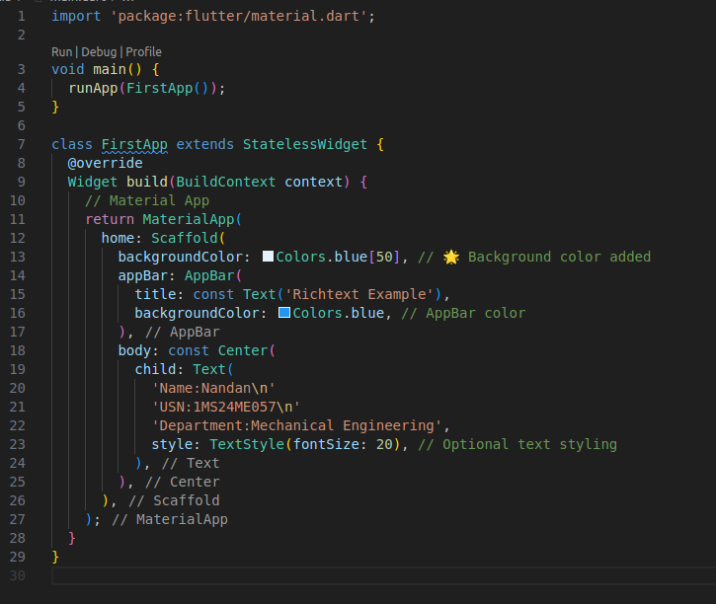
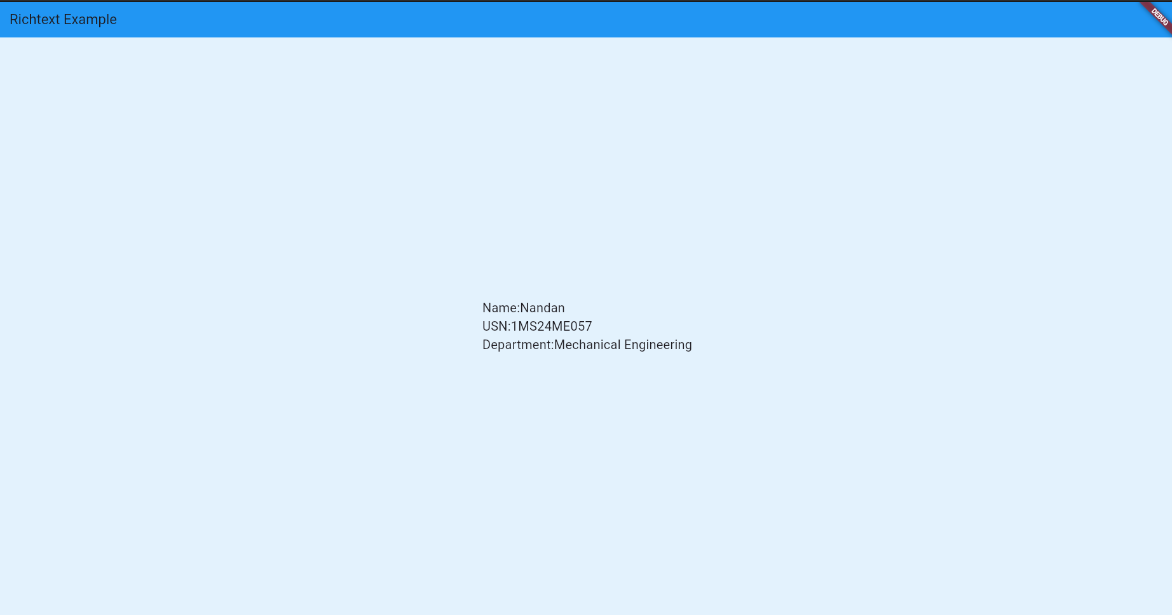
Assignment -3
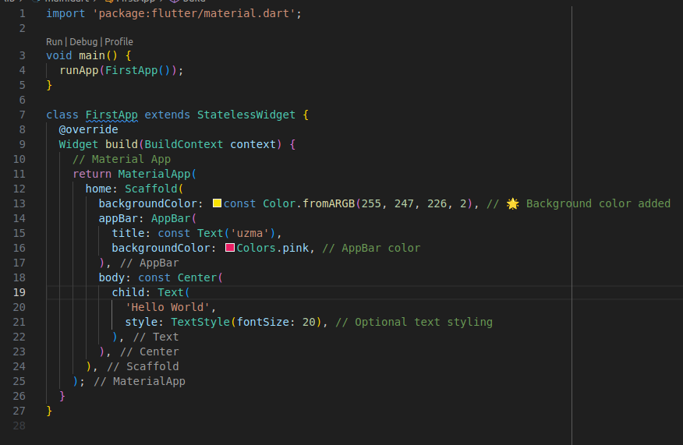
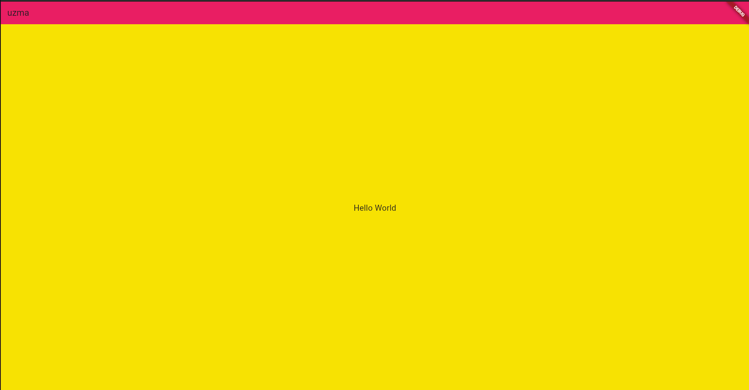
Assignment - 1
