 |  | TERMO DE ACEITE TÉCNICO
Solicitante: PRODEMGE / SEE
NOC/Operadora: Leonardo Martins |  |  | Operadora/Cliente: Eduardo Tadra
GRE/Prodemge: Leonardo Martins |  |  | Responsável/cliente: Cintia Batista da Rocha
Consórcio  EMC/Vodanet | VSAT-ID  SEE-TEDO-22602 |  | Porta kbps  2048/1024 | Plataforma  VSAT
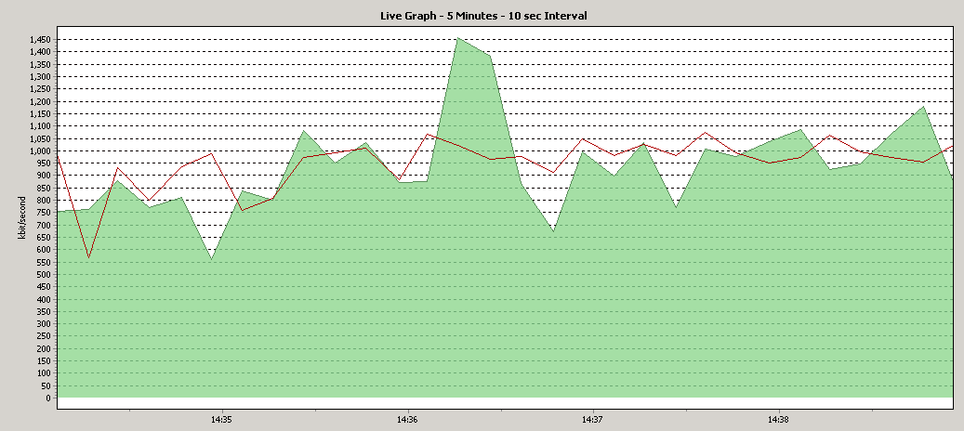

# dvb tx show
Satellite (DVB) TX Configuration
--------------------------------
Auto start : Enabled
IDU Output Power : -20 dBm
IDU Max Output Power: 0.0 dBm
ODU Output Power : 33.2 dBm
EIRP : 46.5 dBW
Default CW Frequency: 0.000000 GHz
ATM mode : VC-Mux
Header Compression : UDP/IP

Satellite (DVB) Transmitter Status
--------------------------------
State : On (DVB-RCS2)
IDU Output Power : -19.6 dBm
ODU Output Power : 32.6 dBm
EIRP : 45.9 dBW
Es/No : 13.5 dB
Header Compression : Disabled - HC for RCS2 not supported by HUB
Timing correction : 690 us (281031 us)
Frequency correction: 140 Hz
# dvb rx show

Satellite (DVB) RX Configuration
--------------------------------
Auto start : Enabled
Max Traffic MODCOD : 23 16APSK-9/10
RX watchdog : 15 minute

Idx Pri SymbRate[Msps] Freq[GHz] Mode PopId SatId Pos SatName Name Enable
* 0 0 4.883300 12.176420 DVB-S2 104 0 0.0 E Yes
1 1 16.667000 11.962753 DVB-S2 2 0 0.0 E Yes

Satellite (DVB) Receiver Status
--------------------------------
Rx State : On
DVB State : Forward link up
Network : 65281, Prodemge@Vodanet
Frequency : 12.176444 GHz
Symbol Rate : 4.883045 Msps
S2 ModCod
- receiving : 21 16APSK-5/6
- current max : 21 16APSK-5/6
Pilot : On
Frame length : Short
DVB S2 Mode : ACM
DVB S2 Stream type : MPEG-TS
Roll off : 0.20
SNR : 16.0 dB
Input Power : -32 dBm
#
Pinging 10.215.192.1 with 32 bytes of data:

Reply from 10.215.192.1: bytes=32 time=578ms TTL=56
Reply from 10.215.192.1: bytes=32 time=541ms TTL=56
Reply from 10.215.192.1: bytes=32 time=553ms TTL=56
Reply from 10.215.192.1: bytes=32 time=543ms TTL=56
Reply from 10.215.192.1: bytes=32 time=537ms TTL=56
Reply from 10.215.192.1: bytes=32 time=533ms TTL=56
Reply from 10.215.192.1: bytes=32 time=596ms TTL=56
Reply from 10.215.192.1: bytes=32 time=539ms TTL=56
Reply from 10.215.192.1: bytes=32 time=520ms TTL=56
Reply from 10.215.192.1: bytes=32 time=563ms TTL=56
Reply from 10.215.192.1: bytes=32 time=535ms TTL=56
Reply from 10.215.192.1: bytes=32 time=545ms TTL=56
Reply from 10.215.192.1: bytes=32 time=531ms TTL=56
Reply from 10.215.192.1: bytes=32 time=656ms TTL=56
Reply from 10.215.192.1: bytes=32 time=565ms TTL=56

Ping statistics for 10.215.192.1:
Packets: Sent = 15, Received = 15, Lost = 0 (0% loss),
Approximate round trip times in milli-seconds:
Minimum = 520ms, Maximum = 656ms, Average = 555ms

Lista de sites acessados:
www.globo.com – ok
www.yahoo.com – ok
www.hotmail.com – ok
www.google.com – ok

Responsável pelo teste de navegação:
Nome: Cintia Batista loura da Rocha
Função: Diretora
Identidade: 11632445
Fone: 31 3661 8252

