 |  | TERMO DE ACEITE TÉCNICO
Solicitante: Secretaria de Estado de Educação - SEDUC
NOC/Operadora: Wallace Teixeira |  |  | Operadora/Cliente: Jean Polini
ATI: Weslley Souza |  |  | Responsável/cliente: João Batista Vieira Passos
Operadora  Global Eagle | VSAT-ID  ATI-ES-0066-IND |  | Porta kbps  1024/256 | Tipo  Indoor
Piauí, 30 de agosto de 2018
Contrato: 016/2018

1 – Local da Instalação

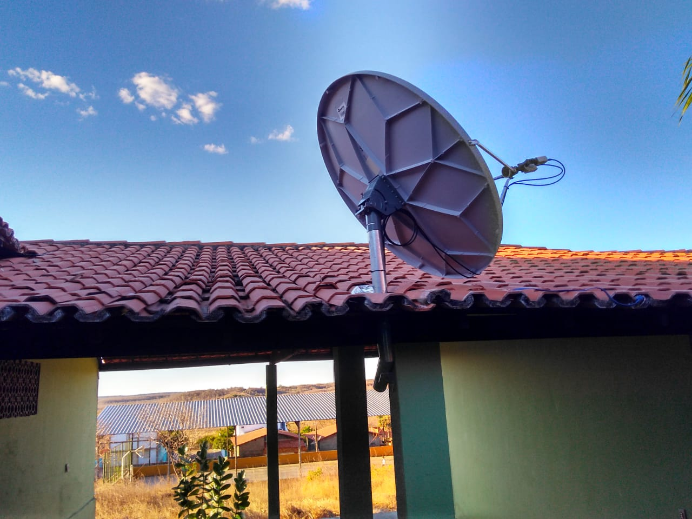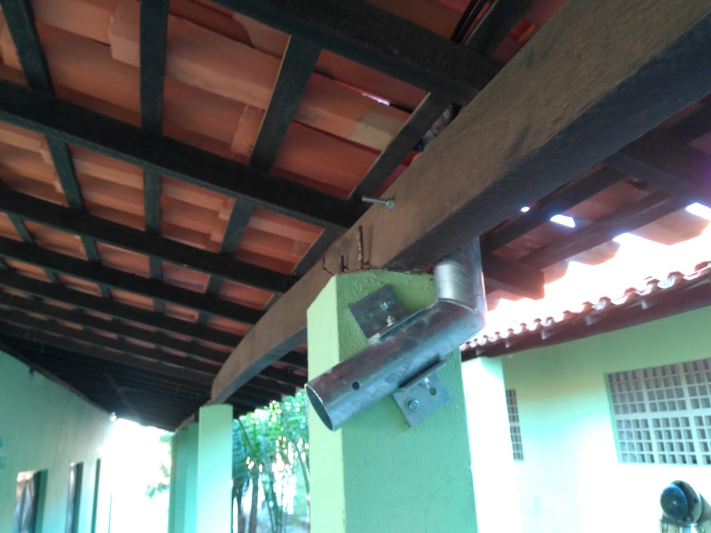
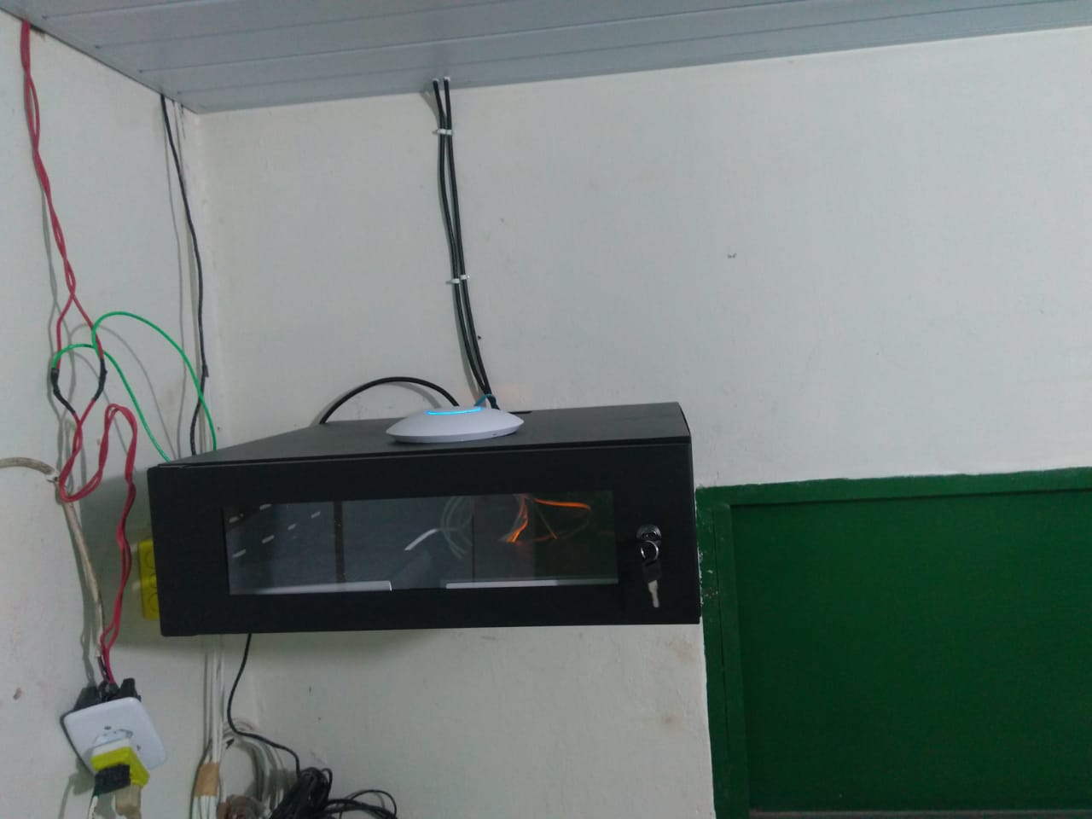 | 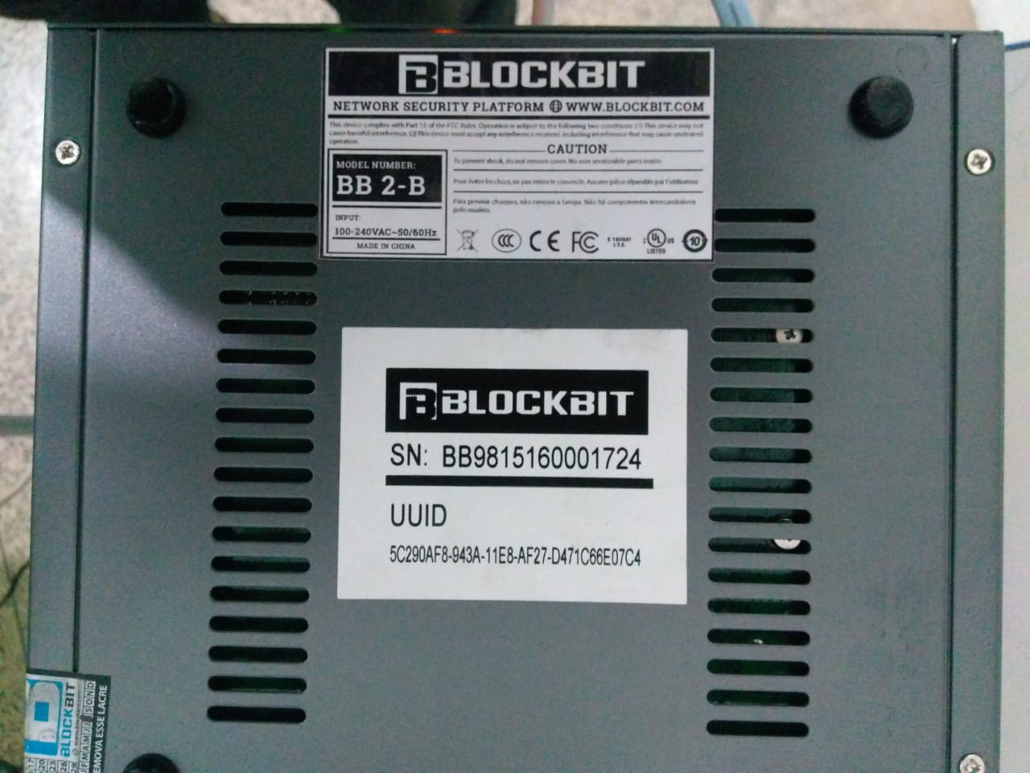

2 – Configurações do Modem

# device show
System Information:
Name : ATI-ES-0029-IND
Location : PI
Contact :
System Up time : 0 days, 06:52:30
CPU Load : 7%
System time(UTC) : 29 August 2018 19:44:34
Broadcast Message : not set

HW:
Model : SatLink 2000
HW ID : 120033
Main board ID : 120026 R6.2

MAC addresses:
Ethernet (LAN) : 00:20:0e:10:94:a2
Satellite (DVB) : 00:20:0e:10:94:a2

# dvb rx show

Satellite (DVB) RX Configuration
--------------------------------
Auto start : Enabled
Max Traffic MODCOD : 23 16APSK-9/10
RX watchdog : 15 minute

Idx Pri SymbRate[Msps] Freq[GHz] Mode PopId SatId Pos SatName Name Enable
* 0 0 25.000000 11.628079 DVB-S2 105 0 0.0 E Yes

Satellite (DVB) Receiver Status
--------------------------------
Rx State : On
DVB State : Forward link up
Network : 1326, ATI-PI
Frequency : 11.628108 GHz
Symbol Rate : 24.999858 Msps
S2 ModCod
- receiving : 1 QPSK-1/4
- current max : 15 8PSK-5/6
Pilot : On
Frame length : Short
DVB S2 Mode : ACM
DVB S2 Stream type : MPEG-TS
Roll off : 0.25
SNR : 11.8 dB
Input Power : -37 dBm

# dvb tx show

Satellite (DVB) TX Configuration
--------------------------------
Auto start : Enabled
IDU Output Power : -20 dBm
IDU Max Output Power: 0.0 dBm
Default CW Frequency: 0.000000 GHz
ATM mode : VC-Mux
Header Compression : None

Satellite (DVB) Transmitter Status
--------------------------------
State : On (DVB-RCS2)
IDU Output Power : -19.9 dBm
Es/No : 17.0 dB
Header Compression : Disabled
Timing correction : -104 us (250064 us)
Frequency correction: 330 Hz

# arp show

NetAddr State MacAddr If
10.225.1.58 Dynamic 00:90:27:f0:2f:42 1

# ip show
Interfaces
If IPAddress SubnetMask BroadCastAddr MTU Alias AdminStatus
1 10.225.1.57 255.255.255.252 10.225.1.59 1500 eth0 1
3 172.18.193.213 255.255.255.255 N/A 1500 dvb0 1
4 N/A N/A N/A 1500 air0 1

3 – Configurações dos Equipamentos

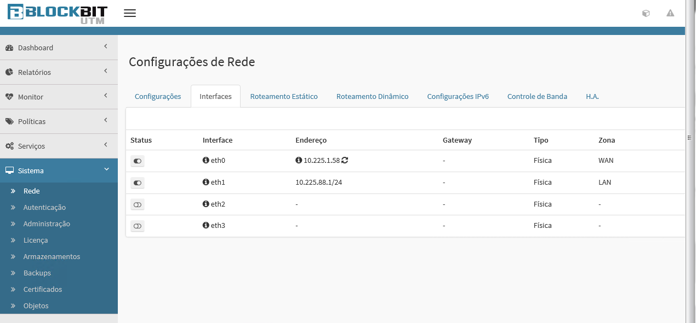

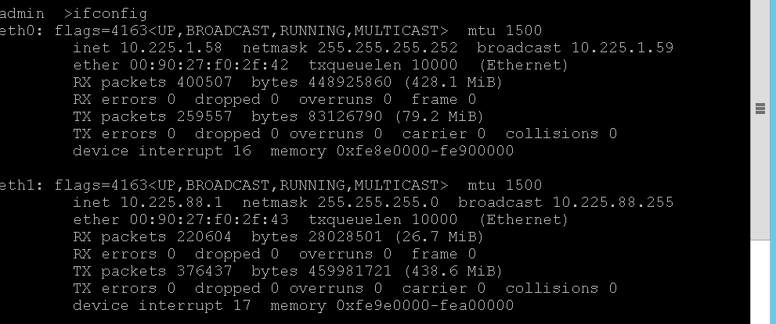

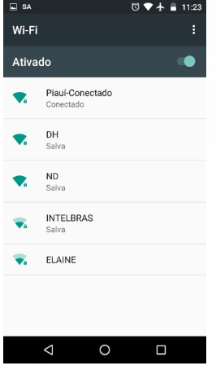

4 – Teste de Velocidade

Download

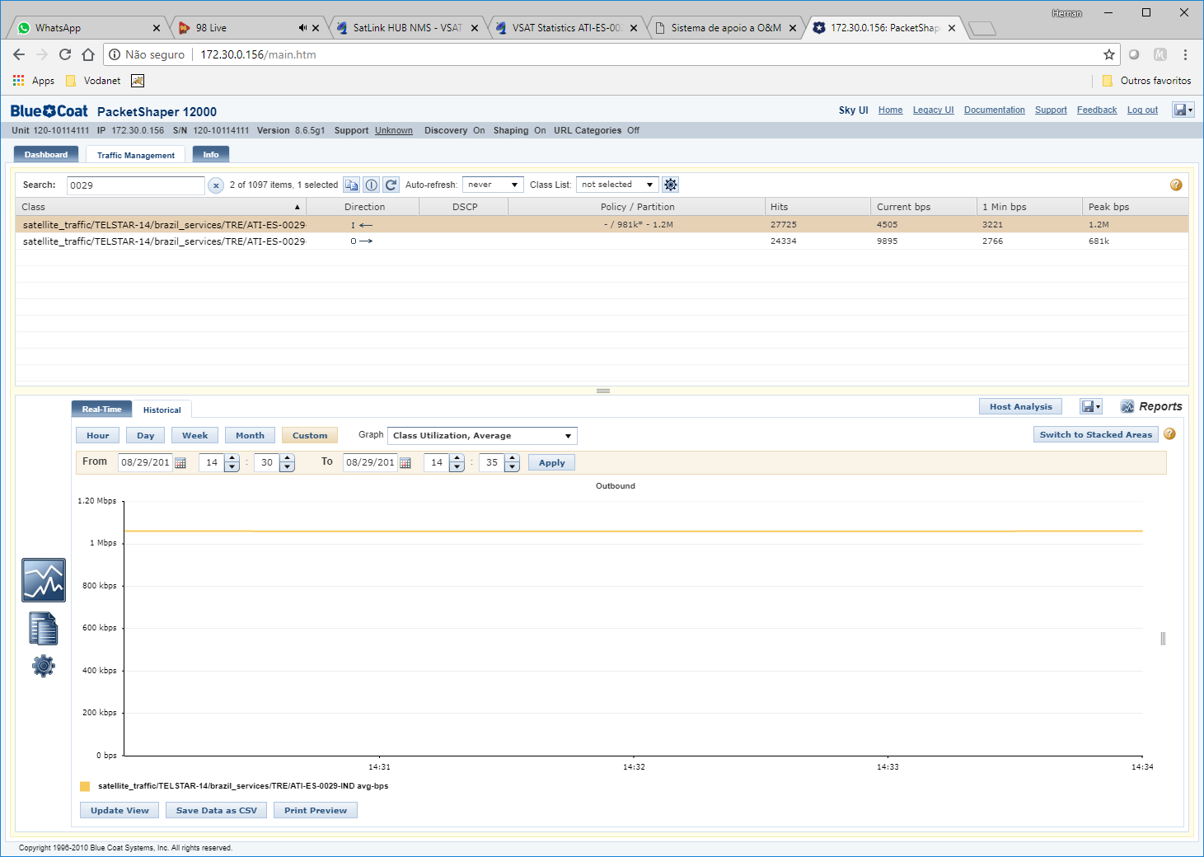

Upload

