 |  | TERMO DE ACEITE TÉCNICO
Solicitante: VIVO- Projeto Escolas Rurais
NOC/Operador: Guilherme Henrique |  |  | Cliente: VIVO
Empresa  EMC Brasil | VSAT-ID  VIVO-PER-23163860-CE |  | Link kbps  256k/128k | Plataforma  VSAT
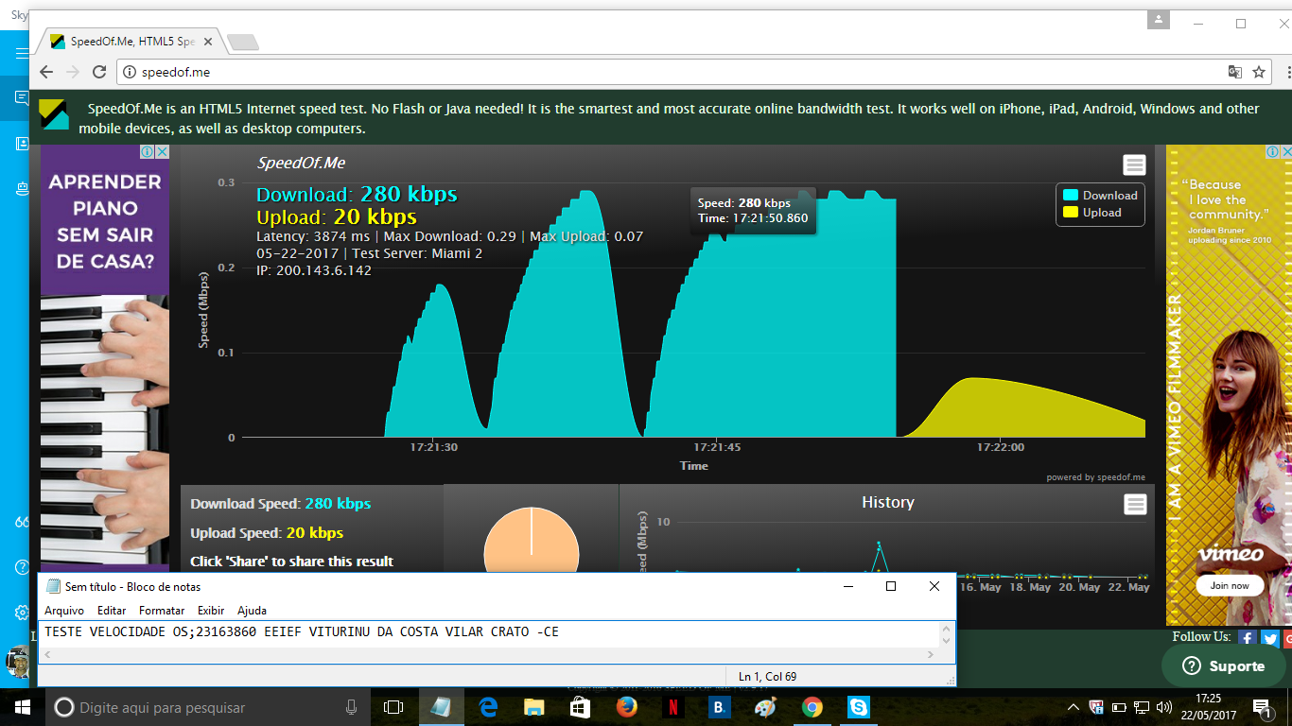

# dvb tx show

Satellite (DVB) TX Configuration
--------------------------------
Auto start : Enabled
IDU Output Power : -20 dBm
IDU Max Output Power: 0.0 dBm
Default CW Frequency: 0.000000 GHz
ATM mode : VC-Mux
Header Compression : None

Satellite (DVB) Transmitter Status
--------------------------------
State : On (DVB-RCS2)
IDU Output Power : -20.0 dBm
Es/No : 15.0 dB
Header Compression : Disabled
Timing correction : -102 us (254216 us)
Frequency correction: 20 Hz
# dvb rx show

Satellite (DVB) RX Configuration
--------------------------------
Auto start : Enabled
Max Traffic MODCOD : 23 16APSK-9/10
RX watchdog : 15 minute

Idx Pri SymbRate[Msps] Freq[GHz] Mode PopId SatId Pos SatName Name Enable
* 0 0 15.000000 12.059000 DVB-S2 102 0 0.0 E Yes
1 1 9.320000 12.055825 DVB-S2 4 0 0.0 E Yes

Satellite (DVB) Receiver Status
--------------------------------
Rx State : On
DVB State : Forward link up
Network : 1326, T14R Beam
Frequency : 12.059103 GHz
Symbol Rate : 15.000001 Msps
S2 ModCod
- receiving : 18 16APSK-2/3
- current max : 22 16APSK-8/9
Pilot : On
Frame length : Short
DVB S2 Mode : ACM
DVB S2 Stream type : MPEG-TS
Roll off : 0.20
SNR : 15.4 dB
Input Power : -32 dBm

