|  |  |  |  |  |  |  |
| --- | --- | --- | --- | --- | --- | --- |
|  | | | **TERMO DE ACEITE TÉCNICO** | | | |
| **Solicitante:** VIVO- Projeto Escolas Rurais | | | | | | |
| **NOC/Operador: Alexandre Cruz** | | | | | **Cliente: VIVO** | |
|  | | | | |  | |
| **Empresa**  EMC Brasil | **VSAT-ID** | | | | **Link kbps** 256/128 | **Plataforma** VSAT |
|  | VIVO-PER-25085778-PB | |  |

# dvb tx show

Satellite (DVB) TX Configuration

--------------------------------

Auto start : Enabled

IDU Output Power :

-

30

dBm

IDU Max Output Power: 0.0 dBm

ODU Output Power : 32.7 dBm

EIRP : 46.0 dBW

Default CW Frequency: 14.125750 GHz

ATM mode : VC

-

Mux

Header Compression : None

Satellite (DVB) Transmitter Status

--------------------------------

State : On (DVB

-

RCS)

IDU Output Power :

-

21.4

dBm

ODU Output Power

:

32.4 dBm

EIRP : 45.7 dBW

Es/No : 13.0 dB

Header Compression : Disabled

Timing correction :

-

us (260566 us)

164

Frequency correction:

-

90

Hz

# dvb rx show

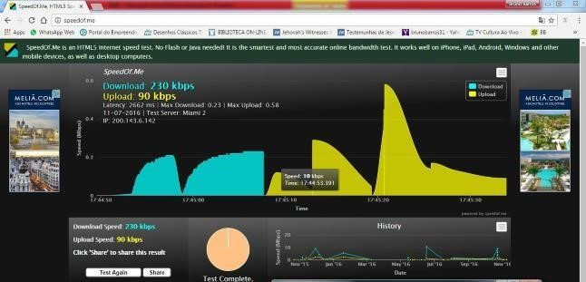

|  |
| --- |
| Satellite (DVB) RX Configuration  --------------------------------  Auto start : Enabled  Max Traffic MODCOD : 23 16APSK-9/10  RX watchdog : 15 minute    Idx Pri SymbRate[Msps] Freq[GHz] Mode PopId SatId Pos SatName Name  Enable  * 0 0 9.320000 12.055825 DVB-S2 102 0 0.0 E Yes    Satellite (DVB) Receiver Status  --------------------------------  Rx State : On  DVB State : Forward link up Network : 1326, T14R Beam  Frequency : 12.055811 GHz Symbol Rate : 9.320139 Msps  S2 ModCod   * receiving : 14 8PSK-3/4 * current max : 16 8PSK-8/9 Pilot : On   Frame length : Short  DVB S2 Mode : ACM  DVB S2 Stream type : MPEG-TS Roll off : 0.20  SNR : 13.0 dB Input Power : -25 dBm      IP DVB 172.18.131.69 /32 |