YOOBEE COLLEGE OF CREATIVE INNOVATION

Master of Software Engineering
Professional Software Engineering - MSE800

Assessment 1: Object-Oriented Programming
Design and Architecture

P2P Car Rental System

Lecturer: Dr. Mohammad Norouzifard

Student Name: Batbold Chuluunbaatar
Student ID: 270894331
Date: 24 May 2026

System Design and Architecture

Architecture overview
The system has a 4-layer architecture that communicate with the layer directly below them.

Layer | Folder | Responsibility
1. Presentation | ui/ | CLI menus for each user role.
2. Service | services/ | Business logic: booking, auth, admin operations.
3. Model | models/ | OOP entities: User, Car, Booking, Review.
4. Data Access | database/ | SQLite connection and all SQL queries.

Entity Relationship Diagram
The database contains five tables: USERS, CARS, BOOKINGS, REVIEWS, and INSURANCE_CLAIMS. All three user types are stored in the USERS table, using a role column to differentiate between them. The owner_id is stored directly in the BOOKINGS table to allow for faster queries of which owner booked the car. The discount_code and discount_amount are also stored in the BOOKINGS table to allow for auditing of any discounts applied to a booking. Finally, CHECK constraints are used on all status columns to ensure that only valid values are entered into those columns at the database level.

Table | Primary Key | Foreign Keys | Key Constraints
USERS | id | none | email UNIQUE, role CHECK (owner/renter/admin)
CARS | id | owner_id -> USERS | is_approved BOOL, daily_rate REAL
BOOKINGS | id | car_id, renter_id, owner_id | status CHECK (5 values), discount_code, discount_amount
REVIEWS | id | booking_id, reviewer_id, reviewee_id | rating CHECK (1-5)
INSURANCE_CLAIMS | id | booking_id | status CHECK (pending/approved/rejected)

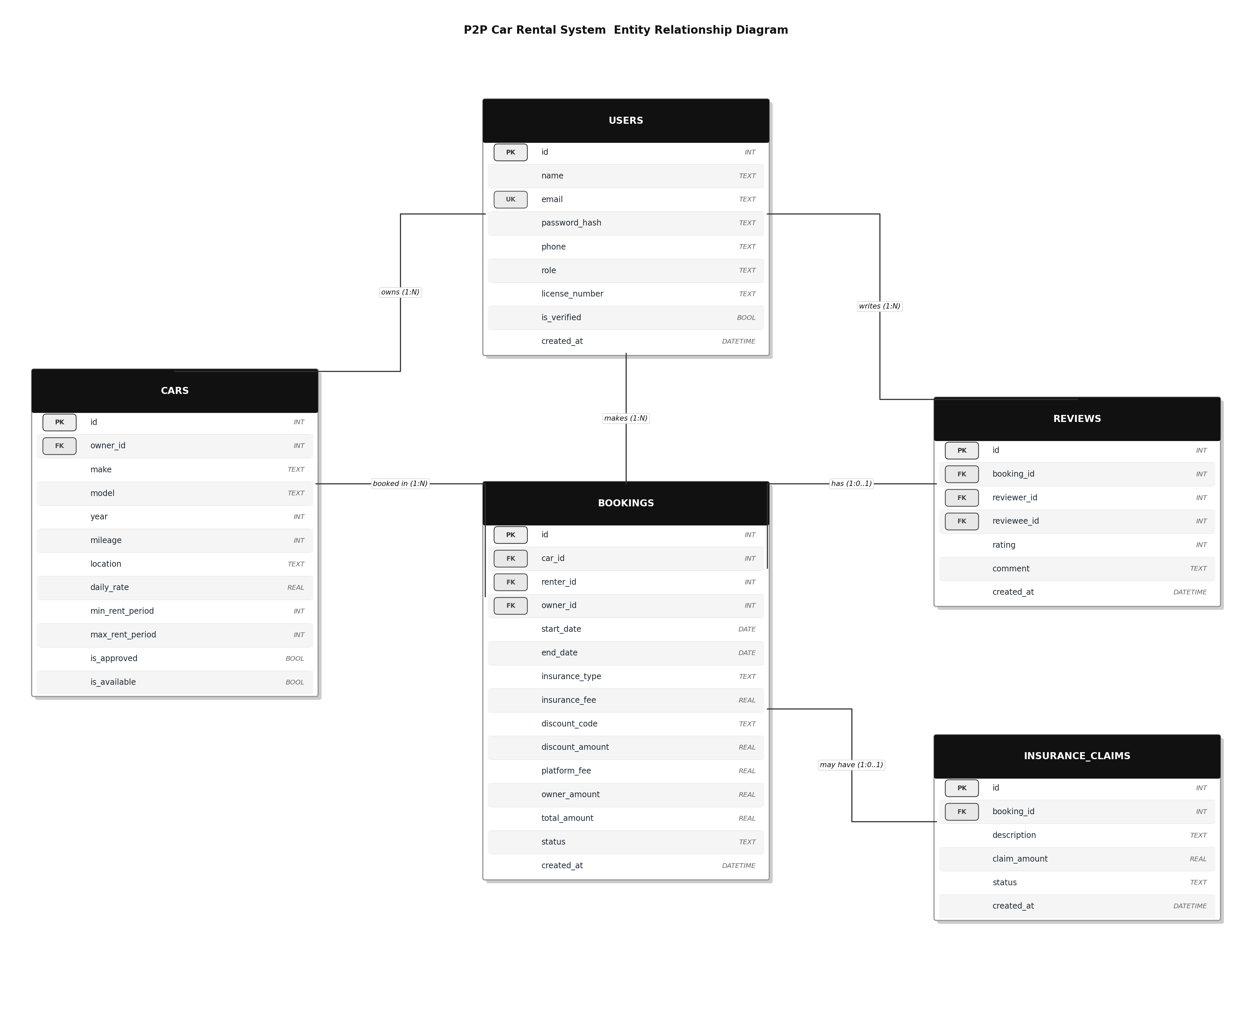
Figure 1: ERD with 5 tables, 8 foreign keys, and 1 unique key

Use Case Diagram
The system has three actors: Owner, Renter, and Admin. Two relationship types are used.

- "include": a mandatory step that always runs. "Make booking" always includes "Check availability" and "Calculate total fee".
- "extend": an optional step. "Make booking" can extend with "Select insurance" or "Apply discount code".

Actor | Use Cases
Owner | Register/login, add car listing, remove car listing, approve booking, reject booking, view earnings.
Renter | Register/login, Search for available cars by date periods, view car details, make booking, cancel booking, submit review.
Admin | Verify user KYC, approve car listing, reject car listing, view all bookings, handle insurance claim, view reports, suspend user.

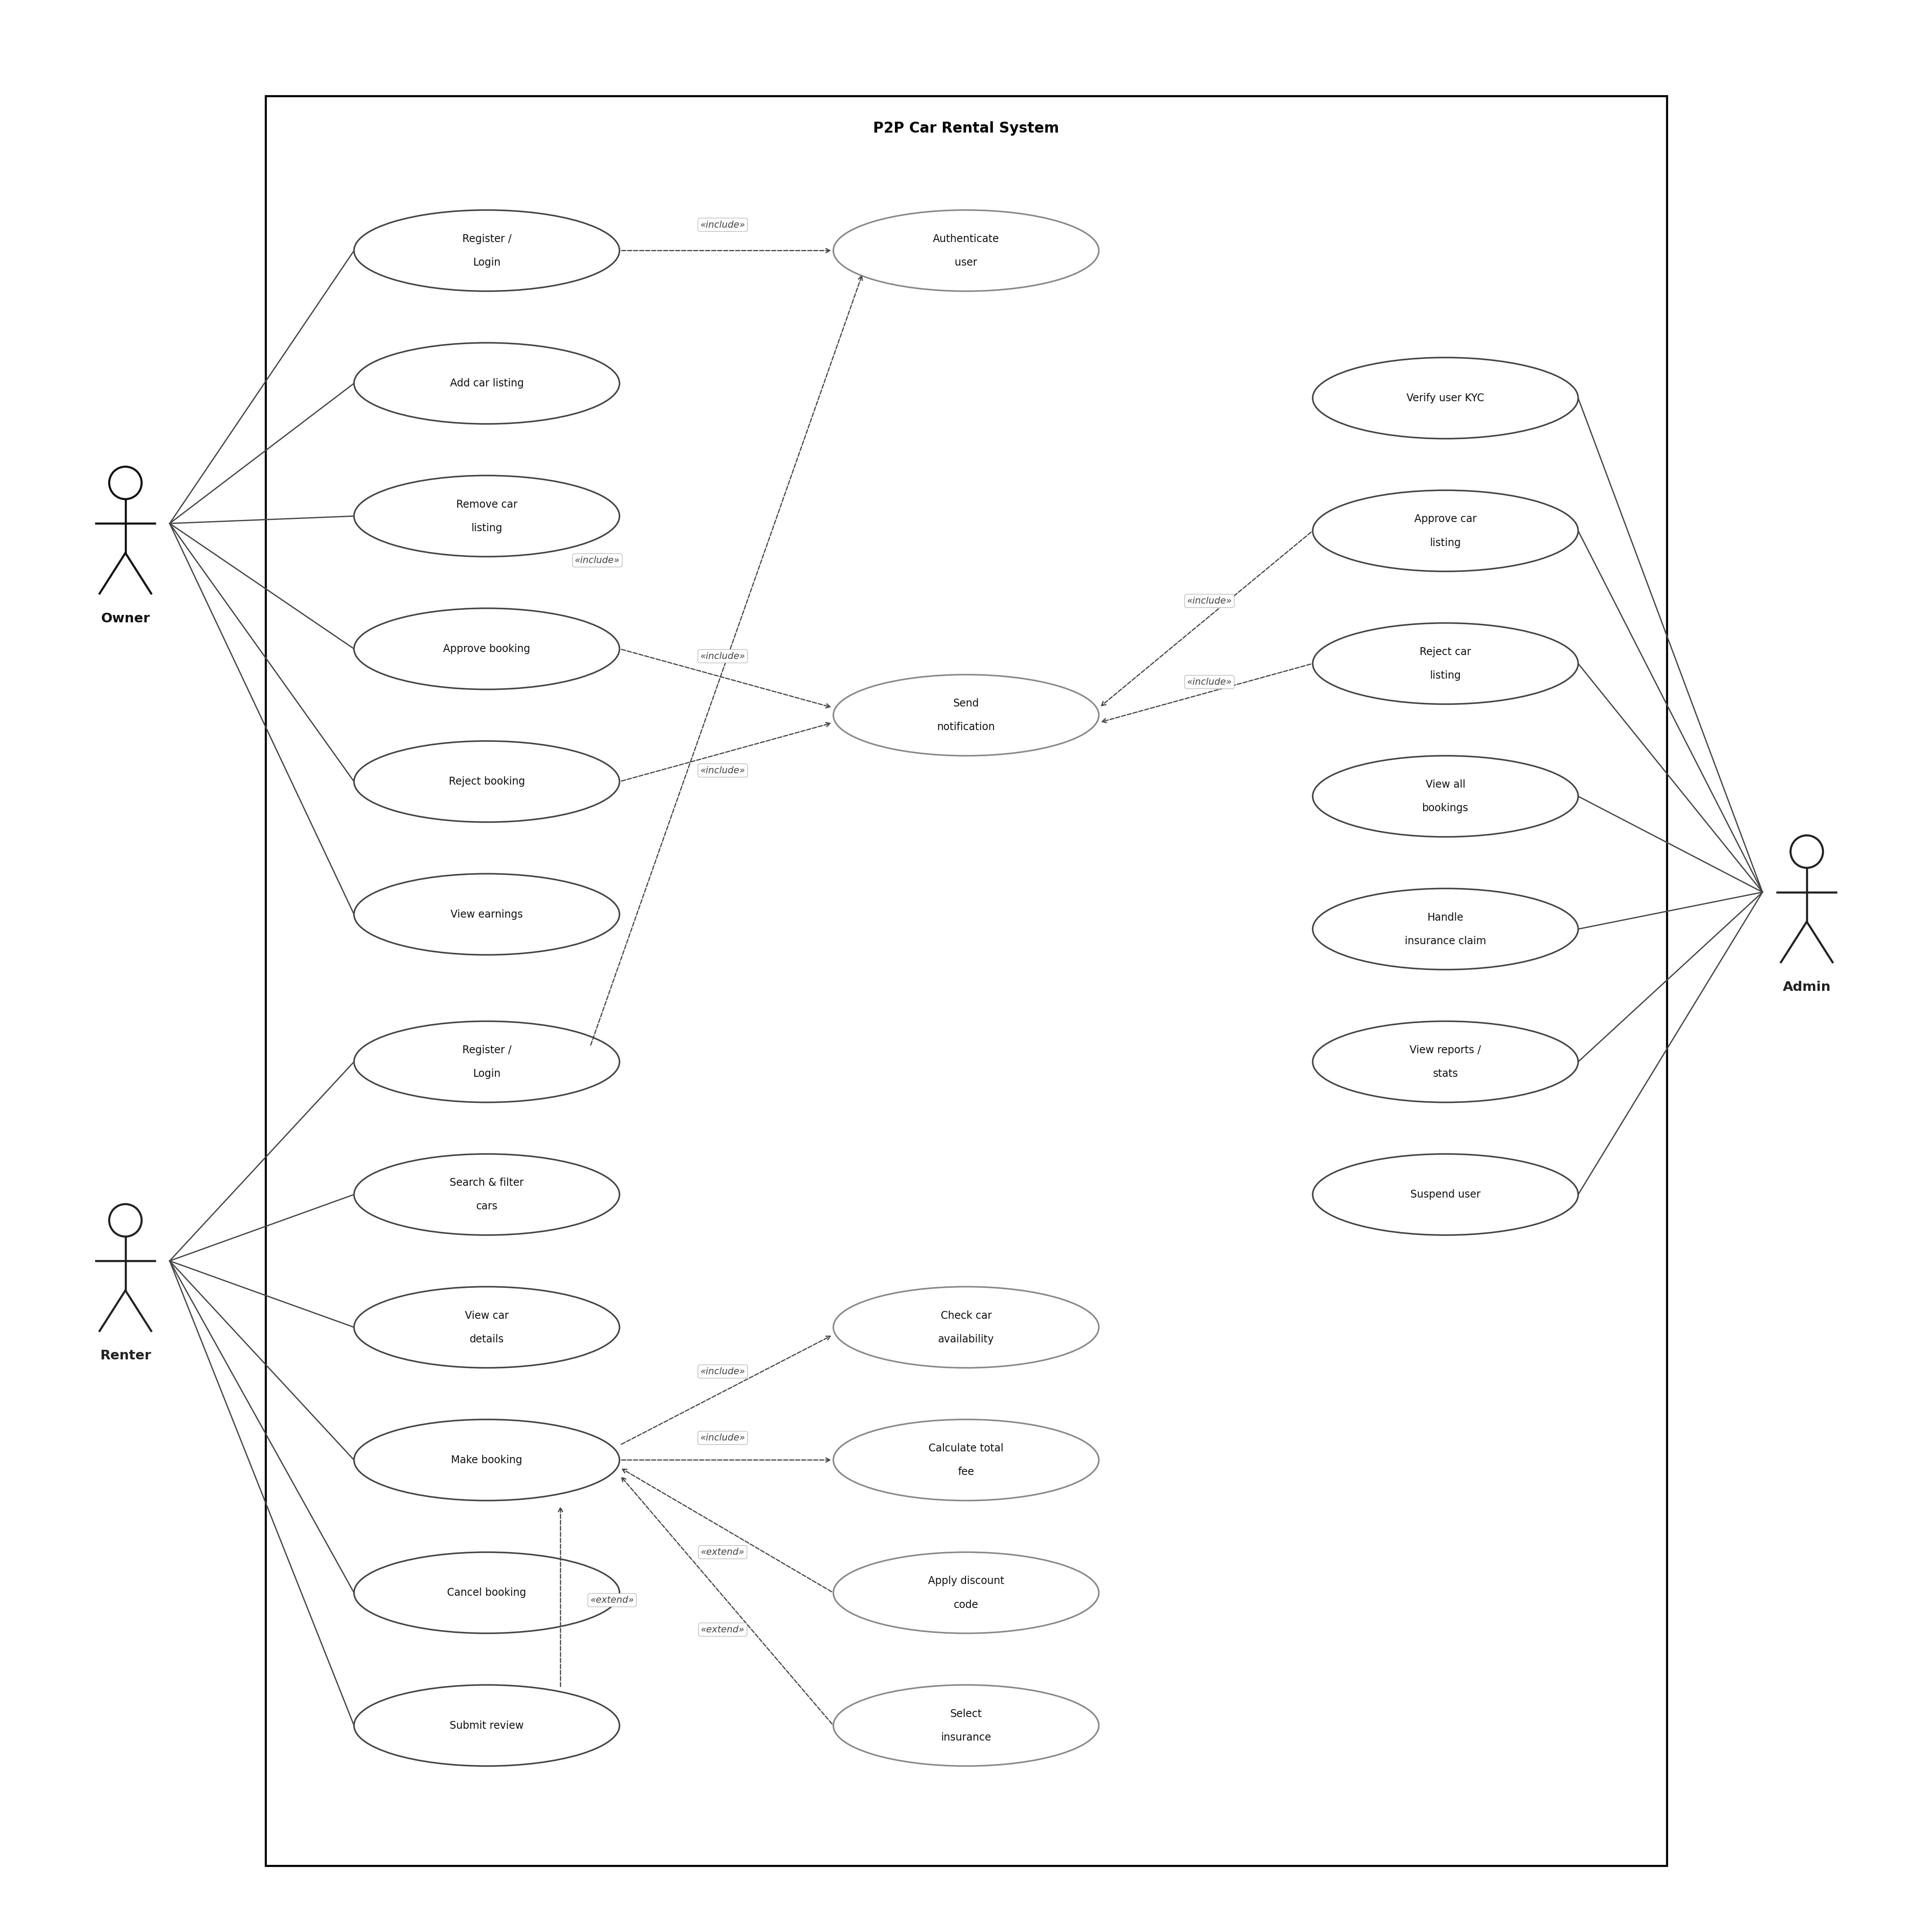
Figure 2: Use Case Diagram with 3 actors and 19 use cases

Class Diagram
The User class is abstract. It uses abc.ABC and defines view_dashboard() as an abstract method. Owner, Renter, and Admin each inherit from User and provide their own version of this method.

Principle | How it is applied
Encapsulation | All attributes use a single underscore prefix (_id, _name). They are accessed only through @property methods.
Abstraction | User and InsuranceStrategy are abstract base classes (ABC). They define the interface but not the implementation.
Inheritance | Owner, Renter, and Admin inherit all attributes and methods from User.
Polymorphism | view_dashboard() is defined once in User but works differently for each subclass. The main menu calls it without knowing the role.

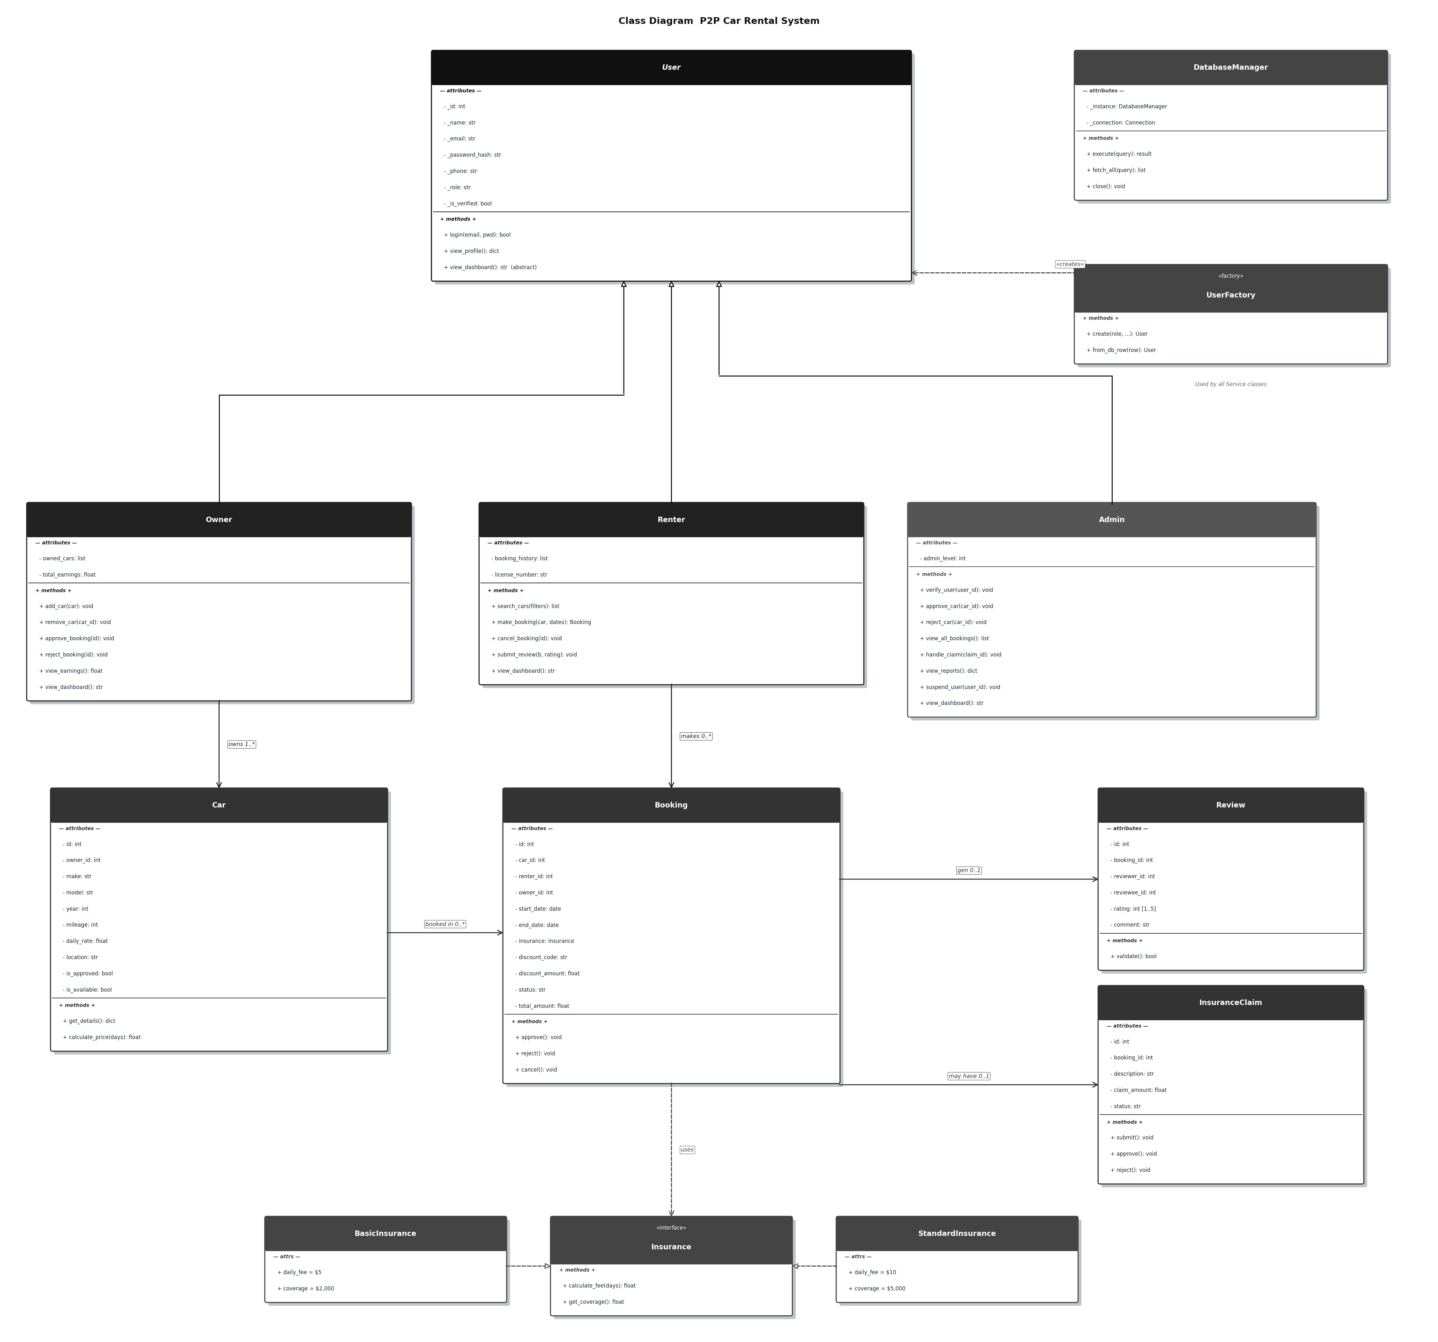
Figure 3: Class Diagram showing the OOP hierarchy and design patterns

Sequence Diagram: Make booking
The Make booking use case is the most complex in the system. The sequence diagram shows 9 participants and the messages between them in order.

Step | Action | Notes
1 | Renter logs in | Includes: Authenticate user
2 | Renter searches for cars | SQL query with location and price filters
3 | Renter views car details | Get one car record by ID
4 | Renter enters booking dates | is_valid_date_range() is called first
5 | System is checking availability | Include: Check car availability
6 | System calculates the fee | Include: Calculate total fee
7 | Renter selects insurance | Extend (optional)
8 | Renter applies a discount code | Extend (optional)
9 | System saves the booking | INSERT into BOOKINGS with status = pending
10 | System notifies the owner | Include: Send notification

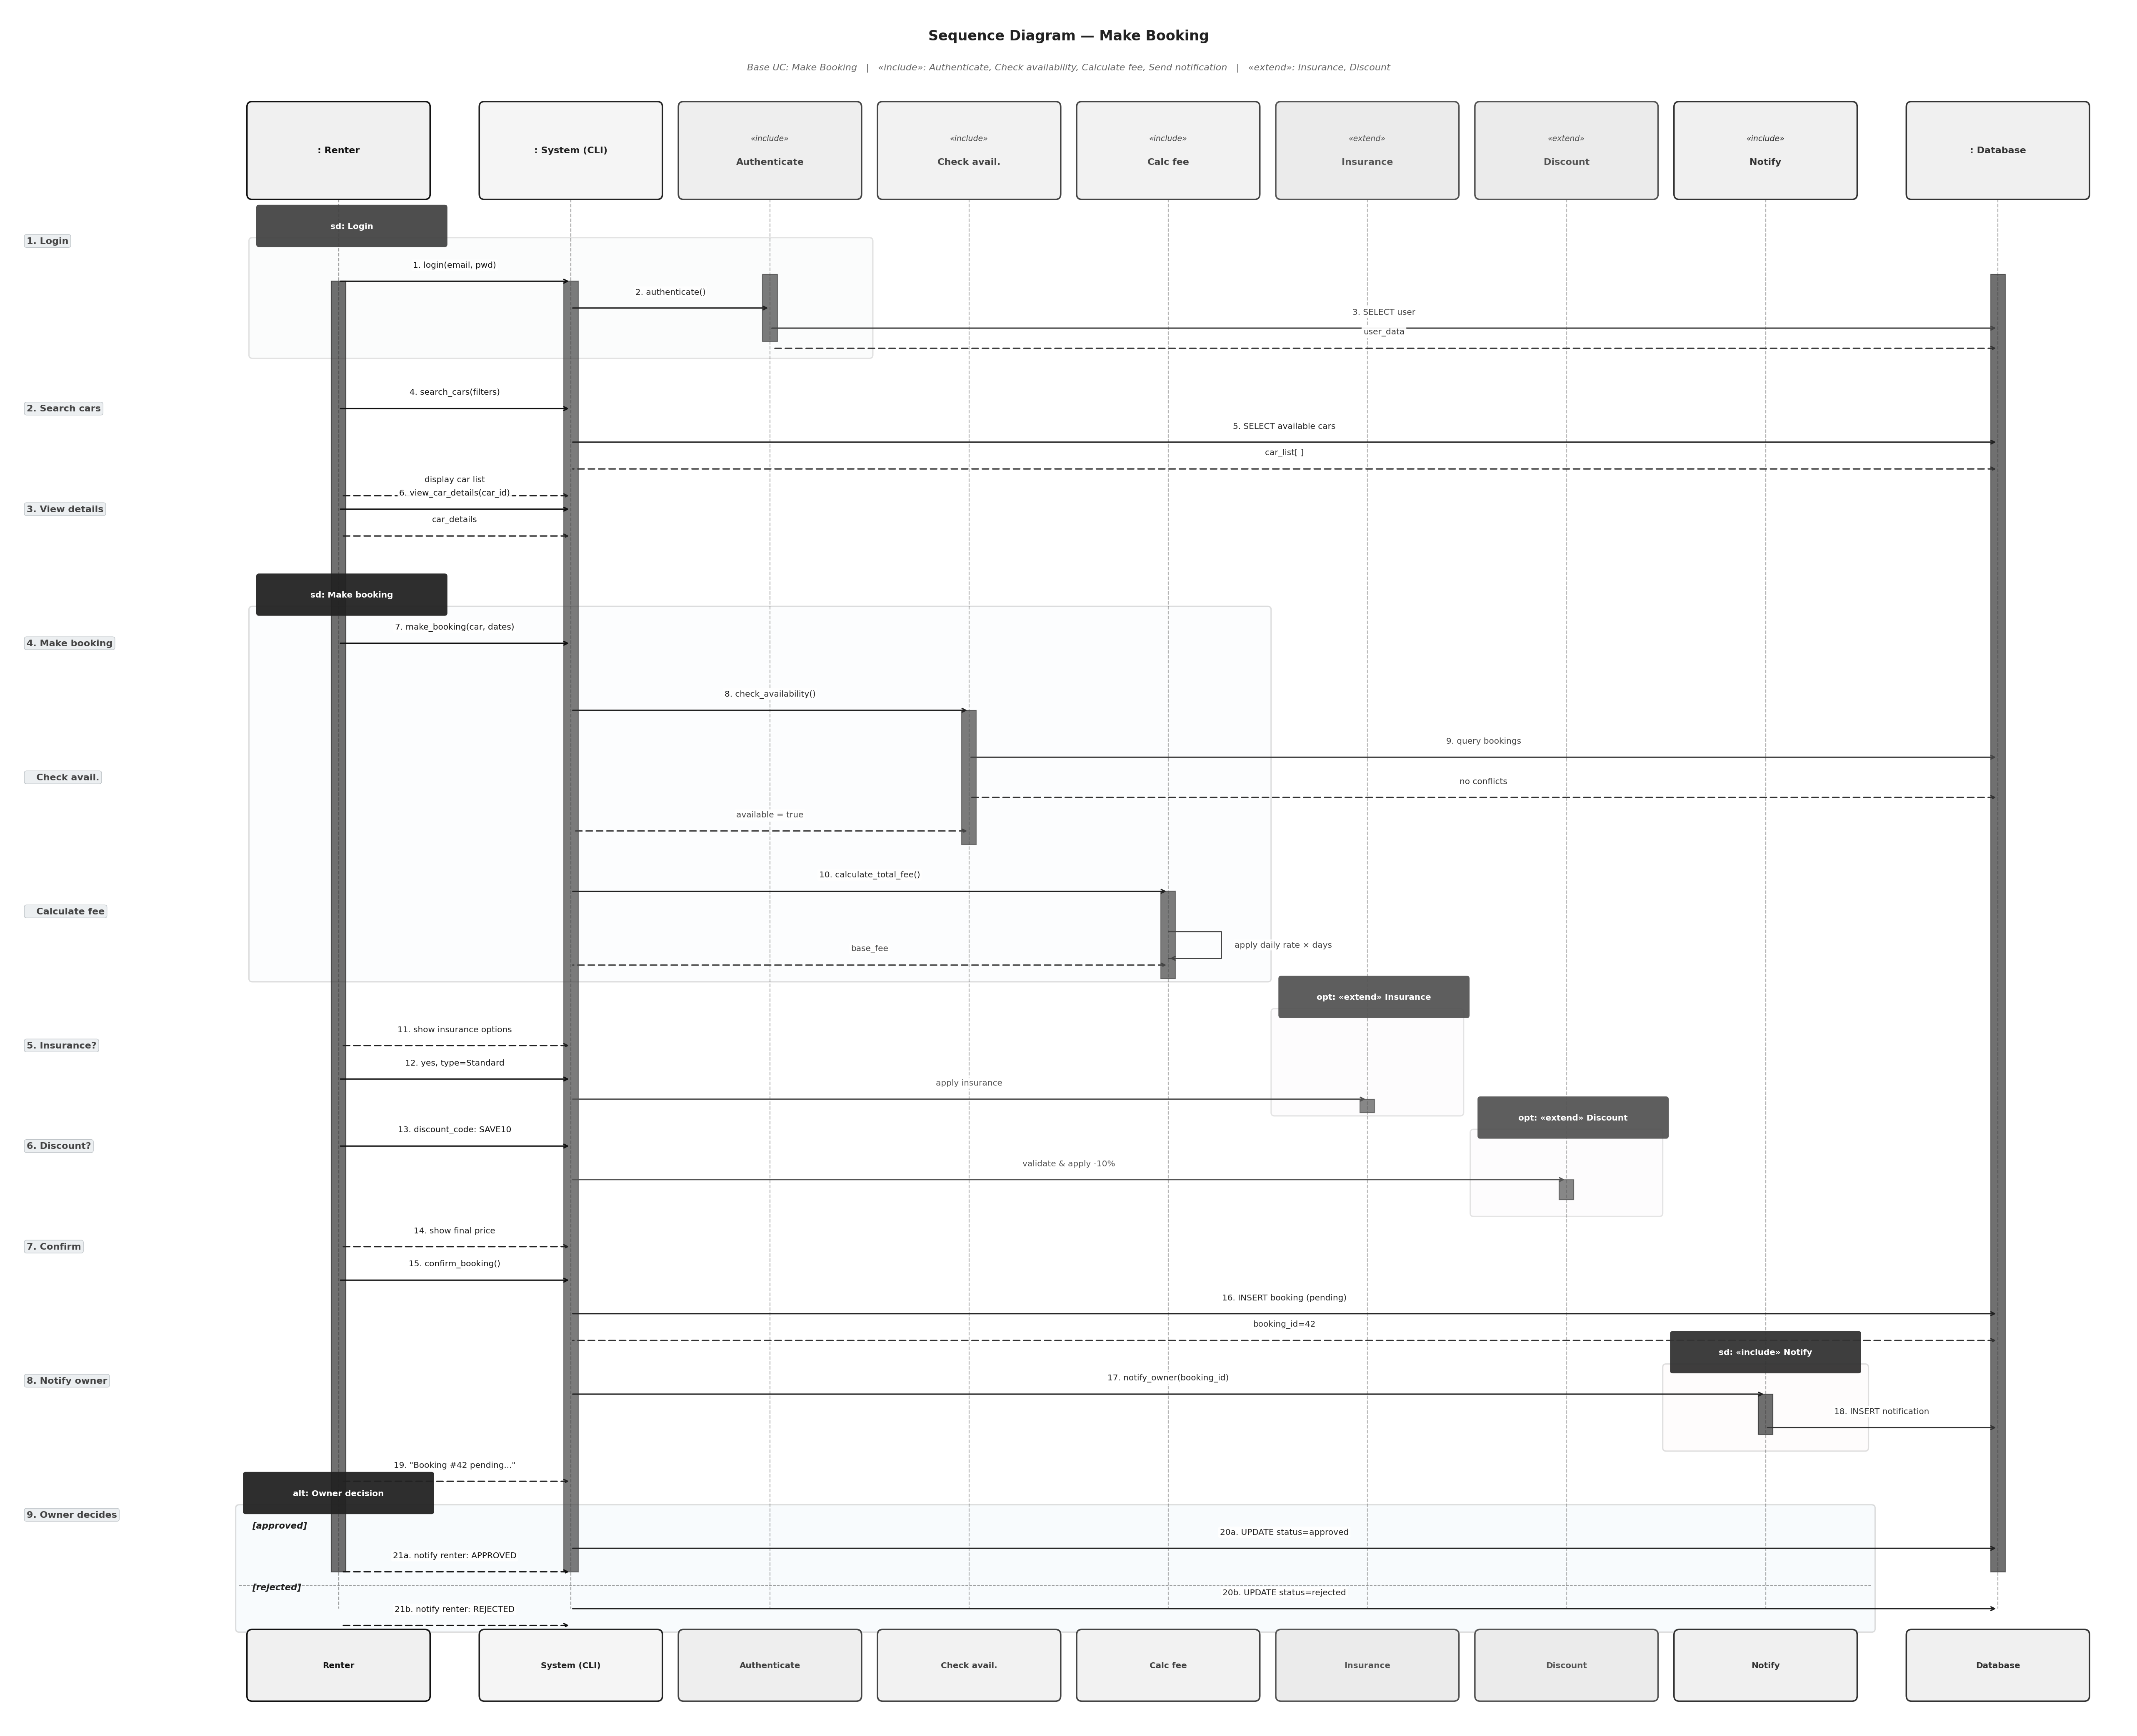
Figure 4: Sequence Diagram for the Make Booking use case

Activity Diagrams
Four activity diagrams show the step-by-step flow for the main use cases. Each uses decision nodes, fork and join bars for parallel steps, and start and end nodes.

Make booking
After a renter enters the dates for their booking, two steps run in parallel using a fork. The system checks if the car is available for those dates and calculates the total fee for the booking at the same time. The renter then has the option to add insurance or a discount code. If the renter confirms the booking, the details are saved.

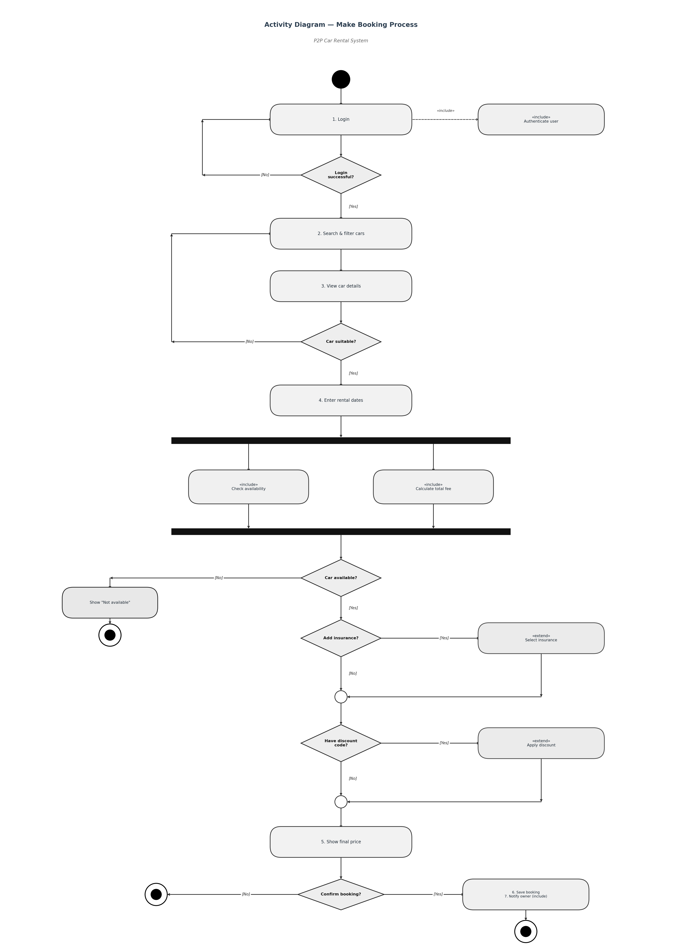
Figure 5: Activity Diagram for the Make Booking process

Add car listing
The diagram includes two separate swimlanes which separate Owner activities from Admin activities. The owner enters car details and submits the listing. The system stores the information under pending status while it sends an alert to the admin team. The admin team reviews the matter before they choose to approve or reject it. The system shows the car in search results after it receives approval.

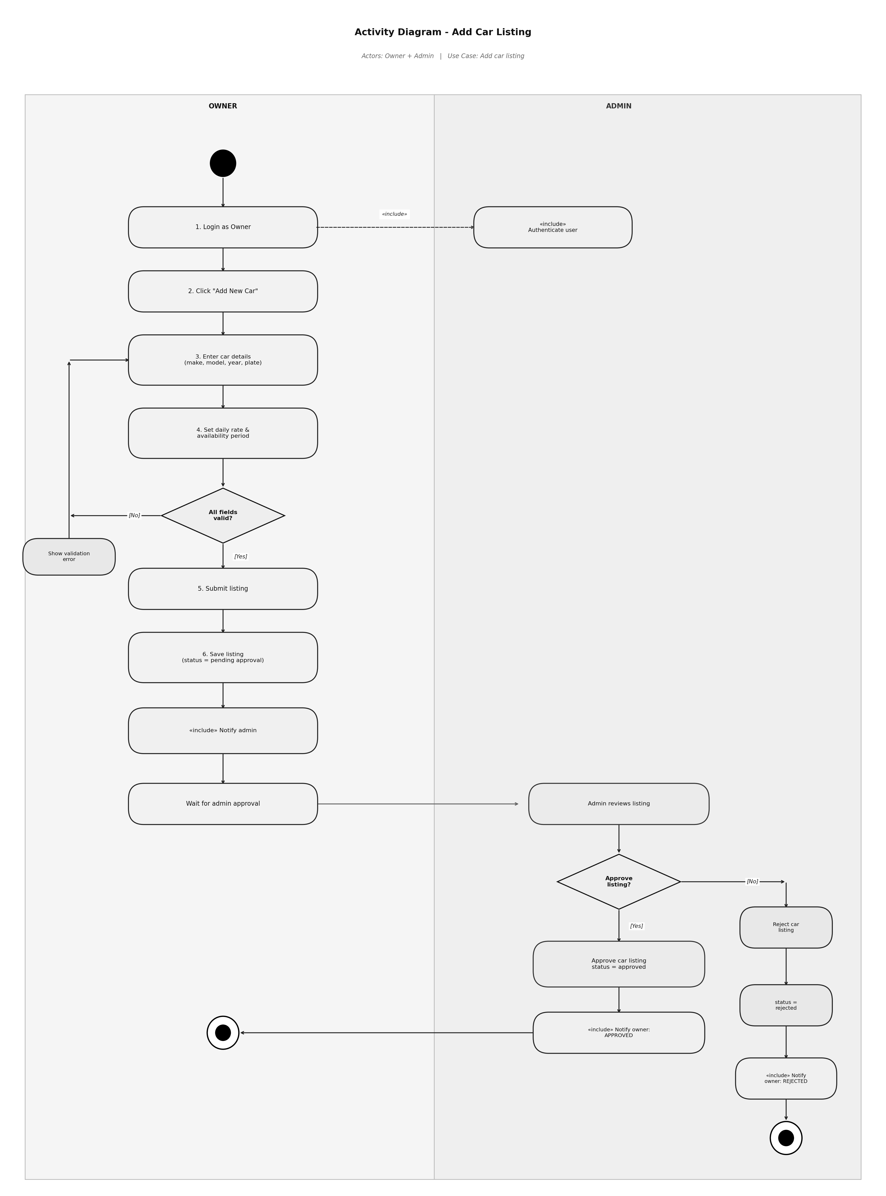
Figure 6: Activity Diagram for adding a car listing

Approve or reject booking
The owner logs into the application and views the pending booking requests. The owner checks the rating and booking history of the renter before making the decision. If the owner approves the booking, the status is updated to approved and the renter is notified. If the owner rejects the booking, the owner is asked for the reason for rejection and the status is updated to rejected.
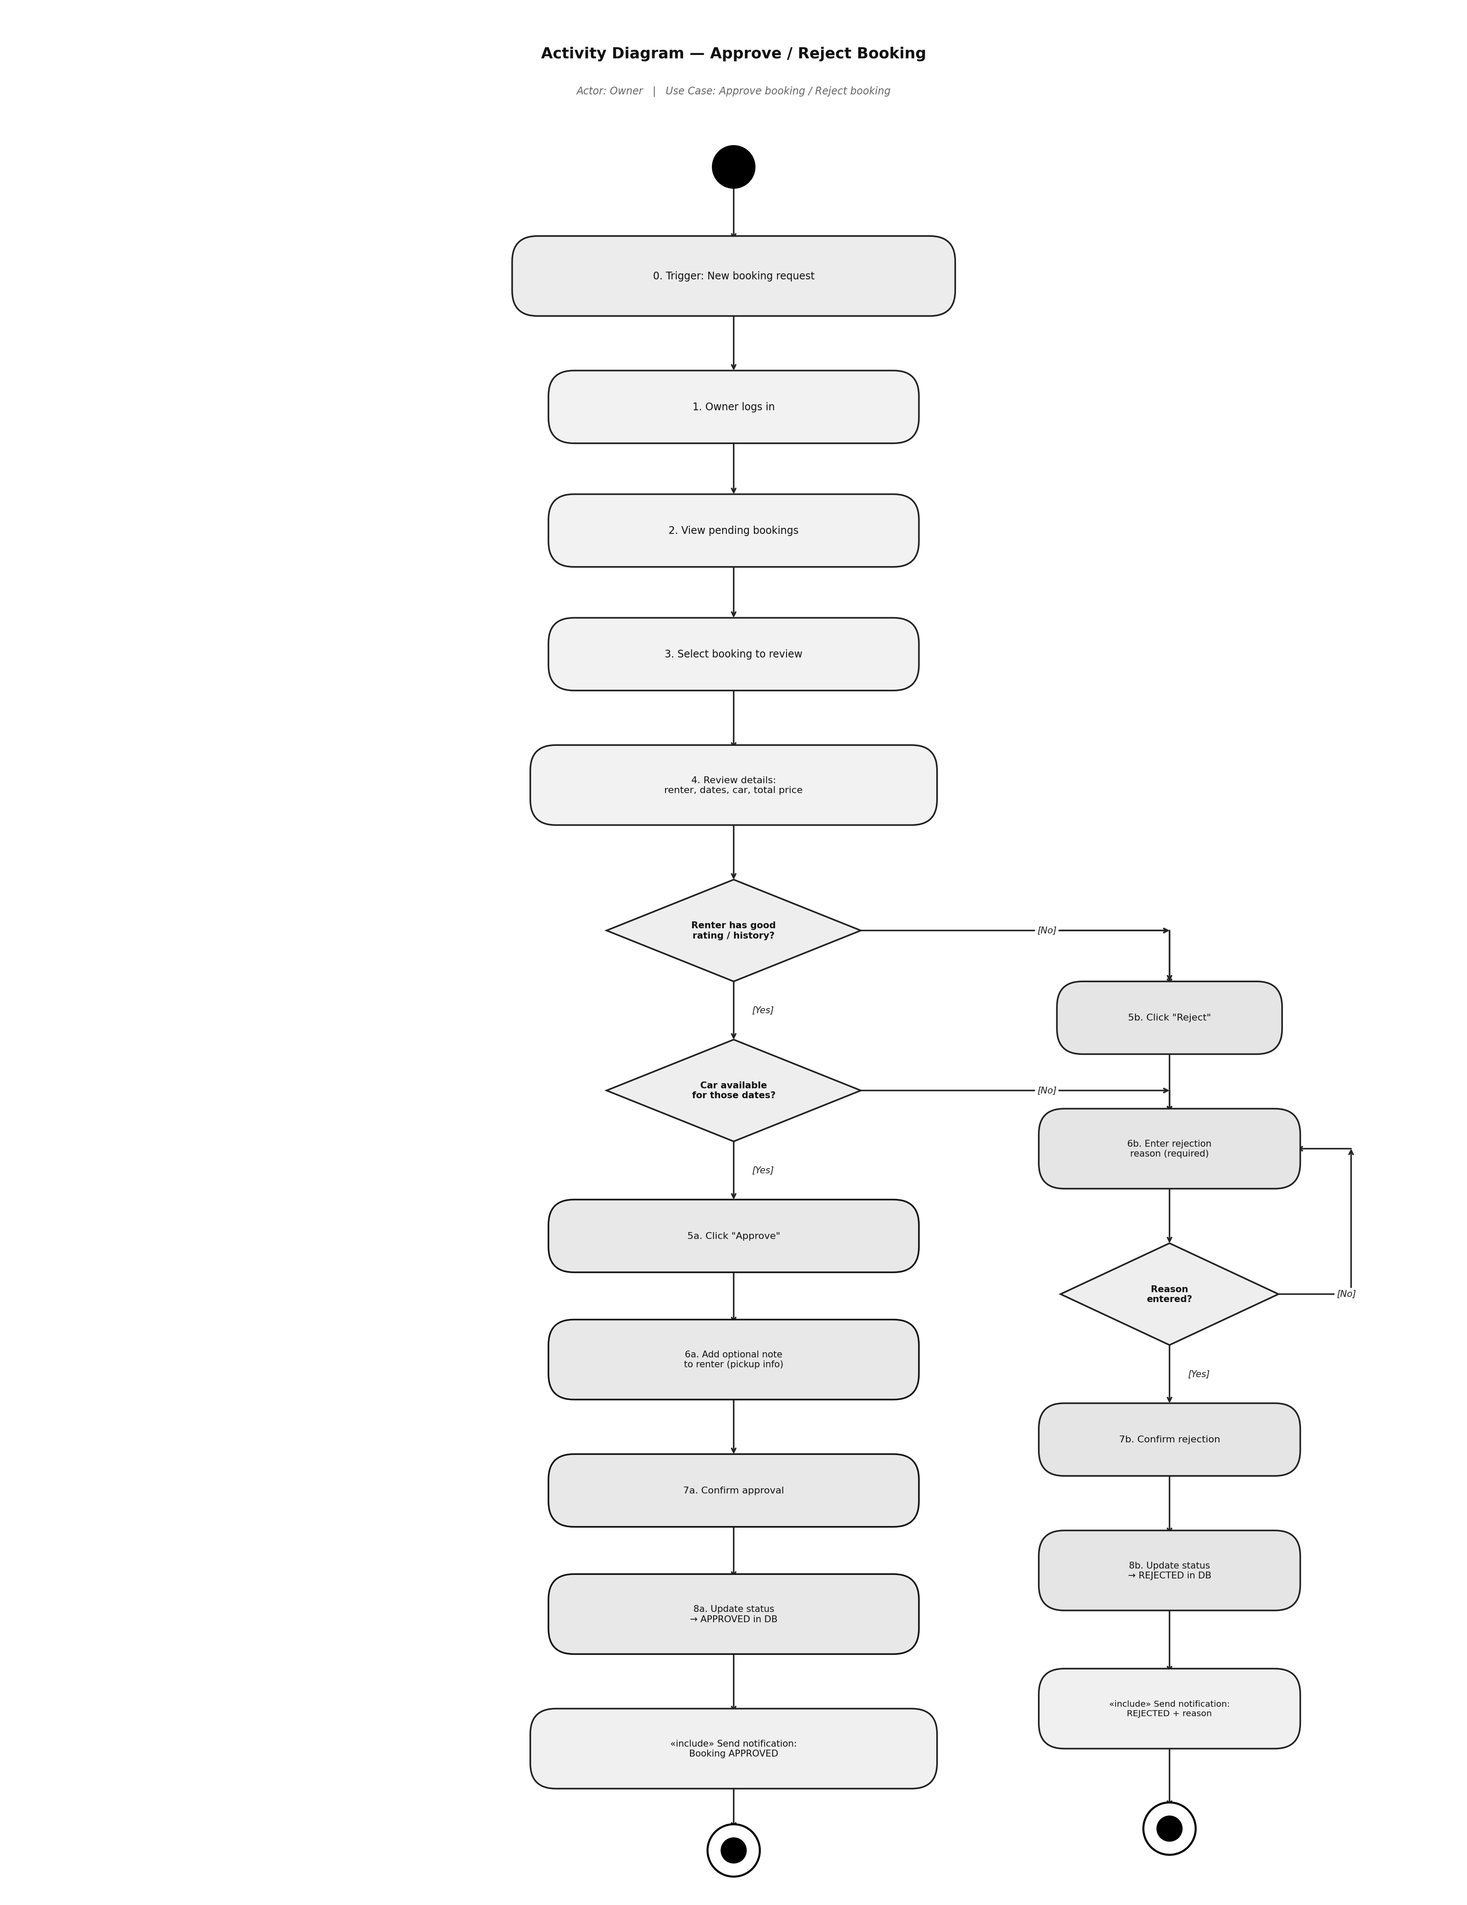
Figure 7: Activity Diagram for approving or rejecting a booking

Handle Insurance Claim
The diagram consists of three separate swimlanes which represent Owner and Admin and Renter functions. The owner files a claim after the rental. The evidence submission process requires both owners and renters to send their evidence at the same time through the fork system. The admin reviews all submitted evidence to make a decision between full claim approval or partial payment or complete claim deny.
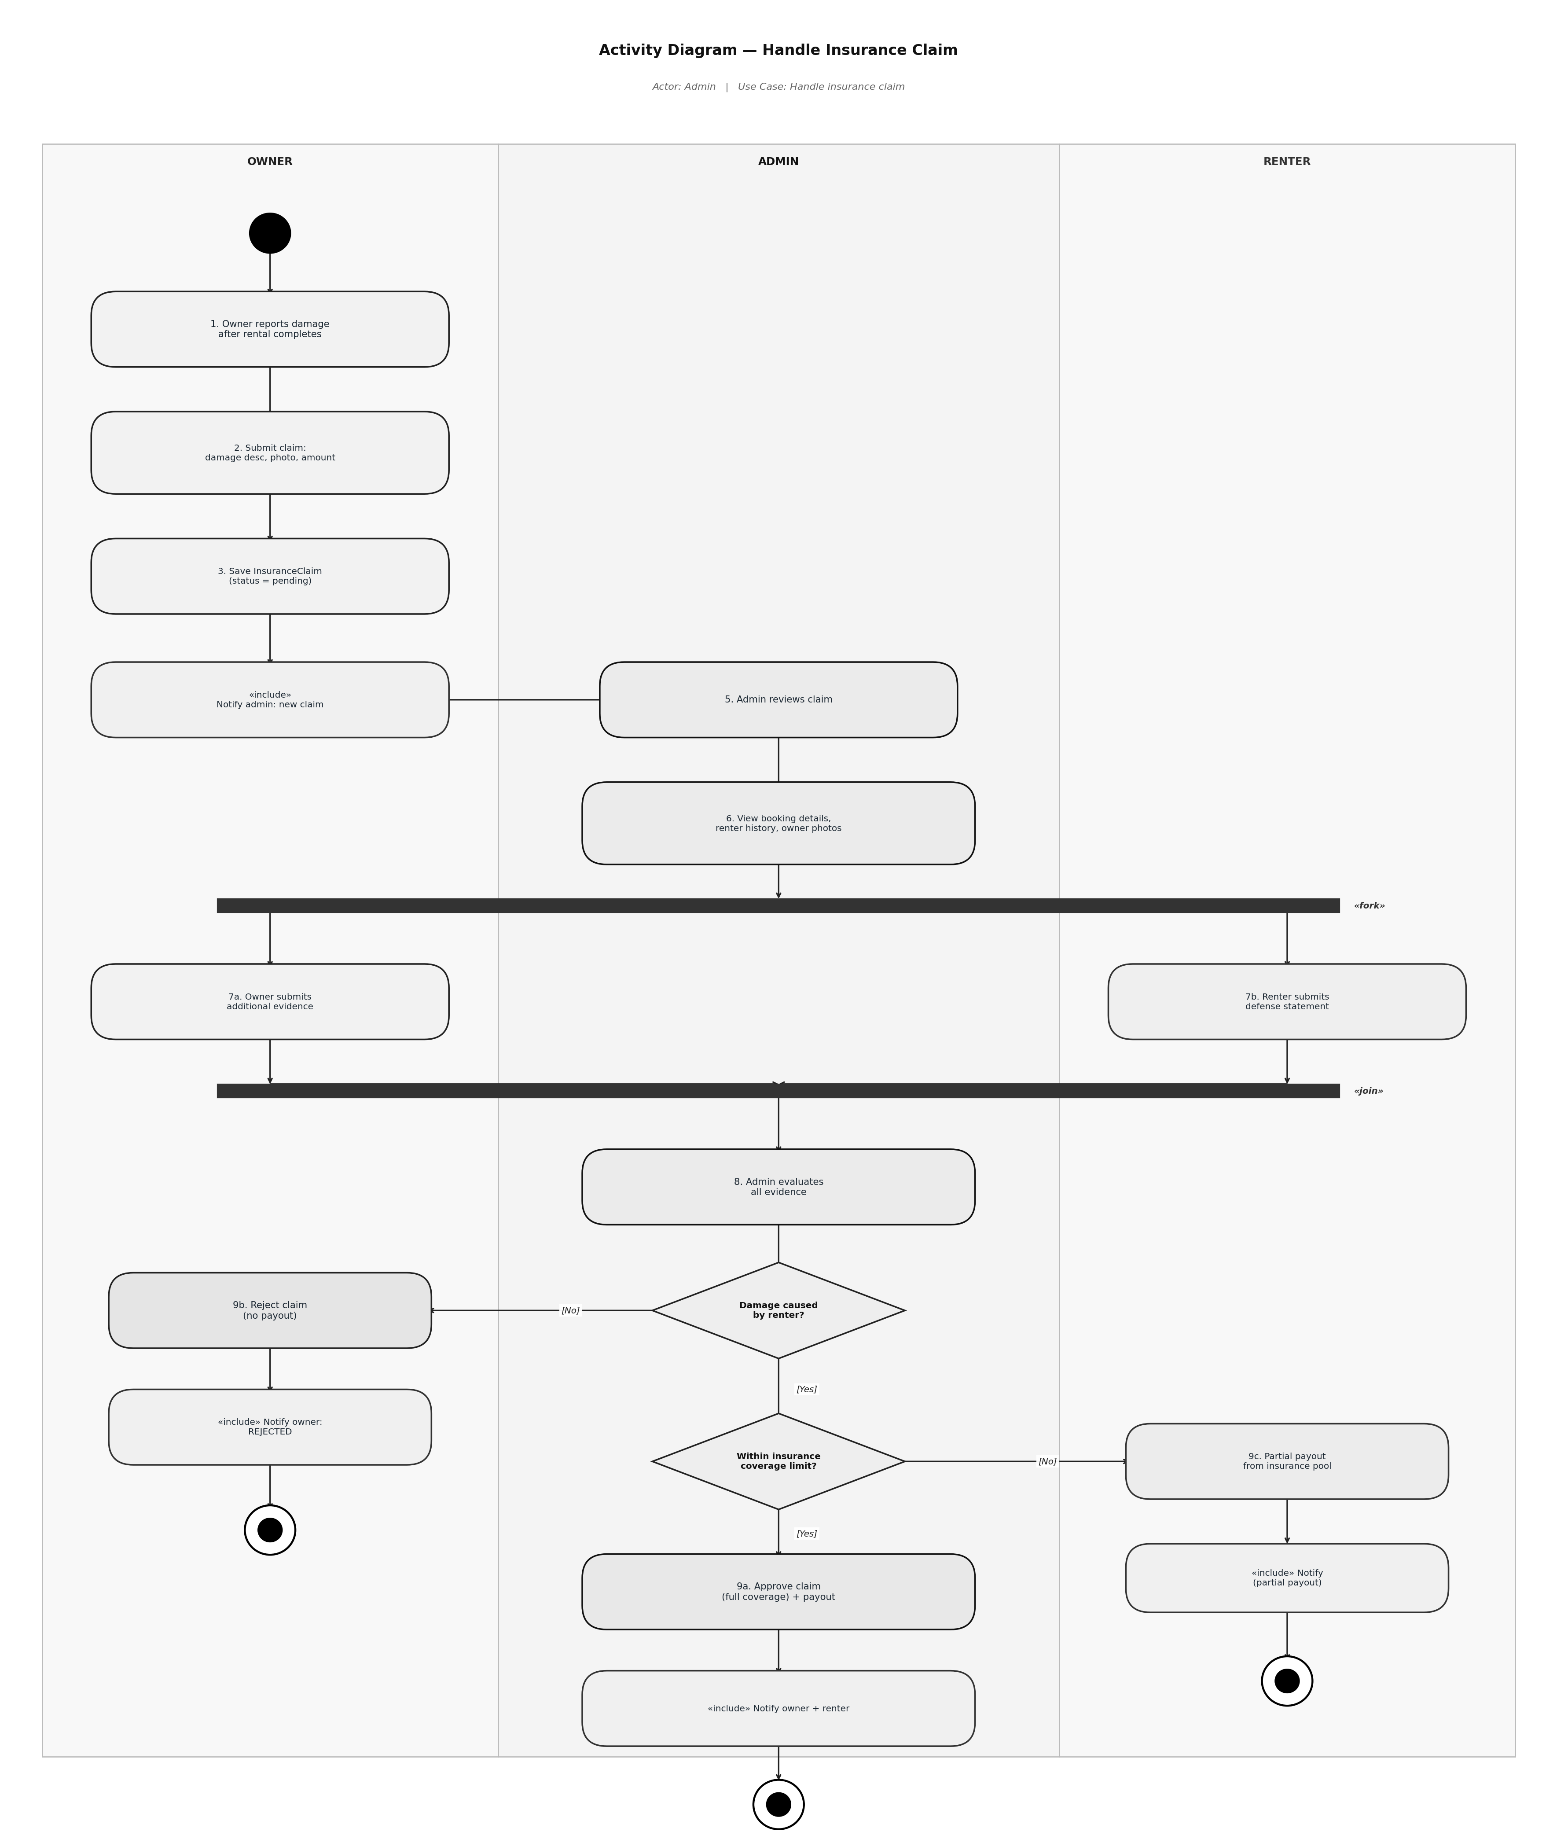
Figure 8: Activity Diagram for handling an insurance claim

