YOOBEE COLLEGE OF CREATIVE INNOVATION

Master of Software Engineering
Professional Software Engineering - MSE800

Assessment 1: Object-Oriented Programming

P2P Car Rental System

Lecturer: Dr. Mohammad Norouzifard

Student Name: Batbold Chuluunbaatar
Student ID: 270894331
Date: 24 May 2026

Abstract
This system is Python-based command line software for renting cars (P2P Car Rental System). Renters are connected to car owners through this system. There are three types of users: Owner, Renter, and Admin. The platform charges a service fee for every booking, and each one has its own menu.

The system operates through the basic principles of object-oriented programming which include encapsulation together with inheritance and abstraction and polymorphism. The system uses three design patterns which include Singleton and factory and strategy patterns. The system data storage through SQLite database implementation will bring about cost savings for operational activities. A maintenance plan and UML diagrams for the system are also provided with the project.

Table of Contents
1. Introduction 3
2. System requirements 4
3. Installation and configuration 4
4. User guide 5
5. Project structure 7
6. Design patterns 8
7. System Design and Architecture 10
7.1 Architecture overview 10
7.2 Entity Relationship Diagram 10
7.3 Use Case Diagram 11
7.4 Class Diagram 12
7.5 Sequence Diagram: Make booking 14
7.6 Activity Diagrams 15
8. Testing 20
9. Maintenance and Support Plan 21
9.1 Software maintenance 21
9.2 Versioning 22
9.3 Backward compatibility 23
9.4 Future roadmap 23
10. Conclusion 24
11. References 25
Appendix: Default credentials 25

1. Introduction
This document provides a description of the P2P Car Rental System, which is based on python-based command line application. It enables car owners to list their vehicles and then search and book them.An admin is responsible for verifying users and authorizing cars.

The platform operates in a P2P model without any cars being on hand. It links individuals with private owners. The owner of unreliable cars gains revenue from their vehicles. Renters are offered a greater range of choices, often at lower rates than those in traditional rental services.

Problem statement
The system (P2P) service must address multiple issues together.
- The platform will allow the service after verifying the user. This should influence trust in the user.
- Listings of cars must be reviewed before they appear in search results.
- The functioning of booking requires the interval of dates, pricing, and approvals.
- Risk can be reduced through insurance services
- All users should be able to rate and view ratings from others based on the services they have received.

Objectives
Objective | How it is achieved
OOP principles | Abstract User class with Owner, Renter, and Admin subclasses. Protected attributes with @property access. Polymorphic dashboard method.
Design patterns | Singleton for the database. Factory for user creation. Strategy for insurance
Layered architecture | Four layers: Presentation, Service, Model, and Data Access. Each layer communicates only with the one below it.
Environment support | config.py can read APP_ENV and switches between dev, test, and prod settings, depends on purpose.
Documentation | UML diagrams: ERD, Use Case, Class, Sequence, and Activity diagrams.

2. System requirements

Software requirements
Software | Version | Purpose
Python | 3.8 or higher | Programming language.
SQLite | Built into Python | Database and no separate installation needed.
tabulate | 0.9.0 | Prints formatted tables in the CLI.
colorama | 0.4.6 | Adds color to CLI output.

No separate database server is needed. SQLite saves all data in one file: database/car_rental.db. The database file is created automatically and seed data (admin account) inserted on the first run.

Hardware requirements
Component | Minimum
CPU | 1 GHz or faster
RAM | 1GB
Disk space | 1GB free
Display | 80-column terminal or wider

3. Installation and configuration

Step 1: Extract the project source files
Extract the zip file (source_code.zip) to any folder and open a terminal and navigate to that folder.

Step 2: Create and activate a virtual environment
python -m venv venv
On Windows:
venv\Scripts\activate
On macOS or Linux:
source venv/bin/activate

Step 3: Install dependencies
pip install -r requirements.txt

Step 4: Run the application
python main.py
On first run, the system creates the database, sets up all tables, creates the default admin account, and shows the main menu.

Configuration
config.py contains all settings. The APP_ENV variable selects the environment. If not set, dev is used as default.

Environment | Database | Purpose
dev (default) | database/car_rental.db | For development, data is saved between runs.
test | :memory: | For testing, Data is deleted when the app closes.
prod | database/car_rental_prod.db | For production use.

To switch environment:
APP_ENV=test python main.py

Key configuration values
Constant | Default | Description
PLATFORM_FEE_PERCENT | 15% | Commission on each booking for platform.
LONG_TERM_DISCOUNTS | 7d=10%, 30d=20% | Discount conditions for longer rentals.
DISCOUNT_CODES | SAVE10, WELCOME20, SUMMER15 | Available discount codes.
DEFAULT ADMIN_EMAIL | admin@p2p.com | Auto created admin login.

4. User guide
The system has three roles including renter, owner, and admin. Each role has its own menu. Test all features in the order below.

Step | Action | Role
1 | Login as admin (admin@p2p.com / admin123). | Admin
2 | Register a new owner account, then log out. | -
3 | Register a new renter account, then log out. | -
4 | Login as admin and verify both users. | Admin
5 | Login as owner and add an own car. | Owner
6 | Login as admin and approve the car. | Admin
7 | Login as renter, search for cars, and make a booking. | Renter
8 | Login as owner and approve the booking. | Owner
9 | Login as renter and submit a review. | Renter

Owner features
- Add car listing: Enter and save make, model, year, mileage, location, daily rate, and min and max rent periods. The listing approved by admin approval.
- Manage bookings: view pending requests and approve or reject each one.
- View earnings: see total income from completed bookings.

Renter features
- Search cars: filter by location and maximum daily price.
- Make booking: Selecting the rental period and calculating the total price, select an insurance options and enter a discount code.
- Cancel booking: allowed before the rental start date.
- Submit review: rate the owner from 1 to 5 stars after the rental ends.

Admin features
- Verify users: check that new registrations are real people (KYC).
- Approve cars: review and approve or reject new car listings.
- Handle claims: review insurance claims and decide to approve, partially pay, or reject.
- View reports: see total users, cars, bookings, and platform revenue.
- Suspend users: remove verification from users who break the rules.

Calculation of price
- Base price = daily rate x number of days
- Long-term discount: 7 or more days = 10% off. 30 or more days = 20% off.
- Discount code: optional extra percentage off.
- Platform fee = 15% of the owner amount (service fee of the system).
- Insurance fee = daily insurance rate x number of days (optional).

Insurance options | Daily fee | Coverage
None | $0.00 | No coverage. Renter accepts all risk.
Basic | $5.00 | $2,000 coverage for minor damage.
Standard | $10.00 | $5,000 coverage.
Premium | $15.00 | Full coverage.

Discount codes
Discount codes can be entered during the booking process. They apply a percentage off the base price after the long-term discount is applied.

Code | Discount
SAVE10 | 10% off the base price
WELCOME20 | 20% off the base price
SUMMER15 | 15% off the base price

5. Project structure
The project uses a 4-layer architecture. Each folder has one responsibility.

Folder / File | Layer | Responsibility
main.py | Entry point | Initializes the database and starts the main menu.
config.py | Configuration | All settings. Reads APP_ENV to switch environments.
database/db_manager.py | Data Access | Singleton database manager. Runs all SQL queries.
models/ | Model | OOP entities: User (abstract), Owner, Renter, Admin, Car, Booking, Review.
factories/user_factory.py | Model | Creates the correct User subclass from a role string.
patterns/insurance_strategy.py | Model | Four insurance classes sharing one interface.
services/ | Service | Business logic: AuthService, CarService, BookingService, AdminService, ReviewService.
ui/ | Presentation | CLI menus: main_menu, owner_menu, renter_menu, admin_menu.
utils/ | Helper | security.py (password hashing), validators.py, helpers.py (display functions).

6. Design patterns
The system uses three design patterns, each one was chosen because it solves a specific problem in the code.

Singleton: DatabaseManager
If different parts of the code each open their own database connection, memory is wasted and write conflicts can occur. The DatabaseManager (database/db_manager.py) solves this by overriding __new__. Every call to DatabaseManager() returns the same object. Only one connection is ever created.

class DatabaseManager:
_instance = None
def __new__(cls):
if cls._instance is None:
cls._instance = super().__new__(cls)
cls._instance._initialize()
return cls._instance

All parts of the application share this one connection. The database tables are also created only once, when the connection is first opened.

Factory: UserFactory
When a user logs in, the system needs to create an Owner, Renter, or Admin object depending on the role stored in the database. UserFactory puts all creation logic in one place (factories/user_factory.py). The factory also has a from_db_row() method that creates a user object directly from a database row.

class UserFactory:
@staticmethod
def create(role, user_id, name, email, ...):
if role == "owner":
return Owner(user_id, name, email, ...)
elif role == "renter":
return Renter(user_id, name, email, ...)
elif role == "admin":
return Admin(user_id, name, email, ...)

Strategy: InsuranceStrategy
The system offers four insurance options (patterns/ insurance_strategy.py). Each has a different daily fee and coverage limit. The Strategy pattern lets each plan be a separate class. The BookingService (services/ booking_service.py) calls insurance.calculate_fee(days) without knowing which plan is active. To add a new plan, only a new subclass is needed.

class InsuranceStrategy(ABC):
@property
@abstractmethod
def daily_fee(self) -> float: pass

@abstractmethod
def calculate_fee(self, days: int) -> float: pass

class BasicInsurance(InsuranceStrategy):
daily_fee = 5.0 # $2,000 coverage

class StandardInsurance(InsuranceStrategy):
daily_fee = 10.0 # $5,000 coverage

class PremiumInsurance(InsuranceStrategy):
daily_fee = 15.0 # Full coverage

Pattern summary
Pattern | Problem solved | File
Singleton | One database connection shared across the whole app. | database/db_manager.py
Factory | Create the right User subclass from a role string. | factories/user_factory.py
Strategy | Swap insurance pricing at runtime without changing the booking logic. | patterns/insurance_strategy.py

7. System Design and Architecture

7.1 Architecture overview
The system has a 4-layer architecture that communicate with the layer directly below them.

Layer | Folder | Responsibility
1. Presentation | ui/ | CLI menus for each user role.
2. Service | services/ | Business logic: booking, auth, admin operations.
3. Model | models/ | OOP entities: User, Car, Booking, Review.
4. Data Access | database/ | SQLite connection and all SQL queries.

7.2 Entity Relationship Diagram
The database contains five tables: USERS, CARS, BOOKINGS, REVIEWS, and INSURANCE_CLAIMS. All three user types are stored in the USERS table, using a role column to differentiate between them. The owner_id is stored directly in the BOOKINGS table to allow for faster queries of which owner booked the car. The discount_code and discount_amount are also stored in the BOOKINGS table to allow for auditing of any discounts applied to a booking. Finally, CHECK constraints are used on all status columns to ensure that only valid values are entered into those columns at the database level.

Table | Primary Key | Foreign Keys | Key Constraints
USERS | id | none | email UNIQUE, role CHECK (owner/renter/admin)
CARS | id | owner_id -> USERS | is_approved BOOL, daily_rate REAL
BOOKINGS | id | car_id, renter_id, owner_id | status CHECK (5 values), discount_code, discount_amount
REVIEWS | id | booking_id, reviewer_id, reviewee_id | rating CHECK (1-5)
INSURANCE_CLAIMS | id | booking_id | status CHECK (pending/approved/rejected)

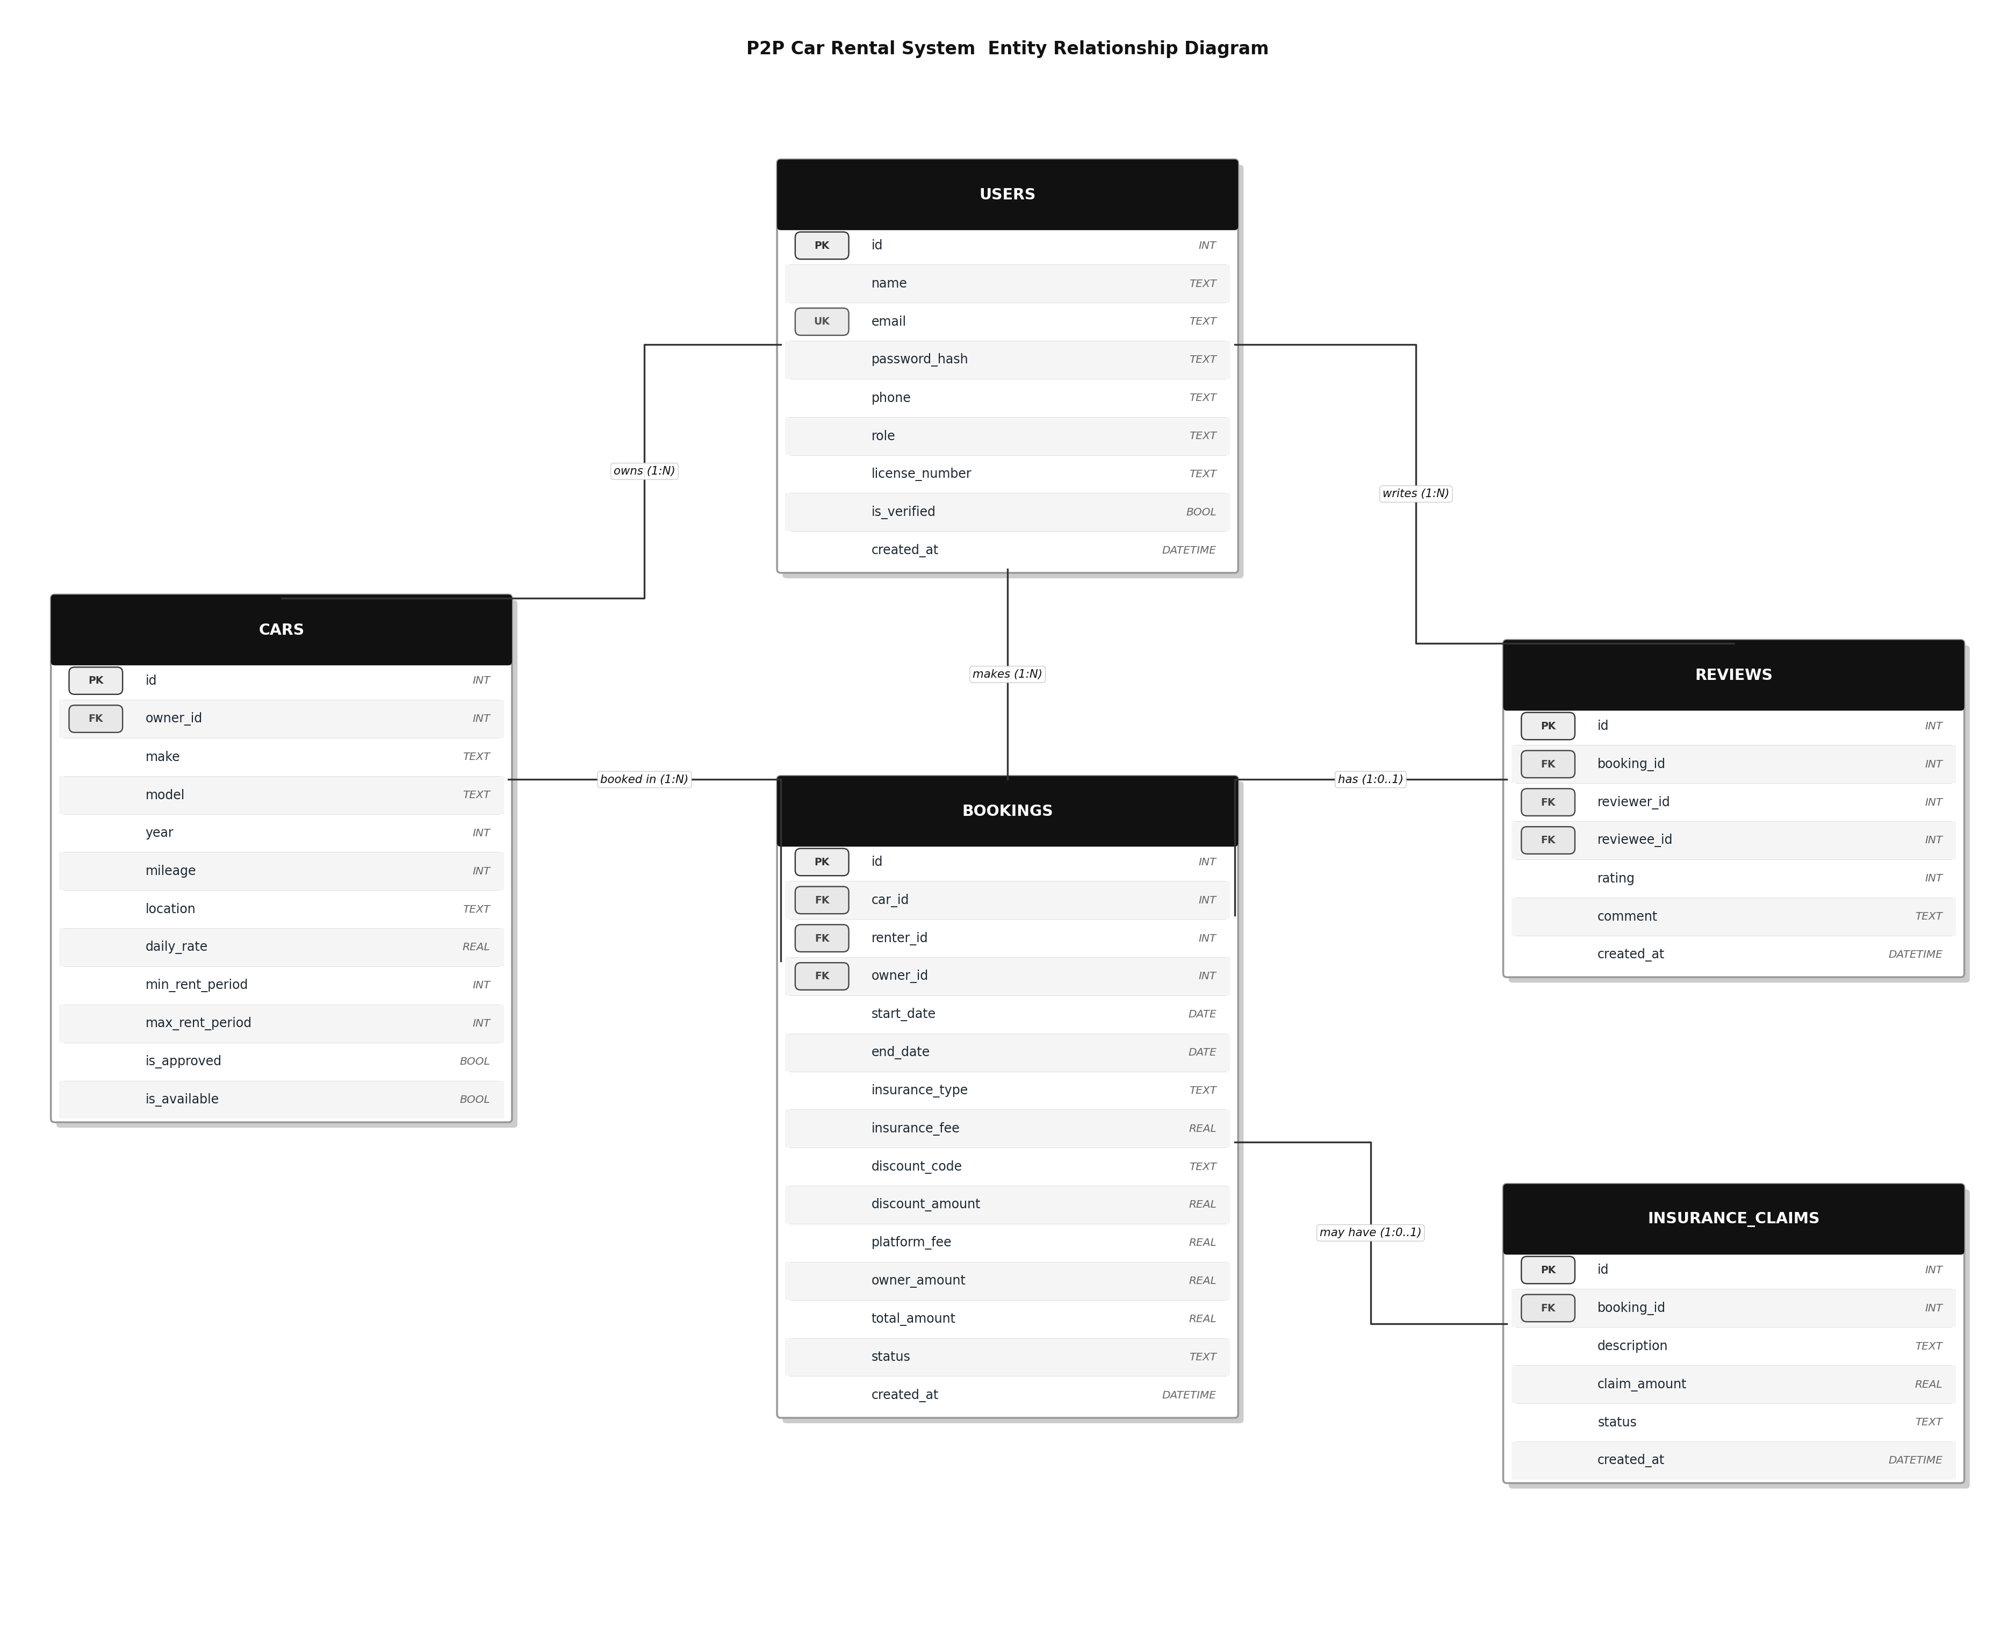
Figure 1: ERD with 5 tables, 8 foreign keys, and 1 unique key

7.3 Use Case Diagram
The system has three actors: Owner, Renter, and Admin. Two relationship types are used.

- "include": a mandatory step that always runs. "Make booking" always includes "Check availability" and "Calculate total fee".
- "extend": an optional step. "Make booking" can extend with "Select insurance" or "Apply discount code".

Actor | Use Cases
Owner | Register/login, add car listing, remove car listing, approve booking, reject booking, view earnings.
Renter | Register/login, Search for available cars by date periods, view car details, make booking, cancel booking, submit review.
Admin | Verify user KYC, approve car listing, reject car listing, view all bookings, handle insurance claim, view reports, suspend user.

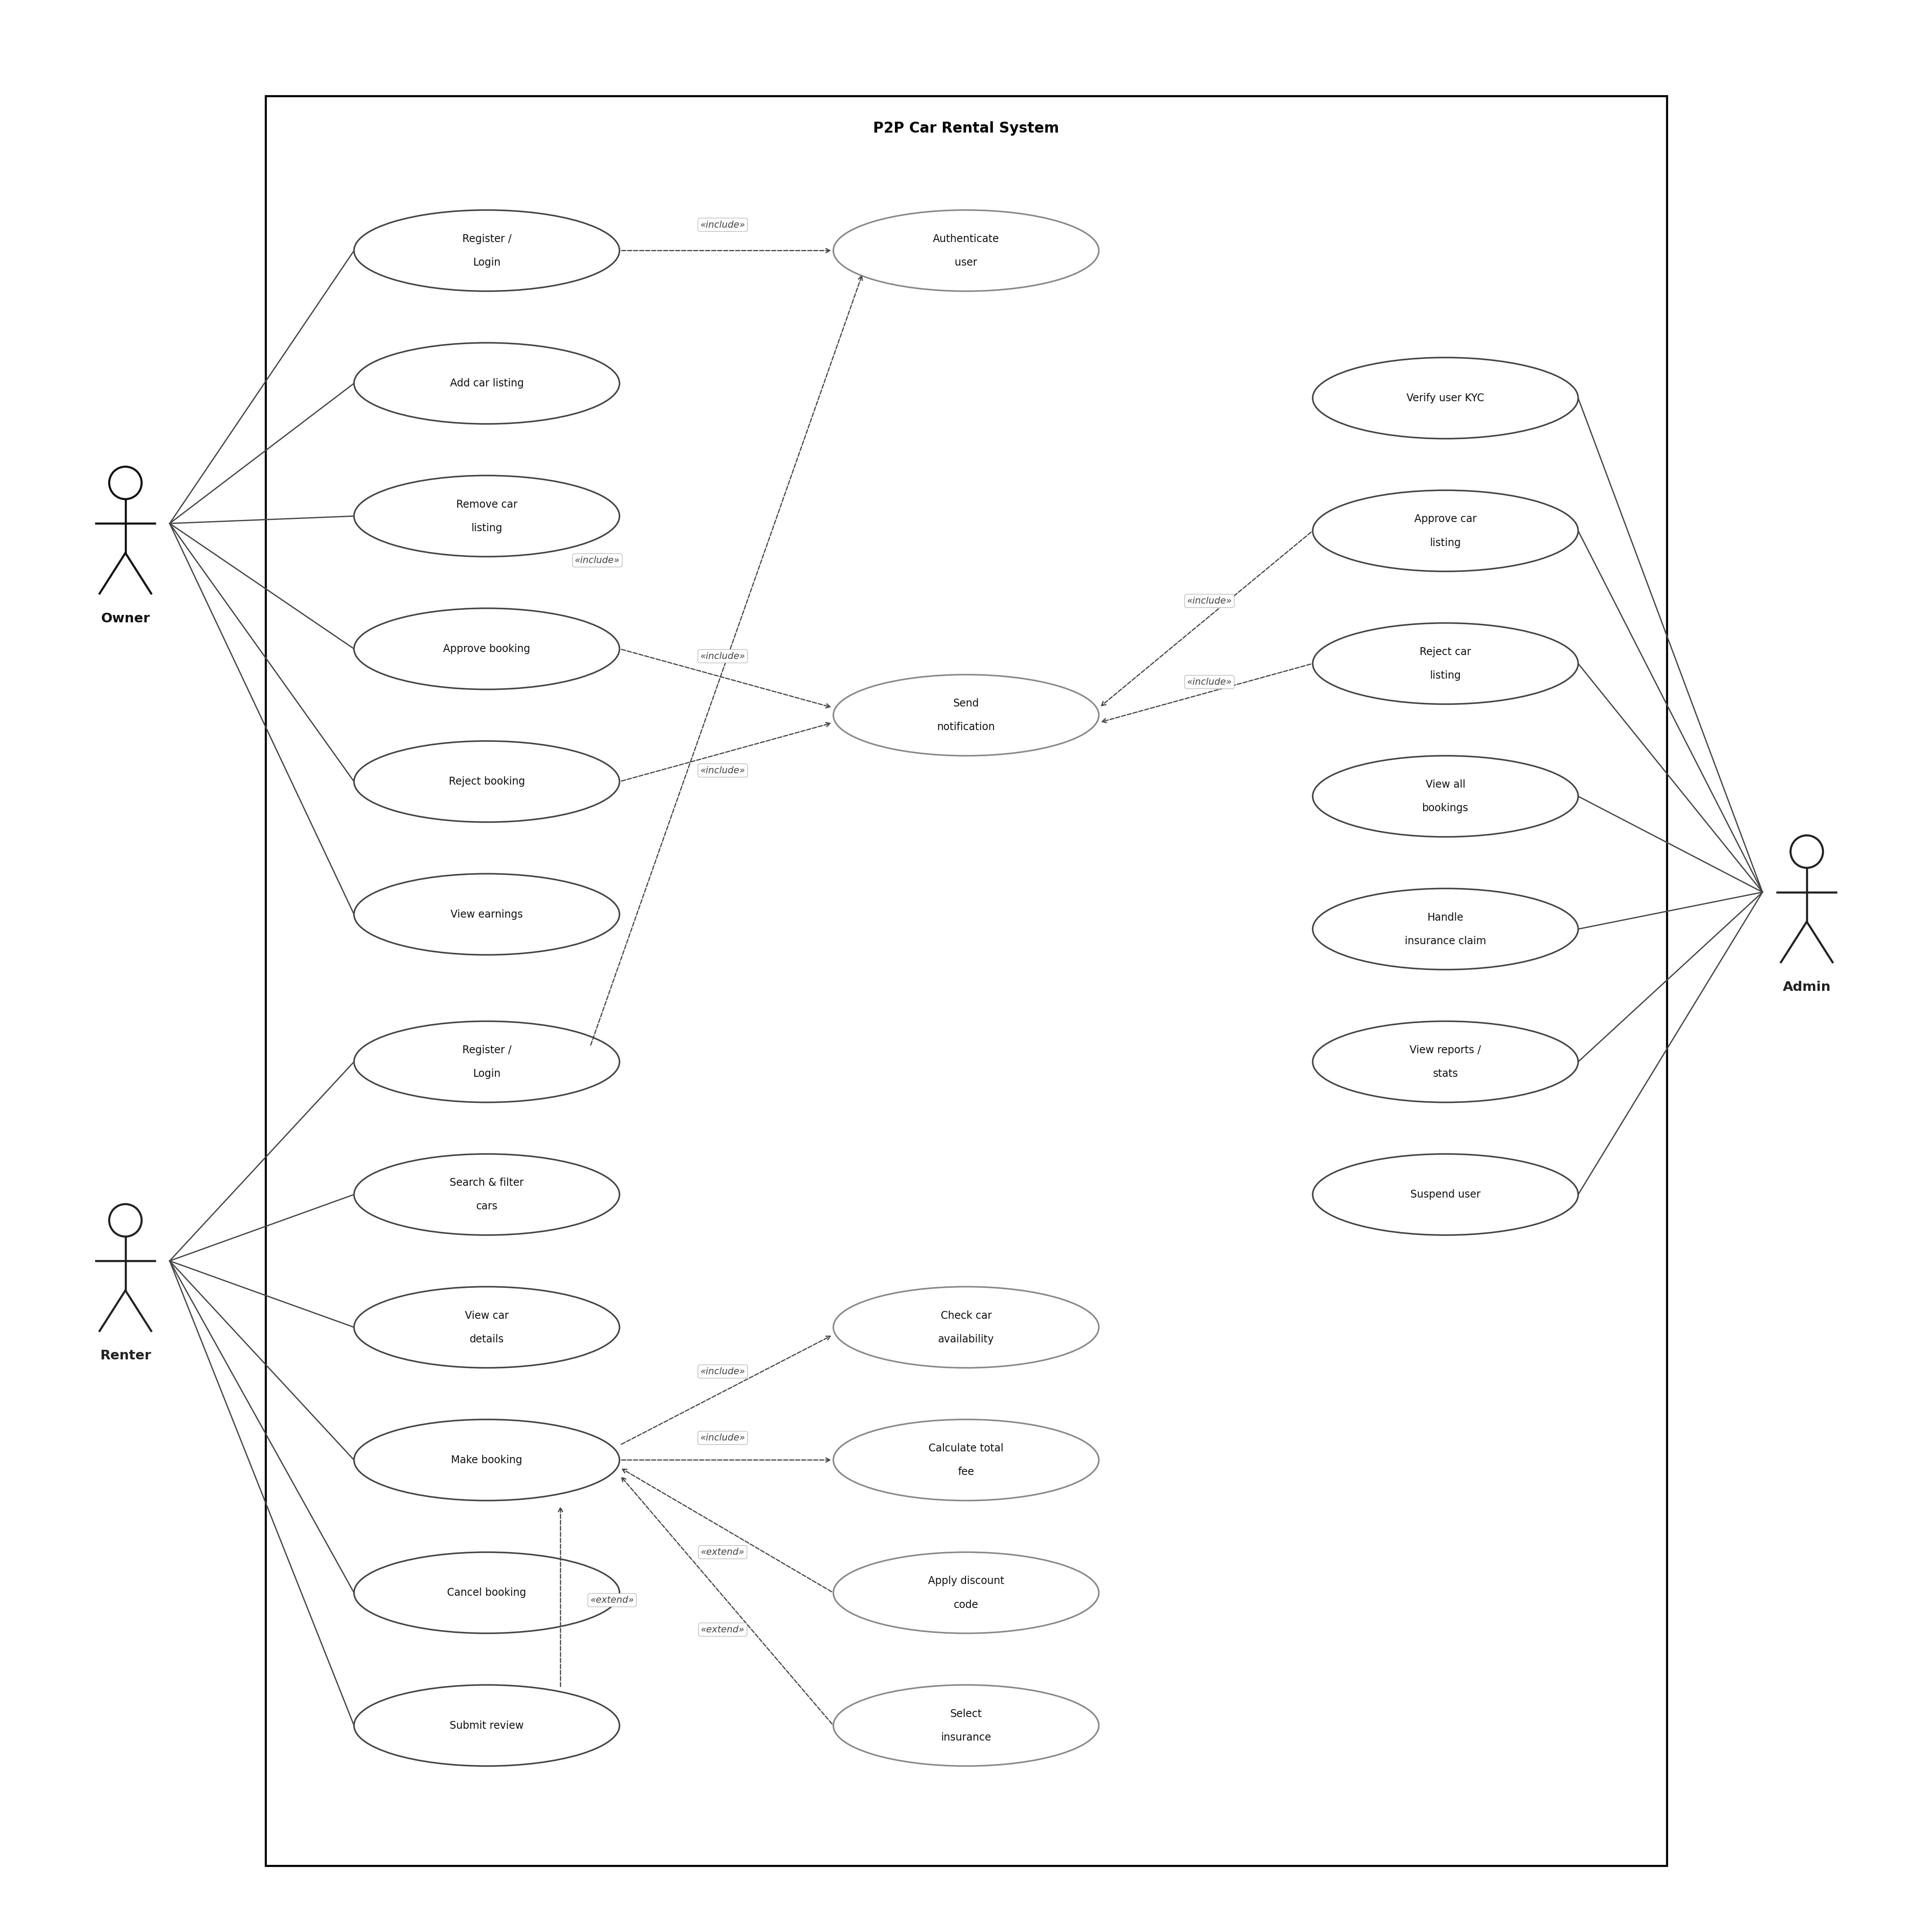
Figure 2: Use Case Diagram with 3 actors and 19 use cases

7.4 Class Diagram
The User class is abstract. It uses abc.ABC and defines view_dashboard() as an abstract method. Owner, Renter, and Admin each inherit from User and provide their own version of this method.

Principle | How it is applied
Encapsulation | All attributes use a single underscore prefix (_id, _name). They are accessed only through @property methods.
Abstraction | User and InsuranceStrategy are abstract base classes (ABC). They define the interface but not the implementation.
Inheritance | Owner, Renter, and Admin inherit all attributes and methods from User.
Polymorphism | view_dashboard() is defined once in User but works differently for each subclass. The main menu calls it without knowing the role.

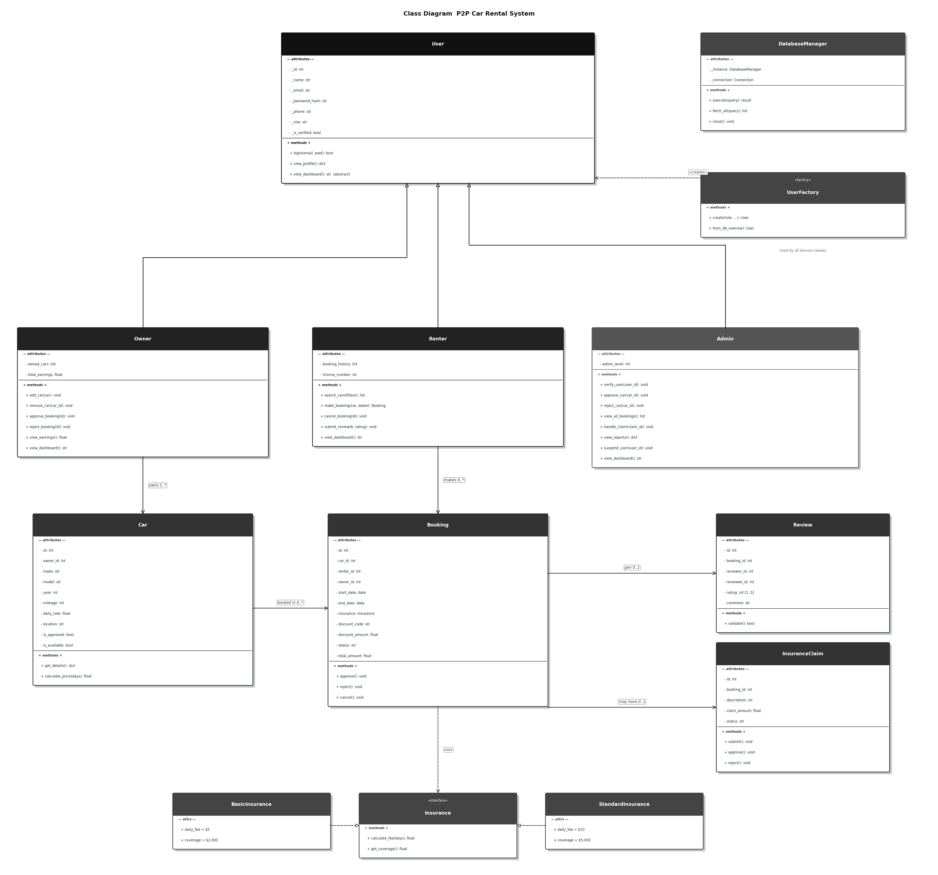
Figure 3: Class Diagram showing the OOP hierarchy and design patterns

7.5 Sequence Diagram: Make booking
The Make booking use case is the most complex in the system. The sequence diagram shows 9 participants and the messages between them in order.

Step | Action | Notes
1 | Renter logs in | Includes: Authenticate user
2 | Renter searches for cars | SQL query with location and price filters
3 | Renter views car details | Get one car record by ID
4 | Renter enters booking dates | is_valid_date_range() is called first
5 | System is checking availability | Include: Check car availability
6 | System calculates the fee | Include: Calculate total fee
7 | Renter selects insurance | Extend (optional)
8 | Renter applies a discount code | Extend (optional)
9 | System saves the booking | INSERT into BOOKINGS with status = pending
10 | System notifies the owner | Include: Send notification

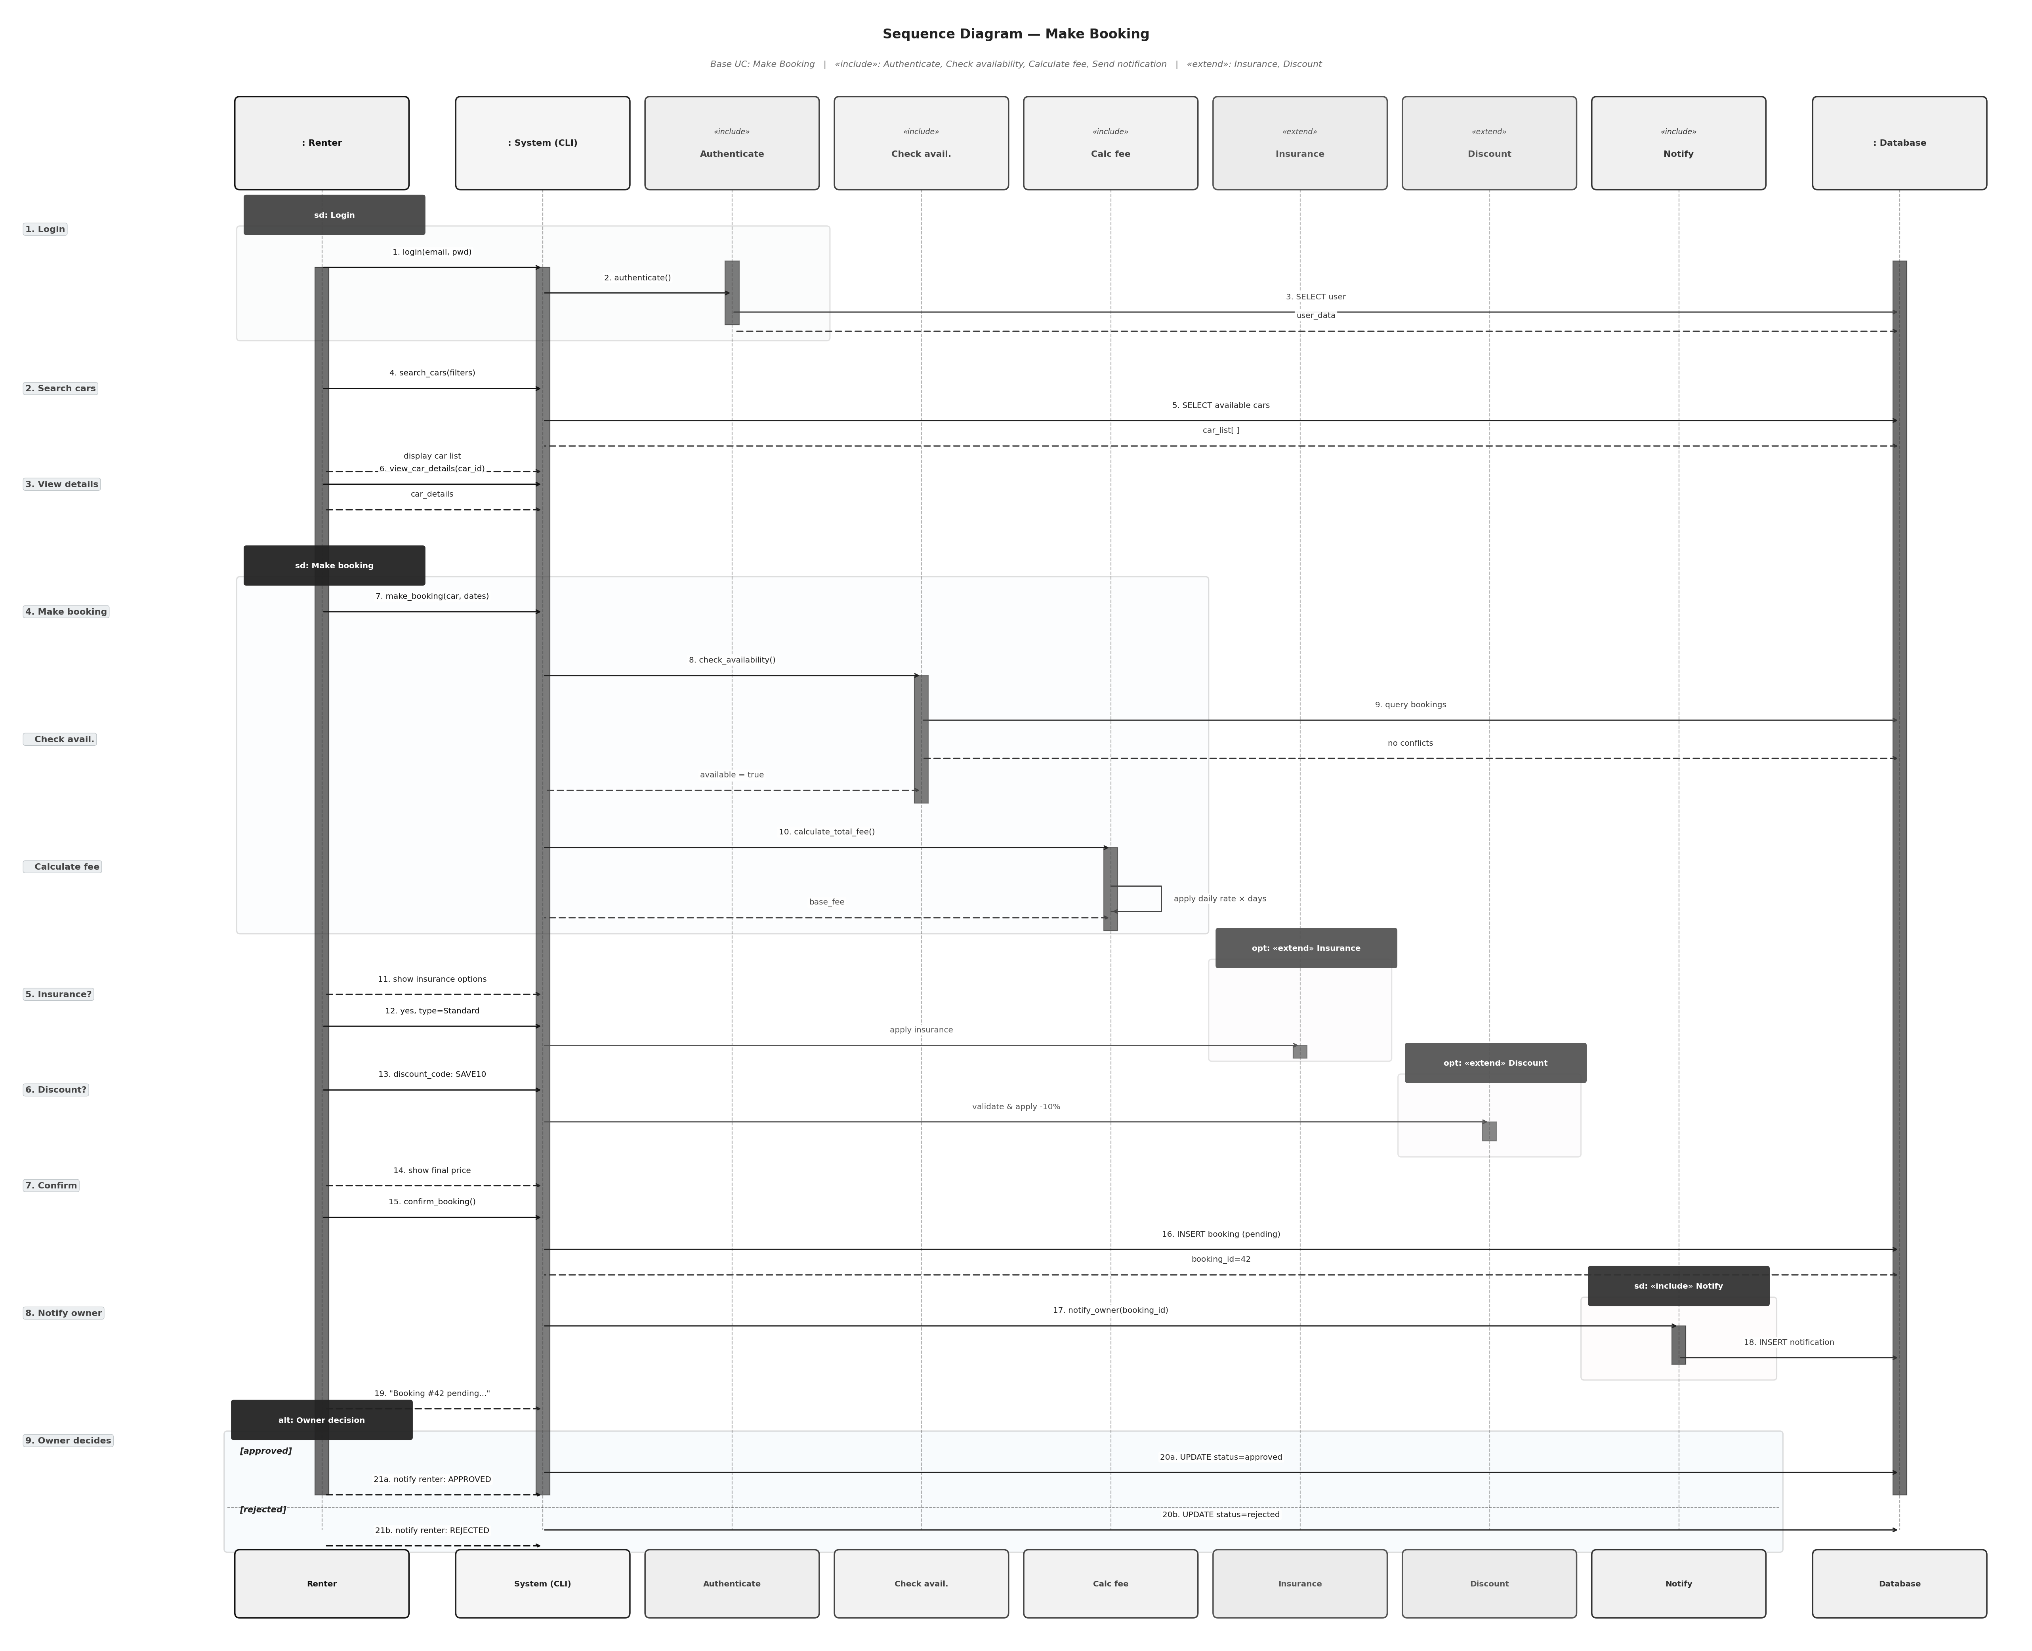
Figure 4: Sequence Diagram for the Make Booking use case

7.6 Activity Diagrams
Four activity diagrams show the step-by-step flow for the main use cases. Each uses decision nodes, fork and join bars for parallel steps, and start and end nodes.

Make booking
After a renter enters the dates for their booking, two steps run in parallel using a fork. The system checks if the car is available for those dates and calculates the total fee for the booking at the same time. The renter then has the option to add insurance or a discount code. If the renter confirms the booking, the details are saved.

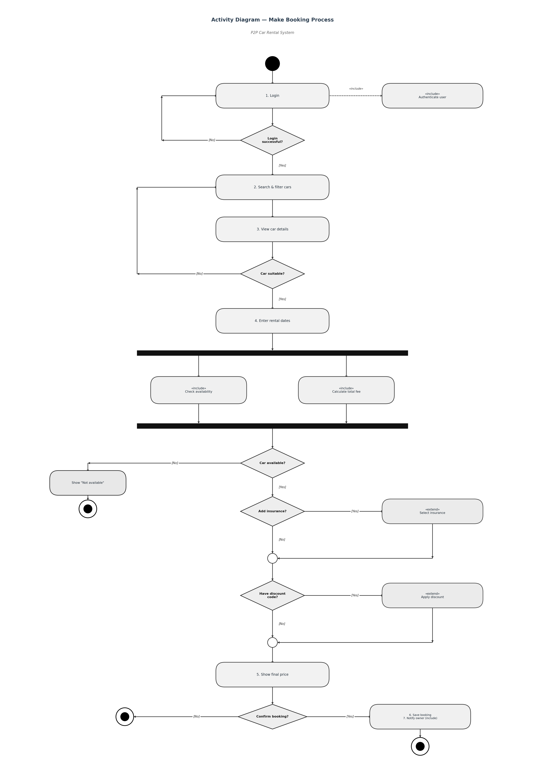
Figure 5: Activity Diagram for the Make Booking process

Add car listing
The diagram includes two separate swimlanes which separate Owner activities from Admin activities. The owner enters car details and submits the listing. The system stores the information under pending status while it sends an alert to the admin team. The admin team reviews the matter before they choose to approve or reject it. The system shows the car in search results after it receives approval.

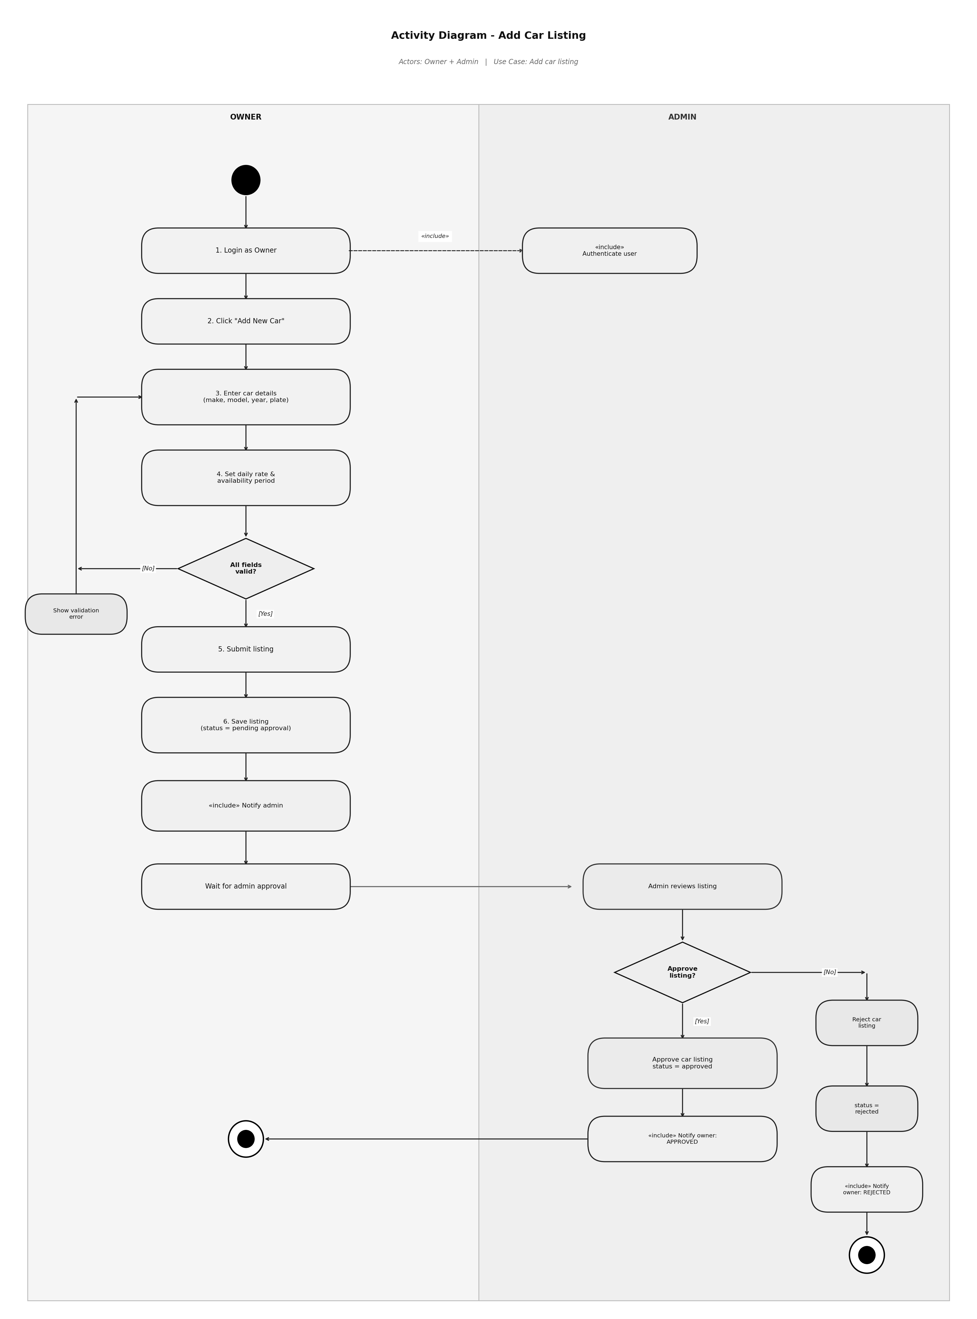
Figure 6: Activity Diagram for adding a car listing

Approve or reject booking
The owner logs into the application and views the pending booking requests. The owner checks the rating and booking history of the renter before making the decision. If the owner approves the booking, the status is updated to approved and the renter is notified. If the owner rejects the booking, the owner is asked for the reason for rejection and the status is updated to rejected.
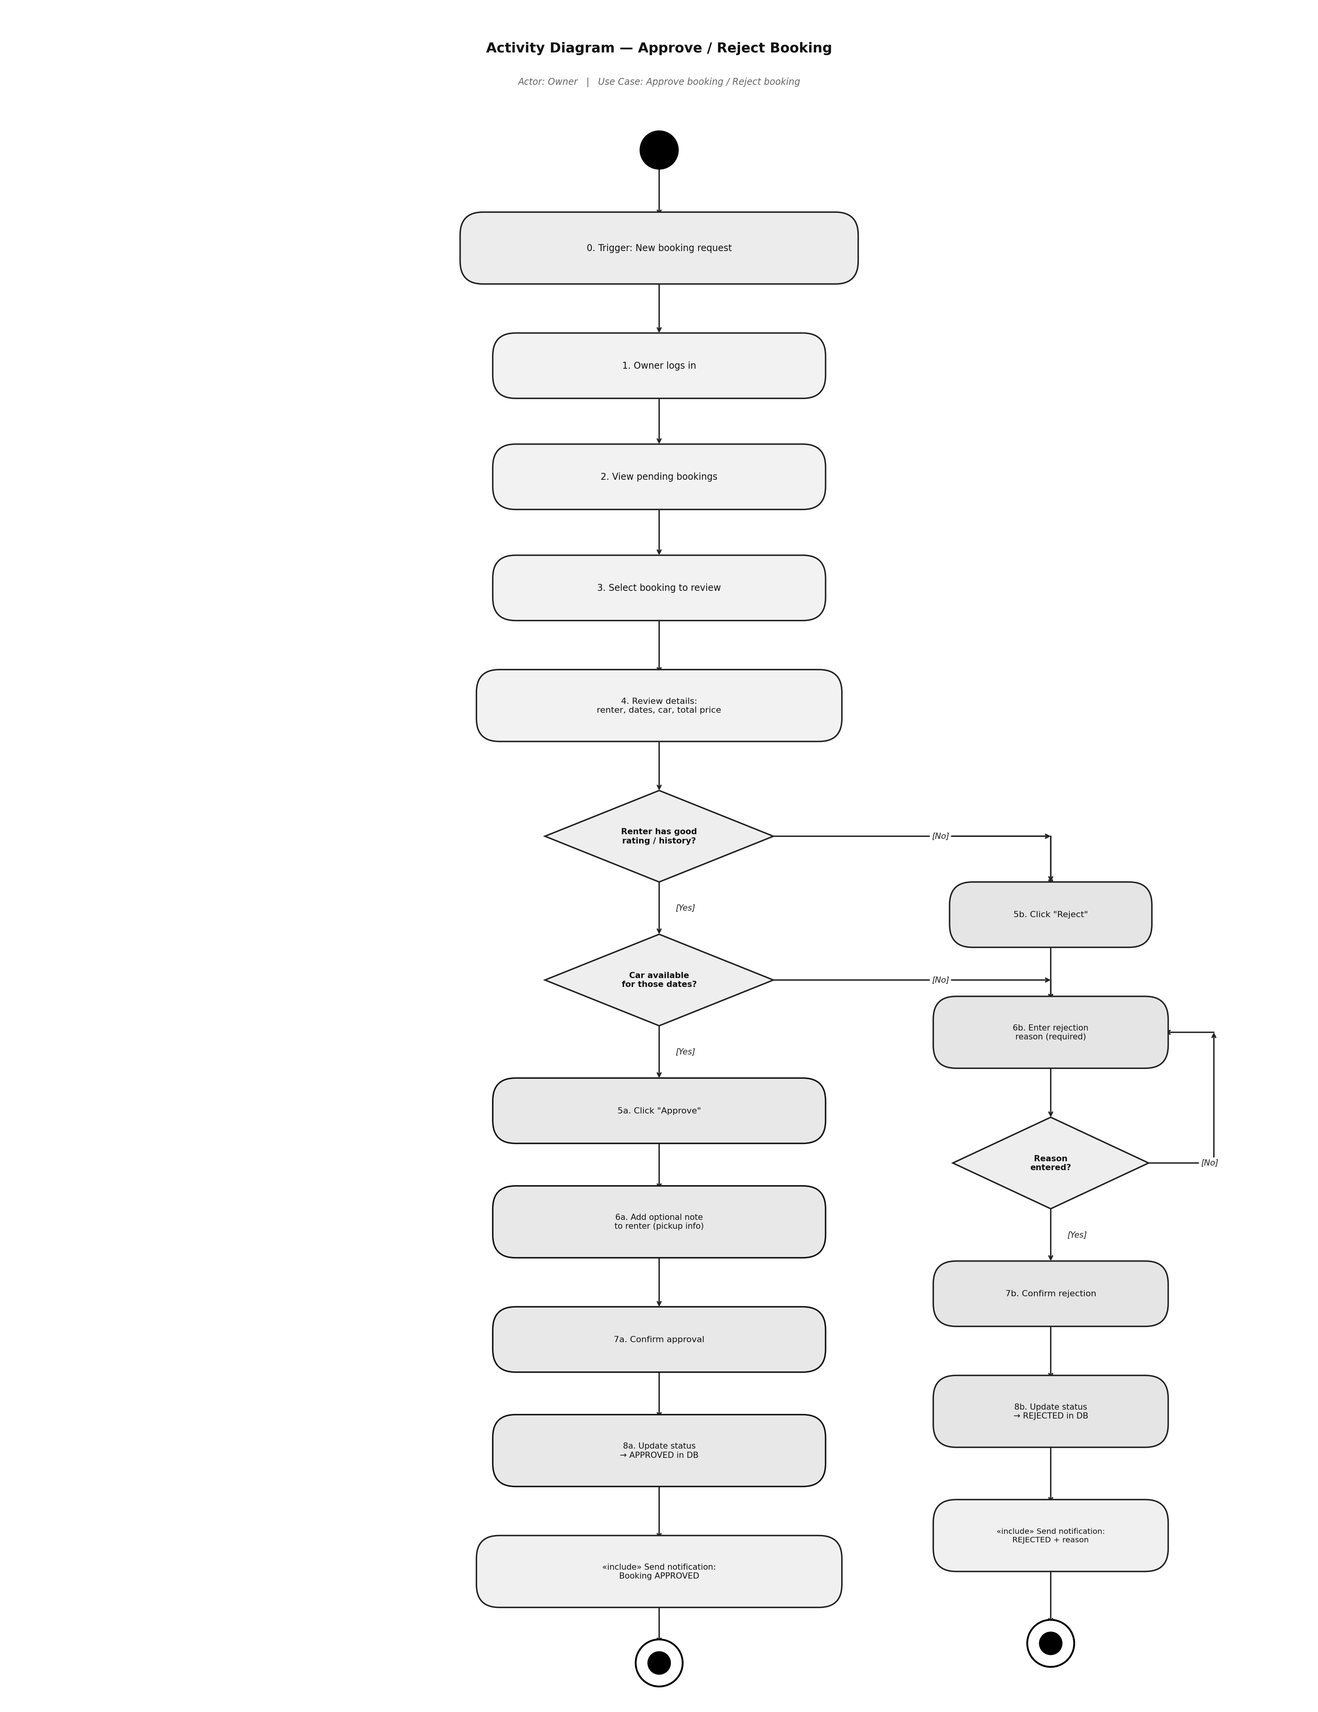
Figure 7: Activity Diagram for approving or rejecting a booking

Handle Insurance Claim
The diagram consists of three separate swimlanes which represent Owner and Admin and Renter functions. The owner files a claim after the rental. The evidence submission process requires both owners and renters to send their evidence at the same time through the fork system. The admin reviews all submitted evidence to make a decision between full claim approval or partial payment or complete claim deny.
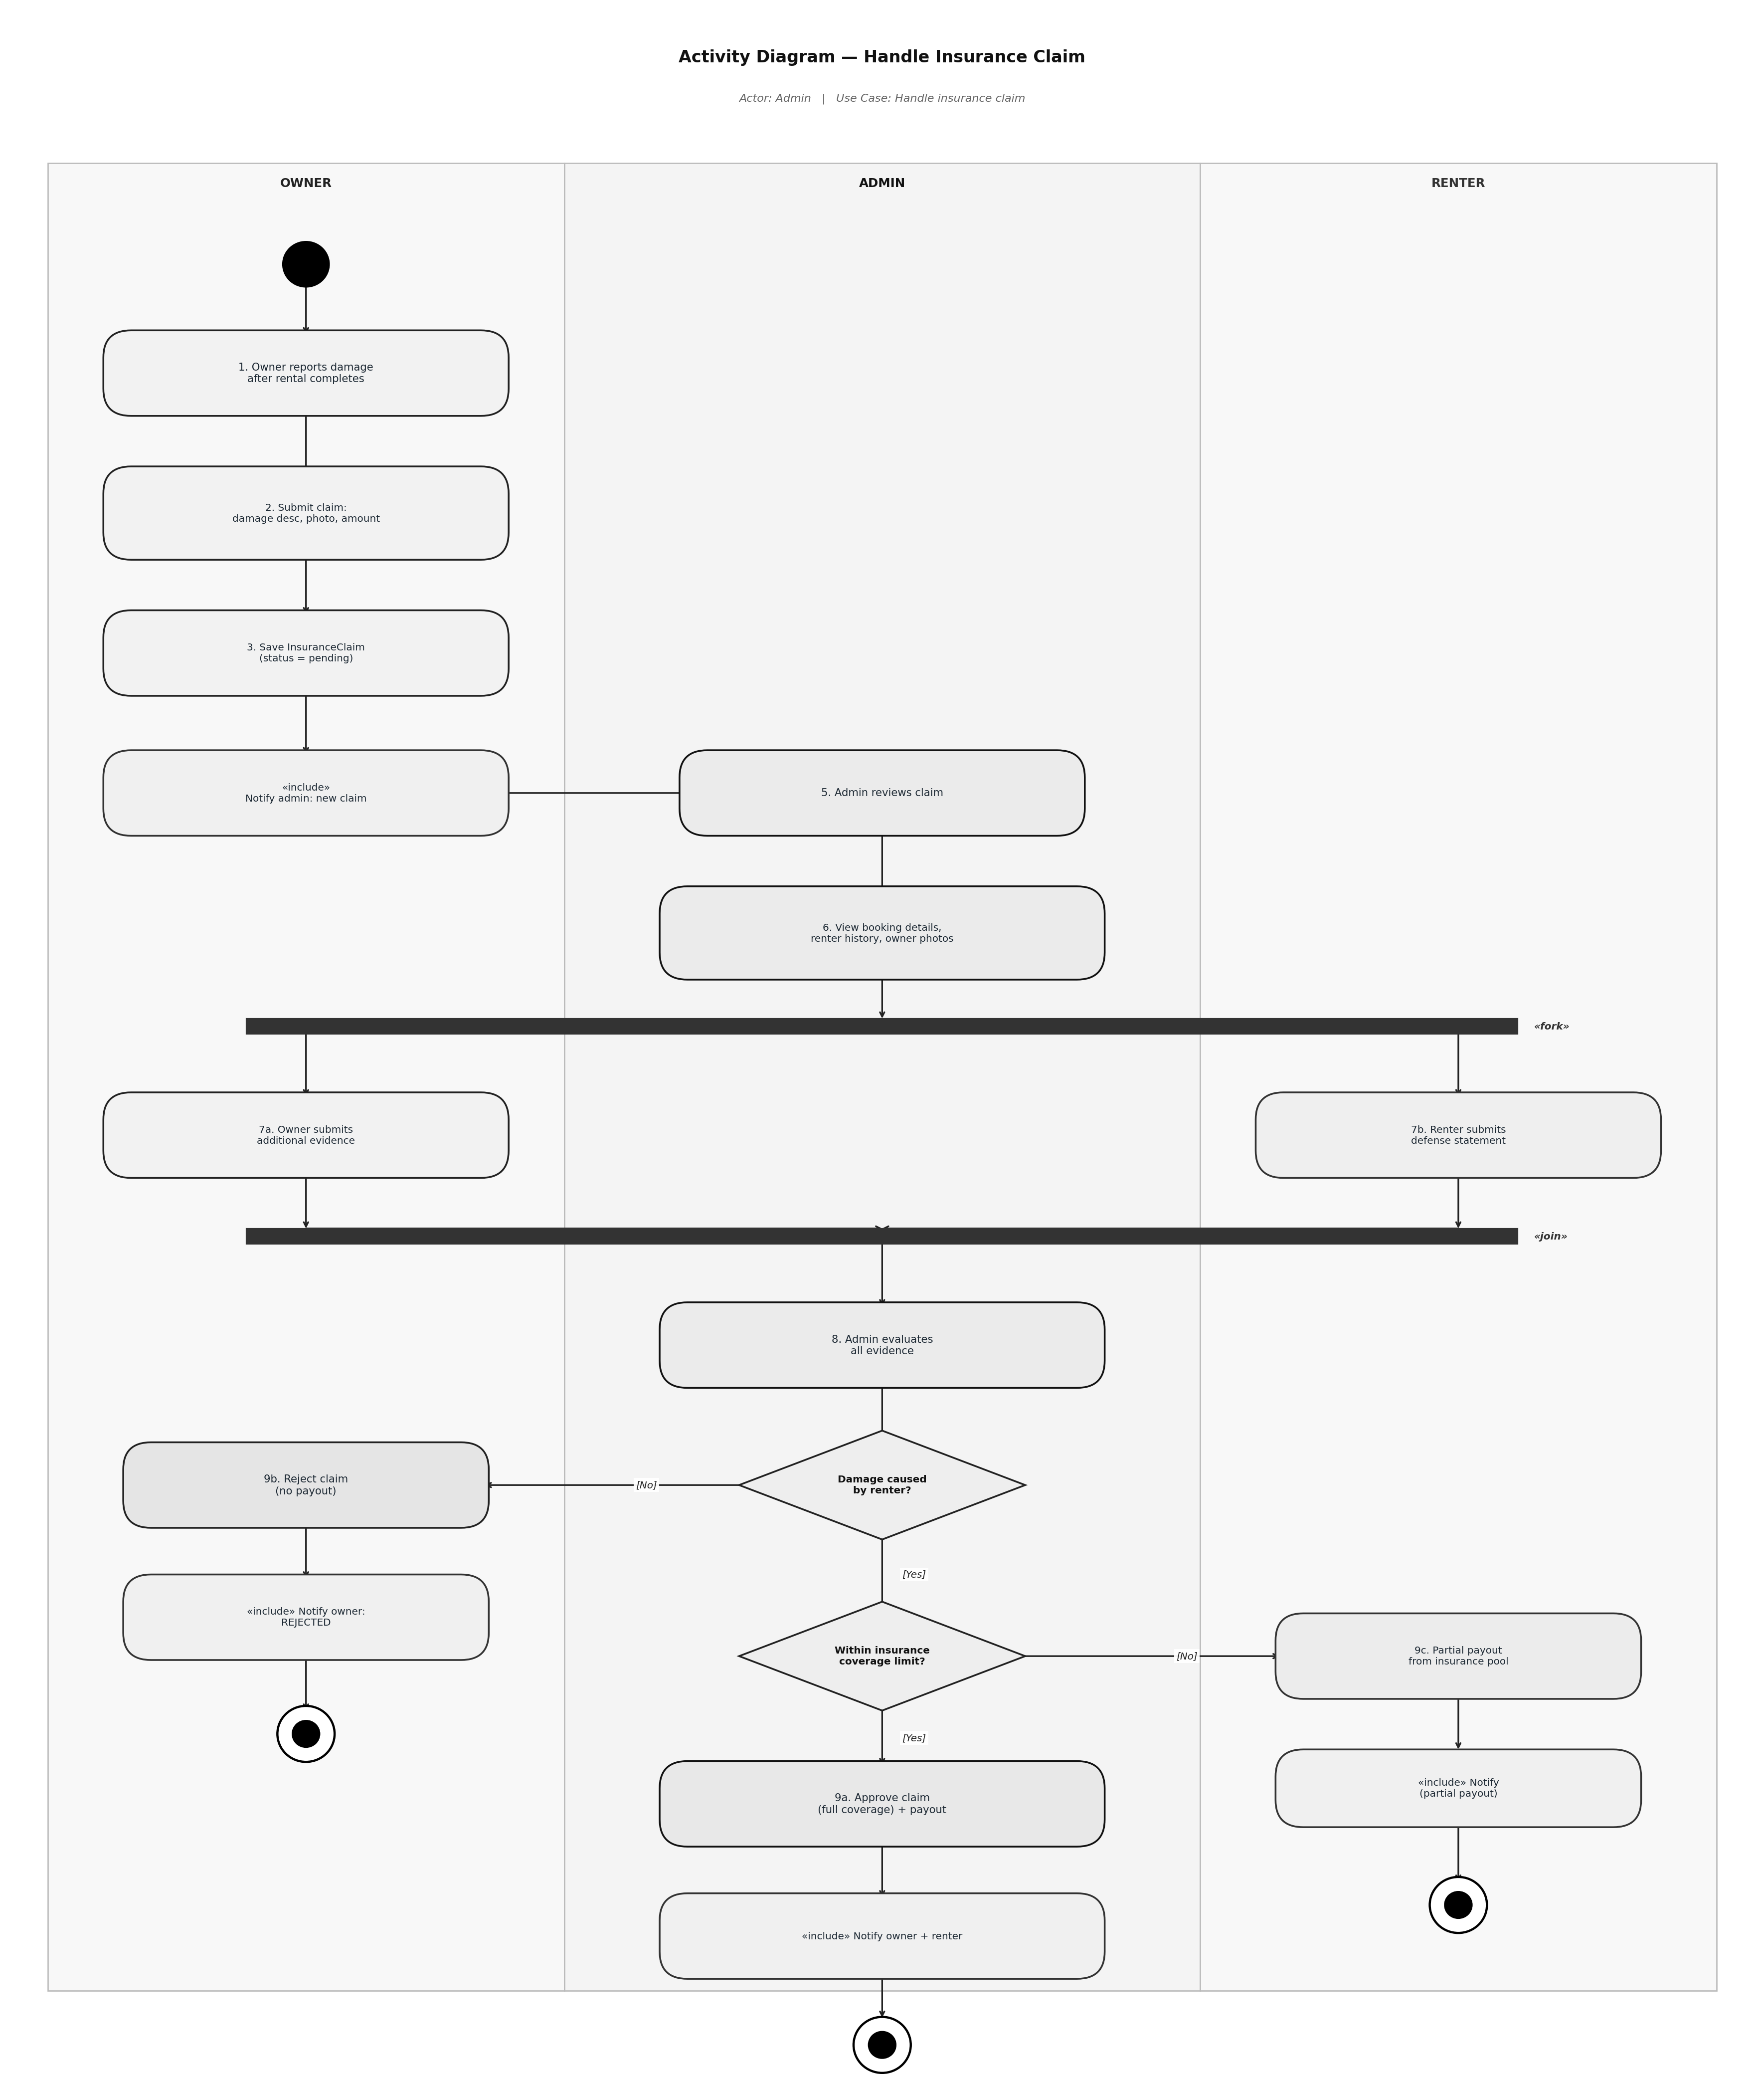
Figure 8: Activity Diagram for handling an insurance claim
8. Testing
The system was manually tested using integration tests, with each test checks one full feature from start to end and as in result all 15 test cases passed.

# | Action/scenario | Result
1 | Default admin account created on first run. | PASS
2 | Register with a duplicate email address. | PASS (rejected)
3 | Admin verifies a pending user. | PASS
4 | Owner adds a car and admin approves it. | PASS
5 | Renter searches by location and maximum price. | PASS
6 | Renter makes a 10-day booking with insurance and discount. | PASS
7 | Pricing is calculated correctly (see below). | PASS
8 | Date overlap detected. Conflicting booking rejected. | PASS
9 | Owner approves a booking. | PASS
10 | Renter submits a review with rating 1 to 5. | PASS
11 | Renter submits a rating outside 1 to 5. | PASS (rejected)
12 | Admin views platform statistics. | PASS
13 | Login with wrong password. | PASS (rejected)
14 | Renter cancels a booking before the start date. | PASS
15 | Renter tries to cancel a completed booking. | PASS (rejected)

Pricing verification
Toyota Camry, $60/day, 10 days, Standard insurance, SAVE10 code:

Step | Value
Base price (10 x $60.00) | $600.00
Long-term discount (7+ days = 10% off) | -$60.00
SAVE10 discount code (10% off) | -$54.00
Owner amount | $486.00
Platform fee (15% of owner amount) | +$72.90
Standard insurance ($10/day x 10 days) | +$100.00
Total paid by renter | $658.90

The system output matched this calculation exactly.

9. Maintenance and Support plan
After the release of the system, it must be maintained to confirm it continues to function correctly and address user’s needs. There are three main areas of maintenance discussed in this section including software maintenance, versioning, and backward compatibility.

Maintenance is one aspect of software development costs. Studies have shown that the cost of maintenance for software can be higher than the cost of development of the software (Haleem et al., 2025). Having a plan for software maintenance helps to manage these costs for the project from the beginning.

9.1 Software maintenance
The ISO/IEC/IEEE 14764 standard (ISO/IEC/IEEE, 2022) defines four types of software maintenance.

Type | Description | Example
Corrective | Fixing bugs found after release. | Fixing the date validation logic in the booking flow.
Adaptive | Updating for new environments. | Adding support for a new Python version.
Perfective | Improving or adding features. | Sorting car search results by rating.
Preventive | Reducing future problems. | Refactoring BookingService to lower complexity.

Issue Handling Process
- The user reports the issue through email or the issue tracker.
- The team assigns a severity level to the issue.
- A ticket is created detailing the issue and how to reproduce it.
- A developer is assigned to the ticket and creates a fix in a separate branch.
- A second developer reviews the code.
- All tests are run to ensure nothing is broken.
- The fix is merged and a new release is published.
- The changelog is updated.

Severity levels and response times
Severity | Example | Response time | Fix time
Critical | System is down or data is lost. | 1 hour | 4 hours
High | A main feature does not work. | 2 hours | 8 hours
Medium | Minor bug with a workaround. | 12 hours | 24 hours
Low | Visual issue or typo. | 3 days | Next release

Code quality tools
- Git: version control and every change is tracked.

These tools are recommended for future development:
- Pytest: unit and integration tests (docs.pytest.org/en/stable/)
- Black: consistent code formatting (black.readthedocs.io)
- Flake8: checking common Python mistakes (flake8.pycqa.org)
- GitHub Actions: automated testing on every commit (github.com/features/actions)

9.2 Versioning
The project uses Semantic Versioning 2.0.0 (Preston-Werner, 2013). Each version number has three parts: MAJOR.MINOR.PATCH.

Part | When to increase | Example
MAJOR | A change breaks backward compatibility. | v1.0.0 becomes v2.0.0
MINOR | New feature added. Old features still work. | v1.2.0 becomes v1.3.0
PATCH | Bug fixed. No features added or removed. | v1.2.3 becomes v1.2.4

Release schedule
Type | Frequency | Content
Patch (1.0.x) | As needed | Bug fixes only.
Minor (1.x.0) | Every 4 to 6 weeks | New features. No breaking changes.
Major (x.0.0) | Every 12 to 18 months | Large changes. May break old behavior.

Git tags and changelog
Every release is tagged in Git. A CHANGELOG.md file records all changes following the Keep a Changelog standard (Oliver, 2017). Each entry has four sections: Added, Changed, Fixed, and Removed.

git tag -a v1.0.0 -m "Initial release"
git push origin v1.0.0

9.3 Backward compatibility
Backward compatibility means new versions can still work with data from older versions.

Type | Description | Example
Data compatibility | New code can read old database files. | A v1.0 database still works in v1.5 after migration.
API compatibility | Old function names and parameters still work. | register(name, email) works the same in v2.0.
User experience | Menu structure stays similar between versions. | Existing users do not need to relearn the system.

Database migrations
When the database schema changes, a migration script will update the old database without deleting any data. These scripts are numbered and stored within the database/migrations/ directory. Each script uses the command ALTER TABLE ... ADD COLUMN IF NOT EXISTS to allow the script to be run more than once without causing any issues to the database.

Deprecation lifecycle
Stage | What happens | Duration
1. Announce | Users are told the feature will be removed. | 6 months before removal
2. Coexist | Old and new features both work. Old one shows a warning. | 3 to 6 months
3. Remove | Old feature is removed from the code. | In the next major version

Future roadmap
Version | Target | Planned changes
v1.0.0 | Current | Initial release with all core features.
v1.1.0 | Q3 2026 | Email notifications via SMTP.
v1.2.0 | Q4 2026 | Loyalty points and tier discounts.
v1.3.0 | Q1 2027 | Multi-language support.
v2.0.0 | Q2 2027 | PostgreSQL backend and REST API.
v2.1.0 | Q3 2027 | Mobile app (React Native).
v2.2.0 | Q4 2027 | Stripe payment integration.
v3.0.0 | Q2 2028 | Smart matching with machine learning.

10. Conclusion
This project brought together OOP principles, design patterns, and architectures can be implemented into a single Python application.

All of the main OOP principles are demonstrated within the project. Data encapsulation is used to protect the data within each of the model classes. Inheritance is used to create a clean user hierarchy for the application. Abstraction hides the implementation details of the application behind interfaces. Polymorphism allows for the application to handle the different user roles and insurance types without the use of additional conditional statements.

Three design patterns are implemented within the project to solve various problems. The Singleton design pattern is used to control access to the database. The Factory design pattern removes the need to repeat the logic for creating users for the application. The Strategy design pattern makes it easy to add new insurance pricing algorithms for the application.

The application uses a 4-layer software architecture to keep the code organized. Each layer of the architecture has a specific job and does not depend upon the layers above it in the architecture. The application supports three different environments through a single configuration file. Eight UML diagrams are included to document the application’s structure, behavior, and process flows. The maintenance plan for the application covers all four types of software maintenance, semantic versioning, backward compatibility, and includes a 24-month development roadmap for the application.

11. References

Haleem, M., Islam, M., Ahmed, M. N., Farooqui, N. A., Khan, A. N., Hussain, M. R., Ahmed, J. S., Ahmed, M. M., and Khan, I. M. (2025). A Critical Review for Software Maintenance Cost Estimation Models: A Data Driven Approach. IEEE Access. https://doi.org/10.1109/ACCESS.2025.3618759

ISO/IEC/IEEE (2022). ISO/IEC/IEEE 14764:2022 Software Engineering: Software Life Cycle Processes - Maintenance (Edition 3). International Organization for Standardization. https://www.iso.org/obp/ui/en/#iso:std:iso-iec-ieee:14764:ed-3:v1:en

Oliver, O. (2017). Keep a Changelog 1.0.0. https://keepachangelog.com/

Preston-Werner, T. (2013). Semantic Versioning 2.0.0. https://semver.org/

Appendix: Default credentials
On the first run, the system creates a default admin account automatically.

Field | Value
Email | admin@p2p.com
Password | admin123
Role | Admin

