YOOBEE COLLEGE OF CREATIVE INNOVATION

Master of Software Engineering
Professional Software Engineering - MSE800

Assessment 1: Object-Oriented Programming

Final Report
P2P Car Rental System

Lecturer: Dr. Mohammad Norouzifard

Student Name: Batbold Chuluunbaatar
Student ID: 270894331
Date: 24 May 2026

Abstract
The P2P Car Rental System is a command-line application written in Python. It connects car owners with renters. Three user types exist: Owner, Renter, and Admin. Each has a separate menu. The platform takes a 15% fee on each booking.

The system applies all four OOP principles: encapsulation, inheritance, abstraction, and polymorphism. Three design patterns are used: Singleton, Factory, and Strategy. Data is stored in an SQLite database. The project includes 8 UML diagrams and a maintenance plan.

Keywords: Object-Oriented Programming, Python, SQLite, Design Patterns, UML, Singleton, Factory, Strategy, CLI.

Table of Contents
1. Introduction 5
2. System Requirements 6
3. Installation and Configuration 7
4. User Guide 9
4.5 Discount Codes 11
5. Project Structure 12
6. Design Patterns 12
6.1 Singleton: DatabaseManager 12
6.2 Factory: UserFactory 13
6.3 Strategy: InsuranceStrategy 13
7. System Design and Architecture 15
7.1 Architecture Overview 15
7.2 Entity Relationship Diagram 15
7.3 Use Case Diagram 17
7.4 Class Diagram 18
7.5 Sequence Diagram: Make Booking 20
7.6 Activity Diagrams 21
8. Testing 25
9. Maintenance and Support Plan 27
9.1 Software Maintenance 27
9.2 Versioning 30
9.3 Backward Compatibility 32
9.4 Future Roadmap 34
10. Conclusion 35
11. References 36
Appendix: Default Credentials 37

1. Introduction
This document describes the P2P Car Rental System. The system is a command-line application built in Python. It lets car owners list their vehicles and renters search and book them. An admin manages user verification and car approvals.

The P2P model means the platform does not own any cars. It connects private owners with renters. Owners earn money from cars they do not use every day. Renters get more choices, often at lower prices than traditional rental companies.

1.1 Problem Statement
A P2P platform needs to handle several problems at once.
- Trust: the platform needs to verify that users are real people before they can transact.
- Quality: car listings need to be reviewed before they appear in search results.
- Booking: dates, pricing, and approvals all need to work together correctly.
- Damage: when a car is damaged, the platform needs a clear process for handling the claim.
- Reviews: users need a way to rate each other after a completed rental.

1.2 Objectives
Objective | How it is achieved
OOP principles | Abstract User class with Owner, Renter, and Admin subclasses. Protected attributes with @property access. Polymorphic dashboard method.
Design patterns | Singleton for the database. Factory for user creation. Strategy for insurance pricing.
Layered architecture | Four layers: Presentation, Service, Model, and Data Access. Each layer communicates only with the one below it.
Environment support | config.py reads APP_ENV and switches between dev, test, and prod settings.
Documentation | 8 UML diagrams: ERD, Use Case, Class, Sequence, and 4 Activity diagrams.

2. System Requirements

2.1 Software Requirements
Software | Version | Purpose
Python | 3.8 or higher | Main programming language.
SQLite | Built into Python | Database. No separate installation needed.
tabulate | 0.9.0 | Prints formatted tables in the CLI.
colorama | 0.4.6 | Adds color to CLI output.

No separate database server is needed. SQLite saves all data in one file: database/car_rental.db. The file is created automatically on the first run.

2.2 Hardware Requirements
Component | Minimum
CPU | 1 GHz or faster
RAM | 512 MB
Disk space | 50 MB free
Display | 80-column terminal or wider

3. Installation and Configuration

3.1 Installation
Follow these steps in order.

Step 1: Extract the project files
Extract p2p_car_rental.zip to any folder. Open a terminal and navigate to that folder.

Step 2: Create and activate a virtual environment
python -m venv venv
On Windows:
venv\Scripts\activate
On macOS or Linux:
source venv/bin/activate

Step 3: Install dependencies
pip install -r requirements.txt

Step 4: Run the application
python main.py
On the first run, the system creates the database, sets up all tables, creates the default admin account, and shows the main menu.

3.2 Configuration
All settings are in config.py. The APP_ENV variable selects the environment. If not set, dev is used.

Environment | Database | Purpose
dev (default) | database/car_rental.db | Development. Data is saved between runs.
test | :memory: | Testing. Data is deleted when the app closes.
prod | database/car_rental_prod.db | Production use.

To switch environment:
APP_ENV=test python main.py

3.3 Key Configuration Values
Constant | Default | Description
PLATFORM_FEE_PERCENT | 15% | Commission on each booking.
LONG_TERM_DISCOUNTS | 7d=10%, 30d=20% | Discount tiers for longer rentals.
DISCOUNT_CODES | SAVE10, WELCOME20, SUMMER15 | Available discount codes.
DEFAULT_ADMIN_EMAIL | admin@p2p.com | Auto-created admin login.

4. User Guide
The system has three roles. Each role has its own menu. To test all features, follow this order:

Step | Action | Role
1 | Login as admin (admin@p2p.com / admin123). | Admin
2 | Register a new owner account, then log out. | Anonymous
3 | Register a new renter account, then log out. | Anonymous
4 | Login as admin and verify both users. | Admin
5 | Login as owner and add a car listing. | Owner
6 | Login as admin and approve the car. | Admin
7 | Login as renter, search for cars, and make a booking. | Renter
8 | Login as owner and approve the booking. | Owner
9 | Login as renter and submit a review. | Renter

4.1 Owner Features
- Add car listing: enter make, model, year, mileage, location, and daily rate. The listing waits for admin approval.
- Manage bookings: view pending requests and approve or reject each one.
- View earnings: see total income from completed bookings.

4.2 Renter Features
- Search cars: filter by location and maximum daily price.
- Make booking: choose dates, select insurance, and enter a discount code. The system validates dates before confirming.
- Cancel booking: allowed before the rental start date.
- Submit review: rate the owner from 1 to 5 stars after the rental ends.

4.3 Admin Features
- Verify users: check that new registrations are real people (KYC).
- Approve cars: review and approve or reject new car listings.
- Handle claims: review insurance claims and decide to approve, partially pay, or reject.
- View reports: see total users, cars, bookings, and platform revenue.
- Suspend users: remove verification from users who break the rules.

4.4 Pricing
- Base price = daily rate x number of days
- Long-term discount: 7 or more days = 10% off. 30 or more days = 20% off.
- Discount code: optional extra percentage off.
- Platform fee = 15% of the owner amount.
- Insurance fee = daily insurance rate x number of days (optional).

Insurance Option | Daily Fee | Coverage
None | $0.00 | No coverage. Renter accepts all risk.
Basic | $5.00 | $2,000 coverage for minor damage.
Standard | $10.00 | $5,000 coverage.
Premium | $15.00 | Full coverage.

4.5 Discount Codes
Discount codes can be entered during the booking process. They apply a percentage off the base price after the long-term discount is applied.

Code | Discount
SAVE10 | 10% off the base price
WELCOME20 | 20% off the base price
SUMMER15 | 15% off the base price

5. Project Structure
The project uses a 4-layer architecture. Each folder has one responsibility.

Folder / File | Layer | Responsibility
main.py | Entry point | Initializes the database and starts the main menu.
config.py | Configuration | All settings. Reads APP_ENV to switch environments.
database/db_manager.py | Data Access | Singleton database manager. Runs all SQL queries.
models/ | Model | OOP entities: User (abstract), Owner, Renter, Admin, Car, Booking, Review.
factories/user_factory.py | Model | Creates the correct User subclass from a role string.
patterns/insurance_strategy.py | Model | Strategy pattern. Four insurance classes sharing one interface.
services/ | Service | Business logic: AuthService, CarService, BookingService, AdminService, ReviewService.
ui/ | Presentation | CLI menus: main_menu, owner_menu, renter_menu, admin_menu.
utils/ | Helper | security.py (password hashing), validators.py, helpers.py (display functions).

6. Design Patterns
The system uses three design patterns from the Gang of Four catalog (Gamma, Helm, Johnson, and Vlissides, 1994). Each one was chosen because it solves a specific problem in the code.

6.1 Singleton: DatabaseManager
If different parts of the code each open their own database connection, memory is wasted and write conflicts can occur. The DatabaseManager solves this by overriding __new__. Every call to DatabaseManager() returns the same object. Only one connection is ever created.

class DatabaseManager:
_instance = None
def __new__(cls):
if cls._instance is None:
cls._instance = super().__new__(cls)
cls._instance._initialize()
return cls._instance

All parts of the application share this one connection. The database tables are also created only once, when the connection is first opened.

6.2 Factory: UserFactory
When a user logs in, the system needs to create an Owner, Renter, or Admin object depending on the role stored in the database. UserFactory puts all creation logic in one place. The factory also has a from_db_row() method that creates a user object directly from a database row.

class UserFactory:
@staticmethod
def create(role, user_id, name, email, ...):
if role == "owner":
return Owner(user_id, name, email, ...)
elif role == "renter":
return Renter(user_id, name, email, ...)
elif role == "admin":
return Admin(user_id, name, email, ...)

6.3 Strategy: InsuranceStrategy
The system offers four insurance options. Each has a different daily fee and coverage limit. The Strategy pattern lets each plan be a separate class. The BookingService calls insurance.calculate_fee(days) without knowing which plan is active. To add a new plan, only a new subclass is needed.

class InsuranceStrategy(ABC):
@property
@abstractmethod
def daily_fee(self) -> float: pass

@abstractmethod
def calculate_fee(self, days: int) -> float: pass

class BasicInsurance(InsuranceStrategy):
daily_fee = 5.0 # $2,000 coverage

class StandardInsurance(InsuranceStrategy):
daily_fee = 10.0 # $5,000 coverage

class PremiumInsurance(InsuranceStrategy):
daily_fee = 15.0 # Full coverage

6.4 Pattern Summary
Pattern | Problem solved | File
Singleton | One database connection shared across the whole app. | database/db_manager.py
Factory | Create the right User subclass from a role string. | factories/user_factory.py
Strategy | Swap insurance pricing at runtime without changing the booking logic. | patterns/insurance_strategy.py

7. System Design and Architecture

7.1 Architecture Overview
The system uses a 4-layer architecture. Layers only communicate with the layer directly below them.

Layer | Folder | Responsibility
1. Presentation | ui/ | CLI menus for each user role.
2. Service | services/ | Business logic: booking, auth, admin operations.
3. Model | models/ | OOP entities: User, Car, Booking, Review.
4. Data Access | database/ | SQLite connection and all SQL queries.

7.2 Entity Relationship Diagram
The database has five tables: USERS, CARS, BOOKINGS, REVIEWS, and INSURANCE_CLAIMS. The USERS table stores all three user types using a role column. The owner_id in BOOKINGS is stored directly for faster queries. The discount_code and discount_amount are stored in BOOKINGS for audit purposes. All status columns use CHECK constraints to prevent invalid values at the database level.

Table | Primary Key | Foreign Keys | Key Constraints
USERS | id | none | email UNIQUE, role CHECK (owner/renter/admin)
CARS | id | owner_id -> USERS | is_approved BOOL, daily_rate REAL
BOOKINGS | id | car_id, renter_id, owner_id | status CHECK (5 values), discount_code, discount_amount
REVIEWS | id | booking_id, reviewer_id, reviewee_id | rating CHECK (1-5)
INSURANCE_CLAIMS | id | booking_id | status CHECK (pending/approved/rejected)

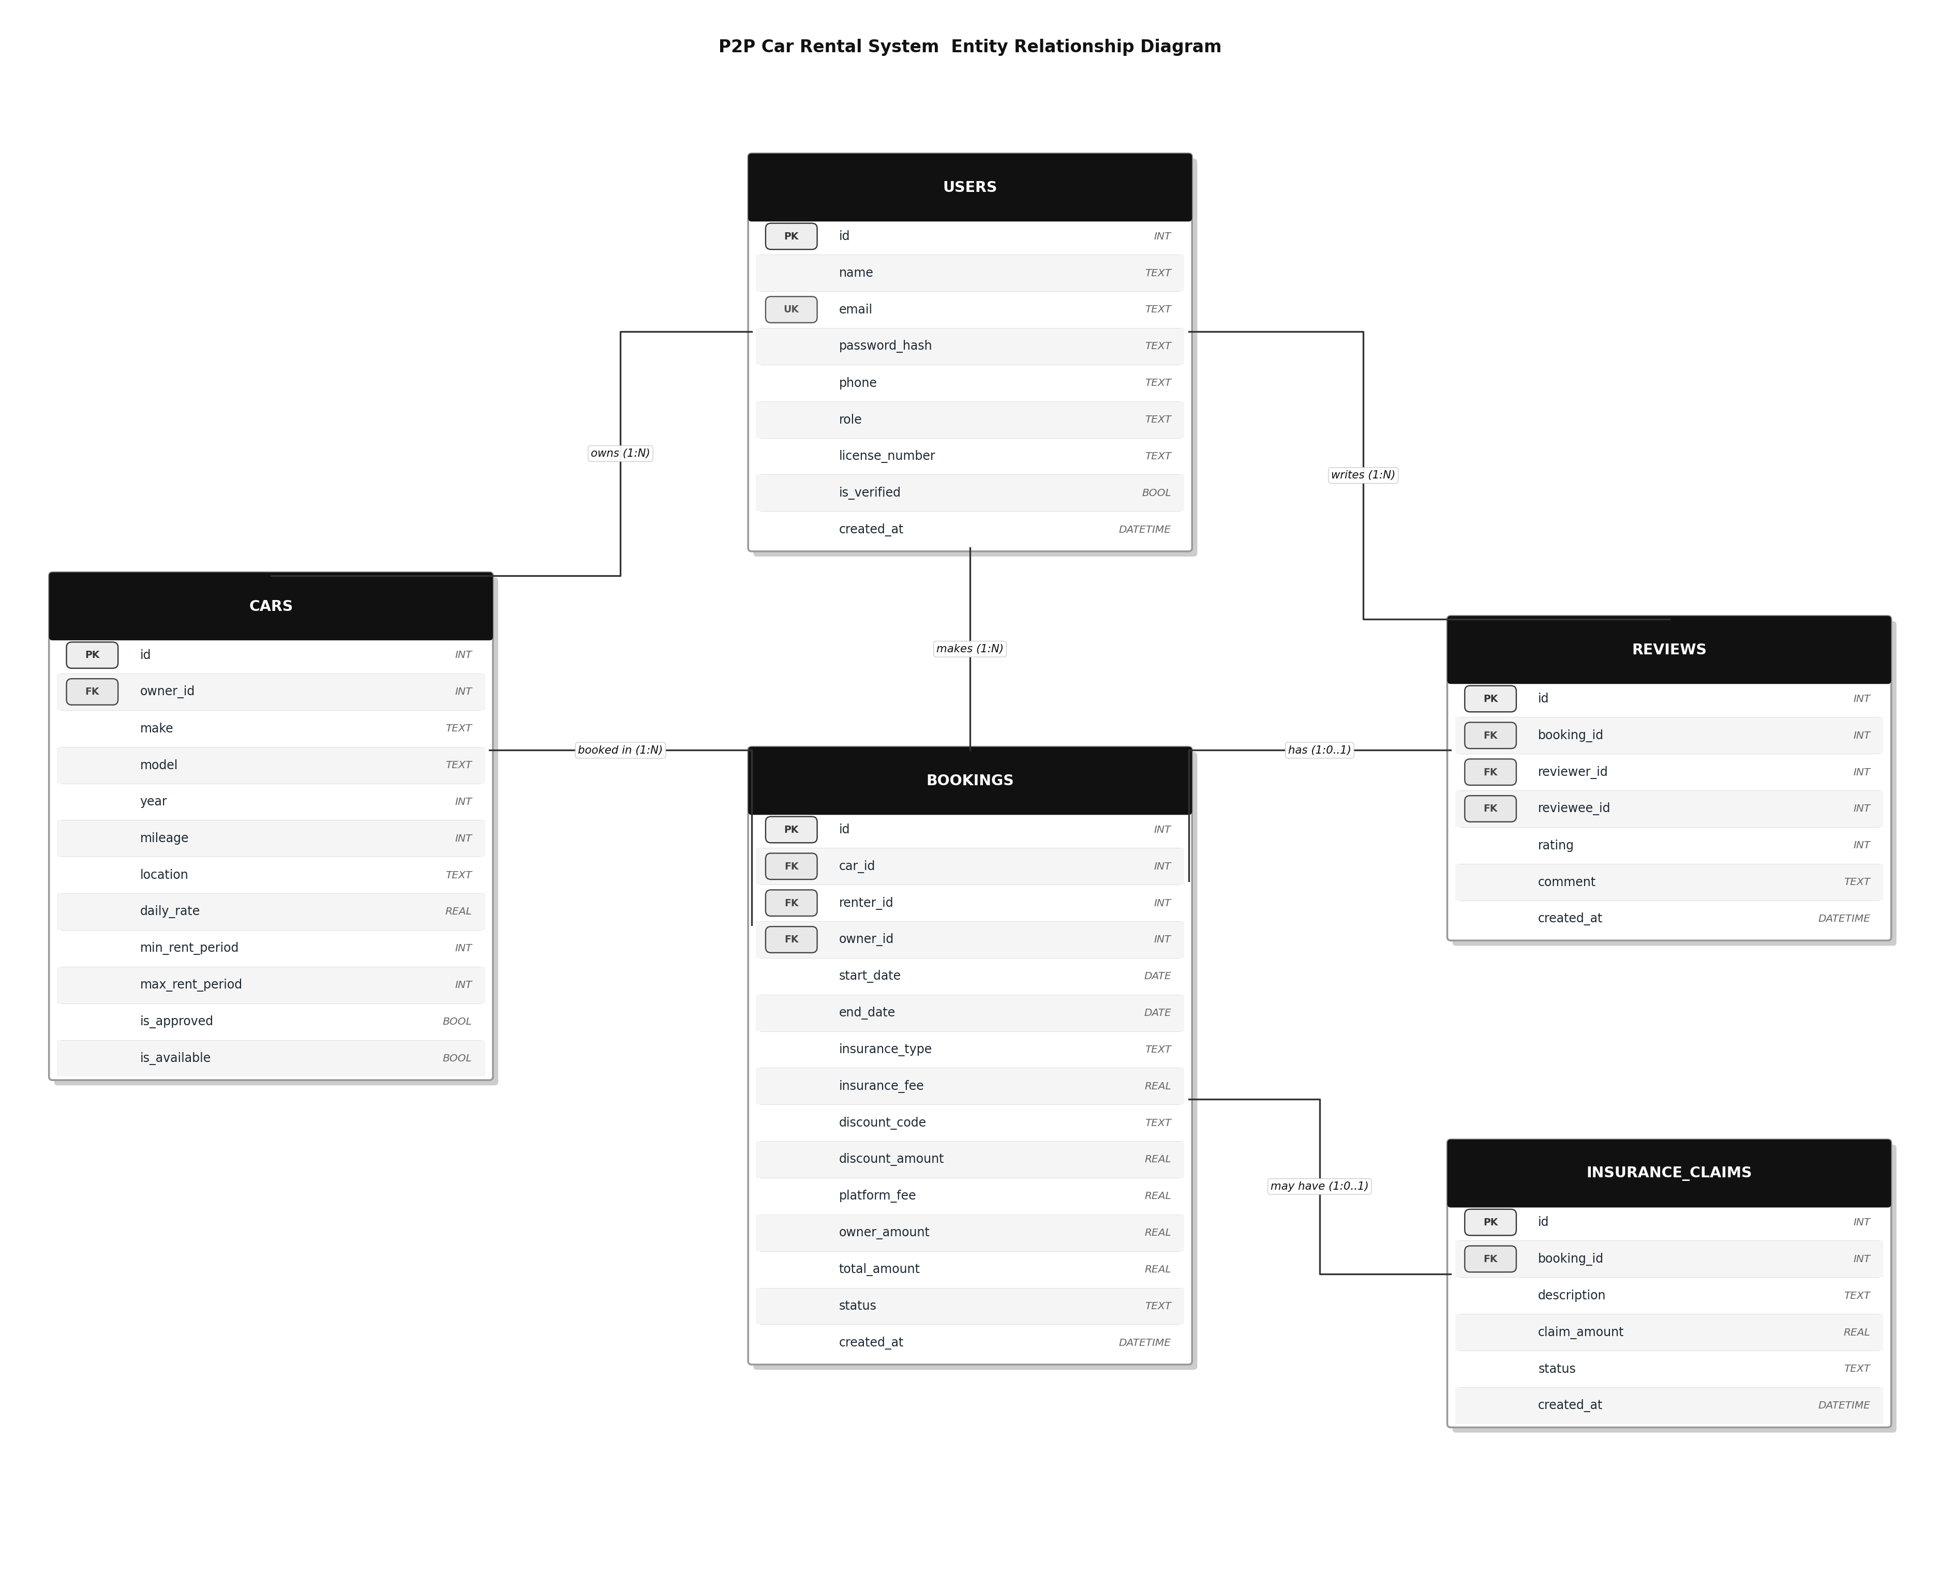
Figure 1: ERD with 5 tables, 8 foreign keys, and 1 unique key

7.3 Use Case Diagram
The system has three actors: Owner, Renter, and Admin. Together they cover 19 use cases. Two relationship types are used.

- "include": a mandatory step that always runs. "Make booking" always includes "Check availability" and "Calculate total fee".
- "extend": an optional step. "Make booking" can extend with "Select insurance" or "Apply discount code".

Actor | Use Cases
Owner | Register/login, add car listing, remove car listing, approve booking, reject booking, view earnings.
Renter | Register/login, search and filter cars, view car details, make booking, cancel booking, submit review.
Admin | Verify user KYC, approve car listing, reject car listing, view all bookings, handle insurance claim, view reports, suspend user.

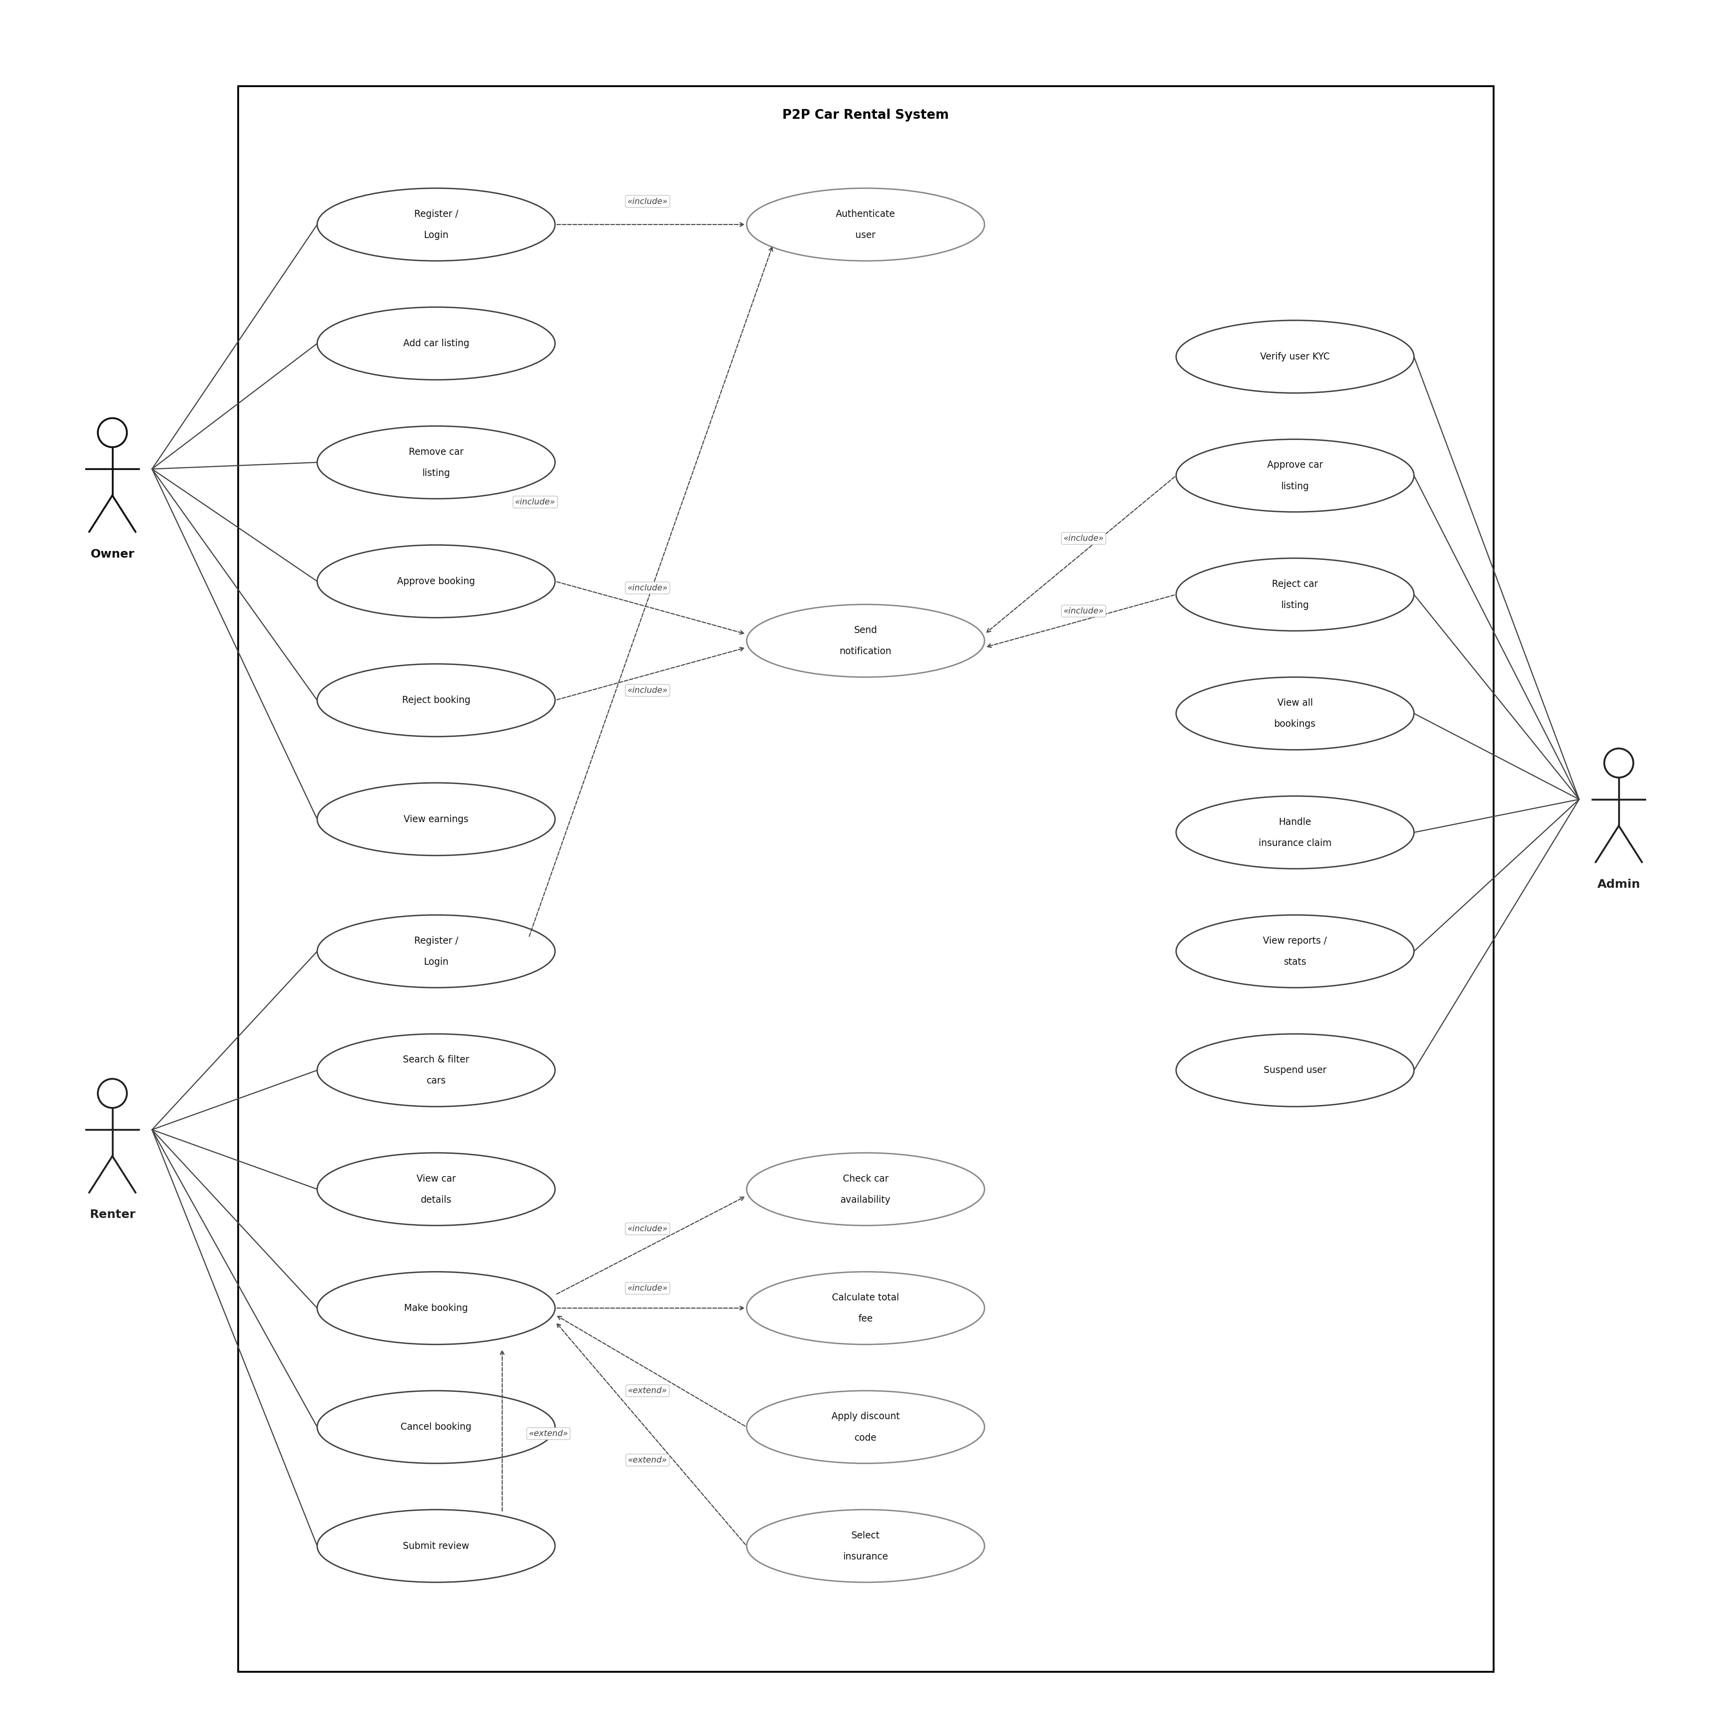
Figure 2: Use Case Diagram with 3 actors and 19 use cases

7.4 Class Diagram
The User class is abstract. It uses abc.ABC and defines view_dashboard() as an abstract method. Owner, Renter, and Admin each inherit from User and provide their own version of this method.

Principle | How it is applied
Encapsulation | All attributes use a single underscore prefix (_id, _name). They are accessed only through @property methods.
Abstraction | User and InsuranceStrategy are abstract base classes. They define the interface but not the implementation.
Inheritance | Owner, Renter, and Admin inherit all attributes and methods from User.
Polymorphism | view_dashboard() is defined once in User but works differently for each subclass. The main menu calls it without knowing the role.

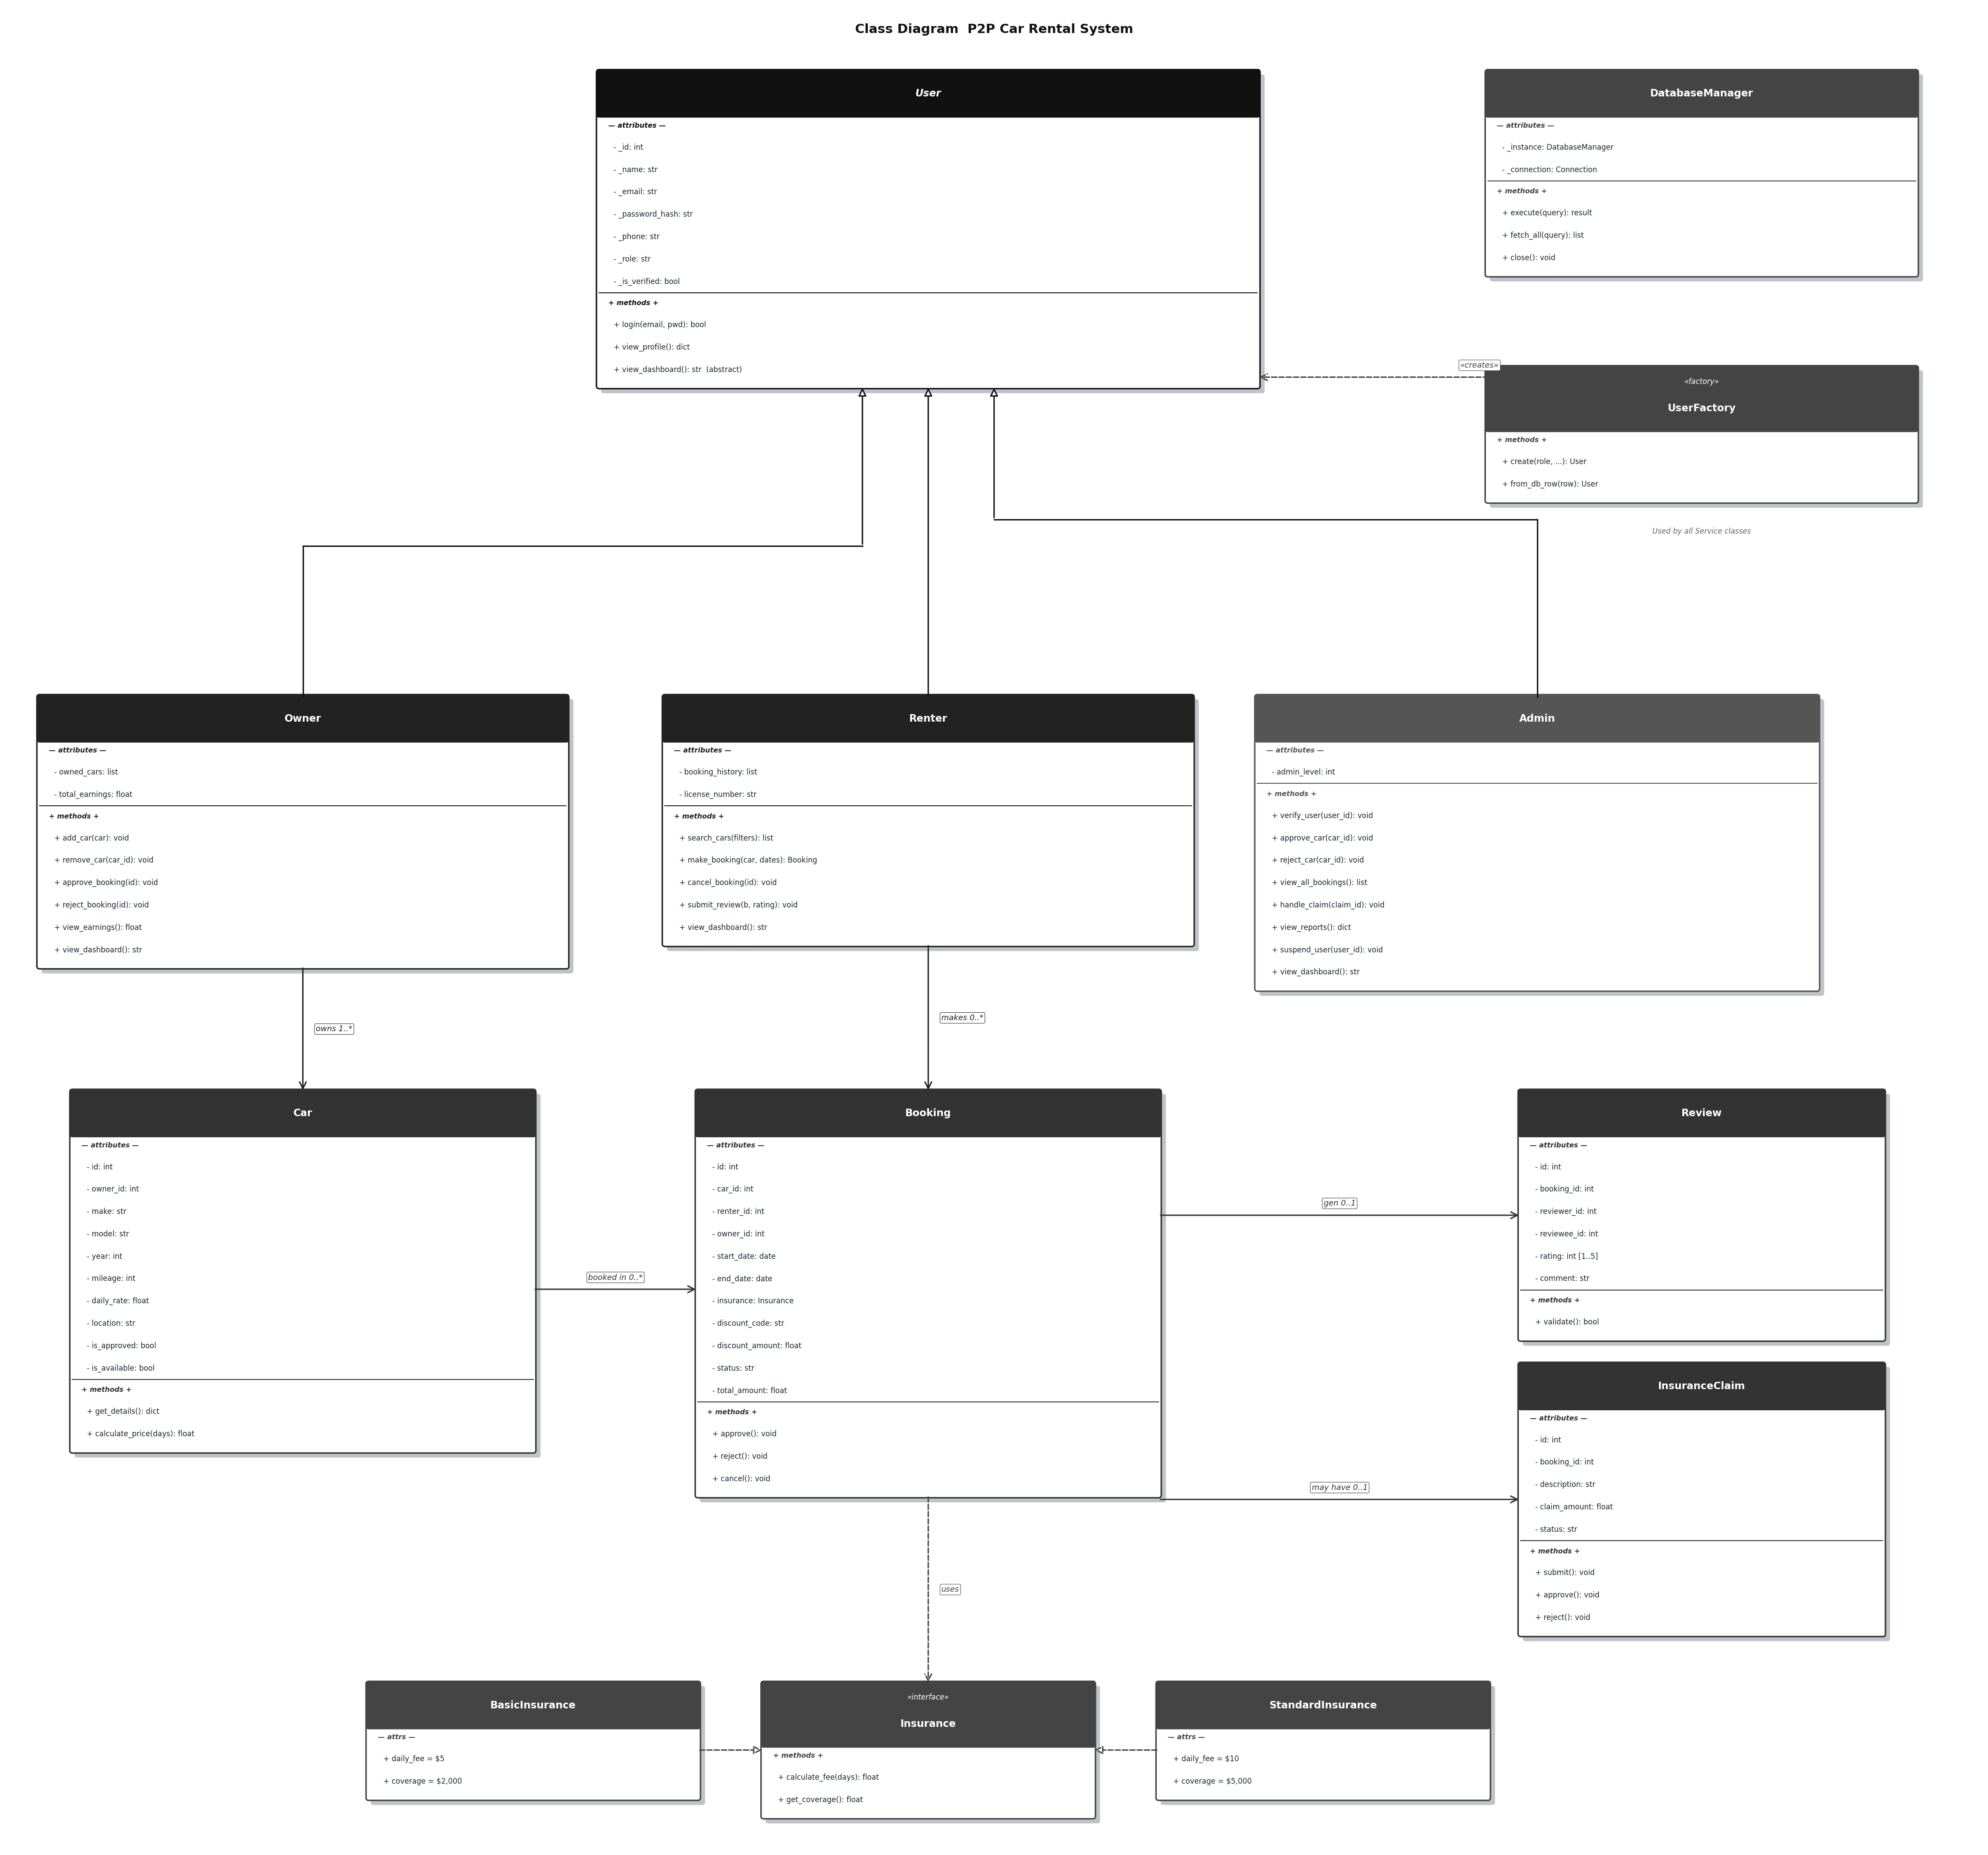
Figure 3: Class Diagram showing the OOP hierarchy and design patterns

7.5 Sequence Diagram: Make Booking
The Make Booking use case is the most complex in the system. The sequence diagram shows 9 participants and the messages between them in order.

Step | Action | Notes
1 | Renter logs in. | Includes: Authenticate user
2 | Renter searches for cars. | SQL query with location and price filters
3 | Renter views car details. | Get one car record by ID
4 | Renter enters booking dates. | is_valid_date_range() is called first
5 | System checks availability. | Include: Check car availability
6 | System calculates the fee. | Include: Calculate total fee
7 | Renter selects insurance. | Extend (optional)
8 | Renter applies a discount code. | Extend (optional)
9 | System saves the booking. | INSERT into BOOKINGS with status = pending
10 | System notifies the owner. | Include: Send notification

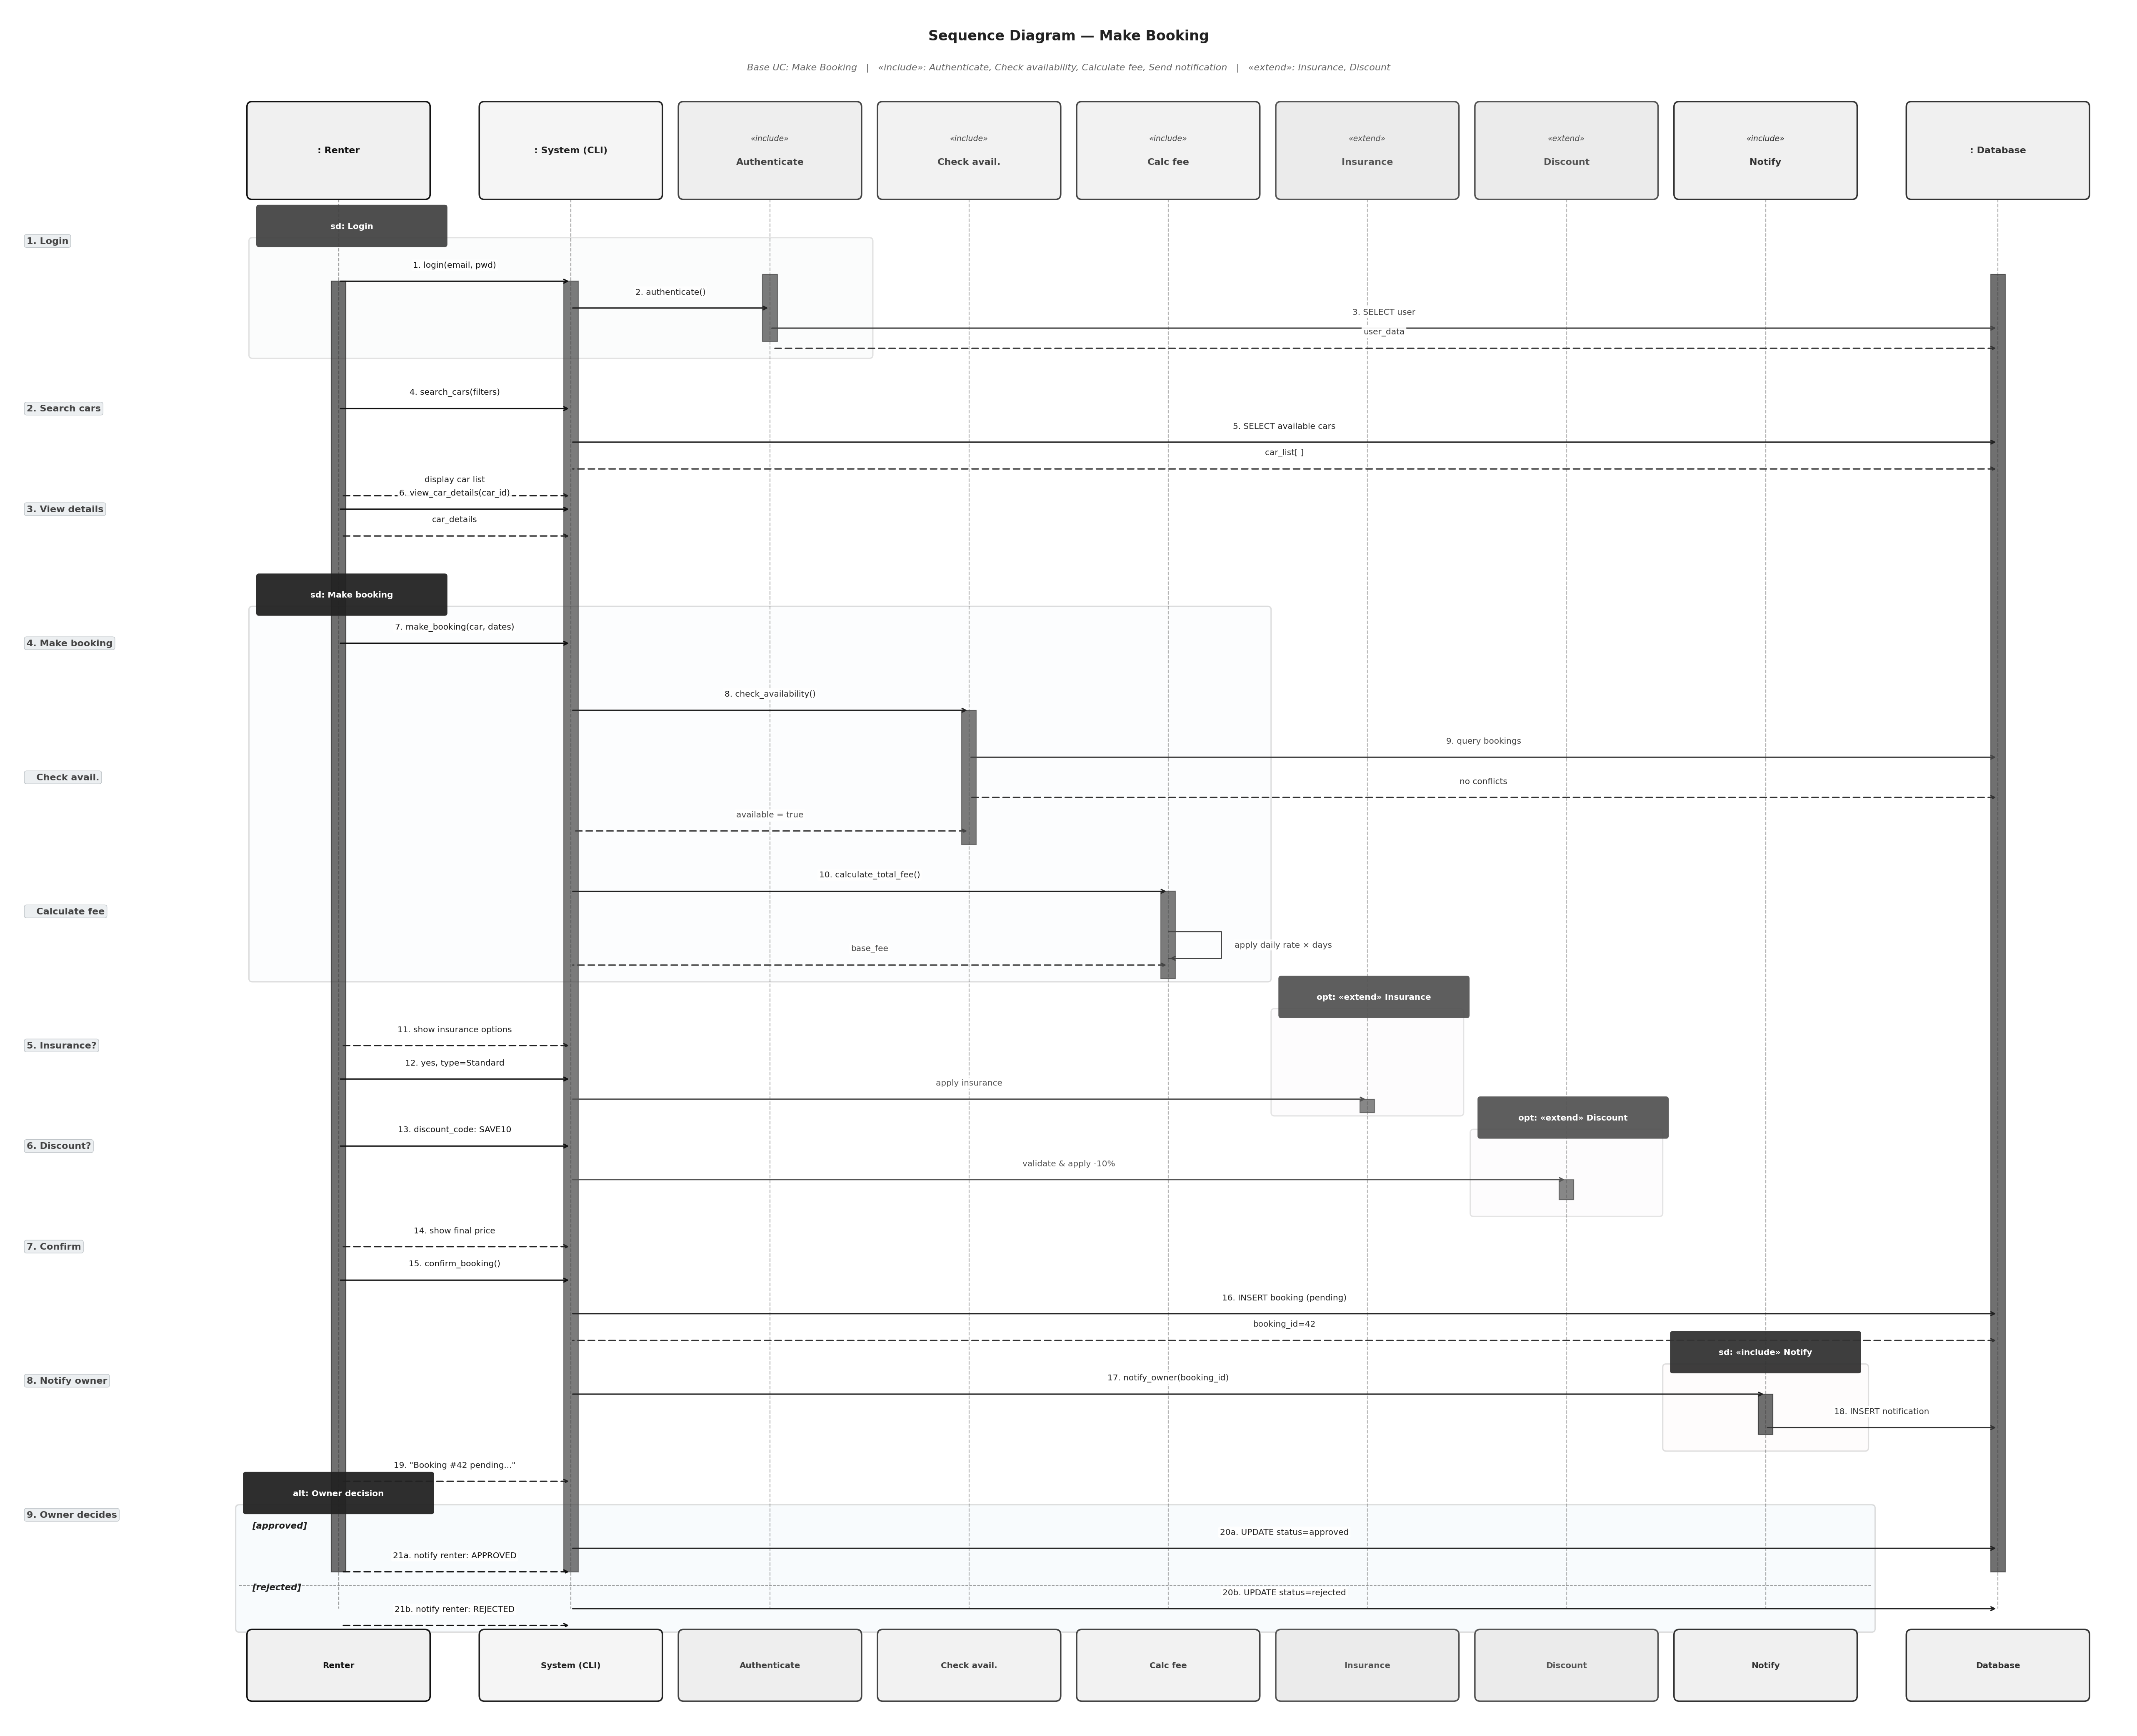
Figure 4: Sequence Diagram for the Make Booking use case

7.6 Activity Diagrams
Four activity diagrams show the step-by-step flow for the main use cases. Each uses decision nodes, fork and join bars for parallel steps, and start and end nodes.

7.6.1 Make Booking
After the renter enters dates, two steps run in parallel using a fork: the system checks car availability and calculates the total fee at the same time. The renter then optionally adds insurance and a discount code. If the renter confirms, the booking is saved.

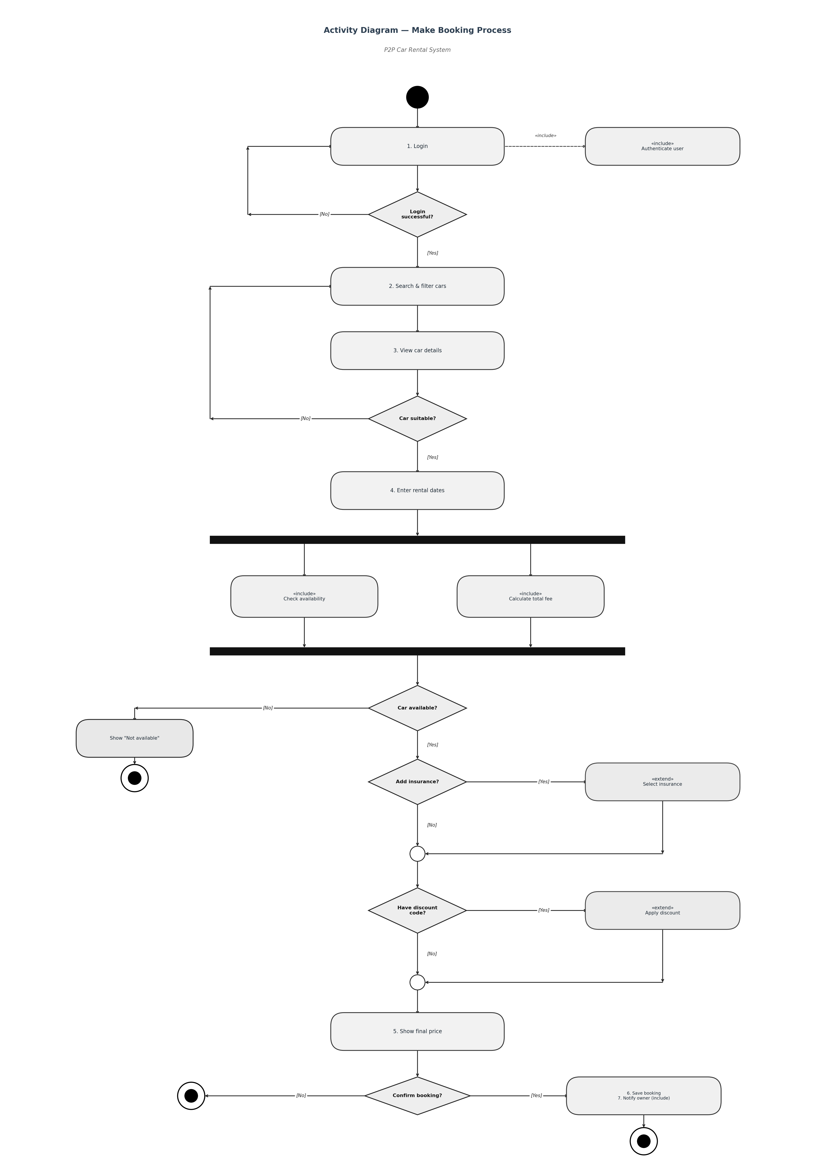
Figure 5: Activity Diagram for the Make Booking process

7.6.2 Add Car Listing
This diagram has two swimlanes: Owner and Admin. The owner enters car details and submits the listing. The system saves it with status = pending and notifies the admin. The admin reviews and either approves or rejects. If approved, the car appears in search results.

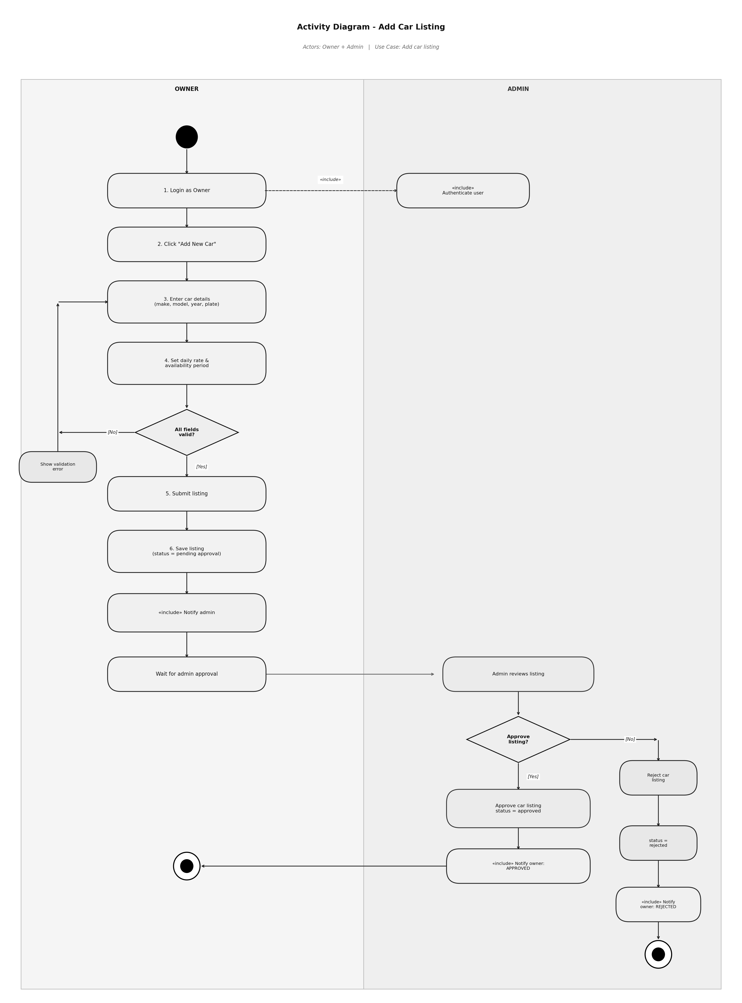
Figure 6: Activity Diagram for adding a car listing

7.6.3 Approve or Reject Booking
The owner logs in and views pending bookings. The owner checks the renter's rating and history before deciding. The approve path updates status to approved and notifies the renter. The reject path asks the owner for a reason, then updates status to rejected.

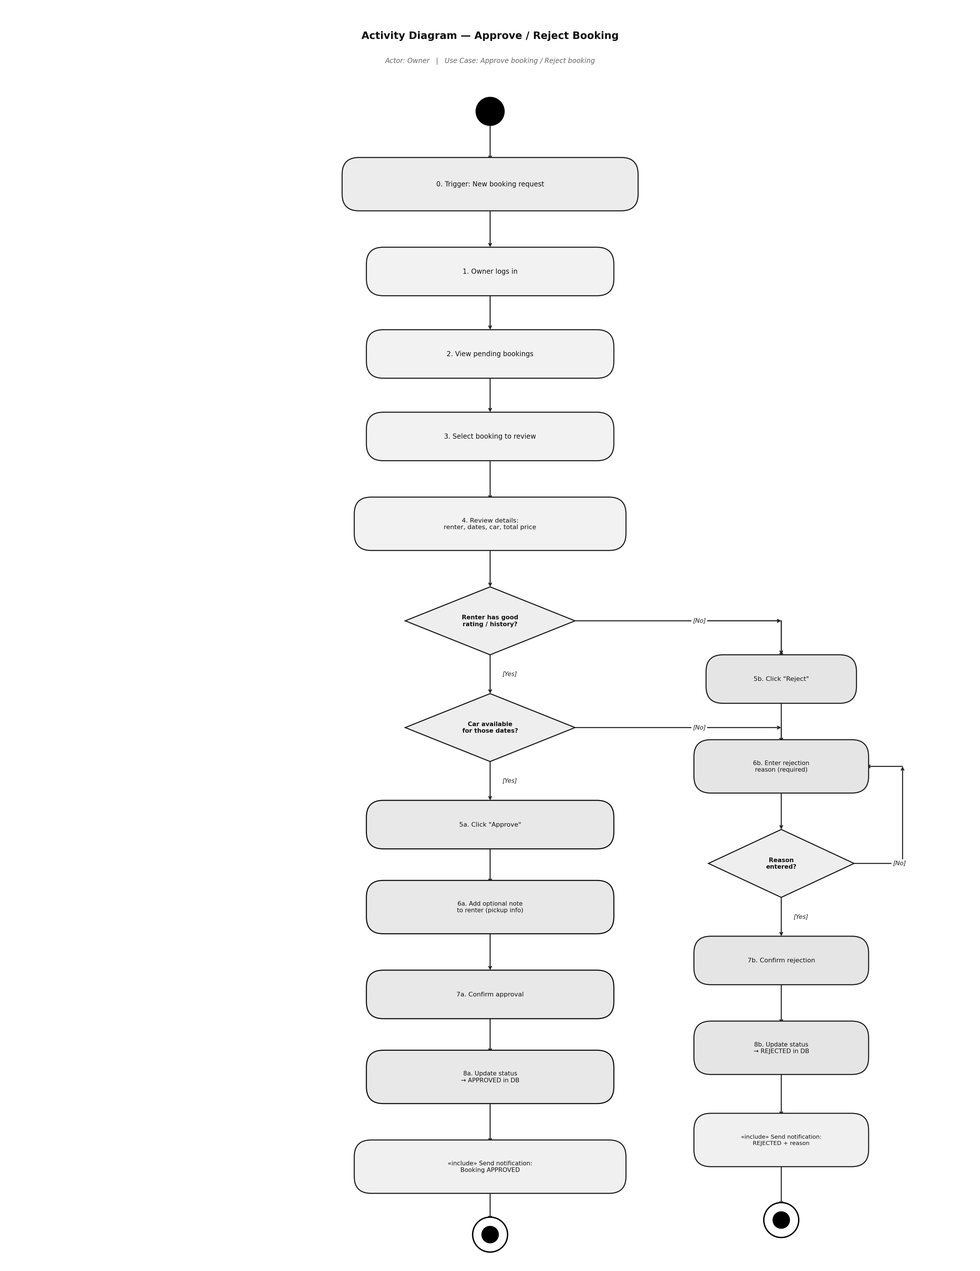
Figure 7: Activity Diagram for approving or rejecting a booking

7.6.4 Handle Insurance Claim
This diagram has three swimlanes: Owner, Admin, and Renter. The owner files a claim after the rental. Both the owner and renter can submit evidence in parallel (fork). The admin then evaluates all evidence and decides: approve the full amount, give a partial payout, or reject the claim.

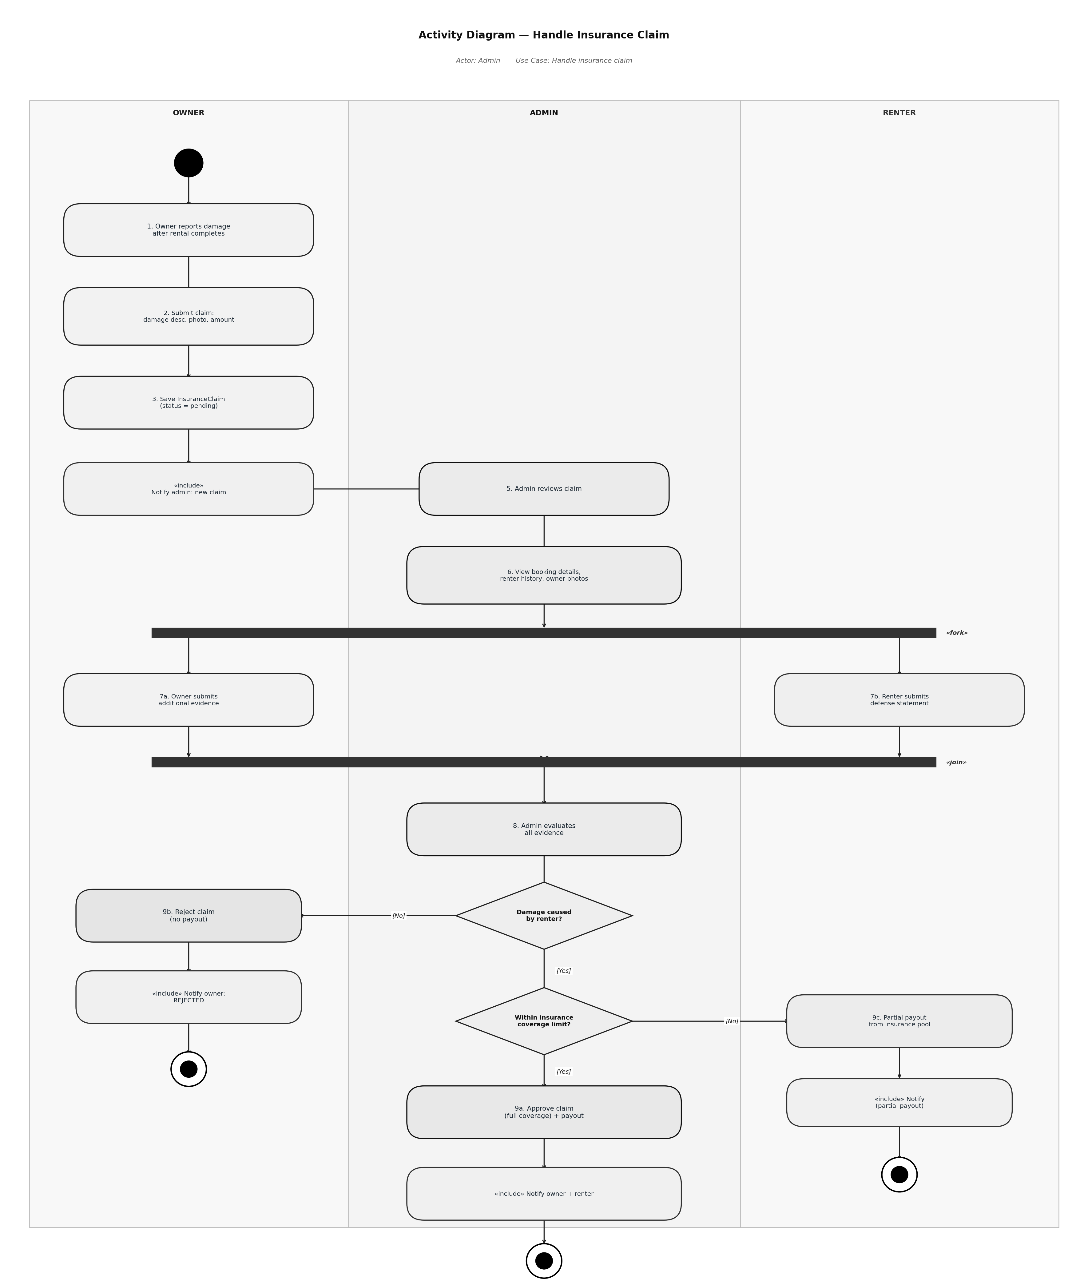
Figure 8: Activity Diagram for handling an insurance claim

8. Testing
The system was tested by hand using integration tests. Each test checks one full feature from start to end. All 15 test cases passed.

# | Scenario | Result
1 | Default admin account created on first run. | PASS
2 | Register with a duplicate email address. | PASS (rejected)
3 | Admin verifies a pending user. | PASS
4 | Owner adds a car and admin approves it. | PASS
5 | Renter searches by location and maximum price. | PASS
6 | Renter makes a 10-day booking with insurance and discount. | PASS
7 | Pricing is calculated correctly (see below). | PASS
8 | Date overlap detected. Conflicting booking rejected. | PASS
9 | Owner approves a booking. | PASS
10 | Renter submits a review with rating 1 to 5. | PASS
11 | Renter submits a rating outside 1 to 5. | PASS (rejected)
12 | Admin views platform statistics. | PASS
13 | Login with wrong password. | PASS (rejected)
14 | Renter cancels a booking before the start date. | PASS
15 | Renter tries to cancel a completed booking. | PASS (rejected)

8.1 Pricing Verification
Toyota Camry, $60/day, 10 days, Standard insurance, SAVE10 code:

Step | Value
Base price (10 x $60.00) | $600.00
Long-term discount (7+ days = 10% off) | -$60.00
SAVE10 discount code (10% off) | -$54.00
Owner amount | $486.00
Platform fee (15% of owner amount) | +$72.90
Standard insurance ($10/day x 10 days) | +$100.00
Total paid by renter | $658.90

The system output matched this calculation exactly.

9. Maintenance and Support Plan
This section describes how the system will be maintained after release. It covers three areas: software maintenance, versioning, and backward compatibility.

Software maintenance is a large part of the total cost of any project. Research shows that maintenance can account for the majority of total software lifecycle spending, often exceeding the initial development cost (Haleem et al., 2025). A clear plan helps manage this from the start.

9.1 Software Maintenance

9.1.1 Types of Maintenance
The ISO/IEC/IEEE 14764 standard (ISO/IEC/IEEE, 2022) defines four types of software maintenance.

Type | Description | Example
Corrective | Fixing bugs found after release. | Fixing the date validation logic in the booking flow.
Adaptive | Updating for new environments. | Adding support for a new Python version.
Perfective | Improving or adding features. | Sorting car search results by rating.
Preventive | Reducing future problems. | Refactoring BookingService to lower complexity.

9.1.2 Issue Handling Process
- User reports the issue by email or through the issue tracker.
- The team assigns a severity level to the report.
- A ticket is created with the details and steps to reproduce.
- A developer is assigned and creates a fix in a separate branch.
- A second developer reviews the code.
- All tests are run to confirm nothing is broken.
- The fix is merged and a new release is published.
- The changelog is updated.

9.1.3 Severity Levels and Response Times
Severity | Example | Response Time | Fix Time
Critical | System is down or data is lost. | 1 hour | 4 hours
High | A main feature does not work. | 4 hours | 24 hours
Medium | Minor bug with a workaround. | 1 day | 1 week
Low | Visual issue or typo. | 3 days | Next release

9.1.4 Code Quality Tools
- Git: version control. Every change is tracked.
- GitHub Actions: runs tests automatically on every commit.
- pytest: unit and integration tests.
- Black: consistent code formatting.
- Flake8: checks for common Python mistakes.

9.2 Versioning

9.2.1 Semantic Versioning
The project uses Semantic Versioning 2.0.0 (Preston-Werner, 2013). Each version number has three parts: MAJOR.MINOR.PATCH.

Part | When to increase | Example
MAJOR | A change breaks backward compatibility. | v1.0.0 becomes v2.0.0
MINOR | New feature added. Old features still work. | v1.2.0 becomes v1.3.0
PATCH | Bug fixed. No features added or removed. | v1.2.3 becomes v1.2.4

9.2.2 Release Schedule
Type | Frequency | Content
Patch (1.0.x) | As needed | Bug fixes only.
Minor (1.x.0) | Every 4 to 6 weeks | New features. No breaking changes.
Major (x.0.0) | Every 12 to 18 months | Large changes. May break old behavior.

9.2.3 Git Tags and Changelog
Every release is tagged in Git. A CHANGELOG.md file records all changes following the Keep a Changelog standard (Oliver, 2017). Each entry has four sections: Added, Changed, Fixed, and Removed.

git tag -a v1.0.0 -m "Initial release"
git push origin v1.0.0

9.3 Backward Compatibility
Backward compatibility means new versions can still work with data and files from older versions.

9.3.1 Three Pillars
Pillar | What it means | Example
Data compatibility | New code can read old database files. | A v1.0 database still works in v1.5 after migration.
API compatibility | Old function names and parameters still work. | register(name, email) works the same in v2.0.
User experience | Menu structure stays similar between versions. | Existing users do not need to relearn the system.

9.3.2 Database Migrations
When the database schema changes, a migration script updates the old database without deleting data. Scripts are numbered and stored in database/migrations/. They run in order. Each uses ALTER TABLE ... ADD COLUMN IF NOT EXISTS so it can be run more than once safely.

9.3.3 Deprecation Lifecycle
Stage | What happens | Duration
1. Announce | Users are told the feature will be removed. | 6 months before removal
2. Coexist | Old and new features both work. Old one shows a warning. | 3 to 6 months
3. Remove | Old feature is removed from the code. | In the next MAJOR version

9.4 Future Roadmap
Version | Target | Planned Changes
v1.0.0 | Current | Initial release with all core features.
v1.1.0 | Q3 2026 | Email notifications via SMTP.
v1.2.0 | Q4 2026 | Loyalty points and tier discounts.
v1.3.0 | Q1 2027 | Multi-language support.
v2.0.0 | Q2 2027 | PostgreSQL backend and REST API.
v2.1.0 | Q3 2027 | Mobile app (React Native).
v2.2.0 | Q4 2027 | Stripe payment integration.
v3.0.0 | Q2 2028 | Smart matching with machine learning.

10. Conclusion
This project shows how OOP principles, design patterns, and a layered architecture can work together in one Python application.

- All four OOP principles are applied in working code. Encapsulation protects data in every model class. Inheritance keeps the user hierarchy clean. Abstraction hides implementation details behind interfaces. Polymorphism handles different roles and insurance types without extra conditions.
- Three design patterns each solve a real problem. The Singleton controls database access. The Factory removes repeated user creation logic. The Strategy makes insurance pricing easy to extend.
- The 4-layer architecture keeps code organized. Each layer has one job and does not depend on layers above it.
- Three environments are supported through a single config file.
- 8 UML diagrams document the structure, behavior, and process flows of the system.
- The maintenance plan covers all four maintenance types, semantic versioning, backward compatibility, and a 24-month development roadmap.

10.1 Lessons Learned
Choosing the layered architecture early made adding new features much easier. Insurance, discount codes, and reviews all fit in without touching existing code. Design patterns worked best when they solved a real problem. Writing UML diagrams before coding helped spot design problems early.

11. References

Gamma, E., Helm, R., Johnson, R., and Vlissides, J. (1994). Design Patterns: Elements of Reusable Object-Oriented Software. Addison-Wesley Professional. ISBN: 9780201633610. https://www.amazon.com/dp/0201633612

Haleem, M., Islam, M., Ahmed, M. N., Farooqui, N. A., Khan, A. N., Hussain, M. R., Ahmed, J. S., Ahmed, M. M., and Khan, I. M. (2025). A Critical Review for Software Maintenance Cost Estimation Models: A Data Driven Approach. IEEE Access. https://doi.org/10.1109/ACCESS.2025.3618759

ISO/IEC/IEEE (2022). ISO/IEC/IEEE 14764:2022 Software Engineering: Software Life Cycle Processes - Maintenance (Edition 3). International Organization for Standardization. https://www.iso.org/standard/80710.html

Oliver, O. (2017). Keep a Changelog 1.0.0. https://keepachangelog.com/

Preston-Werner, T. (2013). Semantic Versioning 2.0.0. https://semver.org/

Appendix: Default Credentials
On the first run, the system creates a default admin account automatically.

Field | Value
Email | admin@p2p.com
Password | admin123
Role | Admin (pre-verified)

Change the default password before using the system outside of a development environment.

