Pagination & Sorting

* PageableApplication.class

package com.cjc.main;

import org.springframework.boot.CommandLineRunner;

import org.springframework.boot.SpringApplication;

import org.springframework.boot.autoconfigure.SpringBootApplication;

import org.springframework.context.annotation.Bean;

import com.cjc.main.model.Student;

import com.cjc.main.repository.DaoI;

@SpringBootApplication

public class PeginationSorting1Application {

public static void main(String[] args) {

SpringApplication.run(PeginationSorting1Application.class, args);

}

@Bean

public CommandLineRunner init(DaoI repository)

return args -> {

repository.save(new Student(null, "ABC", "pune"));

repository.save(new Student(null, "DEF", "mumbai"));

repository.save(new Student(null, "GHI", "Goa"));

repository.save(new Student(null, "JKI", "patna"));

repository.save(new Student(null, "LMN","via"));

repository.save(new Student(null, "OPQ","surat"));

repository.save(new Student(null, "RST","kolkata"));

repository.save(new Student(null, "UVW","delhi"));

repository.save(new Student(null, "XYZ","nagpur"));

repository.save(new Student(null, "MHS","leh"));

repository.save(new Student(null, "KBC","Ladhakh"));

repository.save(new Student(null, "JDB","uti"));

repository.save(new Student(null, "MCQ","maisure"));

repository.save(new Student(null, "RGH","lakhnow"));

};

}

}

* Student.class

**package** com.cjc.main.model;

**import** javax.persistence.Entity;

**import** javax.persistence.GeneratedValue;

**import** javax.persistence.Id;

@Entity

**public** **class** Student {

@Id

@GeneratedValue

**private** Long st_id;

**private** String name;

**private** String city;

**public** String getCity() {

**return** city;

}

**public** **void** setCity(String city) {

**this**.city = city;

}

**public** Long getSt_id() {

**return** st_id;

}

**public** **void** setSt_id(Long st_id) {

**this**.st_id = st_id;

}

**public** String getName() {

**return** name;

}

**public** **void** setName(String name) {

**this**.name = name;

}

**public** Student(Long st_id, String name, String city) {

**super**();

**this**.st_id = st_id;

**this**.name = name;

**this**.city= city;

}

**public** Student() {

**super**();

}

}

* Controller.class

**package** com.cjc.main.controller;

**import** org.springframework.beans.factory.annotation.Autowired;

**import** org.springframework.data.domain.Page;

**import** org.springframework.data.domain.PageRequest;

**import** org.springframework.data.domain.Pageable;

**import** org.springframework.data.domain.Sort;

**import** org.springframework.web.bind.annotation.GetMapping;

**import** org.springframework.web.bind.annotation.PathVariable;

**import** org.springframework.web.bind.annotation.RequestMapping;

**import** org.springframework.web.bind.annotation.RestController;

**import** com.cjc.main.model.Student;

**import** com.cjc.main.repository.DaoI;

@RestController

@RequestMapping("/api")

**public** **class** controller {

**private** **static** **final** **int** ***PAGE_SIZE*** = 5;

@Autowired

**private** DaoI di;

@GetMapping(value = "/student/page/{pageNo}")

**public** Page<Student> getStudentPaginated(@PathVariable **int** pageNo) {

/**

* Return the Page object containing list of 5 employees of requested

* page no.

*/

Pageable pageable = PageRequest.*of*(pageNo, ***PAGE_SIZE***);

**return** di.findAll(pageable);

}

@GetMapping(value = "/student/page/sort/{pageNo}")

**public** Page<Student> getStudentPaginatedAndSorted(@PathVariable **int** pageNo) {

/**

* Return the Page object containing list of 5 student of requested

* page and sorted by the first name

*/

Pageable pageableSortedByFirstName = PageRequest.*of*(pageNo, ***PAGE_SIZE***, Sort.*by*("name"));

/**

* Return the Page object containing list of 3 employees of requested

* page and sorted by the city in descending order

*/

Pageable pageableSortedByCityDesc = PageRequest.*of*(pageNo, ***PAGE_SIZE***, Sort.*by*("city").descending());

/**

* Return the Page object containing list of 5 employees of page 0 and

* sorted by the city in descending order and first name in ascending

* order

*/

Pageable pageableSortedByCityDescFirstNameAsc = PageRequest.*of*(pageNo, ***PAGE_SIZE***, Sort.*by*("name").descending().and(Sort.*by*("city")));

// return di.findAll(pageableSortedByFirstName);

**return** di.findAll(pageableSortedByCityDesc);

//return di.findAll(pageableSortedByCityDescFirstNameAsc);

}

@GetMapping(value = "/student/sort")

**public** Iterable<Student> getStudentSored() {

/**

* Returns all entities sorted by the given options.

*/

**return** di.findAll(Sort.*by*("city").ascending() );

}

}

* DaoI

**package** com.cjc.main.repository;

**import** org.springframework.data.jpa.repository.JpaRepository;

**import** org.springframework.stereotype.Repository;

**import** com.cjc.main.model.Student;

@Repository

**public** **interface** DaoI **extends** JpaRepository<Student, Integer> {

}

* Application.properties

server.port=8081

spring.mvc.view.suffix=.jsp

spring.datasource.username=root

spring.datasource.password=root

spring.datasource.driver-class-name=com.mysql.jdbc.Driver

spring.datasource.url=jdbc:mysql://localhost:3306/paginationsorting

spring.jpa.hibernate.ddl-auto=update

spring.jpa.properties.hibernate.dialect=org.hibernate.dialect.MySQLDialect

* Output
* API: <http://localhost:8081/api/student/sort>

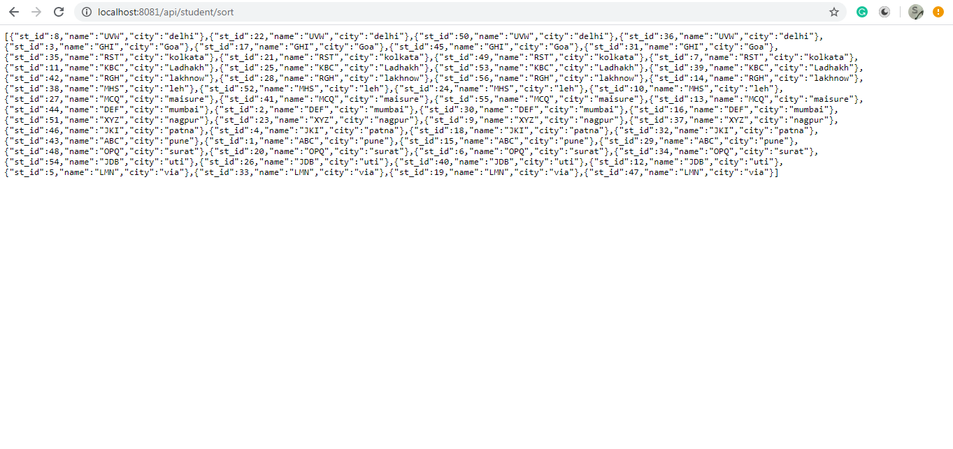

* API: <http://localhost:8081/api/student/page/sort/0>

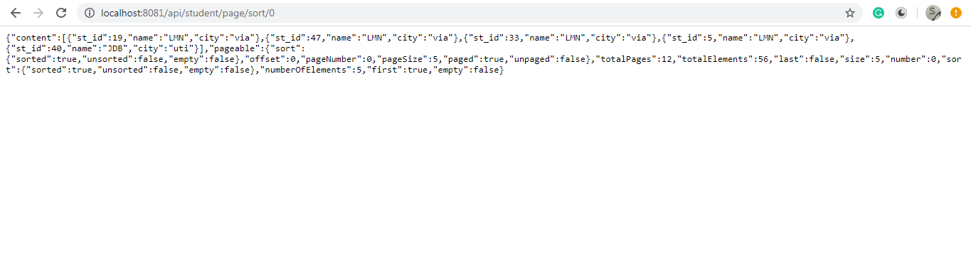

* APLI: [http://localhost:8081/api//student/page/0](http://localhost:8081/api/student/page/0)

