Assignment 3

Question 1:



* There’s a very large difference in the number of observations between the control group (23,524) and the treatment group (564,577). This shows an imbalance in the dataset, which may influence the ability for comparisons and may require extra consideration when interpreting results.
* The control and treatment groups appear fairly balanced across pre-experiment variables in terms of both means and variability which supports reliable comparisons between treatment outcomes.

Question 2:

* The mean converted rate is higher in the treatment group (0.0255) compared to the control group (0.0179), indicating a potential positive effect of the marketing treatment on conversions. the difference in CI widths might be partly due to the larger sample size in the treatment group.

Question 3:

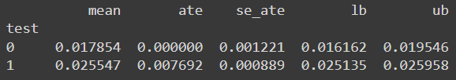

Question 4:

Question 5:

* This plot shows the mean conversion rate along with 95% confidence intervals for both treatment and control groups across deciles of total impressions.
* In the lower deciles, the conversion rates for both groups are close, with relatively narrow confidence intervals, suggesting limited variation. In the higher deciles (8-10), the treatment group has a notably higher mean conversion rate, with wider confidence intervals due to greater variability.

Bonus

Question 6:

* Overall Return on Advertising Spending: 1.39

Question 7:

* Targeted Return on Advertising (Positive Deciles Only): 15.12

Question 8:

* The results reveal that selectively targeting ads based on impression deciles significantly improve the return on advertising spending. By focusing only on the deciles with positive returns, we achieve a much higher return (15.12) than the overall return when targeting all deciles (1.39). Targeting based on decile will allow for a better allocation of ad budgets by avoiding spending in the deciles that do not result in positive returns. This will increase the overall return on investment in advertisements.