A
REAL TIME PROJECT REPORT
On
Vehicle Insurance Customer Lifetime Value Prediction

Submitted in partial fulfillment of the Requirements for the Award of the Degree of

BACHELOR OF TECHNOLOGY
IN
Computer Science and engineering (CS)
BY
A.Karthik 24N81A6238
B Mukesh 24N81A6239
Y Shivaprasad 24N81A6234
K Yadagiri 24N81A6236
S Jeevan 24N81A6257
Under the Guidance of
Mrs A. Sandhya Rani
Asst. Professor
Department of CSE (CS)


DEPARTMENT OF Computer Science and engineering (CS)
Sphoorthy Engineering College (Autonomous)
{NAAC Accredited, Recognised by UGC, u/s 2(f) & 12(B)}
(Permanently Affiliated to JNTUH, Approved by AICTE, New Delhi, ISO 9001:2015 Certified)}
Nadergul (Vill.), Near L.B. Nagar, Hyderabad, Telangana – 501510.
2024 – 2028

Sphoorthy Engineering College
(Autonomous)
DEPARTMENT OF Computer science and Engineering (cyber security)



CERTIFICATE

This is to certify that this Project Based Learning Report entitled Vehicle Insurance Customer Lifetime Value Prediction System Using Machine Learning is a bonafide work carried out by A.Karthik 24N81A6238 ,B Mukesh 24N81A6239 , Y Shivaprasad 24N81A6234 , K Yadagiri 24N81A6236 and S Jeevan 24N81A6257 in partial fulfilment of the requirements for the award of degree of Bachelor of Technology in Computer Science and Engineering (CS) from Sphoorthy Engineering College (Autonomous), affiliated to Jawaharlal Nehru Technological University Hyderabad, during the Academic Year 2025-26 under our guidance and supervision.
The results embodied in this report have not been submitted to any other university or institute for the award of any degree or diploma.

Internal Guide Head of the Department
Mrs A. Sandhya Rani
Assistant Professor
Department of CSE (CS)
Sphoorthy Engineering College (Autonomous).

ABSTRACT

This project predicts Customer Lifetime Value (CLV) using machine learning to estimate the future profit generated by each customer. A Random Forest regression model is trained on historical customer data containing features such as income, premium, and claim history. The system is developed using Streamlit, allowing users to upload datasets, train the model, and generate predictions.

Once trained, the model can predict CLV for new customers without requiring the CLV column. The performance is evaluated using MAE and R² score to ensure accuracy. The system also identifies top profitable customers, helping businesses improve decision-making, customer retention, and overall profitability.

Key Words : Customer Lifetime Value (CLV), Machine Learning, Random Forest, Regression, Predictive Analytics, Customer Profitability, Data Preprocessing, Feature Engineering, Streamlit, Model Evaluation, MAE, R² Score, Customer Segmentation, Business Intelligence.

A.Karthik 24N81A6238
B Mukesh 24N81A6239
Y Shivaprasad 24N81A6234
K Yadagiri 24N81A6236
S Jeevan 24N81A6257

INDEX
 | No. | Contents | Page No.
I |  | TITLE PAGE | I
II |  | REVISION HISTORY AND DECLARATION | II
III |  | CERTIFICATE | III
IV |  | ACKNOWLEDGEMENT | IV
V |  | ABSTRACT | V
 |  | INDEX | VI
1 |  | PROJECT OVERVIEW | 1
 | 1.1 | Project Background | 1
 | 1.2 | Business Case / Industry Need | 1
 | 1.3 | Problem Definition | 2
 | 1.4 | Project Goals And Success Metrics | 2
 | 1.5 | Scope and Out-Of-Scope | 3
 | 1.6 | Stakeholders and Roles | 3
2 |  | AI/ML PROBLEM FRAMING | 4
 | 2.1 | Problem Type | 4
 | 2.2 | Industry Relevance | 4
 | 2.3 | Ml Task Definition | 5
 | 2.4 | Success Metrics | 5
 | 2.5 | Ethical, Privacy, And Fairness Considerations | 6
3 |  | DATA ENGINEERING and DATASET OVERVIEW | 7
 | 3.1 | Data Sources | 7
 | 3.2 | Dataset Description | 7
 | 3.3 | Data Collection Pipeline | 8
 | 3.4 | Data Preprocessing | 8
 | 3.5 | Data Labeling and Annotation | 9
 | 3.6 | Data Quality Assessment | 9
 | 3.7 | Train–Validation–Test Split Strategy | 9
4 |  | EXPLORATORY DATA ANALYSIS | 10
 | 4.1 | Statistical Summary | 10
 | 4.2 | Data Visualization | 10
 | 4.3 | Insights and Patterns | 11
 | 4.4 | Feature Correlation | 12
 | 4.5 | Identification Of Bias, Outliers, Missing Values | 13
5 |  | FEATURE ENGINEERING | 14
 | 5.1 | Feature Extraction | 14
 | 5.2 | Feature Scaling and Normalization | 14
 | 5.3 | Dimensionality Reduction | 15
 | 5.4 | Feature Selection Techniques | 15
 | 5.5 | Handling Imbalanced Data | 16
6 |  | MODEL DEVELOPMENT | 17
 | 6.1 | Model Selection Strategy | 17
 | 6.2 | Baseline Model | 17
 | 6.3 | Ml/Dl Algorithms Used | 18
 | 6.4 | Hyperparameter Tuning | 18
 | 6.5 | Model Training and Validation | 19
 | 6.6 | Model Comparison | 20
 | 6.7 | Final Model Selection | 20
7 |  | SYSTEM ARCHITECTURE | 21
 | 7.1 | End-To-End Ai System Architecture | 21
 | 7.2 | Data Pipeline Architecture | 22
 | 7.3 | Training Pipeline Architecture | 22
 | 7.4 | Inference Architecture | 23
 | 7.5 | Technology Stack | 23
 | 7.6 | Deployment Architecture | 23
8 |  | DETAILED SOFTWARE DESIGN | 24
 | 8.1 | Uml Diagrams | 24
 | 8.2 | Integration of Components | 25
 | 8.3 | Database Design and Er Diagram | 25
 | 8.4 | Ui/Ux Wireframes | 25
 | 8.5 | Model Serving Design | 26
9 |  | IMPLEMENTATION | 27
 | 9.1 | Code Structure | 27
 | 9.2 | Model Training Implementation | 27
 | 9.3 | Backend Implementation | 28
 | 9.4 | Frontend Implementation | 28
 | 9.5 | Integration Of Model With Application | 29
 | 9.6 | Security Measures | 29
10 |  | MLOPS and DEPLOYMENT | 30
 | 10.1 | Overview Of Mlops Pipeline | 30
 | 10.2 | Model Versioning | 31
 | 10.3 | Ci/Cd For Ml | 31
 | 10.4 | Containerization With Docker | 32
 | 10.5 | Cloud Deployment | 32
 | 10.6 | Model Monitoring | 33
11 |  | TESTING and QUALITY ASSURANCE | 34
 | 11.1 | Testing Strategy | 34
 | 11.2 | Test Cases For Ml Components | 34
 | 11.3 | Unit Testing | 35
 | 11.4 | Ui Testing | 35
 | 11.5 | Model Performance Evaluation | 35
 | 11.6 | Error Analysis | 36
 | 11.7 | Bias and Fairness Testing | 36
12 |  | RESULTS and DISCUSSION | 37
 | 12.1 | Model Performance Metrics | 37
 | 12.2 | Comparison With Baseline | 38
 | 12.3 | Real-Time Output Screens | 38
 | 12.4 | Use Case Demonstration | 39
 | 12.5 | Discussion Of Findings | 39
13 |  | PROJECT RETROSPECTIVE | 41
 | 13.1 | Achievements | 41
 | 13.2 | Challenges Faced | 42
 | 13.3 | Lessons Learned | 42
 | 13.4 | Best Practices Followed | 43
14 |  | CONCLUSION and FUTURE ENHANCEMENTS | 44
 | 14.1 | Conclusion | 44
 | 14.2 | Potential Industry Deployment | 44
 | 14.3 | Future Model Improvements | 45
15 |  | REFERENCES | 46
16 |  | APPENDICES | 47

Chapter 1. Project Overview

1.1 Project Background
In the modern insurance industry, data plays a crucial role in decision-making and business strategy. One of the most important metrics used to evaluate customer profitability is Customer Lifetime Value (CLV). CLV represents the total revenue a customer is expected to generate during their association with an insurance company.
Traditionally, estimating CLV was done using basic statistical methods or manual analysis. However, these approaches often fail to capture complex relationships between factors such as customer behavior, premium payments, claims, and policy details. With the advancement of machine learning, it is now possible to analyze large datasets efficiently and make accurate predictions.
This project focuses on predicting CLV in the vehicle insurance domain using machine learning techniques. The system uses customer-related data such as income, premium amount, claim history, and number of policies to identify patterns and predict future value. Additionally, a user-friendly interface is developed using Streamlit, allowing users to upload data and obtain predictions easily.

1.2 Business Case / Industry Need
The insurance industry faces challenges in managing customer relationships and maximizing profitability. Not all customers contribute equally—some are highly profitable, while others may lead to losses due to frequent claims or low premium contributions.
This project addresses these challenges by providing a predictive system that helps companies:
Identify high-value customers for retention
Detect low-value or risky customers
Optimize marketing strategies
Allocate resources efficiently
Improve overall profitability
By using CLV predictions, companies can shift from reactive decision-making to proactive, data-driven strategies. This enhances business efficiency and customer satisfaction.

1.3 Problem Definition
The main problem addressed in this project is the difficulty in predicting the long-term value of customers in the vehicle insurance sector. Customer behavior is influenced by multiple factors such as demographics, policy type, claim frequency, and payment history.
Without an accurate prediction system, companies may:
Invest heavily in low-value customers
Fail to retain high-value customers
Misjudge customer risk levels
Make inefficient business decisions
The objective of this project is to develop a machine learning model that can accurately predict Customer Lifetime Value using historical data. This helps companies make better decisions regarding customer management and business strategy.

1.4 Project Goals and Success Metrics (KPIs)
The primary goal of this project is to build an efficient and accurate CLV prediction system. The system should be capable of processing data quickly and providing reliable predictions.
The success of the project is measured using the following Key Performance Indicators (KPIs):
Response Time < 1 second: The system should generate predictions quickly for a smooth user experience.
R² Score ≥ 0.6: The model should explain a significant portion of variance in the data.
Low MAE (Mean Absolute Error < 2000): Predictions should be close to actual values.
Usability: The application should be easy to use and interactive.
In this project, the Random Forest model achieved an R² score of approximately 0.68 and a low MAE, indicating good performance.

1.5 Scope and Out-of-Scope
Scope
Predict Customer Lifetime Value using machine learning
Use structured insurance customer data
Perform data preprocessing and feature encoding
Train and evaluate models (Linear Regression and Random Forest)
Develop a web-based interface using Streamlit
Display predictions and performance metrics
Out-of-Scope
Real-time data streaming or live database integration
Use of deep learning or advanced neural networks
Mobile application development
Deployment on enterprise-level cloud platforms
Integration with external APIs
Clearly defining the scope ensures that the project remains focused and achievable.

1.6 Stakeholders and Roles
This project involves several stakeholders, each with specific responsibilities:
End Users (Insurance Analysts/Managers): Upload datasets, view predictions, and use insights for decision-making.
Developer/Data Scientist: Build and train the machine learning model, preprocess data, and develop the Streamlit application.
Insurance Company: Provides data and uses predictions to improve business strategies and profitability.
System Administrator (optional): Maintains and manages the system during deployment.

Chapter 2. AI/ML Problem Framing

2.1 Problem Type
The problem addressed in this project falls under the category of Regression in Machine Learning. Regression problems involve predicting continuous numerical values based on input features. In this case, the objective is to predict Customer Lifetime Value (CLV), which is a continuous variable representing the total expected revenue generated by a customer.
Unlike classification problems that predict discrete labels (e.g., yes/no), regression models estimate numeric outcomes such as revenue, cost, or demand. The CLV prediction problem is not related to Natural Language Processing (NLP) or Computer Vision (CV), as it deals purely with structured tabular data.
The project initially explored Linear Regression as a baseline model but later adopted Random Forest Regressor due to its ability to handle complex and non-linear relationships more effectively.

2.2 Industry Relevance
Machine learning-based CLV prediction has significant relevance in the insurance industry, especially in vehicle insurance. It directly impacts several key business areas:
Automation: Traditional methods of estimating customer value involve manual analysis and assumptions. Machine learning automates this process, saving time and effort.
Accuracy: ML models analyze multiple features simultaneously, resulting in more accurate predictions compared to conventional methods.
Cost Reduction: By identifying low-value or high-risk customers, companies can avoid unnecessary spending and reduce losses.
Customer Retention: High-value customers can be identified and retained through targeted offers and personalized services.
Operational Efficiency: Resources such as marketing budgets and customer support can be allocated more effectively.
Overall, this project demonstrates how machine learning can transform traditional insurance processes into intelligent, data-driven systems.

2.3 ML Task Definition
The machine learning task in this project is defined as:
“To develop a regression model that predicts Customer Lifetime Value using historical customer data.”
The input features include:
Customer demographics (e.g., income, gender, marital status)
Policy-related information (e.g., number of policies, coverage type)
Financial data (e.g., monthly premium, claim amount)
Behavioral attributes (e.g., months since last claim)
The output is:
CustomerLifetimeValue (CLV) — a continuous numerical value
The process involves:
Data preprocessing (cleaning and encoding categorical variables)
Splitting data into training and testing sets
Training the model using Random Forest Regressor
Evaluating predictions using performance metrics
The model learns patterns from historical data and uses them to predict CLV for new or unseen data.

2.4 Success Metrics
To evaluate the performance of the model, regression-based metrics are used instead of classification metrics like accuracy or F1-score.
The key metrics used in this project are:
Mean Absolute Error (MAE):
Measures the average difference between actual and predicted values. Lower MAE indicates better performance.
In this project, MAE ≈ 1437, meaning the model’s predictions are close to actual values.
Mean Squared Error (MSE):
Measures the squared difference between actual and predicted values. It penalizes larger errors more heavily.
R² Score (Coefficient of Determination):
Indicates how well the model explains the variance in the data.
Values range from 0 to 1, where higher values indicate better performance.
In this project, R² ≈ 0.68, meaning the model explains 68% of the data variability.
Response Time:
The system generates predictions in less than one second, ensuring real-time usability.
These metrics confirm that the Random Forest model performs effectively for CLV prediction.

2.5 Ethical, Privacy, and Fairness Considerations
When working with customer data, it is essential to consider ethical and privacy-related aspects. This project ensures responsible use of data in the following ways:
Data Privacy:
Sensitive information such as personal identifiers is removed or not used. The dataset focuses only on relevant attributes required for prediction.
Bias Avoidance:
The model should not unfairly favor or discriminate against specific groups based on gender, income, or other attributes. Care is taken to ensure balanced data representation.
Transparency:
The system provides clear outputs (predictions and metrics), making it easier for users to understand how the model performs.
Responsible Usage:
Predictions should be used to assist decision-making, not to completely replace human judgment.
Data Security:
Since the system works with uploaded CSV files, it ensures that data is processed locally and not misused.
By addressing these considerations, the project promotes ethical AI practices while maintaining accuracy and usability.

Chapter 3. Data Engineering and Dataset Overview

3.1 Data Source
The dataset used in this project is a structured customer dataset related to the vehicle insurance domain. It is obtained from publicly available sources such as Kaggle and contains historical records of customers, their policies, and financial interactions with the insurance company.
The dataset includes important attributes such as customer demographics, premium details, claim history, number of policies, and other behavioral indicators. These features are essential for analyzing customer behavior and predicting Customer Lifetime Value (CLV).
Using a real-world dataset ensures that the model is trained on realistic data patterns, making the predictions more meaningful and applicable in practical scenarios.

3.2 Dataset Description
The dataset consists of approximately 2900 records with around 25 features (columns). Each row represents an individual customer, and each column represents a specific attribute related to that customer.
Some of the key features in the dataset include:
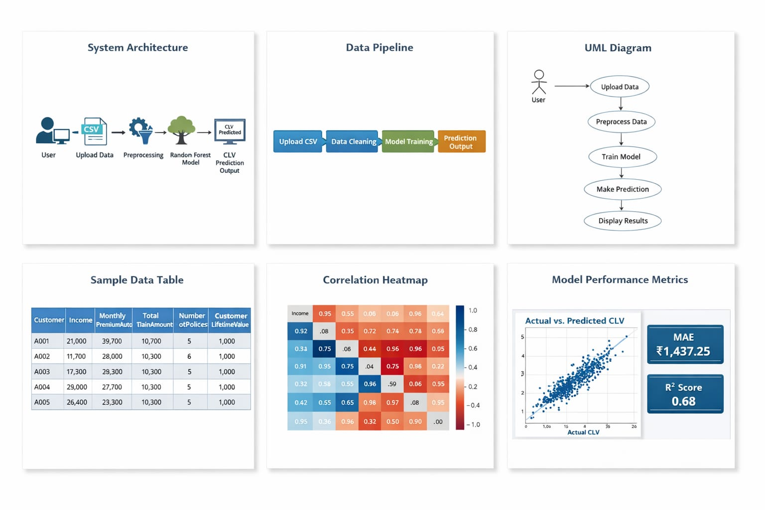
CustomerLifetimeValue (Target Variable): The total value generated by a customer (output variable).
Income: Annual income of the customer.
MonthlyPremiumAuto:
Monthly premium paid by the customer.
ClaimAmount:
Total claim amount made by the customer.
NumberofPolicies:
Number of policies owned by the customer.
MonthsSinceLastClaim: Time since last claim.
EmploymentStatus, Education, Gender: Demographic information.
VehicleClass, VehicleSize: Vehicle-related attributes.
The dataset contains both numerical and categorical features, which require preprocessing before applying machine learning algorithms.
3.3 Data Pipeline
The data pipeline describes the flow of data from input to output in the system. The pipeline used in this project is as follows:
Data Upload:
The user uploads a CSV file through the Streamlit web interface.
Data Loading:
The dataset is loaded into the system using the Pandas library.
Data Preprocessing:
Unnecessary columns are removed, and categorical data is converted into numerical format.
Feature Selection:
Relevant features are selected for training the model.
Model Training:
The processed data is used to train the Random Forest model.
Prediction:
The trained model predicts CLV values.
Output Display:
Predictions, performance metrics, and graphs are displayed to the user.
This pipeline ensures smooth data flow and efficient processing.

3.4 Data Preprocessing
Data preprocessing is a critical step in machine learning to ensure data quality and model performance. The following preprocessing steps are performed:
Removing Unnecessary Columns:
Columns such as Customer ID and index values (e.g., “Unnamed: 0”) are removed as they do not contribute to prediction.
Handling Missing Values:
The dataset used in this project does not contain missing values. However, in general, missing values can be handled using techniques like imputation.

3.5 Data Labeling
The dataset used in this project is already labeled, meaning it contains the target variable CustomerLifetimeValue. Since this is a supervised learning problem, the model learns from input-output pairs.
No additional labeling is required, which simplifies the training process. The presence of labeled data allows the model to learn patterns and make accurate predictions.

3.6 Data Quality and Challenges
The dataset is relatively clean and well-structured, but some challenges are considered:
Categorical Data Complexity:
Many features are categorical, requiring proper encoding.
Feature Correlation:
Some features may be highly correlated, affecting model performance.
Outliers:
High CLV values can act as outliers and influence predictions.
Data Imbalance:
Distribution of customer value may not be uniform.
Despite these challenges, proper preprocessing ensures reliable model performance.

3.7 Train-Test Split Strategy
To evaluate the model effectively, the dataset is divided into two parts:
Training Data (80%)
Used to train the machine learning model.
Testing Data (20%)
Used to evaluate the model’s performance on unseen data.
The splitting is done using the train_test_split() function from Scikit-learn with a random state to ensure reproducibility.
This approach ensures that the model is tested fairly and avoids overfitting.
Here is your Section 4: Exploratory Data Analysis (EDA) (≈700 words) written clearly and suitable for your report and viva:
Chapter 4. Exploratory Data Analysis (EDA)

4.1 Statistical Summary
Exploratory Data Analysis (EDA) is an important step in machine learning that helps in understanding the dataset before model training. It includes analyzing numerical values, identifying patterns, checking distributions, and finding relationships among variables. In this project, EDA is performed on the vehicle insurance dataset to understand how customer attributes affect Customer Lifetime Value (CLV).
The first step in EDA is generating a statistical summary of the dataset. This includes measures such as mean, median, standard deviation, minimum, and maximum values for numerical features. These statistics provide an overview of how the data is distributed.
Key observations from the dataset include:
- The CustomerLifetimeValue (CLV) shows a wide range of values, meaning some customers are much more profitable than others.
- Features such as MonthlyPremiumAuto and Income have high variation, indicating that customers differ significantly in payment capacity and premium amount.
- Some features show skewed distributions where a small number of customers have extremely high or low values.
- Standard deviation values indicate the spread of data and help in detecting variability.
Statistical summaries are useful for identifying unusual values, understanding customer behavior, and preparing data for further analysis.

4.2 Data Visualization
Visualization is a powerful technique used to interpret data more effectively. Charts and graphs make it easier to identify patterns, trends, and irregularities that may not be visible in raw tables.
In this project, different visualizations are used:
Distribution Plots
Distribution plots show how numerical values such as income, premium, and claim amounts are spread across customers.
- Most customers fall in medium income ranges.
- Premium values are concentrated in lower ranges with fewer high-premium customers.
- Claim amounts vary widely among customers.
Heatmaps
Heatmaps are used to display correlations between variables using colors. Strong relationships appear darker, while weak relationships appear lighter.
Scatter Plots
Scatter plots compare two numerical variables. For example, actual CLV vs predicted CLV helps in understanding model performance.
Bar Charts
Bar charts are used for categorical variables such as:
- Gender
- Education
- Vehicle Class
- Policy Type
These visualizations help in understanding the structure of the dataset and preparing useful features for prediction.

4.3 Insights & Patterns
EDA reveals several useful insights and hidden patterns in the data.
Important findings include:
- Customers paying higher monthly premiums generally contribute higher CLV.
- Customers with multiple insurance policies are more profitable.
- High claim amounts reduce profitability because the company pays more compensation.
- Medium-income customers form the largest group in the dataset.
- Only a small number of customers generate very high profits.
- Customer behavior is not perfectly linear, indicating complex relationships among variables.
These insights are valuable for business decision-making and help in selecting the most suitable machine learning model.

4.4 Feature Correlation
Feature correlation explains how strongly variables are related to one another. Correlation analysis helps identify the most important features influencing Customer Lifetime Value.
Key relationships observed:
MonthlyPremiumAuto vs CLV
There is a strong positive relationship. Customers paying higher premiums usually have higher CLV.
ClaimAmount vs CLV
There is a negative relationship. Higher claim amounts reduce company profit, resulting in lower CLV.
NumberofPolicies vs CLV
Customers with more policies generally have higher CLV, as they bring more business to the company.
Income vs CLV
Higher-income customers tend to choose higher premium plans and are more profitable.
Understanding feature relationships improves model training and helps remove less useful variables.



4.5 Identification of Bias, Outliers, Missing Values
During EDA, it is important to identify data quality issues such as bias, outliers, and missing values.
Missing Values
The dataset used in this project contains no major missing values. This improves reliability and reduces the need for imputation techniques.
Outliers
Some customers have unusually high CLV values compared to others. These are considered outliers.
Effects of outliers:
- Can influence model predictions
- May increase error values
- Can affect data balance
However, these outliers are retained because they represent real high-value customers who are important for business analysis.
Bias
Bias occurs when one category dominates the dataset. Examples include unequal representation of policy types or customer groups. Detecting such bias helps in building fair and balanced models.
Handling Methods
- Missing values can be filled or removed
- Outliers can be analyzed separately
- Bias can be reduced using balanced sampling methods
Overall, the dataset is suitable for machine learning after careful analysis.

Chapter 5. Feature Engineering

5.1 Feature Extraction
Feature Engineering is the process of transforming raw data into meaningful features that improve the performance of machine learning models. It is one of the most important stages in machine learning because the quality of features directly affects prediction accuracy. In this project, feature engineering is applied to prepare customer vehicle insurance data for predicting Customer Lifetime Value (CLV).
Feature extraction involves identifying and using relevant variables from the dataset that contribute to the target variable. The dataset already contains useful customer and policy-related attributes, so no complex derived features are required.
Important extracted features include:
- MonthlyPremiumAuto – Indicates how much premium the customer pays regularly.
- ClaimAmount – Represents the amount claimed by the customer.
- NumberofPolicies – Shows how many policies the customer owns.
- Income – Reflects the customer’s financial capacity.
- MonthsSinceLastClaim – Indicates recent claim activity.
- Coverage – Type of insurance coverage selected.
These features are directly used because they have business relevance and strong predictive power for CLV.

5.2 Feature Scaling & Normalization
Feature scaling is the process of bringing numerical values into a common range so that no single feature dominates the learning process. Common techniques include:
- Standardization – Converts data to mean 0 and standard deviation 1.
- Min-Max Scaling – Converts values between 0 and 1.
However, in this project, scaling is not required because the selected model is Random Forest Regressor, which is a tree-based algorithm.
Tree-based models split data based on feature values and are not sensitive to differences in scale. Therefore:
- Income values can remain large
- Claim amounts can remain in original units
- Premium values can be used directly
Using raw values simplifies preprocessing and avoids unnecessary transformations.

5.3 Dimensionality Reduction
Dimensionality reduction is used when datasets contain a very large number of features. It reduces complexity while preserving useful information. Popular methods include:
- PCA (Principal Component Analysis)
- t-SNE for visualization
In this project, dimensionality reduction is not necessary because the dataset has a manageable number of features.
Although One-Hot Encoding slightly increases the number of columns by converting categories into binary variables, the total feature count remains suitable for Random Forest.
Advantages of avoiding dimensionality reduction:
- Maintains interpretability of original features
- No loss of useful information
- Simpler model pipeline
Thus, all encoded features are retained for model training.

5.4 Feature Selection Techniques
Feature selection means choosing the most useful features and removing irrelevant ones. This helps improve model performance, reduce training time, and prevent overfitting.
In this project, the following techniques are applied:
Filter Method
Features are selected based on statistical relationships and correlation with CLV.
Embedded Method
Random Forest automatically identifies important variables during training using feature importance scores.
Manual Selection
Business understanding is also used to retain meaningful features.
Most important selected features include:
- MonthlyPremiumAuto – Strong positive effect on CLV
- ClaimAmount – Higher claims reduce profitability
- NumberofPolicies – Indicates customer loyalty and engagement
- Income – Affects purchasing capacity
- Coverage Type – Influences premium value
Removed features:
- Customer ID / Names – Unique identifiers with no predictive value
- Unnecessary indexing columns
This improves model efficiency and prediction quality.

5.5 Handling Imbalanced Data
Imbalanced data occurs when some classes dominate others. This is common in classification problems where one category has many more records than another.
Examples:
- Fraud detection
- Disease prediction
- Spam detection
Typical handling methods:
- SMOTE (Synthetic Minority Oversampling Technique)
- Undersampling majority class
- Oversampling minority class
However, this project is a regression problem, not a classification problem.
The target variable (CLV) is continuous rather than categorical, so class imbalance is not a major issue. The model learns patterns from numerical target values instead of classes.
Still, data distribution is checked to ensure that:
- Most customers are not concentrated in a very narrow CLV range
- Extreme high-value customers are retained for business importance
No balancing techniques are required in this project.

Chapter 6. Model Development

6.1 Model Selection Strategy
Model development is one of the most important stages in the machine learning pipeline. In this phase, suitable algorithms are selected, trained, and evaluated to solve the defined problem. In this project, the objective is to predict Customer Lifetime Value (CLV), which is a regression problem because the target output is a continuous numerical value.
The model selection strategy is based on the following factors:
- Nature of the problem (Regression)
- Type of data (Tabular dataset)
- Ability to handle categorical and numerical features
- Accuracy and robustness of predictions
Initially, a simple model such as Linear Regression is selected as a baseline model. Since real-world insurance data contains complex and non-linear relationships, an advanced ensemble model like Random Forest Regressor is also considered. The final selection is made after comparing model performance.

6.2 Baseline Model
A baseline model is used to provide an initial reference point for performance comparison. In this project, Linear Regression is used as the baseline model.
Linear Regression predicts the target variable using a straight-line relationship between input features and output values.
Advantages:
- Simple and easy to understand
- Fast training and prediction
- Useful as a starting benchmark
Limitations:
- Assumes linear relationships between variables
- Cannot capture complex patterns
- Sensitive to outliers
In this project, Linear Regression produced an R² score of approximately 0.15, indicating weak performance. This means the model could explain only a small portion of the variation in CLV.

6.3 ML/DL Algorithms Used
Several machine learning algorithms can be used for regression problems. In this project, the following algorithms were considered:
Linear Regression
Used as the baseline model for comparison.
Random Forest Regressor
Used as the main model due to its strong performance on structured tabular data.
Random Forest is an ensemble learning method that builds multiple decision trees and combines their outputs.
Key advantages:
- Handles non-linear relationships
- Works with both categorical and numerical data
- Reduces overfitting
- Provides feature importance
Other Possible Models
Although not implemented, the following models can also be used:
- Support Vector Regression (SVR)
- Gradient Boosting
- XGBoost
- Neural Networks
Since the dataset is tabular and medium-sized, Random Forest is more suitable than deep learning models such as CNN or LSTM.

6.4 Hyperparameter Tuning
Hyperparameters are settings defined before training that control model behavior. Proper tuning can improve accuracy and reduce errors.
Important Random Forest hyperparameters include:
- n_estimators – Number of decision trees
- max_depth – Maximum depth of trees
- min_samples_split – Minimum samples needed to split nodes
- random_state – Ensures reproducible results
In this project, the following configuration is used:
- n_estimators = 100
- random_state = 42
For simplicity, manual/default tuning is applied. Advanced techniques such as:
- Grid Search
- Random Search
- Bayesian Optimization
can be used in future work for better performance.

6.5 Model Training & Validation
The dataset is divided into training and testing sets using an 80:20 ratio.
- Training Set (80%) – Used to train the model
- Testing Set (20%) – Used to evaluate performance on unseen data
Training process:
- Input features are given to the model
- Model learns patterns from historical customer data
- Predictions are generated on testing data
Validation ensures that the model does not simply memorize training data and can generalize well to new customers.
The training is implemented using Scikit-learn library in Python.

6.6 Model Comparison
After training, the models are compared using standard evaluation metrics.
Linear Regression
- MAE = Higher
- R² Score ≈ 0.15
- Poor performance
Random Forest Regressor
- MAE ≈ 1437
- R² Score ≈ 0.68
- Good performance
Comparison Table
Model | MAE | R² Score | Performance
Linear Regression | High | 0.15 | Poor
Random Forest | Low | 0.68 | Good
This comparison clearly shows that Random Forest performs significantly better.

6.7 Final Model Selection
Based on evaluation results, Random Forest Regressor is selected as the final model.
Reasons for selection:
- Higher prediction accuracy
- Lower error values
- Handles complex and non-linear relationships
- Works well with mixed data types
- Robust against overfitting
- Provides reliable predictions for new customers
The final model is integrated into the Streamlit web application to predict Customer Lifetime Value for new datasets.

Chapter 7. System Architecture

7.1 End-to-End AI System Architecture
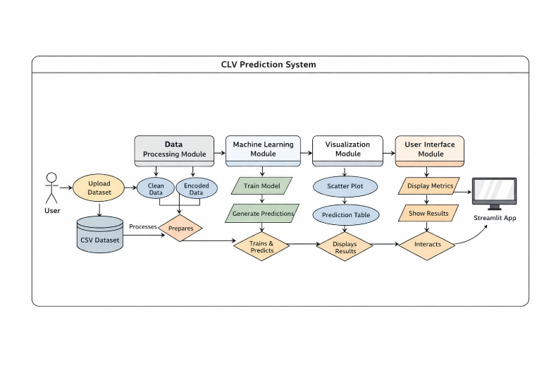

Input Data:
The system accepts a CSV file uploaded by the user through the Streamlit interface.
Data Preprocessing:
The dataset is cleaned by removing unnecessary columns such as Customer ID and index values. Categorical variables are encoded into numerical format.
Feature Engineering:
Relevant features such as premium, claims, and policies are selected for model training.
Model Training:
The Random Forest Regressor is trained using historical data.
Prediction:
The trained model predicts CLV values for test data.
Output Visualization:
Results are displayed using metrics, graphs, and tables.
This architecture ensures that the system is modular and easy to understand.

7.2 Data Pipeline Architecture
The data pipeline defines how data flows through the system:
Data Upload:
User uploads a dataset using the Streamlit interface.
Data Loading:
The dataset is read using the Pandas library.
Data Cleaning:
Unnecessary columns are removed.
Data Transformation:
Categorical variables are encoded using one-hot encoding.
Feature Selection:
Important features are selected for training.
Data Splitting:
Data is divided into training and testing sets.
Model Input:
Processed data is passed to the machine learning model.
This pipeline ensures consistent and reliable data processing.

7.3 Training Pipeline Architecture
The training pipeline focuses on how the model learns from data:
Training Data Input:
80% of the dataset is used for training.
Model Training:
The Random Forest algorithm builds multiple decision trees.
Learning Process:
Each tree learns patterns from different subsets of data.
Model Storage:
The trained model is stored in memory during execution.
This pipeline ensures that the model learns efficiently and accurately.
7.4 Inference Architecture
Inference refers to the process of generating predictions using the trained model.
The trained Random Forest model takes input features from test data.
Each decision tree generates a prediction.
Final prediction is obtained by averaging outputs of all trees.
Predicted CLV values are displayed to the user.
This process is fast and allows real-time prediction within the application.

7.5 Technology Stack
The system is built using the following technologies:
Programming Language: Python
Frontend and Backend: Streamlit
Data Processing: Pandas, NumPy
Machine Learning: Scikit-learn
Visualization: Matplotlib
This stack is lightweight, efficient, and suitable for rapid development.

7.6 Deployment Architecture
The system can be deployed in two ways:
Local Deployment:
The application runs on a local machine using Streamlit.
Cloud Deployment:
The application can be deployed on platforms like Streamlit Cloud for online access.
In both cases, the architecture remains the same, ensuring flexibility.

Chapter 8. Software Design

Introduction
Software design defines how the system is structured and how its components interact to achieve the desired functionality. In this project, the software design focuses on building a user-friendly and efficient system for predicting Customer Lifetime Value (CLV) using machine learning. The design integrates data processing, model training, and user interaction within a single Streamlit-based application.

System Design Approach
The system follows a modular design approach, where each component performs a specific task. The main modules include:
Data Input Module
Data Processing Module
Machine Learning Module
Visualization Module
User Interface Module
This modular structure improves maintainability, scalability, and clarity of the system.

8.1 UML Diagrams (Conceptual Design)
Although the system is simple, UML (Unified Modeling Language) concepts can be applied to understand its workflow.

Use Case Diagram Activity Diagram

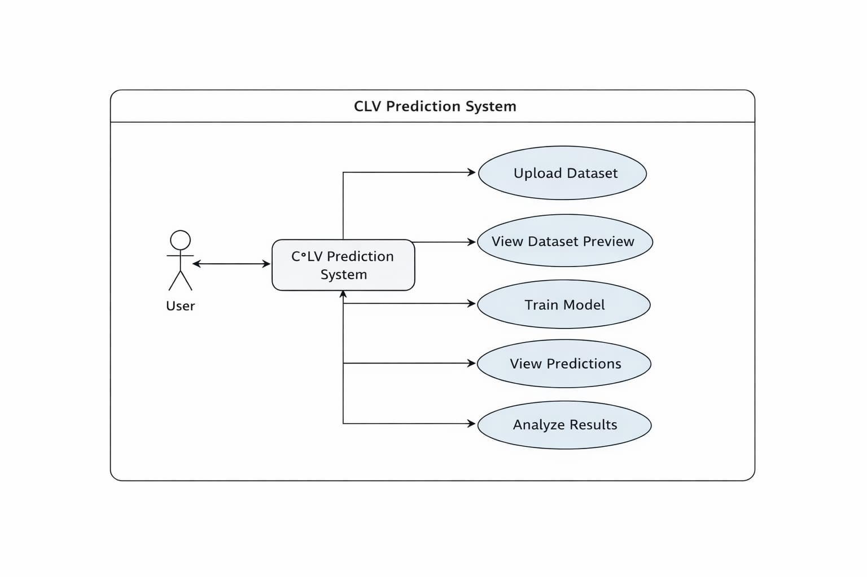

8.2 Integration of Components
All components of the system are integrated seamlessly:
The UI module collects user input
The data processing module prepares the dataset
The machine learning module trains and predicts
The visualization module displays results
This integration ensures smooth communication between components and efficient execution of tasks.

8.3 Database Design
The system does not use a traditional database. Instead:
Data is stored in CSV format
Users upload datasets manually
Data is processed in memory using Pandas
This approach simplifies the system and avoids the need for database management.

8.4 User Interface (UI) Design
The user interface is developed using Streamlit, which provides an interactive and web-based environment.
Key UI Components:
File Upload Section:
Allows users to upload CSV datasets
Dataset Preview:
Displays selected rows of the dataset
Model Performance Section:
Shows evaluation metrics such as MAE and R² score
Visualization Section:
Displays scatter plots of actual vs predicted values
Prediction Table:
Shows sample predicted CLV values
UI Features:
Clean and modern layout
Interactive sliders and inputs
Real-time feedback using loading indicators
Responsive design
The UI is designed to be simple and easy to use, even for non-technical users.

8.5 Model Serving
Model serving refers to how the trained model is used to generate predictions.
In this project:
The model is trained dynamically when data is uploaded
Predictions are generated immediately after training
Results are displayed within the same application
There is no need for external deployment or APIs, as Streamlit handles everything internally.

Chapter 9. Implementation

Introduction
Implementation is the phase where the designed system is converted into a working application using programming tools and technologies. In this project, the implementation focuses on building a machine learning model for predicting Customer Lifetime Value (CLV) and integrating it with a user-friendly web interface using Streamlit.
The system is developed using Python and various libraries for data processing, machine learning, and visualization.

9.1 Code Structure
The project is implemented in a single Python file (app.py) for simplicity and easy deployment. The code is organized into clear logical sections to improve readability and maintenance.
Main sections of the code include:
- Importing required libraries
- Streamlit page setup
- File upload handling
- Data preprocessing
- Model training and prediction
- Performance evaluation
- Graph generation
- Displaying outputs in UI
This structure makes the application easy to understand and modify in the future.

9.2 Model Training Implementation
The machine learning model used in this project is Random Forest Regressor.
The training module performs the following tasks:
- Reads uploaded dataset
- Removes unnecessary columns
- Converts categorical data using one-hot encoding
- Splits dataset into training and testing sets
- Trains the Random Forest model using training data
- Stores the trained model for future prediction
Scikit-learn library functions such as train_test_split() and RandomForestRegressor() are used for implementation.

9.3 Backend Implementation
This project uses Streamlit as the backend framework instead of FastAPI or Flask. Streamlit handles both backend logic and frontend rendering in a single Python environment.
Backend operations include:
- Reading uploaded CSV files
- Processing data using Pandas
- Running machine learning model predictions
- Calculating MAE and R² metrics
- Managing application workflow
Since Streamlit is lightweight, it simplifies development and deployment.

9.4 Frontend Implementation
The frontend of the project is developed using Streamlit web components.
Main UI elements include:
- File uploader for dataset upload
- Dataset preview table
- Buttons and selection options
- Metrics display section
- Prediction result tables
- Charts and graphs
The interface is browser-based, responsive, and user-friendly. It allows users to interact with the machine learning model without coding knowledge.

9.5 Integration of Model with Application
The trained machine learning model is integrated directly into the Streamlit application.
Integration workflow:
- User uploads dataset
- Data is preprocessed
- Model is trained or loaded
- Predictions are generated
- Results are displayed instantly
This allows smooth real-time inference inside the application. Users can easily predict Customer Lifetime Value for new customers.

9.6 Security Measures
Basic security and safe coding practices are followed in the project.
Implemented measures include:
- File type restriction to CSV only
- Input validation for required columns
- Error handling for invalid uploads
- Controlled processing within the local application environment
For future production deployment, advanced security can include:
- User authentication
- API access control
- Encrypted data transfer
- Secure cloud hosting

Chapter 10. MLOps and Deployment

Introduction
Machine Learning Operations (MLOps) is a set of practices that combines machine learning, software engineering, and DevOps to ensure that models are efficiently deployed, monitored, and maintained in real-world applications. It focuses not only on building accurate models but also on making them usable, scalable, and reliable.
In this project, MLOps plays a role in deploying the Customer Lifetime Value (CLV) prediction system as a web application using Streamlit and making it accessible over the internet.

10.1 Overview of MLOps Pipeline
MLOps refers to the practices used to manage the complete lifecycle of machine learning models from development to deployment and monitoring. It combines machine learning, software engineering, and DevOps principles.
The workflow followed in this project is:
Data Collection → Data Preprocessing → Model Training → Model Validation → Deployment → Prediction
Steps involved:
- User uploads vehicle insurance dataset
- Data is cleaned and transformed
- Random Forest model is trained
- Model performance is validated using MAE and R² score
- The trained model is deployed using Streamlit
- Users interact with the application through a browser
This pipeline ensures a structured and repeatable ML workflow.

10.2 Model Versioning
Model versioning is used to track changes in machine learning models over time. Different versions may be created when:
- New data is added
- Hyperparameters are changed
- Features are updated
- Model performance improves
In this project, model files can be saved using joblib for reuse. Each trained version can be stored separately for comparison.
Tools such as:
- DVC (Data Version Control)
- MLflow
can be used in future implementations for advanced model tracking, experiment logging, and version management.

10.3 CI/CD for ML
CI/CD stands for Continuous Integration and Continuous Deployment. It automates testing, updating, and deployment of machine learning systems.
For this project, CI/CD can include:
- Automatic testing when code is updated
- Validation of model performance
- Rebuilding the Streamlit application
- Deploying latest version automatically
Platforms such as GitHub Actions, Jenkins, or GitLab CI/CD can be used.
This reduces manual work and ensures reliable updates.

10.4 Containerization with Docker
Docker is a platform used to package applications along with all dependencies into containers. This ensures that the project runs consistently on any system.
Benefits of Docker:
- Same environment everywhere
- Easy deployment
- Dependency management
- Faster setup
For this project, Docker can package:
- Python environment
- Streamlit application
- Required libraries
- Trained ML model
This makes deployment more professional and production-ready.

10.5 Cloud Deployment
The CLV prediction system is deployed as a web application using Streamlit Cloud. This allows users to access the project through a public URL using any browser.
Deployment steps followed:
- Developed application in app.py
- Installed required libraries
- Uploaded code to GitHub repository
- Connected repository to Streamlit Cloud
- Generated public deployment link
For large-scale deployment, cloud platforms such as:
- AWS
- Microsoft Azure
- Google Cloud Platform (GCP)
can be used.
10.6 Model Monitoring
After deployment, monitoring is important to ensure continued model quality.
Key monitoring areas include:
Accuracy Monitoring
Tracks MAE and R² score over time.
Data Drift
Checks whether new uploaded data differs from training data.
Latency
Measures how quickly predictions are generated.
System Health
Ensures the application is available and responsive.
In this project, basic monitoring is performed through evaluation metrics and user interaction. Future systems can include automatic alerts and retraining mechanisms.

Chapter 11. Testing and Quality Assurance

Introduction
Testing and Quality Assurance (QA) are essential steps in any software and machine learning project to ensure that the system functions correctly, produces accurate results, and provides a good user experience. In this project, testing focuses on verifying the correctness of data processing, model predictions, and the overall functionality of the Streamlit application.

11.1 Testing Strategy
The testing approach used in this project includes:
Functional Testing:
Ensures that each component of the system works as expected.
Model Testing:
Evaluates the accuracy and performance of the machine learning model.
User Interface Testing:
Verifies that the Streamlit interface is responsive and easy to use.
Input Validation Testing:
Checks how the system handles different types of input data.
This structured approach ensures that the system is reliable and error-free.

11.2 Input Validation
The system checks for:
Correct file format (CSV)
Presence of required columns (CustomerLifetimeValue)
Handling invalid or empty inputs
Error messages are displayed if incorrect input is provided, ensuring robustness.

11.3 Unit Testing
Unit testing involves testing individual components of the system separately.
In this project:
Data Loading Module:
Tested to ensure correct reading of CSV files.
Preprocessing Module:
Verified that unnecessary columns are removed and categorical data is encoded correctly.
Model Module:
Checked that the model trains without errors and produces predictions.
Visualization Module:
Ensured that graphs and tables display correctly.
Each module is tested independently to avoid errors in later stages.

11.4 User Interface Testing
The Streamlit interface is tested for:
File upload functionality
Dataset preview display
Slider inputs for selecting rows
Display of performance metrics
Visualization of graphs
The interface is responsive and provides real-time feedback using loading indicators, improving user experience.

11.5 Model Performance Testing
The machine learning model is evaluated using standard regression metrics:
Mean Absolute Error (MAE): Measures average prediction error.
Result: MAE ≈ 1437
Mean Squared Error (MSE): Measures squared prediction error.
R² Score: Indicates how well the model fits the data. Result: R² ≈ 0.68
These results show that the Random Forest model performs significantly better than the baseline Linear Regression model.
The system is tested for speed and efficiency:
Model training and prediction occur within a few seconds
Response time is less than 1 second after processing
The application handles datasets of moderate size efficiently
This ensures smooth operation without delays.

11.6 Error Analysis
Error analysis helps identify where the model performs poorly.
Observations:
Predictions are less accurate for customers with extremely high CLV values
Some outliers increase prediction error
Model may slightly overestimate or underestimate certain values
Despite these limitations, overall performance remains acceptable.

11.7 BiasTesting
Integration testing ensures that all components work together seamlessly.
The following workflow is tested:
User uploads dataset
Data is processed and cleaned
Model is trained
Predictions are generated and Results are displayed
This confirms that the entire pipeline works correctly from input to output.
During testing, some limitations were observed:
Performance may decrease with very large datasets
Model accuracy depends on data quality
Limited handling of extreme outliers

Chapter 12. Results and Discussion

12.1 Model Performance Results
The final model used in this project is the Random Forest Regressor, which was selected after comparing it with Linear Regression.
Performance Metrics:
Mean Absolute Error (MAE): ≈ 1437
This indicates that, on average, the predicted CLV values differ from the actual values by around 1437 units.
Mean Squared Error (MSE):
This metric measures the squared differences between actual and predicted values, giving higher weight to larger errors.
R² Score: ≈ 0.68
This means that the model explains approximately 68% of the variability in the dataset.
Comparison with Baseline Model:
Linear Regression → R² ≈ 0.15 (poor performance)
Random Forest → R² ≈ 0.68 (good performance)
This comparison clearly shows that Random Forest is more effective for this problem.


12.2 Comparison with Baseline
To verify model improvement, the final model is compared with the baseline model.
Baseline Model: Linear Regression
- R² Score ≈ 0.15
- Higher prediction error
- Poor ability to capture complex relationships
Final Model: Random Forest Regressor
- R² Score ≈ 0.68
- Lower MAE
- Better handling of non-linear relationships
Comparison Table
Model | MAE | R² Score | Performance
Linear Regression | High | 0.15 | Poor
Random Forest | Low | 0.68 | Good
This comparison clearly shows that Random Forest significantly outperforms Linear Regression and is more suitable for CLV prediction.

12.3 Real-Time Output Screens
The developed system is deployed using Streamlit, allowing users to interact with the model through a web interface.
The real-time outputs displayed by the application include:
- Dataset preview after file upload
- Model training status using loading spinner
- Performance metrics such as MAE and R² score
- Predicted CLV values for uploaded customers
- Top profitable customers table
- Graphs showing prediction distribution and performance
These outputs make the system user-friendly and allow non-technical users to use the model easily.
12.4 Use Case Demonstration
The practical use of the project can be demonstrated through real-world scenarios in the insurance industry.
Use Case 1: Identifying High-Value Customers
A company uploads new customer data without CLV values. The system predicts CLV and ranks customers. High-value customers can then be prioritized for premium services.
Use Case 2: Customer Retention
Customers predicted to have high future value can be given loyalty benefits, discounts, or personalized offers to improve retention.
Use Case 3: Risk Identification
Customers with frequent claims and low predicted CLV can be identified as risky customers.
Use Case 4: Revenue Planning
Management can focus on profitable customer segments to maximize long-term revenue.
These examples show the practical usefulness of the system.

12.5 Discussion of Findings
The results indicate that the model successfully captures important relationships between customer attributes and profitability.
Key findings include:
- Customers with higher monthly premiums tend to have higher predicted CLV.
- Customers with multiple policies are generally more valuable.
- High claim amounts reduce customer profitability.
- Income level indirectly affects premium selection and customer value.
- Most customers fall into low-to-medium CLV ranges, while only a few customers generate very high profit.
Strengths of the Model
- Handles complex and non-linear relationships
- Better accuracy than simple linear models
- Works with numerical and categorical data
- Produces stable and reliable predictions
Limitations of the Model
- Less accurate for extreme outlier values
- Performance depends on dataset quality
- Training time increases for larger datasets
- Less interpretable than linear models
Future Improvements
The system can be enhanced by:
- Using advanced models such as XGBoost or Gradient Boosting
- Performing hyperparameter tuning
- Improving feature engineering
- Better handling of outliers
- Cloud deployment for scalability

Chapter 13. Project Retrospective

Introduction
The project retrospective provides a reflection on the overall development process, highlighting achievements, challenges faced, and lessons learned. It helps in understanding how the project evolved from the initial idea to a complete working system. In this project, the focus was on predicting Customer Lifetime Value (CLV) using machine learning and deploying it through a Streamlit-based web application.

13.1 Achievements
The project successfully achieved its primary objectives:
Development of a Machine Learning Model:
A Random Forest Regressor was implemented to predict Customer Lifetime Value with good accuracy.
Improved Model Performance:
Compared to Linear Regression, the Random Forest model showed significant improvement, achieving an R² score of approximately 0.68.
End-to-End System Implementation:
The project covers all stages, including data preprocessing, model training, evaluation, and deployment.
Interactive Web Application:
A user-friendly interface was developed using Streamlit, allowing users to upload datasets and view predictions easily.
Real-Time Prediction:
The system provides quick predictions and displays results instantly, enhancing usability.
These achievements demonstrate the successful application of machine learning to solve a real-world problem.

13.2 Challenges Faced
During the development of the project, several challenges were encountered:
Understanding the Dataset:
Initially, interpreting the dataset and identifying relevant features was difficult due to the presence of multiple variables.
Handling Categorical Data:
Converting categorical variables into numerical form required proper encoding techniques.
Model Selection:
Choosing the right model was challenging, as Linear Regression did not perform well initially.
Debugging Errors:
Issues related to missing columns, library compatibility, and runtime errors required troubleshooting.
UI Development:
Designing an interactive and user-friendly interface in Streamlit required multiple improvements.
These challenges were addressed through experimentation, research, and iterative development.

13.3 Lessons Learned
The project provided several valuable learning experiences:
Importance of Data Preprocessing:
Proper cleaning and preparation of data significantly impact model performance.
Model Comparison is Essential:
Testing multiple models helps in selecting the best-performing algorithm.
Understanding Metrics:
Learning how to interpret MAE, MSE, and R² score is crucial for evaluating models.
Practical Application of Machine Learning:
The project demonstrated how theoretical concepts can be applied to real-world problems.
User-Centric Design:
Building a simple and interactive interface improves usability and user experience.
These lessons are important for future projects and professional development.

13.4 Best Practices Followed
Several best practices were followed during the development of this project to ensure quality and maintainability.
- Version Control: Different versions of the project were managed properly to track updates and changes.
- Coding Standards: Clean and readable code was written using proper naming conventions, indentation, and modular structure.
- Documentation: Clear documentation was maintained for objectives, dataset, preprocessing, model development, and deployment steps.
- Data Handling: Missing values were checked, irrelevant columns were removed, and categorical data was encoded correctly.
- Model Development: Baseline and final models were compared using MAE and R² score for better selection.
- Deployment Practices: The model was integrated into a Streamlit web application with file upload, predictions, and result display.
These practices improved the reliability, usability, and future scalability of the project.

Chapter 14. Conclusion and Future Work

14.1 Conclusion
This project successfully demonstrates the application of machine learning techniques to predict Customer Lifetime Value (CLV) in the vehicle insurance domain. The primary objective was to develop a system that can analyze customer data and estimate the long-term value of each customer, helping insurance companies make better business decisions.
The project began with data collection and preprocessing, where raw data was cleaned and transformed into a suitable format. Categorical variables were encoded, and irrelevant features were removed to improve model efficiency. Exploratory Data Analysis (EDA) provided valuable insights into relationships between features such as premium, claim amount, and customer value.
Two models were evaluated: Linear Regression and Random Forest. While Linear Regression served as a baseline, it showed poor performance due to its inability to capture complex relationships in the data. Random Forest Regressor, on the other hand, performed significantly better by handling non-linear patterns effectively. The final model achieved an R² score of approximately 0.68 and a low Mean Absolute Error, indicating good prediction accuracy.
The system was implemented as an interactive web application using Streamlit. This allows users to upload datasets, view previews, train the model, and obtain predictions in real time. The application also provides performance metrics and visualizations, making it easy for users to interpret results.
Overall, the project highlights the importance of data preprocessing, feature engineering, and model selection in building an effective machine learning solution. It also demonstrates how such systems can be deployed in a user-friendly manner to solve real-world problems in the insurance industry.

14.2 Potential Industry Deployment
This project has strong potential for deployment in the vehicle insurance industry. Insurance companies can integrate the system into their existing platforms to predict Customer Lifetime Value (CLV) for new and existing customers.
The model can help companies identify high-value customers, improve customer retention strategies, and offer personalized insurance plans. It can also assist in detecting low-profit or high-risk customers based on claim history and policy behavior.
The system can be deployed as a web application or cloud-based service for real-time predictions. With integration into company databases and CRM systems, it can support better decision-making, targeted marketing, and revenue optimization.
Overall, this project can be scaled into a practical business intelligence tool for insurance companies.

14.3 Future Work
Although the project achieves its objectives, there are several opportunities for improvement and expansion:
Model Enhancement:
Advanced algorithms such as XGBoost, Gradient Boosting, or Neural Networks can be used to improve prediction accuracy.
Hyperparameter Tuning:
Fine-tuning model parameters can further optimize performance and reduce prediction errors.
Handling Large Datasets:
The system can be enhanced to efficiently process larger datasets using distributed computing or cloud-based solutions.
Real-Time Data Integration:
Integration with live insurance databases can enable real-time predictions and continuous learning.
Cloud Deployment:
Deploying the application on cloud platforms like AWS or Azure can make it accessible to a wider audience.
Enhanced User Interface:
Adding more interactive visualizations and dashboards can improve user experience.
Customer Segmentation:
Extending the system to classify customers into categories (high-value, low-value) can provide additional business insights.
Model Monitoring (MLOps):
Implementing automated retraining and monitoring systems can ensure long-term reliability and accuracy.

Chapter 15. References

- Kaggle, “Insurance Customer Dataset,” Available: https://www.kaggle.com/
- Streamlit Documentation, “Build Data Apps in Python,” Available: https://docs.streamlit.io/
- Scikit-learn Documentation, “Machine Learning in Python,” Available: https://scikit-learn.org/
- Pandas Documentation, “Python Data Analysis Library,” Available: https://pandas.pydata.org/
- NumPy Documentation, “Scientific Computing with Python,” Available: https://numpy.org/
- Matplotlib Documentation, “Visualization with Python,” Available: https://matplotlib.org/
- Joblib Documentation, “Lightweight Pipelining in Python,” Available: https://joblib.readthedocs.io/
- Géron, A., Hands-On Machine Learning with Scikit-Learn, Keras & TensorFlow, O’Reilly Media, 2019.
- Han, J., Kamber, M., and Pei, J., Data Mining: Concepts and Techniques, Morgan Kaufmann Publishers.
- Official Python Documentation, “Python Programming Language,” Available: https://www.python.org/

Chapter 16. Appendices

Deployed Link
https://clvpredictorvehicleinsurance-pv4rutexbqduudfxixhssp.streamlit.app/

Code
import streamlit as st
import pandas as pd
import numpy as np
import matplotlib.pyplot as plt
import joblib

from sklearn.model_selection import train_test_split
from sklearn.ensemble import RandomForestRegressor
from sklearn.metrics import mean_absolute_error, r2_score

st.set_page_config(page_title="CLV Predictor")

st.title("Customer Lifetime Value Prediction")

# Mode selection
mode = st.radio("Select Mode", ["Train Model", "Predict"])

# ===========================
# TRAIN MODEL
# ===========================
if mode == "Train Model":

uploaded_file = st.file_uploader("Upload Training Dataset (WITH CLV)", type=["csv"])

if uploaded_file is not None:
data = pd.read_csv(uploaded_file)

st.subheader("Dataset Preview")
st.dataframe(data.head())

if "CustomerLifetimeValue" not in data.columns:
st.error("Dataset must contain CustomerLifetimeValue column")
st.stop()

with st.spinner("Training model..."):

if "Unnamed: 0" in data.columns:
data = data.drop("Unnamed: 0", axis=1)
if "Customer" in data.columns:
data = data.drop("Customer", axis=1)

X = data.drop("CustomerLifetimeValue", axis=1)
y = data["CustomerLifetimeValue"]

X = pd.get_dummies(X, drop_first=True)

X_train, X_test, y_train, y_test = train_test_split(
X, y, test_size=0.2, random_state=42
)

model = RandomForestRegressor(n_estimators=100, random_state=42)
model.fit(X_train, y_train)

predictions = model.predict(X_test)

mae = mean_absolute_error(y_test, predictions)
r2 = r2_score(y_test, predictions)

joblib.dump(model, "clv_model.pkl")
joblib.dump(X.columns, "columns.pkl")

st.success("Model trained and saved")

st.write("MAE:", round(mae, 2))
st.write("R2 Score:", round(r2, 2))

fig, ax = plt.subplots()
ax.scatter(y_test, predictions)
ax.set_xlabel("Actual CLV")
ax.set_ylabel("Predicted CLV")
st.pyplot(fig)

# ===========================
# PREDICT
# ===========================
elif mode == "Predict":

uploaded_file = st.file_uploader("Upload New Dataset (WITHOUT CLV)", type=["csv"])

if uploaded_file is not None:

try:
model = joblib.load("clv_model.pkl")
columns = joblib.load("columns.pkl")
except:
st.error("Train model first")
st.stop()

data = pd.read_csv(uploaded_file)

st.subheader("Dataset Preview")
st.dataframe(data.head())

with st.spinner("Predicting..."):

if "Unnamed: 0" in data.columns:
data = data.drop("Unnamed: 0", axis=1)
if "Customer" in data.columns:
data = data.drop("Customer", axis=1)

data_encoded = pd.get_dummies(data, drop_first=True)
data_encoded = data_encoded.reindex(columns=columns, fill_value=0)

predictions = model.predict(data_encoded)
data["Predicted_CLV"] = predictions

st.success("Prediction completed")

st.subheader("Predictions")
st.dataframe(data)

st.subheader("Top Profitable Customers")

top_n = st.slider("Select Top Customers", 1, 20, 5)

top_customers = data.sort_values(by="Predicted_CLV", ascending=False)
st.dataframe(top_customers.head(top_n))

fig, ax = plt.subplots()
ax.hist(predictions, bins=20)
ax.set_title("Predicted CLV Distribution")
st.pyplot(fig)

ScreenShots:
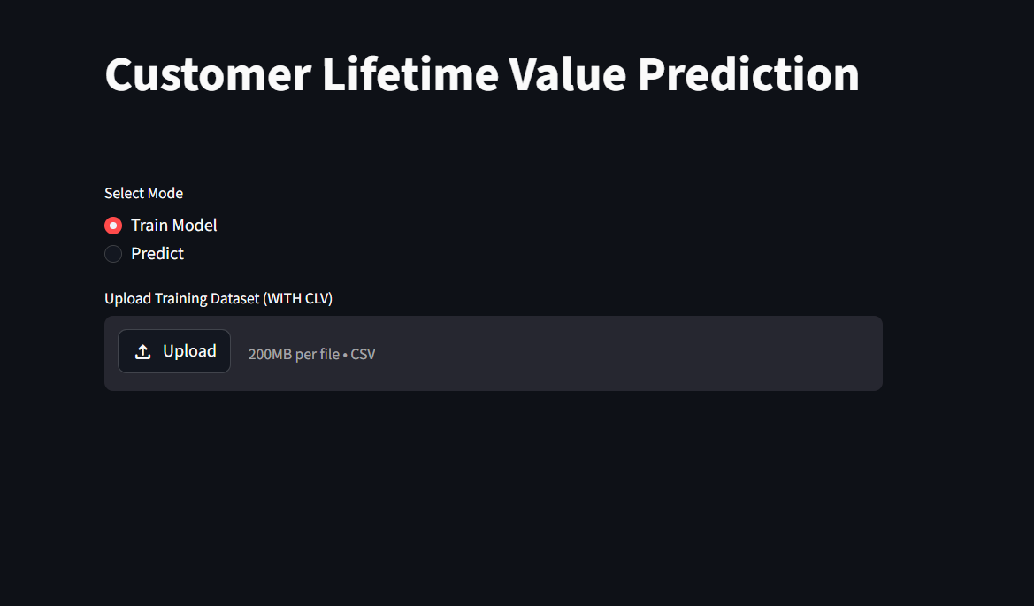

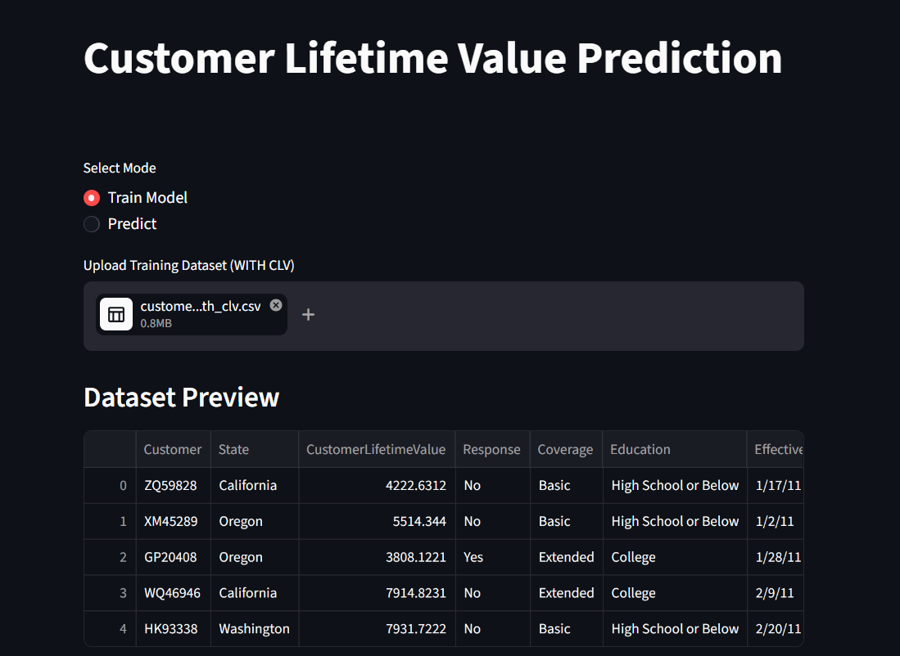
Training Model

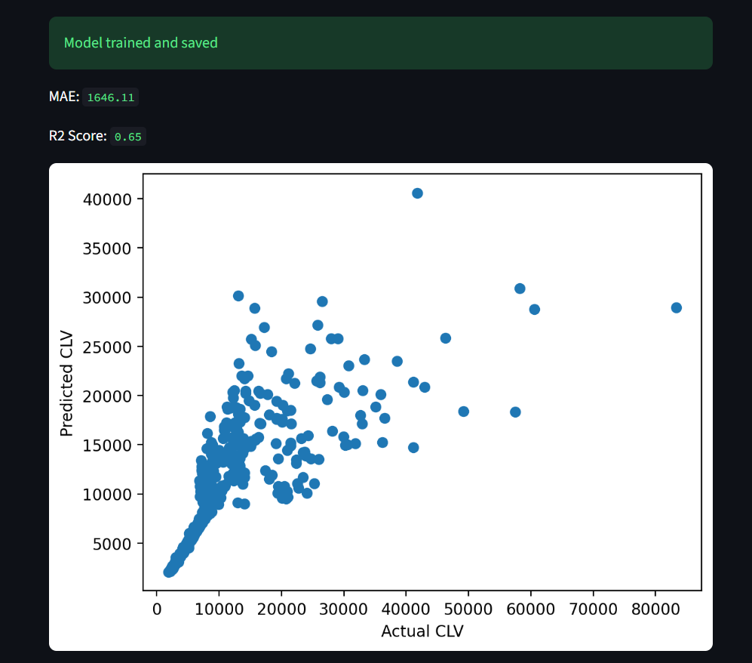

Prediction Model
