Ange Nadette BATETE

Y3C

On 20 September 2024

**Python homework**

**Type conversion:** In Python refers to the process of converting a value from one data type to another. This is done either happen **automatically (implicit)** or **manually(explicit)**

* **Implicit type conversion**

Python automatically converts one data type to another, when necessary, usually when performing operations between different types.

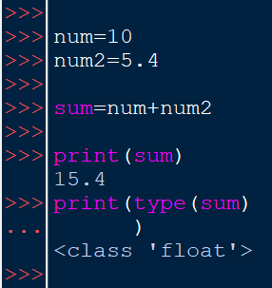

* **Explicit type conversion**

Explicit type conversion is done manually by the programmer using built-in functions. Some of the commonly used type conversion functions are:

**int():** converts a value to an integer.

**float():** converts a value to a float.

**str():** converts a value to a string.

**complex():** converts a value to a complex number.

**list(), tuple(), set():** convert to collection types.

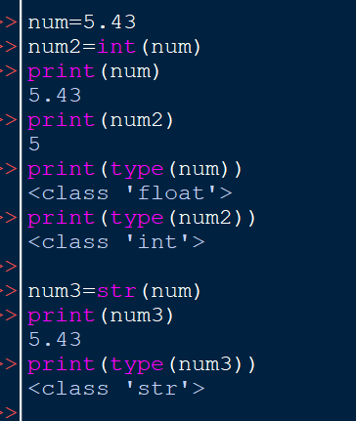

* **Exception:** In some cases type conversion doesn’t happen.

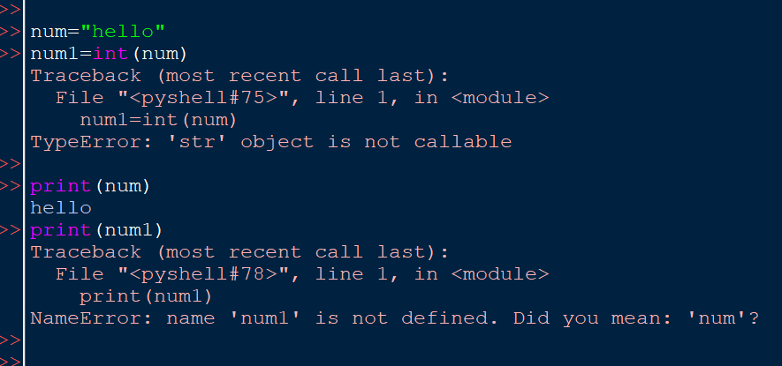

**1. Extracting Imaginary and Real Parts of a Complex Number:**

In Python, a complex number is represented as a + bj, where **a** is the real part, and **b** is the imaginary part. To extract the real and imaginary parts, you can use the **.real** and **.imag** attributes.

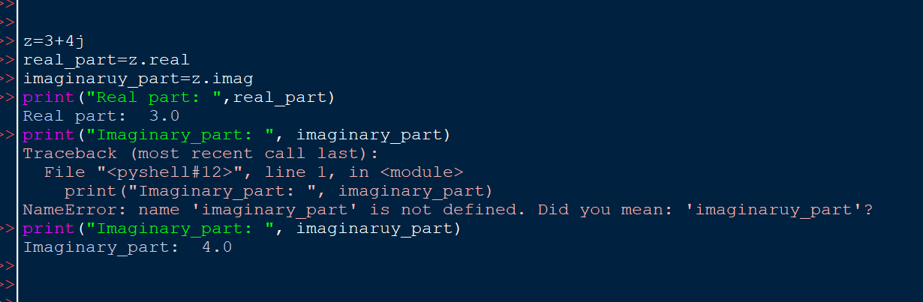

**2. Arithmetic Operations on Complex Numbers:**

Python allows basic arithmetic operations on complex numbers. These include addition, subtraction, multiplication, division, and even exponentiation.

1. **Addition and Subtraction:**

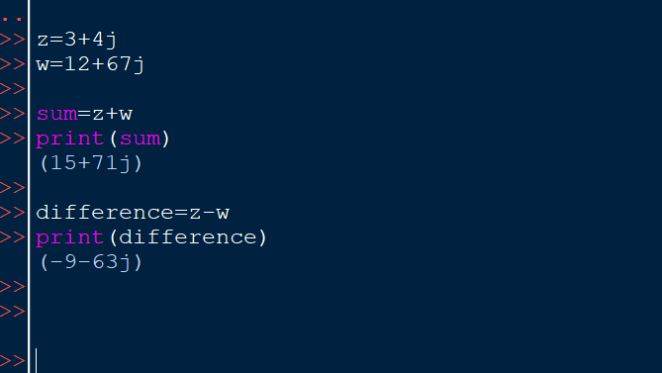

1. **Multiplication and Division**

