MA10230 Methods and Applications 1A, 2017/18

## MA10230 Methods and Applications 1A, 2017/18

Thomas Cottrell

September 2017

### Lecture notes and audio recording

#### Department of Mathematical Sciences, The University of Bath

I accept that the material included in the lecture, notes and any recording made of the lecture is protected by copyright and may be used only for my own personal study. I will not make or distribute copies nor allow any other person to have access to or use the notes or any recording.

I acknowledge that the lecture or the notes may contain accidental inaccuracies and that it is intended to be used in conjunction with other materials or sources and my own self study activities. I understand that the future supply of notes/permission to record lectures is dependent on my keeping to this condition.

### Contents

Introduction  
1 Integration  
 1.1 Fundamental Theorem of Calculus  
 1.2 Hyperbolic functions  
 1.3 Integrating functions involving square roots  
 1.4 Integrating rational functions  
 1.5 Reciprocals of trigonometric functions  
 1.6 Reduction formulae  
 1.7 Arc length and surface areas of revolution  
2 Multivariable Differentiation  
 2.1 Functions of several variables  
 2.2 Partial derivatives  
 2.3 Critical points  
 2.4 Chain rules  
3 Multivariable Integration  
 3.1 Double integrals  
 3.2 Change of variable using the Jacobian  
 3.3 Polar coordinates  
 3.4 Double integrals in polar coordinates  
 3.5 Triple integrals  
 3.6 Triple integrals in spherical coordinates  
4 Ordinary Differential Equations (ODEs)  
 4.1 Overview  
 4.2 Separable first order differential equations  
 4.3 Homogeneous equations  
 4.4 Linear first order ordinary differential equations  
 4.5 Bernoulli equations  
 4.6 Exact equations  
 4.7 Linear second order ordinary differential equations

### List of Figures

1 Exponential growth  
2 The area   
3   
4   
5   
6  corresponds to twice the shaded area  
7 Finding a substitution to integrate the curve   
8 Definite integral of the curve   
9   
10 Hyperboloid of revolution  
11 Plane intersecting   
12 A function with an absolute maximum and absolute minimum.  
13 A function with a relative maximum that is not absolute.  
14 Saddle point  
15 Volume between region and surface   
16 Region subdivision  
17 Rectangular region   
18 Type I region  
19 Type II region  
20 Example region 1  
21 Example region 2  
22 Region of evaluation  
23 Choose axes and to achieve this region  
24 Sketch of region  
25 Cartesian coordinates  
26 Polar coordinates  
27 Triangle with vertices , ,   
28 Archimedean spiral  
29 Logarithmic spiral  
30 Cardioid  
31 A simple polar region  
32 Region which is not rectangular  
33 Region   
34 Type I region  
35 Form of regions  
36 Projection of onto the -plane  
37 Spherical coordinates  
38 Upper hemisphere  
39 Sketch of example

### List of Tables

#### Overview and Aims

**Semester 1:** MA10230 Methods and Applications 1A: Calculus

**Semester 2:** MA10236 Methods and Applications 1B: Vectors and Mechanics

* Revise integration, and use integration techniques to integrate a variety of functions.
* Introduce calculus in several variables: partial differentiation, double and triple integrals.
* Introduce various types of ordinary differential equations (ODEs).
* Show how these methods help us solve many problems arising in applications.
* Provide foundations for Mechanics in Semester 2.
* Links with Analysis – which explains the maths behind the methods.

### Introduction

The following example is intended to illustrate how calculus is applied in other fields. You don’t have to follow every step at this stage (although some of you will). By the end of the unit, you should be able to tackle more complex examples.

Example.

Application: predicting global population.

Population is a function of time .

Express this as:

A.

**Table**

|  |  |
| --- | --- |
|  |  |
| Year | Population (millions) |
|  |  |
| 1000 | 310 |
|  |  |
| 1800 | 978 |
|  |  |
| 1900 | 1650 |
|  |  |
| 1990 | 5263 |
|  |  |
| 2000 | 6070 |
|  |  |
| 2008 | 6707 |
|  |  |
| 2008 | 6707 |
|  |  |
| 2010 | 6873 |
|  |  |
|  |  |

B.

**Graph** (figure (1))

No alt text was set.

Figure 1: Exponential growth

C.

**Differential equation**

Population is . What is the **rate of change** of the population?

In a time interval :

* A proportion of population produce children.
* A proportion of population die.
* A proportion of population emigrate to Mars.

So,

where .

Let (see analysis course).

Then

A differential equation like this, describing population growth, was used by Thomas Malthus, early 19th century.

#### Parameter estimation

The UN estimates that the population grows by per year.

Let be time in years.

We separate the variables in our differential equation, then integrate (details later, when we study differential equations).

We are interested in the change over one year, so let , so , and consider

This is the proportional increase in population over one year, so the UN estimate tells us that

Hence

#### Application

How long would it take for the population to double?

Pros:

* Model easy to solve
* Gives testable predictions

Cons:

* Unrealistic – does not include effects of resource depletion, over-crowding, medical advances, agricultural advances, etc.

To construct more realistic models, we will need to be able to

* work with more than one independent variable;
* construct and solve more complex differential equations;
* evaluate more complex integrals.

### 1 Integration

Recall: There are two different types of integral. Suppose we have a function .

1.

The **indefinite integral** of is a function such that

We write

This defines integration as the inverse of differentiation (antidifferentiation). is called the **antiderivative** of .

2.

The **definite integral** is defined as the **net signed area** between and the horizontal axis between and . It is written

You are probably used to using indefinite integrals to evaluate definite integrals, e.g.

But why are we allowed to combine definite and indefinite integrals in this way?

#### 1.1 Fundamental Theorem of Calculus

This theorem establishes the astonishing connection between indefinite and definite integrals.

Theorem 1.1.

Let be a continuous function on .

**Part A.**

The function has an antiderivative given by

(signed area between and , definite integral).

**Part B.**

Given any antiderivative of ,

We don’t have the formal mathematics required to prove this rigorously, and won’t have until Semester 2 of Analysis 1. Isaac Newton didn’t have that formal mathematics yet either, so we (roughly) followed the method of justification he used in 1669.

Justification of Part A.

We wish to differentiate

Suppose changes by a small increment . The corresponding change in is , so the average rate of change from to is

As , this approaches the derivative .

Now, consider the diagram in figure (2).

No alt text was set.

Figure 2: The area

By definition of the definite integral defining ,

There is a point with such that , as shown in figure (2). So

Hence

As , (since it gets sandwiched between and ), so and

Hence is an antiderivative for .

(see Analysis 1 Semester 2 for a rigorous proof). □

Note that this result allows us to differentiate certain functions defined in terms of integrals. Explicitly, the statement “ is an antiderivative for ” means that

Notice also that the derivative of does not depend on the lower limit of the integral, . If we were to evaluate the integral and write an explicit expression for (assuming that this is possible), this constant would only contribute a constant term to that expression; the derivative of that constant term would therefore be .

Justification of Part B.

Let be an antiderivative of .

So

Hence

Now

so

□

Corollary 1.2.

Proof.  Let be an antiderivative of , so

Then by Fundamental Theorem of Calculus,

□

#### 1.2 Hyperbolic functions

Hyperbolic functions are a type of function related to trigonometric functions. We will use them to help us integrate various types of functions, using a technique called **integration by substitution**, which we’ll meet in the next section.

##### Sketches

What do and look like?

As , .

As , .

.

No alt text was set.

Figure 3:

Hanging chains (e.g. those in suspension bridges) have shape, called a "catenary".

Soap bubbles between wands have a surface derived from the shape.

As , .

As , .

No alt text was set.

Figure 4:

As , .

As , .

No alt text was set.

Figure 5:

##### Hyperbolic identities

Hyperbolic functions satisfy identities similar to trigonometric identities.

Examples.

1.

because

Compare this with the trigonometric identity

2.

Using and dividing through by gives

i.e.

Compare this with the trigonometric identity

3.

The hyperbolic addition formula for is

The corresponding trigonometric identity is

(See Exercise Sheet 1.)

4.

The hyperbolic addition formula for is

The corresponding trigonometric identity is

In fact, **Osborn’s Rule** states that any trigonometric identity can be converted into a hyperbolic identity by

* replacing trigonometric functions with their hyperbolic counterparts,
* swapping the sign of any product of two s.

Note: be careful with the second step, e.g.

so becomes (see Example 2).

This arises because hyperbolic and trigonometric functions are related as follows:

where .

This comes from Euler’s relation:

##### Geometric interpretation

In trigonometric expressions such as , , etc., can be interpreted as an angle. Similarly, in and , can be interpreted as an area.

Since , for any , the point lies on the curve . Then corresponds to twice the area bounded by this curve, the -axis, and the line from the origin to the point , as shown in figure (6).

No alt text was set.

Figure 6: corresponds to twice the shaded area

Because of this, the inverse hyperbolic functions are denoted , , etc. – “ar” is an abbreviation of “area”.

##### Differentiating hyperbolic functions

Since hyperbolic functions are defined in terms of the exponential function, they are straightforward to differentiate.

Similarly,

#### 1.3 Integrating functions involving square roots

Integrals involving functions with square roots often arise in mechanics. In this section, we will investigate methods for integrating them using trigonometric and hyperbolic substitutions.

Recall that integration by substitution is a technique for evaluating integrals involving composite functions, using the formula

derived from the chain rule for differentiation. (For a more detailed reminder of integration by substitution, see the additional notes on the course Moodle page.)

Example.

Evaluate the integral

where .

The integrand is a semicircle with radius . To inform which choice of substitution to use, consider figure (7). The coordinates of any point on the curve can be expressed in terms of , the angle between the -axis and the line segment from the origin to that point, using trigonometric functions.

No alt text was set.

Figure 7: Finding a substitution to integrate the curve

From the right-angled triangle in figure (7), we see that

We will use this for our substitution. Then , , and

using ; alternatively, one can deduce this from the right-angled triangle in figure (7).

Thus the integral is

The second term can be simplified further: using the trigonometric identities

we have

Thus

For a geometric interpretation of this answer, consider the definite integral

|  |  |
| --- | --- |
|  | (1.1) |

where . This definite integral is the area shown in figure (8), divided into two regions, and .

No alt text was set.

Figure 8: Definite integral of the curve

The region is a sector of a circle of radius with angle , and therefore has area

the first term in the expression for the definite integral (1.1).

The region is a triangle with base length and height , and therefore has area

the second term in the expression for the definite integral (1.1).

There are a total of six similar cases (including this one) of integrals involving square roots:

1.

( )

2.

( )

3.

4.

5.

( )

6.

( )

Case 2.

This integrand includes the same square root expression as Case 1, so we use the same substitution,

With this substitution, and .

Case 3.

In Cases 1 and 2, we simplified the square root using the trigonometric identity

In this case, we will use the hyperbolic identity

in a similar way. To do this, we use the substitution , so

Recall from Exercise Sheet 1, question 4(a), that

so

Case 4, 5 and 6.

See Exercise Sheet 2.

#### 1.4 Integrating rational functions

In this section, we will investigate methods for integrating rational functions. A rational function is a function of the form

They can be used to approximate many other functions.

##### Numerator , denominator linear

So

##### Numerator , denominator quadratic

We first consider two simpler cases, then show how the general case can be reduced to one of these.

Examples 1.3.

1.

Substitution: let , so that .

Then

so

2.

In this case, we have several options:

* Use partial fractions:
* If , use . Then .
* If , use , so .

We will not cover the details of the substitutions here, since they are so similar to the substitution in Case 1.

##### General quadratic denominator

Given an integral with a general quadratic denominator,

|  |  |
| --- | --- |
|  | (1.2) |

we perform the following steps:

* Complete the square in the denominator.
* Use a substitution to transform this into
* with and constant.
* If , this can be integrated directly.
* Otherwise, integrate using the method from Case 1 or Case 2 from Examples 1.3.

Example 1.4.  
 Evaluate

We have completed the square in the denominator. Now let , so . Then

For completeness, there follows an argument for evaluating 1.2 for general values of , and . Since this is notationally fiddly, but not substantially more complicated than the previous example, this general argument will not be covered in the lectures.

The denominator is

To simplify the notation, write , which is a constant. We make the substitution , so .

Then, from (1.3),

so

If , use substitution for with .

If , use partial fractions or a or substitution for with .

If , the integral does not require a substitution.

##### General quadratic numerator and denominator

Given an integral with a general quadratic numerator and denominator,

we use a series of transformations to break this into expressions that we already know how to integrate.

Example.  
Evaluate

We write for the integrand. First, we manipulate the integrand to remove the term from the numerator:

We cannot do the same to simplify the linear over quadratic term; however, this would be straightforward to integrate if the numerator was the derivative of the denominator.

Observe: , so we write

We have broken into three terms that we can integrate. Notice that the third term is a multiple of the function from Example 1.4. We get

As before, the fully general case will not be covered in lectures, but is included here for completeness:

#### 1.5 Reciprocals of trigonometric functions

The methods in the previous have uses beyond integrating rational functions. Certain other integrals can be evaluated by making a careful choice of substitution that converts the integrand into a rational function.

In the following examples we look at substitution that does this for integrals involving trigonometric functions. The substitution we will use is not at all obvious substitution – it was described by Michael Spivak (author of one of the recommended books for Analysis 1) as “the world’s sneakiest substitution”.

Example.  
Evaluate .

We will use the substitution . Consider the right-angled triangle

No alt text was set.

We have

so

Also

so

Observe that this substitution will convert any integral involving only , and , combined by addition, multiplication and division, into the integral of a rational function. We now use it to evaluate the integral in our example.

Then

#### 1.6 Reduction formulae

Recall that integration by parts is a technique for evaluating integrals involving products of functions using the formula

which is derived from the product rule for differentiation. (For a more detailed reminder of integration by parts, see the additional notes on the course Moodle page.)

Sometimes complicated integrals can be reduced to simpler expressions by successive application of integration by parts, giving a type of formula called a **reduction formula**.

Examples.

1.

,

Write

Let

so

Then, using integration by parts,

This formula allows us to evaluate for a given value of – provided we also do so for all lower values of :

so

2.

,

Write this as

Let

so

Then, using integration by parts,

But

Rearranging this gives

We can use this calculate any . For example, when , we get

#### 1.7 Arc length and surface areas of revolution

##### Arc length

We often need to know the length of a curve between two points, e.g. what is the length of the ropes holding Clifton suspension bridge (see Exercise Sheet 3).

**Idea.**  Given a curve

No alt text was set.

Let be the arc length and a short section of it.

No alt text was set.

By Pythagoras’ Theorem,

As this becomes an identity

The arclength between and is then

Example.

Find the arc length of the graph of the function

on the interval .

Sketch the graph of for :

If , is undefined.

We have if , hence never.

As , .  
As , as well.

No alt text was set.

Also,

So when .

Now, the arc length is

with

Thus,

Example.

It can be shown that a hanging chain forms a curve (see Exercise Sheet 4 Q.5)

The arc length on the interval is

**Warning.**  Calculating arc length often leads to integrals we cannot evaluate, e.g. yields

##### Surface areas of revolutions

Given a curve we can generate a surface (of revolution) by rotating the curve about the -axis.

What is the area of such a surface?

**Idea.**  Split the shell into thin strips

No alt text was set.

The area of the shell of a Conical Frustum is .

Thus, the area of the strip is approximately (set )

As

Hence, using the previous arclength formula

Example.

Consider the curve , creating a hyperboloid of revolution (the flipped cooling tower).

No alt text was set.

Figure 9:

No alt text was set.

Figure 10: Hyperboloid of revolution

As

the surface area is

Hence, the substitution yields and so

### 2 Multivariable Differentiation

So far we have worked only with functions in one variable (usually called or ). In this chapter we will look at functions of multiple variables where those variables are allowed to be independent of one another. The calculus of such functions is more complicated than the single variable case, and we will look at this in detail for functions of and variables.

#### 2.1 Functions of several variables

As always in this course, we will only deal with real functions of real variables. Although we allow multiple variables, the value of the function will still be a single real number.

Definition 2.1.  
For a (non-zero) natural number , a **function of variables** is a function

or a function

where .

##### Remarks:

* We will focus on the cases when and .
* As with the single variable case, we have to allow the domain to be a subset of , in case there are points at which the function is not defined (e.g. due to dividing by , square roots of negatives, etc.).
* The codomain of our functions is always , **not** .

##### Notation:

* For a function of variables, we write
* for the value of at the point .
* Similarly, for a function of variables, we write
* For a function of variables, we write

Examples.

1.

Equation of a plane: linear expression in and , e.g.

2.

Polynomials in and , e.g.

3.

We can include terms involving both and :

4.

A trigonometric example:

We will use these examples throughout this chapter. 3D plots shown in the lecture.

#### 2.2 Partial derivatives

In this section we develop the tools for studying rates of change of functions of more than one variable. As usual we do this using differentiation.

We look at the two-variable case first (other cases are similar). We are used to differentiating with respect to an independent variable, but now we have two independent variables, and .

Two possibilities:

* Differentiate with respect to ; keep fixed.
* Differentiate with respect to ; keep fixed.

We can do either of these. The derivatives we get are called **partial derivatives**.

Definition 2.2.  
Given a function of two variables, if is a point in the domain of , the **partial derivative of with respect to**  is

Similarly, the **partial derivative of with respect to**  is

This definition may look scary but the moral is fairly simple: if we fix , becomes a function of only, and we can differentiate it with respect to in the usual way (and vice versa).

##### Notation:

The partial derivatives are themselves functions of two variables . We write them either as

or

The symbol is a stylised used mainly for partial derivatives. It is derived from the Cyrillic alphabet.

##### Interpretation

In the definition of , we treated as a constant (holding fixed) and differentiated with respect to . The act of fixing a value of corresponds to looking at a certain plane with an equation of the form , a constant. Such a plane intersects , as shown in figure (11).

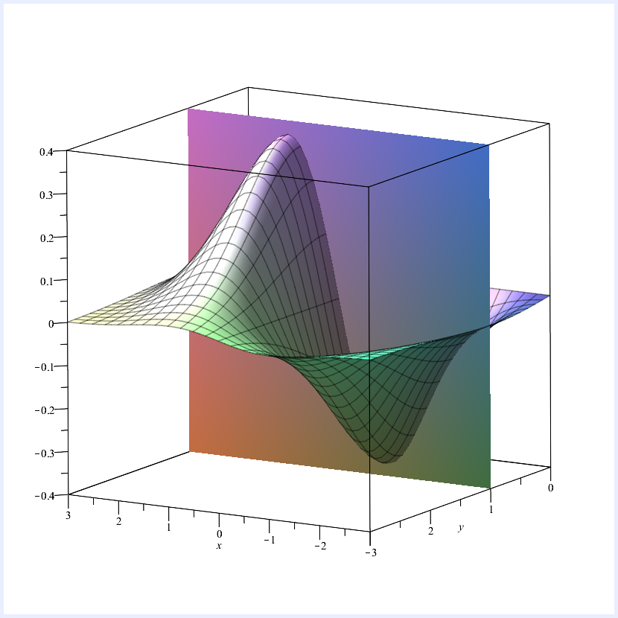

Figure 11: Plane intersecting

The intersection of the surface and the plane is a curve that depends on . The value of the partial derivative at a particular point is the gradient of this curve for that particular value. Similarly, for , the plane intersects in a curve; is the gradient of this curve for a given value.

Examples.

1.

, then

2.

, then

3.

, then

4.

, then

##### Higher order partial derivatives

Partial derivatives are functions of two variables, so they have partial derivatives of their own. The resulting functions are called **second order partial derivatives**. This is like the second derivative of a function of one variable, but now we have four possibilities:

The last two cases are called **mixed second-order partial derivatives**.

Similarly, third order, fourth order, etc. partial derivatives can be obtained by successive differentiation.

Examples.

1.

, then

2.

, then

3.

, then

4.

, then

##### Equality of mixed partials

In the examples, the two mixed partials were equal. This is true in general.

Theorem 2.3 (Clairaut’s Theorem).  
 Let be a function of two variables. If and are continuous at a point , then

See Analysis 2B for a proof. A version of Theorem 2.3 also holds in the -variable case for .

#### 2.3 Critical points

In the one-variable case we can use the derivative of a function to find its critical points: maxima, minima, and points of inflection. We can do something similar for functions of two variables, using partial derivatives.

First, we want to know what kind of features we’re trying to identify. As in the one-variable case, we have **maxima** and **minima**, which can be either absolute (aka global) or relative (aka local) (see figure (12)).

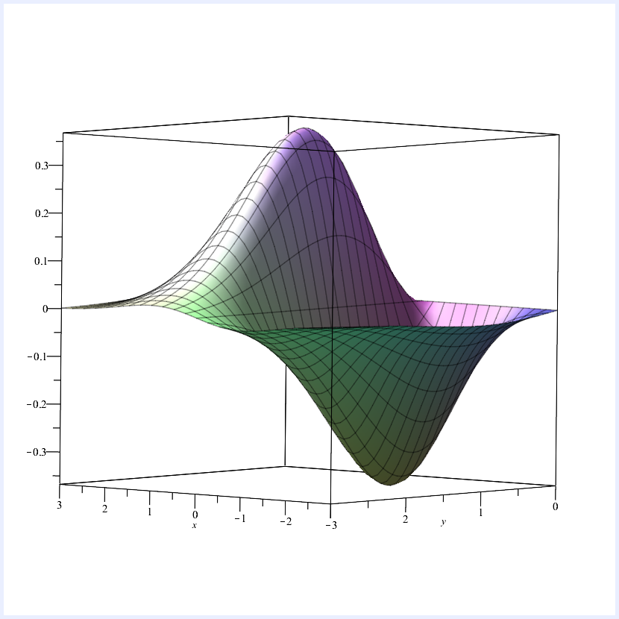

Figure 12: A function with an absolute maximum and absolute minimum.

The definitions of global maxima and minima are straightforward:

Definition 2.4.  
A function of two variables is said to have an **absolute maximum** at if for all .

A function of two variables is said to have an **absolute minimum** at if for all .

The definitions of the relative versions are a bit fiddly (see figure (13)):

Definition 2.5.  
A function of two variables is said to have a **relative maximum** at if there is a disc centred at such that for all inside the disc.

A function of two variables is said to have a **relative minimum** at if there is a disc centred at such that for all inside the disc.

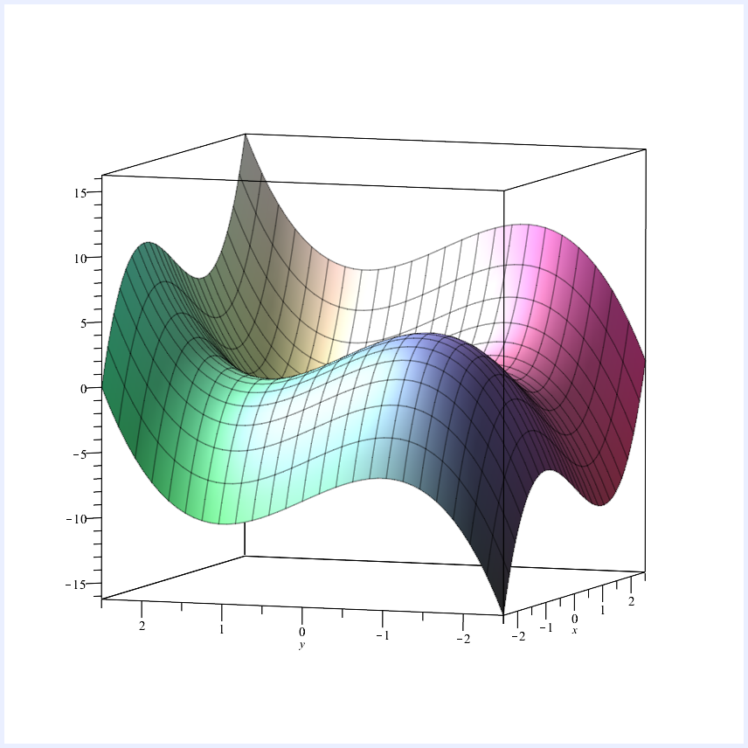

Figure 13: A function with a relative maximum that is not absolute.

Collectively, maxima and minima are called **extrema** (singular: extremum). We can use partial derivatives to find most extrema (except for those on the boundaries of the domain), due to the following result:

Theorem 2.6.  
If has a relative extremum at , and if the partial derivatives of exist at , then

The converse is not necessarily true: if the partial derivatives at a point are both , that point is not guaranteed to be a relative extremum.

Definition 2.7.  
A point in the domain of a function is called a **critical point** if

or if one or both partial derivatives do not exist at .

As in the one-variable case, not all critical points are extrema. A critical point that is not an extremum is called a **saddle point** (figure (14)):

No alt text was set.

Figure 14: Saddle point

How do we tell if a critical point is an extremum?

Theorem 2.8 (Second Partials Test).  
Let be a function of two variables with continuous second-order partial derivatives in some disc centred at a critical point , and let

(a)

If and , then is a relative minimum.

(b)

If and , then is a relative maximum.

(c)

If , then is a saddle point.

(d)

If , no conclusion can be drawn.

For a proof, see Analysis 2B; here we simply give some informal justification.

Compare this with the one-variable version: suppose has a critical point at . If , the gradient is decreasing as increases, so is a relative maximum. Similarly, if , the gradient is increasing as increases, so is a relative minimum.

Now consider the two-variable case. If , then and have the same sign at , and is comparatively small, indicating little interaction between the two variables. Thus, similar to the one-variable case, either , and the critical point is a relative maximum, or , and it is a relative minimum.

If , then either and have different signs at , or is comparatively large and there is a lot of interaction between variables (or both). Either of these possibilities leads to a saddle point.

Remark.  
The stands for **determinant**, so-called since it determines the nature of critical point. It can also be expressed as the determinant of a matrix whose entries are the second order partials.

Example.  
Recall the function . The critical points occur when

i.e. when

So the critical points are

We use the second partial test:

so

* at , and , so is a relative minimum;
* at , , so is a saddle point;
* at , , so is a saddle point;
* at , , , so is a relative maximum.

#### 2.4 Chain rules

As in the one-variable case, there are chain rules for differentiating composite functions of several variables. There are various cases.

##### Variables depend on

The simplest case is the following: let be a differentiable function of two variables and , where , are differentiable functions of . Then is a differentiable function of , and

The three-variable version is similar: let be a differentiable function of three variables , and , where , , are differentiable functions of . Then is a differentiable function of , and

Examples.

1.

We begin with a simple example where we can easily find the answer directly. Let

Then, by the chain rule,

We can check this directly by writing purely in terms of :

so

2.

Let

Find the value of at .

By the chain rule,

Now, at ,

so

##### Some useful applications of the chain rule

1.

Deriving rules of differentiation, e.g. the Product Rule. What is

We can think of this as

where , are functions of . By the chain rule

We have

so

Similarly, we can derive the quotient rule.

We can also derive a rule for differentiating functions of the form

(See Worksheet 7, exercise 5.)

2.

Differentiating , where depends on .

Think of this as , where

Then , so by the chain rule

##### Variables depend on and

In the next case, the variables are themselves functions of two variables, and .

Let be a differentiable function of two variables and , where

are differentiable functions of and . Then is a differentiable function of and , and its partial derivatives are given by

Example.  
Let

Then, by the chain rule,

and

As in the previous case, there is a version of this chain rule for functions of variables; and, in fact, both cases also have versions for functions of variables. We won’t cover these in this course, but they look very similar to the chain rules we have seen.

### 3 Multivariable Integration

#### 3.1 Double integrals

We have seen integration of functions of one variable (which we now refer to as “single integration”). We now move on to definite integration of functions of two variables.

|  |  |
| --- | --- |
| **Single integrals:** | **Double integrals:** |
| Area under a curve. | Volume under a surface. |
| Integrate over an interval of -values. | Integrate over a region of the -plane. |
| Evaluate using indefinite integral. | Evaluate using partial integration. |
|  |  |

##### Regions

Double integrals are performed over a region of the plane – there are a lot more possibilities for the shape of this region than there were in one-dimension, where we always used an interval.

The double integral of a function over a region is denoted

where should be read as “with respect to area ”.

This gives the volume of the solid between the region of the -plane and the surface , pictured in figure (15).

No alt text was set.

Figure 15: Volume between region and surface

##### Properties of double integrals

Like single integrals, double integrals satisfy the usual linearity conditions:

* For a constant ,
* For functions and ,

Also, if the region can be subdivided into regions and (figure (16)), then

No alt text was set.

Figure 16: Region subdivision

##### Evaluating double integrals with iterated integration

We will express the process of evaluating double integrals in terms of two single integrals: one with respect to , one with respect to . We will start with the simplest possible regions (rectangles), then look at some more complicated ones.

Suppose we want to evaluate the double integral of a function over a rectangular region (figure (17)).

No alt text was set.

Figure 17: Rectangular region

Geometrically, this double integral is the volume of a solid. For a fixed value of , the cross-sectional area of this solid is given by

by which we mean: integrate with respect to , treat as a constant. The result is a function of . Now suppose varies by a small increment , giving a thin slice of the volume. We can approximate the volume of the slice as

the volume of a prism. Thus

As , this becomes an identity:

The volume from to is then

Notice that we could equally well have integrated with respect to first, to find the cross-sectional area for a fixed value of , then integrated with respect to – either order of integration would have given the volume of the solid, and therefore the same result.

Theorem 3.1 (Fubini’s Theorem – special case).  
Let be the rectangle defined by

If is continuous on then

Example.  
Evaluate the double integral

where is the region defined by , .

Using partial integration there are two possibilities: integrate first with respect to , then ; or integrate first with respect to , then . We will do both, then compare.

So

##### Double integrals over non-rectangular domains

In general this is very difficult, owing to the wide variety of possibilities for regions of the plane. We’ll look at certain types of non-rectangular regions that we can deal with.

Consider a double integral

The inner partial integral (with respect to ) must give a function of . If and are functions of , the resulting partial integral is still a function of . This allows us to integrate over regions of the form (figure (18)).

No alt text was set.

Figure 18: Type I region

The integral looks like

The outer limits must still be constant to give a numerical answer.

Similarly, we can integrate over a region of the form (figure (19))

No alt text was set.

Figure 19: Type II region

using

Examples.

1.

Evaluate the integral

where is the region pictured in figure (20).

No alt text was set.

Figure 20: Example region 1

2.

Some regions can be considered in either way – especially those involving simple geometric shapes such as triangles. In cases like this it may be that we can integrate in one order, but not the other. In such situations, we may need to change the order of integration, as in the following integral.

Calculate the double integral

We cannot perform the -integration first since we do not know an antiderivative of . Instead we will reverse the order of integration. To find the new limits, we sketch the region of integration in figure (21).

No alt text was set.

Figure 21: Example region 2

In this region, varies from to the line , and varies between and . Thus the integral is

#### 3.2 Change of variable using the Jacobian

Change of variable is the analogue of integration by substitution for double integrals. It allows us to replace our variables and with new variables and . This can be useful for evaluating integrals over complicated regions.

Suppose we want to evaluate the double integral of a function over the region pictured in figure (22).

No alt text was set.

Figure 22: Region of evaluation

The region is rectangular, so integration ought to be easy – but it’s not because the sides of the rectangle are not parallel to the coordinate axes. To evaluate this integral with the methods we already know we would need to divide the region into three subregions.

**Solution:** Draw some new axes! We’ll call them and . We want to choose them so that the region looks something like (figure (23)).

No alt text was set.

Figure 23: Choose axes and to achieve this region

How do we get from a point on the -plane to the corresponding point on the -plane?

Define a **transformation**

where .

To find and in terms of and , we pick where we want our - and -axes to appear on the -plane.

-axis: occurs when ; should be parallel to the lines and , so pick

-axis: occurs when ; should be parallel to and , so pick

So takes a point on the -plane, and gives a point on the -plane.

We want to use this to make a substitution that will turn

(where is “with respect to area on the -plane”) into an integral in terms of and , integrating over a region of the -plane.

##### Reminder: substitution for single integrals

If we have , then

If is decreasing, , then , so this is

So in general,

where , are the -limits, and .

So we replace with (and swap the limits when ).

##### Change of variable for double integrals

For double integrals, we need to replace (area on the -plane) with something in terms of (area on the -plane). The expression we use is related to the derivatives of and .

Definition 3.2.  
If is a transformation from the -plane to the -plane defined by

then the **Jacobian of** , denoted (or ), is defined by

The Jacobian (named after 19th Century German mathematician Carl Jacobi) appears in place of in the change of variables formula.

Theorem 3.3.  
If the transformation , maps the region in the -plane to in the -plane, and if and does not change sign on , then

Example.  
We now use this to evaluate an integral over the rectangular region from the beginning of the section. Consider

where is the rectangular region with vertices

as described at the beginning of the section.

For our transformation from the -plane to the -plane, we chose

To find the Jacobian, we need to find and in terms of and .

Hence

so the Jacobian is

So

Change of variable doesn’t just work for rectangular regions – with the right choice of variable, we can apply it to other regions as well, and even transform non-rectangular regions into rectangular ones.

Example.  
Evaluate

where is the region bounded by the lines

and the hyperbolas

No alt text was set.

Figure 24: Sketch of region

We want a transformation that will change this region (figure (24)) into a rectangle in the -plane, so the boundary curves should correspond to constant values of and .

Rewrite the boundary curves as

So try the transformation

The lines in the -plane corresponding to the boundary curves in the -plane are

This gives us our -limits and -limits.

For the Jacobian, we need to express and in terms of and :

( , , , are all positive on the region, so we can safely use the positive square roots)

So the Jacobian is:

Observe that, unlike in the previous example, this Jacobian is not constant.

Thus the integral is

#### 3.3 Polar coordinates

In Section 3.2 we saw that, for integrals over certain awkward-shaped regions, it is convenient to be able to transform the plane to a new set of coordinate axes.

In the examples we’ve seen so far this transformation gave us a new cartesian plane. In this section we look at a different coordinate system: **polar coordinates**.

##### Cartesian coordinates:

* Two perpendicular axes (figure (25)).
* Specify a point on the plane using two real numbers, and – horizontal and vertical distances from origin.
* Each point has unique -coordinates.
* Named after René Descartes. Also known as rectangular coordinates.

No alt text was set.

Figure 25: Cartesian coordinates

##### Polar coordinates:

No alt text was set.

Figure 26: Polar coordinates

* One axis (“polar axis”) – like positive half of the cartesian -axis, with origin (figure (26)).
* Specify a point by two real numbers:
  + (“radius”): distance from the origin;
  + : anticlockwise angle between axis and line segment from to .
* For a given , is unique, but is not, since:
* is the origin for all values of .

##### Relationship between polar and cartesian coordinates

We can move between polar and cartesian coordinates. Consider figure (27).

No alt text was set.

Figure 27: Triangle with vertices , ,

Considering the triangle with vertices , , , we observe that

so to change from polar to cartesian coordinates, use the transformation

Changing from cartesian to polar coordinates is a bit trickier. By Pythagoras’ Theorem:

There is no easy formula for , but we can use

Note that gives values between and , so will not consistently give the value of .

##### Equations of curves in polar coordinates

Some curves are much easier to write in polar coordinates than in cartesian coordinates.

Examples.

1.

Circle of radius .

In cartesian coordinates:

or

In polar coordinates:

This will be very useful for simplifying integrals over circular regions.

2.

Spirals: Archimedean spiral (figure (28)), , constant and Logarithmic spiral (figure (29)), , , constant.

No alt text was set.

Figure 28: Archimedean spiral

No alt text was set.

Figure 29: Logarithmic spiral

3.

Cardioids (figure (30)): and , constant.

No alt text was set.

Figure 30: Cardioid

More generally: limaçons , , , constants.

##### Simple polar regions

When we use polar coordinates for integration, we will integrate over a particular kind of region that is straightforward to express in polar coordinates, called a **simple polar region**.

Definition 3.4.  
A **simple polar region** is a region of the plane enclosed between two **rays** , , and two (continuous) curves , , satisfying

An example is shown in the diagram (31).

No alt text was set.

Figure 31: A simple polar region

#### 3.4 Double integrals in polar coordinates

Using change of variable and the Jacobian, we can convert an integral in cartesian coordinates into an integral in polar coordinates. This can simplify certain integrals, especially those over circular regions, and those involving .

Example (Volume of a sphere).  
In cartesian coordinates, a sphere of radius has the equation

or:

So the volume of the sphere is

where is the circular region bounded by

Thus in cartesian coordinates, the integral is:

This is complicated. We can simplify it by changing to polar coordinates. We have

so the Jacobian is

Note that the region is a simple polar region; the boundary rays and curves give the following limits for the integral:

Thus the volume is

This agrees with the standard formula for the volume of a sphere.

In this example we started with the integrand and limits in cartesian coordinates, and converted to polar coordinates, using the Jacobian to change variable. However, we may be given the integrand and limits in polar form originally. In this case, although we don’t need to make a change of variable, we still need to multiply the integrand by the Jacobian.

Theorem 3.5.  
If is a simple polar region bounded by the rays , , and the curves , , and if is continuous on , then

We won’t prove this theorem, but here is an explanation of why it is true:

Double integration treats regions with constant limits as rectangles, but in polar coordinates such regions are not rectangular. Consider, for example figure (32).

No alt text was set.

Figure 32: Region which is not rectangular

Double integration treats the regions and as rectangles with the same area – but they’re not rectangles, and is much larger than . The contribution made to the area of a region is proportional to the distance from the origin (i.e. proportional to the radius). This explains why the Jacobian is .

When we use double integration to integrate something in polar form, we are effectively changing variable to a cartesian -plane. Note that is always positive, and is between and , but that otherwise this is a standard cartesian plane and that regions with constant limits are now rectangular.

Example.  
Evaluate the double integral

where is the region in the first quadrant between the the circle and the cardioid (figure (33)).

No alt text was set.

Figure 33: Region

Observe that is a simple polar region, with limits given by

Thus the integral is

#### 3.5 Triple integrals

As with partial differentiation, we can extend double integration to higher numbers of variables. We will look at integration in the variable case (we won’t go any higher than this).

##### -dimensional regions

**Double integrals:** integrate over a D region of the -plane.

**Triple integrals:** integrate over a D region of -space.

For us, this will always be a finite solid.

**Notation**

The triple integral of a function of variables, , over a -dimensional region is denoted

You should read as “with respect to volume”. The doesn’t stand for anything – unlike the case of double-integrals (where we use ) there is no standard letter used for D regions.

##### What does it respresent?

In the and variable cases, definite integrals represented a tangible geometric quantity.

**Single integrals:** area under a curve.

**Double integrals:** volume under a surface.

**Triple integrals:** ?

We live in a universe with spacial dimensions, but a triple integral is something -dimensional, so we don’t have the words to describe what it represents geometrically.

Triple integrals can tell us about physical quantities though. For example:

* mass of an object (integrate its density)
* centre of mass/centre of gravity
* volume
* gravitational potential
* magnetic and electric fields
* position of a particle in quantum physics

##### Properties of triple integrals

As with single and double integrals, we have the usual linearity properties:

* For a constant ,
* For functions and ,

Also, if the region can be subdivided into regions and , then

##### Triple integrals over cuboids

For double integrals, the simplest regions for integration were rectangular boxes.

Similarly, for triple integration, the simplest regions are cuboids – like the case of evaluating double integrals over rectangles, triple integrals over cuboids have constant limits.

Theorem 3.6.  
Let be the cuboid defined by

If is continuous on the region , then

Moreover, in the integral on the right, one can alter the order of integration, without changing the resulting value of the integral.

For triple integrals, there are six possible orders of integration. In the following example we will evaluate a triple integral using one of these orders, but any other order would give the same result.

Example.  
Evaluate the triple integral

over the cuboid defined by

##### More general regions

In the -variable case we looked at regions of the form in figure (34).

No alt text was set.

Figure 34: Type I region

In the -variable case, we generalise this by replacing

* with a region of the -plane (one we can perform double integration over);
* the curves and with surfaces and .

This gives regions of the form shown in figure (35).

No alt text was set.

Figure 35: Form of regions

**Terminology:**

* is called a **simple -solid**;
* is the **lower surface**;
* is the **upper surface**.

Theorem 3.7.  
For a simple -solid , as described above, and continuous on ,

Example.  
Evaluate the triple integral

where is the simple -solid bounded by

and the projection of onto the -plane is the triangle (figure (36)) with vertices

No alt text was set.

Figure 36: Projection of onto the -plane

From the diagram, we have

* -limits: and ;
* -limits: and .

Thus the integral is

#### 3.6 Triple integrals in spherical coordinates

There are a lot of possibilities for three-dimensional regions, and so far we can only integrate over a very narrow range of possibilities. In order to expand our possibilities for regions to integrate over, we will use an alternative coordinate system called **spherical coordinates**.

Spherical coordinates are a -dimensional analogue of polar coordinates (figure (37)). In this case we have three coordinates:

* radius (sometimes denoted ), the distance from the origin;
* , the angle from the positive -axis (called the **azimuthal** angle);
* , the angle from the positive -axis (called the **polar** angle).

No alt text was set.

Figure 37: Spherical coordinates

##### Converting between spherical and cartesian coordinates

As in the two dimensional case with polar coordinates, we can convert between the spherical and cartesian coordinate systems.

To convert from spherical to cartesian coordinates, use:

As for polar coordinates, these can all be derived geometrically by considering the appropriate right-angled triangles.

To convert from cartesian to spherical coordinates, use:

As in the case of polar coordinates, evaluating a triple integral uses the Jacobian for the transformation from spherical to cartesian coordinates. We haven’t covered change of variable for triple integrals, but it proceeds in the same way as for double integrals. The Jacobian looks like

This is the determinant of a matrix. We won’t go into details of how to calculate these (for anyone interested, they are covered in Algebra 1A, Section 7). In this case, the Jacobian is

Observe that, since , this is always positive. Thus, when converting a triple integral over a region to spherical coordinates, we use the following result:

where

As in the case of double integrals in polar coordinates, even if we are given the limits and the integrand in spherical coordinates, we still need to multiply by the Jacobian, . This is because triple integration treats regions with constant limits as cuboids, when in fact they are not in the case of spherical coordinates.

Example.  
Use spherical coordinates to evaluate the triple integral

The first thing to do in a problem like this is to find the limits of the integral in spherical coordinates. From the limits in cartesian coordinates, we see that this is a simple -solid. The projection of the region onto the -plane is bounded by

so it is a circle with radius , centred at the origin. The lower surface is , the -plane, and the upper surface is

Thus, the region is upper hemisphere (i.e. the part for which ) of a sphere with radius , centred on the origin (figure (38)).

No alt text was set.

Figure 38: Upper hemisphere

Therefore in spherical coordinates, the limits will be given by

To express the integrand in spherical coordinates, we use

Thus we have

Hence the integral is

##### Surfaces given by constant values of , ,

* , constant: sphere of radius , centre at the origin.
* , constant: half-plane perpendicular to the -plane, bounded by the -axis; is the (anticlockwise) angle with the positive -axis.
* , constant: varies depending on .
  + gives the positive -axis (not a surface).
  + gives a cone, centred around the positive -axis, vertex at the origin; is the angle with the positive -axis.
  + gives the -plane.
  + gives a cone, centred around the negative -axis, vertex at the origin; is the angle with the positive -axis, so is the angle with the negative -axis.
  + gives the negative -axis.

Planes parallel to the -plane are not given by constant functions in spherical coordinates (other than the -plane itself).

Consider a point the plane , where is constant. Then

so, rearranging,

For , this gives the plane .

For , this gives the plane .

##### Determining limits of regions in spherical coordinates

See the handout, distributed in the Wednesday Week 10 lecture, and also available on the Week 10 section of the course Moodle page.

Note: this handout comes from a book (**Calculus** by Anton, Bivens, and Davis), and uses in place of and in place of .

Example.  
Given a 3-dimensional region , the triple integral

gives the volume of . (Often the is omitted.) We will use this to derive the standard formula for the volume of a sphere.

Let be a sphere of radius , centred at the origin. Then the volume of is

### 4 Ordinary Differential Equations (ODEs)

Differential equations are widely used in science, engineering and economics. After 400 years there are still lots of open problems to solve.

#### 4.1 Overview

A differential equation is an equation which links , , , etc.

Examples.

|  |  |
| --- | --- |
|  | Easy |
|  | Hard |
|  | Very hard |
|  | Easy |

“Ordinary” means there is only one independent variable.

#### Some terminology

* The **order** of a differential equation is the largest number of derivatives.

|  |  |
| --- | --- |
|  | * **First** order |
|  | * **Second** order |
|  | * **Fourth** order |

* A differential equation is **linear** if we only have , or and no functions such as .
  + Linear equations are easy to solve and very common.
  + Nonlinear equations are often **very** hard to solve. The solutions usually use numerical methods.
* The **initial condition(s)** of a differential equation is information about the solution at a point . We need this to find a particular solution to the equation; that is, one that does not depend on any arbitrary constants.

|  |  |
| --- | --- |
| * First order: | * Need to know |
|  |  |
| * Second order: | * Need to know , |

#### 4.2 Separable first order differential equations

Definition 4.1.  
A **separable** first order ordinary differential equation has the form

We can solve these **directly by integration**:

Rearrange and integrate

Example.

Separate and integrate

Example.  
In the introduction to the course we saw a basic model for world population. A more sophisticated model for population might satisfy the differential equation

Separating variables and integrating gives

To find we need some initial data. Let at .

Multiply by and exponentiate

Rearrange

Sketch:

At ,

As ,

No alt text was set.

Figure 39: Sketch of example

#### 4.3 Homogeneous equations

A function is homogeneous of degree if

Examples.

(homogeneous, degree )

(homogeneous, degree )

(homogeneous, degree )

##### Degree .

The general form for a homogeneous differential equation of degree is

Solution.  Let . Then

Hence

Example.

Let . Then

Let . Then

So

Hence

If , , .

#### 4.4 Linear first order ordinary differential equations

These take the form

|  |
| --- |
|  |

The LHS is a linear combination of and its derivative.

We solve these by using an **integrating factor**.

Lemma 4.2.  
If then

Proof.  By chain rule

□

The function is called the **integrating factor**.

Proposition 4.3.  
The equation

|  |  |
| --- | --- |
|  | (4.1) |

has solution

Proof.  Consider

Hence if satisfies (4.1), then

□

Examples.

1.

So

where

Integrating factor:

Hence

(note: non-trivial constant)

2.

Rearranging,

so

where , .

Integrating factor:

Hence

#### 4.5 Bernoulli equations

A differential equation of the form

is called a Bernoulli equation (named after Jacob Bernoulli, who proposed it, and his brother Johann Bernoulli, who found a solution).

If or they are linear. Solve by integrating factor ( ) or separation ( ). Otherwise they are non-linear.

**Method** for or .

Idea: use a substitution to make the equation linear.

Divide by :

Let . Then by the chain rule

Substitute

This equation is now **linear** in the -terms: use integrating factor to solve.

Examples.

1.

Bernoulli equation with

Divide by

Let . So

Substitute

Integrating factor

Then

Hence

2.

Rearrange

Bernoulli equation with

So satisfies

Rearrange

Integrating factor

So

Then

3.

Rearrange

Bernoulli equation with

So satisfies

Rearrange

Integrating factor

Hence

Then .

4.

Logistic growth: (e.g. population) (see Section 4.2)

Rearrange

to Bernoulli equation with

So satisfies

Integrating factor gives

#### 4.6 Exact equations

Consider a differential equation of the form

This includes functions of two variables and .

Suppose there exists some function such that

(“partial derivative”: rate of change with respect to if held constant)

(rate of change with respect to if held constant)

Then

Now, the chain rule for two variables says:

So

So is an **implicit** solution to the differential equation, i.e. if satisfy , they will also satisfy the ODE.

#### Test for exactness

The equation

is exact if .

#### Finding the solution

We can find by integrating or , but we have to be careful. We have

Integrate both sides with respect to :

where is constant with respect to , but may depend on .

What is ? Differentiate both sides with respect to :

Rearranging,

Hence

So an exact ODE has implicit solution where

Examples.

1.

Inspiration:

So satisfied

where , .

Hence solution is .

2.

.

So

Hence the ODE is exact. So solution is where

Hence implicit solution of ODE is

3.

So

Hence exact.

Next, find :

So

Hence the ODE has implicit solution

4.

So

Hence exact.

Next, find .

Hence

Hence the ODE has implicit solution

#### 4.7 Linear second order ordinary differential equations

##### Overview

These take the form

Example (Falling ball).

Each of these equations has an uncountable number of solutions. To find a **unique** solution we must specify **two** properties of the solution.

A.

Initial value problem: , ; **and** at **some** point,  
e.g. throwing a ball.

B.

(Dirichlet) Boundary value problem: , ;  
e.g. making the ball land on target.

C.

(Neumann) Boundary value problem: , ;  
i.e.  at two points, arises in studying biological problems.

##### Free linear second order ODEs

Theorem 4.4 (Superposition).  
 Let and be solutions to the second order ODE

Then

is also a solution for any constants .

Proof.  Due to the linearity of the derivative

Hence

so is also a solution to the equation. □

Definition 4.5.  
We call a **linear combination** of and .

Definition 4.6.  
 and are **linearly independent** if there are **no** non-zero constants and such that

Remark.  
 may still be satisfied at **some** values of .

Theorem 4.7.  
A free linear second order ODE has **exactly two** linearly independent solutions. Any solution of the ODE are linear combinations of these two solutions.

Definition 4.8.  
Let the free linear second order ODE have two linearly independent solutions , . Then the **general solution** is

Example.  
Simple harmonic motion (e.g. oscillation of a spring, simple pendulum, molecular vibration)

Two linearly independent solutions are and .

So, general solution is

##### Constructing the General solution

Consider

|  |  |
| --- | --- |
|  | (4.2) |

Suppose , constant. Then

Hence (4.2) is satisfied if is such that

This quadratic in is the **auxiliary equation (AE)**.

Solutions are

Depending on the type of solutions of the AE there are three cases to distinguish:

Case 1.

( ) real and distinct

General solution

Solution behaviour: No oscillations;  
long term growth ( or ) or decline ( and ).

Remark.

and are linearly independent because

is not constant.

Case 2.

( ) complex conjugates,

General solution

Solution behaviour: Oscillatory with long term growth or decline .

Proof.

Real and imaginary parts of the roots of the auxiliary equation

are

Thus

are solutions of (4.2).

But and involve complex numbers for all . The ODE is real-valued. We want real-valued solutions.

By Euler’s formula

Recall superposition (Theorem 4.4): Linear combinations of and are also solutions (even with complex coefficients).

So

is a solution, as well as

is a solution.

Clearly , are real-valued and linearly independent.

So the general solution is

□

Case 3.

( ) , so write for the unique root of the AE.

Then is real-valued and the general solution is

Solution behaviour: no oscillations, long term growth ( ) or decline ( ).

Proof.  If

Then

Hence

But

and

□

##### Forced linear second order ordinary differential equations

In practice solved by three methods:

1.

Undetermined coefficients: the method we will use. Easy but only works for simple cases.

2.

Transforms:

|  |  |
| --- | --- |
| Fourier |  |
| Laplace |  |

Widely used in science and engineering.

3.

Variation of constants / Green’s functions

very general (extends to etc. but hard to use (need to find ).

##### Basic idea for systematic substitution

1.

Find **most general solution possible** of the equation

: CF: **complementary function**.

2.

Find a **particular solution** of the equation

: PI: **Particular integral**.

3.

Set .

We will focus on finding the particular solution for some simple cases of .

##### Particular integrals involving exponentials

Suppose

|  |  |
| --- | --- |
|  | (4.6) |

, constants.

Set .

Then

So satisfies (4.6) if

Remark.  
This method blows up if In this case solves

i.e. is part of the complementary function. This is called **resonance**. In this case we have to use

or if is even a double root of use

Remark.  
In case of sums of (non-resonance) exponentials, e.g.

use

##### Particular integrals involving sine and cosine

Example.

Solve

Complimentary function satisfies:

so

PI: Let

Hence

if

Hence, solve

So

Hence

**General case:** Suppose

|  |  |
| --- | --- |
|  | (4.7) |

for some frequency .

**Even if or**  set

Then

if

Solving system for and

Remark.  
 must be non-zero.

**Special case shortcut**. If and then (4.7) reads

In this case it is sufficient to use

Then, for ,

##### Particular integrals involving polynomials

Example.  
Solve

Complimentary function satisfies

So

PI: Let

So

If

Equating coefficients

Hence

so

**General Case:** Suppose

Try

Then is a polynomial. Equate coefficients of powers of in

to find in terms of and .