Test 005: Put a labeled figure/table inside a theorem/proof etc.
Emma Cliffe, Skills Centre: MASH, University of Bath
August 2020
Table of Contents

Here is a figure
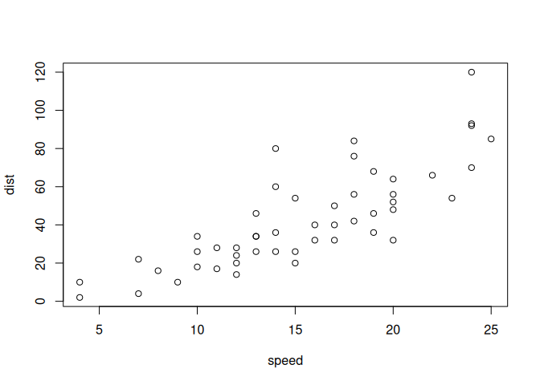
Figure 1.1: Something else to do with cars

Here is the putting of a figure inside another built in environment

Example 2.1
Here is an example.
Figure 2.1: Something to do with cars
This is a test. So, you need an empty line before and after the above for it to be a float. At the end of an environment this means that you need TWO empty lines. This is Pandoc.

Here is the putting of a figure inside a newtheorem

Example:
An example
Figure 3.1: Something to do with cars

Here is when we set width - and everything is different now
Figure 4.1: Something else to do with cars

