Test 015: Put a labeled figure/table inside a theorem/proof etc. but also have maths in the caption
Emma Cliffe, Skills Centre: MASH, University of Bath
September 2026
Table of Contents

Here is a figure
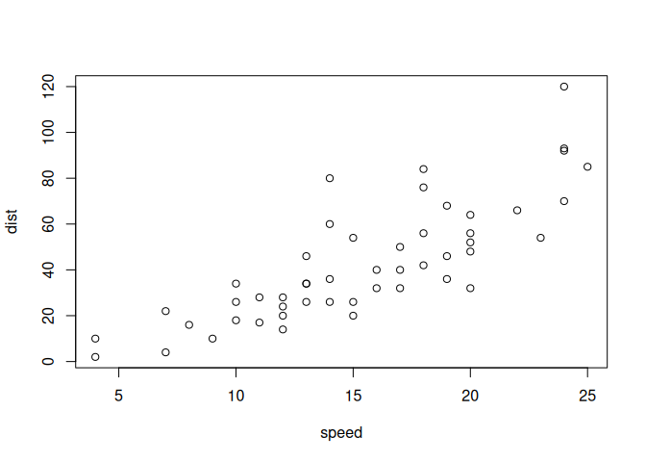
Figure 1.1: Something else to do with cars 1 $A×B$

Here is a figure with hyphen in the label
Hyphens in figure labels works…
Figure 2.1: Something else to do with cars 1- $A×B$
Here I am referencing the first figure 1.1 and second 2.1

Here is the putting of a figure inside another built in environment

Example 3.1
Here is an example.
Figure 3.1: Something to do with cars 2
This is a test. So, you need an empty line before and after the above for it to be a float. At the end of an environment this means that you need TWO empty lines. This is Pandoc.

Here is the putting of a figure inside a newtheorem

Example 4.1:
An example
Figure 4.1: Something to do with cars 3
Here I reference that theorem 4.1

Here is when we set width - and everything is different now
Figure 5.1: Something else to do with cars 4

Where do hyphens break?
They only break in newtheorem, not inbuilt, not figures

Example 6.1
Here is a final example.
Here I reference that last theorem 6.1

Example 6.2:
The broken one.
Here I reference the broken one 6.2

Nugget 6.1:
The good one.
Here I reference the good one 6.1

Nugget 6.2:
The good one bad.
Here I reference the good one bad 6.2

