Images: using iframe and alternatives for dynamic element including in theorems
Emma Cliffe, Skills Centre: MASH, University of Bath
Sept 2023
Table of Contents

Here is a figure
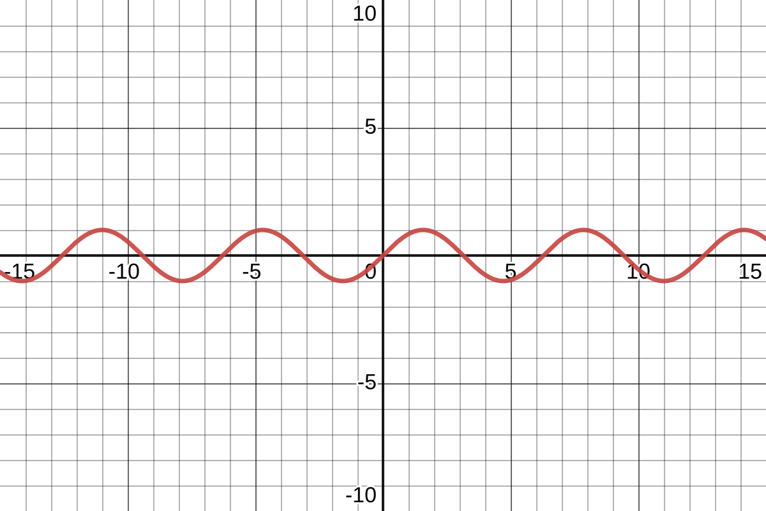
Interactive plot of sine

Here is the putting of a figure inside another built in environment

Example 2.1
Here is an example.
Interactive plot of sine
This is some text below. A bug sometimes means this disappears but I cannot replicate in a clean document.

Here is the putting of a figure inside a newtheorem

Example:
An example
Interactive plot of sine
This is some text below. A bug sometimes means this disappears but I cannot replicate in a clean document.

