Test 004: Put a labeled figure/table inside a theorem/proof etc.

Emma Cliffe, Skills Centre: MASH, University of Bath

August 2020

Table of Contents

# Here is a figure

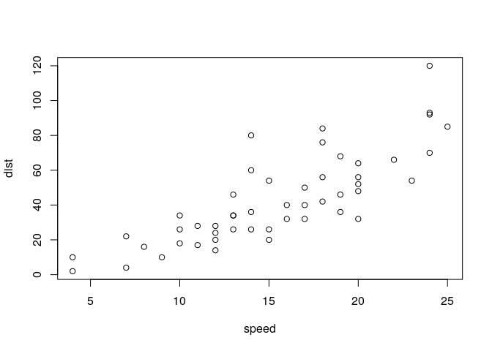

Figure 1.1: Something else to do with cars

# Here is the putting of a figure inside another built in environment

Example 2.1

Here is an example.



Figure 2.1: Something to do with cars

This is a test. So, you need an empty line before and after the above for it to be a float. At the end of an environment this means that you need TWO empty lines. This is Pandoc.

# Here is the putting of a figure inside a newtheorem

Example:

An example



Figure 3.1: Something to do with cars