Images: using iframe and alternatives for dynamic element including in theorems

Emma Cliffe, Skills Centre: MASH, University of Bath

Sept 2023

Table of Contents

# Here is a figure

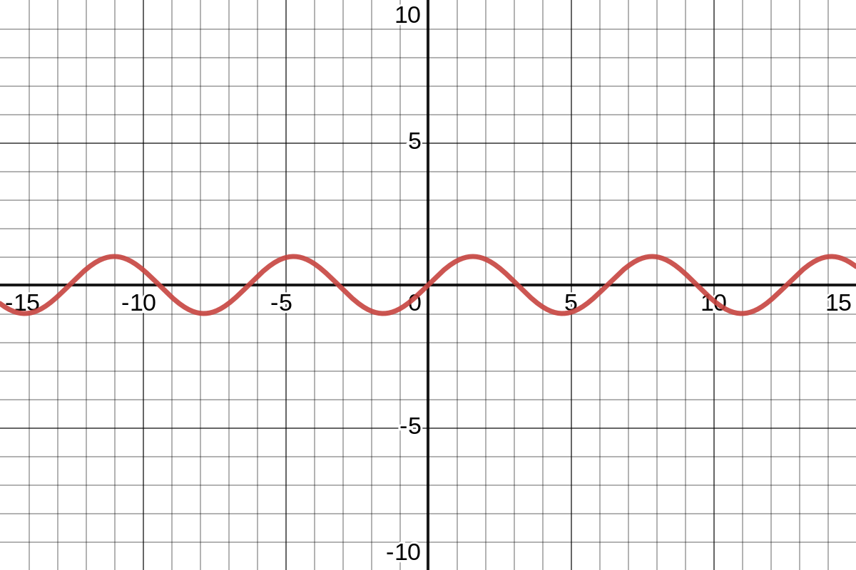

[Interactive plot of sine](https://www.desmos.com/calculator/lbcljsazlt)

# Here is the putting of a figure inside another built in environment

Example 2.1

Here is an example.



[Interactive plot of sine](https://www.desmos.com/calculator/lbcljsazlt)

This is some text below. A bug sometimes means this disappears but I cannot replicate in a clean document.

# Here is the putting of a figure inside a newtheorem

Example:

An example



[Interactive plot of sine](https://www.desmos.com/calculator/lbcljsazlt)

This is some text below. A bug sometimes means this disappears but I cannot replicate in a clean document.