

Seminar Report

On

“Fault Detection in Printed Circuit Boards Using Computer Vision”

By

**Abhinav Bathe**

**PRN: 1032222447**

Under The Guidance of

**Dr. Sridevi Karande**

**School of Computer Science & Engineering**

**Department of Computer Engineering & Technology**

**\* 2024-2025 \***



**MIT-World Peace University (MIT-WPU)**

**Faculty of Engineering**

**School of Computer Science and Engineering**

**Department of Computer Engineering and Technology**

**CERTIFICATE**

This is to certify that Mr Abhinav Bathe of B.Tech CSE(AI&DS) DCET, School of Computer Science & Engineering, Semester -VI PRN No. 1032222447, has Successfully Completed Seminar on

“Fault Detection in Printed Circuit Boards Using Computer Vision”

to my satisfaction and submitted the same during the academic year 2025-2026 towards the partial fulfillment of degree of Bachelor of Technology in School of Computer Science & Engineering DCET under Dr. Vishwanath Karad MIT-World Peace University, Pune.

_________________ _________________

Dr. Sridevi Karande Dr. Balaji Patil

Seminar Guide Program Director, DCET, SoCSE

**LIST OF FIGURES**

|  |  |
| --- | --- |
| **Title** | **Page Number** |
|  |  |
| 3.1 Workflow of the proposed system | 7 |
| 3.2.2 YOLOv8 Architecture | 11 |
| 4.2 Output plots after training the model | 16 |
| 4.3 Grad-CAM heatmap visualization | 17 |

**LIST OF TABLES**

|  |  |
| --- | --- |
| **Title** | **Page Number** |
| 2. Literature Survey | 3 |
| 3.2.2 YOLOv8 backbone architecture | 10 |
| 3.2.2 YOLOv8 neck architecture | 10 |
| 3.2.2 YOLOv8 head architecture | 11 |
| 3.3.2 Hyperparameters used for training the model | 13 |
| 4.1 Defect classes in the dataset | 14 |
| 4.2 Performance Metrics Obtained | 15 |

**ABBREVIATIONS**

|  |  |  |
| --- | --- | --- |
| **Abbreviation** | **Full Form** | **Description** |
| PCB | Printed Circuit Boards | A flat board that mechanically supports and electrically connects electronic components |
| CNN | Convolutional Neural Network | A Deep Learning architecture used for image processing |
| YOLO | You Only Look Once | Object detection computer vision algorithm |
| Grad-CAM | Gradient-weighted Class Activation Mapping | Visualizes CNN focus using heatmaps. |
| XAI | Explainable AI | Explains AI decisions for transparency. |
| SiLU | Sigmoid Linear Unit | Smooth activation combining sigmoid and linear functions. |
| NMS | Non-Maximum Suppression | Removes redundant overlapping detection boxes. |
| FPY | Feature Pyramid Network | Multi-scale feature extraction for detection. |
| mAP | Mean Average Precision | Measures model accuracy across classes. |
| SGD | Stochastic Gradient Descent | Optimizes model using mini-batches. |

**ACKNOWLEDGEMENT**

I would like to express my sincere gratitude to everyone who contributed to the successful completion of this research work on **Fault Detection in Printed Circuit Boards Using Computer Vision** First and foremost, I extend my heartfelt appreciation to my mentor, **Dr. Sridevi Karande,** for their invaluable guidance, insightful feedback, and unwavering support throughout this project. Their expertise and encouragement played a crucial role in shaping the direction of this research.

I would also like to acknowledge the contributions of my university, **MIT-World Peace University**, for providing the necessary resources and a conducive environment for research and experimentation.

A special thanks to my peers and colleagues, whose discussions and suggestions greatly enriched my understanding of the topic. Their constructive criticism and collaboration have been invaluable.

Lastly, I would like to express my deepest appreciation to my **family and friends**, whose unwavering support and encouragement have been instrumental in keeping me motivated throughout this journey.

This work is the result of collective effort, and I am deeply grateful to everyone who has contributed to its success.

Abhinav Bathe

1032222447

**INDEX**

|  |  |
| --- | --- |
| Abstract | I |
| Technical Content | II |
| Details of Technology | 1 |
| 1. Introduction | 1 |
| 2. Literature Survey | 3 |
| 3. Details of Technology | 7 |
| 3.1 Overview of proposed system | 7 |
| 3.2 Model Selection and architecture | 9 |
| * 1. Model training | 12 |
| 4. Experimental Work | 13 |
| 4.1 Dataset Description | 13 |
| 4.2 Training Results | 14 |
| 4.3 Integration of Grad-CAM | 16 |
| 4.4 Challenges and Limitations | 17 |
| 4.5 Future Scope | 18 |
| Conclusion | 20 |
| References | 21 |

**ABSTRACT**

Printed Circuit Boards (PCBs) serve as the backbone of modern electronic systems, offering both electrical interconnectivity and physical support for various electronic components. They are indispensable across industries such as consumer electronics, automotive, aerospace, telecommunications, and healthcare. With the rising demand for high-performance and miniaturized electronic devices, ensuring the quality of PCBs has become increasingly crucial.

Conventional inspection methods—such as manual visual checks and electrical testing—are often inefficient, error-prone, and unsuitable for large-scale manufacturing environments. To address these challenges, this work explores an automated defect detection pipeline leveraging the YOLO (You Only Look Once) object detection algorithm.

Using a labeled PCB defect dataset comprising various fault categories—including missing holes, mouse bites, open circuits, shorts, spurs, and spurious copper—it demonstrates data preprocessing, annotation parsing, and model training using the YOLO framework. Furthermore, to enhance interpretability and build trust in the model's decisions, the approach integrates Explainable AI (XAI) techniques such as Grad-CAM (Gradient-weighted Class Activation Mapping.

This deep learning-based, explainable inspection pipeline offers a scalable and accurate solution for real-time PCB fault detection, significantly improving quality control while reducing manual effort and production errors.

**KEYWORDS**

Printed Circuit Boards, Artificial Intelligence, Semi-Conductors, Computer Vision, Deep Learning, Convolutional Neural Networks, YOLO, Explainable AI, Grad-CAM,

**TECHNICAL CONTENT**

1. **Introduction:**

Printed Circuit Boards (PCBs) are foundational elements in virtually all electronic systems, enabling the compact arrangement and interconnection of electronic components. Their ubiquity spans a wide range of applications in consumer electronics, automotive systems, aerospace instrumentation, telecommunication infrastructures, and medical devices. As electronic devices become increasingly sophisticated and miniaturized, the complexity of PCB designs continues to rise, making quality assurance a critical step in the manufacturing process.

Defects in PCBs, such as missing components, open circuits, shorts, or irregular copper traces, can compromise device performance, reduce product lifespan, or lead to complete system failure. Traditional inspection techniques—including manual visual inspection and electrical probing—are limited by human error, low scalability, and inefficiency in high-volume production environments. As a result, there is a growing need for automated, accurate, and scalable methods to detect and classify PCB defects.

Recent advancements in computer vision and deep learning have opened new avenues for automating visual inspection tasks in manufacturing. Object detection models, particularly the YOLO (You Only Look Once) architecture, have demonstrated remarkable performance in real-time detection scenarios. YOLO’s single-shot detection approach allows for simultaneous localization and classification, making it a suitable candidate for detecting PCB defects in an industrial setting.

This research presents a comprehensive pipeline for PCB defect detection using the Ultralytics implementation of YOLO. The pipeline encompasses dataset preparation, annotation parsing, and model training on a publicly available PCB defect dataset featuring multiple defect categories. In addition to achieving accurate defect detection, this work integrates Explainable AI (XAI) techniques—specifically Gradient-weighted Class Activation Mapping (Grad-CAM)—to provide visual explanations of the model's predictions. This interpretability is crucial for validating model behavior and fostering trust in AI-driven inspection systems.

The proposed approach aims to enhance manufacturing quality control by offering a fast, interpretable, and highly accurate solution for PCB fault detection. The results demonstrate the potential of combining object detection and explainability to achieve intelligent and transparent inspection systems suitable for real-world deployment.

1. **Literature Survey:**

|  |  |  |  |  |  |
| --- | --- | --- | --- | --- | --- |
| title | Year | Journal/Conference | Dataset | Findings | Gaps |
| Advancements in PCB Defect Detection: An In-Depth Exploration of Image Processing Techniques [1] | 2024 | ICPCSN | Custom Dataset | Under various illumination angles and using image subtraction technique, defects were detected | Robust to noise, lighting intensity variations, and highly dependent on the input image quality. Dataset size was quite small. |
| An improved YOLOv3 method for PCB surface defect detection [2] | 2021 | IEEE International Conference on Power Electronics, Computer Applications (ICPECA) | Open Laboratory of Intelligent Robots at Peking University PCB Dataset | mean average precision of 92.13%, detection rate of 63 frames per second | Small dataset, fails to provide information about how the model detects different types of defects under various conditions. |
| Automated PCB Defect Identification System using Machine Learning Techniques [3] | 2023 | International Conference on Advancements in Electrical, Electronics, Communication, Computing and Automation (ICAECA) | Not Mentioned | Used Tiny YOLOv2 and vgg16 to find defects. System was integrated with raspberryPi 4 and a camera to capture and process images. | System is designed only for a single PCB desgin, and is aimed at small scale manufacturing |
| Efficient Fault Detection Methods in Printed Circuit Boards using Machine Learning Techniques [4] | 2024 | International Conference on Computing Communication and Networking Technologies (ICCCNT) | PCB Defect Dataset from kaggle | proposed method attains a model accuracy in the range of 0.954, precision with 0.96, recall with 0.94, and F1-score with 0.95. | Study doesnot address the performance of the proposed model under various lighting conditions, images with noise, and orientation of PCB. |
| Flaw Detection in PCB using Deep Learning and Image Processing [5] | 2024 | International Conference on Sustainable Computing and Smart Systems (ICSCSS) | DeepPCB Dataset | 90.5% mAP using ResNet-34 was achieved. Precision of 92% was obtained and f1-score of 0.92 was obtained | The PR curve shows high-confidence predictions with a high true positive rate but may miss some true cases, making it unsuitable when false positives are costly. |
| PCB Defect Detection Using Deep Learning Methods [6] | 2024 | International Conference on Computing Communication and Networking Technologies (ICCCNT) | Open Laboratory of Intelligent Robots at Peking University PCB Dataset | The YOLO model successfully detected and identified defects demonstrating its real-time processing capabilities and the adaptability to handle various defect types simultaneously. | Challenges such as dataset quality, class imbalance, and adaptation to complex PCB designs and lighting variations were noted. |
| PCB-Fire: Automated Classification and Fault Detection in PCB [7] | 2020 | International Conference on Multimedia Processing, Communication & Information Technology (MPCIT) | DSLR Dataset | Using OpenCV techniques and YOLOv3, The overall accuracy of the algorithm obtained by testing  20 PCB images is 75.48%. | Suited for applications where a component is missing, not suited for finding any kind of defects on the PCB. |

**Table 1. Literature Survey**

1. **Details of Technology:**

**3.1 Overview of Proposed System**

The proposed system is a complete pipeline for the automatic detection and interpretation of faults in Printed Circuit Boards (PCBs) using deep learning-based object detection, enhanced with explainable AI (XAI).

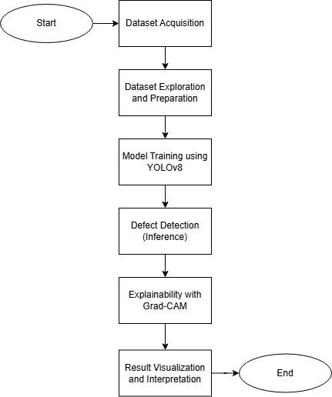

**Fig 1. Workflow of the proposed system**

**3.1.1 Dataset Acquisition**

The input to the system is a labelled dataset of PCB images, where each image is accompanied by an annotation file describing the location and category of defect for each image.

**3.1.2 Data Exploration and Preparation**

Before training the object detection model, exploration of dataset was conducted to understand its quality, structure and distribution. Statistical analysis was performed to count the number of defects instances per class to identify potential class imbalance. Some images were visualized to verify the correctness of data.

After the exploration process, the dataset is divided into training, testing and validation subsets. Corresponding images and annotations files are organized into structured directories.

**3.1.3 Model Training**

The Ultralytics YOLOv8 model is selected for its high performance and efficiency in real-time object detection tasks. The model is trained on the prepared dataset using specified hyperparameters such as learning rate, batch size, number of epochs, and input image resolution. The training process automatically saves the best-performing model weights.

**3.1.4 Inference**

Once training is complete, the model is used to detect defects in unseen test images. The model outputs include bounding boxes, confidence scores, and predicted class labels for each detected defect. These outputs are visualized by overlaying the predictions on the original images, enabling intuitive interpretation of results.

**3.1.5 Explainability with Grad-CAM**

To improve model transparency, the trained YOLO model is integrated with Grad-CAM Grad-CAM generates heatmaps indicating the regions in the image that contributed most to the model’s predictions. These heatmaps are overlaid on the original images to visually explain the model’s attention during defect classification.

**3.1.6 Result Visualization**

The final outputs include both the detection results (bounding boxes and labels) and the Grad-CAM visualizations, providing a comprehensive understanding of the model’s predictions.

**3.2 Model Selection and Architecture**

The model selected for this study is YOLOv8, the latest installment in the YOLO (You Only Look Once) object detection family developed by Ultralytics. YOLOv8 is a high-performance, anchor-free object detection model designed for speed and accuracy, making it especially suitable for industrial applications such as printed circuit board (PCB) defect detection. Its ability to process images in real time while maintaining high precision makes it an ideal choice for automated quality control systems.

**3.2.1 Justification for Model Selection**

One of the key requirements in manufacturing and industrial inspection settings is the ability to perform real-time detection. In PCB assembly lines, thousands of units may pass through the inspection stage per hour, and any lag in detection can delay production. YOLOv8 is specifically optimized for low-latency inference, often achieving over 30 frames per second (FPS) on modern GPUs, even for complex detection tasks. This makes it well-suited for deployment in automated inspection systems where fast decision-making is critical. (add source)

PCB defect detection often involves identifying very small objects with subtle visual differences—such as missing copper, open circuits, spurious lines, or short circuits. YOLOv8 incorporates a decoupled head architecture, which enables it to learn finer distinctions between object classes and improve bounding box localization. (add source)

**3.2.2 Architecture of YOLO**

YOLOv8 consists of three main components:

Backbone: Responsible for initial feature extraction, YOLOv8 utilizes a modified version of CSPDarknet or a proprietary backbone tailored by Ultralytics to enhance representational capacity.

|  |  |  |
| --- | --- | --- |
| **Layer Type** | **Output Shape (approx.)** | **Details** |
| Conv (3×3) | 640×640×32 | Basic convolution |
| C2f Block | 320×320×64 | Modified CSP with fewer bottlenecks |
| C2f Block | 160×160×128 | Downsample + residual conv |
| C2f Block | 80×80×256 | More depth + downsample |
| SPPF | 80×80×256 | Spatial Pyramid Pooling (fast variant) |

**Table 2. YOLOv8 backbone architecture [9]**

Neck: The feature pyramid network (FPN) or PANet structure aggregates multi-scale features to improve object localization, especially for small defects that are common in PCBs.

|  |  |  |
| --- | --- | --- |
| **Layer Type** | **Output Shape** | **Details** |
| Upsample | 160×160×128 | Upsample + concat |
| C2f Block | 160×160×128 | Feature refinement |
| Upsample | 320×320×64 | Upsample + concat |
| C2f Block | 320×320×64 | Final neck output |
| Downsample | 160×160×128 | For bottom-up path |
| C2f Block | 160×160×128 | More fusion |
| Downsample | 80×80×256 | For deep features |
| C2f Block | 80×80×256 | Final fused features |

**Table 3. YOLOv8 neck architecture [9]**

Head: The detection head predicts bounding boxes, object confidence scores, and class probabilities. In YOLOv8, this head is decoupled, with separate branches for classification and regression, which leads to more stable and efficient training.

|  |  |  |
| --- | --- | --- |
| **Layer Type** | **Feature Map** | **Detects Objects** |
| Detect | 80×80 (P3) | Small objects |
| Detect | 40×40 (P4) | Medium objects |
| Detect | 20×20 (P5) | Large objects |

**Table 4. YOLOv8 Head architecture [9]**

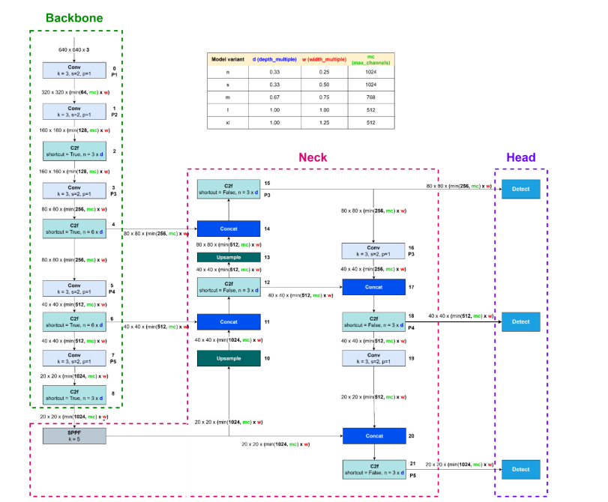

**Fig. 2. YOLOv8 Architecture visualization [9]**

**3.2.3: Advantages of YOLOv8 over its predecessors**

* Anchor-Free Predictions: Unlike traditional YOLO models that rely on predefined anchor boxes, YOLOv8 predicts object centers directly, simplifying the model and improving flexibility across datasets.
* SiLU Activation Function: All convolutional layers employ the Sigmoid Linear Unit (SiLU), which provides smoother gradients and better optimization than conventional activation functions.
* Normalization: Batch Normalization layers are applied to stabilize learning and accelerate convergence.
* Post-processing: Non-Maximum Suppression (NMS) is applied to remove redundant detections based on confidence thresholds.

**3.3 Model Training**

**3.3.1 Dataset splitting**

The dataset which was used was split into three subsets:

**Training Set (70%):** Used to train the YOLOv8 model and learn object representations.

**Validation Set (20%)**: Used to monitor the model's performance during training and prevent overfitting.

**Test Set (10%):** Reserved for the final evaluation of the model’s accuracy and generalization ability.

The data split was performed randomly while ensuring that all defect classes were proportionally represented in each subset.

**3.3.2 Hyperparameters**

|  |  |  |
| --- | --- | --- |
| **Hyperparameter** | **Value** | **Description** |
| **Batch Size** | 16 | Number of images per training iteration. |
| **Epochs** | 100 | Number of full passes through the training set. |
| **Learning Rate** | 0.001 | Initial rate at which the model updates weights. |
| **Input Resolution** | 640 × 640 | Standard input size for YOLOv8 models. |
| **Optimizer** | SGD | Stochastic Gradient Descent with momentum. |
| **Scheduler** | Cosine decay | Reduces learning rate over time for better convergence. |

**Table 4. Hyperparameters used for training the model**

1. **Experimental Work**

**4.1 Dataset Description**

The dataset utilized in this study is the PCB Defects Dataset, originally published by the Open Lab on Human Robot Interaction at Peking University and made publicly available on GitHub. This dataset is specifically designed for printed circuit board (PCB) defect detection and classification tasks. [10]

The dataset consists of 1,386 high-resolution grayscale images of PCB boards, each annotated with defect type and bounding box information. These images simulate real manufacturing conditions and include various levels of complexity and visual noise to reflect practical inspection scenarios.

There aresix distinct types of PCB defects, annotated and labeled consistently across the dataset:

|  |  |
| --- | --- |
| **Class Index** | **Defect type** |
| 0 | Missing Hole |
| 1 | Mouse Bite |
| 2 | Open Circuit |
| 3 | Short |
| 4 | Spur |
| 5 | Spurious Copper |

**Table 5. Defect classes in the dataset**

The missing hole defect refers to the absence of a drilled hole where one is required for placing through-hole components, potentially leading to assembly or connectivity issues.

A mouse bite defect appears as small, irregular notches or cuts along the PCB edges, resembling the marks left by a mouse bite, often occurring when PCBs are separated from a larger panel and resulting in structural imperfections.

The open circuit defect is characterized by a break or gap in the conductive path, which disrupts the flow of current and can render parts of the circuit inoperative.

In contrast, a short defect occurs when two or more conductive elements are unintentionally connected, creating a path of low resistance that may lead to component damage or functional failure.

The spur defect involves thin, stray copper lines extending from traces, which may interfere with signals or lead to electrical shorts if they bridge unintended connections.

Lastly, the spurious copper defect consists of random, leftover copper patches not associated with any functional circuit paths, posing risks of electromagnetic interference or unplanned conductivity.

**4.2 Training results**

The YOLOv8s model was trained on the PCB Defects dataset using annotated images for six classes of common PCB faults. The dataset was divided into training and validation subsets, with 70% of the images used for training and 20% for validation and 10% for testing. The model was trained for 100 epochs with a batch size of 16, an initial learning rate of 0.001 to augment the dataset and improve generalization.

During training, key metrics such as training loss**,** validation loss**,** precision**,** recall, and mean Average Precision were tracked to evaluate the model’s performance. These metrics were plotted over the epochs, allowing the observation of convergence behavior. The model demonstrated steady improvements in classification and localization capabilities across training epochs.

|  |  |  |  |  |
| --- | --- | --- | --- | --- |
| **Class** | **Instances** | **Precision** | **Recall** | **mAP** |
| All | 155 | 0.97 | 0.96 | 0.992 |
| missing_hole | 29 | 1.00 | 0.967 | 0.995 |
| mouse_bite | 35 | 0.93 | 0.971 | 0.985 |
| open_circuit | 26 | 1.00 | 0.86 | 0.99 |
| short | 27 | 0.95 | 0.963 | 0.991 |
| spur | 14 | 0.962 | 1.00 | 0.995 |
| spurious_copper | 24 | 0.98 | 1.00 | 0.995 |

**Table 6. Performance Metrics Obtained**

The final validation results showed high mAP scores across all six defect classes, indicating the model's strong ability to detect and distinguish among different types of PCB defects. Confusion matrices and precision-recall curves further supported the model's accuracy, showing minimal class confusion.

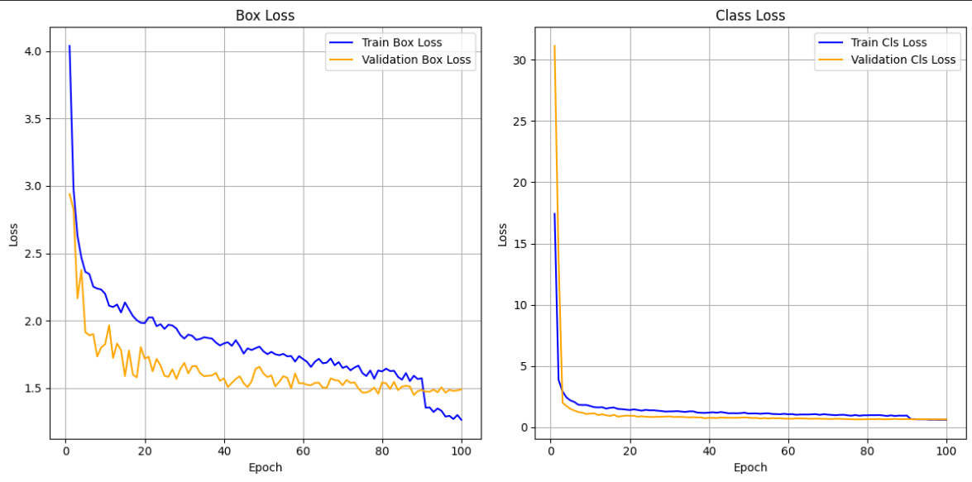

**Fig 3. Output plots after training the model**

According to Figure 3, the bounding box regression loss, or box loss, suggests that there is no overfitting, and the bounding boxes being predicted are correct most of the time. The classification loss exhibits a sharp decline during the initial epochs and stabilizes thereafter, with near-overlapping curves for training and validation. This suggests that the model rapidly learns to distinguish between defect classes and maintains consistent classification performance.

**4.3 Integration of Grad-CAM**

To improve model transparency and interpretability, Gradient-weighted Class Activation Mapping (Grad-CAM) was applied to visualize the internal decision-making process of the YOLOv8 model. Grad-CAM generates heatmaps that highlight the regions in the input image that contributed most to the model’s predictions.

In the case of the PCB Defects dataset, Grad-CAM was used to produce activation maps for various correctly and incorrectly classified images across all six defect classes. For instance, in correctly predicted cases of “missing hole,” the heatmaps showed strong activation over the regions where the holes were absent. Similarly, for defects like “short” and “spur,” Grad-CAM effectively localized the critical trace areas where the anomaly was present.

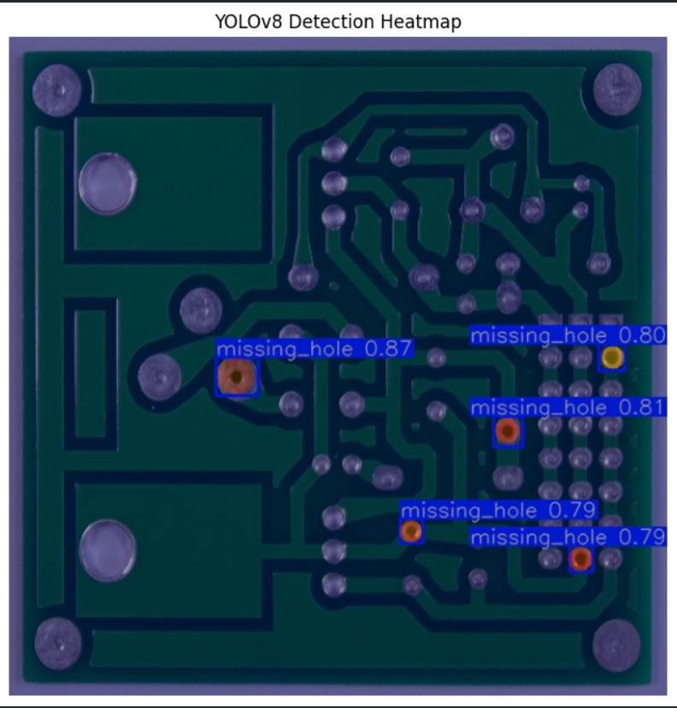

**Fig 4. Grad-CAM heatmap visualization**

In Fig.4, the model has identified several missing holes in the PCB. Each missing hole is bounded by a box and has a confidence score. Around each bounding box, there is a heatmap, which indicates where the model is focusing when detecting that particular defect.

Red regions represent the highest activation, signifying strong influence on the model's decision. Orange regions indicate high but slightly lower importance, while yellow reflects moderate contribution. Blue regions correspond to low or negligible impact. This color-coded attention mapping facilitates interpretability by highlighting areas most relevant to defect detection.

**4.4 Challenges and Limitations**

4.4.1 Similar Looking Defects

One of the most prominent challenges is the model's tendency to produce false positives in images with complex background patterns or overlapping defects. Due to the fine-grained nature of PCB images, visually similar defect types such as spur and spurious copper, or mouse bite and missing hole often confuse the model.

These categories share overlapping visual features like rough edges, irregular copper shapes, or small holes, leading to inter-class misclassification.

A spur, which is a thin unwanted extension from a trace, may be mistakenly identified as spurious copper due to its shape. Mouse bites, which manifest as jagged notches, can sometimes be confused with missing holes, particularly if the bite pattern overlaps a drilled pad.

4.4.2 Limitations of Grad-CAM with YOLO

YOLO is a fully convolutional model with multiple output heads, making it complex to trace a single prediction back to a particular convolutional layer.

Grad-CAM was originally designed for classification models, where a single output is backpropagated. With object detection, especially when there are multiple bounding boxes and class predictions per image, choosing which output to analyze becomes non-trivial. As a result, Grad-CAM visualizations may sometimes appear blurred or unfocused, particularly if the chosen target layer is too deep or too shallow.

**4.5 Future Scope**

The proposed YOLOv8-based approach for PCB defect detection shows significant promise, and its scope can be extended across various directions in both research and industrial settings.

One of the most impactful areas of future work involves scaling this approach to more diverse and real-world datasets. The current dataset is relatively controlled and synthetic; integrating images from actual factory floors, with varying lighting conditions, noise, and occlusions, would improve the model's robustness. Expanding the dataset to include new defect categories and handling multi-defect instances per PCB would also make the model more applicable in dynamic industrial environments.

On the explainability front, the inclusion of Grad-CAM provides basic insight into the model’s decision-making process, but more advanced XAI techniques can be explored. Approaches like Score-CAM, Layer-wise Relevance Propagation (LRP), and SHAP (SHapley Additive exPlanations) could offer deeper insights into model behavior and allow engineers to trust predictions even in borderline cases. These techniques can also aid in debugging model errors, improving data quality, and refining annotations.

Furthermore, this system holds strong potential for real-time deployment on production lines. With optimizations such as quantization, pruning, and GPU acceleration, the YOLOv8 model can be embedded into edge devices or robotic vision systems to inspect PCBs on-the-fly. Real-time alerts could help manufacturers identify defects immediately and reduce downstream failures, leading to cost savings and improved quality assurance.

Lastly, integrating this model into an active learning loop, where human experts verify uncertain predictions and feed corrected labels back into the training set, could continually improve performance and adapt the system to evolving manufacturing standards.

**Conclusion**

This research presents an automated and explainable solution for detecting defects in printed circuit boards (PCBs) using the YOLOv8 deep learning model, complemented by Grad-CAM-based visual interpretability. Through efficient preprocessing, annotation, and training on a labeled Public dataset, the model demonstrated high accuracy in identifying six critical PCB defect classes: missing hole, mouse bite, open circuit, short, spur, and spurious copper. The YOLOv8 model's real-time detection capabilities, combined with its lightweight architecture, make it suitable for high-speed industrial environments where precision and efficiency are essential.

Incorporating explainable AI through Grad-CAM further enhances the model's transparency by visualizing regions of attention that contribute to its predictions. This not only builds trust in automated decisions but also assists in identifying potential misclassifications or ambiguous cases.

While the results are encouraging, the study also identifies challenges such as class confusion and interpretability limitations in multi-object settings. Nevertheless, the approach lays a strong foundation for future advancements in smart manufacturing systems, including real-world deployment, domain adaptation, and more advanced explainability tools.

In conclusion, this work contributes to the growing field of intelligent quality inspection by offering a practical, scalable, and interpretable framework for PCB defect detection—paving the way for more reliable and automated electronics manufacturing processes.

**References**

1. Q. Ling and N. A. M. Isa, "Printed Circuit Board Defect Detection Methods Based on Image Processing, Machine Learning and Deep Learning: A Survey," in *IEEE Access*, vol. 11, pp. 15921-15944, 2023, doi: 10.1109/ACCESS.2023.3245093
2. T. Khare, V. Bahel and A. C. Phadke, "PCB-Fire: Automated Classification and Fault Detection in PCB," *2020 Third International Conference on Multimedia Processing, Communication & Information Technology (MPCIT)*, Shivamogga, India, 2020, pp. 123-128, doi: 10.1109/MPCIT51588.2020.9350324.
3. Z. Lan, Y. Hong and Y. Li, "An improved YOLOv3 method for PCB surface defect detection," *2021 IEEE International Conference on Power Electronics, Computer Applications (ICPECA)*, Shenyang, China, 2021, pp. 1009-1015, doi: 10.1109/ICPECA51329.2021.9362675.
4. A. Sharma, M. Agrawal, P. Sardeshpande, A. Gupta, A. Pasha and R. R. Khandelwal, "PCB Defect Detection Using Deep Learning Methods," *2024 15th International Conference on Computing Communication and Networking Technologies (ICCCNT)*, Kamand, India, 2024, pp. 1-7, doi: 10.1109/ICCCNT61001.2024.10726140.
5. R. Raffik, B. Sabitha, D. Arunprasanth, E. Karthikeyan, A. G. Padmanaaban and V. S. Prasanth, "Automated PCB Defect Identification System using Machine Learning Techniques," *2023 2nd International Conference on Advancements in Electrical, Electronics, Communication, Computing and Automation (ICAECA)*, Coimbatore, India, 2023, pp. 1-5, doi: 10.1109/ICAECA56562.2023.10200565
6. V. Anbumani, S. Padmapriya, R. RajaRaja, N. Vikram, S. Ranjith and B. T. Abhinav, "Efficient Fault Detection Methods in Printed Circuit Boards using Machine Learning Techniques," *2024 15th International Conference on Computing Communication and Networking Technologies (ICCCNT)*, Kamand, India, 2024, pp. 1-6, doi: 10.1109/ICCCNT61001.2024.10725322.
7. J. Sood, M. Agrawal, Pratik, R. R. Khandelwal, H. Zambani and A. Ghumade, "Advancements in PCB Defect Detection: An In-Depth Exploration of Image Processing Techniques," *2024 4th International Conference on Pervasive Computing and Social Networking (ICPCSN)*, Salem, India, 2024, pp. 166-173, doi: 10.1109/ICPCSN62568.2024.00036.
8. Y. M. Rao, P. Abhinav, D. S. Nayak and N. S. Reddy, "Flaw Detection in PCB Using Deep Learning and Image Processing," *2024 2nd International Conference on Sustainable Computing and Smart Systems (ICSCSS)*, Coimbatore, India, 2024, pp. 1280-1285, doi: 10.1109/ICSCSS60660.2024.10625505.
9. Hidayatullah, P., Syakrani, N., Sholahuddin, M. R., Gelar, T., & Tubagus, R. (2025). YOLOv8 to YOLO11: A Comprehensive Architecture In-depth Comparative Review. https://arxiv.org/abs/2501.13400.
10. W. Huang and P. Wei, A PCB Dataset for Defects Detection and Classification. 2019. <https://arxiv.org/abs/1901.08204>

