1C: PERCEPTRON MODEL

According to perceptron model, we can find a discriminant vector w such that divides the data points linearly.

We can update the value of w in each iteration if we find that current w doesn’t classify all the points correctly.

🡨w $t^{}$ + training rate\*(t\*x)

Where x is the misclassified point and t is its value.

Implementation:

We will divide the dataset in the training and testing dataset in the ratio 70:30

We have taken training rate as 0.01 and maximum no. of iterations to be 10^6.

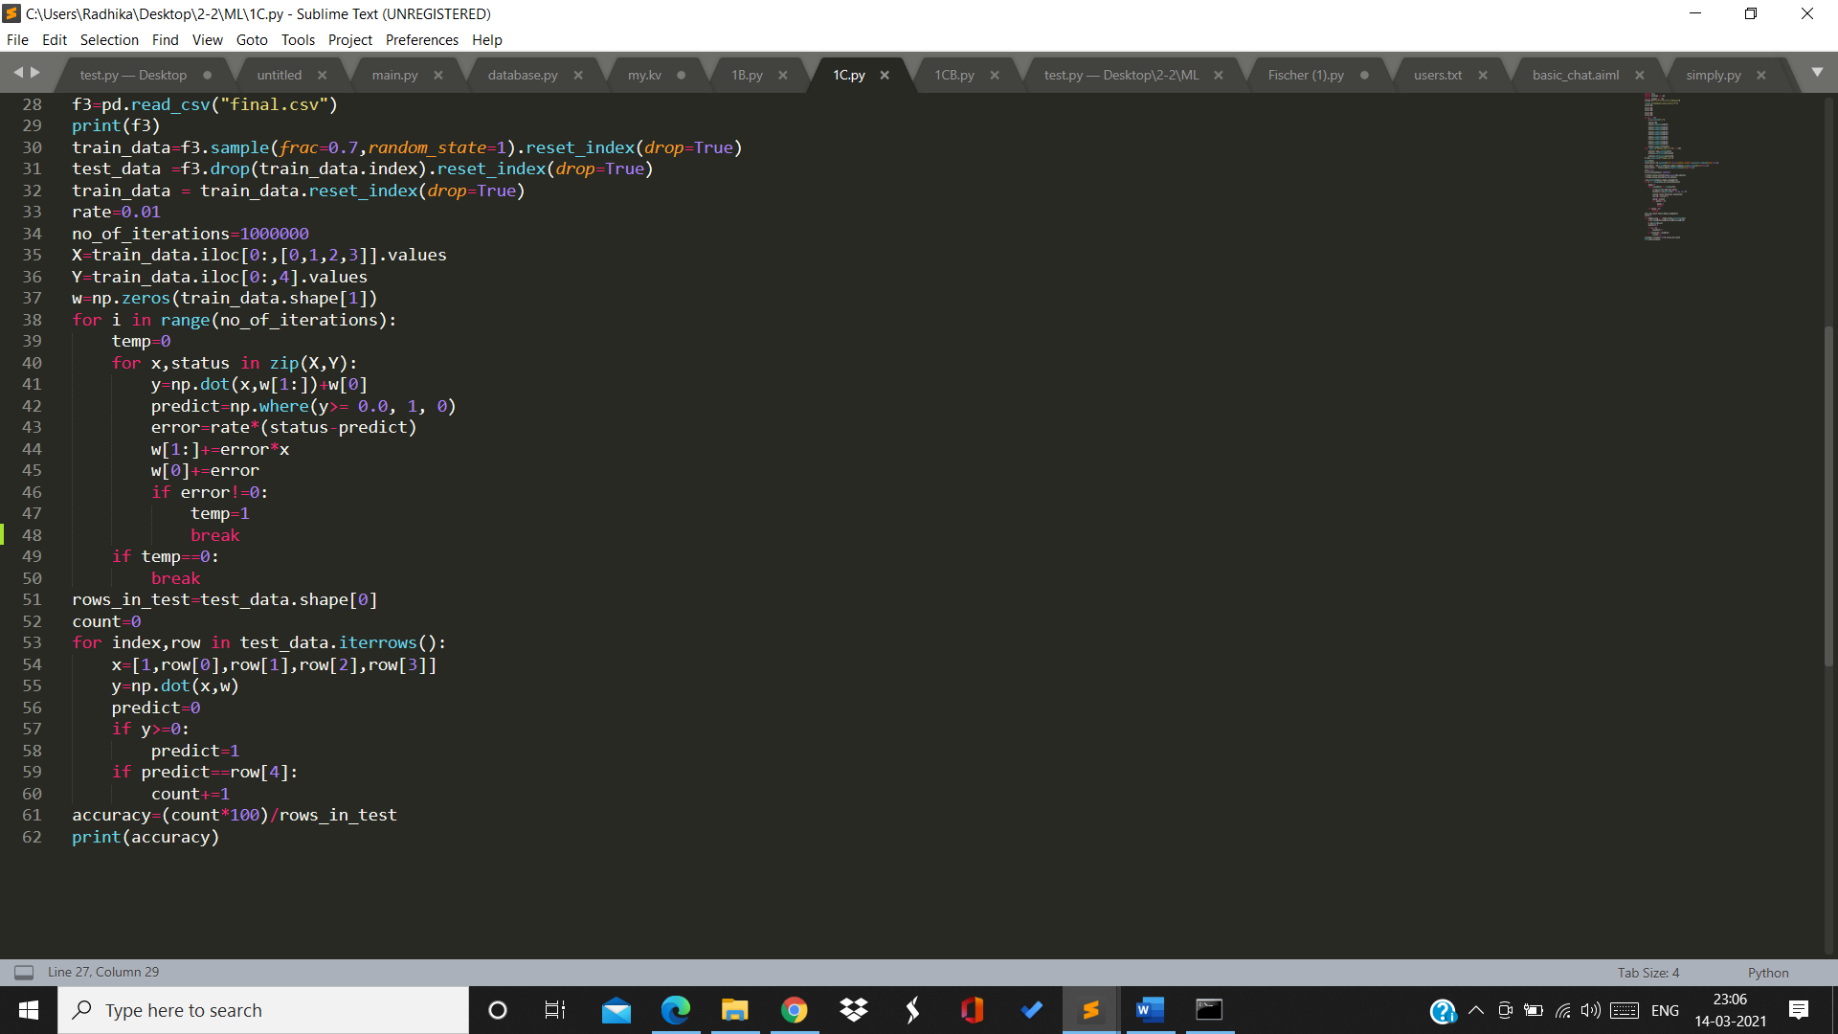

X represents the columns with the features of dataset and Y represents the column with the classification value.

We will update the value of w until we get all the points correctly classified or until we cover all 10^6 iterations.

We will then test our model on the testing data and find the accuracy



Output:

For 1st dataset:

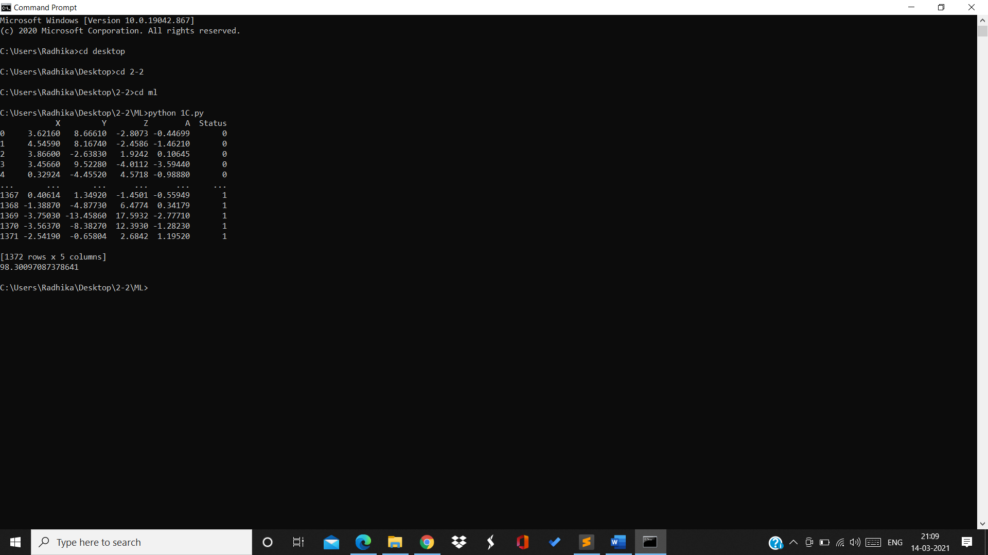

For 2nd dataset: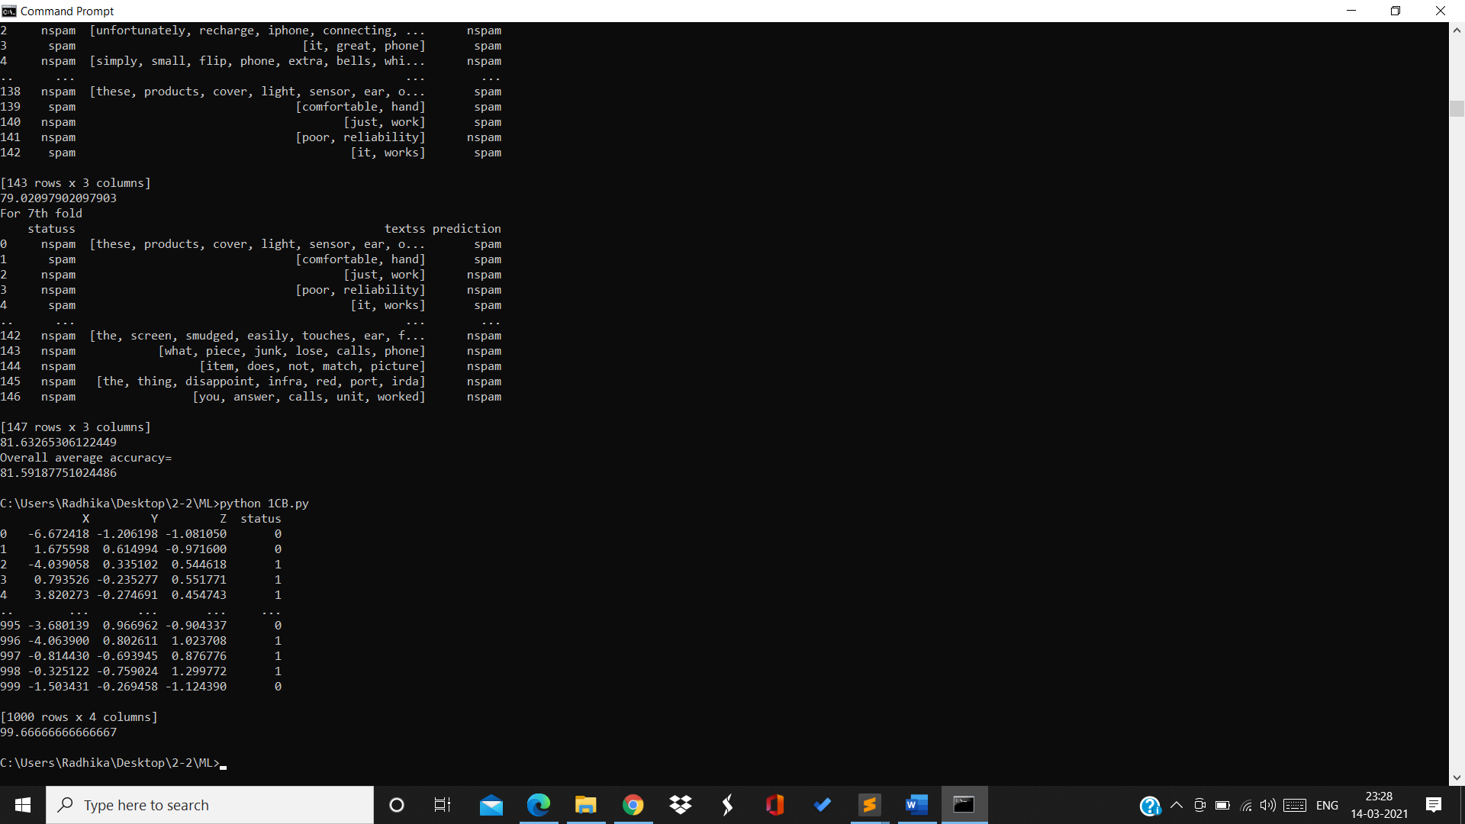

RESULT:

Accuracy of dataset 1 : 98.3 %

Accuracy of dataset 2: 99.67%

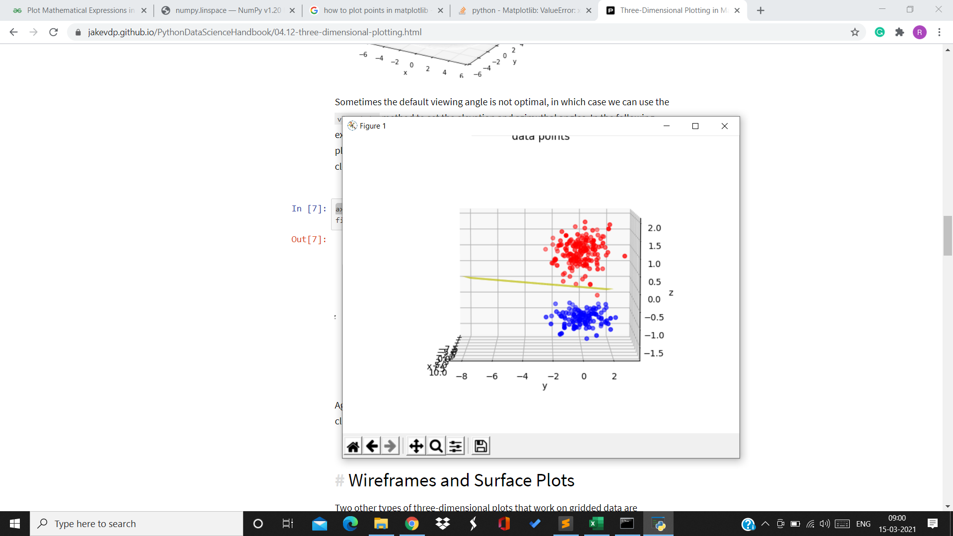

(Visualization of dataset 2)

Dataset 2 was more linearly separable because the loop broke because there was no misclassification left and the training data points were linearly separable but in dataset 1 the loop ran for all the 10^6 iterations which happened because the data points were not linearly separable.

DISADVANTAGES:

1. The output values of a perceptron can take on only one of two values (0 or 1) due to the hard-limit transfer function.
2. Perceptrons can only classify linearly separable sets of vectors. If a straight line or a plane can be drawn to separate the input vectors into their correct categories, the input vectors are linearly separable. If the vectors are not linearly separable, learning will never reach a point where all vectors are classified properly.

By:

Radhika Sigtia

Bathini Akash

Sharvani