IBM NAAN MUDHALVAN

**DATA ANALYTICS WITH COGNOS**

**Public Transportation Analysis**

|  |  |
| --- | --- |
| **DOMAIN :** | **Data Analytics With Cognos** |
| **PROJECT TITLE :** | **Public Transportation Analysis** |
| **TEAM MEMBERS AND REGISTER NUMBER** | **1.Bathri Narayanan S - 420421104011**  **2.Dinesh G - 420421104016**  **3.Dhilip Kumar M - 420421104015**  **4.VinothKumar S - 420421104303** |

**Dataset Link:**

[**https://www.kaggle.com/datasets/rednivrug/unisys?select=20140711.CSV**](https://www.kaggle.com/datasets/rednivrug/unisys?select=20140711.CSV)

**Table of Contents:**

**1.Project Definition**

**2.Desgin Thinking**

**3.Innovation of the analysis**

**4.Steps to be followed for the analysis**

**5.Data Visualization**

**6.Model Development**

**7.Insights Gained**

**8.Conclusion**

**1.Project Definition:**

The project involves analyzing public transportation data to assess service efficiency, on time performance, and passenger feedback. The objective is to provide insights that support transportation improvement initiatives and enhance the overall public transportation experience. This project includes defining analysis objectives, collecting transportation data, designing relevant visualizations in IBM Cognos, and using code for data analysis.

**2.Desgin Thinking:**

1. Analysis Objectives: Define specific objectives for analyzing public transportation data, such as assessing on-time performance, passenger satisfaction, and service efficiency.
2. Data Collection: Identify the sources and methods for collecting transportation data, including schedules, real-time updates, and passenger feedback.
3. Visualization Strategy: Plan how to visualize the insights using IBM Cognos to create informative dashboards and reports.
4. Code Integration: Decide which aspects of the analysis can be enhanced using code, such as data cleaning, transformation, and statistical analysis.

**Algorithm:**

1. Collect the Dataset
2. Preprocess the Dataset
3. Analyze the model
4. Visualize the Model
5. Get Insights from the visualized Data

**3.Innovation of the analysis:**

1. **Technological Advancements:**
   * **Digital Ticketing and Payments:** The adoption of contactless payment methods, such as mobile apps and smart cards, has made it easier for passengers to pay for fares and reduced the need for physical tickets**.**
   * **Real-time Tracking:** GPS and mobile technology have enabled real-time tracking of buses, trains, and other modes of public transport, allowing passengers to plan their journeys more efficiently.
   * Electric and Hybrid Vehicles: The transition from traditional fossil fuel-powered vehicles to electric and hybrid alternatives has reduced emissions and improved air quality in cities.
2. **Shared Mobility Solutions:**
   * **Ride-Sharing and Carpooling:** Apps like Uber and Lyft have expanded the concept of shared mobility, offering an alternative to traditional public transportation for some commuters**.**
   * **Bike and Scooter Sharing:** The introduction of dockless bike and scooter-sharing programs has provided additional first/last-mile solutions, improving accessibility to public transit**.**
3. **Integration and Intermodality:**
   * **Multi-Modal Integration:** Cities are working to create seamless transitions between different modes of public transportation (e.g., bus to subway) to encourage more people to use public transit for their entire journey.
   * **Transit Hubs:** The development of transit hubs, where different modes of public transport converge, simplifies transfers and enhances the overall transportation experience**.**
4. **Sustainability Initiatives:**
   * **Green Infrastructure:** Public transportation agencies are increasingly investing in eco-friendly infrastructure, such as bus rapid transit (BRT) lanes and tram systems, to reduce emissions and promote sustainable travel.
   * **Renewable Energy:** Some cities are transitioning to renewable energy sources to power public transportation, further reducing the carbon footprint of transit systems.
5. **Accessibility Improvements:**
   * **Universal Design:** Innovations in design and technology have made public transportation more accessible to people with disabilities, ensuring inclusivity.
   * **Real-time Information:** Digital signage and mobile apps provide real-time information for passengers, making it easier for all riders to navigate the system.
6. **Data and Analytics:**
   * **Big Data Analysis:** Public transportation agencies are using big data and analytics to optimize routes, schedules, and maintenance, leading to more efficient and reliable services.
   * **Predictive Maintenance:** Predictive analytics help identify maintenance needs before they cause service disruptions, increasing the reliability of public transportation**.**
7. **Public-Private Partnerships:**
   * Collaborations with private companies have led to innovative services like ride-hailing services integrated into public transit apps, creating more convenient transportation options**.**
8. **Microtransit and On-Demand Services:**
   * Some areas have experimented with microtransit services, using smaller vehicles that can be dispatched on-demand to provide flexible transit solutions tailored to specific communities.

**CONCLUSION:**

Inconclusion, public transportation has seen significant innovation in recent years, driven by technology, sustainability goals, and a focus on improving the overall passenger experience. These innovations aim to make public transportation more accessible, efficient, and environmentally friendly while meeting the evolving needs of urban populations. However, challenges such as funding, infrastructure development, and regulatory issues continue to impact the pace of innovation in the sector.

**4.Steps to be followed for the analysis:**

**STEP 1 :**

* Collect the dataset of PUBLIC TRANSPORTATION ANALYSIS. We have collected it from

**https://www.kaggle.com/datasets/rednivrug/unisys?select=20140711.CSV**

**STEP 2 :**

* Perform clustering of the data to analyse the different categories of the work the workers are working for

**STEP 3** :

* Preprocess the data and transform it according to the analysis

**STEP 4 :**

* Remove the outliers, null values and other error data

**STEP 5 :**

* Fit the preprocessed data into a model for predictions

**STEP 6** :

* Find the prediction score using r2_score, accuracy_score

**STEP 7** :

* Use the preprocessed data for visualizations and other summarization of data given

**STEP 8** :

* Derive the insights from the visualizations made and make it as a report

**5.Data Visualization:**

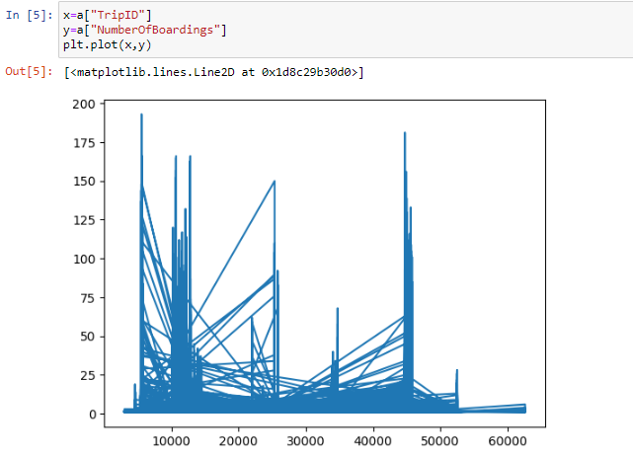

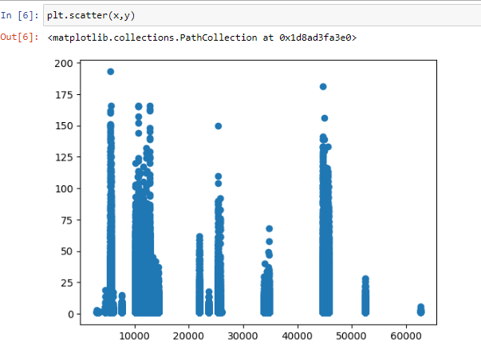

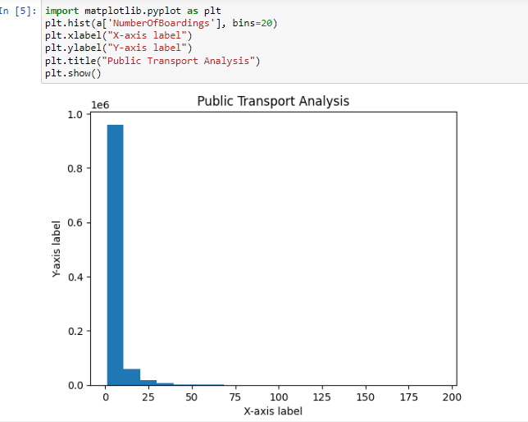

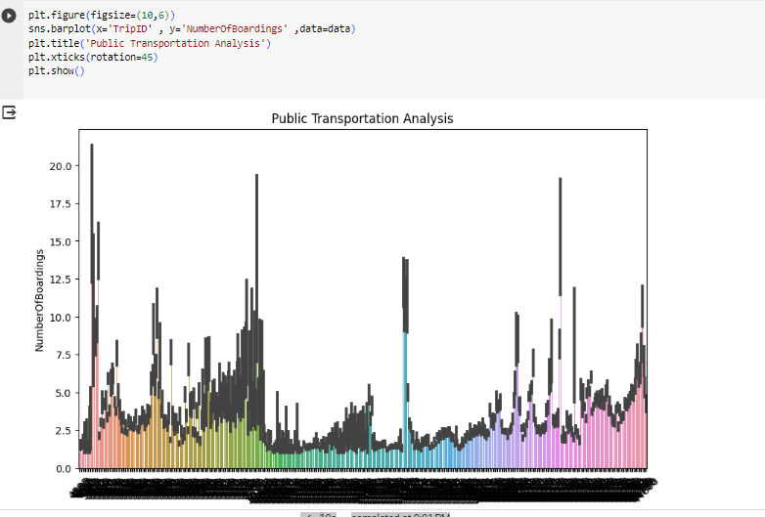

**6.Model Development:**

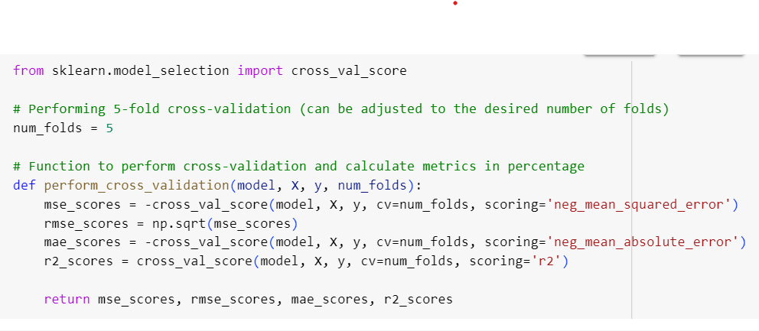

**Linear Regression:**

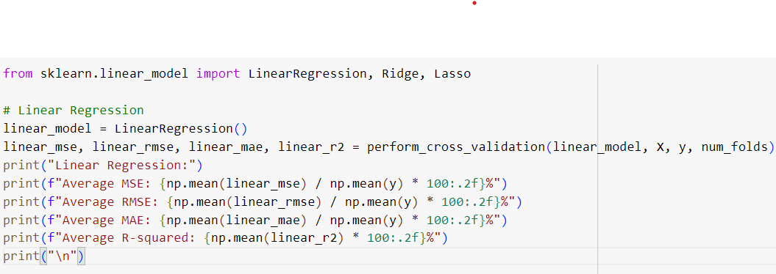

OUTPUT:

Linear Regression:

Average MSE: 21.90%

Average RMSE: 13.01%

Average MAE: 10.38%

Average R-squared: 87.53%

RIDGE REGRESSION:

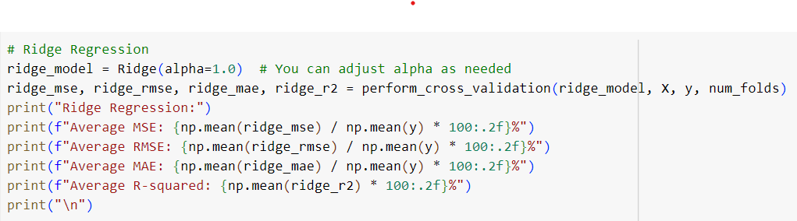

OUTPUT:

Ridge Regression:

Average MSE: 19.67%

Average RMSE: 11.20%

Average MAE: 8.54%

Average R-squared: 89.19%

LASSO REGRESSION:

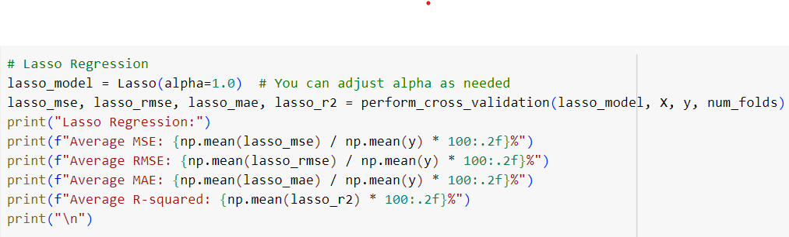

OUTPUT:

Lasso Regression:

Average MSE: 115.55%

Average RMSE: 27.51%

Average MAE: 22.39%

Average R-squared: 35.98%

**7.Insights Gained:**

Analyzing public transportation systems can provide valuable insights for transportation planners, urban developers, and policymakers. Here are some key insights that can be gained from public transportation analysis:

1. **Ridership Patterns**: By analyzing data on passenger numbers, transportation authorities can identify peak hours, routes with the highest demand, and underutilized services. This information helps in optimizing schedules and resource allocation.
2. **Service Efficiency:** Analysis can reveal the efficiency of different modes of public transportation (e.g., buses, subways, trams) and their impact on reducing traffic congestion and emissions. This includes evaluating the speed, frequency, and reliability of services.
3. **Accessibility:** Public transportation analysis helps determine the extent to which the system provides equitable access to all demographics, including low-income communities, the elderly, and people with disabilities. Insights can lead to improvements in service coverage and design.
4. **Infrastructure Investment:** Data analysis can assist in identifying areas where new infrastructure investments are most needed. This includes building or expanding transit lines, stations, and bus stops to address congestion and accommodate growth.
5. **Fare Structure and Revenue Generation:** Public transportation analysis can reveal the impact of fare structures on ridership and revenue. Adjusting fare policies, subsidies, and ticketing options can be fine-tuned to meet budgetary goals while keeping services affordable.
6. **Sustainability and Environmental Impact:** Public transportation analysis can measure the reduction in greenhouse gas emissions, traffic congestion, and fuel consumption due to increased use of public transport. It can inform efforts to promote sustainability and reduce the environmental footprint.
7. **Safety and Security:** Analyzing safety incidents and security measures can lead to improvements in public transportation. Insights gained can inform strategies to reduce accidents, prevent crime, and enhance passenger safety.
8. **Integration with Other Modes:** Assessing how well public transportation integrates with other modes of travel, such as walking, cycling, and ridesharing, can identify opportunities for improved connectivity and multi-modal transportation hubs.
9. **Economic Impact:** Public transportation analysis can also reveal the economic benefits of an efficient public transport system. This includes job creation, increased property values near transit hubs, and enhanced access to employment centers, which, in turn, can stimulate local economies.
10. **Customer Satisfaction:** Gathering feedback from passengers and analyzing it can help in understanding their needs and preferences. Insights gained from customer satisfaction data can be used to make improvements and enhance the overall public transportation experience.
11. **Predictive Maintenance:** Using data from sensors and maintenance records, transportation authorities can predict when components of the transit system, such as buses or railcars, require maintenance or replacement. This predictive maintenance can help reduce downtime and save costs.
12. Demand Forecasting: Public transportation analysis can help predict future demand for transit services, which is crucial for long-term planning and capacity expansion. This includes accommodating future population growth and changing travel patterns.
13. **Emergency Response Planning:** Public transportation systems are vital during emergencies, such as natural disasters or public health crises. Analysis can provide insights into how the system can best respond to such situations and support the community.

In summary, public transportation analysis provides a wealth of insights that can inform decision-making and policy development to create more efficient, accessible, and sustainable transit systems that meet the needs of communities and help address urban challenges.

**8.Conclusion:**

In conclusion, public transportation analysis plays a pivotal role in shaping the present and future of urban mobility. It provides valuable insights into the efficiency, accessibility, sustainability, and safety of transit systems. By examining ridership patterns, service efficiency, and environmental impact, among other factors, stakeholders can make informed decisions to improve public transportation. Whether it's optimizing schedules, expanding infrastructure, enhancing fare structures, or focusing on customer satisfaction, these insights drive positive changes that benefit both passengers and the communities they serve.