Name: Nazir Knuckles
Assignment 5.2
4/19/2026
GitHub Repo: https://github.com/Batking74/csd-310
Screenshot 1
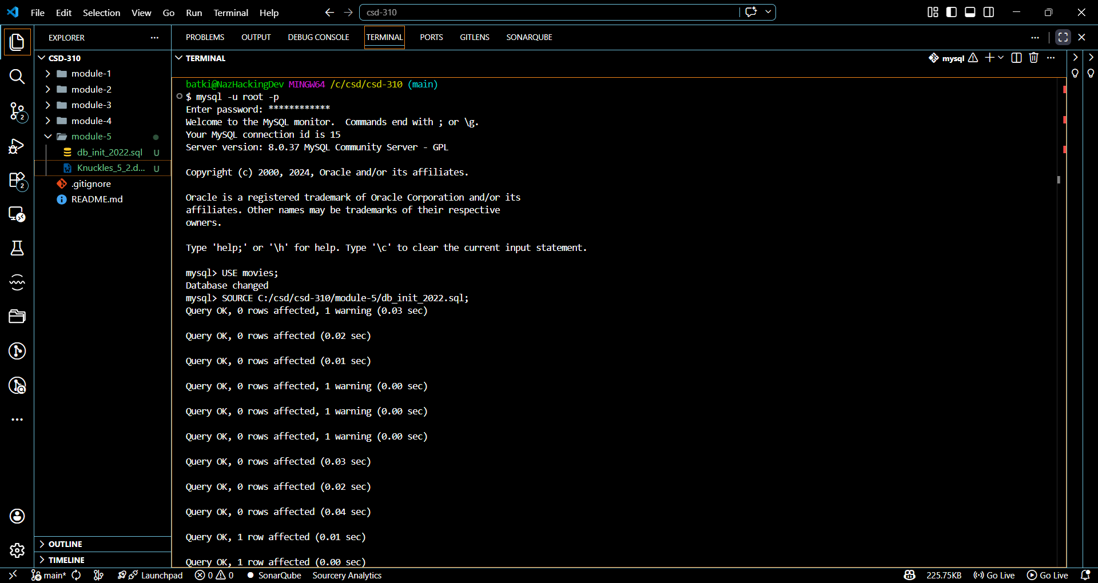

Screenshot 2
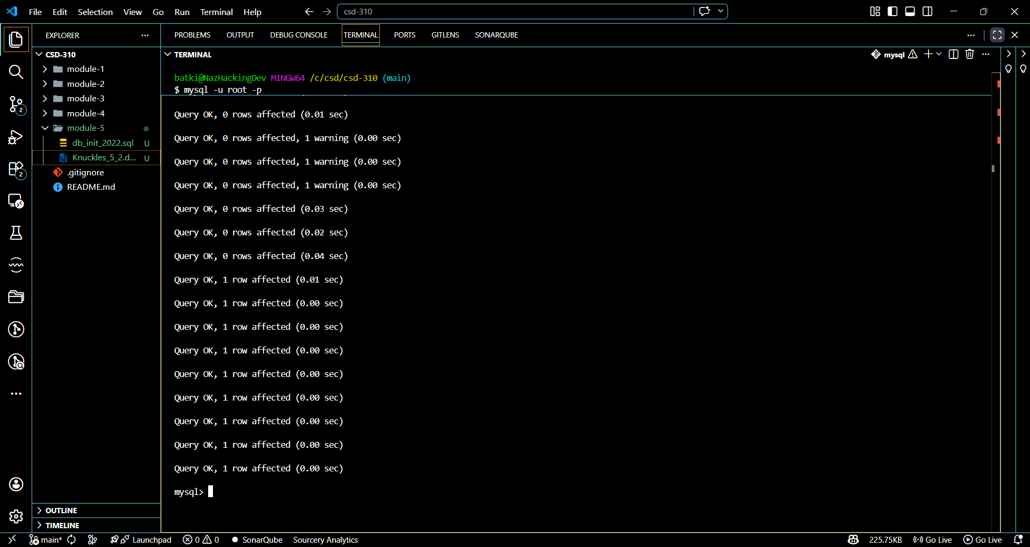
Screenshot 3
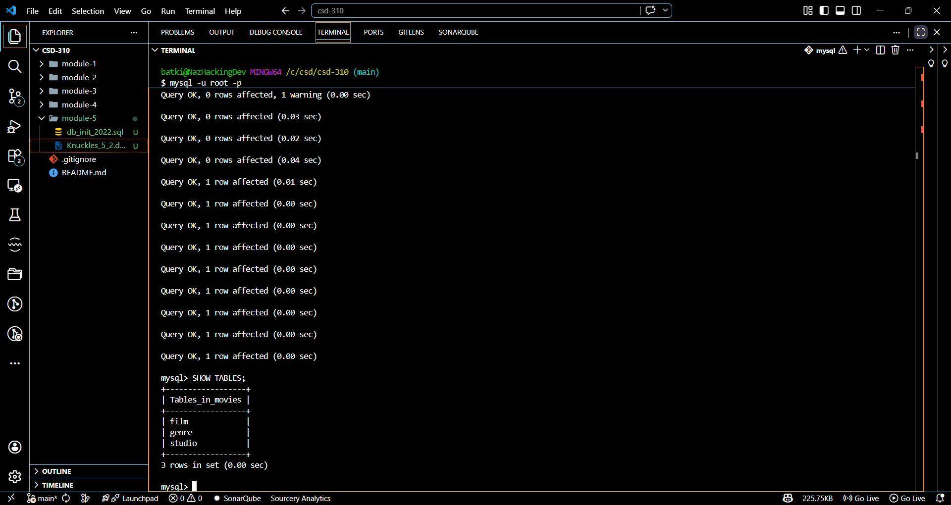
Screenshot 4
