Name: Nazir Knuckles
Assignment 6.2
4/27/2026
GitHub Repo: https://github.com/Batking74/csd-310
Screenshot 1
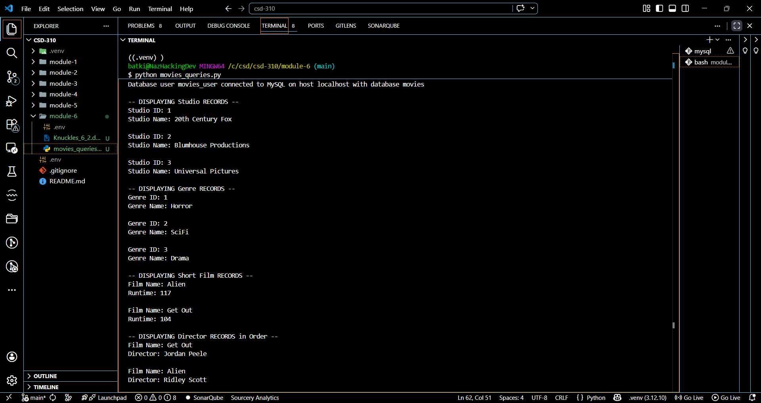

Screenshot 2
