Name: Nazir Knuckles
Assignment 4.2
4/12/2026

- Initial Connection
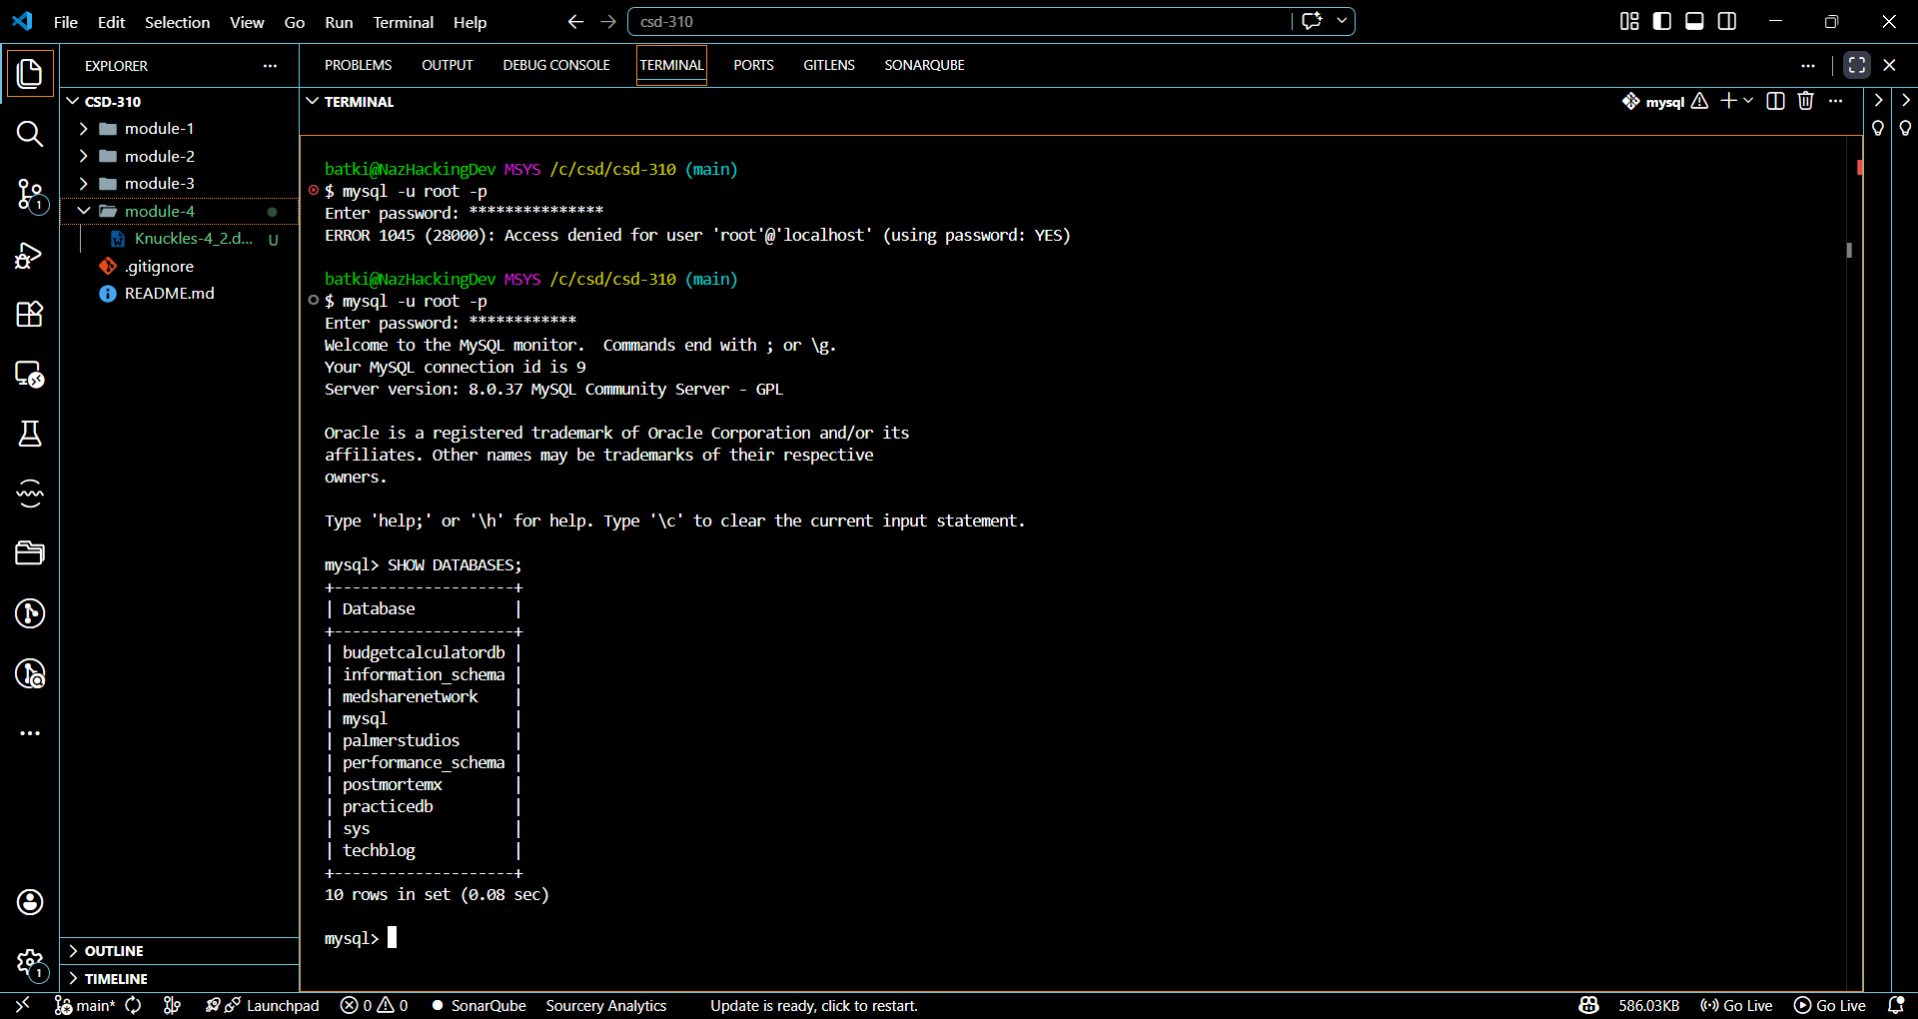

- Movies Database Creation
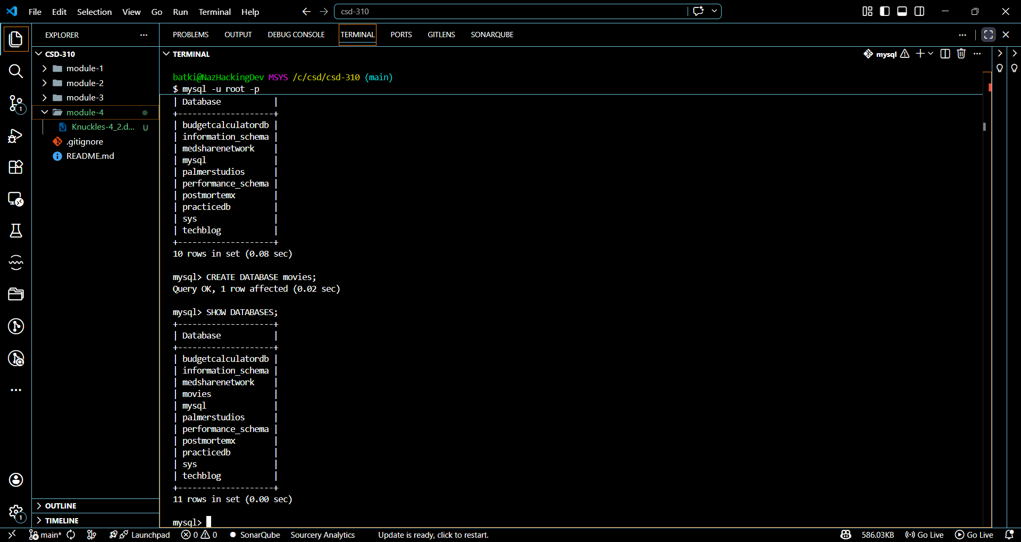

- Three Functions
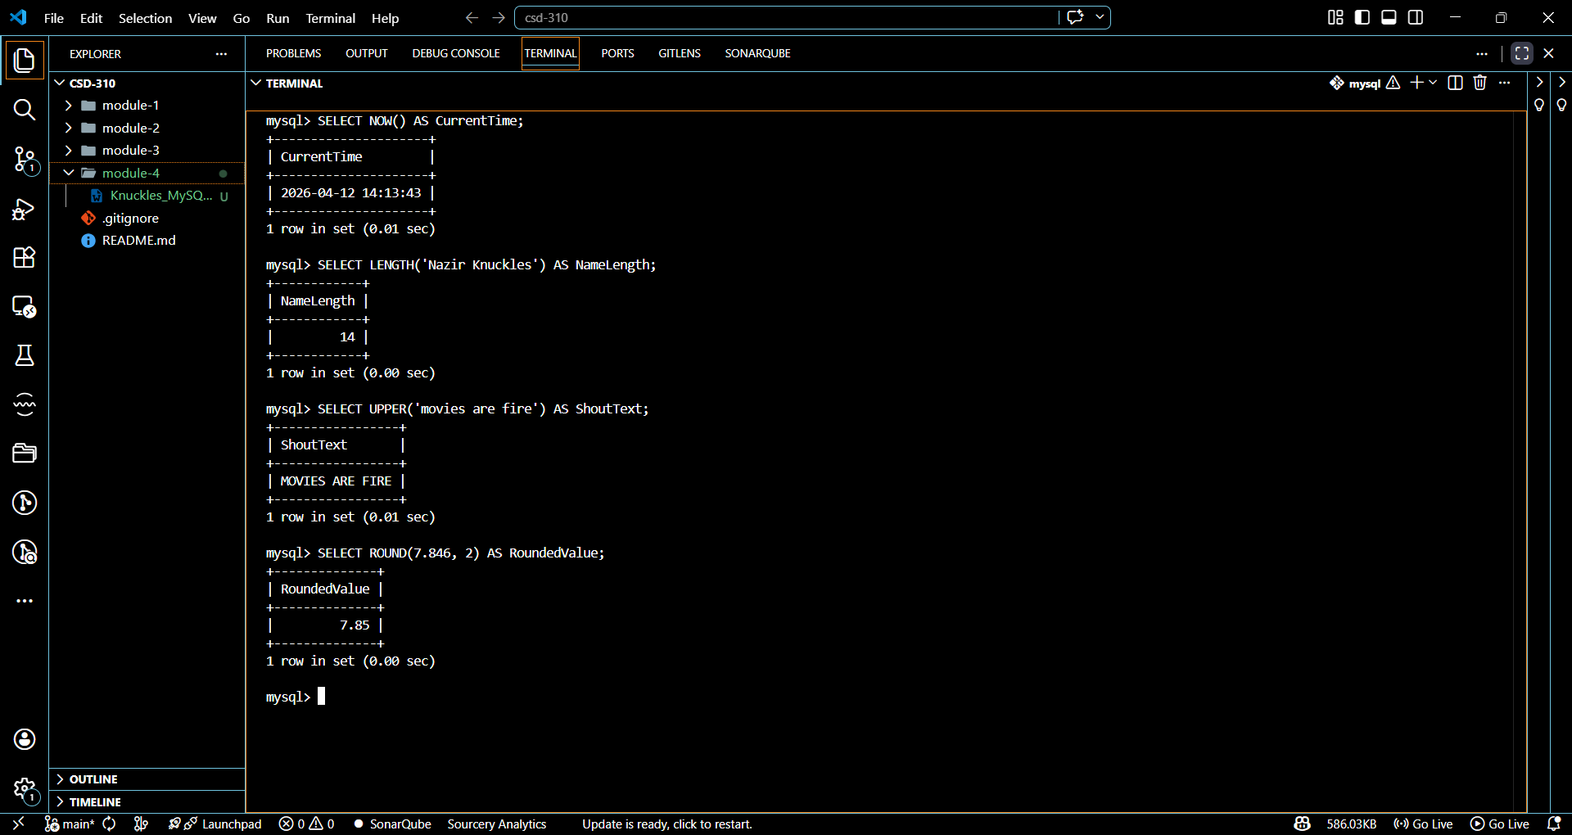

NOW() — Current Date & Time
When it might be used
The NOW() function is used when you need to record or display the current date and time. It is commonly used in applications for logging events, tracking when a user signs in, creating timestamps for records, or monitoring system activity.
LENGTH() — String Length
When it might be used
The LENGTH() function is used to determine how many characters are in a string. It is useful for validating user input (such as checking password length), enforcing character limits, or analyzing text data.
UPPER() — Convert Text to Uppercase
When it might be used
The UPPER() function is used to convert text to uppercase. It is helpful for standardizing text formatting, making comparisons case-insensitive, or improving readability in reports and outputs.
ROUND() — Round Numbers
When it might be used
The ROUND() function is used to round a number to a specified number of decimal places. It is commonly used in financial calculations, statistical analysis, and displaying clean, user-friendly numeric values.

