**How to use the following Linux commands: nmap, tcpdump, ping, mtr, traceroute, dig, airman, airdump, dig, iptables, netstat**

**NMAP:**

Nmap, or Network Mapper, is an open source Linux command line tool for network exploration and security auditing. With Nmap, server administrators can quickly reveal hosts and services, search for security issue

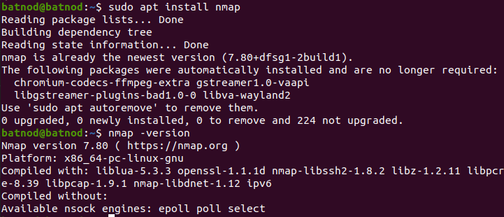

**Nmap command to scan for open ports:**

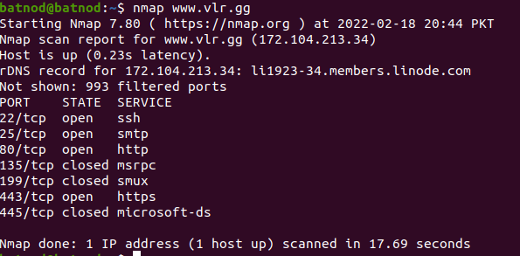

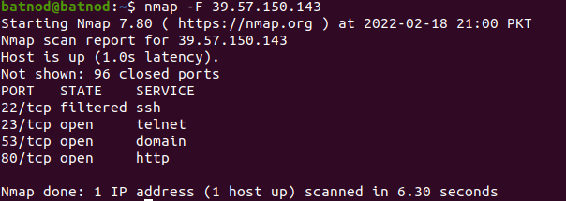

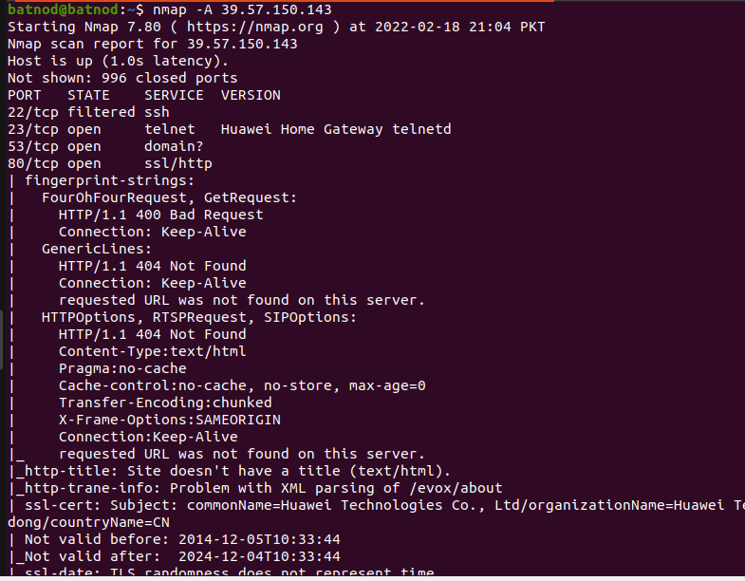

**Tcpdump:**

Tcpdump is a command line utility that allows you to capture and analyze network traffic going through your system. It is often used to help troubleshoot network issues, as well as a security tool.

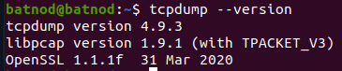

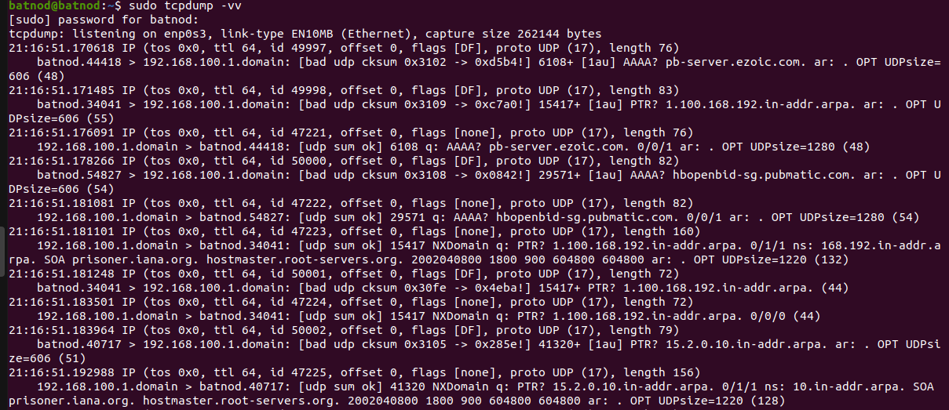

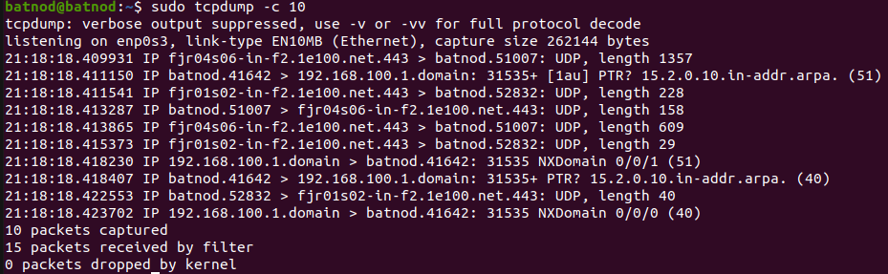

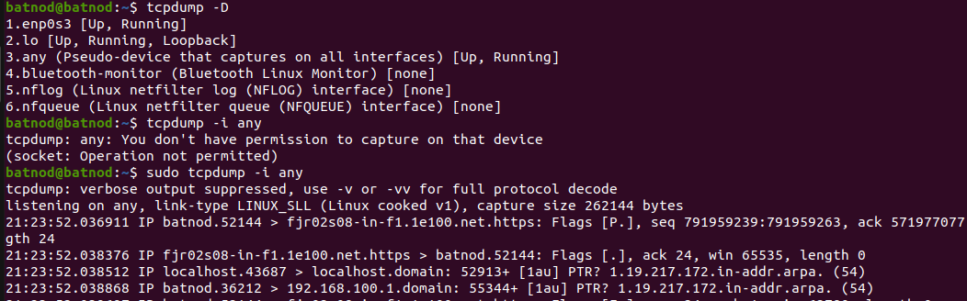

**Ping:**

[Ping](https://www.paessler.com/ping-monitoring) is a command-line utility, available on virtually any operating system with network connectivity, that acts as a test to see if a networked device is reachable.

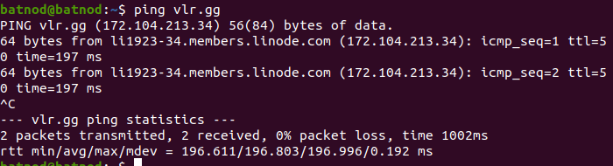

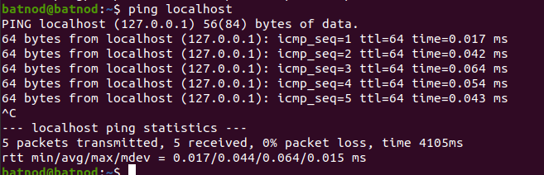



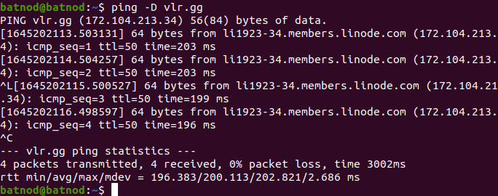

**Mtr:**

MTR is a simple, cross-platform command-line network diagnostic tool that combines the functionality of commonly used traceroute and ping programs into a single tool.



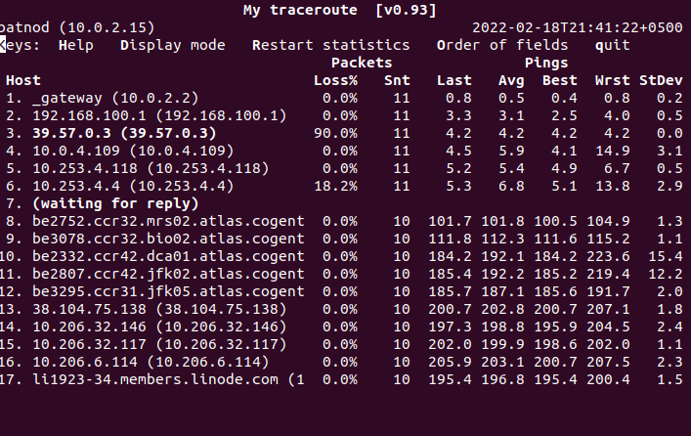

**Traceroute:**

The traceroute command attempts to trace the route an IP packet follows to an Internet host by launching UDP probe packets with a small maximum time-to-live (Max_ttl variable), then listening for an ICMP TIME_EXCEEDED response from gateways along the way.

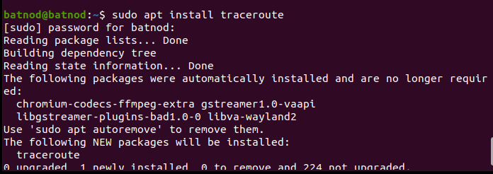



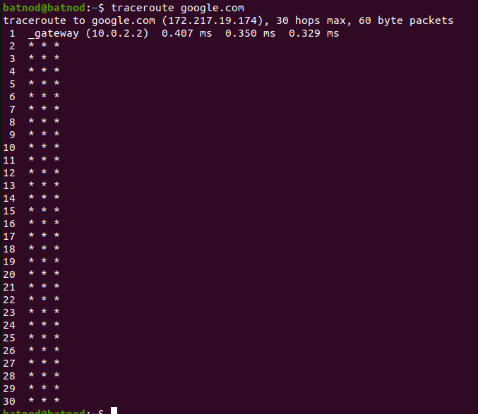

**Dig:**

The command dig is a tool for querying DNS nameservers for information about host addresses, mail exchanges, nameservers, and related information.

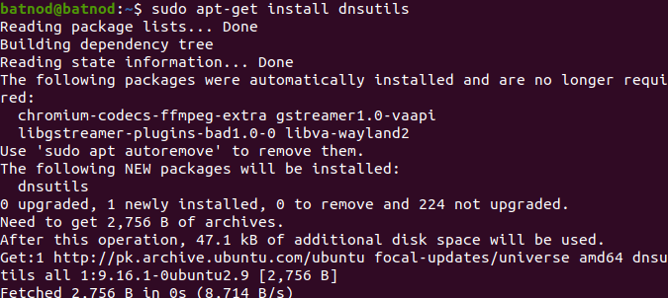

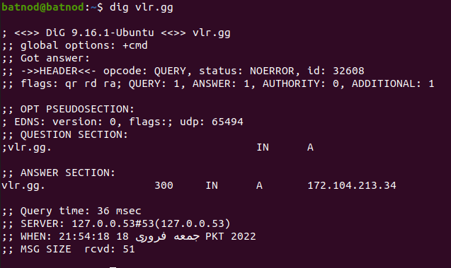



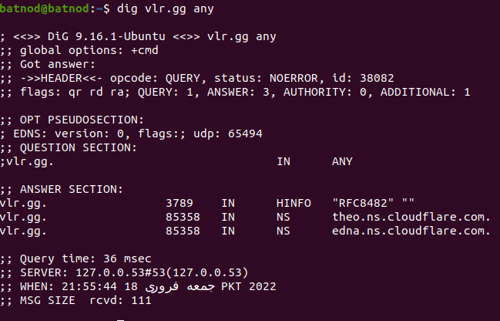

**Airdump:**

airodump-ng is used for packet capturing of raw 802.11 frames for the intent of using them with aircrack-ng.

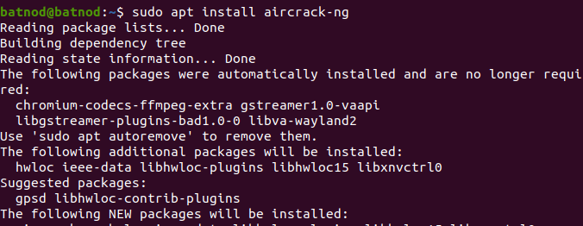

**Iptables:**

iptables is a command line interface used to set up and maintain tables for the Netfilter firewall for IPv4, included in the Linux kernel.

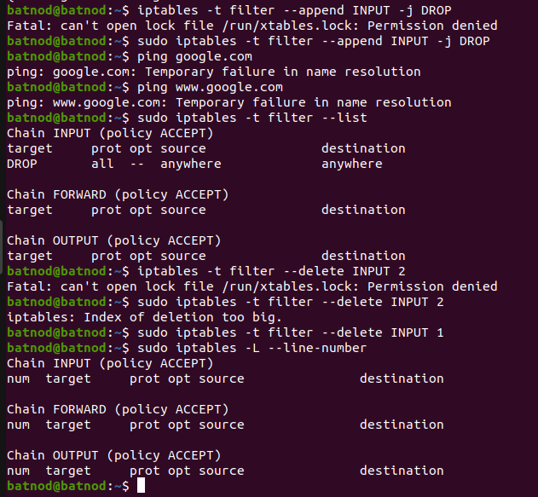

**NETSTAT:**

Netstat is a command line utility that can be used to list out all the network (socket) connections on a system. It lists out all the tcp, udp socket connections and the unix socket connections.



