Dastur oyna ko’rinishlaridan na`munalar

- Xususiy yarimo’tkazgichli asboblarda elektronlar va kovaklar statistikasi (Fermi-Dirak taqsimot funksiyasi)ni haroratning ta’siri orqali tahlil qilish dasturi bosh oynasi.
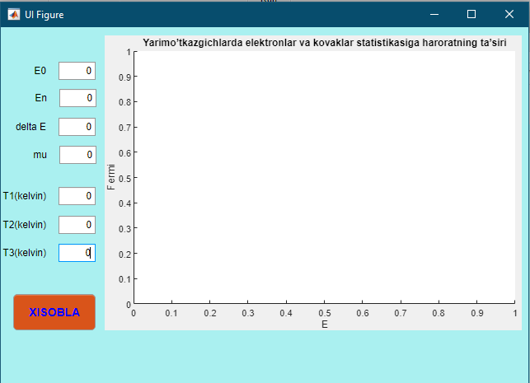
- Run tugmasini bosish orqali Fermi energiyasi (µ), Erkin elektronning boshlang’ich energiyasi (E₀), Erkin elektronning n- sathdagi energiyasi (E_{n}), va kerakli harorat (T1, T2, T3) lar mos ravishda kiritiladi.

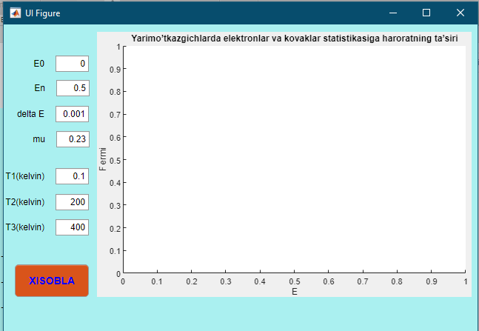

- Xisobla tugmasi yordamida berilgan haroratlardagi elektronlar va kovaklar statistikasini xosil qilamiz.
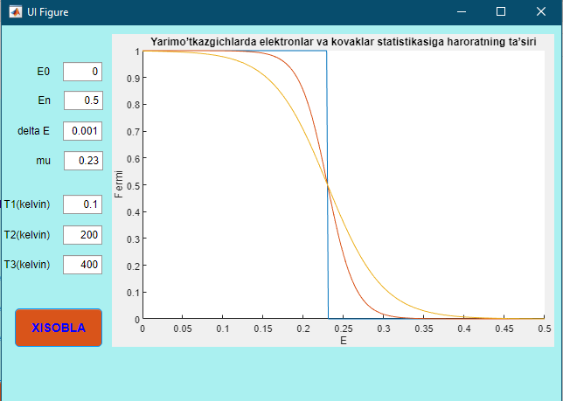

- Xisobla tugmasi yordamida berilgan haroratlardagi elektronlar va kovaklar statistikasini xosil qilamiz.
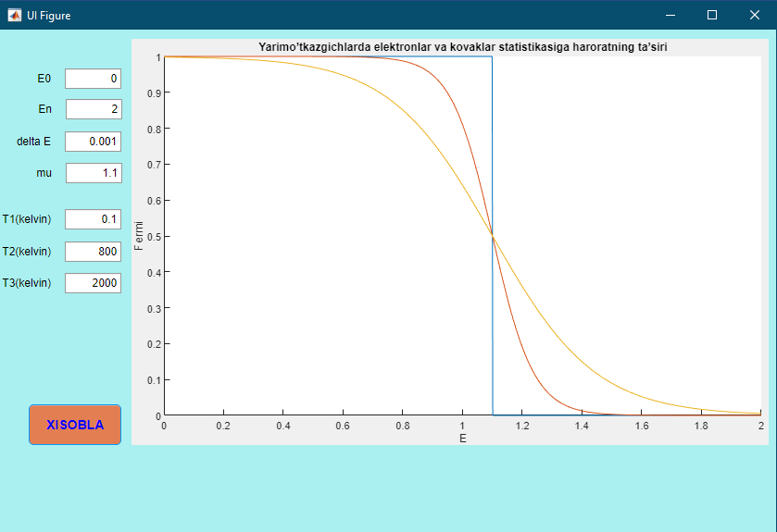

DASTUR MATNI

classdef app4 < matlab.apps.AppBase
% Properties that correspond to app components
properties (Access = public)
UIFigure matlab.ui.Figure
UIAxes matlab.ui.control.UIAxes
E0EditFieldLabel matlab.ui.control.Label
E0EditField matlab.ui.control.NumericEditField
EnEditFieldLabel matlab.ui.control.Label
EnEditField matlab.ui.control.NumericEditField
deltaEEditFieldLabel matlab.ui.control.Label
deltaEEditField matlab.ui.control.NumericEditField
muEditFieldLabel matlab.ui.control.Label
muEditField matlab.ui.control.NumericEditField
T1kelvinEditFieldLabel matlab.ui.control.Label
T1kelvinEditField matlab.ui.control.NumericEditField
T2kelvinEditFieldLabel matlab.ui.control.Label
T2kelvinEditField matlab.ui.control.NumericEditField
T3kelvinEditFieldLabel matlab.ui.control.Label
T3kelvinEditField matlab.ui.control.NumericEditField
XISOBLAButton matlab.ui.control.Button
Label matlab.ui.control.Label
end

properties (Access = private)
k=1.38e-23;
el=1.6e-19;

end

methods (Access = private)
% Button pushed function: XISOBLAButton
function XISOBLAButtonPushed(app, event)

e0=app.E0EditField.Value;
en=app.EnEditField.Value;
e1=app.deltaEEditField.Value;
mu=app.muEditField.Value;
t1=app.T1kelvinEditField.Value;
t2=app.T2kelvinEditField.Value;
t3=app.T3kelvinEditField.Value;

i=e0:e1:en
y1=(1+exp((i-mu).*app.el./(app.k.*t1))).^(-1);
y2=(1+exp((i-mu).*app.el./(app.k.*t2))).^(-1);
y3=(1+exp((i-mu).*app.el./(app.k.*t3))).^(-1);
plot(app.UIAxes,i, y1, i, y2, i, y3);
end
end
% App initialization and construction
methods (Access = private)
% Create UIFigure and components
function createComponents(app)
% Create UIFigure
app.UIFigure = uifigure;
app.UIFigure.Color = [0.6667 0.9412 0.9412];
app.UIFigure.Position = [100 100 640 480];
app.UIFigure.Name = 'UI Figure';
% Create UIAxes
app.UIAxes = uiaxes(app.UIFigure);
title(app.UIAxes, 'Yarimo’tkazgichlarda elektronlar va kovaklar statistikasiga haroratning ta’siri')
xlabel(app.UIAxes, 'E')
ylabel(app.UIAxes, 'Fermi')
app.UIAxes.FontSize = 11;
app.UIAxes.Position = [127 113 506 358];
% Create E0EditFieldLabel
app.E0EditFieldLabel = uilabel(app.UIFigure);
app.E0EditFieldLabel.HorizontalAlignment = 'right';
app.E0EditFieldLabel.Position = [31 417 25 22];
app.E0EditFieldLabel.Text = 'E0';
% Create E0EditField
app.E0EditField = uieditfield(app.UIFigure, 'numeric');
app.E0EditField.Position = [71 417 45 22];
% Create EnEditFieldLabel
app.EnEditFieldLabel = uilabel(app.UIFigure);
app.EnEditFieldLabel.HorizontalAlignment = 'right';
app.EnEditFieldLabel.Position = [32 384 25 22];
app.EnEditFieldLabel.Text = 'En';
% Create EnEditField
app.EnEditField = uieditfield(app.UIFigure, 'numeric');
app.EnEditField.Position = [72 384 45 22];
app.EnEditField.Value = 0.5;
% Create deltaEEditFieldLabel
app.deltaEEditFieldLabel = uilabel(app.UIFigure);
app.deltaEEditFieldLabel.HorizontalAlignment = 'right';
app.deltaEEditFieldLabel.Position = [13 349 43 22];
app.deltaEEditFieldLabel.Text = 'delta E';
% Create deltaEEditField
app.deltaEEditField = uieditfield(app.UIFigure, 'numeric');
app.deltaEEditField.Position = [71 349 45 22];
app.deltaEEditField.Value = 0.001;
% Create muEditFieldLabel
app.muEditFieldLabel = uilabel(app.UIFigure);
app.muEditFieldLabel.HorizontalAlignment = 'right';
app.muEditFieldLabel.Position = [32 315 25 22];
app.muEditFieldLabel.Text = 'mu';
% Create muEditField
app.muEditField = uieditfield(app.UIFigure, 'numeric');
app.muEditField.Position = [72 315 45 22];
app.muEditField.Value = 0.23;
% Create T1kelvinEditFieldLabel
app.T1kelvinEditFieldLabel = uilabel(app.UIFigure);
app.T1kelvinEditFieldLabel.HorizontalAlignment = 'right';
app.T1kelvinEditFieldLabel.Position = [-2 265 58 22];
app.T1kelvinEditFieldLabel.Text = 'T1(kelvin)';
% Create T1kelvinEditField
app.T1kelvinEditField = uieditfield(app.UIFigure, 'numeric');
app.T1kelvinEditField.Position = [71 265 45 22];
app.T1kelvinEditField.Value = 0.1;
% Create T2kelvinEditFieldLabel
app.T2kelvinEditFieldLabel = uilabel(app.UIFigure);
app.T2kelvinEditFieldLabel.HorizontalAlignment = 'right';
app.T2kelvinEditFieldLabel.Position = [-2 230 58 22];
app.T2kelvinEditFieldLabel.Text = 'T2(kelvin)';
% Create T2kelvinEditField
app.T2kelvinEditField = uieditfield(app.UIFigure, 'numeric');
app.T2kelvinEditField.Position = [71 230 45 22];
app.T2kelvinEditField.Value = 200;
% Create T3kelvinEditFieldLabel
app.T3kelvinEditFieldLabel = uilabel(app.UIFigure);
app.T3kelvinEditFieldLabel.HorizontalAlignment = 'right';
app.T3kelvinEditFieldLabel.Position = [-2 196 58 22];
app.T3kelvinEditFieldLabel.Text = 'T3(kelvin)';
% Create T3kelvinEditField
app.T3kelvinEditField = uieditfield(app.UIFigure, 'numeric');
app.T3kelvinEditField.Position = [71 196 45 22];
app.T3kelvinEditField.Value = 400;
% Create XISOBLAButton
app.XISOBLAButton = uibutton(app.UIFigure, 'push');
app.XISOBLAButton.ButtonPushedFcn = createCallbackFcn(app, @XISOBLAButtonPushed, true);
app.XISOBLAButton.BackgroundColor = [0.851 0.3294 0.102];
app.XISOBLAButton.FontSize = 14;
app.XISOBLAButton.FontWeight = 'bold';
app.XISOBLAButton.FontColor = [0 0 1];
app.XISOBLAButton.Position = [16 113 100 44];
app.XISOBLAButton.Text = 'XISOBLA';
% Create Label
app.Label = uilabel(app.UIFigure);
app.Label.BackgroundColor = [0.9216 0.8353 0.6431];
app.Label.FontSize = 14;
app.Label.FontAngle = 'italic';
app.Label.FontColor = [1 0 0];
app.Label.Position = [123 57 510 39];
app.Label.Text = {'Dasturdan o’qituvchilar, yarimo’tkazgichlar fizikasi yo’nalishidagi ilmiy xodimlar, '; 'mustaqil izlanuvchilar va boshqa xohlovchilar foydalanishlari mumkin. '; ''};
end
end
methods (Access = public)
% Construct app
function app = app4
% Create and configure components
createComponents(app)
% Register the app with App Designer
registerApp(app, app.UIFigure)
if nargout == 0
clear app
end
end
% Code that executes before app deletion
function delete(app)
% Delete UIFigure when app is deleted
delete(app.UIFigure)
% Create UIFigure
app.UIFigure = uifigure;
app.UIFigure.Position = [100 100 754 480];
app.UIFigure.Name = 'UI Figure';
% Create A0EditFieldLabel
app.A0EditFieldLabel = uilabel(app.UIFigure);
app.A0EditFieldLabel.HorizontalAlignment = 'right';
app.A0EditFieldLabel.Position = [56 427 25 22];
app.A0EditFieldLabel.Text = 'A0';
% Create A0EditField
app.A0EditField = uieditfield(app.UIFigure, 'numeric');
app.A0EditField.Position = [96 427 100 22];
app.A0EditField.Value = 1.4;
% Create deltaAEditFieldLabel
app.deltaAEditFieldLabel = uilabel(app.UIFigure);
app.deltaAEditFieldLabel.HorizontalAlignment = 'right';
app.deltaAEditFieldLabel.Position = [38 382 43 22];
app.deltaAEditFieldLabel.Text = 'delta A';
% Create deltaAEditField
app.deltaAEditField = uieditfield(app.UIFigure, 'numeric');
app.deltaAEditField.Position = [96 382 100 22];
app.deltaAEditField.Value = 0.1;
% Create AnEditFieldLabel
app.AnEditFieldLabel = uilabel(app.UIFigure);
app.AnEditFieldLabel.HorizontalAlignment = 'right';
app.AnEditFieldLabel.Position = [56 337 25 22];
app.AnEditFieldLabel.Text = 'An';
% Create AnEditField
app.AnEditField = uieditfield(app.UIFigure, 'numeric');
app.AnEditField.Position = [96 337 100 22];
app.AnEditField.Value = 1.4;
% Create TkelvinEditFieldLabel
app.TkelvinEditFieldLabel = uilabel(app.UIFigure);
app.TkelvinEditFieldLabel.HorizontalAlignment = 'right';
app.TkelvinEditFieldLabel.Position = [29 293 52 22];
app.TkelvinEditFieldLabel.Text = 'T(kelvin)';
% Create TkelvinEditField
app.TkelvinEditField = uieditfield(app.UIFigure, 'numeric');
app.TkelvinEditField.Position = [96 293 100 22];
app.TkelvinEditField.Value = 1;
% Create UIAxes
app.UIAxes = uiaxes(app.UIFigure);
title(app.UIAxes, 'Graph')
xlabel(app.UIAxes, 'A')
ylabel(app.UIAxes, 'Fermi')
app.UIAxes.Position = [228 18 512 431];
% Create XisoblashButton
app.XisoblashButton = uibutton(app.UIFigure, 'push');
app.XisoblashButton.ButtonPushedFcn = createCallbackFcn(app, @XisoblashButtonPushed, true);
app.XisoblashButton.Position = [56 177 140 75];
app.XisoblashButton.Text = 'Xisoblash';
end
end
methods (Access = public)
% Construct app
function app = app1
% Create and configure components
createComponents(app)
% Register the app with App Designer
registerApp(app, app.UIFigure)
if nargout == 0
clear app
end
end
% Code that executes before app deletion
function delete(app)
% Delete UIFigure when app is deleted
delete(app.UIFigure)
end
end
end

